MySQL

1. Table: Movies

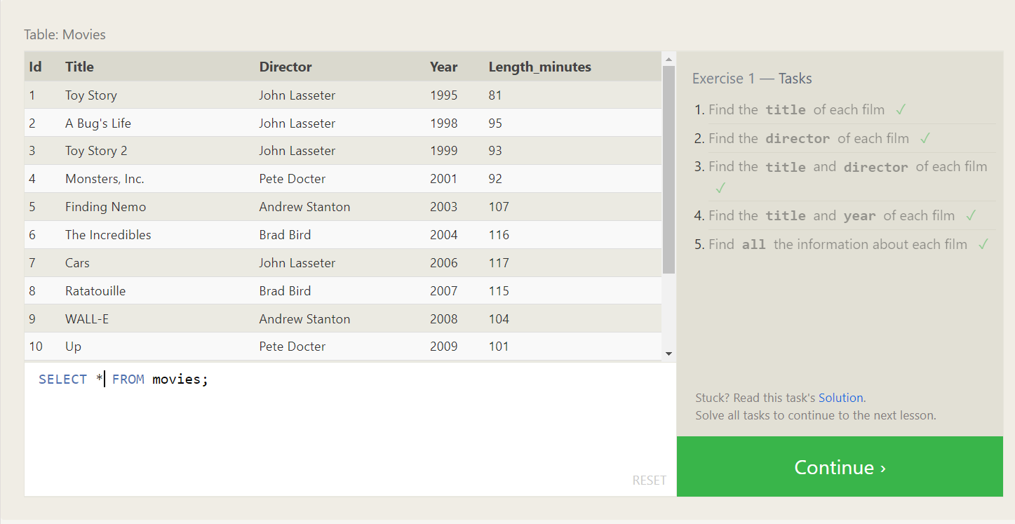

1. Using the right constraints, find the information we need from the Movies table for each task below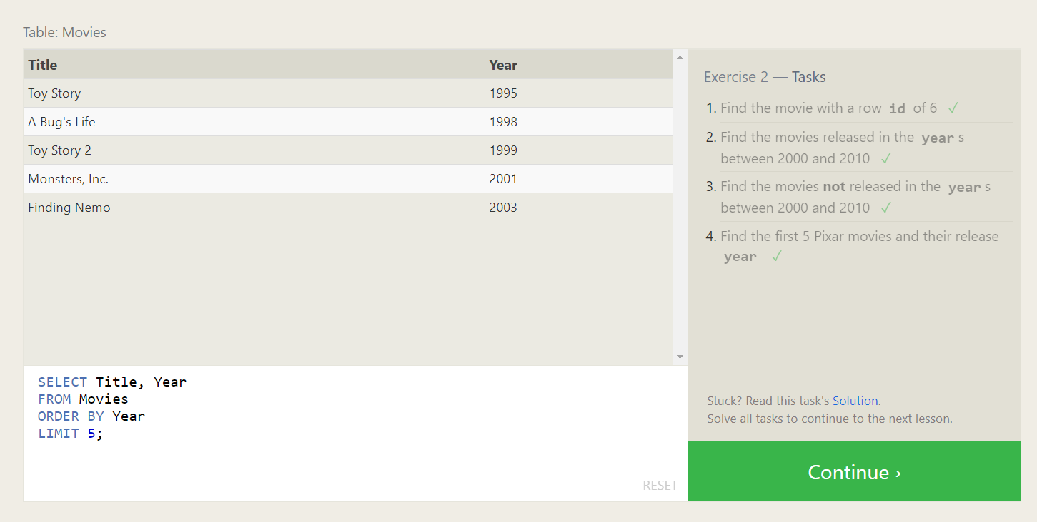
2. Here's the definition of a query with a WHERE clause again, go ahead and try and write some queries with the operators above to limit the results to the information we need in the tasks below. 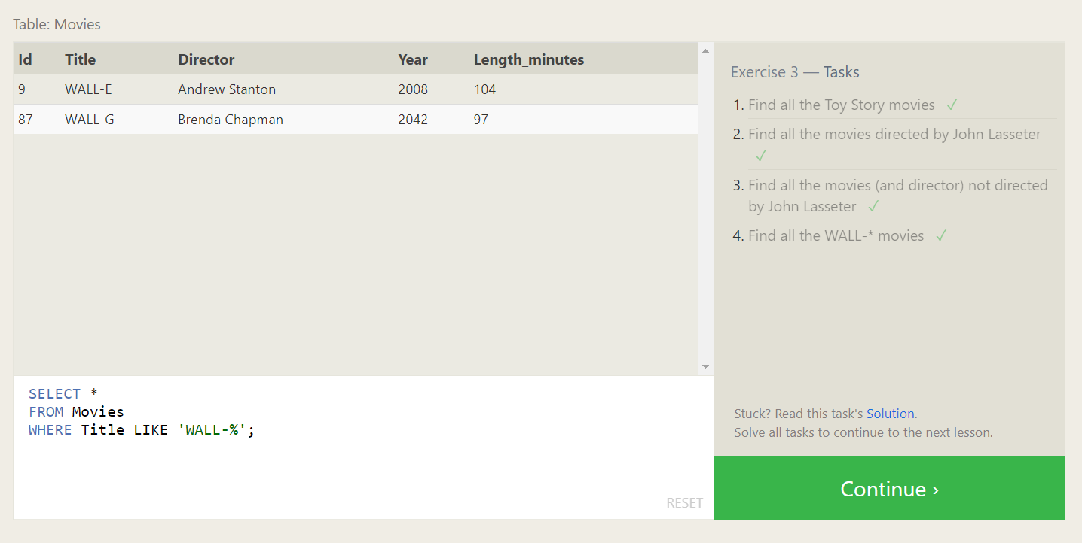
3. There are a few concepts in this lesson, but all are pretty straight-forward to apply. To spice things up, we've gone and scrambled the Movies table for you in the exercise to better mimic what kind of data you might see in real life. Try and use the necessary keywords and clauses introduced above in your queries. 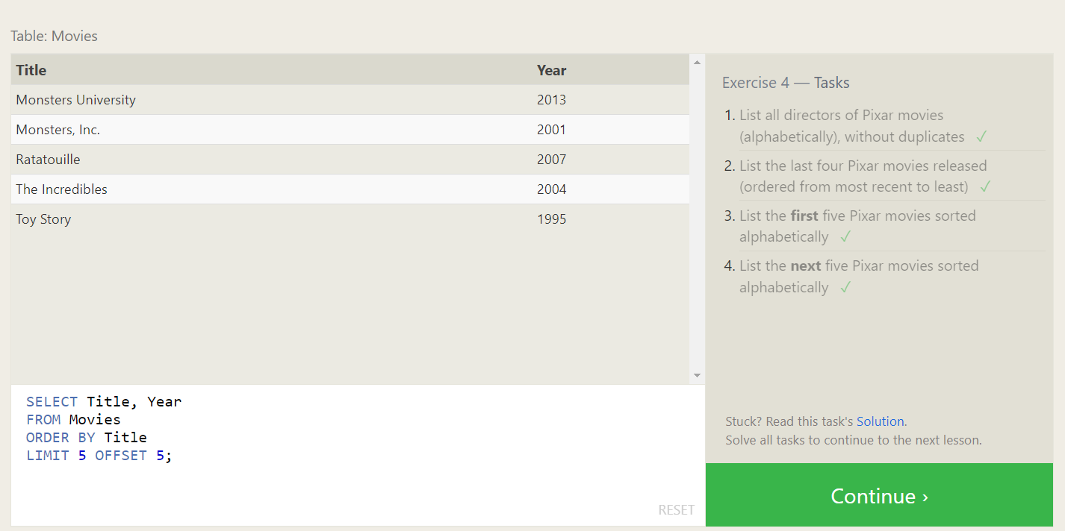
4. In the exercise below, you will be working with a different table. This table instead contains information about a few of the most populous cities of North America including their population and geo-spatial location in the world. 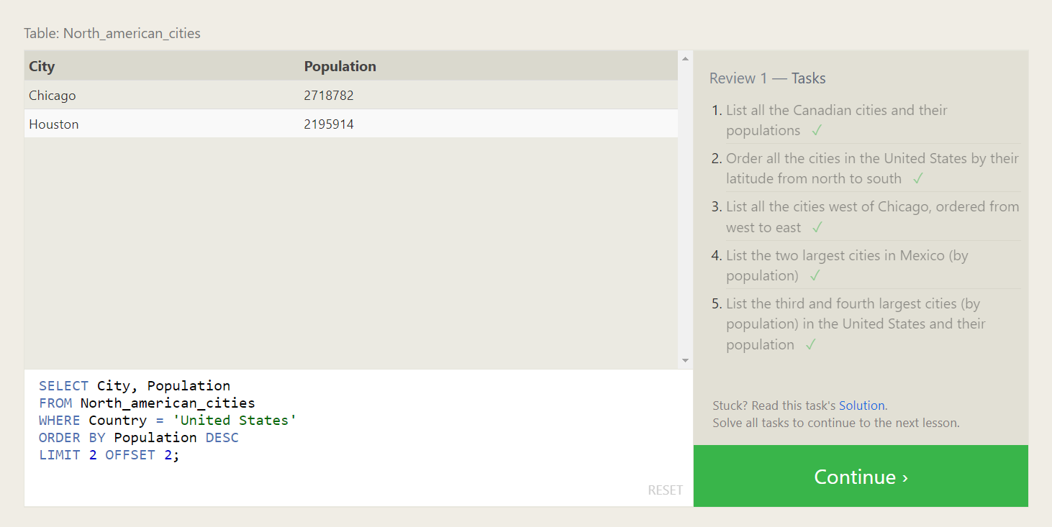
5. We've added a new table to the Pixar database so that you can try practicing some joins. The Box-office table stores information about the ratings and sales of each particular Pixar movie, and the Movie Id column in that table corresponds with the Id column in the Movies table 1-to-1. Try and solve the tasks below using the INNER JOIN introduced above. 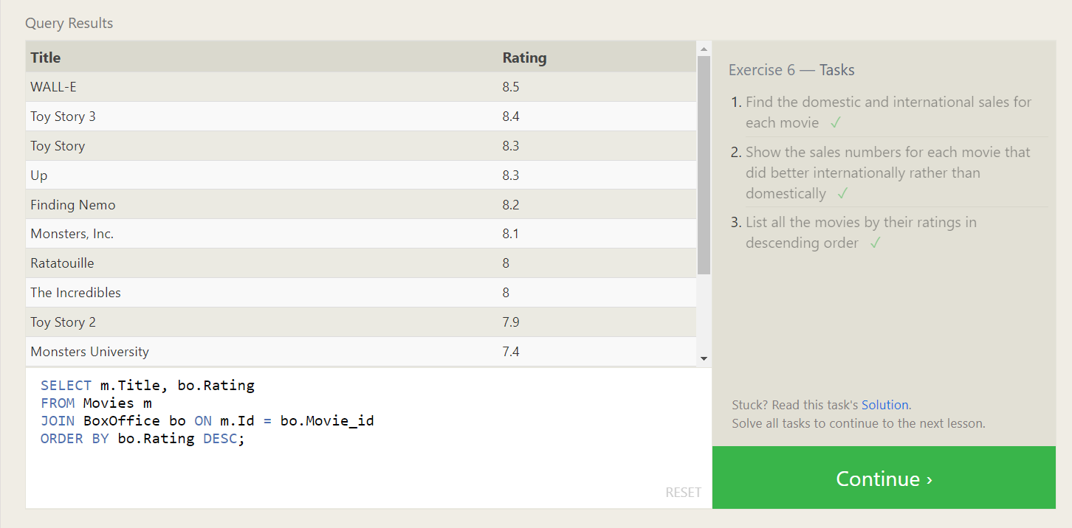
6. In this exercise, you are going to be working with a new table which stores fictional data about Employees in the film studio and their assigned office Buildings. Some of the buildings are new, so they don't have any employees in them yet, but we need to find some information about them regardless.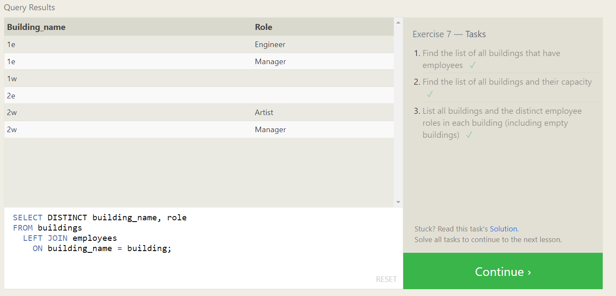
7. This exercise will be a sort of review of the last few lessons. We're using the same Employees and Buildings table from the last lesson, but we've hired a few more people, who haven't yet been assigned a building. 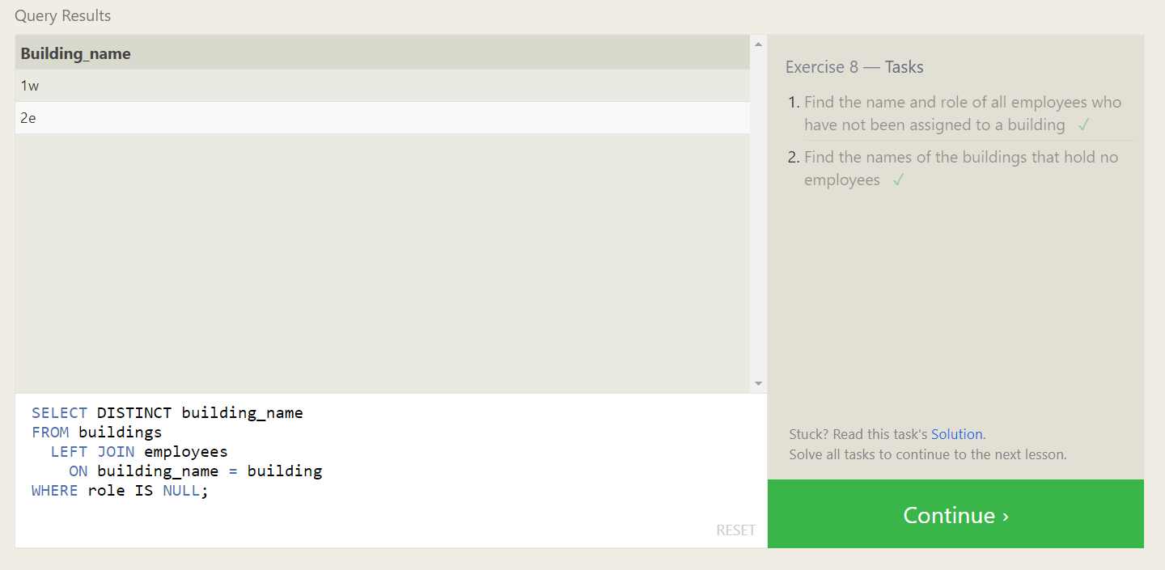
8. SQL Lesson 9: Queries with expressions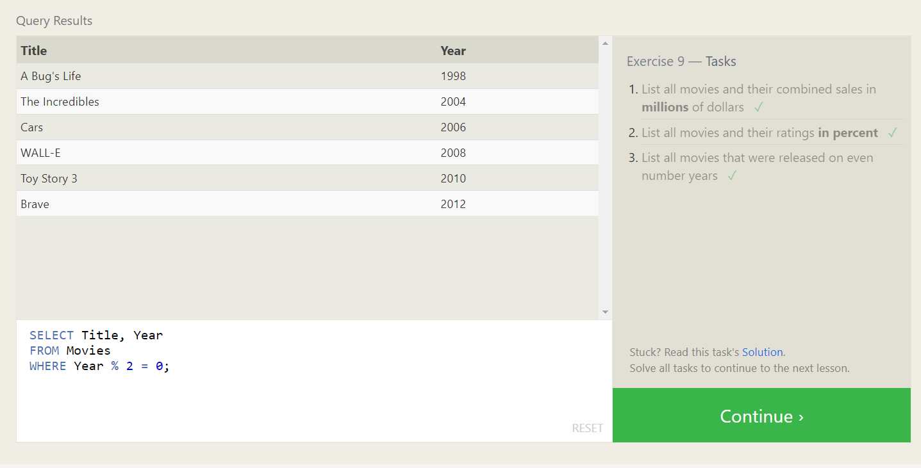
9. SQL Lesson 10: Queries with aggregates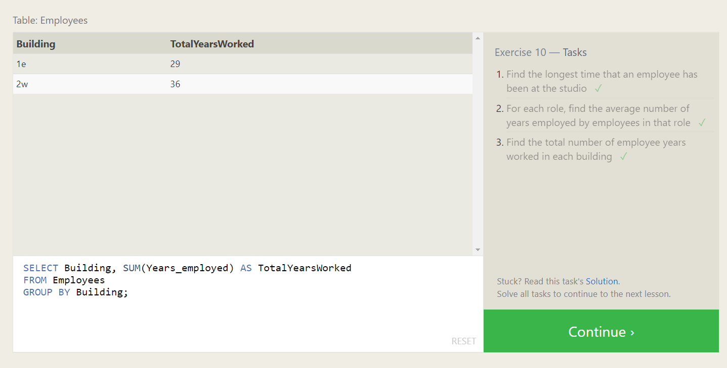
10. SQL Lesson 11: Queries with aggregates (Pt. 2) 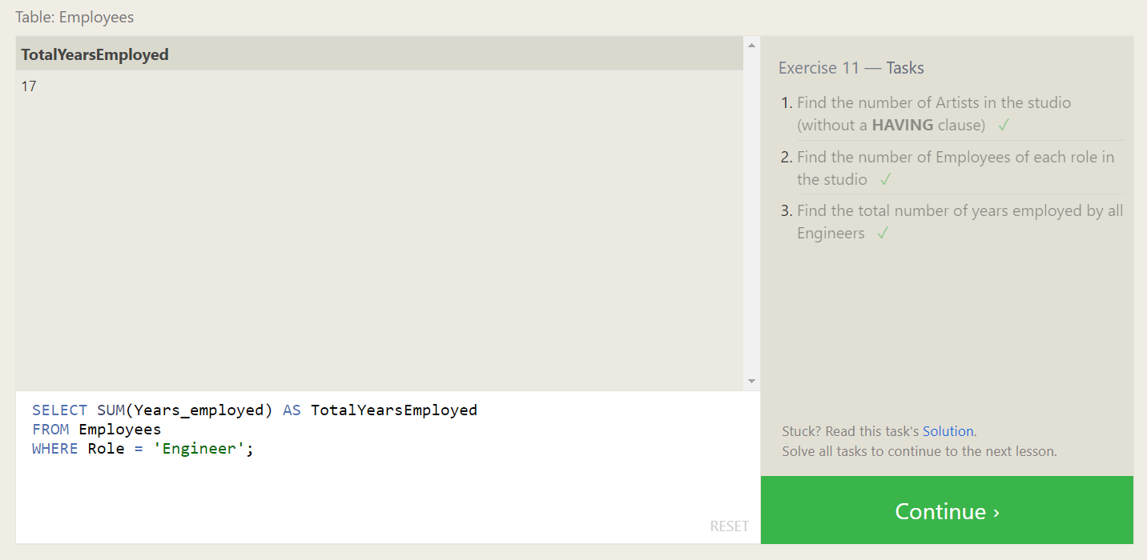
11. SQL Lesson 12: Order of execution of a Query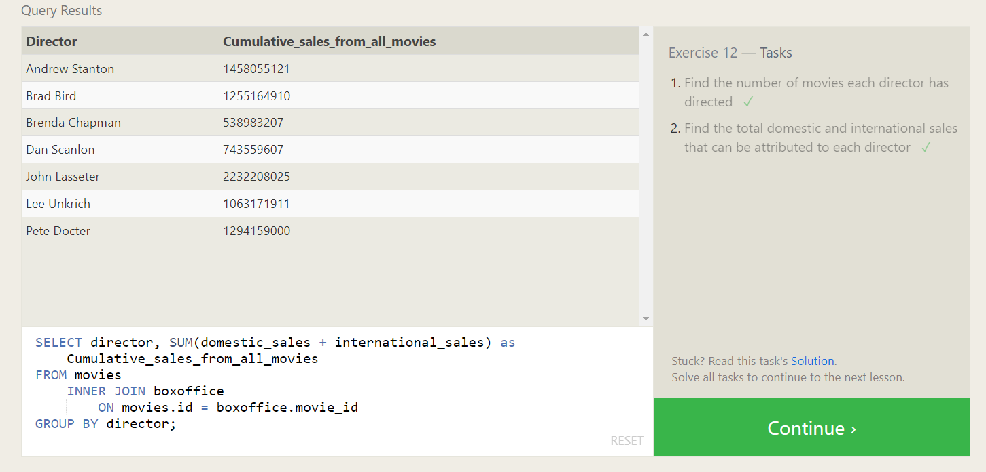
12. SQL Lesson 13: Inserting rows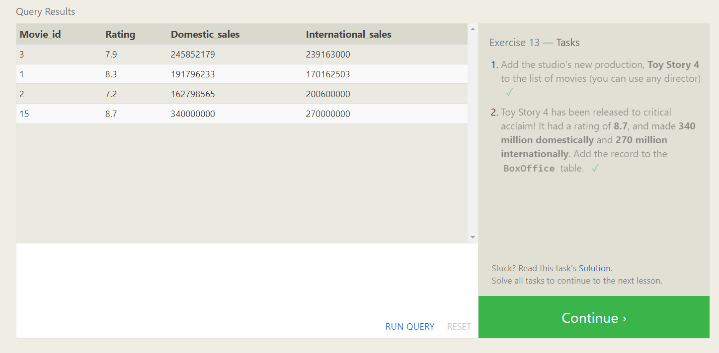
13. SQL Lesson 14: Updating rows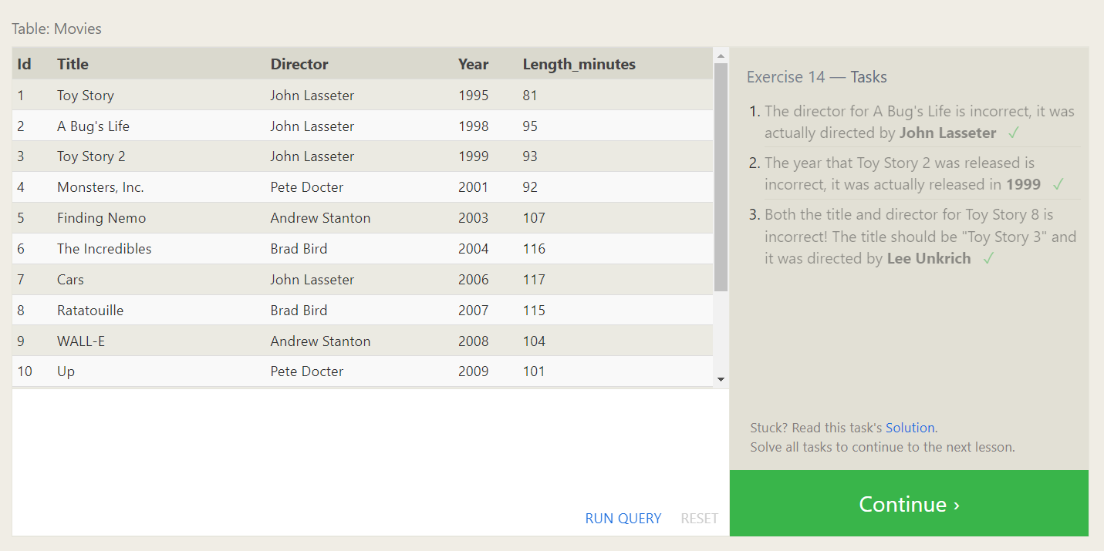
14. SQL Lesson 15: Deleting rows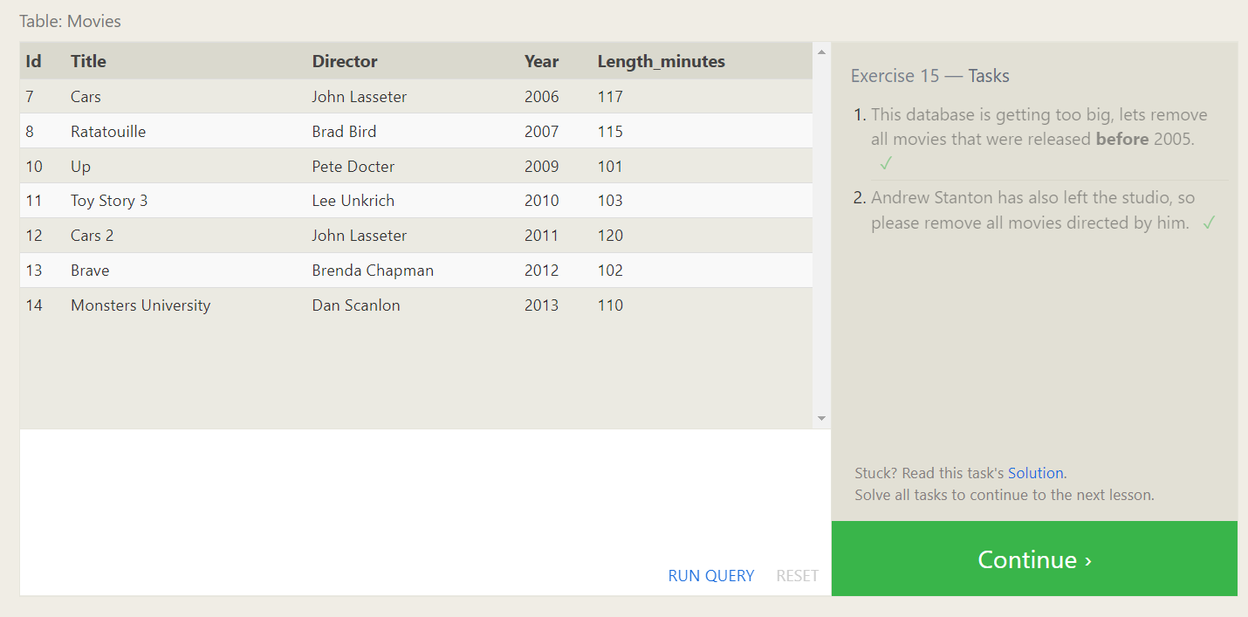
15. SQL Lesson 16: Creating tables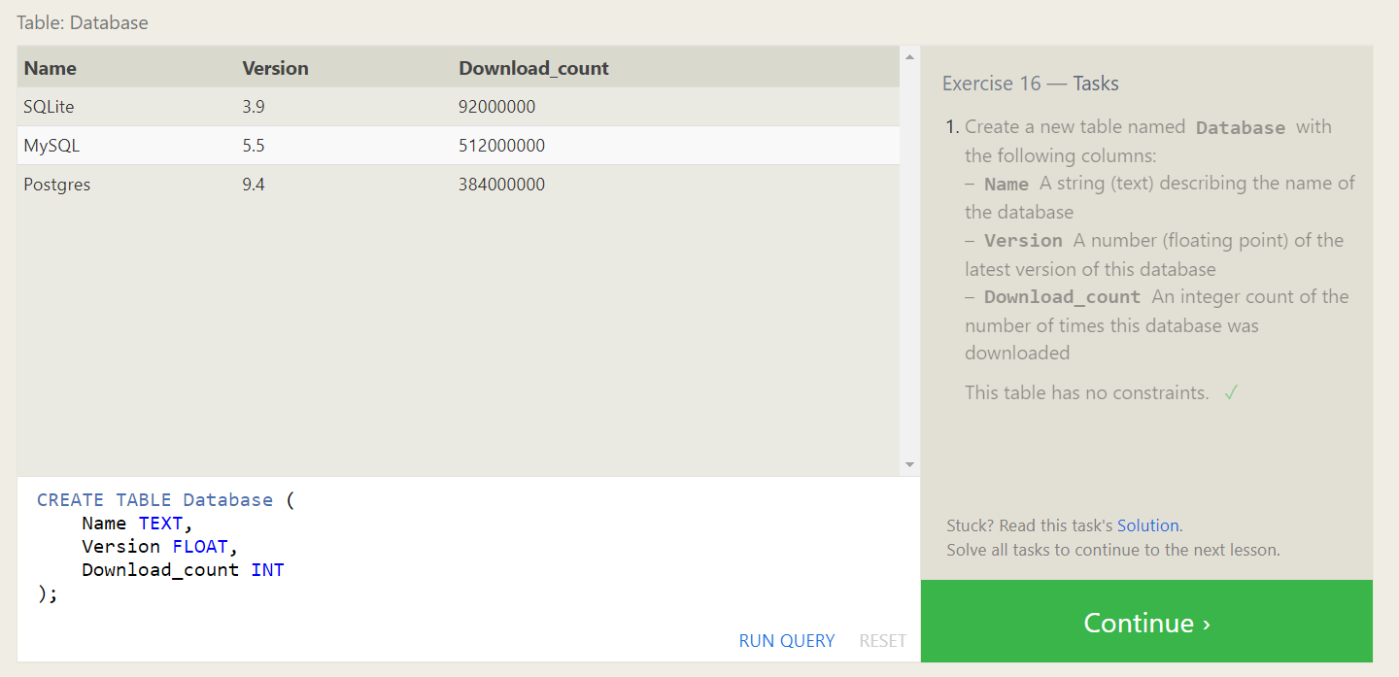
16. SQL Lesson 17: Altering tables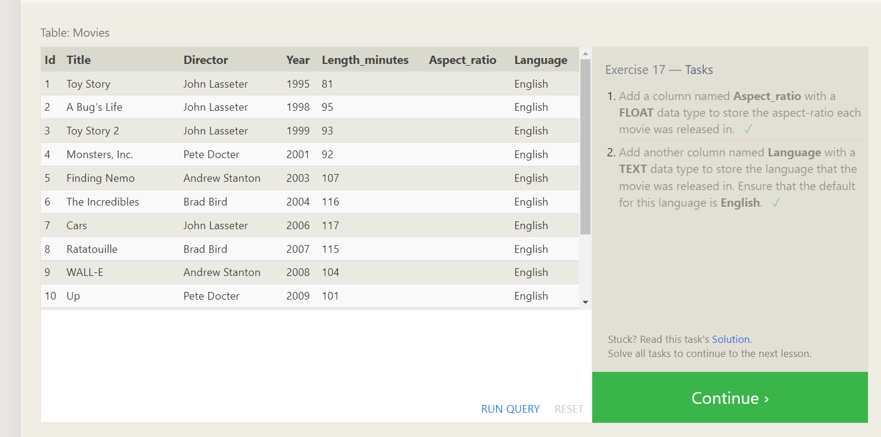
17. SQL Lesson 18: Dropping tables