|  |  |
| --- | --- |
| **EX NO: 4B** | **SHORTEST JOB FIRST – SCHEDULING ALGORITHM** |
| **DATE:** |
| **AIM:**  To write a program to implement cpu scheduling algorithm for shortest job first scheduling.    **ALGORITHM:**     1. Start the program. 2. Get the number of processes and their burst time 3. Initialize the waiting time for process 1 as 0. 4. The processes are stored according to the burst time. 5. The waiting time for the processes are calculated a follows:   for(i=2;i<=n;i++).wt.p[i]=p[i=1]+bt.p[i-1].   1. The waiting time of all the processes summed and then the average time is calculate 7. The waiting time of each processes and average time are displayed.   8. Stop the program.                                                      45 | |

**PROGRAM:**

#include<stdio.h> void main() {

int i,j,k,n,sum,wt[10],tt[10],twt,ttat; int t[10],p[10]; float awt,atat;

printf("enter the number of processer");

scanf("%d",&n); for(i=0;i<n;i++)

{

printf("\n enter burst time %d",i); scanf("\n%d",&t[i]);

} for(i=0;i<n;i++) p[i]=i; for(i=0;i<n;i++)

{

for(k=0;k<i+1;k++)

{ if(t[i]>t[k]) { int temp; temp=t[i]; t[i]=t[k]; t[k]=temp; temp=p[i]; p[i]=p[k]; p[k]=temp; }}

printf("\n\n SHOREST JOB SSHEDULING\n\n");

printf("\nprocerrid\tburst tim\twaitingtime\tturnaround time\n\n"); wt[0]=0; for(i=0;i<n;i++)

{

sum=0; for(k=0;k<i;k++)

{ wt[i]=sum+t[k]; sum=wt[i];

} }

for(i=0;i<n;i++)

{

tt[i]=t[i]+wt[i]; } for(i=0;i<n;i++)

{ wt[i]=sum+t[k]; sum=wt[i];

} } for(i=0;i<n;i++)

{

tt[i]=t[i]+wt[i]; } for(i=0;i<n;i++)

{

printf("%5d\t\t%5d\t\t%5d\t\t%5d\n",p[i],t[i],wt[i],tt[i]);

} twt=0; ttat=t[0]; for(i=1;i<n;i++)

{ twt=twt+wt[i]; ttat=ttat+tt[i]; } awt=(float)twt/n; atat=(float)ttat/n;

printf("\n AVERAGE WAITING TIME %4.2f",awt);

printf("\n AVERAGE TURN AROUND TIME %4.2f",atat);

}

}

**OUTPUT:**

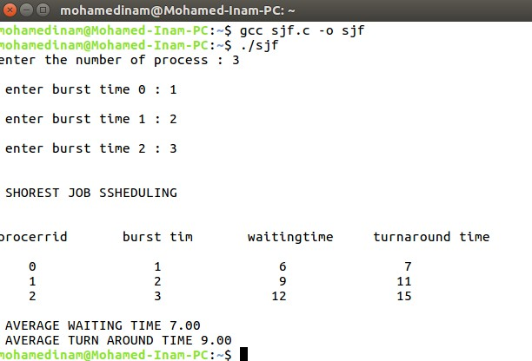

**RESULT:**

Thus the SJF program was executed and verified successfully