TASK:1

1. Create a function module to import a range of customer numbers and export the customer data for the given range.

Customer Data can be found in table KNA1.

Time : 30 minutes

Create a package and keep all objects created for this task in that package.

Paste screenshots of all the objects created for this task.

OUTPUT :

STEP 1: CREATE PACKAGE CREATION:

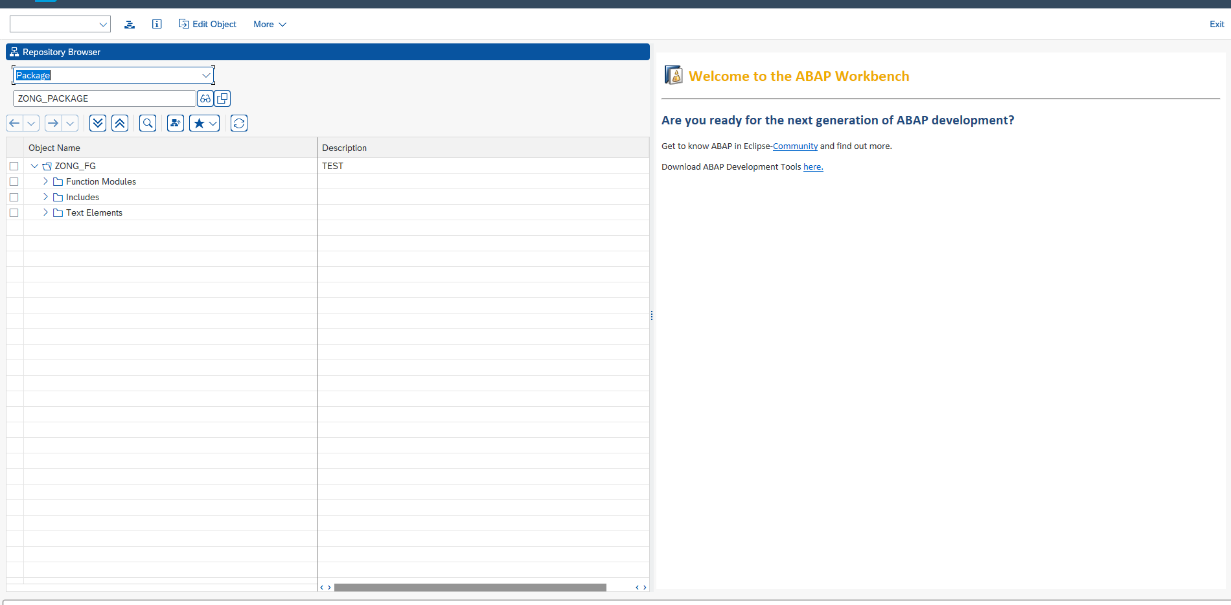

STEP 2 : INPUT TYPE STRUCTURE:

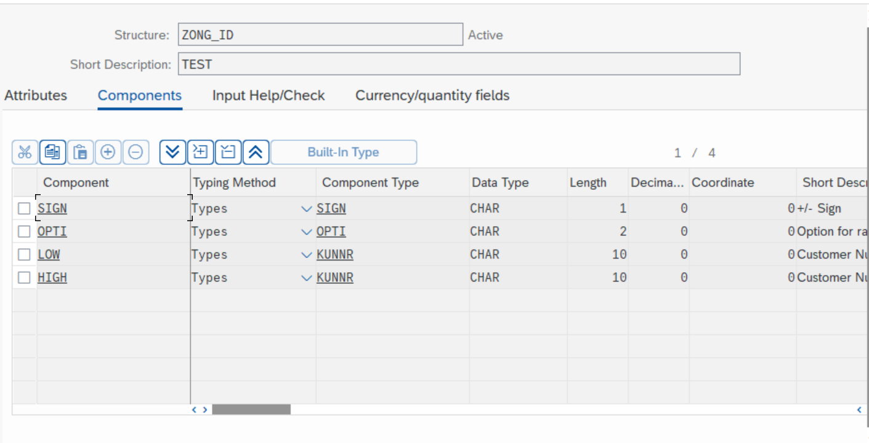

STEP 3 : INPUT TABLE TYPE:

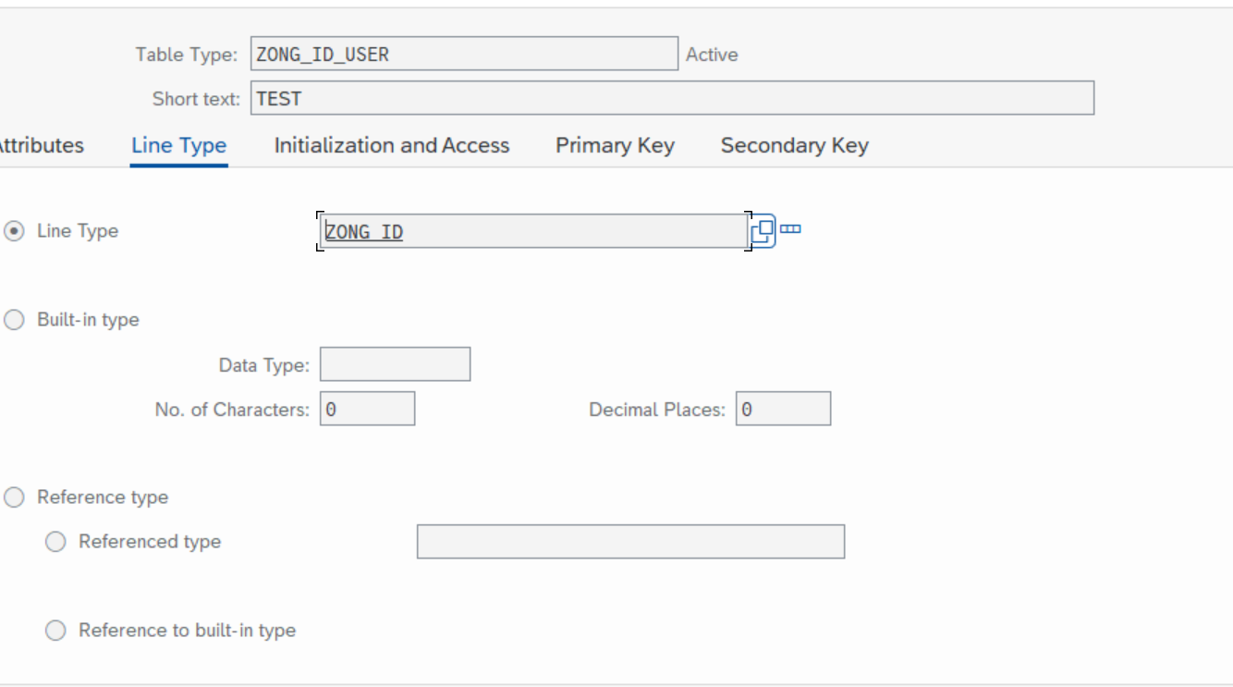

STEP4 : OUTPUT TYPE STRUCTURE:

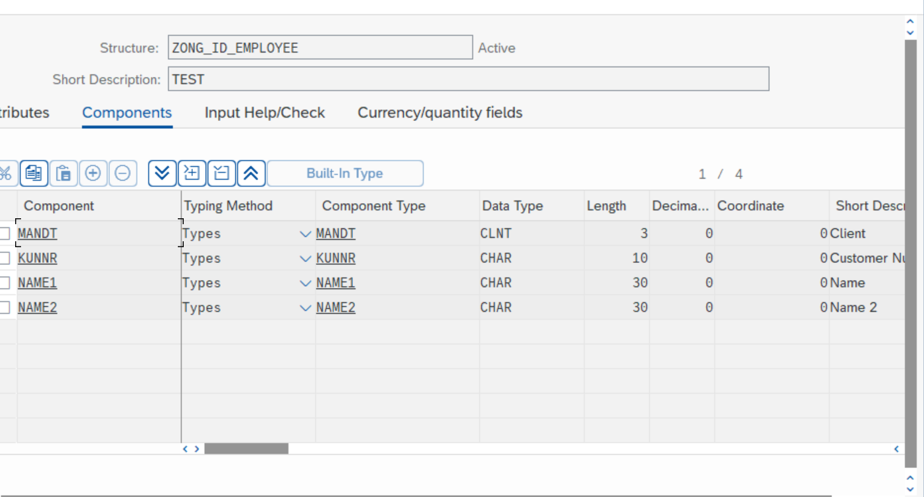

STEP5 : OUTPUT TABLE TYPE:

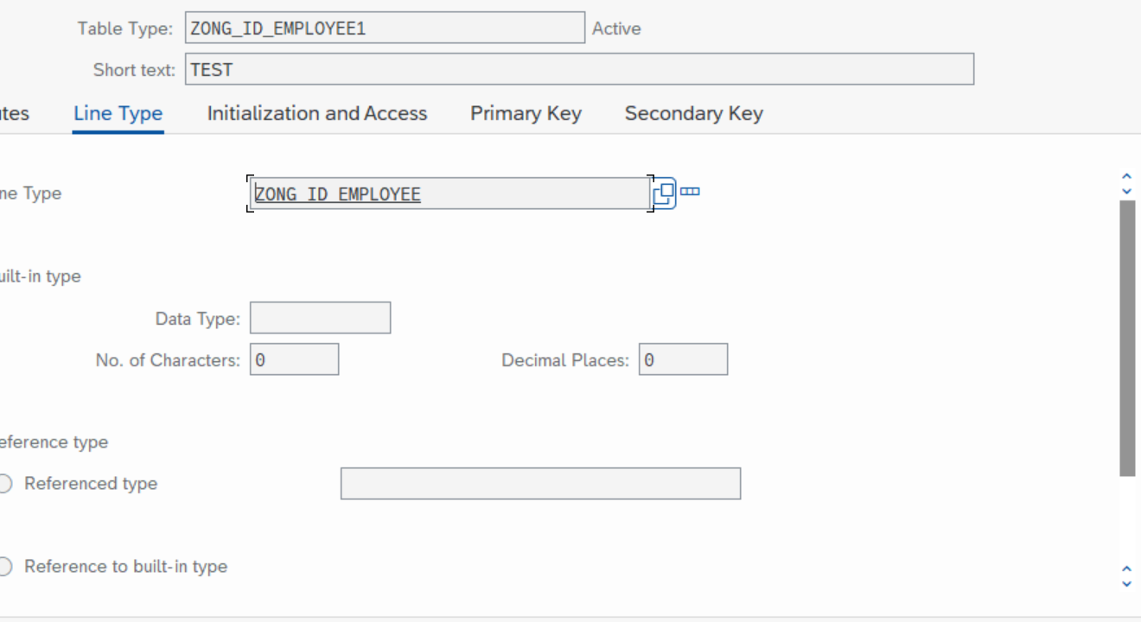

STEP6: PROGRAM:

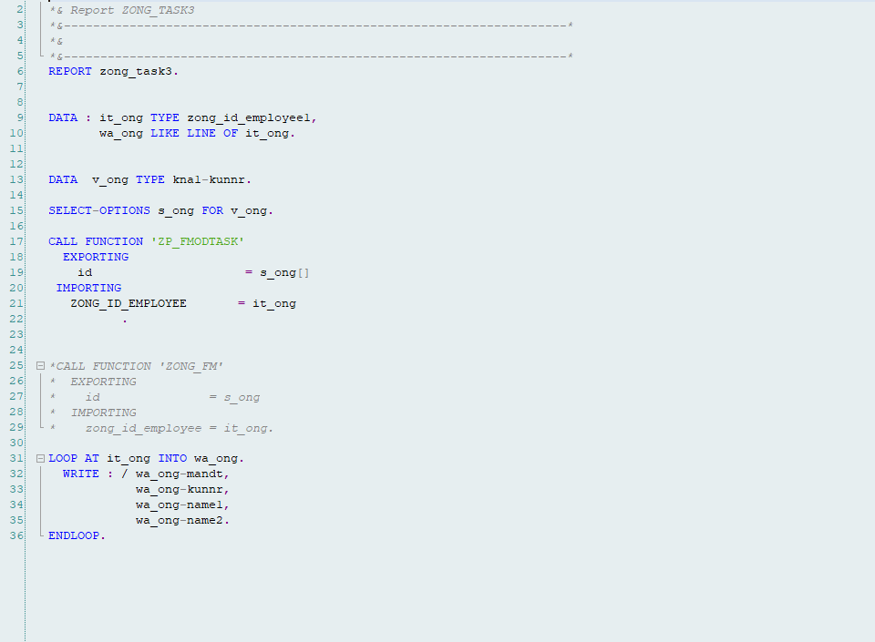

STEP7: FUNCTIONAL GROUP:

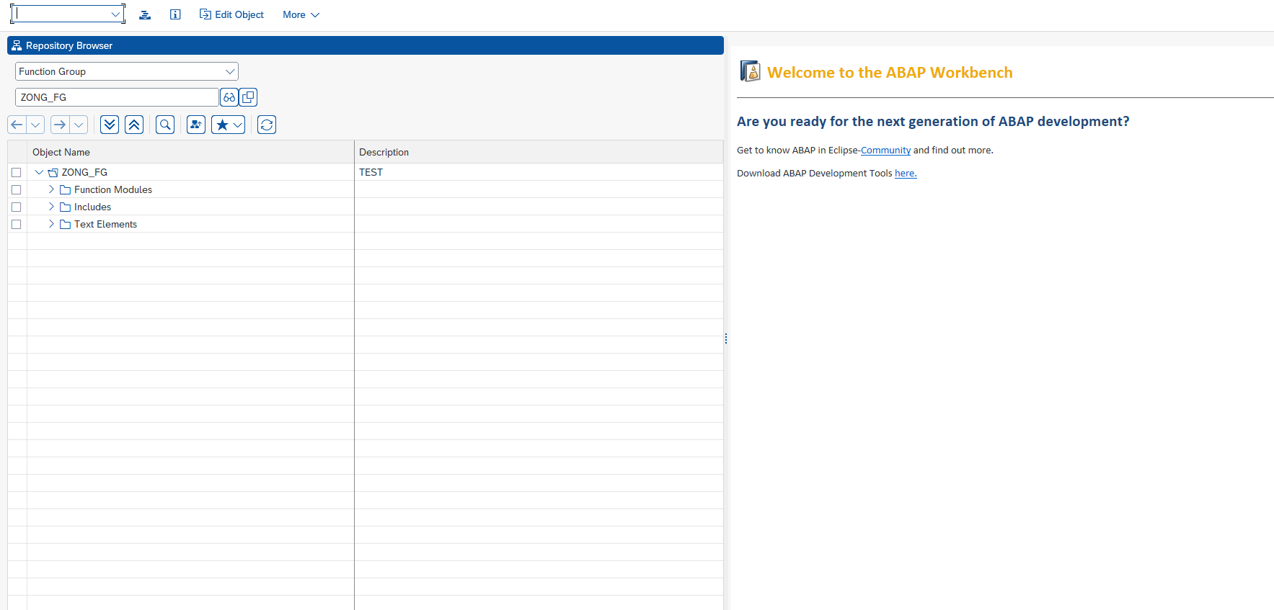

STEP8: FUNCTIONAL MODULE:

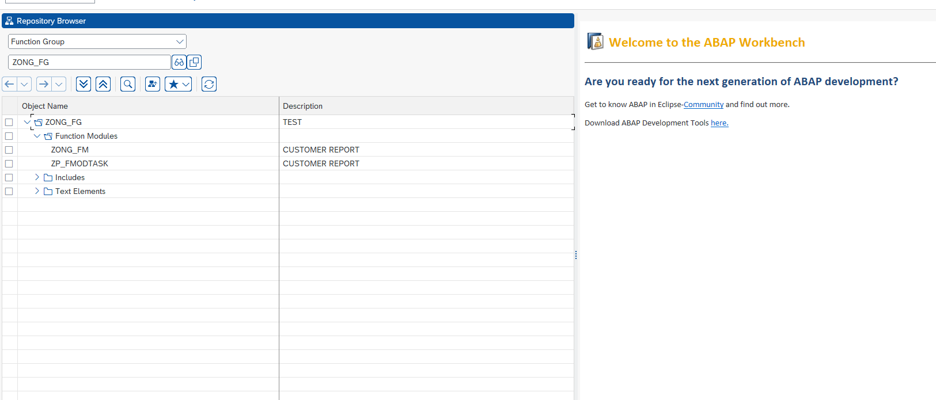

STEP9: IMPORT

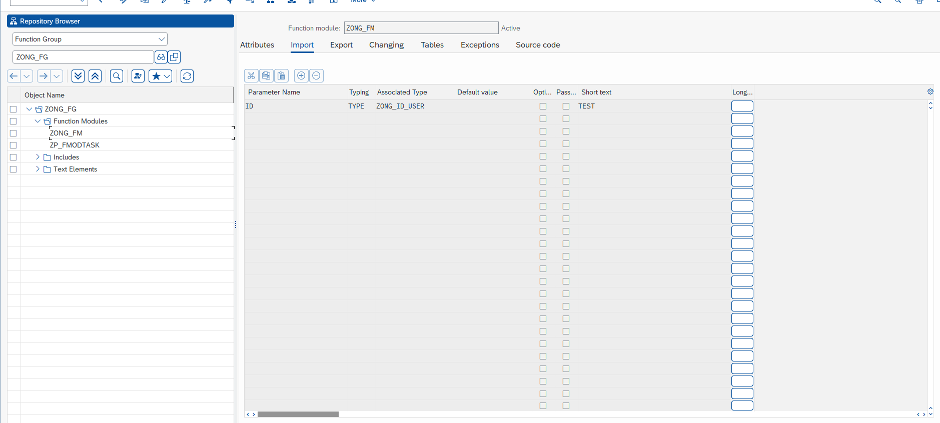

STEP10: EXPORT:

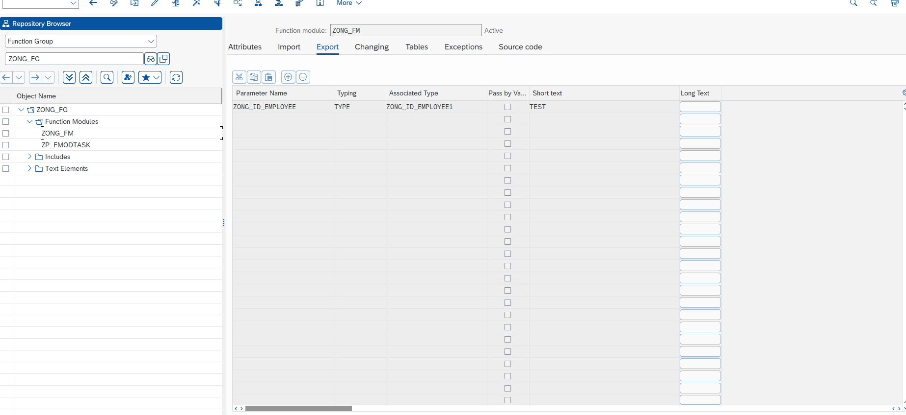

STEP11: SOURCE CODE:

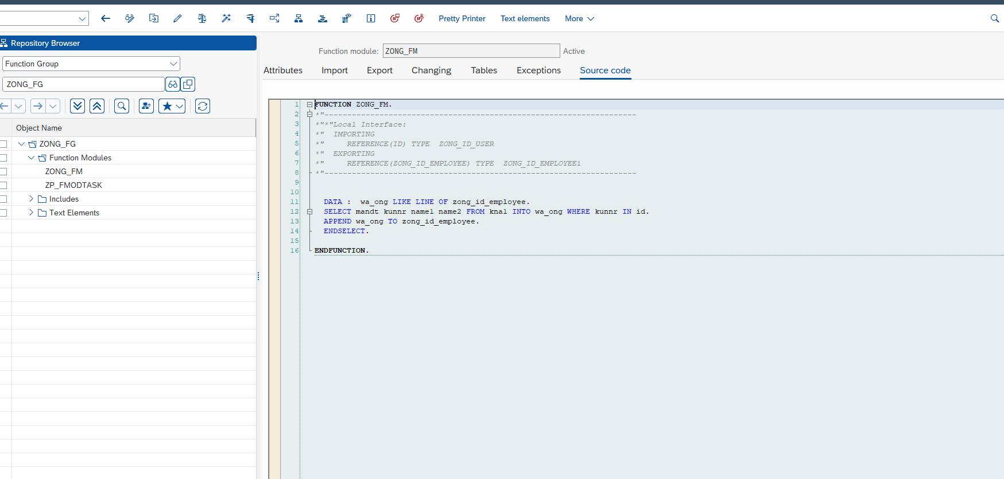

STEP12:OUTPUT RANGE:

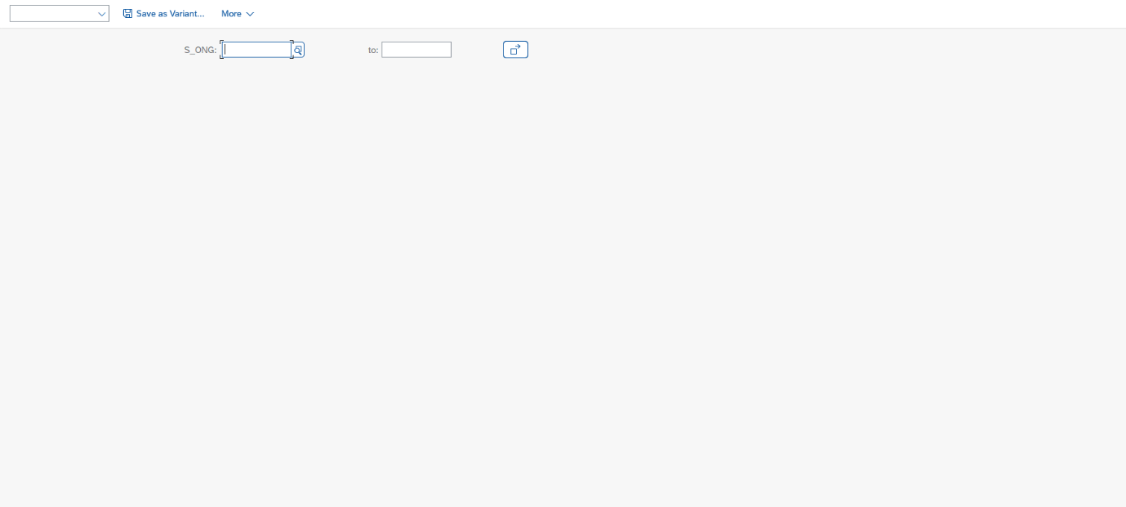

STEP13: OUTPUT:

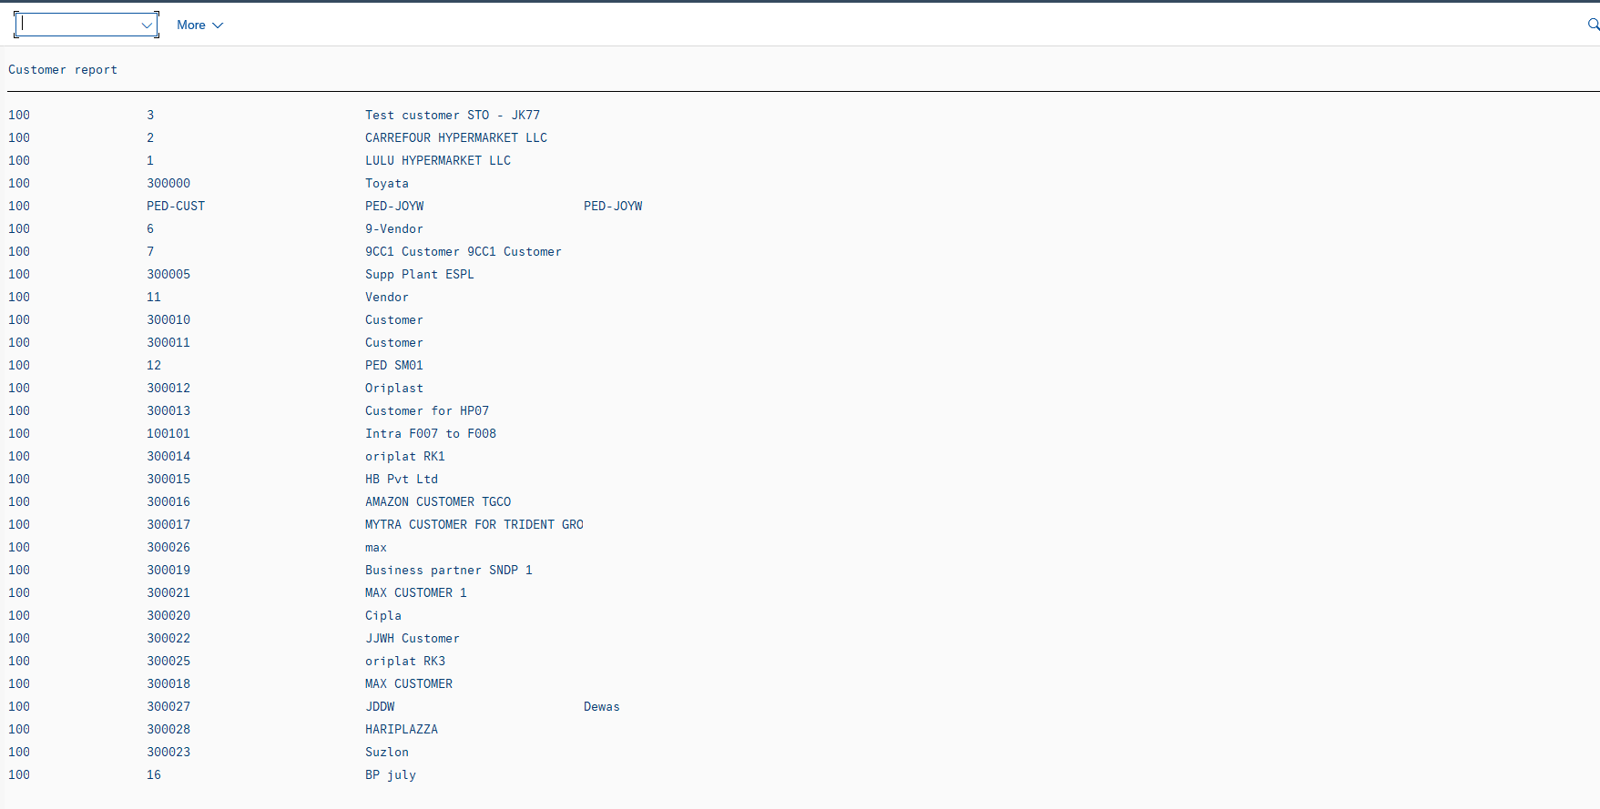

Thank you