**1.Revision History**

**Revision History identify changes to the Design Document.**

|  |  |  |  |
| --- | --- | --- | --- |
| **Name** | **Date** | **Description** | **Version** |
|  |  |  |  |
|  |  |  |  |
|  |  |  |  |

**2.Use Case Diagram: Inventory Management Sub-System**

Employee

**Inventory Management Sub-system**

**3. System Structure**

Inventory Sub-System

Stock Management

Shelves Management

**4. Static structure and Data Analysis**

* 1. **Model-View-Controller (MVC) Model**

**1. Manage Product on Shelves**

1.1 Add Product on Shelves

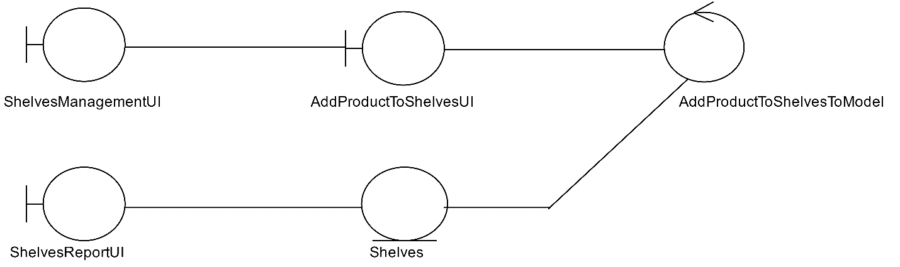

1.2 Edit Product on Shelves

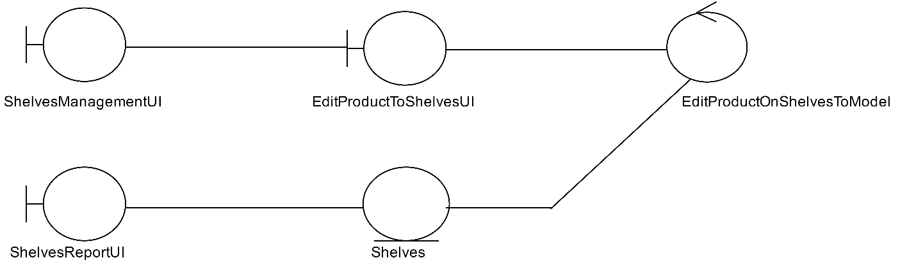

1.3 View Product on Shelves

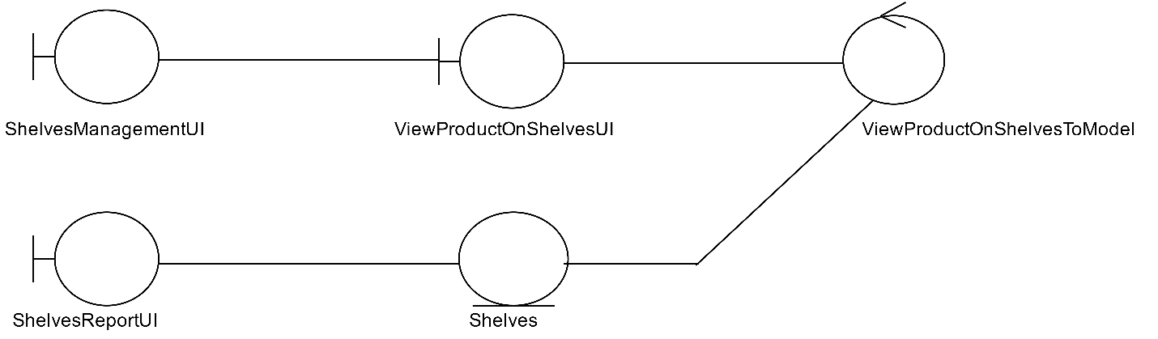

2. Check Number Of Product

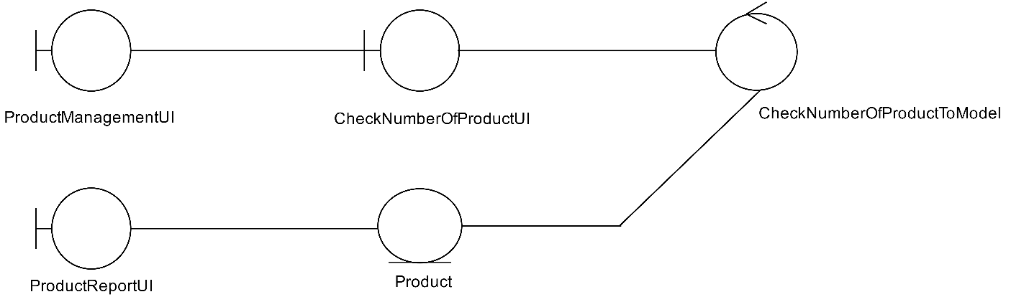

3. Add Stock Of Product

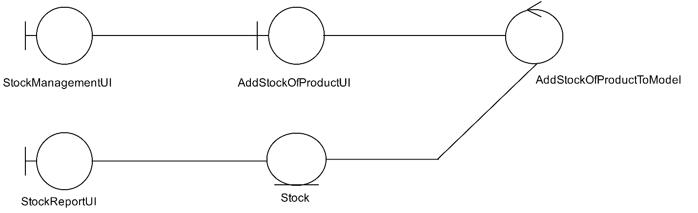

1. Edit Stock Of Product

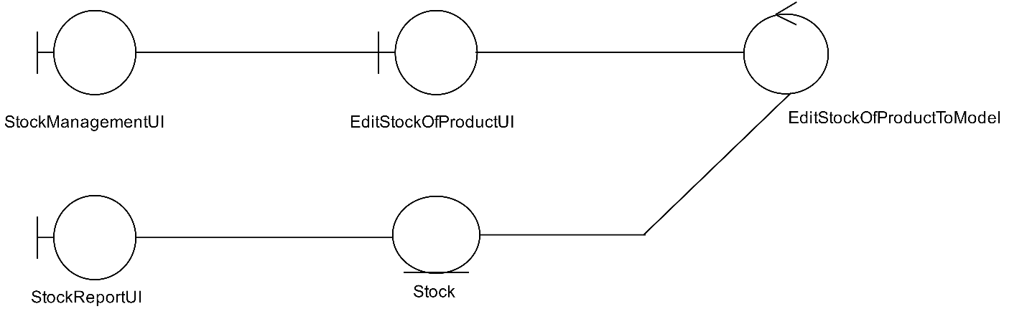

**4.2 Entity Class Diagram: Inventory Management**

Product

ProductID

ProductName

Unit

Type

Status

CostsAvg

Price

NumTotal

Dealer

SupplierName

DateExp

Dealer

CheckNumberOfProduct

Shelves

ShelvesID

ShelvesName

Type

PutProductToShelves

EditProductToShelves

ViewProductOnShelves

StockInventory

StockId

StockDate

0..*

0..1

1

0..*

AddLotProductofStock

EditLotProductofStock

**5. System Behavior Model**

**5.1 Sequence diagram demonstrating operation “Add product to Shelves”**

* This diagram describes the system scenario of “**UC511: Add products to Shelves”**

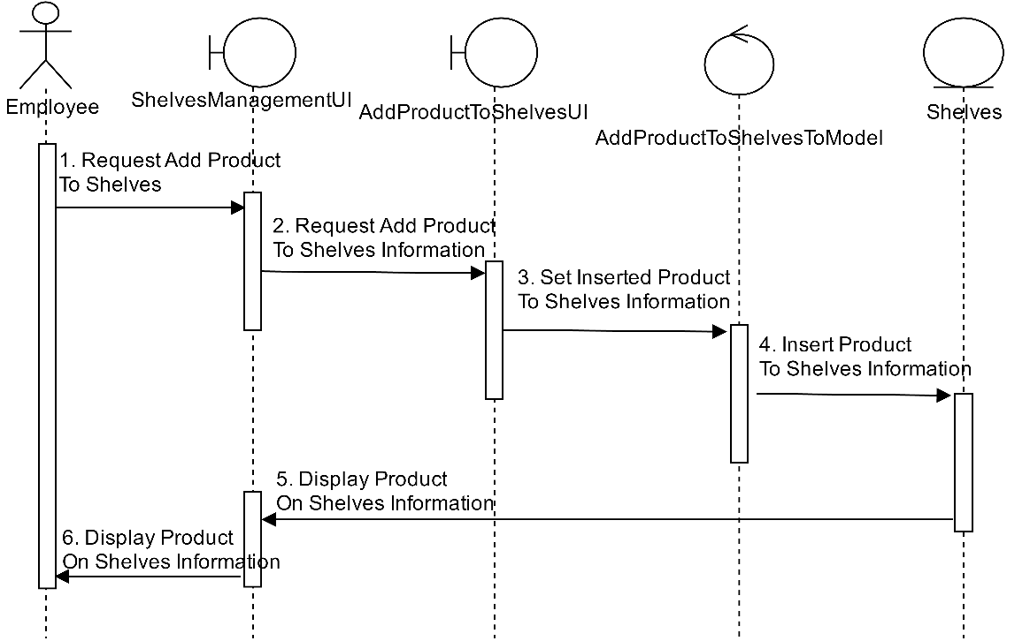

**5.2 Sequence diagram demonstrating operation “Edit Product on shelf”**

* This diagram describes the system scenario of “**UC512: Edit products on Shelves”** 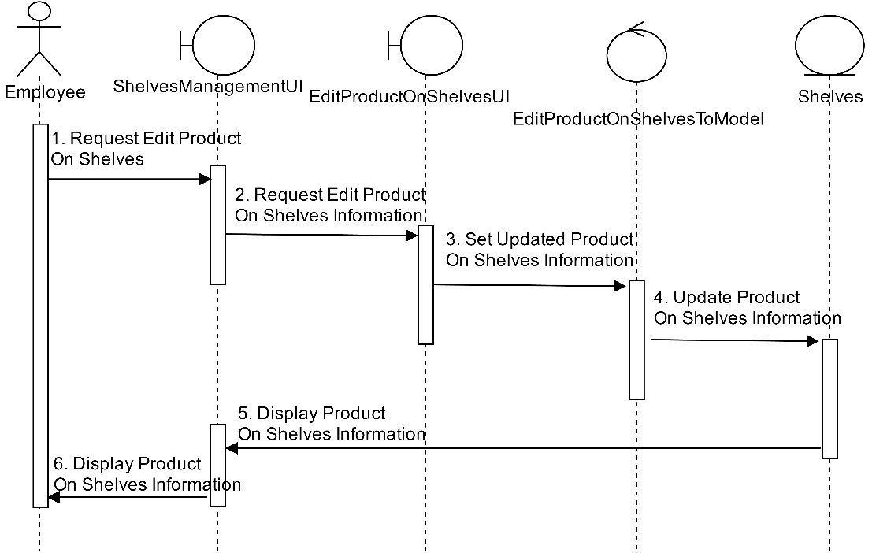

**­**

**5.3 Sequence diagram demonstrating operation “View Product on Shelf”**

* This diagram describes the system scenario of “**UC513: View products on Shelves”**

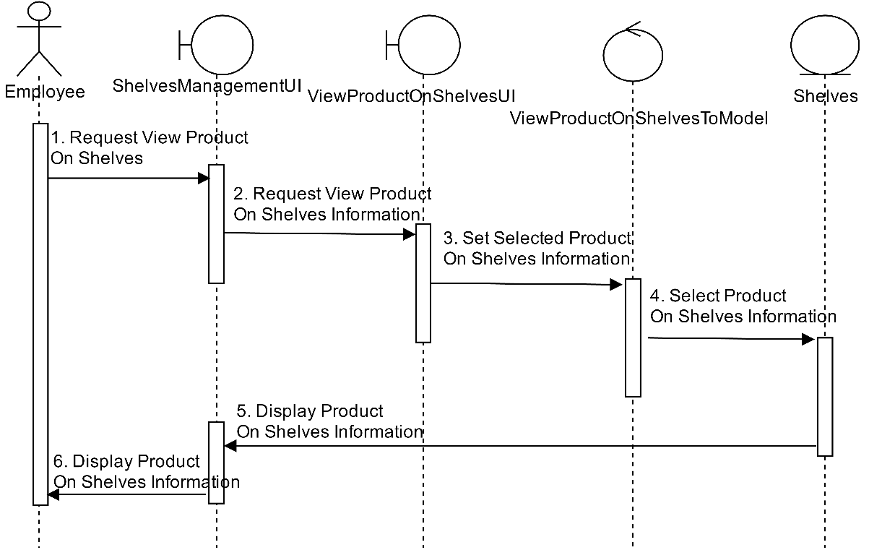

**5.4 Sequence diagram demonstrating operation “Check Number of Product”**

* This diagram describes the system scenario of “**UC520: Check number of Product”**

C:\Users\Filmm\AppData\Local\Microsoft\Windows\INetCacheContent.Word\Film (9).png

**5.5 Sequence diagram demonstrating operation “Add Stock of Product”**

* This diagram describes the system scenario of “**UC530: Add Stock of products”**

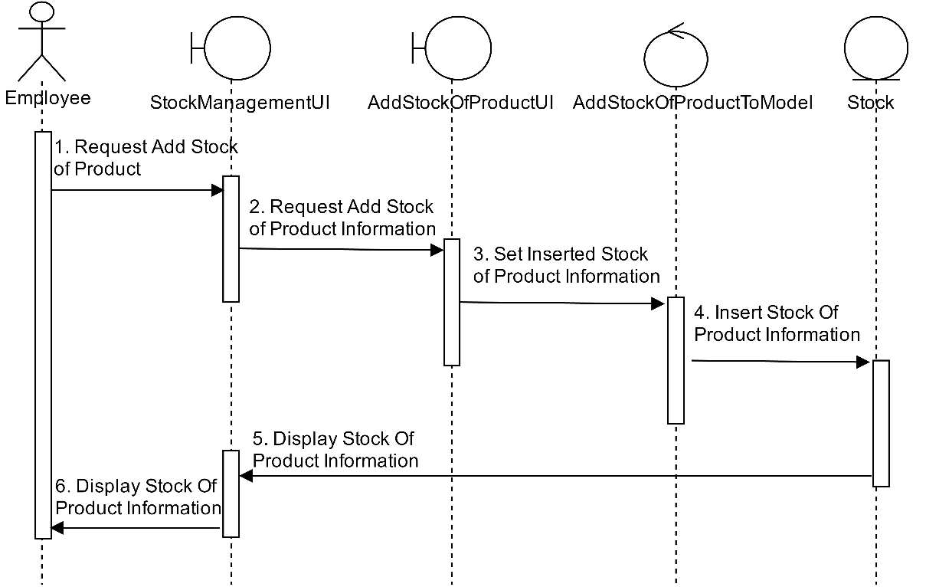

**5.6 Sequence diagram demonstrating operation “Edit Stock of Product”**

* This diagram describes the system scenario of “**UC540: Edit Stock of products”**

