

**Analysis Document**

**Hygeia pharmacy**

Version 1.0

Prepare by

Whatever CO., LTD.

Mister Prakasit Intarasombat 5730213004 (Project Manager)

Miss Araya Choothong 5730213001

Miss Thanyalak Sirikul 5730213014

Mister Tanawut Rungpetnimit 5730213023

Mister Tanawat Saeang 5730213026

Mister Panyaprach Tularak 5730213044

Miss Natthanicha Chonoo 5730213047

7 November, 2016

**Table of Contents**

1. Revision History 1

2. Use Case Overview 1

Use Case Diagram Level 0: Pharmacy System 1

Use Case Diagram Level 1: Sale Order Management Sub-System (UC100) 2

Use Case Diagram Level 1: Purchases Order Management Sub-System (UC200) 2

Use Case Diagram Level 1: Products Management Sub-System (UC300) 3

Use Case Diagram Level 1: Accounting Management Sub-System (UC400) 3

Use Case Diagram Level 1: Inventory Management Sub-System (UC500) 4

Use Case Diagram Level 1: Staff Management Sub-System (UC600) 4

Use Case Diagram Level 1: Report Management Sub-System (UC700) 5

3. System Structure 5

4. Static Structure and Data Analysis 6

4.1 Model-View-Controller (MVC) Model 7

4.1.1 MVC Model: Sale Order Management Sub-System 7

4.1.2 MVC Model: Purchases Order Management Sub-System 8

4.1.3 MVC Model: Products Management Sub-System Sub-System 9

4.1.4 MVC Model: Accounting Management Sub-System 10

4.1.5 MVC Model: Inventory Management Sub-System 10

4.1.6 MVC Model: Staff Management Sub-System 12

4.1.7 MVC Model: Report Management Sub-System 13

4.2 Entity Class Model 14

5. System Behaviour Model 15

Sequence Diagram demonstrating operation “Create sale order” 15

Sequence Diagram demonstrating operation “Add products to orders” 15

Sequence Diagram demonstrating operation “Delete products from orders” 16

Sequence Diagram demonstrating operation “Save orders to database” 16

Sequence Diagram demonstrating operation “Create purchases order” 17

Sequence Diagram demonstrating operation “Add products to purchases orders” 17

Sequence Diagram demonstrating operation “Delete products from purchases order” 18

Sequence Diagram demonstrating operation “Print purchases order” 18

Sequence Diagram demonstrating operation “Add new product” 19

Sequence Diagram demonstrating operation “Delete product list” 19

Sequence Diagram demonstrating operation “Edit product list” 20

Sequence Diagram demonstrating operation “Check product stock” 20

Sequence Diagram demonstrating operation “Create revenue report and print revenue report” 21

Sequence Diagram demonstrating operation “Create expense report and print expense report” 21

Sequence Diagram demonstrating operation “Add Product on Shelves” 22

Sequence Diagram demonstrating operation “Edit Product on Shelves” 22

Sequence Diagram demonstrating operation “View Product on Shelves” 23

Sequence Diagram demonstrating operation “Check Number of Product” 23

Sequence Diagram demonstrating operation “Add Stock of Product” 24

Sequence Diagram demonstrating operation “Edit Stock of Product” 24

Sequence Diagram demonstrating operation “Add new employee details” 25

Sequence Diagram demonstrating operation “Edit employee details” 25

Sequence Diagram demonstrating operation “Delete employee details” 26

Sequence Diagram demonstrating operation “Change permission of employees” 26

Sequence Diagram demonstrating operation “Create daily sales report and print daily sale report” 27

Sequence Diagram demonstrating operation “Create monthly sales report and print monthly sale report” 27

Sequence Diagram demonstrating operation “Create annual sales report and print annual sale report” 28

# Revision History

|  |  |  |  |
| --- | --- | --- | --- |
| **Name** | **Date** | **Description** | **Version** |
|  |  |  |  |
|  |  |  |  |

# 

# Use Case Overview

## Use Case Diagram Level 0: Pharmacy System

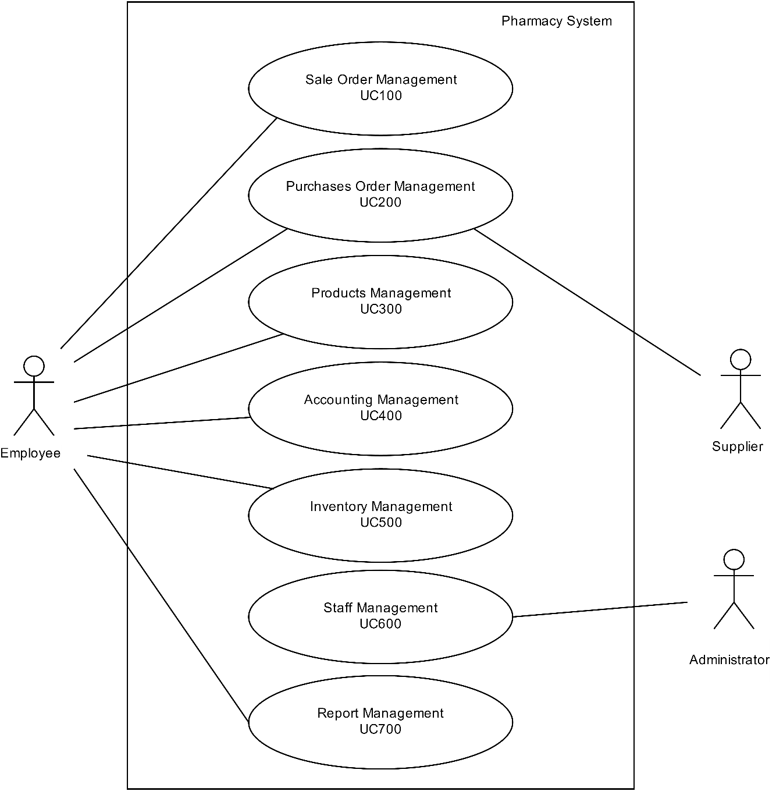

## Use Case Diagram Level 1: Sale Order Management Sub-System (UC100)

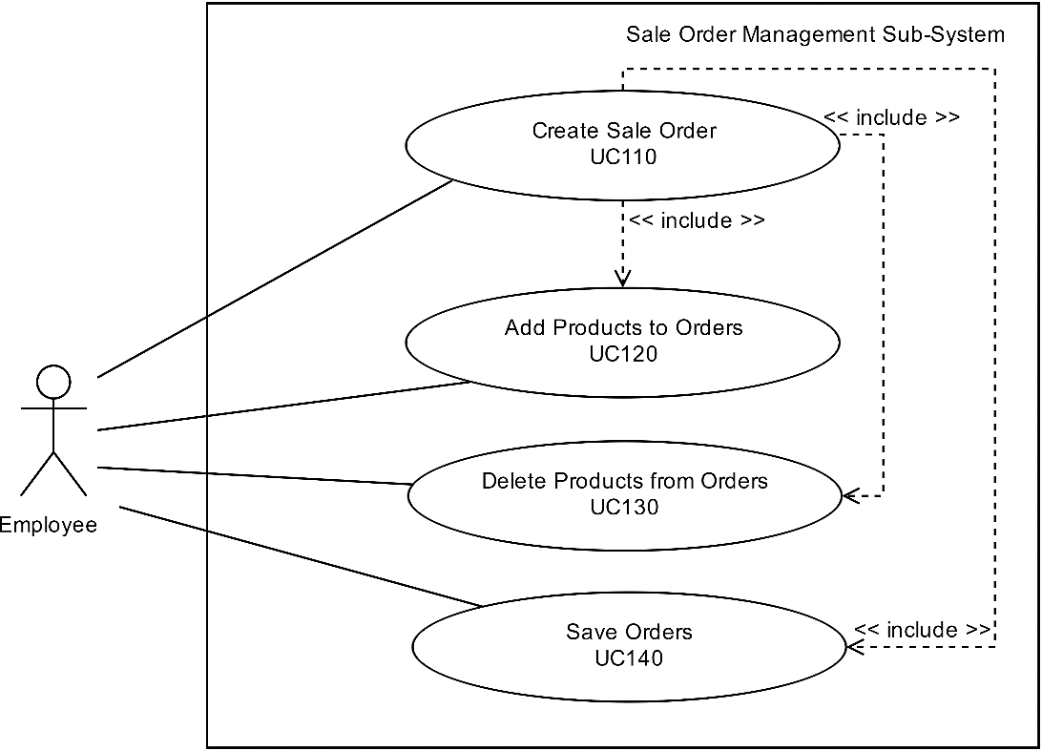

By Araya Choothong

## Use Case Diagram Level 1: Purchases Order Management Sub-System (UC200)

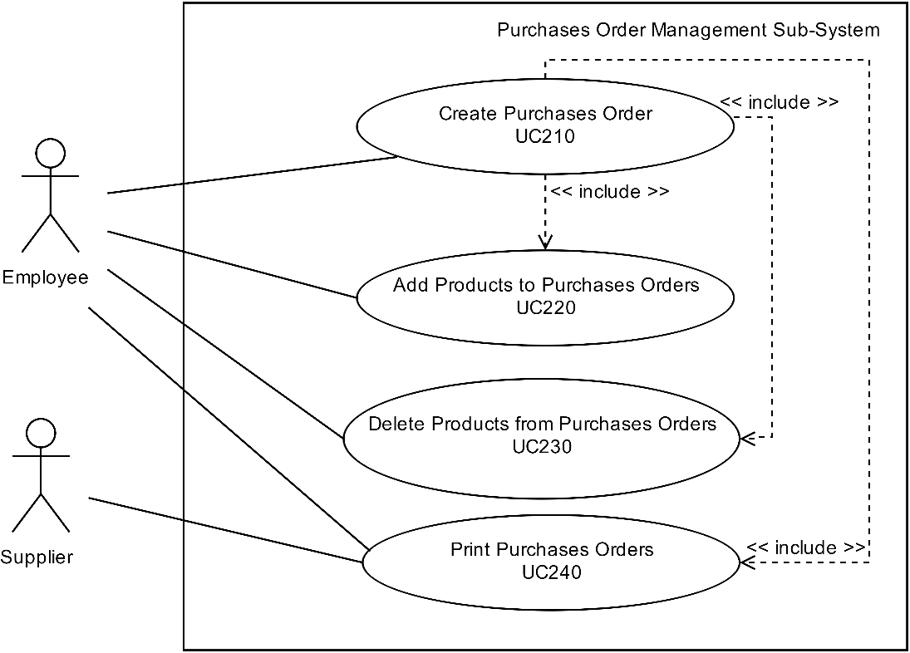

By Prakasit Intarasombat

## Use Case Diagram Level 1: Products Management Sub-System (UC300)

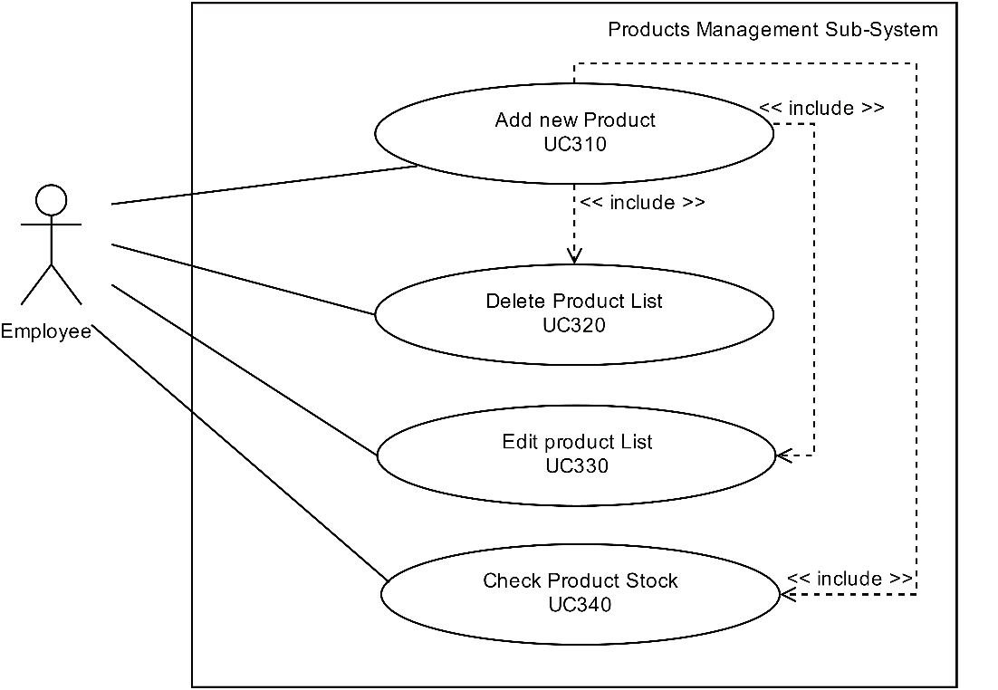

By Thanyalak Sirikul

## Use Case Diagram Level 1: Accounting Management Sub-System (UC400)

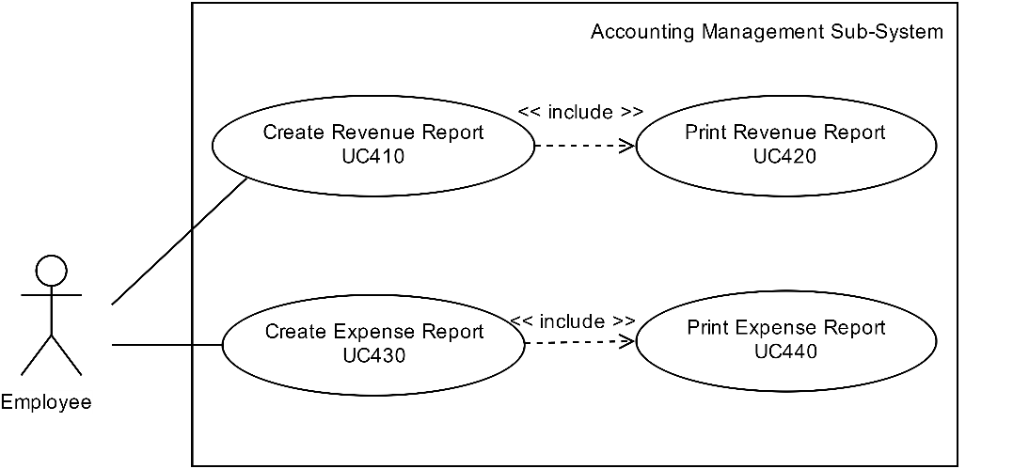

By Tanawut Rungpetnimit

## Use Case Diagram Level 1: Inventory Management Sub-System (UC500)

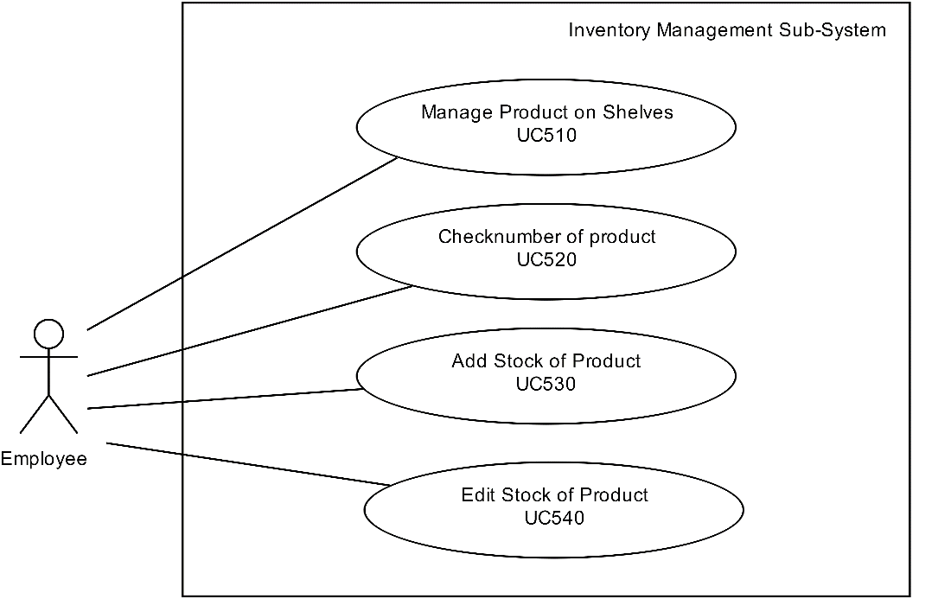

By Tanawat Saeang

## Use Case Diagram Level 1: Staff Management Sub-System (UC600)

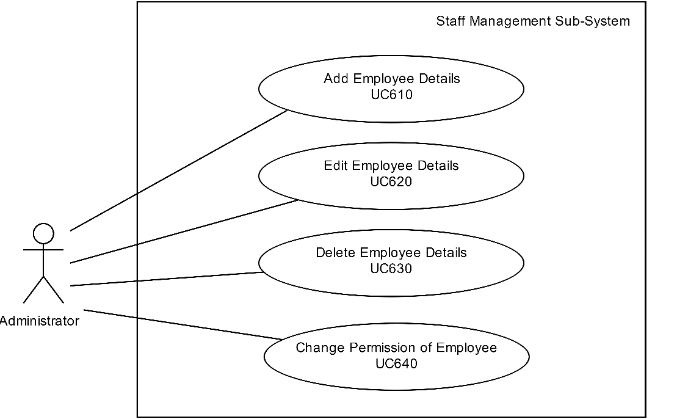

By Panyaprach Tularak

## Use Case Diagram Level 1: Report Management Sub-System (UC700)

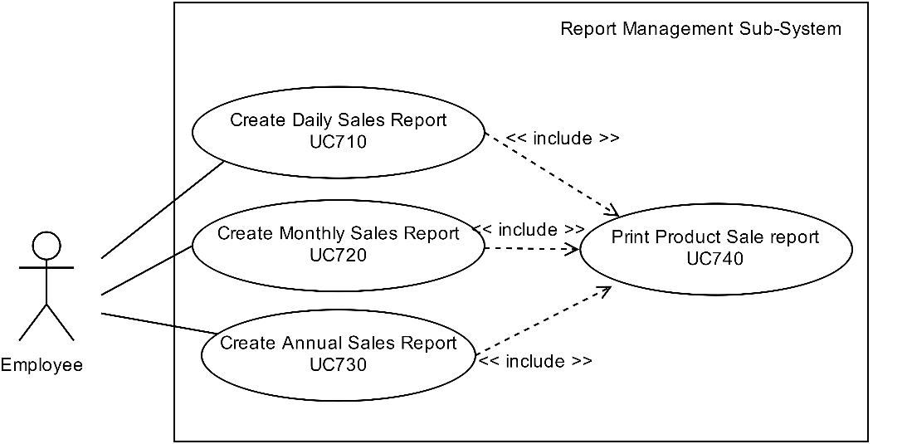

By Natthanicha Chonoo

# System Structure

This should use structure chart to express the breakdown of the system to the lowest manageable levels. It is used to show the hierarchical arrangement of the subsystems in a system. Each rectangular box represents a subsystems. The names of the subsystems are written inside the box. An arrow joins two subsystems that have an invocation relationship.

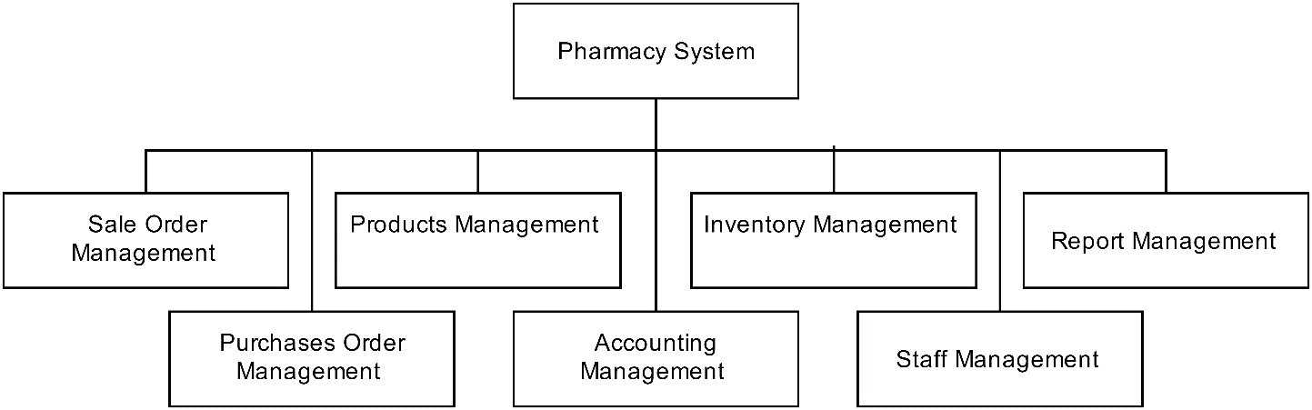

# Static Structure and Data Analysis

This should show the conceptual description of the systematics of the system. Thus, the class diagram is used to describe this static structure of the system. Furthermore, the class diagram is also used for data modelling. Classes in class diagram are classified into 3 types:



**Boundaries (view)**

Objects that interface with system actors (e.g. a user or external service). Windows, screens and menus are examples of boundaries that interface with users.

**Entities (model)**

Objects representing system data, often from the domain model.

**Controls (controller)**

Objects that mediate between boundaries and entities. These serve as the glue between boundary elements and entity elements, implementing the logic required to manage the various elements and their interactions. It is important to understand that you may decide to implement controllers within your design as something other than objects – many controllers are simple enough to be implemented as a method of an entity or boundary class for example.

## 

## ****4.1** Model-View-Controller (MVC) Model**

### 4.1.1 MVC Model: Sale Order Management Sub-System

1. Create sale order

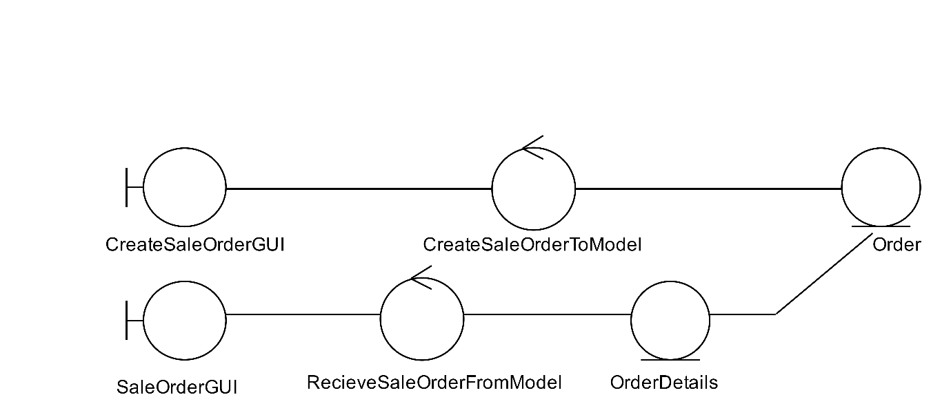

By Araya Choothong

2. Add products to orders

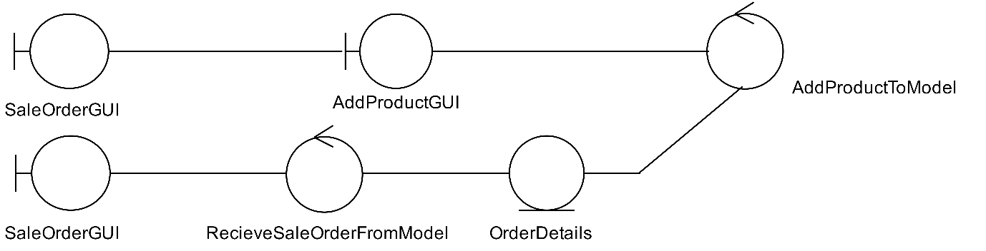

By Araya Choothong

3. Delete products from orders

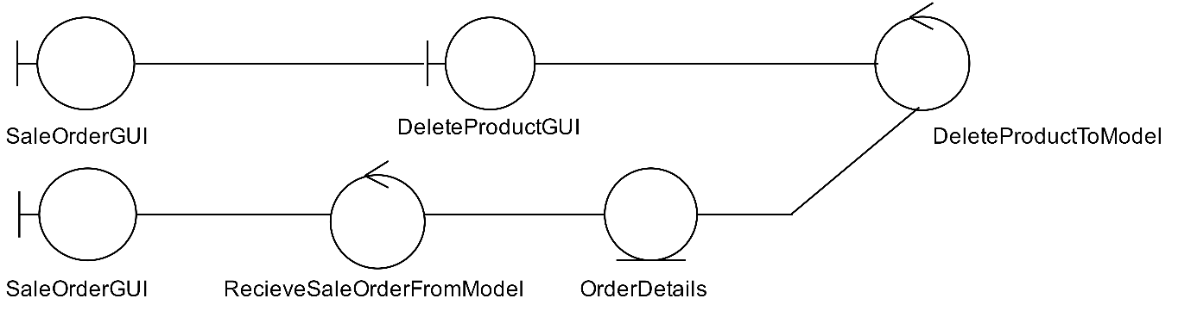

By Araya Choothong

4. Save orders to database

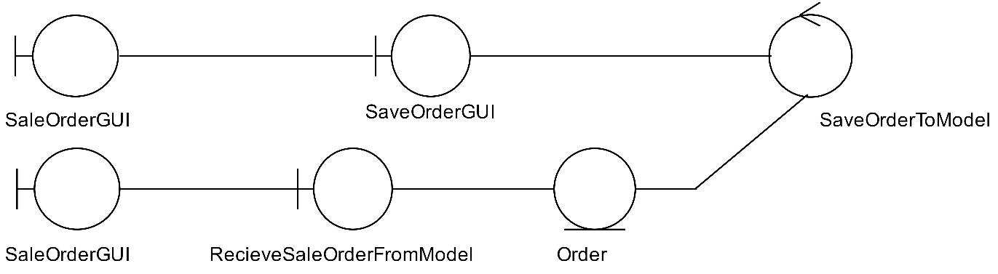

By Araya Choothong

### 4.1.2 MVC Model: Purchases Order Management Sub-System

1. Create purchases order

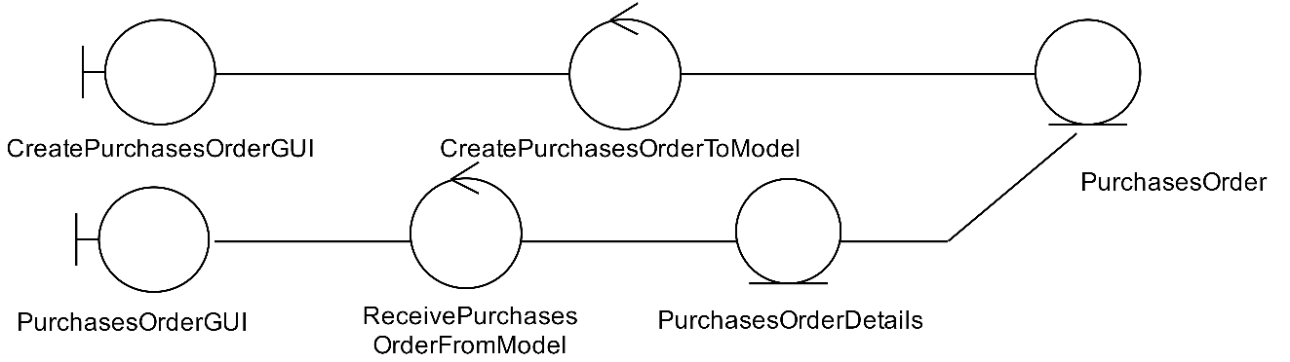

By Prakasit Intarasombat

2. Add products to purchases orders

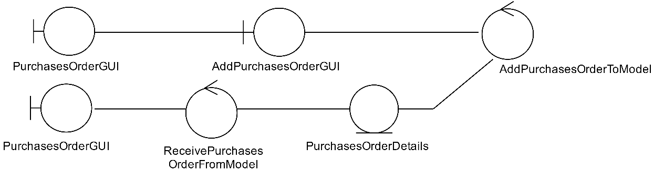

By Prakasit Intarasombat

3. Delete products from purchases order

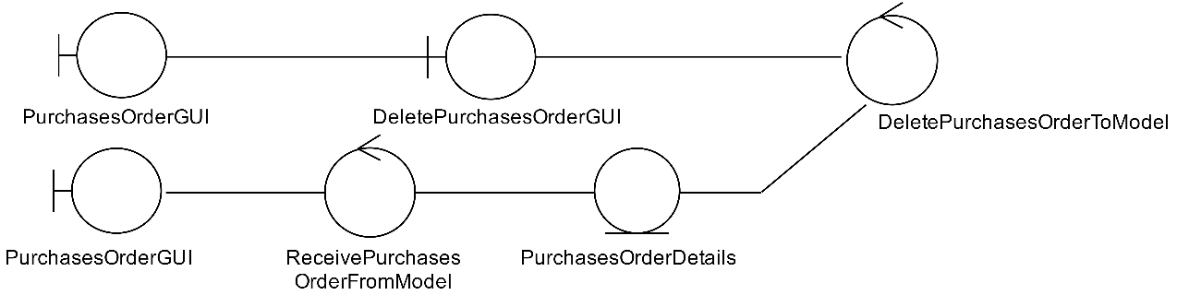

By Prakasit Intarasombat

4. Print purchases order

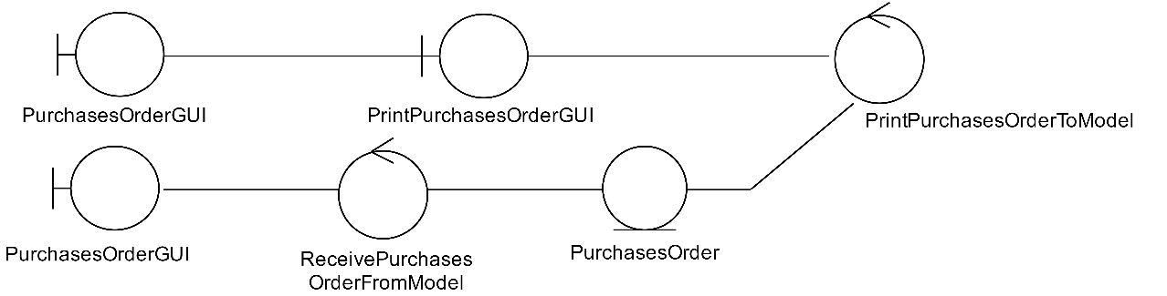

By Prakasit Intarasombat

### 4.1.3 MVC Model: Products Management Sub-System Sub-System

1. Add new product  
 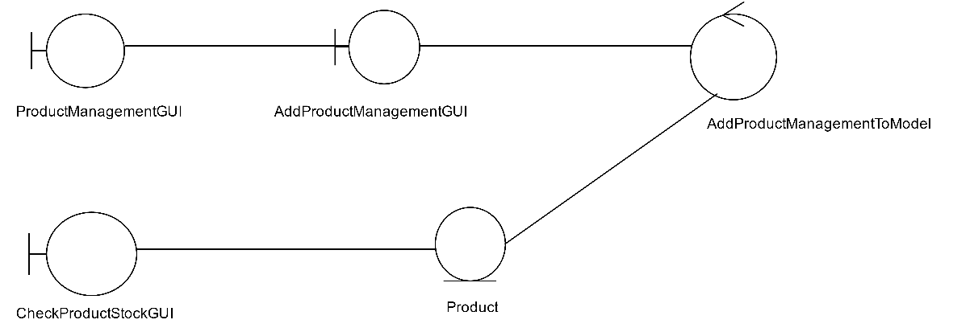

By Thanyalak Sirikul

2. Delete product list

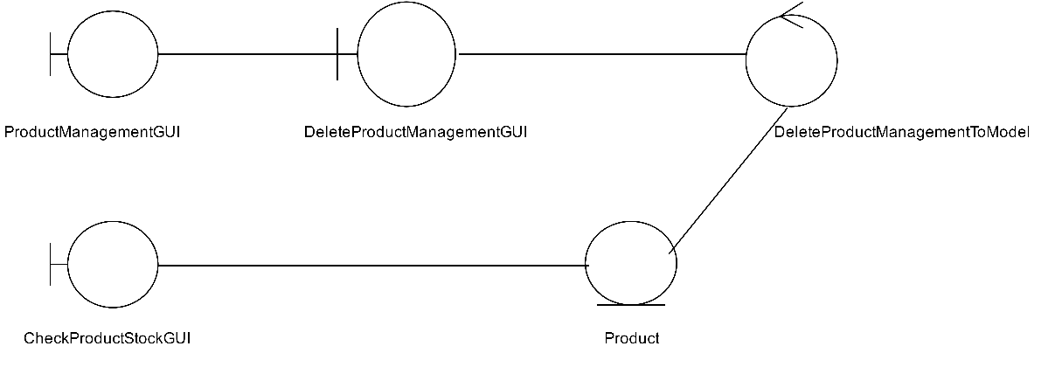  
By Thanyalak Sirikul

3. Edit product list

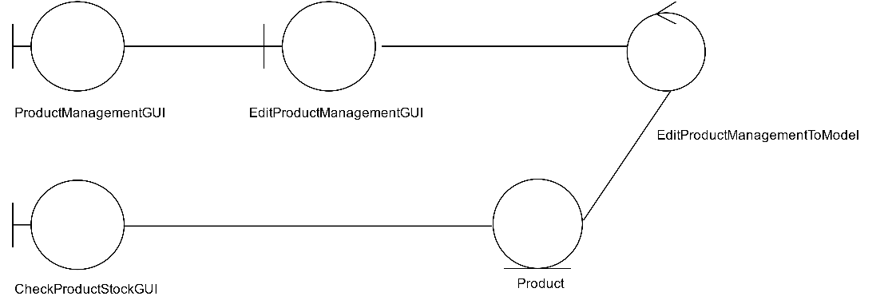

By Thanyalak Sirikul

4. Check product stock

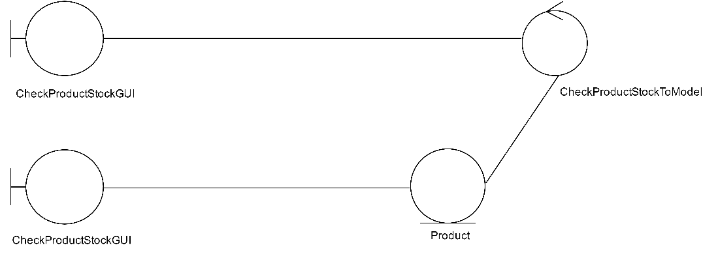

By Thanyalak Sirikul

### 4.1.4 MVC Model: Accounting Management Sub-System

1. Create revenue report and print revenue report

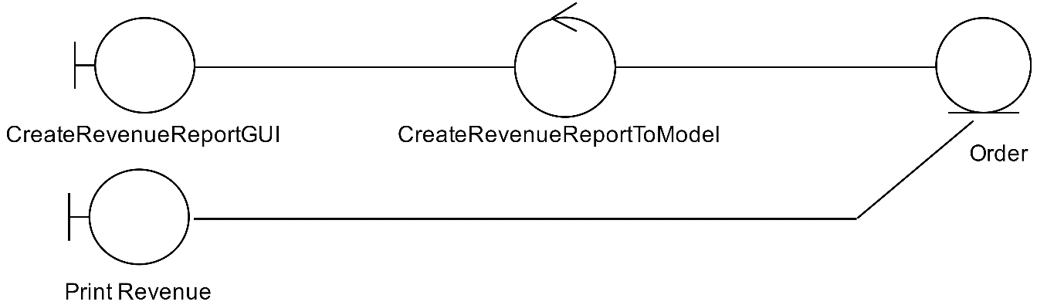

By Tanawut Rungpetnimit

2. Create expenses report and print expense report

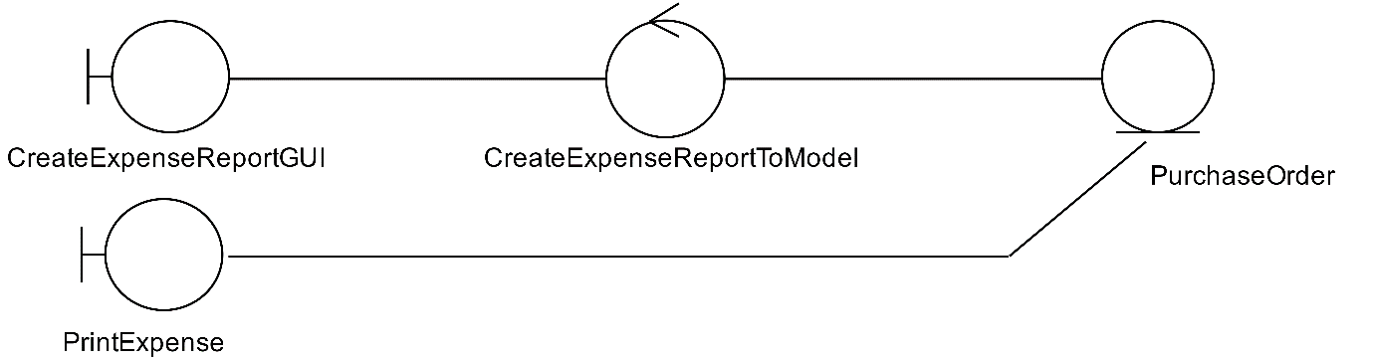

By Tanawut Rungpetnimit

### 4.1.5 MVC Model: Inventory Management Sub-System

1. Management product on the shelves

1.1 Add product on shelves

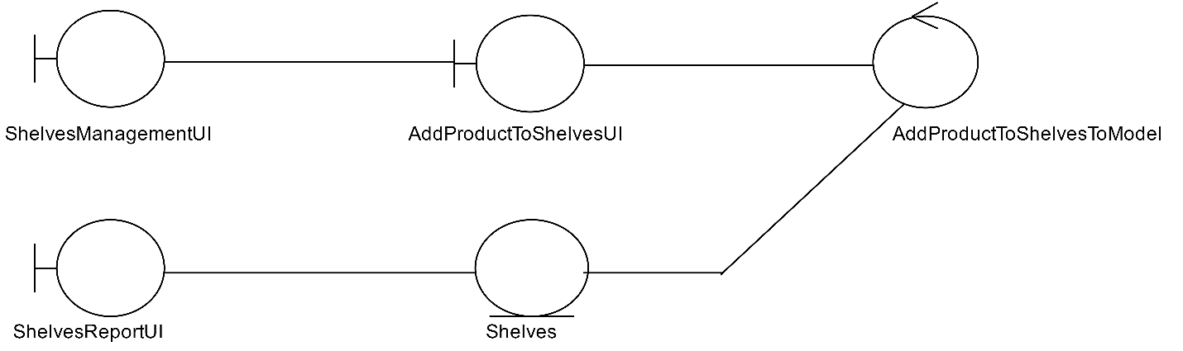

By Tanawat Saeang

1.2 Edit product on shelves

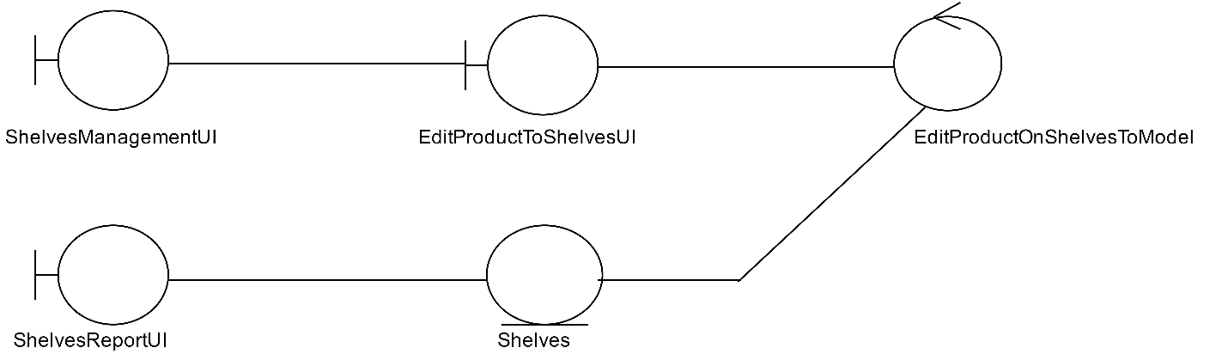

By Tanawat Saeang

1.3 View product on shelves

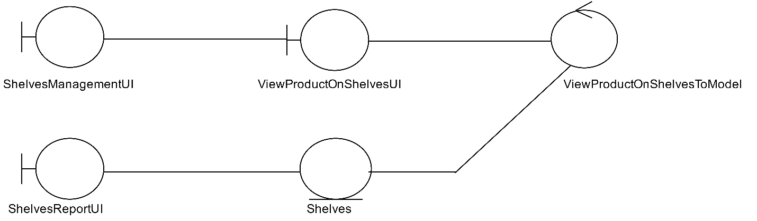

By Tanawat Saeang

2. Check number of product

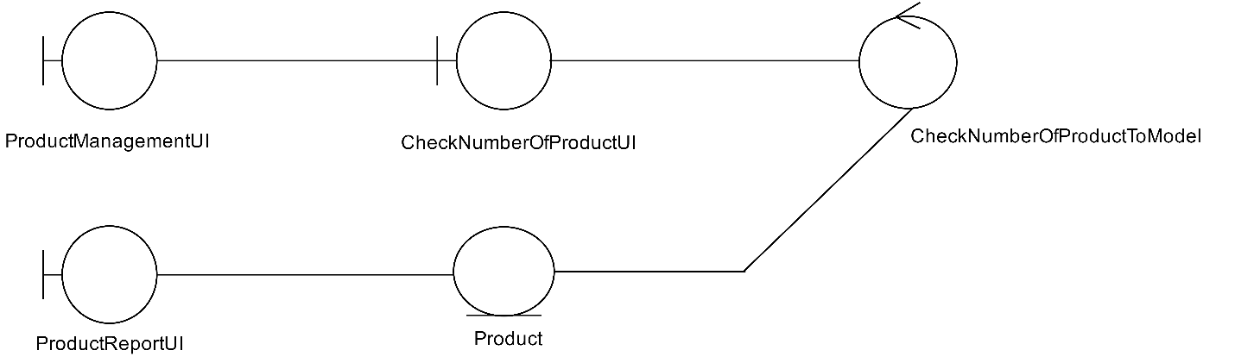

By Tanawat Saeang

3. Add stock of product

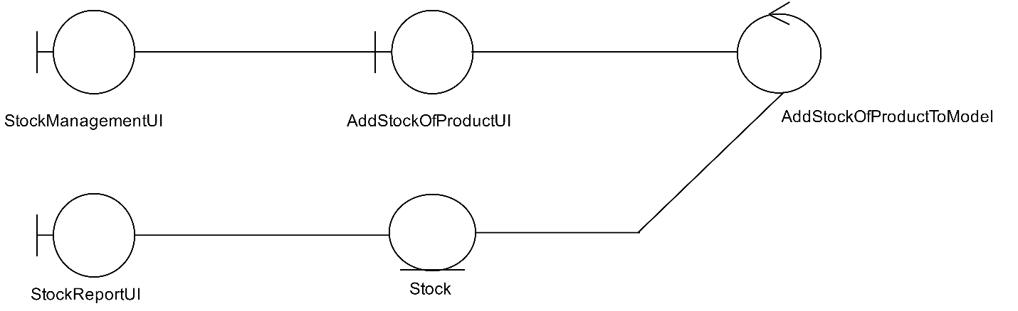

By Tanawat Saeang

4. Edit stock of product

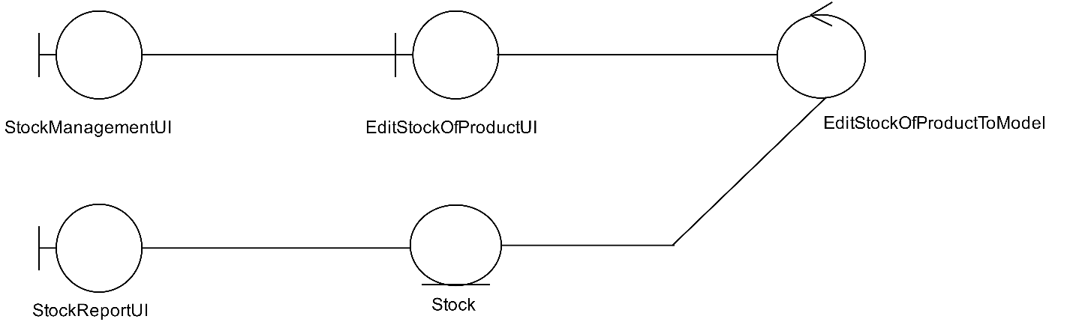

By Tanawat Saeang

### 4.1.6 MVC Model: Staff Management Sub-System

1. Add new employee details

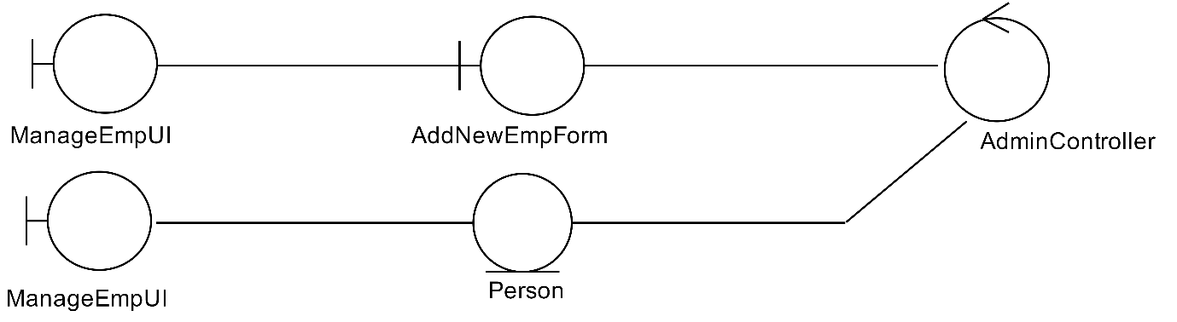

By Panyaprach Tularak

2. Edit employee details

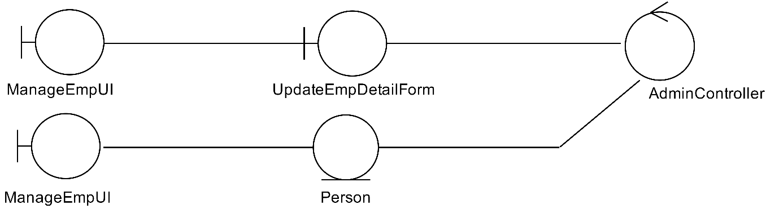

By Panyaprach Tularak

3. Delete employee details

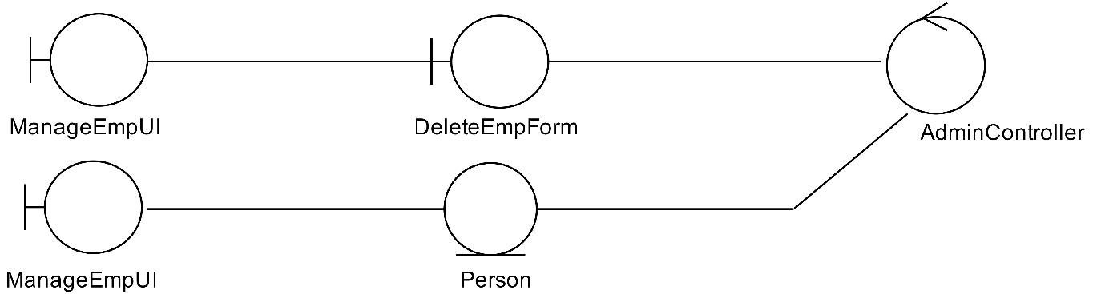

By Panyaprach Tularak

4. Change permission of employees

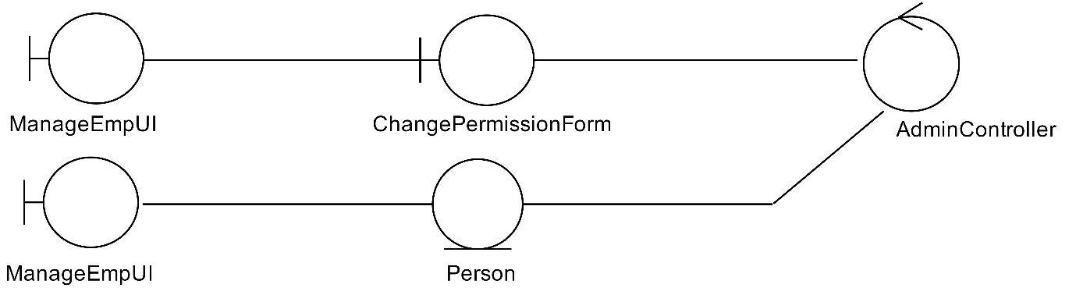

By Panyaprach Tularak

### 4.1.7 MVC Model: Report Management Sub-System

1. Create daily sales report and Print daily sale report

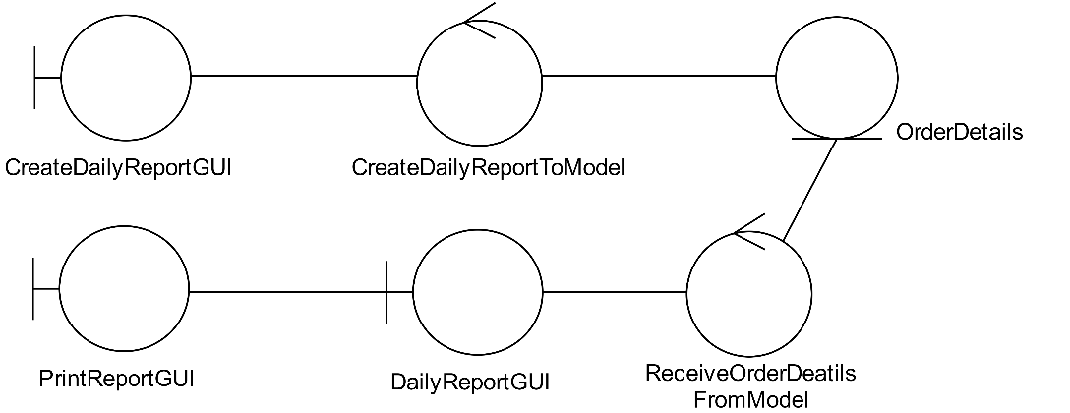

By Natthanicha Chonoo

2. Create monthly sales report and Print monthly sale report

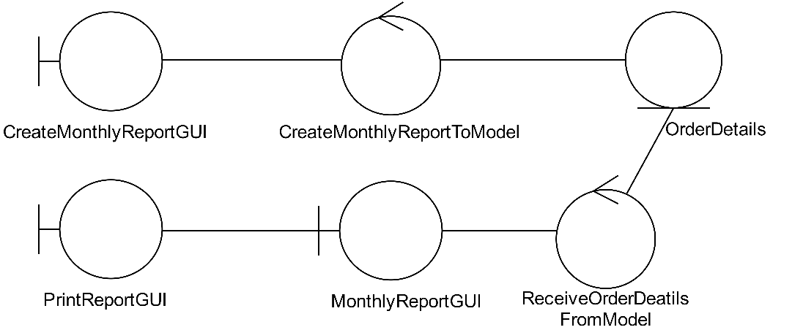

By Natthanicha Chonoo

3. Create annual sales report and Print annual sale report

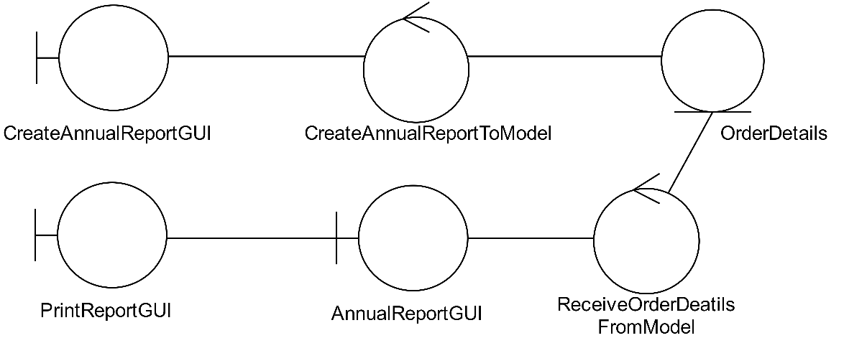

By Natthanicha Chonoo

## 4.2 Entity Class Model

Then, a set of conceptual entity and data model is described by “Entity Class Diagram”. The relationship between each entity class must be specified.

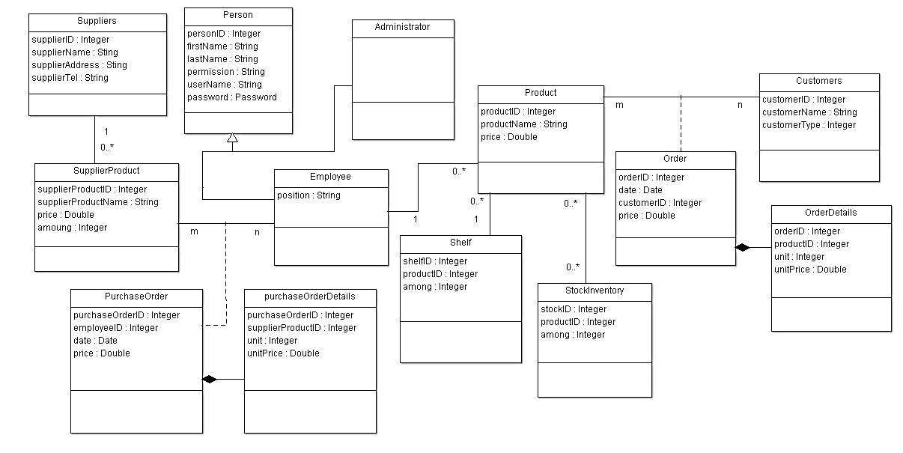

# System Behaviour Model

This section should describe the system behaviour by using a sequence diagram. This diagram must demonstrate the interaction among objects of the system in time sequence. The objects and classes involved the scenario are depicted. The scenario representing the system behaviour or functionality is demonstrated by the sequence of messages exchanged between the objects. For example:

## Sequence Diagram demonstrating operation “Create sale order”

* This diagram describes the system scenario of “**UC110: Create sale order”**

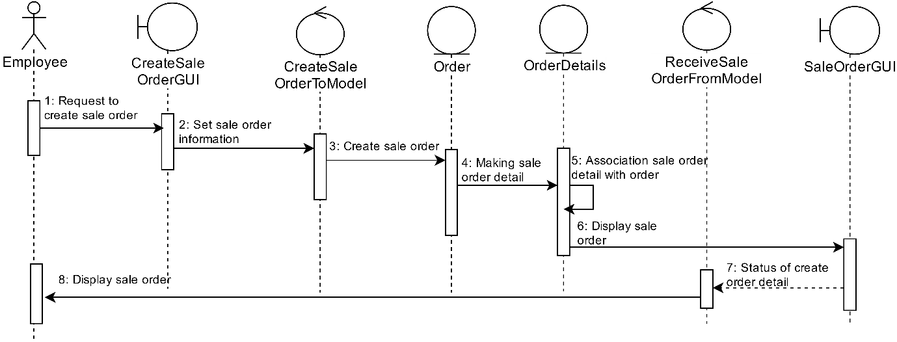

By Araya Choothong

## Sequence Diagram demonstrating operation “Add products to orders”

* This diagram describes the system scenario of “**UC120** **Add products to orders”**

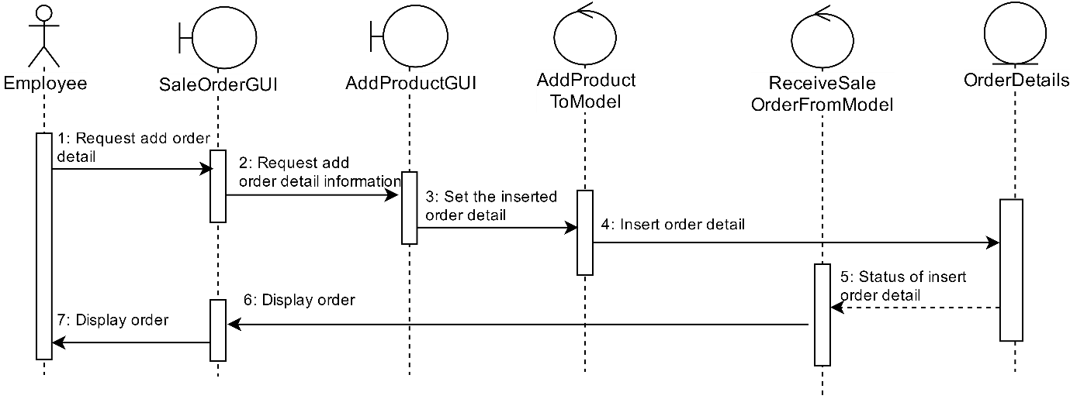

By Araya Choothong

## Sequence Diagram demonstrating operation “Delete products from orders”

* This diagram describes the system scenario of “**UC130: Delete products from orders”**

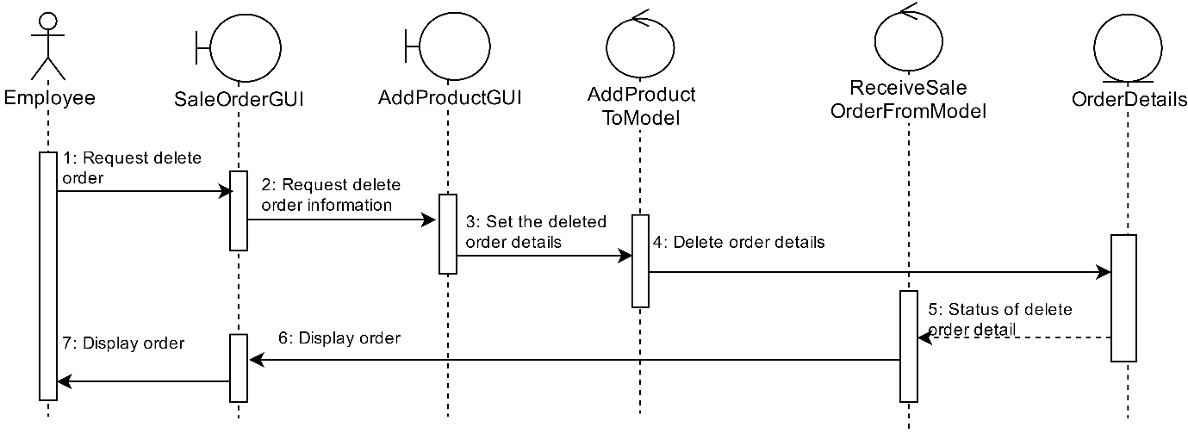

By Araya Choothong

## Sequence Diagram demonstrating operation “Save orders to database”

* This diagram describes the system scenario of “**UC140: Save orders”**

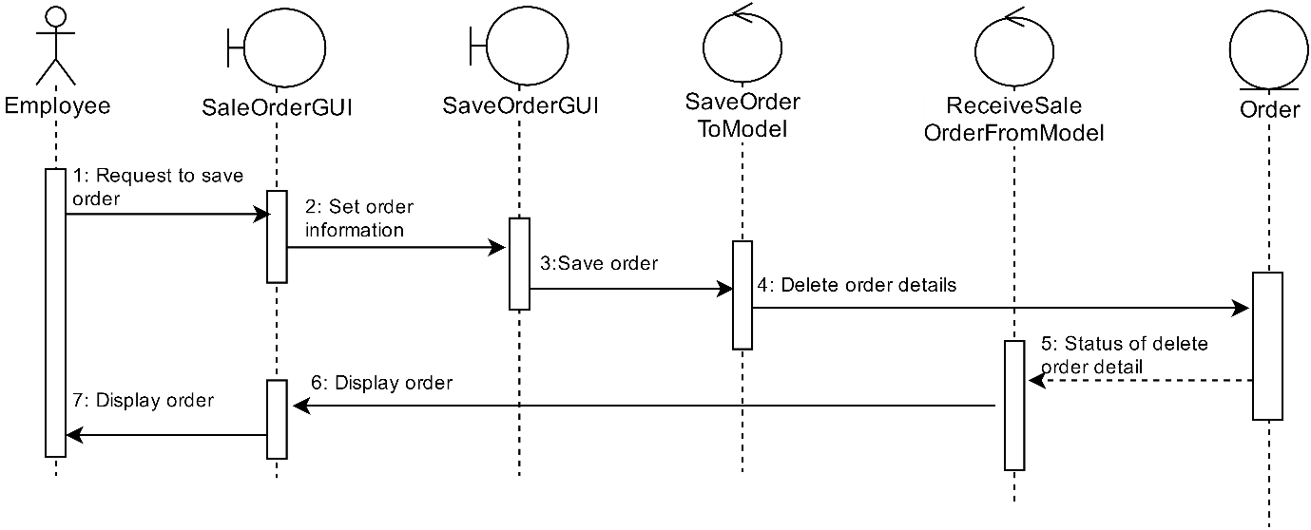

By Araya Choothong

## Sequence Diagram demonstrating operation “Create purchases order”

* This diagram describes the system scenario of “**UC210: Create purchases order”**

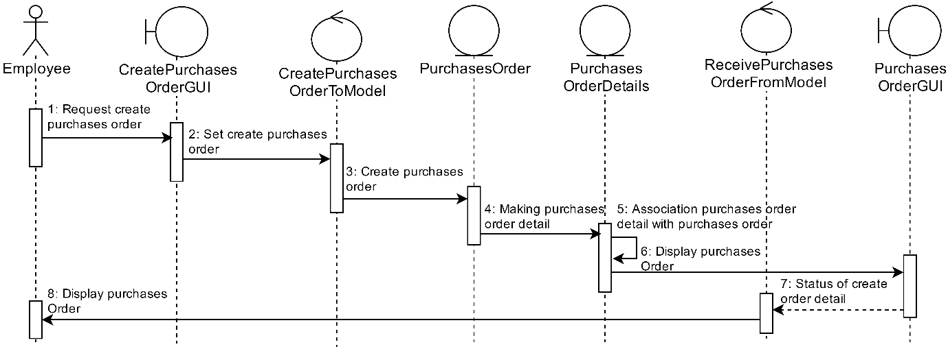

By Prakasit Intarasombat

## Sequence Diagram demonstrating operation “Add products to purchases orders”

* This diagram describes the system scenario of “**UC220: Add products to purchases orders”**

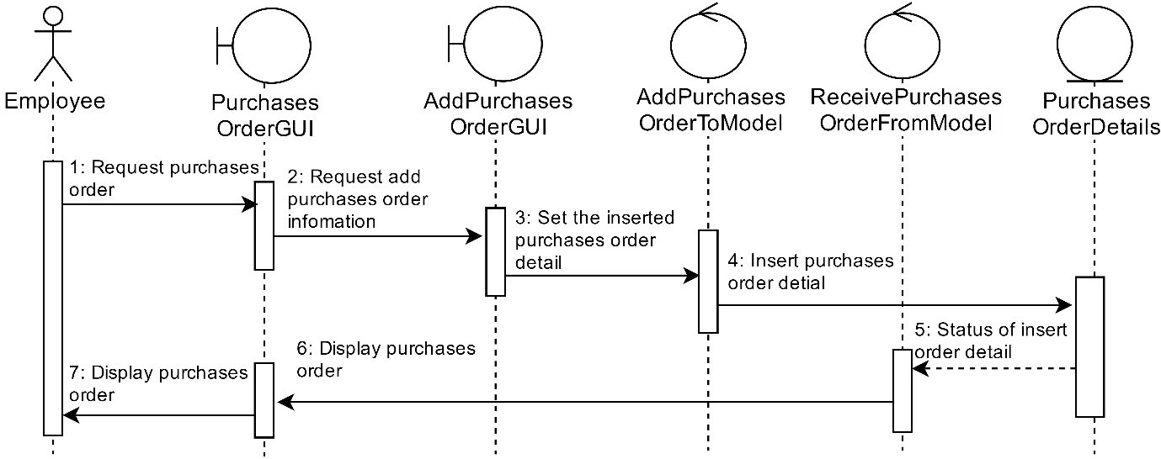By Prakasit Intarasombat

## Sequence Diagram demonstrating operation “Delete products from purchases order”

* This diagram describes the system scenario of “**UC230: Delete products from purchases order”**

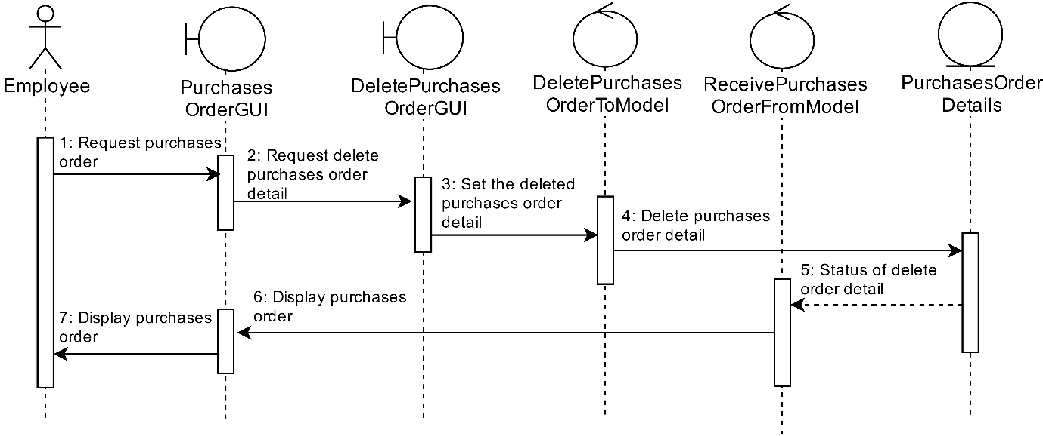

By Prakasit Intarasombat

## Sequence Diagram demonstrating operation “Print purchases order”

* This diagram describes the system scenario of “**UC240: Print purchases order”**

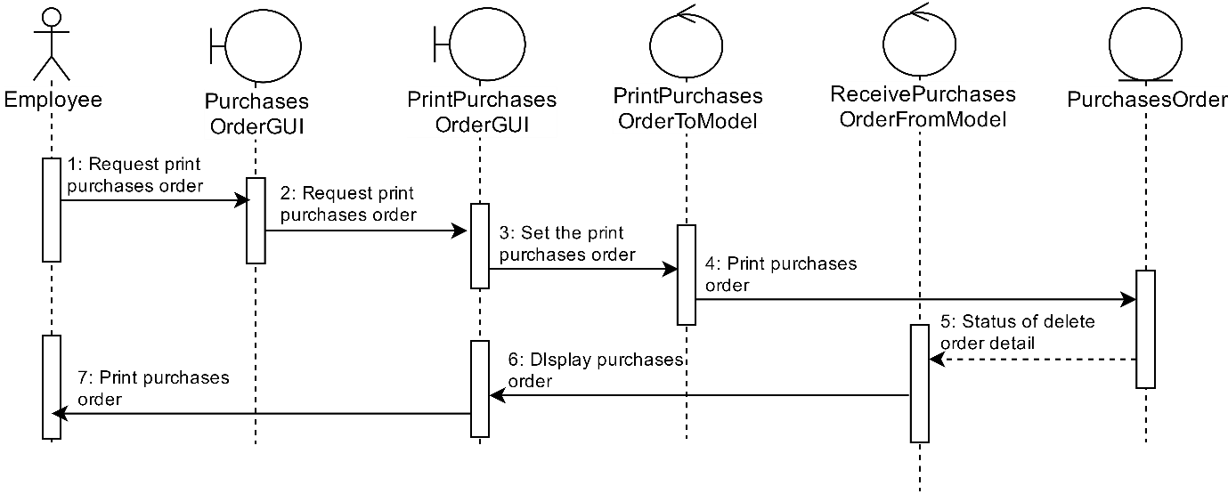By Prakasit Intarasombat

## Sequence Diagram demonstrating operation “Add new product”

* This diagram describes the system scenario of “**UC310: Add new product”**

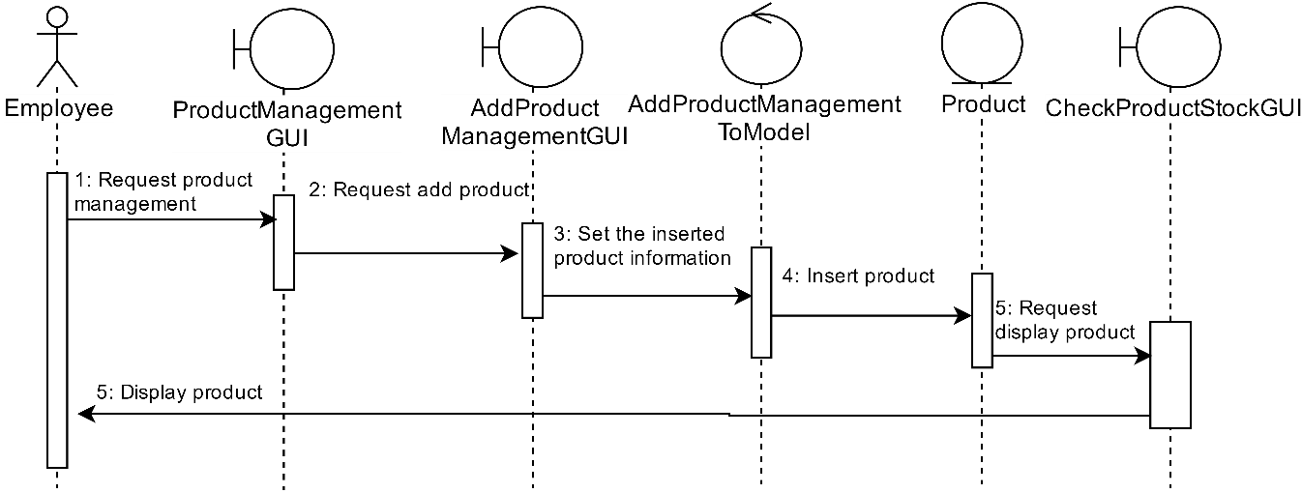By Thanyalak Sirikul

## Sequence Diagram demonstrating operation “Delete product list”

* This diagram describes the system scenario of “**UC320: Delete product list”**

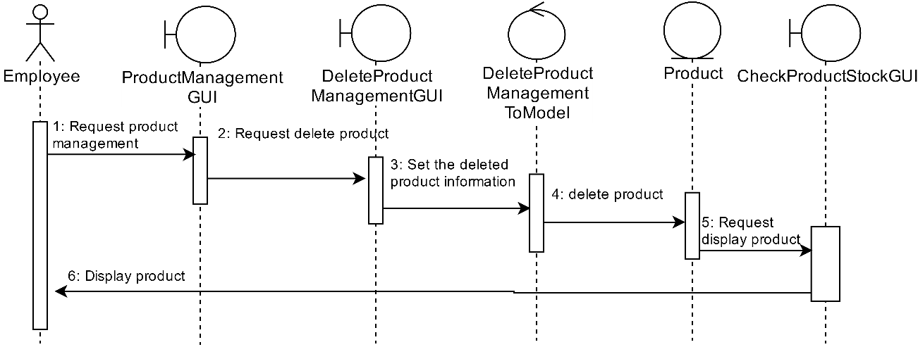By Thanyalak Sirikul

## Sequence Diagram demonstrating operation “Edit product list”

* This diagram describes the system scenario of “**UC330: Edit product list”**

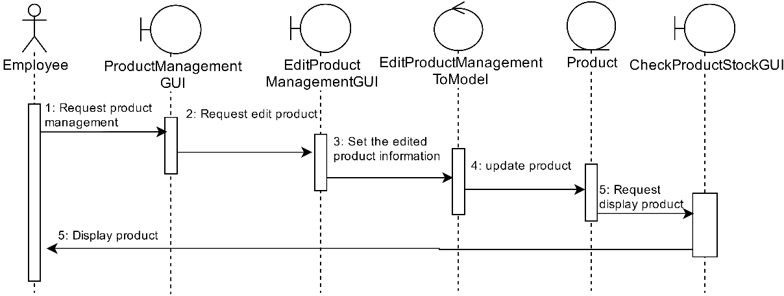

By Thanyalak Sirikul

## Sequence Diagram demonstrating operation “Check product stock”

* This diagram describes the system scenario of “**UC340: Check product stock”**

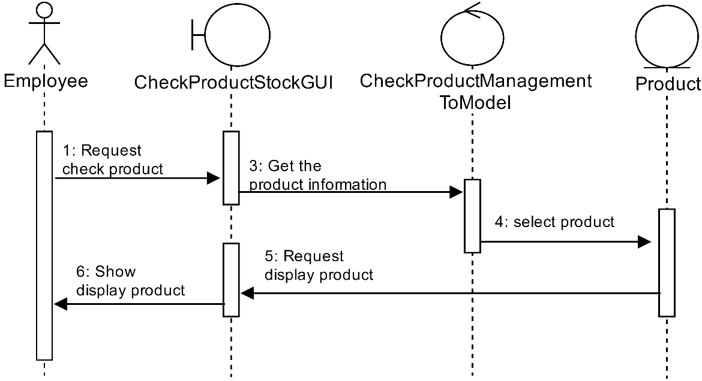

By Thanyalak Sirikul

## Sequence Diagram demonstrating operation “Create revenue report and print revenue report”

* This diagram describes the system scenario of “**UC410: Create revenue report”** and“**UC420: Print revenue report”**

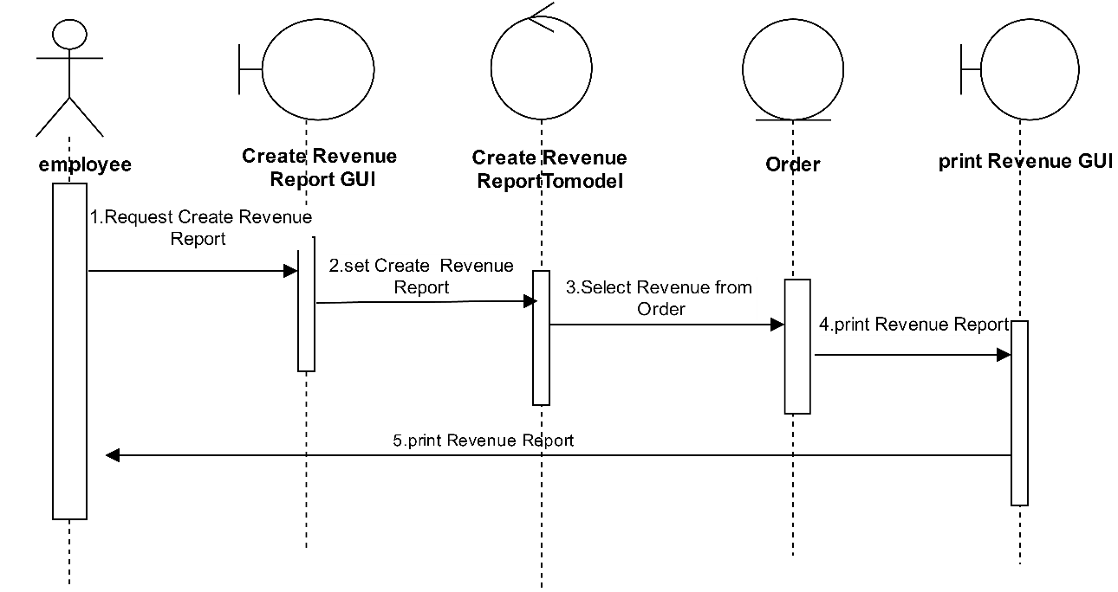

By Tanawut Rungpetnimit

## Sequence Diagram demonstrating operation “Create expense report and print expense report”

* This diagram describes the system scenario of “**UC430: Create expense report”** and “**UC440: Print expense report”**

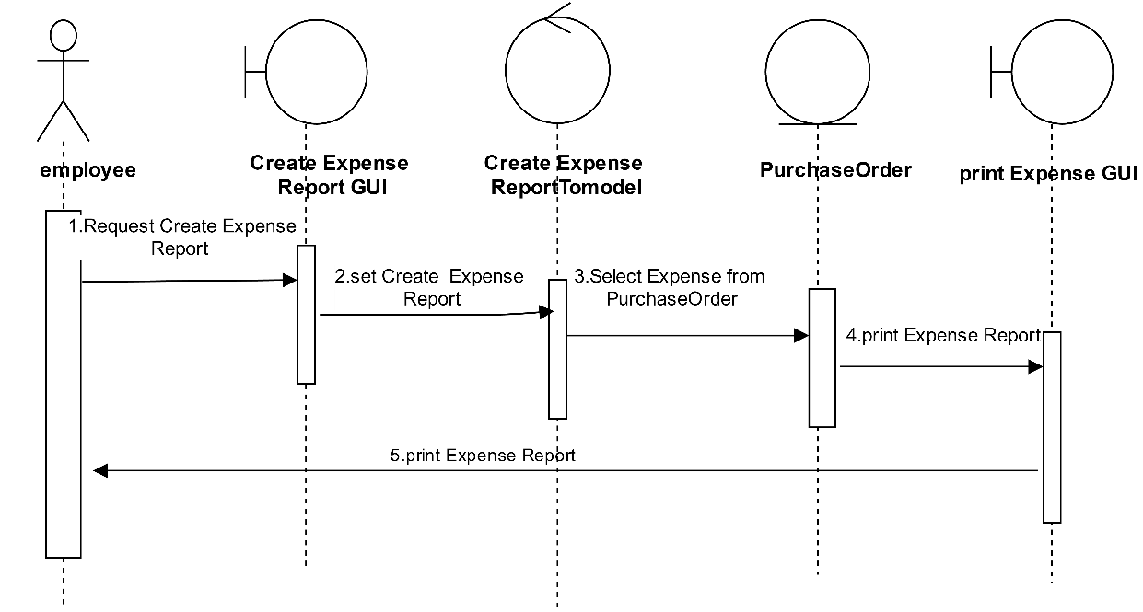

By Tanawut Rungpetnimit

## Sequence Diagram demonstrating operation “Add Product on Shelves”

* This diagram describes the system scenario of “**UC510: Management product on the shelves”**

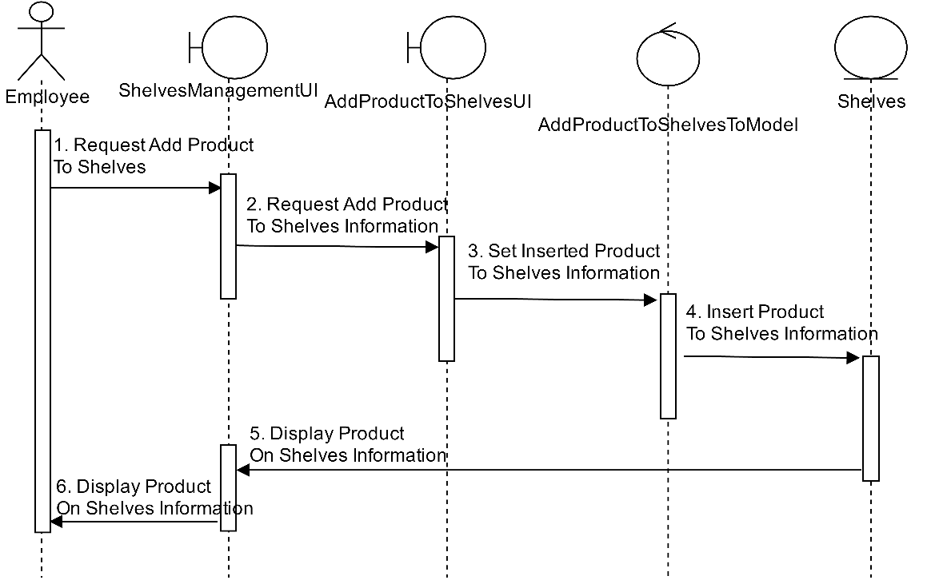

By Tanawat Saeang

## Sequence Diagram demonstrating operation “Edit Product on Shelves”

* This diagram describes the system scenario of “**UC510: Management product on the shelves”**

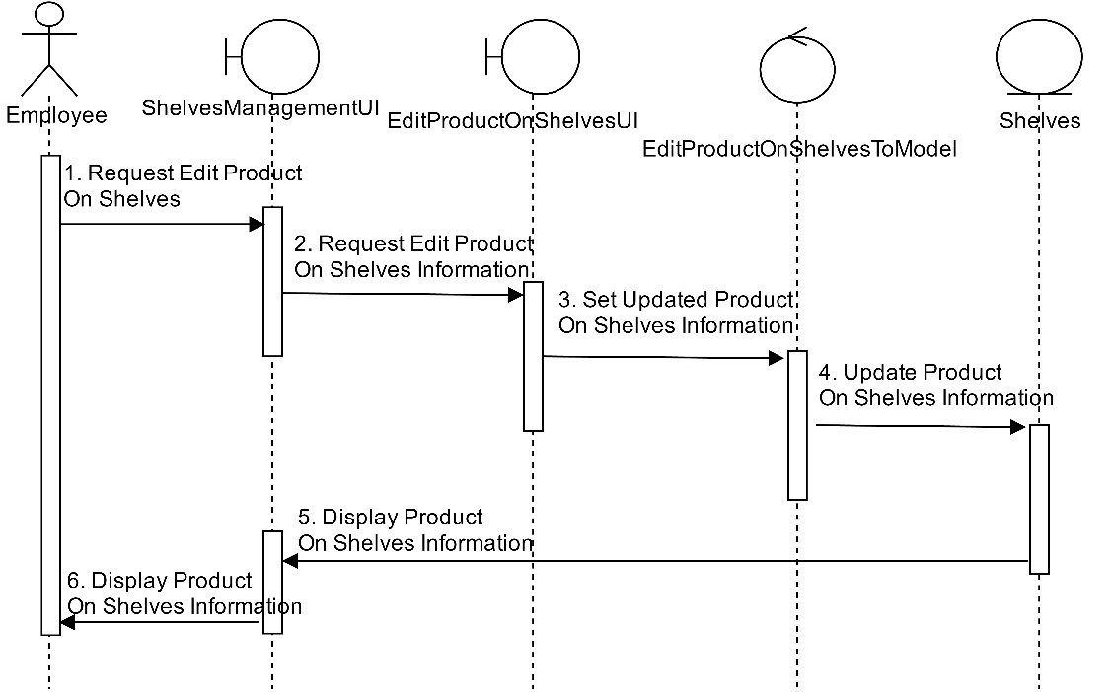

By Tanawat Saeang

## Sequence Diagram demonstrating operation “View Product on Shelves”

* This diagram describes the system scenario of “**UC510: Management product on the shelves”**

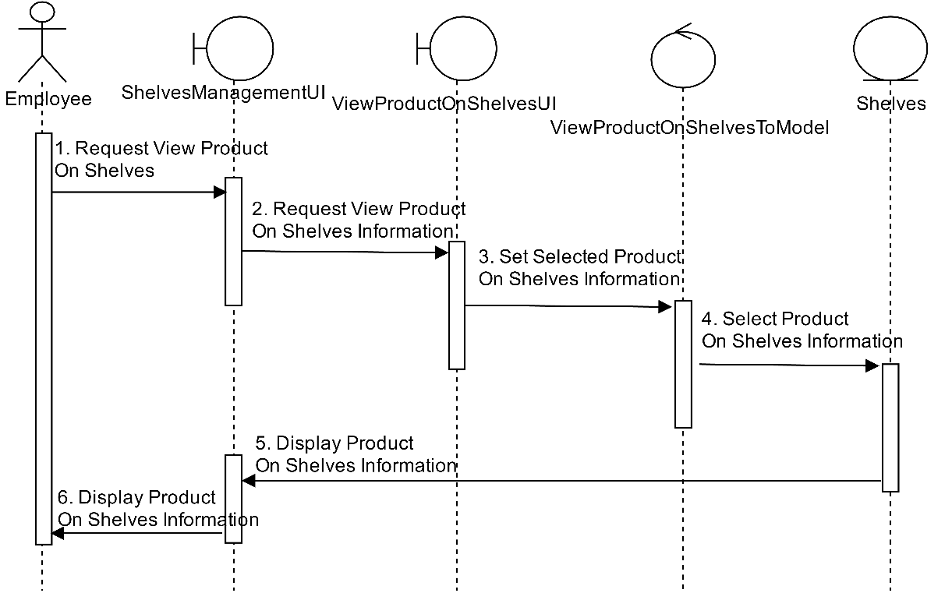

By Tanawat Saeang

## Sequence Diagram demonstrating operation “Check Number of Product”

* This diagram describes the system scenario of “**UC520: Check number of product”**

C:\Users\Filmm\AppData\Local\Microsoft\Windows\INetCacheContent.Word\Film (9).png

By Tanawat Saeang

## Sequence Diagram demonstrating operation “Add Stock of Product”

* This diagram describes the system scenario of “**UC530: Add stock of product list”**

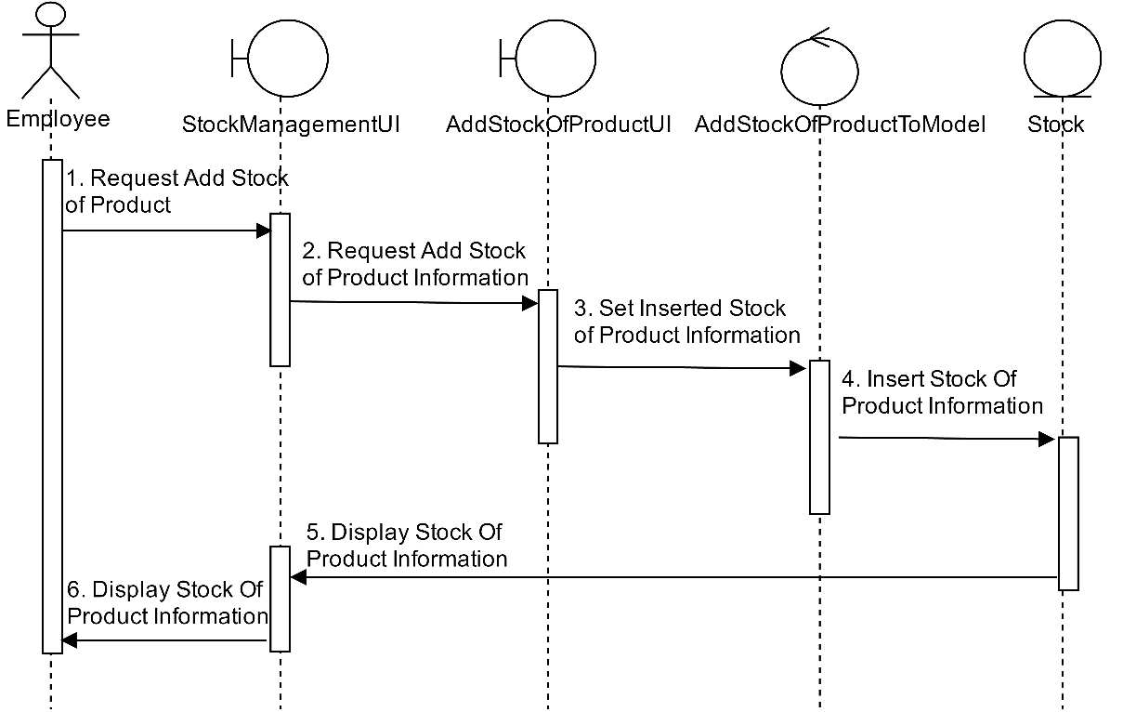

By Tanawat Saeang

## Sequence Diagram demonstrating operation “Edit Stock of Product”

* This diagram describes the system scenario of “**UC540: Edit stock of product”**

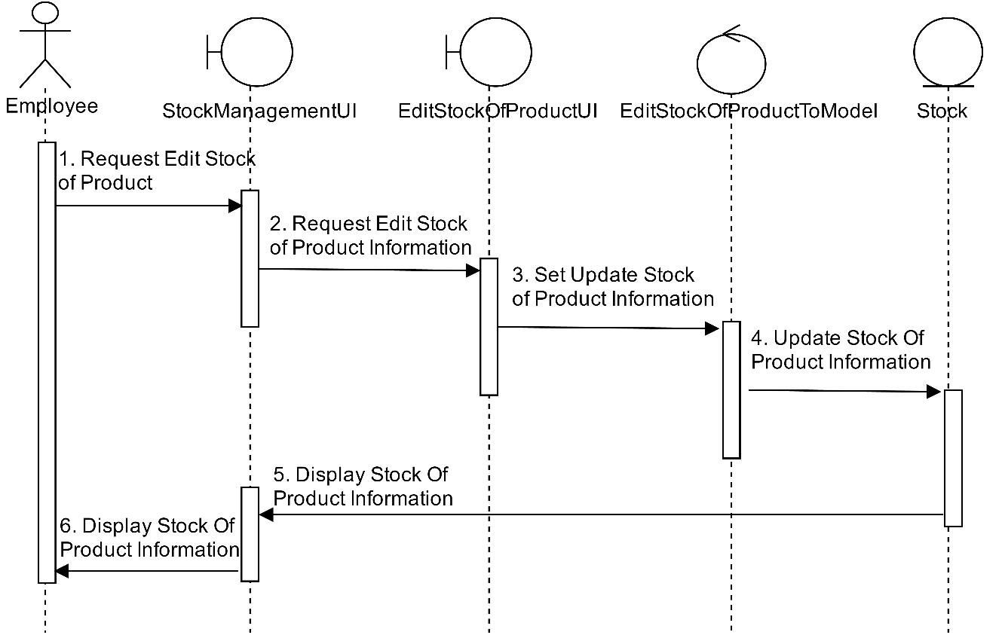

By Tanawat Saeang

## Sequence Diagram demonstrating operation “Add new employee details”

* This diagram describes the system scenario of “**UC610: Add new employee details”**

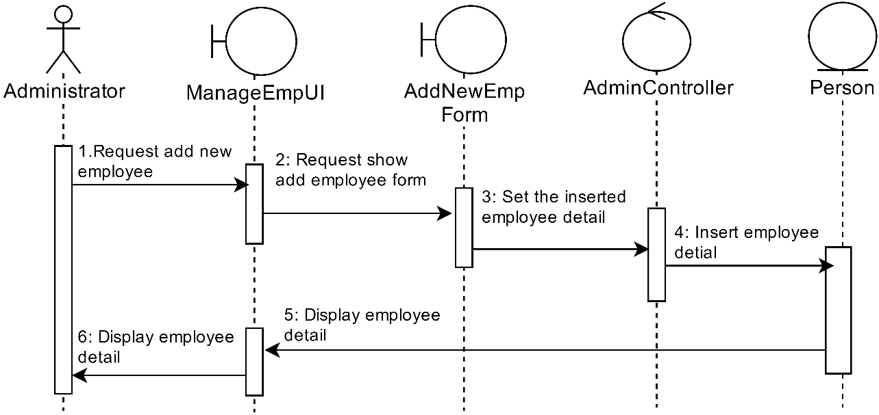

By Panyaprach Tularak

## Sequence Diagram demonstrating operation “Edit employee details”

* This diagram describes the system scenario of “**UC620: Edit employee details”**

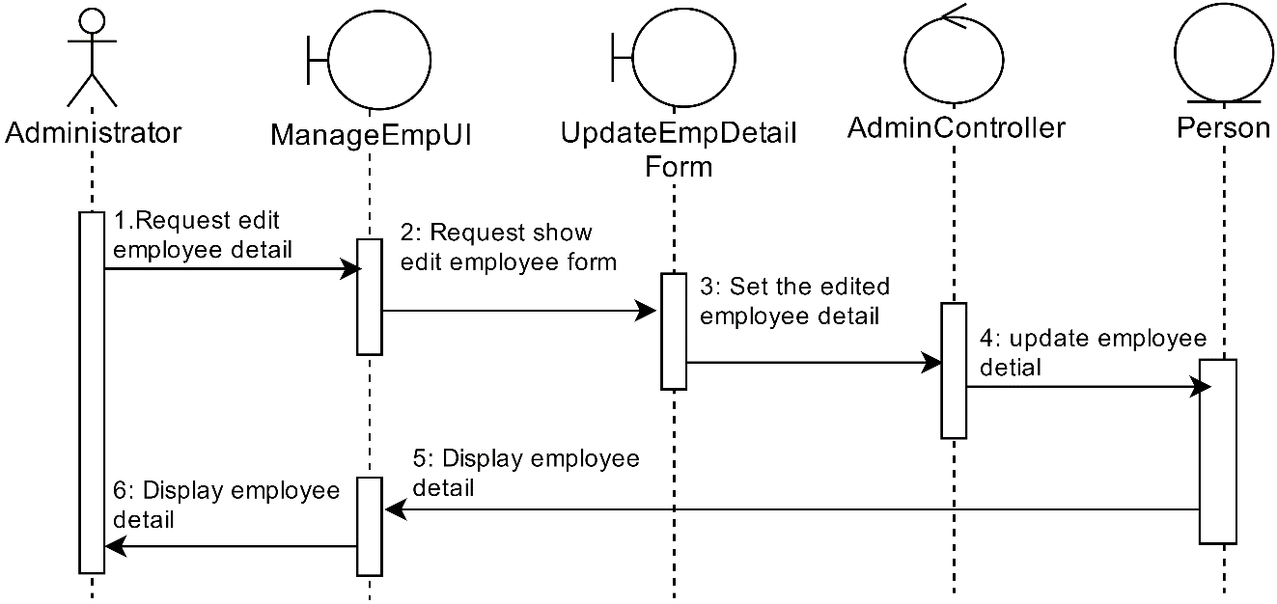

By Panyaprach Tularak

## Sequence Diagram demonstrating operation “Delete employee details”

* This diagram describes the system scenario of “**UC630: Delete employee details”**

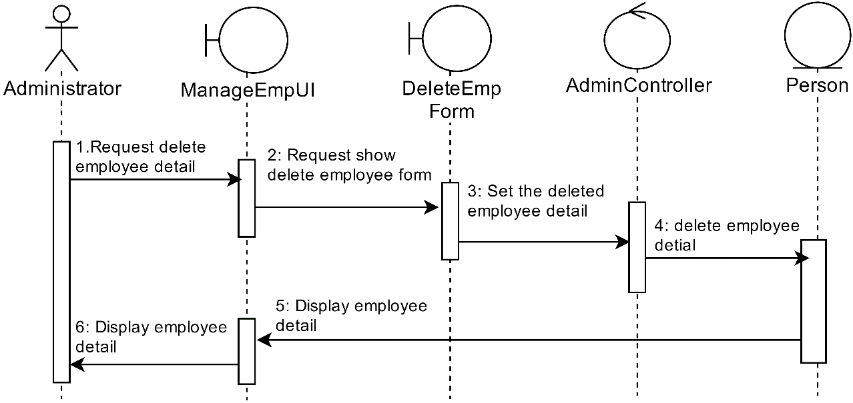

By Panyaprach Tularak

## Sequence Diagram demonstrating operation “Change permission of employees”

* This diagram describes the system scenario of “**UC640: Change permission of employees”**

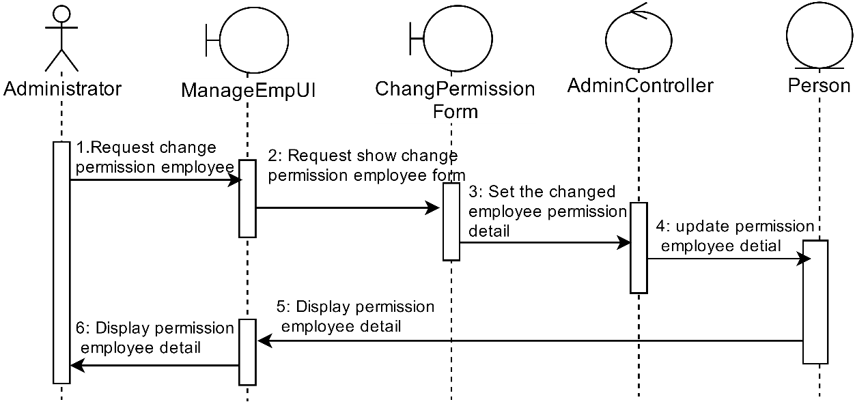

By Panyaprach Tularak

## Sequence Diagram demonstrating operation “Create daily sales report and print daily sale report”

* This diagram describes the system scenario of “**UC710: Edit product list”** and “**UC740: Print product sale report”**

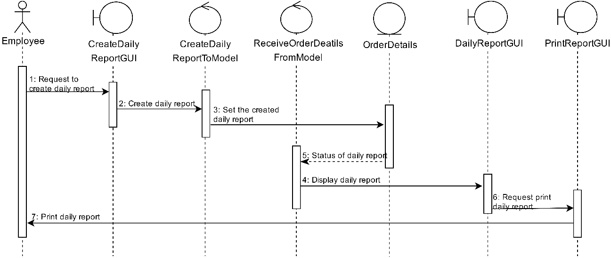

By Natthanicha Chonoo

## Sequence Diagram demonstrating operation “Create monthly sales report and print monthly sale report”

* This diagram describes the system scenario of “**UC720: Edit product list”** and “**UC740: Print product sale report”**

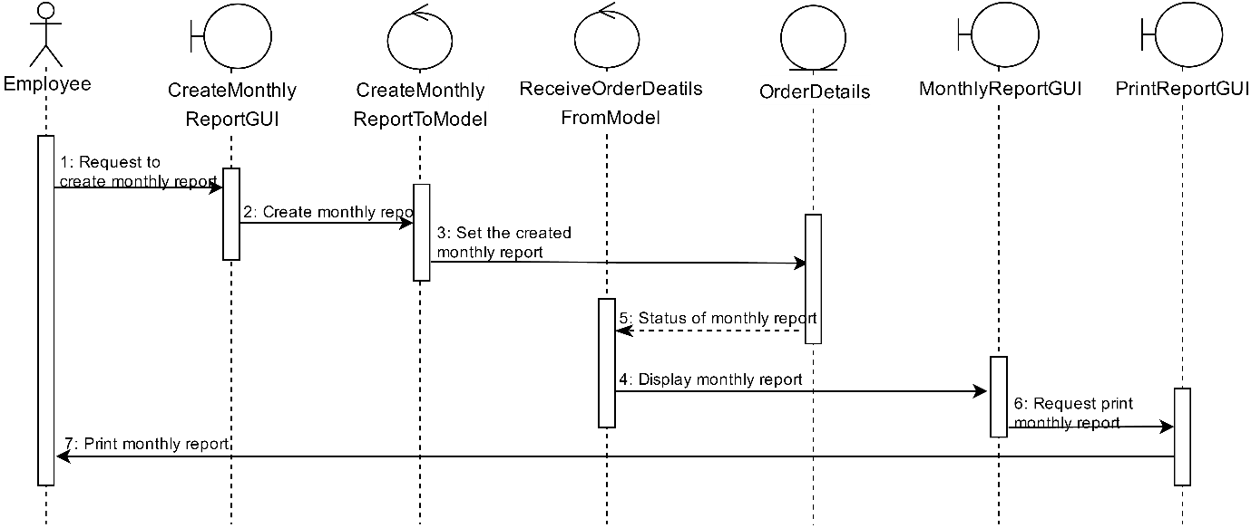

By Natthanicha Chonoo

## Sequence Diagram demonstrating operation “Create annual sales report and print annual sale report”

* This diagram describes the system scenario of “**UC730: Edit product list”** and “**UC740: Print product sale report”**

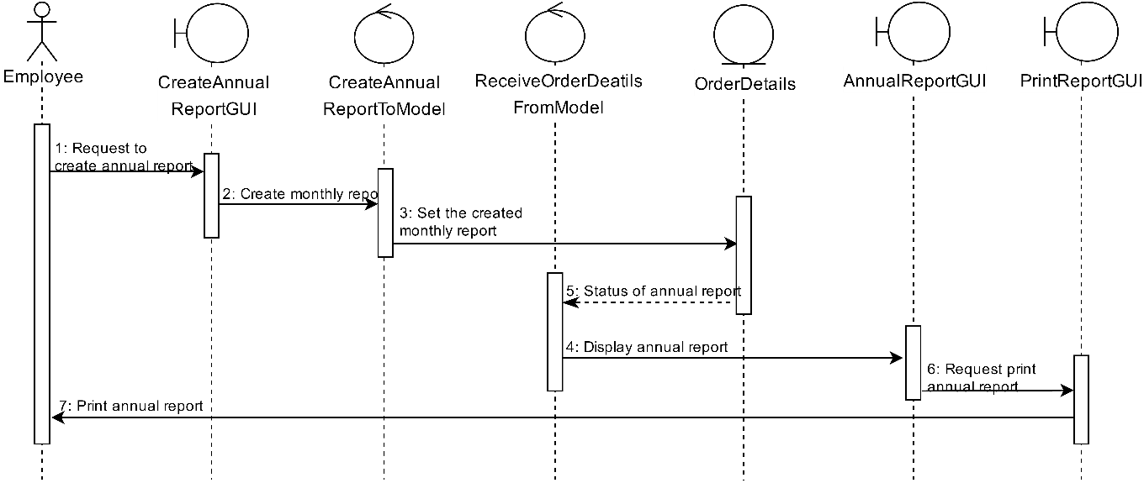

By Natthanicha Chonoo