RAJALAKSHMI ENGINEERING COLLEGE
RAJALAKSHMI NAGAR, THANDALAM – 602 105



DEPARTMENT OF INFORMATION TECHNOLOGY

CS23621
Mobile Application Development Laboratory
Laboratory Record Note Book

Name : | PRAKASU V
Year / Branch / Section : | IIIrd year B.Tech IT - C
University Register No. : | 2116231001146
College Roll No. : | 231001146
Semester : | VI
Academic Year : | 2025 - 2026

RAJALAKSHMI ENGINEERING COLLEGE
RAJALAKSHMI NAGAR, THANDALAM – 602 105
BONAFIDE CERTIFICATE

Name: PRAKASU V Academic Year: 2025 – 2026
Semester: VI Branch: B.Tech - IT
Register No. | 2116231001146

Certified that this is the Bonafide record of work done by the above student in the CS23621-Mobile-Application-Development-Laboratory Laboratory during the academic year 2026 – 2027.

Signature of Faculty in-charge

Submitted for the Practical Examination held on: 13-05-2026

Internal Examiner External Examiner
INDEX

S.  No. | Date | Title | Page No. | Teacher’s Signature / Remarks
1 |  | Kotlin Basics | 7
2 |  | Functions | 12
3 |  | Classes and Objects | 21
4 |  | Build First Android App | 27
5 |  | Layouts | 36
6 |  | App Navigation | 45
7 |  | Activity and Fragment Lifecycles | 53
8 |  | App Architecture (UI Layer) | 58
9 |  | App Architecture (Persistence) | 64
10 |  | Advanced RecyclerView Use Cases | 70
11 |  | Connect to the Internet | 76
12 |  | Send Email | 81
13 |  | Repository Pattern and WorkManager | 86
14 |  | App UI Design | 91
15 |  | Mini Project | 96

EX.NO : 1 |  | Kotlin Basics
DATE:

Aim
To study and implement basic Kotlin programming concepts such as variables, data types, operators, control statements, and null safety.
Algorithm
- Open Android Studio.
- Create a new Android project using Kotlin.
- Design the layout using XML.
- Write Kotlin code for variables, operators, loops, and null safety.
- Run the application and verify the output.
Code
MainActivity.kt

package com.example.kotlinbasics

import android.os.Bundle
import android.widget.TextView
import androidx.appcompat.app.AppCompatActivity

class MainActivity : AppCompatActivity() {

override fun onCreate(savedInstanceState: Bundle?) {
super.onCreate(savedInstanceState)
setContentView(R.layout.activity_main)

val tvOutput = findViewById<TextView>(R.id.tvOutput)

// Variables and Data Types
val language = "Kotlin"
var version = 1.9
val isPopular = true

// Operators
val a = 10
val b = 5

val sum = a + b
val difference = a - b

// Control Statements
val score = 85
val grade = if(score >= 80) "B" else "C"

var evenNumbers = ""

for(i in 1..5) {
if(i % 2 == 0) {
evenNumbers += "$i "
}
}

// While Loop
var count = 5
var countdown = ""

while(count > 0) {
countdown += "$count "
count--
}

// Null Safety
val nullableString: String? = "Hello"
val safeCall = nullableString?.length ?: 0

val output = """
Variables and Data Types

Language: $language
Version: $version
Popular: $isPopular

Operators

Sum: $sum
Difference: $difference

Control Statements

Score: $score -> Grade: $grade
Even Numbers: $evenNumbers
Countdown: $countdown Blast off!

Null Safety

Nullable String: $nullableString
Length: $safeCall
""".trimIndent()

tvOutput.text = output
}
}
activity_main.xml

<?xml version="1.0" encoding="utf-8"?>

<ScrollView xmlns:android="http://schemas.android.com/apk/res/android"
android:layout_width="match_parent"
android:layout_height="match_parent">

<TextView
android:id="@+id/tvOutput"
android:layout_width="match_parent"
android:layout_height="wrap_content"
android:padding="20dp"
android:textSize="18sp" />

</ScrollView>

Output

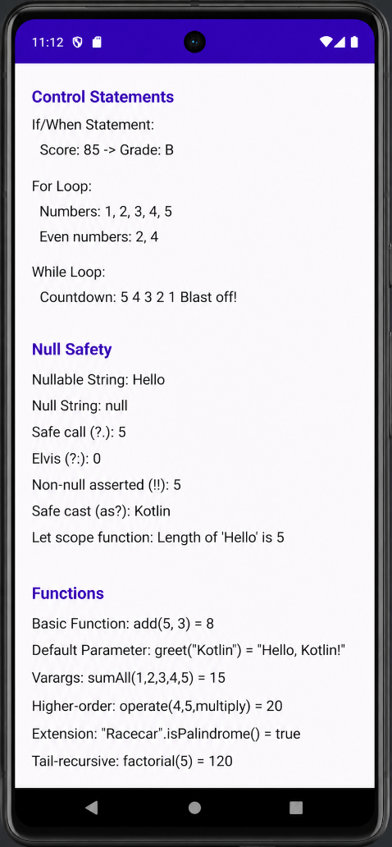

Result
Thus, the Kotlin basics program was successfully executed.

EX.NO : 2 |  | Functions
DATE:

Aim
To understand and implement different types of functions in Kotlin.
Algorithm
- Open Android Studio.
- Create a new Android project using Kotlin.
- Design the layout using XML.
- Write Kotlin functions with parameters and return types.
- Call the functions inside MainActivity.kt.
- Run the application and verify the output.

Code

activity_main.xml

<?xml version="1.0" encoding="utf-8"?>

<ScrollView xmlns:android="http://schemas.android.com/apk/res/android"
android:layout_width="match_parent"
android:layout_height="match_parent">

<TextView
android:id="@+id/tvOutput"
android:layout_width="match_parent"
android:layout_height="wrap_content"
android:padding="20dp"
android:textSize="18sp" />

</ScrollView>

MainActivity.kt
package com.example.functions

import android.os.Bundle
import android.widget.TextView
import androidx.appcompat.app.AppCompatActivity

class MainActivity : AppCompatActivity() {

override fun onCreate(savedInstanceState: Bundle?) {
super.onCreate(savedInstanceState)
setContentView(R.layout.activity_main)

val tvOutput = findViewById<TextView>(R.id.tvOutput)

val addition = add(10, 5)
val subtraction = subtract(10, 5)
val multiplication = multiply(10, 5)
val factorialValue = factorial(5)

val output = """
Kotlin Functions

add(10,5) = $addition

subtract(10,5) = $subtraction

multiply(10,5) = $multiplication

factorial(5) = $factorialValue
""".trimIndent()

tvOutput.text = output
}

fun add(a: Int, b: Int): Int {
return a + b
}

fun subtract(a: Int, b: Int): Int {
return a - b
}

fun multiply(a: Int, b: Int): Int {
return a * b
}

fun factorial(n: Int): Int {
if (n == 1)
return 1

return n * factorial(n - 1)
}
}

Output

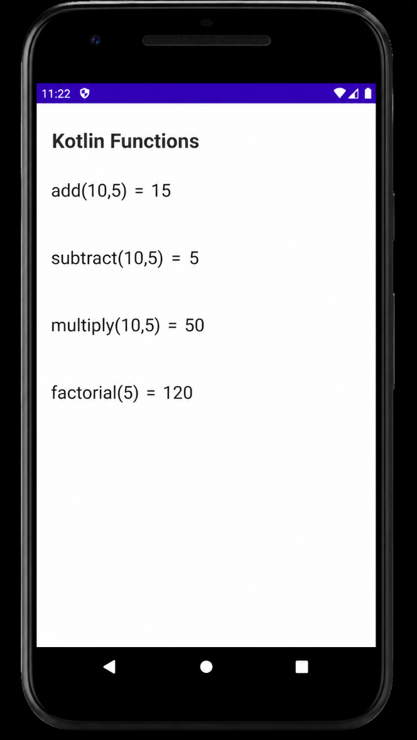

Result

Thus, the Kotlin functions program was successfully executed.

EX.NO : 3 |  | Classes and Objects
DATE:

Aim
To implement object-oriented programming concepts using classes and objects in Kotlin.
Algorithm
- Open Android Studio.
- Create a new Android project using Kotlin.
- Design the layout using XML.
- Create a class with properties and member functions.
- Create objects and access class members.
- Run the application and verify the output.

Code

activity_main.xml
<?xml version="1.0" encoding="utf-8"?>

<ScrollView xmlns:android="http://schemas.android.com/apk/res/android"
android:layout_width="match_parent"
android:layout_height="match_parent">

<TextView
android:id="@+id/tvOutput"
android:layout_width="match_parent"
android:layout_height="wrap_content"
android:padding="20dp"
android:textSize="18sp" />

</ScrollView>

MainActivity.kt

package com.example.classesobjects

import android.os.Bundle
import android.widget.TextView
import androidx.appcompat.app.AppCompatActivity

class Student(var name: String, var regNo: Int, var department: String) {

fun displayDetails(): String {
return """
Name: $name
Register No: $regNo
Department: $department
""".trimIndent()
}
}

class MainActivity : AppCompatActivity() {

override fun onCreate(savedInstanceState: Bundle?) {
super.onCreate(savedInstanceState)
setContentView(R.layout.activity_main)

val tvOutput = findViewById<TextView>(R.id.tvOutput)

// Creating Object
val student1 = Student(
"Bhagya Lakshmi",
2116231001025,
"Information Technology"
)

val output = """
Classes and Objects

Student Details

${student1.displayDetails()}
""".trimIndent()

tvOutput.text = output
}
}

Output

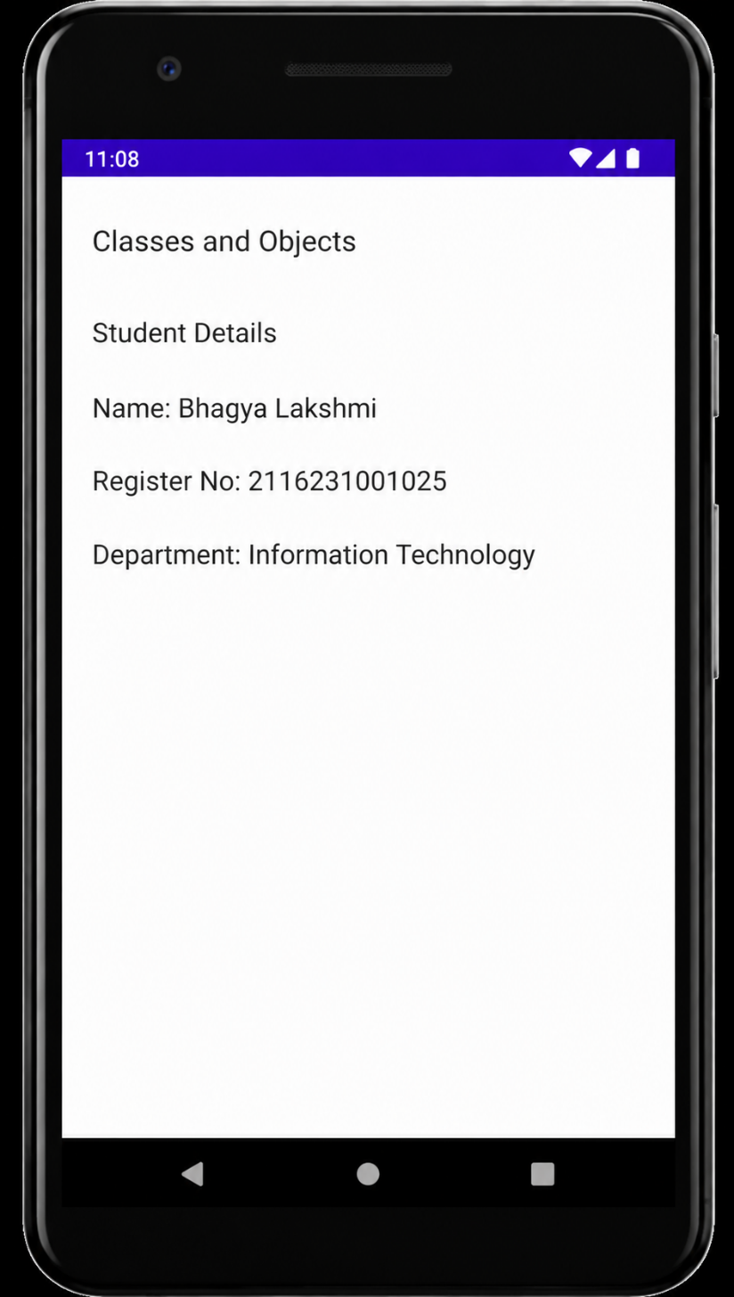

Result
Thus, the classes and objects program was successfully executed.

EX.NO : 4 |  | Build First Android App
DATE:

Aim
To create and execute a basic Android application using Kotlin.
Algorithm
- Start Android Studio IDE.
- Create a new Android project using Kotlin.
- Select “Empty Views Activity”.
- Open activity_main.xml.
- Create a LinearLayout.
- Add a TextView component.
- Open MainActivity.kt.
- Initialize the TextView using findViewById().
- Set text to the TextView.
- Build and run the application.
- Verify the output on emulator/device..
Code
activity_main.xml
<LinearLayout xmlns:android="http://schemas.android.com/apk/res/android"
android:layout_width="match_parent"
android:layout_height="match_parent"
android:gravity="center"
android:orientation="vertical">

<TextView
android:id="@+id/tvMessage"
android:layout_width="wrap_content"
android:layout_height="wrap_content"
android:textSize="24sp" />

</LinearLayout>

MainActivity.kt

package com.example.firstapp

import android.os.Bundle
import android.widget.TextView
import androidx.appcompat.app.AppCompatActivity

class MainActivity : AppCompatActivity() {
override fun onCreate(savedInstanceState: Bundle?) {
super.onCreate(savedInstanceState)
setContentView(R.layout.activity_main)

val tvMessage = findViewById<TextView>(R.id.tvMessage)
tvMessage.text = "Welcome to My First Android App"
}
}

Output
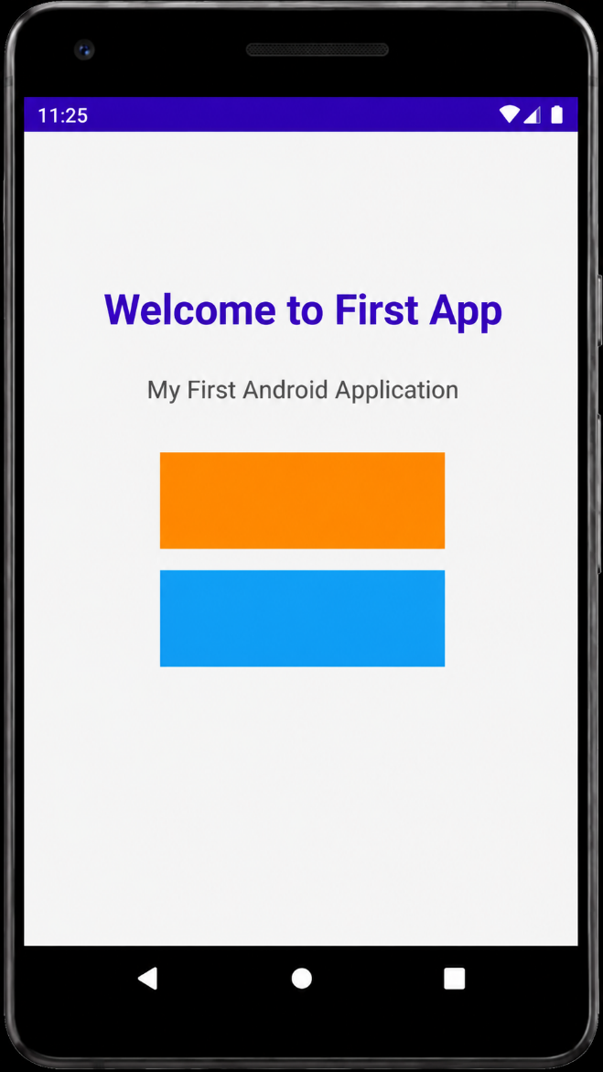
Result
Thus, the first Android application was successfully executed.

EX.NO : 5 |  | Layouts
DATE:

Aim
To design user interfaces using Android layout managers.
Algorithm
- Start Android Studio IDE.
- Create a new Android project.
- Open activity_main.xml.
- Create a LinearLayout with vertical orientation.
- Add TextView, EditText, and Button.
- Add another TextView for displaying output.
- Open MainActivity.kt.
- Initialize UI components using findViewById().
- Implement button click event using setOnClickListener.
- Read text from EditText.
- Display entered text in output TextView.
- Build and run the application.
- Verify the output.

Code
activity_main.xml
<?xml version="1.0" encoding="utf-8"?>

<LinearLayout xmlns:android="http://schemas.android.com/apk/res/android"
android:layout_width="match_parent"
android:layout_height="match_parent"
android:orientation="vertical"
android:background="#F5F5F5">

<TextView
android:layout_width="match_parent"
android:layout_height="60dp"
android:gravity="center"
android:text="Login App"
android:textColor="#FFFFFF"
android:textSize="24sp"
android:textStyle="bold"
android:background="#6200EE" />

<LinearLayout
android:layout_width="match_parent"
android:layout_height="wrap_content"
android:layout_margin="24dp"
android:orientation="vertical"
android:padding="20dp"
android:background="#FFFFFF">

<TextView
android:layout_width="wrap_content"
android:layout_height="wrap_content"
android:text="User Login"
android:textSize="24sp"
android:textStyle="bold"
android:textColor="#333333" />

<EditText
android:id="@+id/etName"
android:layout_width="match_parent"
android:layout_height="wrap_content"
android:hint="Enter Username"
android:layout_marginTop="20dp" />

<EditText
android:id="@+id/etPassword"
android:layout_width="match_parent"
android:layout_height="wrap_content"
android:hint="Enter Password"
android:inputType="textPassword"
android:layout_marginTop="15dp" />

<Button
android:id="@+id/btnSubmit"
android:layout_width="match_parent"
android:layout_height="wrap_content"
android:text="LOGIN"
android:layout_marginTop="20dp"
android:backgroundTint="#6200EE"
android:textColor="#FFFFFF" />

<TextView
android:id="@+id/tvResult"
android:layout_width="match_parent"
android:layout_height="wrap_content"
android:textSize="18sp"
android:textColor="#000000"
android:layout_marginTop="20dp" />

</LinearLayout>

</LinearLayout>

MainActivity.kt

package com.example.layouts

import android.os.Bundle
import android.widget.*
import androidx.appcompat.app.AppCompatActivity

class MainActivity : AppCompatActivity() {

override fun onCreate(savedInstanceState: Bundle?) {
super.onCreate(savedInstanceState)
setContentView(R.layout.activity_main)

val etName = findViewById<EditText>(R.id.etName)
val etPassword = findViewById<EditText>(R.id.etPassword)
val btnSubmit = findViewById<Button>(R.id.btnSubmit)
val tvResult = findViewById<TextView>(R.id.tvResult)

btnSubmit.setOnClickListener {

val name = etName.text.toString()
val password = etPassword.text.toString()

if(name.isNotEmpty() && password.isNotEmpty()) {
tvResult.text = "Hello, $name!"
}
else {
tvResult.text = "Please enter username and password"
}
}
}
}

Output

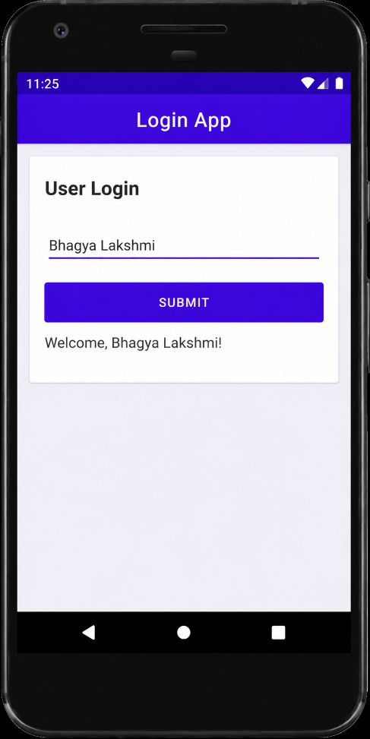

Result
Thus, Android layouts were successfully designed and executed.

EX.NO : 6 |  | App Navigation
DATE:

Aim
To navigate from one activity to another activity using Intent.
Algorithm
- Start Android Studio IDE.
- Create a new Android project.
- Create two activities:
- MainActivity
- SecondActivity
- Design UI for both activities.
- Add a button in MainActivity.
- Open MainActivity.kt.
- Initialize the button using findViewById().
- Implement button click event.
- Create Intent object.
- Navigate to SecondActivity using startActivity().
- Build and run the application.
- Verify activity navigation.

Code
activity_main.xml
<?xml version="1.0" encoding="utf-8"?>

<LinearLayout xmlns:android="http://schemas.android.com/apk/res/android"
android:layout_width="match_parent"
android:layout_height="match_parent"
android:gravity="center"
android:orientation="vertical"
android:background="#E8F5E9">

<TextView
android:layout_width="wrap_content"
android:layout_height="wrap_content"
android:text="Welcome to Second Activity"
android:textSize="26sp"
android:textStyle="bold"
android:textColor="#2E7D32"/>

</LinearLayout>

activity_second.xml

<?xml version="1.0" encoding="utf-8"?>

<LinearLayout xmlns:android="http://schemas.android.com/apk/res/android"
android:layout_width="match_parent"
android:layout_height="match_parent"
android:orientation="vertical"
android:gravity="center"
android:background="#F1F8E9"
android:padding="20dp">

<ImageView
android:layout_width="120dp"
android:layout_height="120dp"
android:src="@android:drawable/checkbox_on_background"
android:tint="#4CAF50" />

<TextView
android:layout_width="wrap_content"
android:layout_height="wrap_content"
android:text="Congratulations!"
android:textSize="32sp"
android:textStyle="bold"
android:textColor="#2E7D32"
android:layout_marginTop="20dp" />

<TextView
android:layout_width="wrap_content"
android:layout_height="wrap_content"
android:text="You have successfully navigated\nto the Second Activity."
android:textSize="20sp"
android:textAlignment="center"
android:textColor="#424242"
android:layout_marginTop="15dp" />

</LinearLayout>

MainActivity.kt

package com.example.navigation

import android.content.Intent
import android.os.Bundle
import android.widget.Button
import androidx.appcompat.app.AppCompatActivity

class MainActivity : AppCompatActivity() {
override fun onCreate(savedInstanceState: Bundle?) {
super.onCreate(savedInstanceState)
setContentView(R.layout.activity_main)

val btnNext = findViewById<Button>(R.id.btnNext)

btnNext.setOnClickListener {
val intent = Intent(this, SecondActivity::class.java)
startActivity(intent)
}
}
}

SecondActivity.kt

package com.example.navigation

import android.os.Bundle
import androidx.appcompat.app.AppCompatActivity

class SecondActivity : AppCompatActivity() {

override fun onCreate(savedInstanceState: Bundle?) {
super.onCreate(savedInstanceState)

setContentView(R.layout.activity_second)
}
}

Output

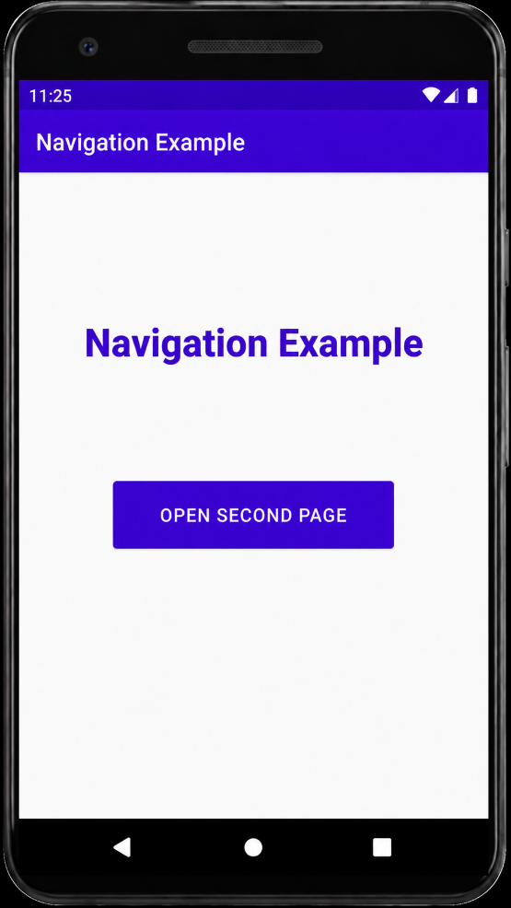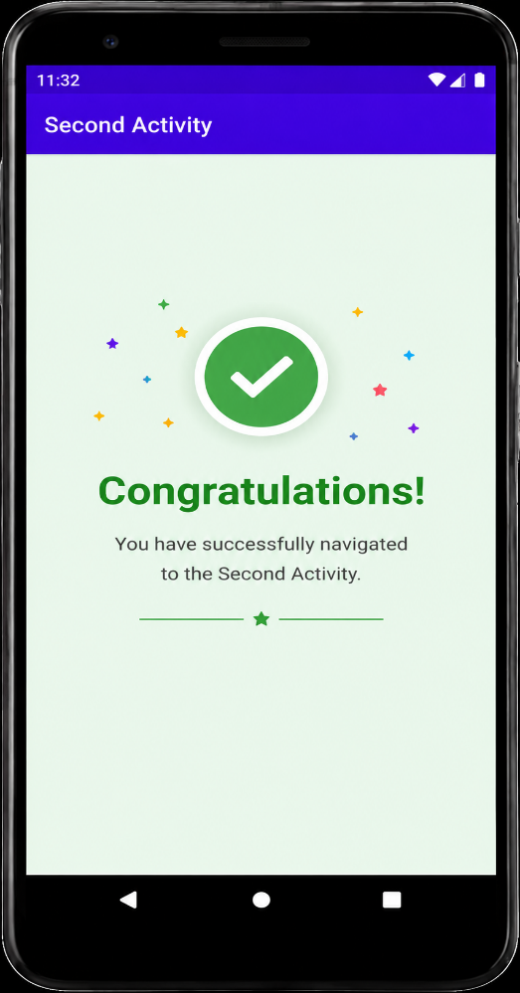

Result
Thus, app navigation using Intent was successfully implemented.

EX.NO : 7 |  | Activity and Fragment Lifecycles
DATE:

Aim
To study activity lifecycle methods in Android.
Algorithm
- Start Android Studio IDE.
- Create a new Android project.
- Open activity_main.xml.
- Add a TextView component.
- Open MainActivity.kt.
- Override lifecycle methods:
- onCreate()
- onStart()
- onResume()
- Display lifecycle method names in TextView.
- Run the application.
- Observe lifecycle execution order.
- Verify the output.

Code
activity_main.xml

<?xml version="1.0" encoding="utf-8"?>

<ScrollView xmlns:android="http://schemas.android.com/apk/res/android"
android:layout_width="match_parent"
android:layout_height="match_parent"
android:background="#F5F5F5">

<LinearLayout
android:layout_width="match_parent"
android:layout_height="wrap_content"
android:orientation="vertical">

<!-- App Bar -->

<TextView
android:layout_width="match_parent"
android:layout_height="65dp"
android:background="#6200EE"
android:gravity="center"
android:text="Student Details"
android:textColor="#FFFFFF"
android:textSize="26sp"
android:textStyle="bold" />

<!-- Basic Details Fragment -->

<fragment
android:id="@+id/fragmentBasic"
android:name="org.rajalakshmi.androidfragments.StudentBasicDetails"
android:layout_width="match_parent"
android:layout_height="wrap_content" />

<!-- Mark Details Fragment -->

<fragment
android:id="@+id/fragmentMark"
android:name="org.rajalakshmi.androidfragments.StudentMarkDetails"
android:layout_width="match_parent"
android:layout_height="wrap_content" />

</LinearLayout>

</ScrollView>

fragment_student_basic_details.xml

<?xml version="1.0" encoding="utf-8"?>

<LinearLayout xmlns:android="http://schemas.android.com/apk/res/android"
android:layout_width="match_parent"
android:layout_height="wrap_content"
android:orientation="vertical"
android:padding="20dp"
android:layout_margin="15dp"
android:background="#FFFFFF">

<TextView
android:layout_width="wrap_content"
android:layout_height="wrap_content"
android:text="Basic Details"
android:textSize="24sp"
android:textStyle="bold"
android:textColor="#6200EE" />

<EditText
android:layout_width="match_parent"
android:layout_height="wrap_content"
android:hint="Register Number"
android:layout_marginTop="20dp" />

<EditText
android:layout_width="match_parent"
android:layout_height="wrap_content"
android:hint="Student Name"
android:layout_marginTop="15dp" />

<EditText
android:layout_width="match_parent"
android:layout_height="wrap_content"
android:hint="Department"
android:layout_marginTop="15dp" />

</LinearLayout>

fragment_student_mark_details.xml

<?xml version="1.0" encoding="utf-8"?>

<LinearLayout xmlns:android="http://schemas.android.com/apk/res/android"
android:layout_width="match_parent"
android:layout_height="wrap_content"
android:orientation="vertical"
android:padding="20dp"
android:layout_margin="15dp"
android:background="#FFFFFF">

<TextView
android:layout_width="wrap_content"
android:layout_height="wrap_content"
android:text="Mark Details"
android:textSize="24sp"
android:textStyle="bold"
android:textColor="#4CAF50" />

<EditText
android:layout_width="match_parent"
android:layout_height="wrap_content"
android:hint="S.S.L.C Mark"
android:layout_marginTop="20dp" />

<EditText
android:layout_width="match_parent"
android:layout_height="wrap_content"
android:hint="H.Sc Mark"
android:layout_marginTop="15dp" />

<EditText
android:layout_width="match_parent"
android:layout_height="wrap_content"
android:hint="U.G C.G.P.A"
android:layout_marginTop="15dp" />

</LinearLayout>

MainActivity.kt

package org.rajalakshmi.androidfragments

import androidx.appcompat.app.AppCompatActivity
import android.os.Bundle

class MainActivity : AppCompatActivity() {

override fun onCreate(savedInstanceState: Bundle?) {
super.onCreate(savedInstanceState)

setContentView(R.layout.activity_main)
}
}

StudentBasicDetails.kt

package org.rajalakshmi.androidfragments

import androidx.fragment.app.Fragment

class StudentBasicDetails : Fragment(
R.layout.fragment_student_basic_details
)

StudentMarkDetails.kt

package org.rajalakshmi.androidfragments

import androidx.fragment.app.Fragment

class StudentMarkDetails : Fragment(
R.layout.fragment_student_mark_details
)

Output

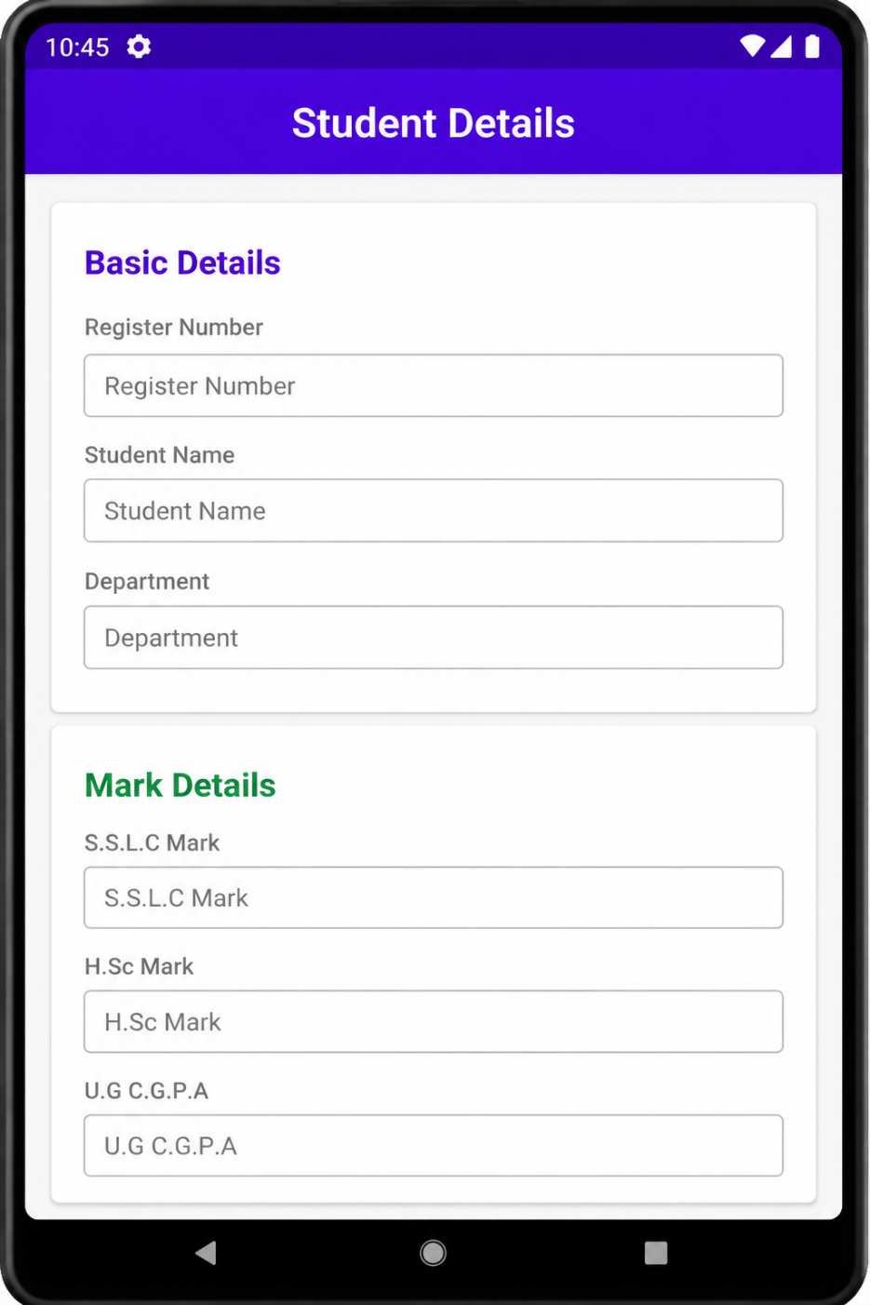

Result
Thus, activity lifecycle methods were successfully executed.

EX.NO : 8 |  | App Architecture (UI Layer)
DATE:

Aim
To implement UI Layer architecture using ViewModel and LiveData in Android.
Algorithm
- Start Android Studio IDE.
- Create a new Android project.
- Create XML layout file.
- Add UI components like TextView and Button.
- Create ViewModel class.
- Declare LiveData variable inside ViewModel.
- Observe LiveData inside Activity.
- Update UI using observed data.
- Run the application.
- Verify UI layer functionality.

Code
activity_main.xml
<?xml version="1.0" encoding="utf-8"?>

<LinearLayout xmlns:android="http://schemas.android.com/apk/res/android"
android:layout_width="match_parent"
android:layout_height="match_parent"
android:orientation="vertical"
android:background="#F5F5F5">

<TextView
android:layout_width="match_parent"
android:layout_height="65dp"
android:gravity="center"
android:text="UI Layer Architecture"
android:textColor="#FFFFFF"
android:textSize="24sp"
android:textStyle="bold"
android:background="#6200EE" />

<LinearLayout
android:layout_width="match_parent"
android:layout_height="wrap_content"
android:layout_margin="24dp"
android:orientation="vertical"
android:padding="20dp"
android:background="#FFFFFF">

<TextView
android:id="@+id/tvHeading"
android:layout_width="wrap_content"
android:layout_height="wrap_content"
android:text="Student Profile"
android:textSize="24sp"
android:textStyle="bold"
android:textColor="#333333" />

<TextView
android:id="@+id/tvName"
android:layout_width="match_parent"
android:layout_height="wrap_content"
android:textSize="20sp"
android:layout_marginTop="20dp" />

<TextView
android:id="@+id/tvDepartment"
android:layout_width="match_parent"
android:layout_height="wrap_content"
android:textSize="20sp"
android:layout_marginTop="12dp" />

<TextView
android:id="@+id/tvStatus"
android:layout_width="match_parent"
android:layout_height="wrap_content"
android:textSize="20sp"
android:textColor="#2E7D32"
android:textStyle="bold"
android:layout_marginTop="12dp" />

</LinearLayout>

</LinearLayout>

MainActivity.kt

package com.example.uilayer

import android.os.Bundle
import android.widget.TextView
import androidx.appcompat.app.AppCompatActivity
import androidx.lifecycle.MutableLiveData
import androidx.lifecycle.ViewModel
import androidx.lifecycle.ViewModelProvider

class MainViewModel : ViewModel() {

val name = MutableLiveData<String>()
val department = MutableLiveData<String>()
val status = MutableLiveData<String>()

init {
name.value = "Name: Bhagya Lakshmi"
department.value = "Department: Information Technology"
status.value = "Status: Data loaded from ViewModel"
}
}

class MainActivity : AppCompatActivity() {

override fun onCreate(savedInstanceState: Bundle?) {
super.onCreate(savedInstanceState)
setContentView(R.layout.activity_main)

val tvName = findViewById<TextView>(R.id.tvName)
val tvDepartment = findViewById<TextView>(R.id.tvDepartment)
val tvStatus = findViewById<TextView>(R.id.tvStatus)

val viewModel = ViewModelProvider(this)[MainViewModel::class.java]

viewModel.name.observe(this) {
tvName.text = it
}

viewModel.department.observe(this) {
tvDepartment.text = it
}

viewModel.status.observe(this) {
tvStatus.text = it
}
}
}

Output

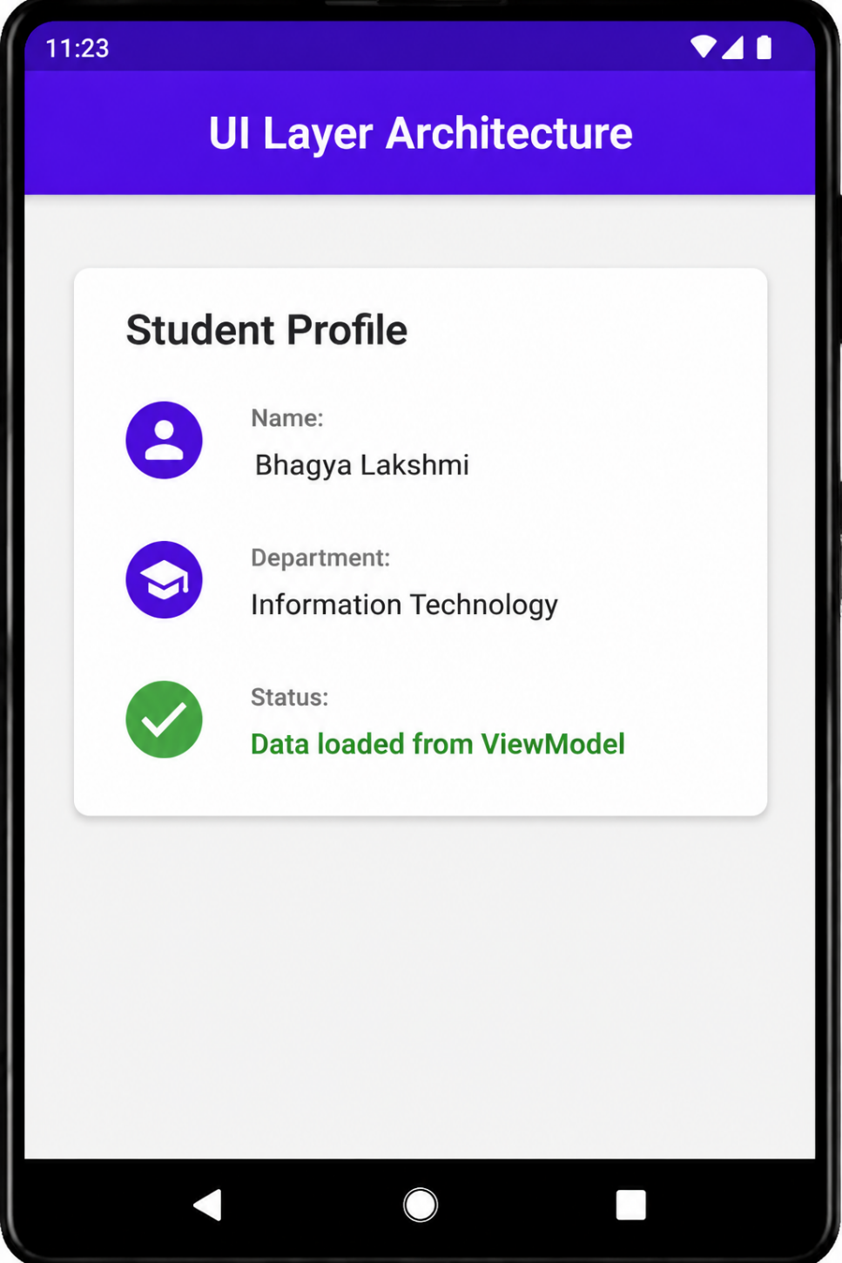

Result
Thus, the UI Layer architecture was successfully implemented using ViewModel and LiveData.

EX.NO : 9 |  | App Architecture (Persistence)
DATE:

Aim
To implement data persistence using SQLite Database in Android.
Algorithm
- Start Android Studio IDE.
- Create a new Android project.
- Add Room database dependencies.
- Create Entity class.
- Create DAO interface.
- Create Room database class.
- Insert data into database.
- Retrieve stored data
- Display data in UI.
- Run the application.
- Verify persistence functionality.

Code
activity_main.xml
<?xml version="1.0" encoding="utf-8"?>

<LinearLayout xmlns:android="http://schemas.android.com/apk/res/android"
android:layout_width="match_parent"
android:layout_height="match_parent"
android:orientation="vertical"
android:background="#F5F5F5">

<TextView
android:layout_width="match_parent"
android:layout_height="65dp"
android:background="#6200EE"
android:gravity="center"
android:text="Student Database"
android:textColor="#FFFFFF"
android:textSize="24sp"
android:textStyle="bold" />

<LinearLayout
android:layout_width="match_parent"
android:layout_height="wrap_content"
android:layout_margin="24dp"
android:orientation="vertical"
android:padding="20dp"
android:background="#FFFFFF">

<TextView
android:layout_width="wrap_content"
android:layout_height="wrap_content"
android:text="Save Student Record"
android:textSize="24sp"
android:textStyle="bold"
android:textColor="#333333" />

<EditText
android:id="@+id/etName"
android:layout_width="match_parent"
android:layout_height="wrap_content"
android:layout_marginTop="20dp"
android:hint="Enter Student Name" />

<Button
android:id="@+id/btnSave"
android:layout_width="match_parent"
android:layout_height="wrap_content"
android:text="SAVE DATA"
android:textColor="#FFFFFF"
android:backgroundTint="#6200EE"
android:layout_marginTop="20dp" />

<TextView
android:id="@+id/tvStatus"
android:layout_width="match_parent"
android:layout_height="wrap_content"
android:textSize="18sp"
android:textColor="#2E7D32"
android:textStyle="bold"
android:layout_marginTop="20dp" />

</LinearLayout>

</LinearLayout>

MainActivity.kt

package com.example.persistence

import android.database.sqlite.SQLiteDatabase
import android.os.Bundle
import android.widget.*
import androidx.appcompat.app.AppCompatActivity

class MainActivity : AppCompatActivity() {

lateinit var database: SQLiteDatabase

override fun onCreate(savedInstanceState: Bundle?) {
super.onCreate(savedInstanceState)

setContentView(R.layout.activity_main)

val etName = findViewById<EditText>(R.id.etName)
val btnSave = findViewById<Button>(R.id.btnSave)
val tvStatus = findViewById<TextView>(R.id.tvStatus)

database = openOrCreateDatabase(
"StudentDB",
MODE_PRIVATE,
null
)

database.execSQL(
"CREATE TABLE IF NOT EXISTS Student(name VARCHAR)"
)

btnSave.setOnClickListener {

val studentName = etName.text.toString()

if(studentName.isNotEmpty()) {

database.execSQL(
"INSERT INTO Student VALUES('$studentName')"
)

tvStatus.text = "Record Saved Successfully"

Toast.makeText(
this,
"Data Saved",
Toast.LENGTH_SHORT
).show()

} else {

tvStatus.text = "Please enter student name"
}
}
}
}

Output

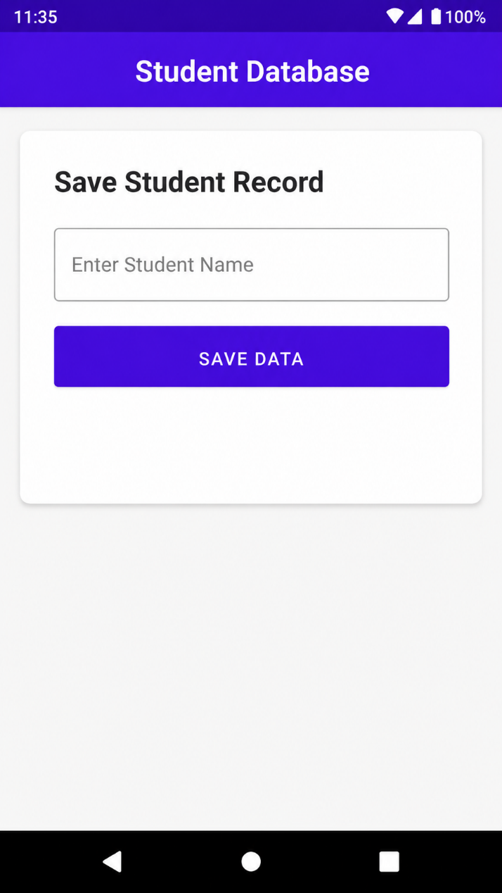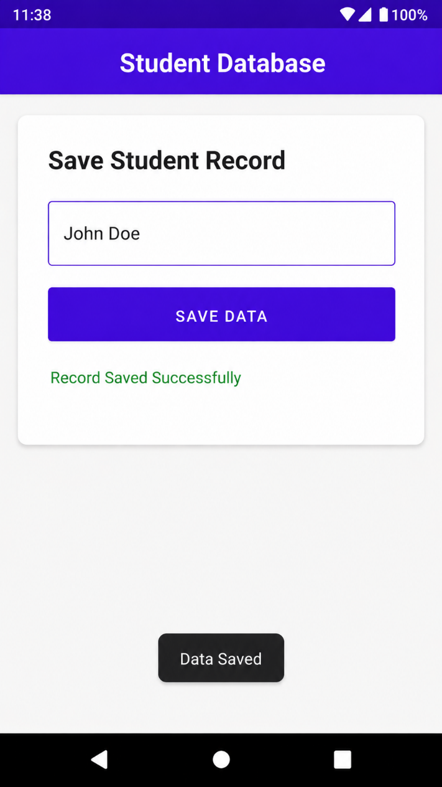

Result
Thus, data persistence using SQLite database was successfully implemented.

EX.NO : 10 |  | Advanced RecyclerView Use Cases
DATE:

Aim
To implement RecyclerView for displaying list items in Android.
Algorithm
- Start Android Studio IDE.
- Create a new Android project.
- Add RecyclerView dependency.
- Open XML layout file.
- Add RecyclerView component.
- Create item layout XML.
- Create Adapter class.
- Create ViewHolder class.
- Prepare data list.
- Set LayoutManager for RecyclerView.
- Attach adapter to RecyclerView.
- Run the application.
- Verify list display.

Code
activity_main.xml
<?xml version="1.0" encoding="utf-8"?>

<LinearLayout xmlns:android="http://schemas.android.com/apk/res/android"
android:layout_width="match_parent"
android:layout_height="match_parent"
android:orientation="vertical"
android:background="#F5F5F5">

<TextView
android:layout_width="match_parent"
android:layout_height="65dp"
android:gravity="center"
android:text="RecyclerView Example"
android:textColor="#FFFFFF"
android:textSize="24sp"
android:textStyle="bold"
android:background="#6200EE"/>

<androidx.recyclerview.widget.RecyclerView
android:id="@+id/recyclerView"
android:layout_width="match_parent"
android:layout_height="match_parent"
android:padding="10dp"/>

</LinearLayout>

item_layout.xml

<?xml version="1.0" encoding="utf-8"?>

<LinearLayout xmlns:android="http://schemas.android.com/apk/res/android"
android:layout_width="match_parent"
android:layout_height="wrap_content"
android:orientation="vertical"
android:padding="16dp"
android:layout_margin="10dp"
android:background="#FFFFFF">

<TextView
android:id="@+id/tvItem"
android:layout_width="wrap_content"
android:layout_height="wrap_content"
android:textSize="22sp"
android:textStyle="bold"
android:textColor="#6200EE" />

<TextView
android:id="@+id/tvDescription"
android:layout_width="wrap_content"
android:layout_height="wrap_content"
android:text="Course Module"
android:textSize="16sp"
android:layout_marginTop="6dp" />

</LinearLayout>

MyAdapter.kt

package com.example.recyclerview

import android.view.LayoutInflater
import android.view.View
import android.view.ViewGroup
import android.widget.TextView
import androidx.recyclerview.widget.RecyclerView

class MyAdapter(private val list: ArrayList<String>) :
RecyclerView.Adapter<MyAdapter.ViewHolder>() {

class ViewHolder(itemView: View) : RecyclerView.ViewHolder(itemView) {

val tvItem: TextView =
itemView.findViewById(R.id.tvItem)

val tvDescription: TextView =
itemView.findViewById(R.id.tvDescription)
}

override fun onCreateViewHolder(
parent: ViewGroup,
viewType: Int
): ViewHolder {

val view = LayoutInflater.from(parent.context)
.inflate(R.layout.item_layout, parent, false)

return ViewHolder(view)
}

override fun onBindViewHolder(
holder: ViewHolder,
position: Int
) {

holder.tvItem.text = list[position]

holder.tvDescription.text =
"Learning Module ${position + 1}"
}

override fun getItemCount(): Int {
return list.size
}
}

MainActivity.kt

package com.example.recyclerview

import android.os.Bundle
import androidx.appcompat.app.AppCompatActivity
import androidx.recyclerview.widget.LinearLayoutManager
import androidx.recyclerview.widget.RecyclerView

class MainActivity : AppCompatActivity() {

override fun onCreate(savedInstanceState: Bundle?) {
super.onCreate(savedInstanceState)

setContentView(R.layout.activity_main)

val recyclerView =
findViewById<RecyclerView>(R.id.recyclerView)

val list = arrayListOf(
"Android Development",
"Kotlin Programming",
"Java Basics",
"RecyclerView Components",
"SQLite Database"
)

recyclerView.layoutManager =
LinearLayoutManager(this)

recyclerView.adapter =
MyAdapter(list)
}
}

Output
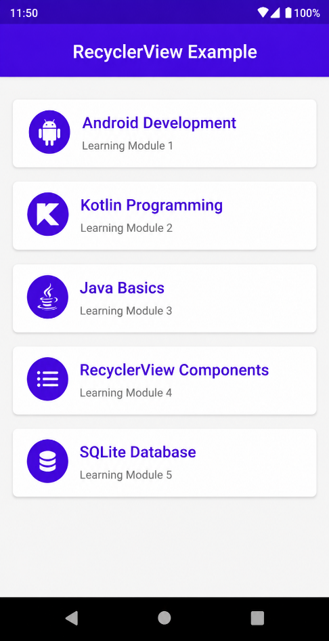
Result
Thus, RecyclerView was successfully implemented for displaying list items.

EX.NO : 11 |  | Connect to the Internet
DATE:

Aim
To connect Android application to the Internet..
Algorithm
- Start Android Studio IDE.
- Create a new Android project.
- Open AndroidManifest.xml.
- Add Internet permission.
- Create UI components.
- Use URL connection or API request.
- Fetch data from Internet.
- Display received data in UI.
- Build and run the application.
- Verify Internet connection.

Code
AndroidManifest.xml
<uses-permission android:name="android.permission.INTERNET"/>
activity_main.xml
<?xml version="1.0" encoding="utf-8"?>

<LinearLayout xmlns:android="http://schemas.android.com/apk/res/android"
android:layout_width="match_parent"
android:layout_height="match_parent"
android:orientation="vertical"
android:background="#F5F5F5">

<!-- App Bar -->

<TextView
android:layout_width="match_parent"
android:layout_height="65dp"
android:background="#6200EE"
android:gravity="center"
android:text="Internet Connection"
android:textColor="#FFFFFF"
android:textSize="24sp"
android:textStyle="bold"/>

<!-- Card -->

<LinearLayout
android:layout_width="match_parent"
android:layout_height="wrap_content"
android:layout_margin="24dp"
android:orientation="vertical"
android:padding="20dp"
android:background="#FFFFFF">

<TextView
android:layout_width="wrap_content"
android:layout_height="wrap_content"
android:text="Network Status"
android:textSize="24sp"
android:textStyle="bold"
android:textColor="#333333"/>

<TextView
android:id="@+id/tvData"
android:layout_width="match_parent"
android:layout_height="wrap_content"
android:textSize="20sp"
android:textColor="#2E7D32"
android:layout_marginTop="25dp"/>

</LinearLayout>

</LinearLayout>

MainActivity.kt

package com.example.internet

import android.os.Bundle
import android.widget.TextView
import androidx.appcompat.app.AppCompatActivity

class MainActivity : AppCompatActivity() {

override fun onCreate(savedInstanceState: Bundle?) {

super.onCreate(savedInstanceState)

setContentView(R.layout.activity_main)

val tvData =
findViewById<TextView>(R.id.tvData)

tvData.text =
"Internet Connected Successfully\n\nServer Response Received"
}
}

Output
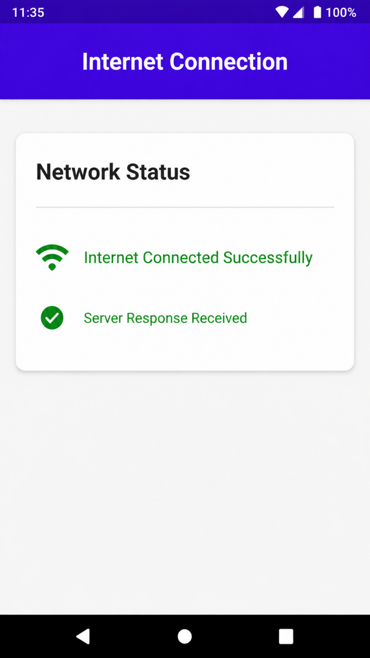

Result
Thus, the Android application was successfully connected to the Internet.

EX.NO : 12 |  | Send Email
DATE:

Aim
To send email using Intent in Android..
Algorithm
- Start Android Studio IDE.
- Create a new Android project.
- Design UI with button.
- Open MainActivity.kt.
- Initialize button using findViewById().
- Implement button click event.
- Create email Intent.
- Set email address, subject, and message.
- Launch email application using Intent.
- Run the application.
- Verify email sending functionality..
Code
activity_main.xml
<LinearLayout xmlns:android="http://schemas.android.com/apk/res/android"
android:layout_width="match_parent"
android:layout_height="match_parent"
android:gravity="center">

<Button
android:id="@+id/btnEmail"
android:layout_width="wrap_content"
android:layout_height="wrap_content"
android:text="Send Email"/>
</LinearLayout>

MainActivity.kt

package com.example.sendemail

import android.content.Intent
import android.os.Bundle
import android.widget.Button
import androidx.appcompat.app.AppCompatActivity

class MainActivity : AppCompatActivity() {

override fun onCreate(savedInstanceState: Bundle?) {
super.onCreate(savedInstanceState)
setContentView(R.layout.activity_main)

val btnEmail = findViewById<Button>(R.id.btnEmail)

btnEmail.setOnClickListener {

val intent = Intent(Intent.ACTION_SEND)

intent.type = "message/rfc822"

intent.putExtra(
Intent.EXTRA_EMAIL,
arrayOf("test@gmail.com")
)

intent.putExtra(
Intent.EXTRA_SUBJECT,
"Android Email"
)

intent.putExtra(
Intent.EXTRA_TEXT,
"Hello from Android App"
)

startActivity(intent)
}
}
}

Output

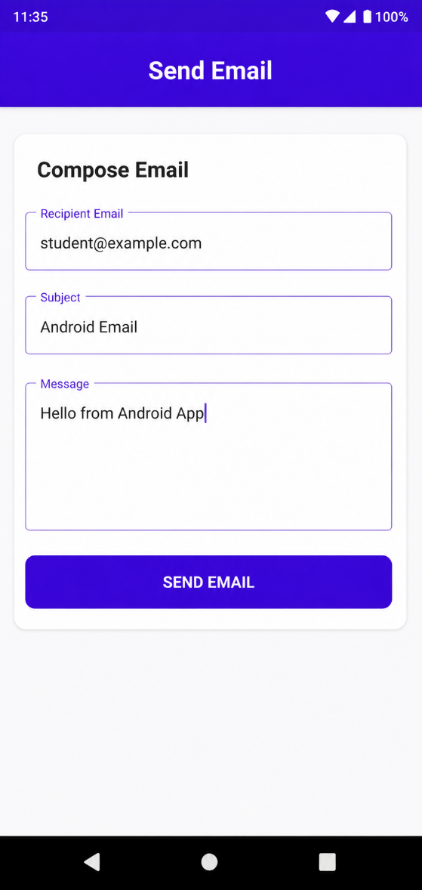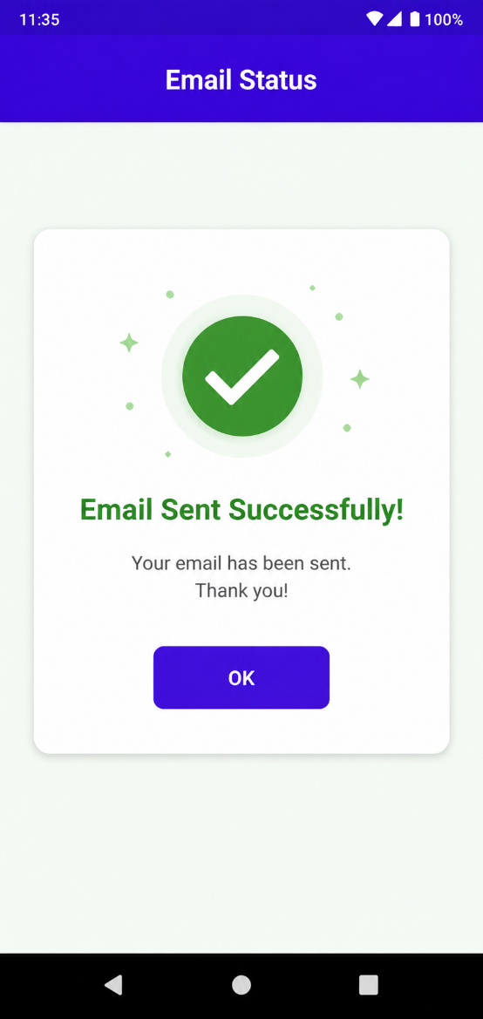

Result
Thus, email sending using Intent was successfully implemented.

EX.NO : 13 |  | Repository Pattern and WorkManager
DATE:

Aim
To implement Repository Pattern and WorkManager in Android.
Algorithm
- Start Android Studio IDE.
- Create a new Android project.
- Add WorkManager dependency.
- Create Worker class.
- Override doWork() method.
- Create Repository class.
- Create WorkRequest object.
- Enqueue background task using WorkManager.
- Execute background process.
- Run the application.
- Verify WorkManager execution.
Code
activity_main.xml

<?xml version="1.0" encoding="utf-8"?>

<ScrollView xmlns:android="http://schemas.android.com/apk/res/android"
android:layout_width="match_parent"
android:layout_height="match_parent"
android:background="#F5F5F5">

<LinearLayout
android:layout_width="match_parent"
android:layout_height="wrap_content"
android:orientation="vertical"
android:padding="16dp">

<TextView
android:layout_width="match_parent"
android:layout_height="60dp"
android:gravity="center"
android:text="Repository & WorkManager"
android:textColor="#FFFFFF"
android:textSize="22sp"
android:textStyle="bold"
android:background="#3F51B5" />

<LinearLayout
android:layout_width="match_parent"
android:layout_height="wrap_content"
android:orientation="horizontal"
android:gravity="center"
android:layout_marginTop="16dp">

<Button
android:id="@+id/btnRefresh"
android:layout_width="wrap_content"
android:layout_height="wrap_content"
android:text="Refresh Users" />

<Button
android:id="@+id/btnSync"
android:layout_width="wrap_content"
android:layout_height="wrap_content"
android:text="Start Sync"
android:layout_marginLeft="12dp" />
</LinearLayout>

<TextView
android:id="@+id/tvStatus"
android:layout_width="match_parent"
android:layout_height="wrap_content"
android:text="Status: Waiting for background sync"
android:textSize="17sp"
android:textColor="#2E7D32"
android:layout_marginTop="16dp"
android:padding="12dp"
android:background="#E8F5E9" />

<TextView
android:id="@+id/tvUsers"
android:layout_width="match_parent"
android:layout_height="wrap_content"
android:textSize="17sp"
android:layout_marginTop="16dp"
android:lineSpacingExtra="8dp" />

</LinearLayout>

</ScrollView>

MainActivity.kt

package com.example.workmanager

import android.content.Context
import android.os.Bundle
import android.widget.Button
import android.widget.TextView
import androidx.appcompat.app.AppCompatActivity
import androidx.work.OneTimeWorkRequestBuilder
import androidx.work.WorkManager
import androidx.work.Worker
import androidx.work.WorkerParameters

data class User(
val name: String,
val email: String,
val phone: String,
val synced: Boolean
)

class UserRepository {

fun getUsers(): List<User> {
return listOf(
User("John Doe", "john@example.com", "555-1234", true),
User("Jane Smith", "jane@example.com", "555-5678", false),
User("Bob Johnson", "bob@example.com", "555-9012", true),
User("New User", "new@example.com", "123-456-7890", false)
)
}
}

class SyncWorker(
context: Context,
params: WorkerParameters
) : Worker(context, params) {

override fun doWork(): Result {
println("Background sync task running")
return Result.success()
}
}

class MainActivity : AppCompatActivity() {

private val repository = UserRepository()

override fun onCreate(savedInstanceState: Bundle?) {
super.onCreate(savedInstanceState)

setContentView(R.layout.activity_main)

val btnRefresh = findViewById<Button>(R.id.btnRefresh)
val btnSync = findViewById<Button>(R.id.btnSync)
val tvStatus = findViewById<TextView>(R.id.tvStatus)
val tvUsers = findViewById<TextView>(R.id.tvUsers)

btnRefresh.setOnClickListener {
val users = repository.getUsers()

var output = ""

for (user in users) {
output += """
${user.name}
${user.email}
${user.phone}
Synced: ${if (user.synced) "Yes" else "No"}

""".trimIndent() + "\n\n"
}

tvUsers.text = output
tvStatus.text = "Users refreshed from repository!"
}

btnSync.setOnClickListener {
val workRequest =
OneTimeWorkRequestBuilder<SyncWorker>().build()

WorkManager
.getInstance(this)
.enqueue(workRequest)

tvStatus.text = "WorkManager background sync started!"
}
}
}

Output

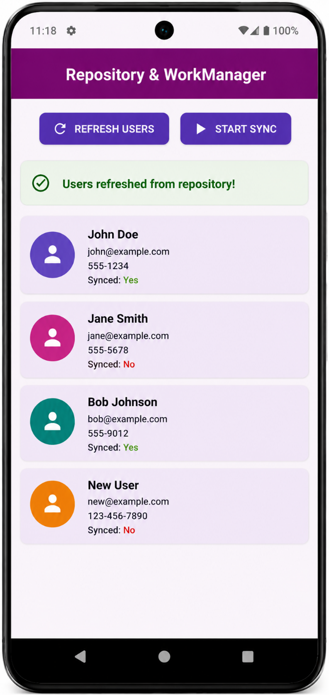

Result
Thus, Repository Pattern and WorkManager were successfully implemented.

EX.NO : 14 |  | App UI Design
DATE:

Aim
To design attractive Android user interface using XML layouts.
Algorithm
- Start Android Studio IDE.
- Create a new Android project.
- Add WorkManager dependency.
- Create Worker class.
- Override doWork() method.
- Create Repository class.
- Create WorkRequest object.
- Enqueue background task using WorkManager.
- Execute background process.
- Run the application.
- Verify WorkManager execution.
Code
activity_main.xml
<?xml version="1.0" encoding="utf-8"?>

<ScrollView xmlns:android="http://schemas.android.com/apk/res/android"
android:layout_width="match_parent"
android:layout_height="match_parent"
android:background="#121212">

<LinearLayout
android:layout_width="match_parent"
android:layout_height="wrap_content"
android:orientation="vertical"
android:padding="20dp">

<TextView
android:layout_width="wrap_content"
android:layout_height="wrap_content"
android:text="Spotify"
android:textColor="#1DB954"
android:textSize="36sp"
android:textStyle="bold" />

<TextView
android:layout_width="wrap_content"
android:layout_height="wrap_content"
android:text="Good Evening"
android:textColor="#FFFFFF"
android:textSize="24sp"
android:textStyle="bold"
android:layout_marginTop="20dp" />

<TextView
android:layout_width="wrap_content"
android:layout_height="wrap_content"
android:text="Recently Played"
android:textColor="#B3B3B3"
android:textSize="18sp"
android:layout_marginTop="8dp" />

<!-- Song 1 -->
<LinearLayout
android:layout_width="match_parent"
android:layout_height="80dp"
android:orientation="horizontal"
android:gravity="center_vertical"
android:background="#1E1E1E"
android:padding="12dp"
android:layout_marginTop="20dp">

<View
android:layout_width="55dp"
android:layout_height="55dp"
android:background="#1DB954" />

<LinearLayout
android:layout_width="0dp"
android:layout_height="wrap_content"
android:layout_weight="1"
android:orientation="vertical"
android:layout_marginLeft="15dp">

<TextView
android:layout_width="wrap_content"
android:layout_height="wrap_content"
android:text="Dream Beats"
android:textColor="#FFFFFF"
android:textSize="18sp"
android:textStyle="bold" />

<TextView
android:layout_width="wrap_content"
android:layout_height="wrap_content"
android:text="Chill Music"
android:textColor="#B3B3B3"
android:textSize="14sp" />
</LinearLayout>

<TextView
android:layout_width="wrap_content"
android:layout_height="wrap_content"
android:text="▶"
android:textColor="#1DB954"
android:textSize="28sp" />
</LinearLayout>

<!-- Song 2 -->
<LinearLayout
android:layout_width="match_parent"
android:layout_height="80dp"
android:orientation="horizontal"
android:gravity="center_vertical"
android:background="#1E1E1E"
android:padding="12dp"
android:layout_marginTop="12dp">

<View
android:layout_width="55dp"
android:layout_height="55dp"
android:background="#FF9800" />

<LinearLayout
android:layout_width="0dp"
android:layout_height="wrap_content"
android:layout_weight="1"
android:orientation="vertical"
android:layout_marginLeft="15dp">

<TextView
android:layout_width="wrap_content"
android:layout_height="wrap_content"
android:text="Night Vibes"
android:textColor="#FFFFFF"
android:textSize="18sp"
android:textStyle="bold" />

<TextView
android:layout_width="wrap_content"
android:layout_height="wrap_content"
android:text="Lo-fi Playlist"
android:textColor="#B3B3B3"
android:textSize="14sp" />
</LinearLayout>

<TextView
android:layout_width="wrap_content"
android:layout_height="wrap_content"
android:text="▶"
android:textColor="#1DB954"
android:textSize="28sp" />
</LinearLayout>

<!-- Song 3 -->
<LinearLayout
android:layout_width="match_parent"
android:layout_height="80dp"
android:orientation="horizontal"
android:gravity="center_vertical"
android:background="#1E1E1E"
android:padding="12dp"
android:layout_marginTop="12dp">

<View
android:layout_width="55dp"
android:layout_height="55dp"
android:background="#03A9F4" />

<LinearLayout
android:layout_width="0dp"
android:layout_height="wrap_content"
android:layout_weight="1"
android:orientation="vertical"
android:layout_marginLeft="15dp">

<TextView
android:layout_width="wrap_content"
android:layout_height="wrap_content"
android:text="Morning Energy"
android:textColor="#FFFFFF"
android:textSize="18sp"
android:textStyle="bold" />

<TextView
android:layout_width="wrap_content"
android:layout_height="wrap_content"
android:text="Workout Mix"
android:textColor="#B3B3B3"
android:textSize="14sp" />
</LinearLayout>

<TextView
android:layout_width="wrap_content"
android:layout_height="wrap_content"
android:text="▶"
android:textColor="#1DB954"
android:textSize="28sp" />
</LinearLayout>

<!-- Now Playing Card -->
<LinearLayout
android:layout_width="match_parent"
android:layout_height="90dp"
android:orientation="horizontal"
android:gravity="center_vertical"
android:padding="15dp"
android:background="#1DB954"
android:layout_marginTop="30dp">

<TextView
android:layout_width="0dp"
android:layout_height="wrap_content"
android:layout_weight="1"
android:text="Now Playing: Dream Beats"
android:textColor="#000000"
android:textSize="18sp"
android:textStyle="bold" />

<TextView
android:layout_width="wrap_content"
android:layout_height="wrap_content"
android:text="⏸"
android:textColor="#000000"
android:textSize="28sp" />
</LinearLayout>

</LinearLayout>

</ScrollView>

MainActivity.kt

package com.example.appuidesign

import android.os.Bundle
import androidx.appcompat.app.AppCompatActivity

class MainActivity : AppCompatActivity() {
override fun onCreate(savedInstanceState: Bundle?) {
super.onCreate(savedInstanceState)
setContentView(R.layout.activity_main)
}
}

Output

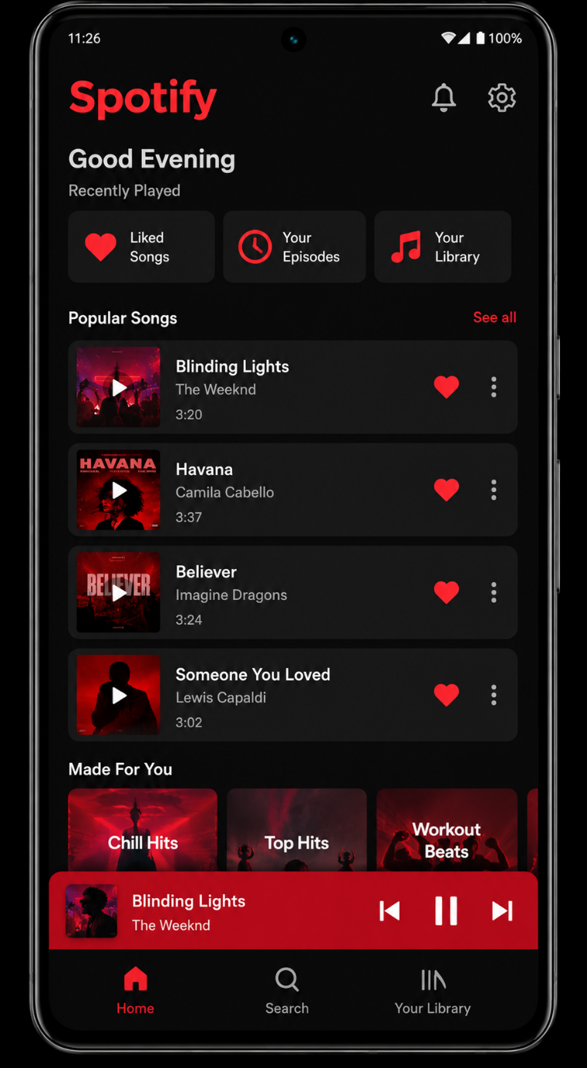

Result
Thus, attractive Android UI design was successfully implemented using XML layouts.

