# EXNO : 1 Web page for college using href, list and frame tags Home.html

<html>

<head>

<title>Home</title>

</head>

<frameset rows="30%,*">

<frame src="frame1.html">

<frameset cols="25%,*">

<frame src="frame2.html" name="f2">

<frame src="frame3.html" name="f3">

</frameset>

</html>

# Frame1.html

<html>

<head><title>frame1</title>

</head>

<body bgcolor="blue">

<h1><img src="H:\IV IT B 2017-21\WP 2018 R\lab\1a\logo.jpg" ALIGN="left"/>

<h1 style="color.green;font-size:15pt">

<marquee bgcolor="#cccccc" loop="-1" scrollamount="6" width="100%"> Adhiyamaan College of Engineering (Autonomous)</marquee>

</h1>

</body>

</html>

# Logo.html

<html>

<head><title>LOGO</title></head>

<body bgcolor="magenta">

<h1><img src="H:\IV IT B 2017-21\WP 2018 R\lab\1a\logo.jpg" ALIGN="right"/>

<center>Adhiyamaan College of Engineering (Autonomous)<br/> Dr.M.G.R.Nagar, Hosur,<br/>

Krishnagiri District, Tamil Nadu,<br/> India. Pin:635 109<br/></center></h1>

</body>

</html>

# Frame2.html

<html>

<head><title>frame2</title>

<style type="text/css"> h1 { font-size:25pt;color:pink;

}

</style>

</head>

<body bgcolor="red">

<h3>

<a href="COURSES.html" target=f3>COURSES</a><br><br>

<a href="dept.html" target=f3>DEPARTMENTS</a></br><br>

<a href="ad.html" target=f3>FACILITIES</a><br><br>

<a href="lib.html" target=f3>LIBRARY</a><br><br>

<a href="COE.html" target=f3>COE</a><br><br>

</h1>

</body>

</html>

# Frame3.html

<html>

<head><title>1st page</title>

<link rel="stylesheet" type="text/css" href="C:\Documents and Settings\Administrator\Desktop\ab\css1.css"/>

</head>

<body bgcolor="tan">

<h1> AHIYAMAAN COLLEGE OF ENGINEERING (AUTONOMOUS). </h1></br>

<h2> WEL COMES YOU ALL</h2>

<h3>

<p><i>Adhiyamaan College of Engineering is one of the educational institutions developed by Adhiyamaan Educational & Research Institution - a trust, which was started in the year 1987-1988 to cater the needs of the nation in the development of technocrats and to provide facilities for educating and training men and women to meet the entrepreneurial and management needs. The management has created adequate infrastructural facilities and sufficient funds and is keen on developing the institution for higher education.</i></p>

<p><i>The Institution is situated 6 kms from Hosur bus stand and railway station. The Institution is well connected to three major Railway Junctions viz., Hosur, Jolarpet and Bangalore.</i></p>

</h3>

</body>

</html>

# COURSES.html

<html>

<head><title>intro</title>

</head>

<font color=red>

<p><b><h1>

Welcome to Adhiyamaan College of Engineering - Affiliated to Anna University</br>

COURSES OFFERED

</p></b></h1><br>

<br></font>

<ol type=1>

<ol>1. B. E., Mechanical Engineering </ol>

<ol>2. B. E., Computer Science & Engineering</ol>

<ol>3. B. E., Electronics and Communication Engineering</ol>

<ol>4. B. E., Electrical and Electronics Engineering</ol>

<ol>5. B. E., Electronics and Instrumentation Engineering</ol>

<ol>6. B. E., Civil Engineering</ol>

<ol>7. B. E., Bio-Medical Engineering</ol>

<ol>8. B. E., Aeronautical Engineering</ol>

<ol>9. B. Tech., Bio-Technology</ol>

<ol>10. B. Tech., Information Technology</ol>

<ol>11. B. Tech., Chemical Engineering</ol>

<ol>12. B. Arch.,( Architecture)

</ol> </ol>

</body>

</html>

# Dept.html

<html>

<head><title>Departments</title>

</head>

<body>

<div align="center">

<table border=2>

<tr>

<th>Dept code</th>

<th>Dept name</th>

</tr>

<tr>

<td>01</td>

<td>CSE</td>

</tr>

<tr>

<td>02</td>

<td>ECE</td>

</tr>

<tr>

<td>03</td>

<td>EEE</td>

</tr> <tr>

<td>04</td>

<td>IT</td>

</tr>

<tr>

<td>05</td>

<td>MECH</td>

</tr>

<tr>

<td>06</td>

<td>AERO</td>

</tr>

</table>

</div>

</body>

</html>

# Ad.html

<html>

<head><title>ADDRESS</title>

</head>

<font color=GREEN>

Name: Adhiyamaan College of Engineering </br> Location:HOSUR

</font>

<ol type=1>

<ol>1. LIBRARY </ol>

<ol>2. SPORTS</ol>

<ol>3. HOSTEL</ol>

<ol>4. TRANSPORT</ol>

<ol>5. BANK FACILITY</ol>

</body>

</html>

# Lib.html

<html>

<head><title>ADDRESS</title>

</head>

<body>

<p>The Central Library has been built to International Standards. It spread over to an area of 4500 sq. m. with ground plus four floors. The library is equipped with a Reference section it could accommodated around 500 students, Digital library, Audio Visual Section, Journal Section, conference room, Research Scholar Section, Newspaper and Magazine Section, and Reprography Section. It has numerous specialized collection of Books, Journals, ASME, ASTM, IEEE-ASPP, Springer, Elsevier, EBSCO Art & Architecture, GREENR - Architecture, J-Gate Engineering, J-Gate Business Management, EMERALD Management, and McGraw Hill.</br>

<P>The library is fully computerized and can be accessed using the OPAC (Online Public Access Catalogue) system which enables the students to search the required books they specifying the author, title, subject and keywords. It facilitates the users to reserve the books they need, and also updates on the status of a particular book and that of the User.</br>

<p>The library has been actively conducting NPTEL Video courses for students every evening. It has also made DELNET - Institution Membership and Inter Library loan available for the students.</br>

</body>

</html>

# COE.html

<html>

<head></head>

<body>

<h1>

Contact Address for More Details:</h1></br>

<h2>

The Controller of Examination,</br> Adhiyamaan College of Engineering,</br>

Dr.M.G.R Nagar, Hosur, Krishnagiri Dt, Tamilnadu- 635109.</h2>

</body>

</html>

# OUTPUTS:

**Home.html**

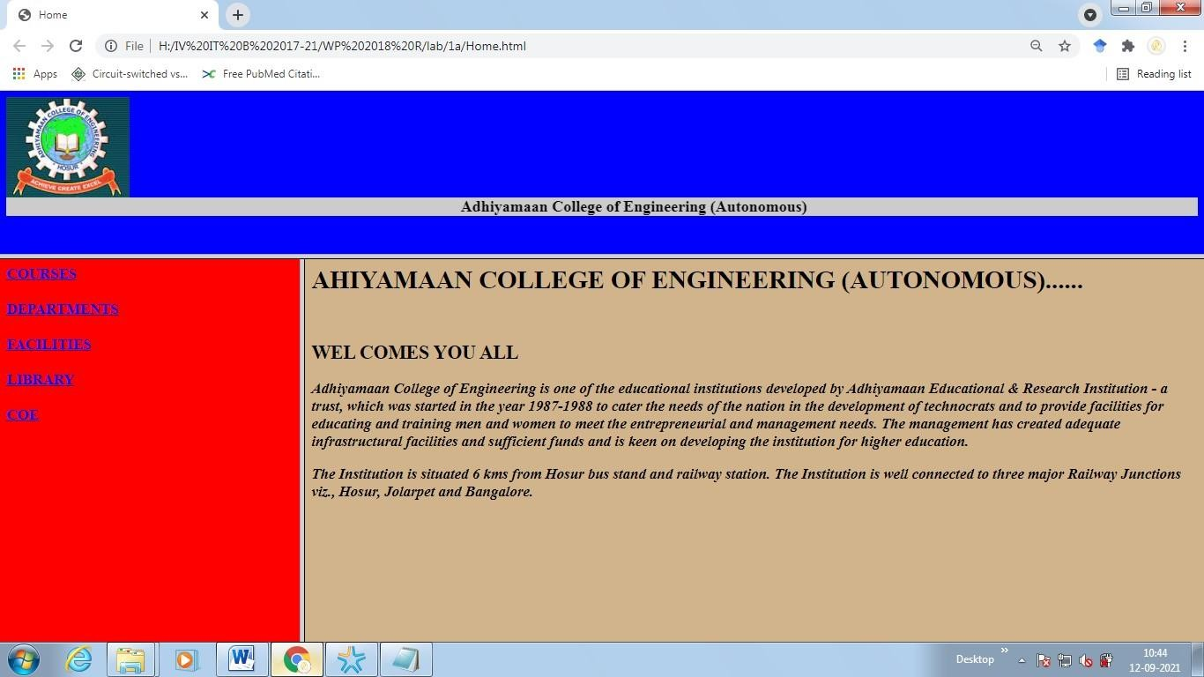

# COURSES.html

**Dept.html**

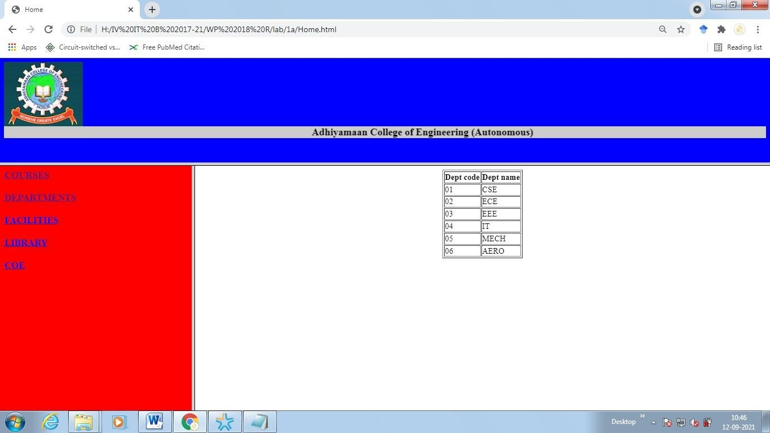

# Ad.html

**Lib.html**

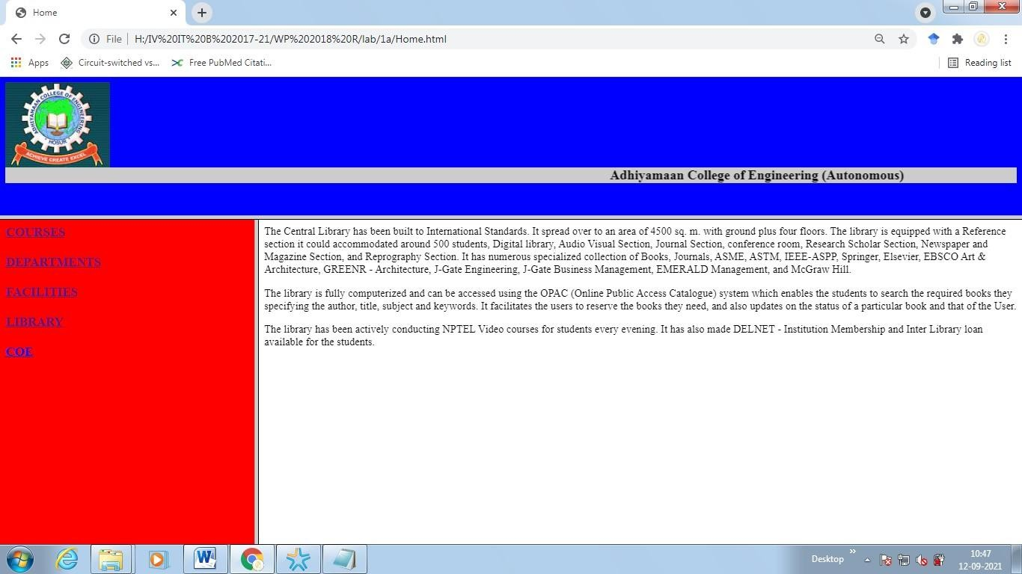

# COE.html

**EX NO : 2 Class timetable using table tag.**

# time table.html

<!DOCTYPE html>

<html>

<body>

<h1>TIME TABLE</h1>

<table border="5" cellspacing="0" align="center">

<!--<caption>Timetable</caption>-->

<tr>

<td align="center" height="50" width="100"><br>

<b>Day/Period</b></br>

</td>

<td align="center" height="50" width="100">

<b>I<br>9:30-10:20</b>

</td>

<td align="center" height="50" width="100">

<b>II<br>10:20-11:10</b>

</td>

<td align="center" height="50" width="100">

<b>III<br>11:10-12:00</b>

width="100">

</td>

<td align="center" height="50"

<b>12:00-12:40</b>

</td>

<td align="center" height="50" width="100">

<b>IV<br>12:40-1:30</b>

</td>

<td align="center" height="50" width="100">

<b>V<br>1:30-2:20</b>

</td>

<td align="center" height="50" width="100">

<b>VI<br>2:20-3:10</b>

</td>

<td align="center" height="50" width="100">

<b>VII<br>3:10-4:00</b>

</tr>

<tr>

</td>

<td align="center" height="50">

<b>Monday</b></td>

<td align="center" height="50">Eng</td>

<td align="center" height="50">Mat</td>

<td align="center" height="50">Che</td>

<td rowspan="6" align="center" height="50">

<h2>L<br>U<br>N<br>C<br>H</h2>

</td>

<td colspan="3" align="center"

</tr>

<tr>

height="50">LAB</td>

<td align="center" height="50">Phy</td>

<td align="center" height="50">

<b>Tuesday</b>

</td>

</tr>

<tr>

</td>

<td colspan="3" align="center" height="50">LAB

<td align="center" height="50">Eng</td>

<td align="center" height="50">Che</td>

<td align="center" height="50">Mat</td>

<td align="center" height="50">SPORTS</td>

<td align="center" height="50">

<b>Wednesday</b>

</td>

<td align="center" height="50">Mat</td>

<td align="center" height="50">phy</td>

<td align="center" height="50">Eng</td>

<td align="center" height="50">Che</td>

<td colspan="3" align="center" height="50">LIBRARY

</td>

</tr>

<tr>

<td align="center" height="50">

<b>Thursday</b>

</td>

<td align="center" height="50">Phy</td>

</td>

</tr>

<tr>

<td align="center" height="50">Eng</td>

<td align="center" height="50">Che</td>

<td colspan="3" align="center" height="50">LAB

<td align="center" height="50">Mat</td>

<td align="center" height="50">

<b>Friday</b>

</td>

</tr>

<tr>

</td>

<td colspan="3" align="center" height="50">LAB

<td align="center" height="50">Mat</td>

<td align="center" height="50">Che</td>

<td align="center" height="50">Eng</td>

<td align="center" height="50">Phy</td>

<td align="center" height="50">

<b>Saturday</b>

</td>

<td align="center" height="50">Eng</td>

<td align="center" height="50">Che</td>

<td align="center" height="50">Mat</td>

<td colspan="3" align="center" height="50">SEMINAR

</td>

<td align="center" height="50">SPORTS</td>

</tr>

</table>

</body>

</html>

# OUTPUT:

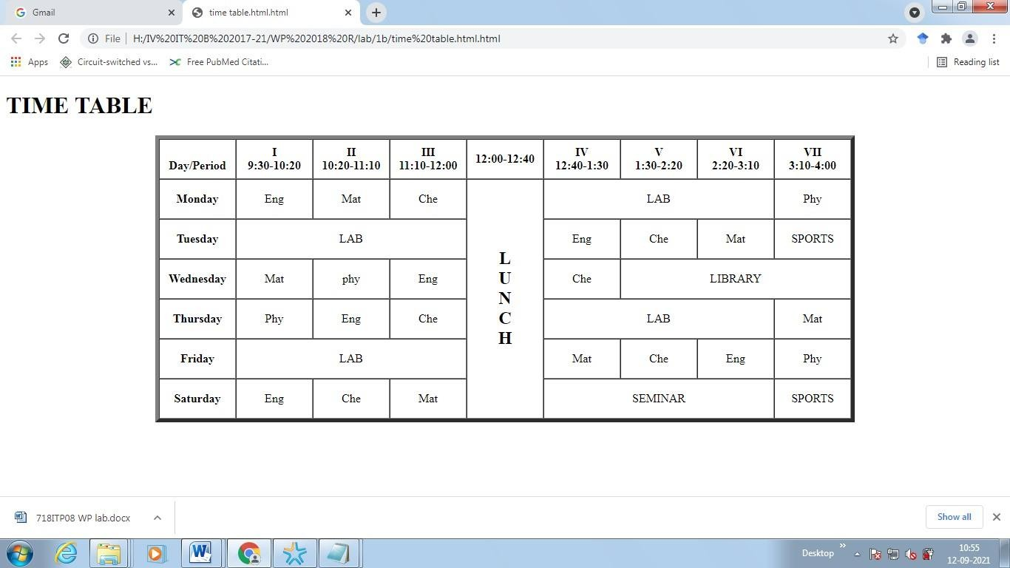

**EX NO : 3 Web page for town Using External, Internal, and Inline CSS**

# Sample.html

<html>

<head>

<style type="text/css"> body

{

background-image: url("L.gpeg"); background- repeat:no-repeat; background-position:center center; background-attachment:fixed;

background-color:pink;

}

a:link { text-decoration:none;color:orange; } a:visited { text-decoration:none;color:red; } a:hover { text-decoration:underline;color:blue; } a:active { text-decoration:underline;color:purple; } h3 { color:green; } .c1{cursor:crosshair}

.c2{cursor:pointer}

.c3{cursor:move}

.c4{cursor:text}

.c5{cursor:wait}

.c6{cursor:help}

</style>

<link rel="stylesheet" type="text/css" href="style.css">

</head>

<body bgcolor="cyan">

<h1 style="color:blue;text-align:center;"> ABOUT HOSUR:: CONCEPT:CSS (Inline, Internal and External) </h1>

<p>Hosur is an industrial city located in the Indian state of Tamil Nadu. </p>

<p class="left">It is located on the bank of the river River Ponnaiyar: Styled by class "Left"</p>

<p class="center">Hosur is home to major industries: Styled by class "Center"</p>

<p class="right">Hosur is my town: Styled by class "Right"</p>

<b>Hosur was known as Chevidapadi in the 10th century: normal Bold</b> <br>

<b id="headline">Hosur was part of Kingdom of Mysore: Bold Text is Styled </b>

<h2><b><a href=" images.html">Click HERE TO VIEW HOSUR IMAGES</a></b></h2>

<h3 class="c1">Hosur experiences a tropical savanna climate: The cursor over this element is plus sign</h3>

<h3 class="c2">The coolest month is January with an average low temperature : The cursor over this element is a pointing hand</h3>

<h3 class="c3">Hosur is an industrial hub :The cursor over this element is a grasping hand</h3>

<h3 class="c4">A variety of fruits and vegetables are cultivated around Hosur. :The cursor over this element is a I bar</h3>

<h3 class="c5">The land is very fertile and there is significant access to fresh water as well as labor.:The cursor over this element is a wait</h3>

<h3 class="c6">National Highway AH43 (NH 44) passes through Hosur connecting it with Bangalore: The cursor over this element is a question mark</h3>

</html>

# style.css

p.left { text- align:left; color:blue; font-family:Cambria; font-size:large; text- indent:20px;

}

p.center {

text-align:center; text- decoration:underline; text- transform:uppercase; letter- spacing:-3px; word-spacing:20px; font-size:larger;

}

p.right { text-align:right; color:red; font- family:Tahoma; font- size:15pt; text- decoration:overline;

font-style:italic;

} b#headline

{ color:orange; font- size:22px; font- family:arial; text- decoration:underline;

}

# Images.html

<html><body>

<h2>HTML Image</h2>

<img src="1.jpg" alt="temple" width="200" height="300">

<img src="2.jpg" alt="ol fort" width="200" height="300">

<img src="3.jpg" alt="old municipal office" width="200" height="300">

<img src="4.jpg" alt="Railway station" width="200" height="300">

<img src="5.jpg" alt="pin code" width="200" height="300">

<img src="6.jpg" alt="ACE,hosur" width="200" height="300">

</body>

</html>

# OUTPUTS:

**Sample.html**

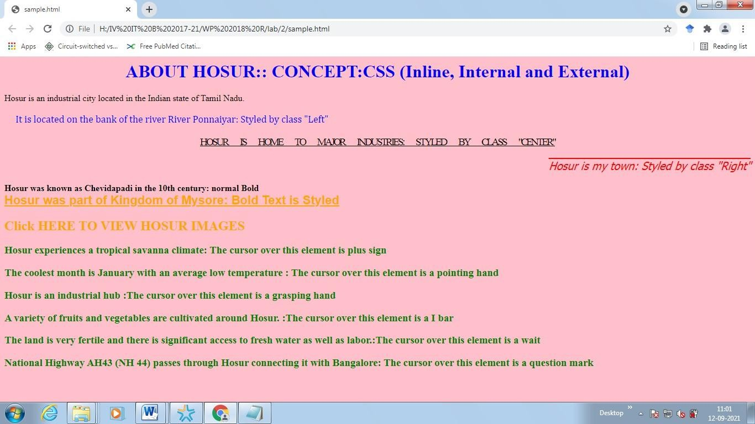

# Images.html

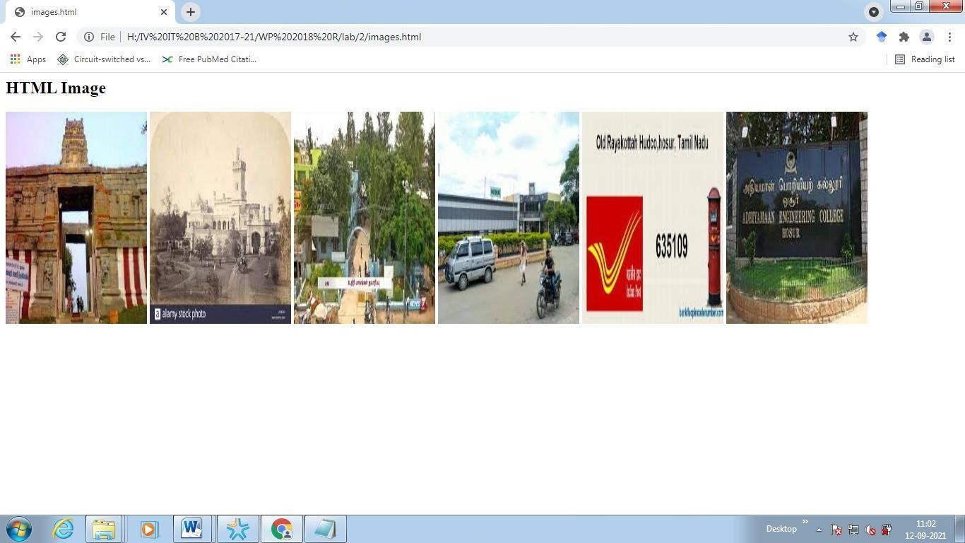

**EX NO 4 Student registration form for job application and validation of**

# the form fields using JavaScript.

**StudentRegistration.html**

<html>

<head>

<script type="text/javascript" src="validate.js"></script>

</head>

<body>

<form action="#" name="StudentRegistration" onsubmit="return(validate());">

<table cellpadding="2" width="20%" bgcolor="99FFFF" align="center" cellspacing="2"> <tr>

<td colspan=2>

<center><font size=4><b>Student Registration Form</b></font></center> </td>

</tr>

<tr>

<td>Name</td>

<td><input type=text name=textnames id="textname" size="30"></td> </tr>

<tr>

<td>College Name</td>

<td><input type="text" name="collegename" id="collegename" size="30"></td>

</tr>

<tr>

<td>University </td>

<td><input type="text" name="University" id="University" size="30"></td>

</tr>

<tr>

<td>Course completed</td>

<td><select name="Course">

<option value="-1" selected>select..</option>

<option value="B.Tech">B.TECH</option>

<option value="MCA">MCA</option>

<option value="MBA">MBA</option>

<option value="BCA">BCA</option>

</select></td>

</tr>

<td>Percentage</td>

<td><input type="text" name="Percentage" id="Percentage" size="30"></td> </tr>

<tr>

<td>Prefred position</td>

<td><select name="position">

<option value="-1" selected>select..</option>

<option value="Software Engineer">Software Engineer</option>

<option value="Testing Engineer">Testing Engineer</option>

<option value="Networking Engineer">Networking Engineer</option>

<option value="Developer">Developer</option>

<option value="others">others</option>

</select></td>

<tr>

<td>DOB</td>

<td><input type="text" name="dob" id="dob" size="30"></td>

</tr>

<tr>

<td>EmailId</td>

<td><input type="text" name="emailid" id="emailid" size="30"></td>

</tr>

<tr>

<td>MobileNo</td>

<td><input type="text" name="mobileno" id="mobileno" size="30"></td> </tr>

<tr>

<td>Gender</td>

<td><input type="radio" name="Gender" value="male" size="10">Male

<input type="radio" name="Gender" value="Female" size="10">Female</td> </tr>

<tr>

<td>Prefred City for job</td>

<td><select name="City">

<option value="-1" selected>select..</option>

<option value="Chennai">Chennai</option>

<option value="Bangalore">Bangalore</option>

<option value="Hydrabad">Hydrabad</option>

<option value="others">others</option>

</select></td>

</tr>

<tr>

<td>Personal Address</td>

<td><input type="text" name="personaladdress" id="personaladdress" size="30"></td>

</tr>

<tr>

<td>State</td>

<td><select Name="State">

<option value="-1" selected>select..</option>

<option value="Tamilnadu">Tamilnadu</option>

<option value="Karnatka">Karnatka</option>

<option value="other">other</option>

</select></td>

</tr>

<tr>

<td>PinCode</td>

<td><input type="text" name="pincode" id="pincode" size="30"></td>

</tr>

<tr>

<td><input type="reset"></td>

<td colspan="2"><input type="submit" value="Submit Form" /></td>

</tr>

</table>

</form>

</body>

</html>

# Validate.js

function validate()

{

if( document.StudentRegistration.textnames.value == "" )

{

alert( "Please provide your Name!" ); document.StudentRegistration.textnames.focus() ; return false;

}

if( document.StudentRegistration.collegename.value == "" )

{

alert( "Please provide your collegename!" ); document.StudentRegistration.collegename.focus() ; return false;

}

if( document.StudentRegistration.University.value == "" )

{

alert( "Please provide your University!" ); document.StudentRegistration.University.focus() ; return false;

}

if( document.StudentRegistration.Course.value == "-1" )

{

alert( "Please provide your Course!" ); return false;

}

if( document.StudentRegistration.Percentage.value == "" || isNaN( document.StudentRegistration.Percentage.value) || document.StudentRegistration.Percentage.value.length != 4 )

{

alert( "Please provide a Percentage in the format ######." ); document.StudentRegistration.Percentage.focus() ; return false;

}

if( document.StudentRegistration.position.value == "-1" )

{

alert( "Please provide your position!" ); document.StudentRegistration.position.focus() ; return false;

} if( document.StudentRegistration.dob.value == "" )

{

alert( "Please provide your DOB!" ); document.StudentRegistration.dob.focus() ; return false;

} var email = document.StudentRegistration.emailid.value; atpos = email.indexOf("@"); dotpos = email.lastIndexOf("."); if (email == "" || atpos < 1 || ( dotpos - atpos < 2 ))

{ alert("Please enter correct email ID") document.StudentRegistration.emailid.focus() ; return false; } if(

document.StudentRegistration.mobileno.value == "" || isNaN( document.StudentRegistration.mobileno.value) || document.StudentRegistration.mobileno.value.length != 10 )

{

alert( "Please provide a Mobile No in the format 123." ); document.StudentRegistration.mobileno.focus() ;

return false;

}

if ( ( StudentRegistration.Gender[0].checked == false ) && ( StudentRegistration.Gender[1].checked == false ) )

{

alert ( "Please choose your Gender: Male or Female" ); return false;

}

if( document.StudentRegistration.City.value == "-1" )

{

alert( "Please provide your City!" ); document.StudentRegistration.City.focus() ; return false;

}

if( document.StudentRegistration.personaladdress.value == "" )

{

alert( "Please provide your Personal Address!" ); document.StudentRegistration.personaladdress.focus() ; return false;

}

if( document.StudentRegistration.State.value == "-1" )

{ alert( "Please provide your Select State!" );

return false;

}

if( document.StudentRegistration.pincode.value == "" || isNaN( document.StudentRegistration.pincode.value) || document.StudentRegistration.pincode.value.length != 6 )

{

alert( "Please provide a pincode in the format ######." ); document.StudentRegistration.pincode.focus() ;

return false; } return( true );

# OUTPUTS:

**StudentRegistration.html**

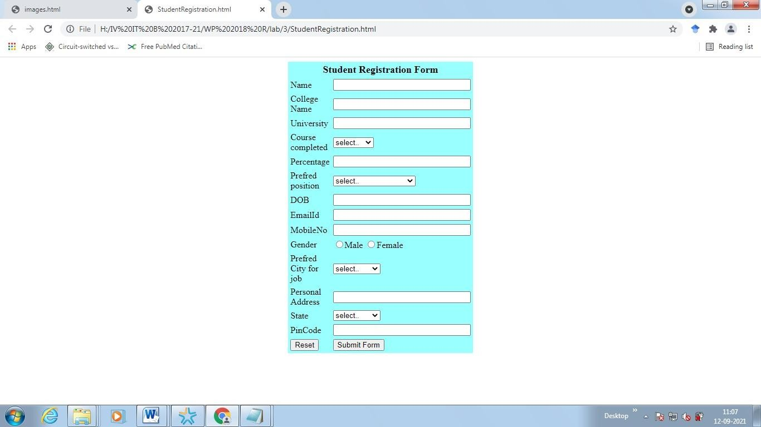

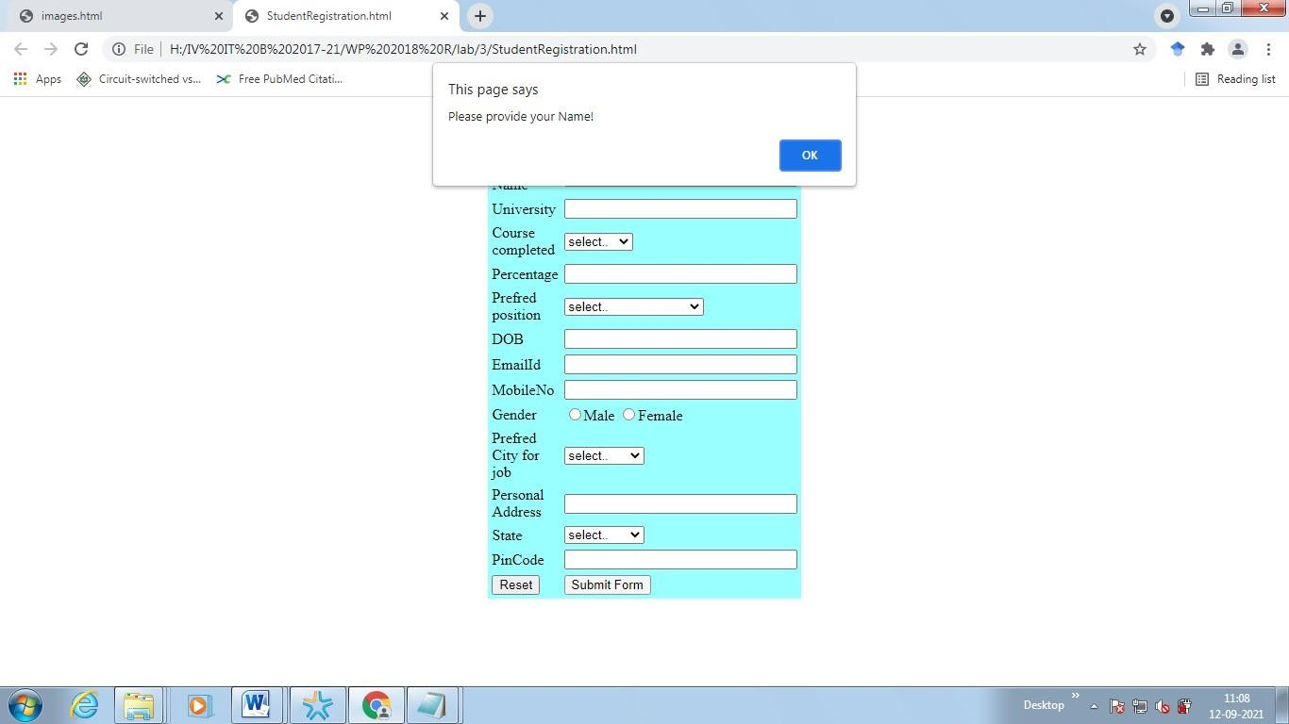

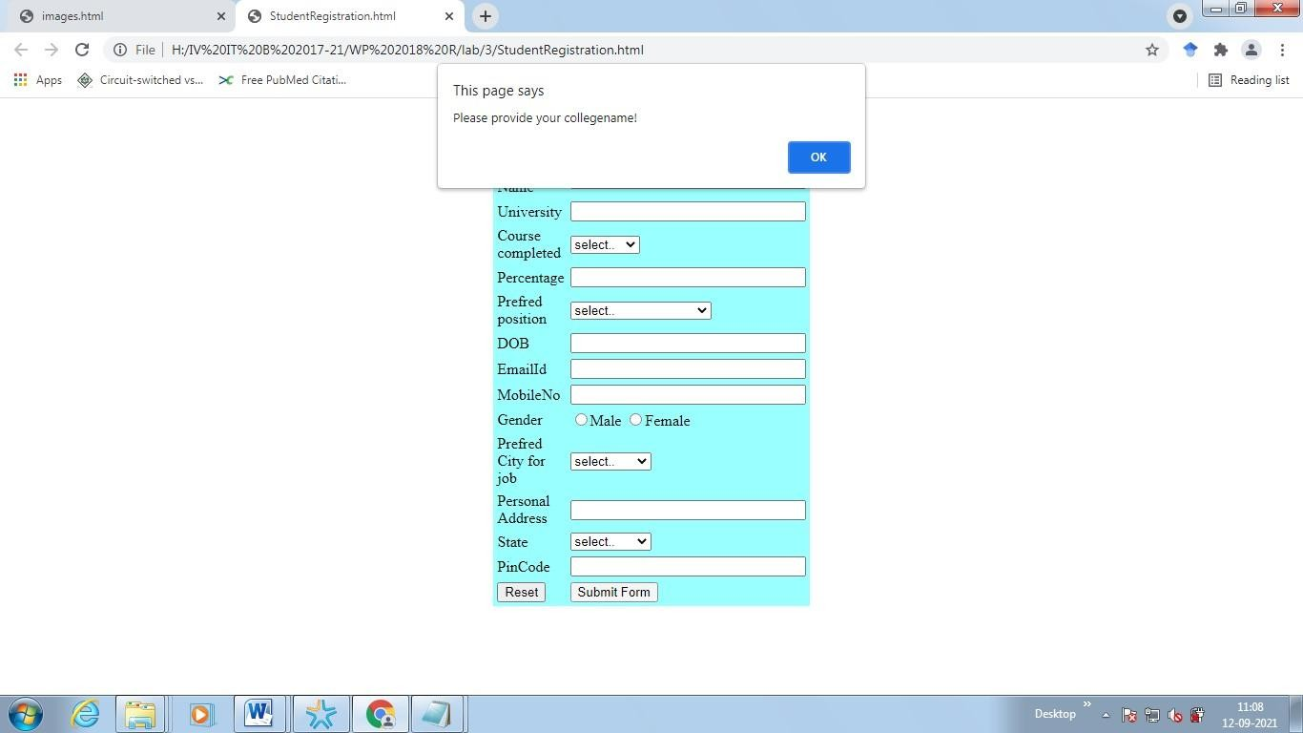

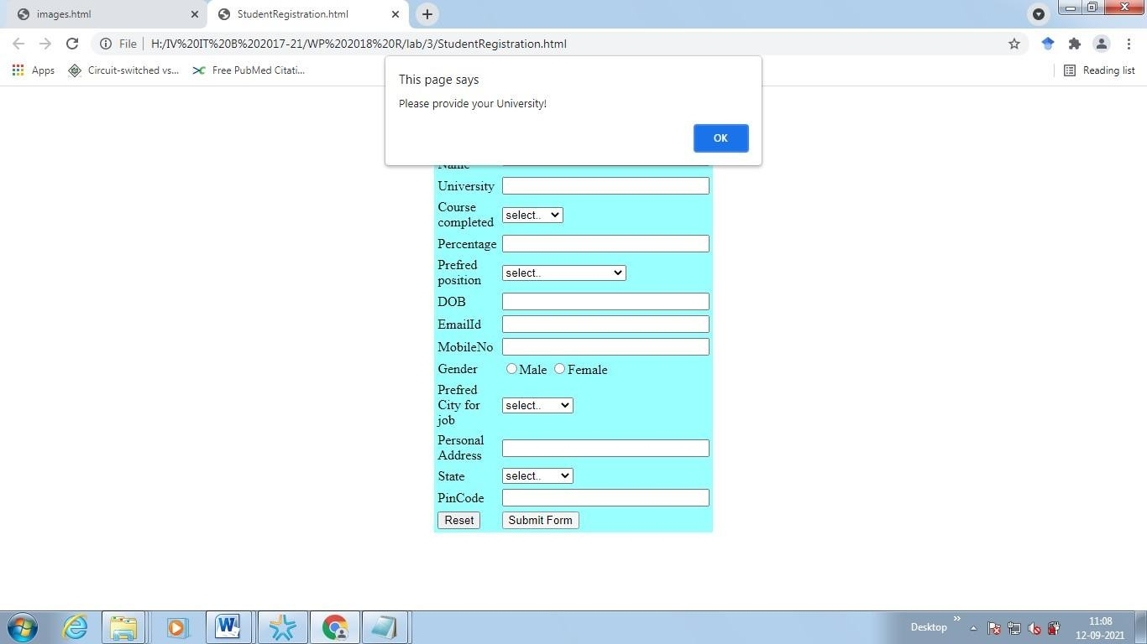

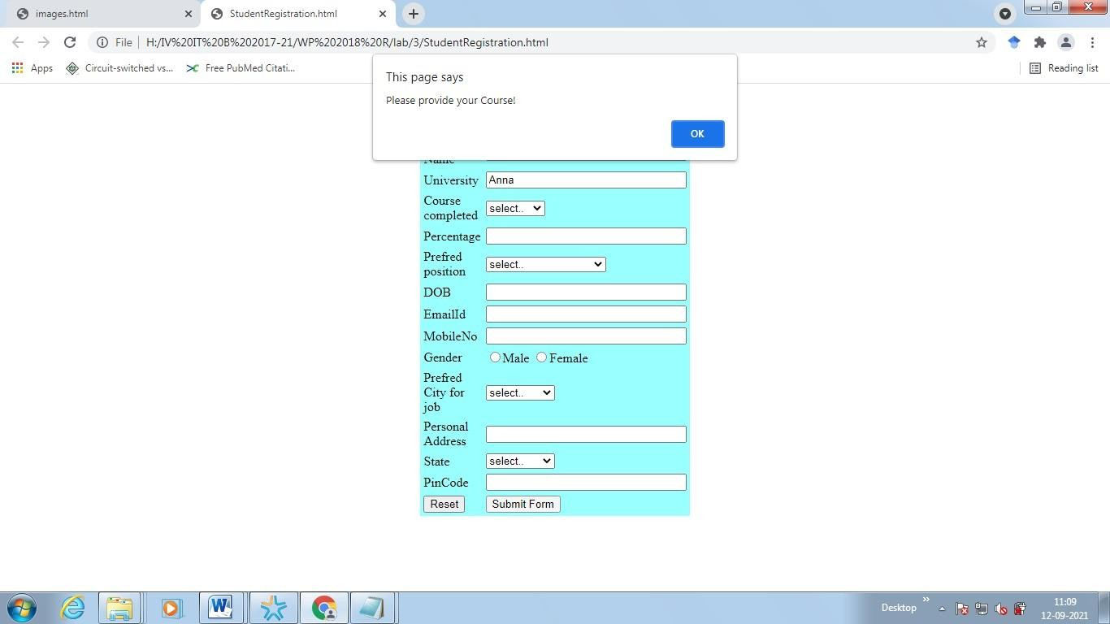



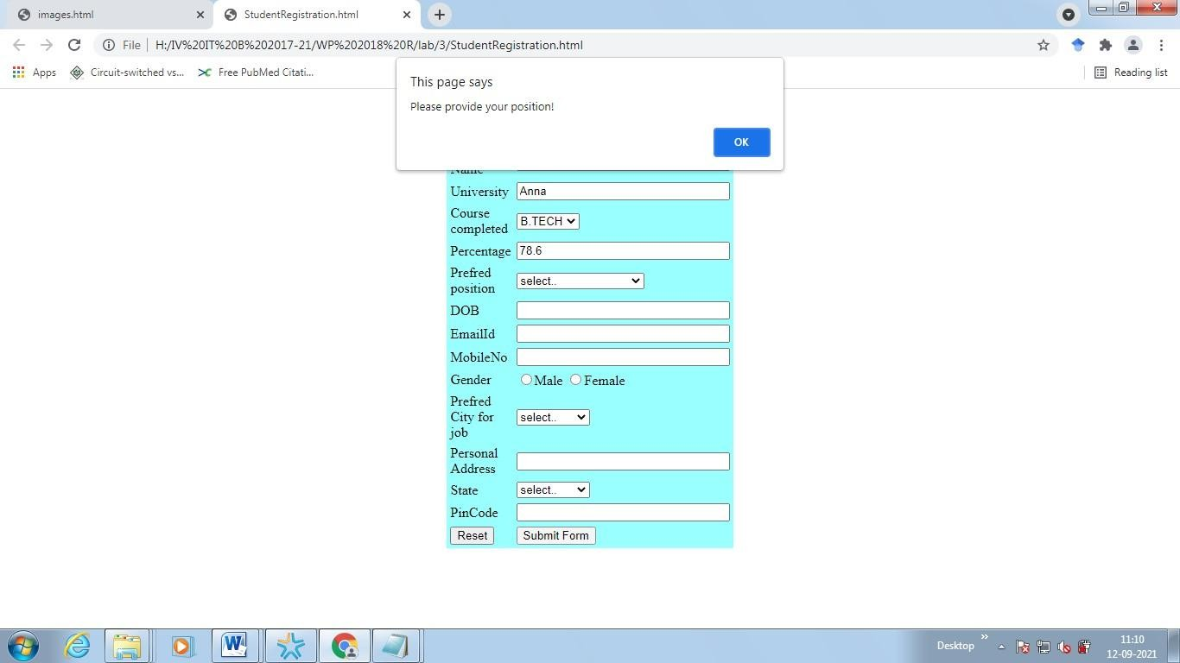

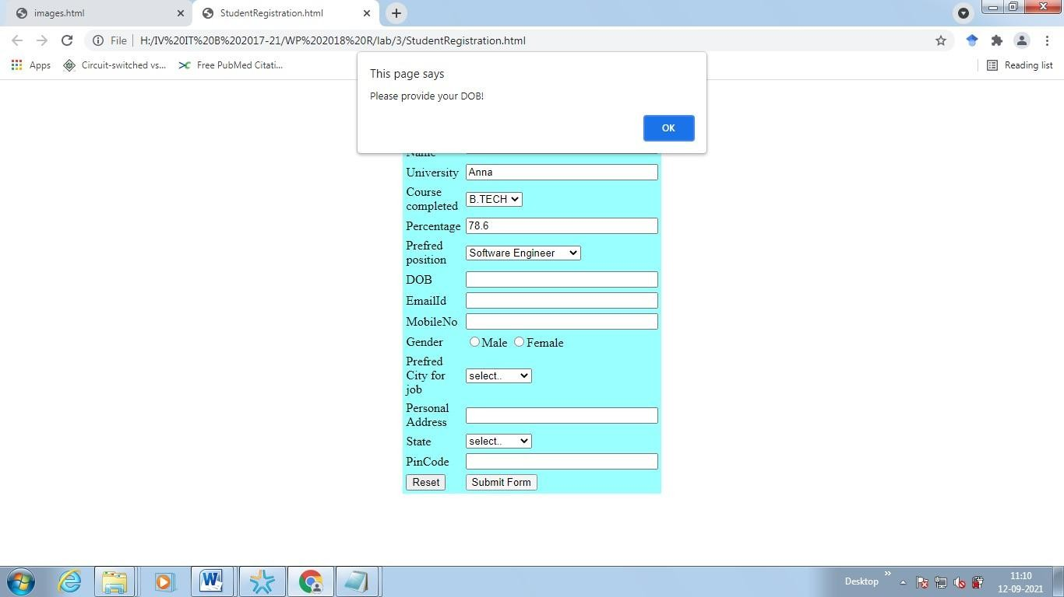

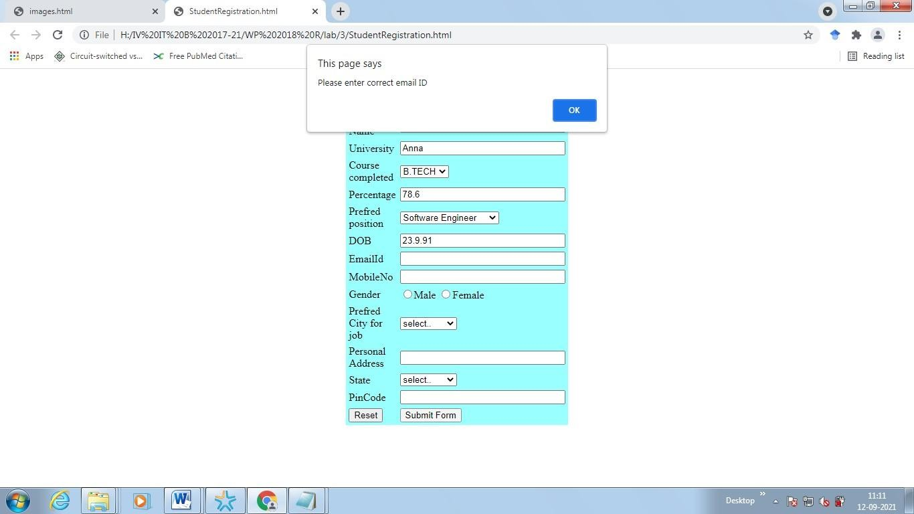

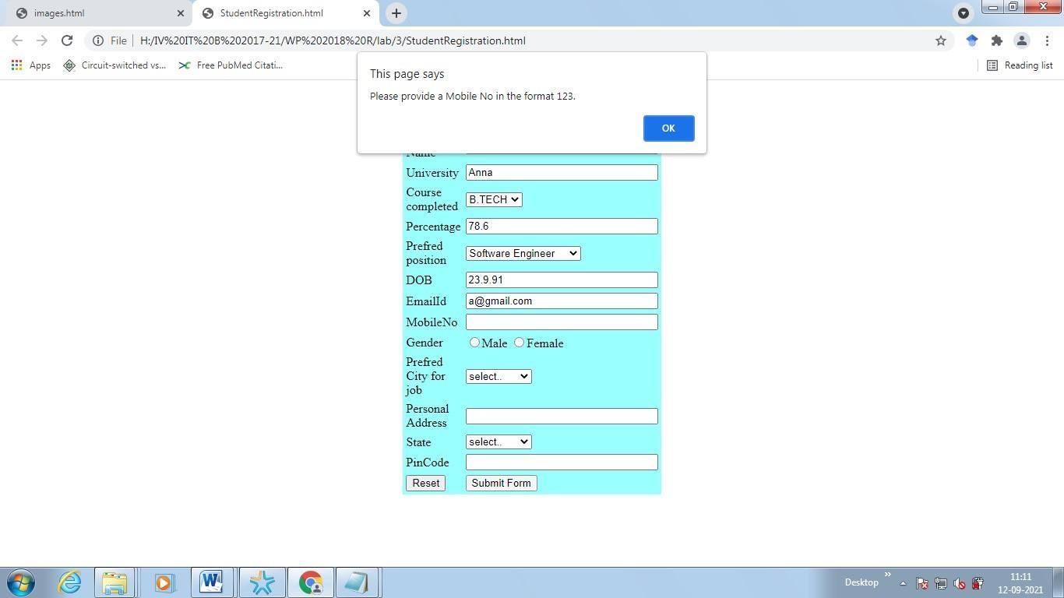

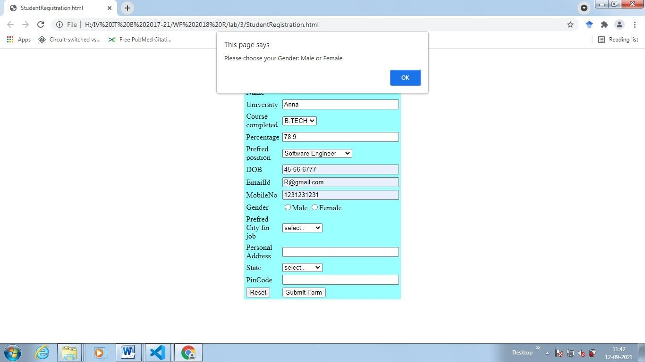

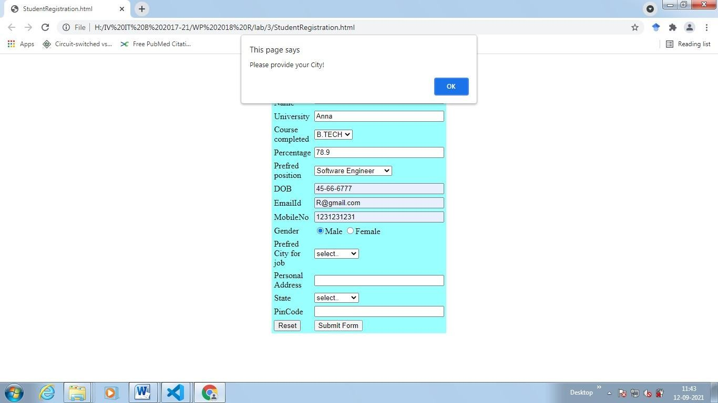

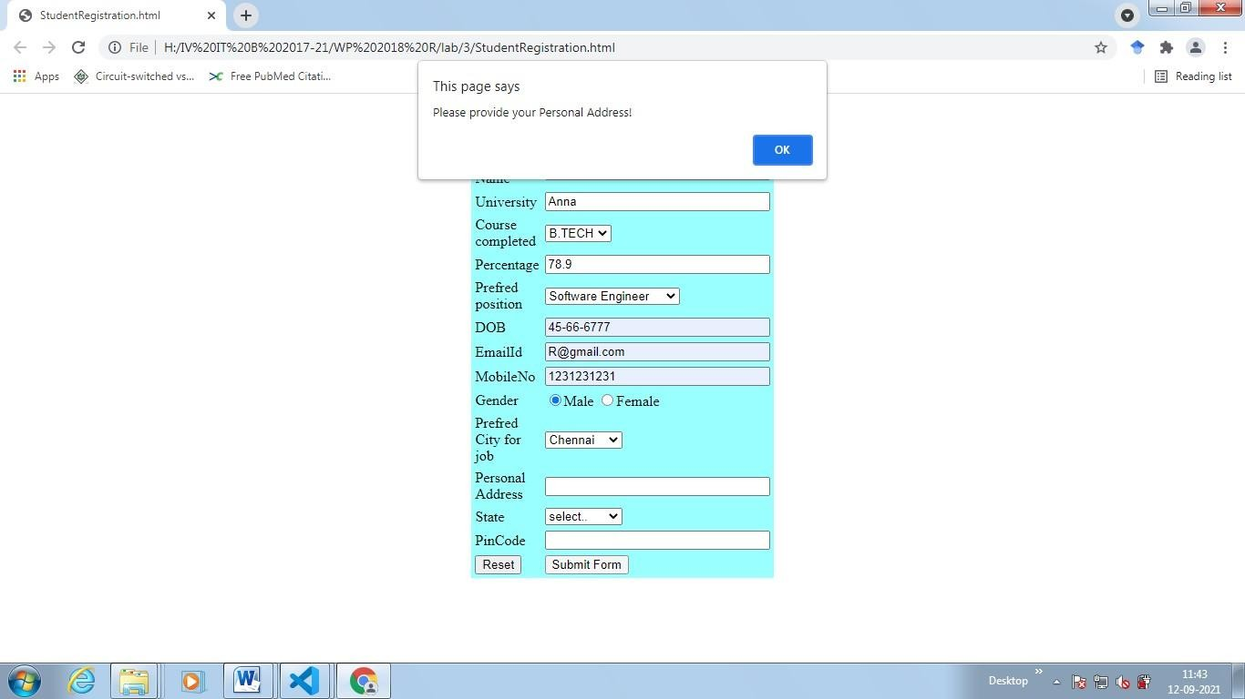

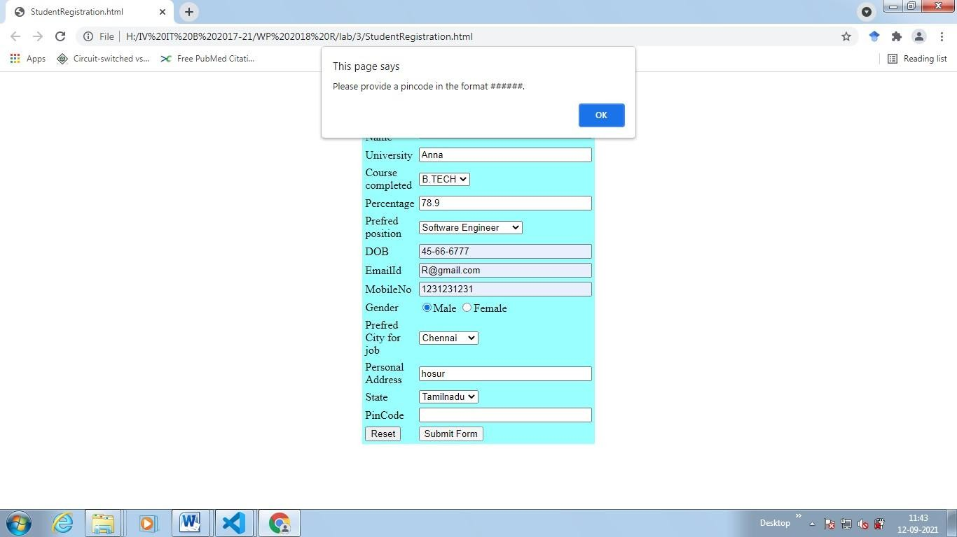

# EX NO: 5 Quiz program with adaptive questions using JavaScript.

**Quiz.html**

<!DOCTYPE html>

<html lang="en">

<head>

<meta charset="utf-8"/>

<title>Quiz</title>

<style>

div#test{ border:#5AB029 3px solid; padding:10px 40px 40px 40px; backgroundcolor:#E5FCE3; width:50%;}

</style>

<h1> <center>Quiz program with adaptive questions using JavaScript</center></h1>

<script type="text/javascript">

// pos is position of where the user in the test or which question they're up to var pos = 0, test, test_status, question, choice, choices, chA, chB, chC, correct = 0; // this is a multidimensional array with 4 inner array elements with 5 elements inside them // if you don't want answers viewable in the code, then you should use PHP and mySQL database var questions = [

["What is 36 + 42", "64", "78", "76", "B"],

["What is 7 x 4?", "21", "27", "28", "C"],

["What is 16 / 4?", "4", "6", "3", "A"],

["What is 8 x 12?", "88", "112", "96", "C"]

];

// this get function is short for the getElementById function function get(x){

return document.getElementById(x);

}

function renderQuestion(){ test = get("test"); if(pos >= questions.length){

test.innerHTML = "<h2>You got "+correct+" of "+questions.length+" questions correct</h2>"; get("test_status").innerHTML = "Test completed"; // resets the variable to allow users to restart the test pos = 0;

correct = 0;

// stops rest of renderQuestion function running when test is completed return false;

}

get("test_status").innerHTML = "Question "+(pos+1)+" of "+questions.length; question = questions[pos][0]; chA = questions[pos][1]; chB = questions[pos][2]; chC = questions[pos][3];

test.innerHTML = "<h3>"+question+"</h3>";

// the += appends to the data we started on the line above test.innerHTML += "<input type='radio' name='choices' value='A'> "+chA+"<br>"; test.innerHTML += "<input type='radio' name='choices' value='B'> "+chB+"<br>"; test.innerHTML += "<input type='radio' name='choices' value='C'> "+chC+"<br><br>"; test.innerHTML += "<button onclick='checkAnswer()'>Submit Answer</button>";

}

function checkAnswer(){

// use getElementsByName because we have an array which it will loop through choices

= document.getElementsByName("choices"); for(var i=0; i<choices.length; i++){ if(choices[i].checked){ choice = choices[i].value;

}

}

// checks if answer matches the correct choice if(choice

== questions[pos][4]){

//each time there is a correct answer this value increases correct++;

}

// changes position of which character user is on pos++;

// then the renderQuestion function runs again to go to next question renderQuestion();

}

window.addEventListener("load", renderQuestion, false);

</script>

</head>

<body>

<h2 id="test_status"></h2>

<div id="test"></div>

</body>

</html>

# OUTPUTS:

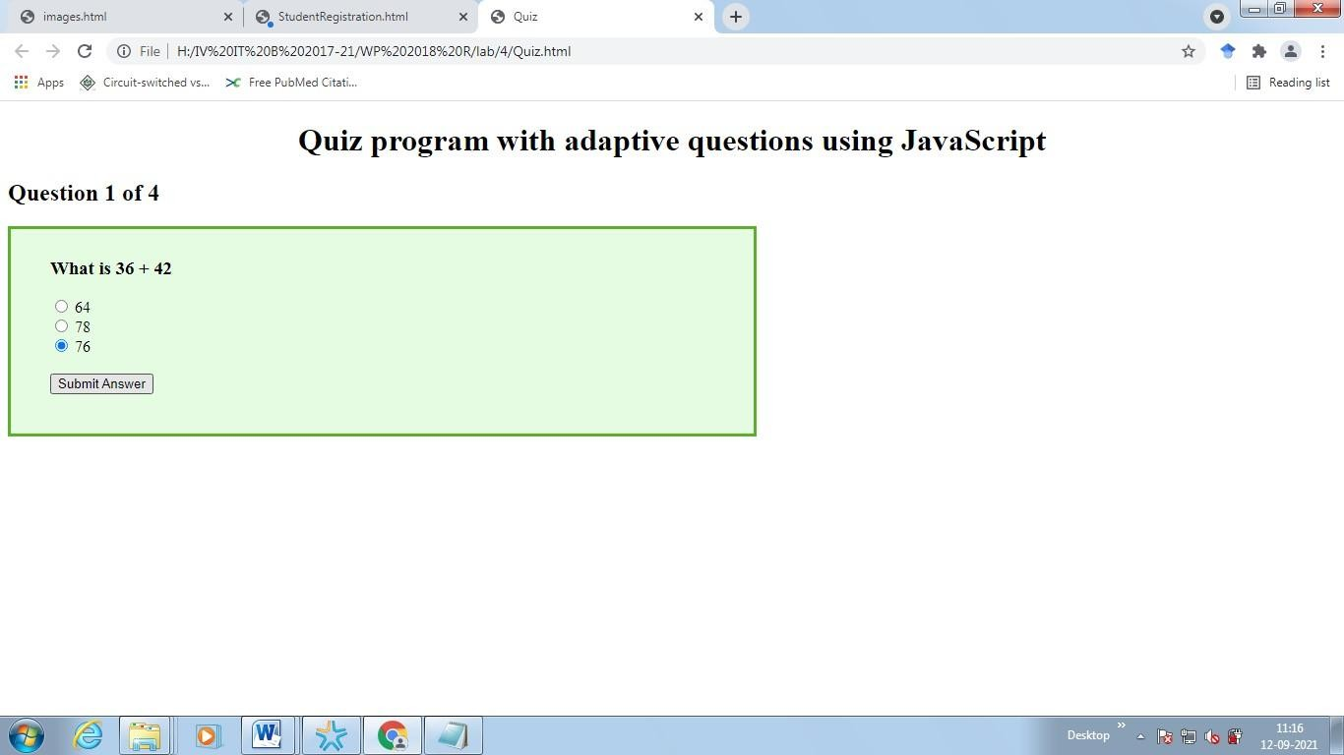**Quiz.html**

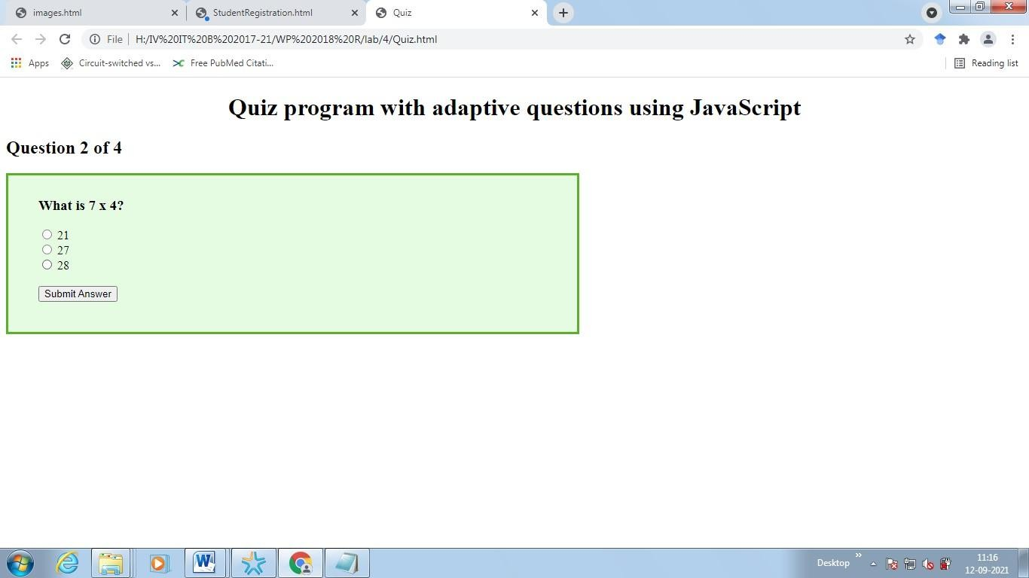

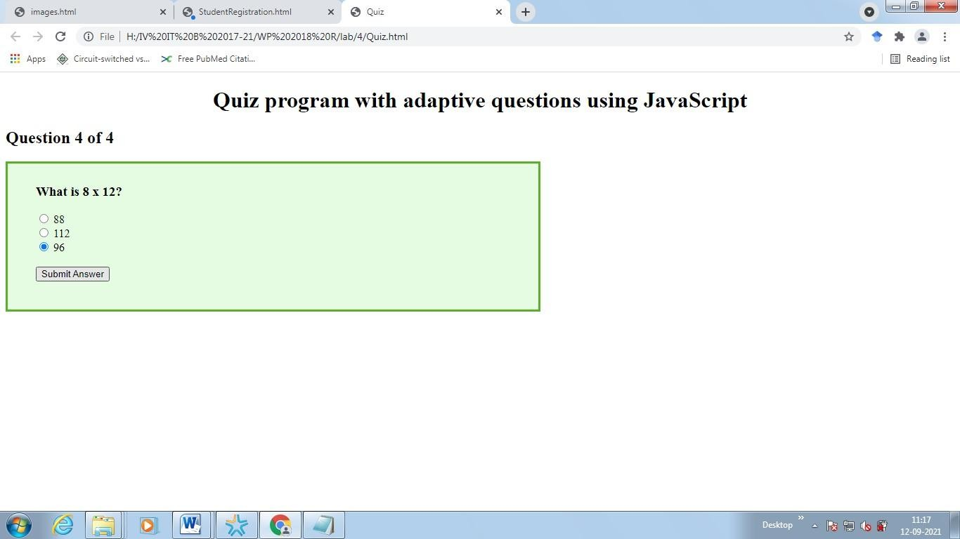

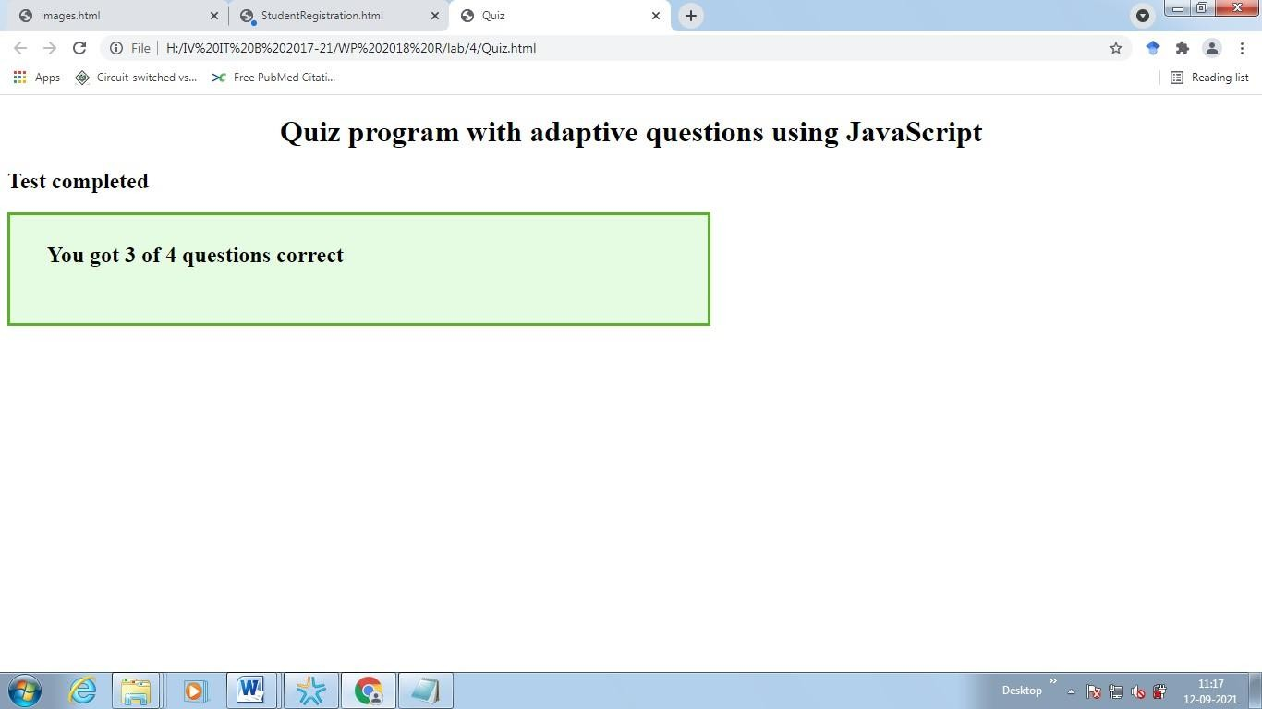

# EX NO 6 Online Event Registration form and validate using Jquery index.html

<!DOCTYPE html>

<html>

<head>

<!-- Latest compiled and minified CSS -->

<link rel="stylesheet" href=

"https://maxcdn.bootstrapcdn.com/bootstrap/ 4.0.0/css/bootstrap.min.css">

<!-- jQuery library -->

<script src= "https://ajax.googleapis.com/ajax/libs/ jquery/3.3.1/jquery.min.js">

</script>

<!-- Popper JS -->

<script src= "https://cdnjs.cloudflare.com/ajax/libs/ popper.js/1.12.9/umd/popper.min.js">

</script>

<!-- Latest compiled JavaScript -->

<script src= "https://maxcdn.bootstrapcdn.com/bootstrap/ 4.0.0/js/bootstrap.min.js">

</script>

</head>

<body><br>

<h1 class="text-center text-success"> Welcome to Dept of IT

</h1>

<p class="text-center">

FORM VALIDATION USING JQUERY

</p>

<div class="container">

<div class="col-lg-8

m-auto d-block">

<form>

<div class="form-group">

<label for ="user">

Username:

</label>

<input type="text"

name="username" id="usernames"

class="form-control">

<h5 id="usercheck" style="color: red;" >

**Username is missing

</h5>

</div>

<div class="form-group">

<label for="user">

Email:

</label>

<input type="email" name="email" id="email" required class="form-control">

<small id="emailvalid" class="form-text text-muted invalid-feedback">

Your email must be a valid email

</small>

</div>

<div class="form-group">

<label for="password">

Password:

</label>

<input type="password" name="pass" id="password" class="form-control">

<h5 id="passcheck" style="color: red;">

**Please Fill the password

</h5>

</div>

<div class="form-group">

<label for="conpassword">

Confirm Password:

</label>

<input type="password" name="username" id="conpassword" class="form-control">

<h5 id="conpasscheck" style="color: red;">

**Password didn't match

</h5>

</div>

<<div class="form-group">

<label for ="Event">

Event:

</label>

<input type="text"

name="Event" id="Event"

class="form-control">

<h5 id="Eventcheck" style="color: red;" >

**Event name is missing

</h5>

</div>

<input type="submit" id="submitbtn" value="Submit" class="btn btn-primary">

</form>

</div>

</div>

<!-- Including app.js jQuery Script -->

<script src="app.js"></script>

</body>

</html>

**app.js** // Document is ready

$(document).ready(function () {

// Validate Username

$('#usercheck').hide(); let usernameError = true;

$('#usernames').keyup(function () {

validateUsername();

});

function validateUsername() { let usernameValue = $('#usernames').val(); if (usernameValue.length == '') {

$('#usercheck').show(); usernameError = false;

return false;

}

else if((usernameValue.length < 3)||

(usernameValue.length > 10)) {

$('#usercheck').show();

$('#usercheck').html

("**length of username must be between 3 and 10"); usernameError = false;

return false;

}

else {

}

}

$('#usercheck').hide();

// Validate Email

const email = document.getElementById('email'); email.addEventListener('blur', ()=>{

let regex =

/^([_\-\.0-9a-zA-Z]+)@([_\-\.0-9a-zA-Z]+)\.([a-zA-Z]){2,7}$/;

let s = email.value;

if(regex.test(s)){

email.classList.remove(

'is-invalid'); emailError = true;

}

else{

false;

})

email.classList.add(

'is-invalid'); emailError =

}

// Validate Password

$('#passcheck').hide(); let passwordError = true;

$('#password').keyup(function () {

validatePassword();

});

function validatePassword() { let passwrdValue =

$('#password').val();

if (passwrdValue.length == '') {

$('#passcheck').show(); passwordError

= false;

return false;

}

if ((passwrdValue.length < 3)|| (passwrdValue.length > 10)) {

$('#passcheck').show();

$('#passcheck').html

("**length of your password must be between 3 and 10");

$('#passcheck').css("color", "red"); passwordError =

false; return false;

} else {

$('#passcheck').hide();

}

}

// Validate Confirm Password

$('#conpasscheck').hide(); let confirmPasswordError = true;

$('#conpassword').keyup(function () { validateConfirmPasswrd();

});

function validateConfirmPasswrd() { let confirmPasswordValue =

$('#conpassword').val(); let

passwrdValue =

$('#password').val();

if (passwrdValue != confirmPasswordValue) {

$('#conpasscheck').show();

$('#conpasscheck').html(

"**Password didn't Match");

$('#conpasscheck').css(

"color", "red"); confirmPasswordError = false; return false;

} else {

$('#conpasscheck').hide();

}

}

// Validate Event

$('#Eventcheck').hide(); let EventError = true;

$('#Event').keyup(function () {

validateEvent();

});

function validateEvent() { let EventValue = $('#Event').val(); if (EventValue.length == '') {

$('#Event').show();

EventError = false; return false;

}

else if((EventValue.length < 10)||

(EventValue.length > 20)) {

$('#Eventcheck').show();

$('#Eventcheck').html

("**length of Event must be between 10 and 20"); EventError = false;

return false;

}

else {

$('#Event').hide();

}

}

// Submitt button

$('#submitbtn').click(function () { validateUsername(); validatePassword(); validateConfirmPasswrd(); validateEmail();

if ((usernameError == true) && (passwordError == true) && (confirmPasswordError == true) &&

(emailError == true))

{ return true;

} else { return false;

}

});

});

# OUTPUTS:

**index.html**

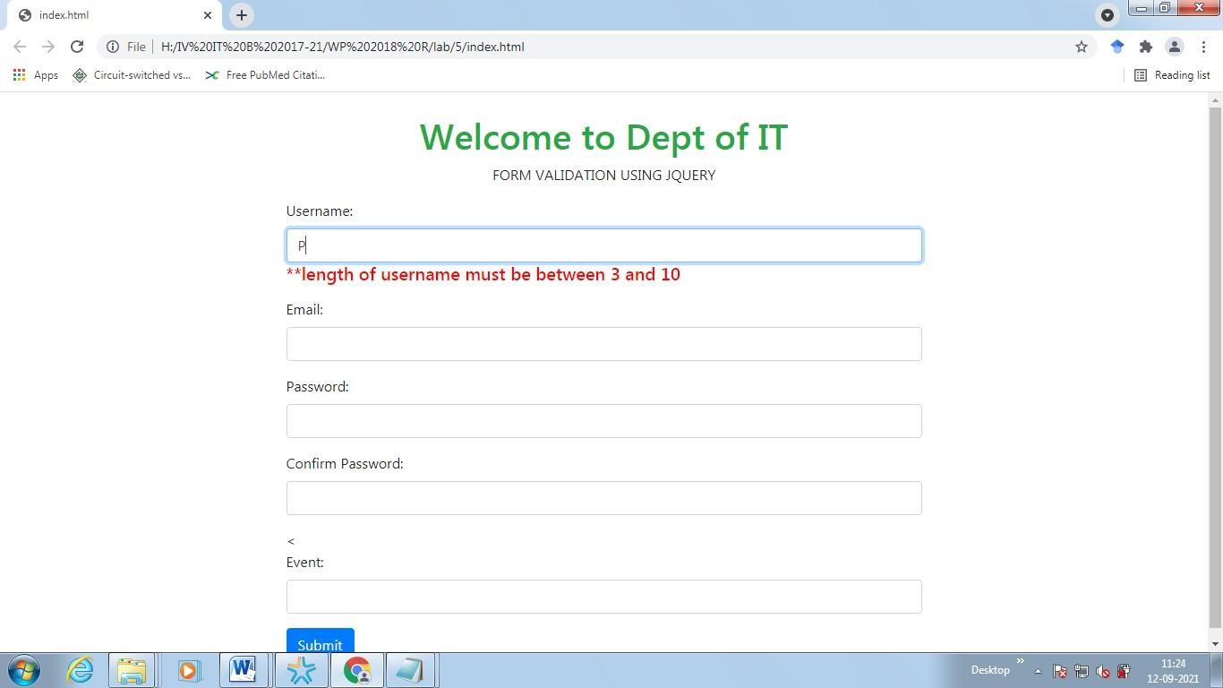

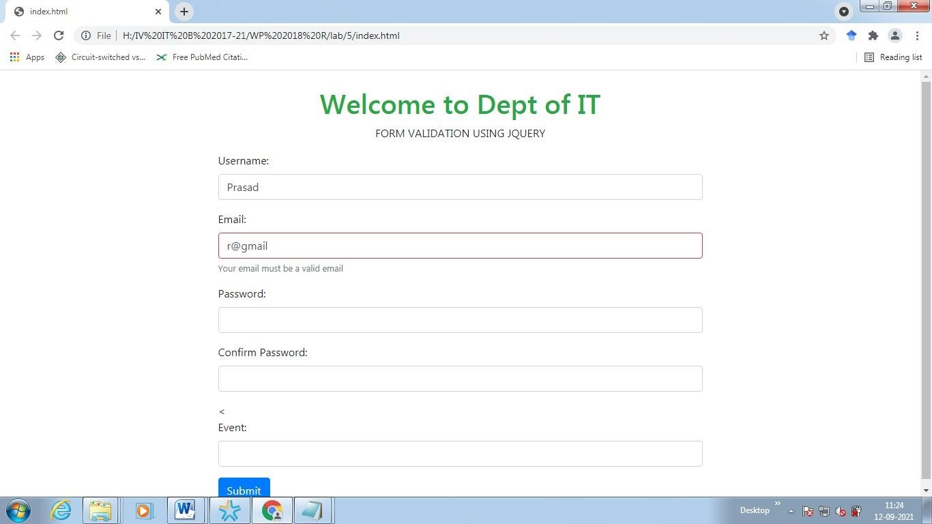

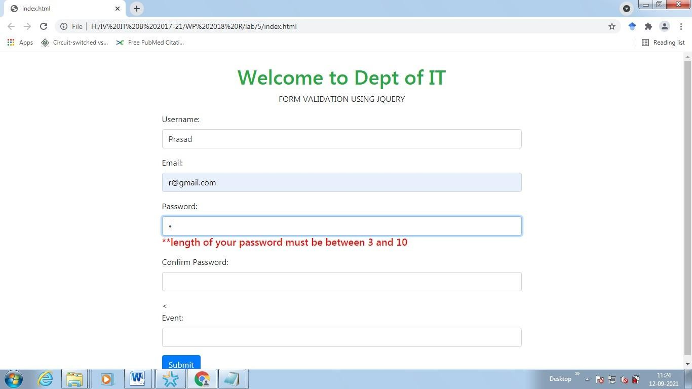

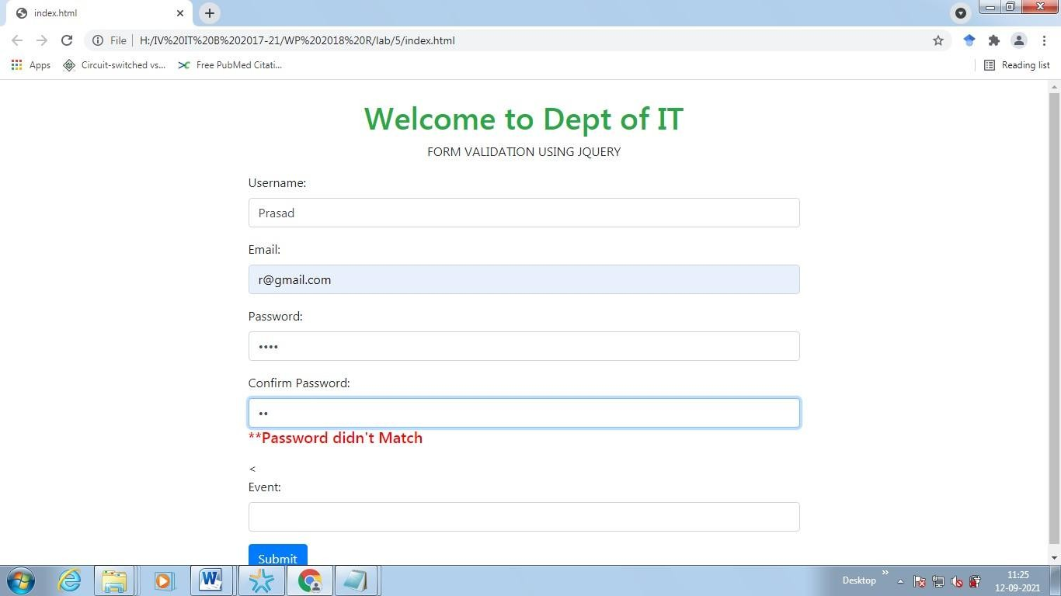

# EX NO : 7 Webpage to display student consolidate mark statement with pass (green color)or fail (red color)

**Calcofres.html**

<html>

<head>

<title>Registration Form</title>

</head>

<body style="background-color:grey";>

<center> <br> <br> <br> <br> <br> <br> <br> <br> <br> <br> <br> <br> <br>

<form name = "form1">

<table border = "1" style="background-color:white; width:500px;";>

<td colspan = "2" align = "center">Student Mark List</td>

<tr>

<tr>

<tr>

<td> Student Name</td>

<td><input type = "text" id="s1"/></td>

</tr>

<td colspan = "2" align = "center">Subject Marks</td>

</tr>

<tr>

<td>Web Programming</td>

<td><input type = "text" name = "wp" id="wp" /></td>

</tr>

<tr>

<td>Computer Graphics</td>

<td><input type = "text" name = "cg" id="cg" /></td>

</tr>

<tr>

<td>System Programming</td>

<td><input type = "text" name = "sp" id="sp"/></td>

</tr>

<td colspan = "2" align = "center"><input type = "button" onclick="calc()" value =

"calculte" id="calculate"/></td>

</tr>

<tr>

<td>Total</td>

<td id="total"></td>

</tr>

<tr>

<td>Result</td>

<td id="result" ></td>

</tr>

</table>

</form>

<script src="app.js"></script>

</center>

</body>

</html>

# app.js

function calc(){ let wp = parseInt(document.getElementById("wp").value); let cg = parseInt(document.getElementById("cg").value); let sp = parseInt(document.getElementById("sp").value);

let t = wp + cg + sp; let total = document.getElementById("total"); let average = document.getElementById("average"); let result = document.getElementById("result"); let grade = document.getElementById("grade");

if( wp<50 || cg < 50 || sp < 50)

{

/*result = "fail"; reult.style.color = "red";

*/

result.innerHTML = "fail"; result.style.color = "red";

total.innerHTML = t;

}

else{

result.innerHTML = "pass"; result.style.color = "green"; console.log("Inside passs");

total.innerHTML = t;

}

}

# OOUTPUTS:

**Calcofres.html**

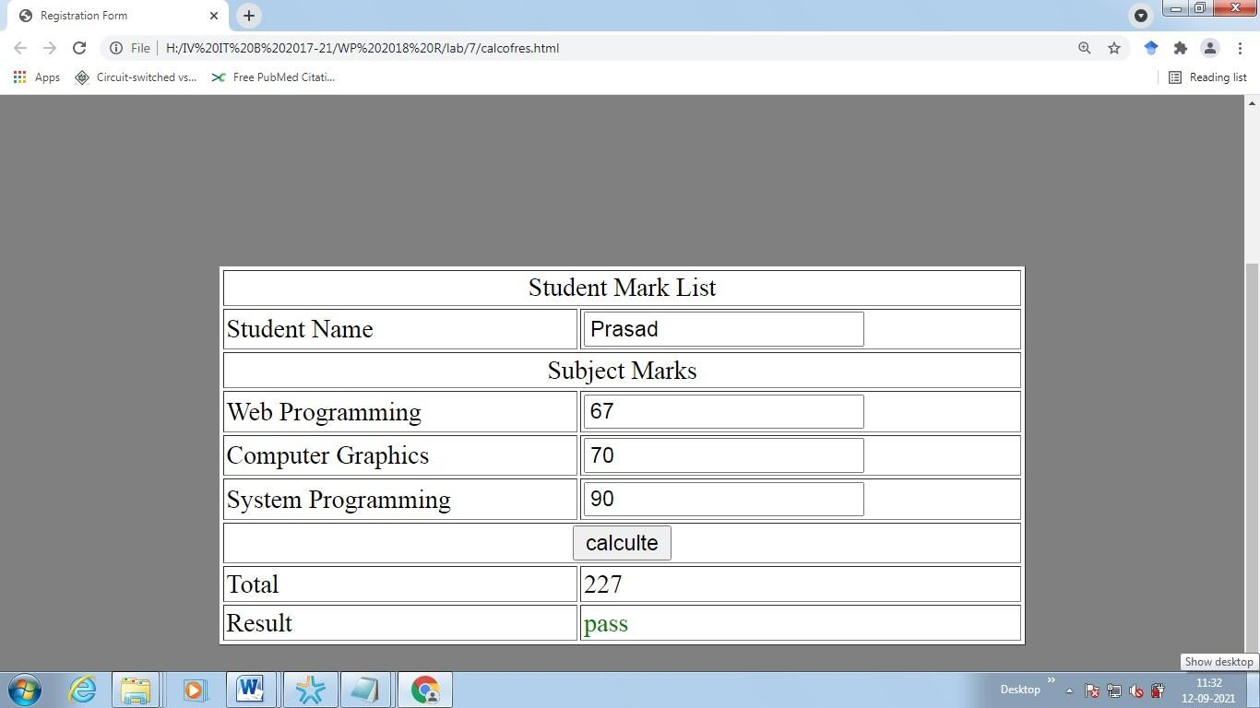

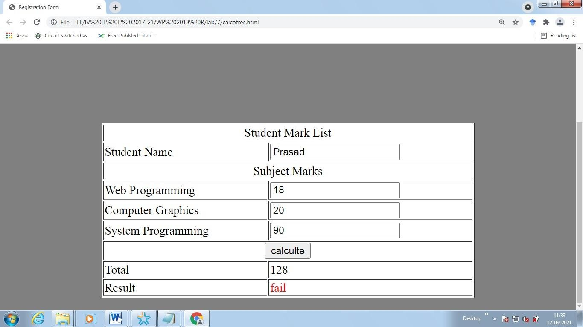

# EX NO 8 Program to change the content of the web page using AJAX

**Index.html**

<!DOCTYPE html>

<html lang="en">

<head>

<meta charset="utf-8">

<title>index.html</title>

<h1>AJAX object to Change the Content of Paragraph</h1>

<script src=" https://code.jquery.com/jquery-3.5.1.min.js"></script>

<script>

$(document).ready(function(){

$("button").click(function(){

$("#pageTitle").html("<h4>AJAX technology (AJAX = Asynchronous JavaScript And XML) is a developer’s dream because it can be used to update a content of a web page without reloading the whole page.</h4>");

});

});

</script>

</head>

<body>

<div id="pageTitle">

<p><b>In conventional web applications data from the server and data to the server are sending synchronously.Which means that when we hit the submit button,

it will direct to a new page with new content.By using AJAX we can update the part of a web page by sending the data to the server or retrieve data from the server asynchronously.</b><p>

</div>

<button type="button">Click To Change Paragraph Content Using AJAX</button>

</body>

</html>

# OUTPUT:

**Index.html**

