***Babu Banarsi Das University***



***Name-Prakhar Pandey Submitted to-***

***Batch-BCADS-25 Ankit Verma***

***Roll No.-1240258318 (22)***

***CREATE DATABASE***

**-Open MongoDB shell**

Write :-mongosh

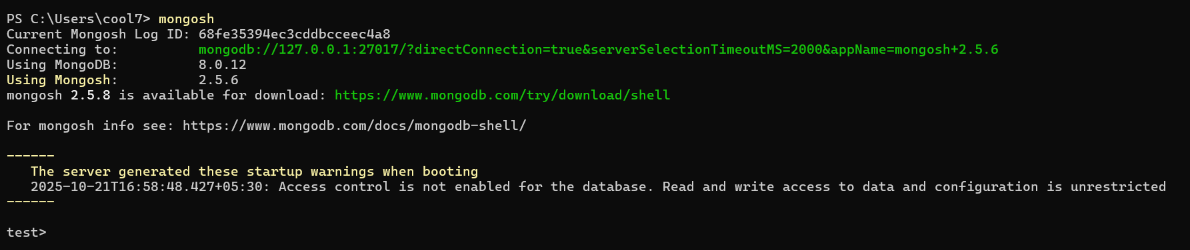

**-Check the Databases Present**

Show dbs

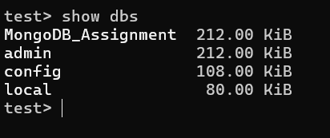

**-use your Database**

Use MongoDB_Assignment

**-Check collections**

Show collections

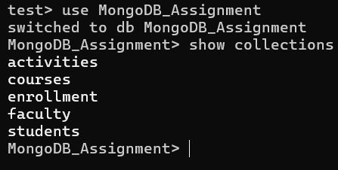

**-Complex Filters & Projections**

**Q1. List the names and departments of students who have more than 85% attendance and are skilled in both "MongoDB" and "Python".**

db.students.find( //Prakhar Pandey -1240258318

{attendance:{$gt:85},

skills:{$all:["MongoDB","Python"]}},

{_id:0,

name:1,

department:1}

);

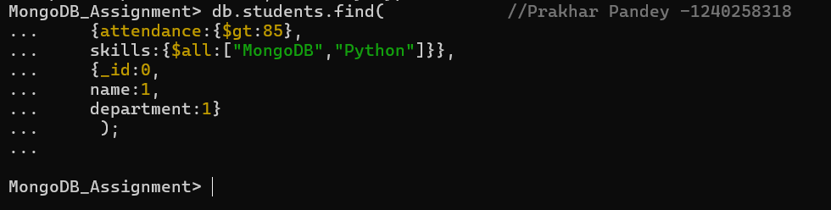

**\***It is not showing any output that means no documents match the condition.

**Q2. Show all faculty who are teaching more than 2 courses. Display their names and the total number of courses they teach.**

db.faculty.aggregate([{ $project: { _id:0,name: 1, totalCourses: { $size: "$courses" } } },

{ $match: { totalCourses: { $gt: 2 } } } ]

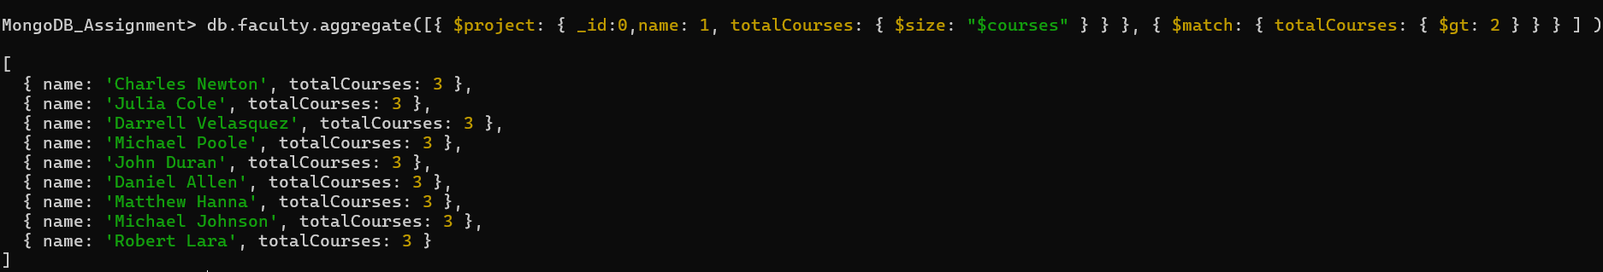

**-Joins ($lookup) and Aggregations**

**Q3. Write a query to show each student’s name along with the course titles they are enrolled in (use $lookup between enrollments, students, and courses).**

db.students.aggregate([

{

$lookup: {

from: "enrollments",

localField: "_id",

foreignField: "student_id",

as: "enrollmentInfo"}},

{

$unwind: "$enrollmentInfo"

},

{ $lookup: {

from: "courses",

localField: "enrollmentInfo.course_id",

foreignField: "_id",

as: "courseInfo"}},

{

$unwind: "$courseInfo"},

{

$project: {

_id: 0,

name: 1,

courseTitle: "$courseInfo.title"}}])

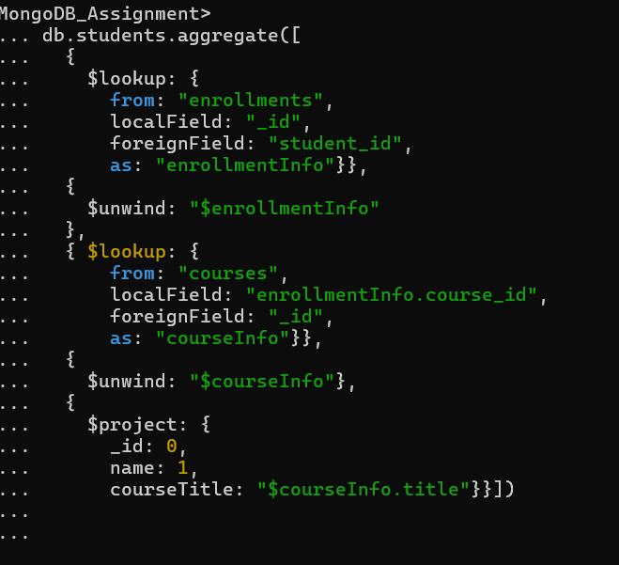

**Q4. For each course, display the course title, number of students enrolled, and average marks (use $group)**

db.enrollments.aggregate([

{

$group: {

_id: "$course_id",

totalStudents: { $sum: 1 },

avgMarks: { $avg: "$marks" }

}

},

{

$lookup: {

from: "courses",

localField: "_id",

foreignField: "_id",

as: "courseInfo"

}

},

{ $unwind: "$courseInfo" },

{

$project: {

_id: 0,

courseTitle: "$courseInfo.title",

totalStudents: 1,

avgMarks: { $round: ["$avgMarks", 2] } // round to 2 decimals

}}])

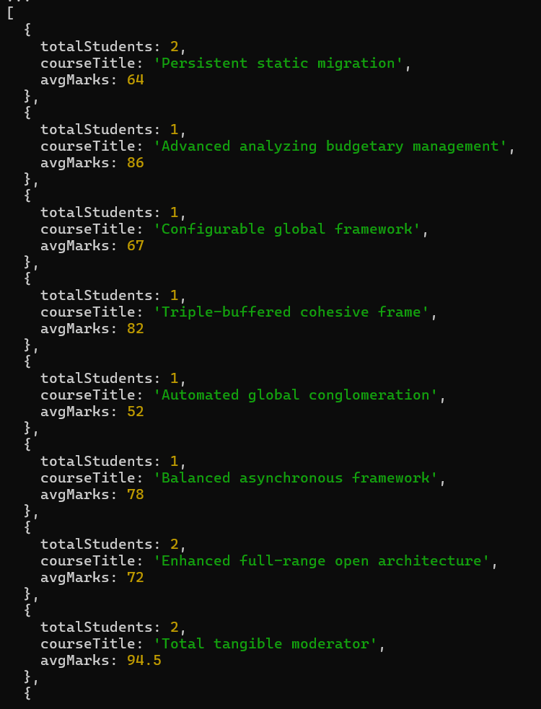

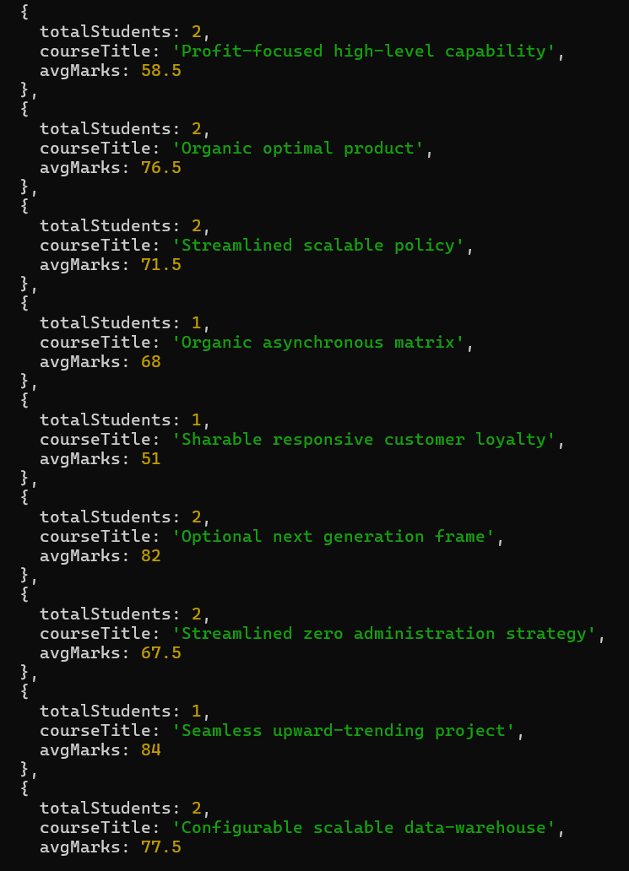

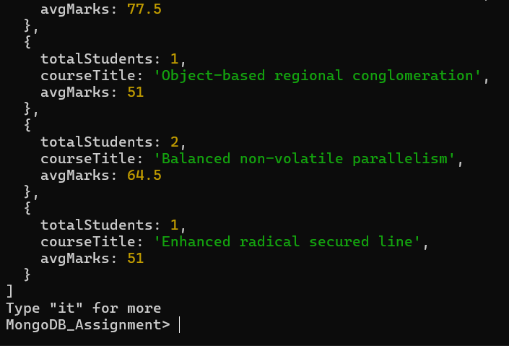

**-Grouping, Sorting, and Limiting**

**Q5. Find the top 3 students with the highest average marks across all enrolled courses.**

db.enrollment.aggregate([

{

$group: {

_id: "$student_id",

avgMarks: { $avg: "$marks" }

}

},

{

$sort: { avgMarks: -1 } // sort by average marks descending

},

{ $limit: 3 }, // take top 3

{

$lookup: {

from: "students",

localField: "_id",

foreignField: "_id",

as: "studentInfo"

}

},

{ $unwind: "$studentInfo" },

{

$project: {

_id: 0,

name: "$studentInfo.name",

department: "$studentInfo.department",

avgMarks: { $round: ["$avgMarks", 2] }

}

}

])

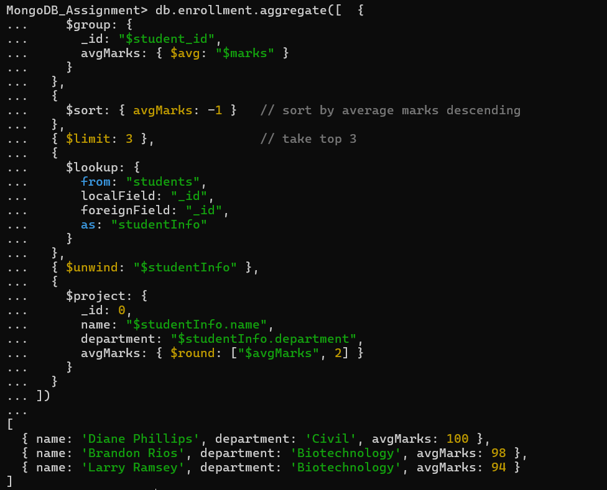

**Q6. Count how many students are in each department. Display the department with the highest number of students.**

db.students.aggregate([

{

$group: {

_id: "$department",

totalStudents: { $sum: 1 }

}

},

{

$sort: { totalStudents: -1 }

},

{ $limit: 1 },

{

$project: {

_id: 0,

department: "$_id",

totalStudents: 1

}

}

])

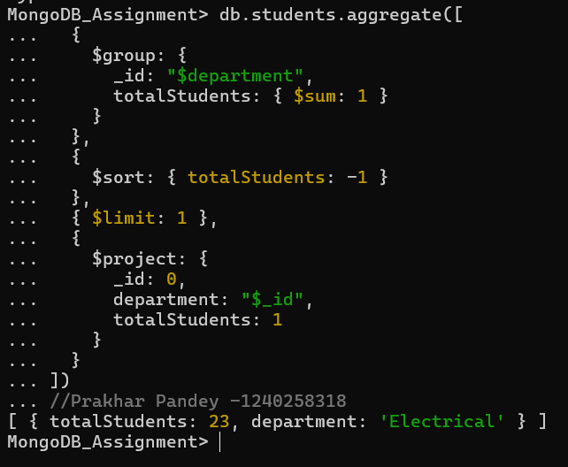

**-Update, Upsert, and Delete**

**Q8. Delete all student activity records where the activity year is before 2022**

db.activities.deleteMany(

{ year: { $lt: 2022 } }

)

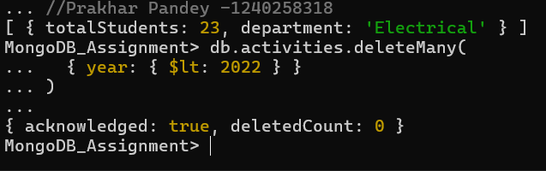

**Q9. Upsert a course record for "Data Structures" with ID "C150" and credits 4—if it doesn’t exist, insert it; otherwise update its title to "Advanced Data Structures"**

db.courses.updateOne(

{ _id: "C150" },

{

$set: {

title: "Advanced Data Structures",

credits: 4

}

},

{ upsert: true }

)

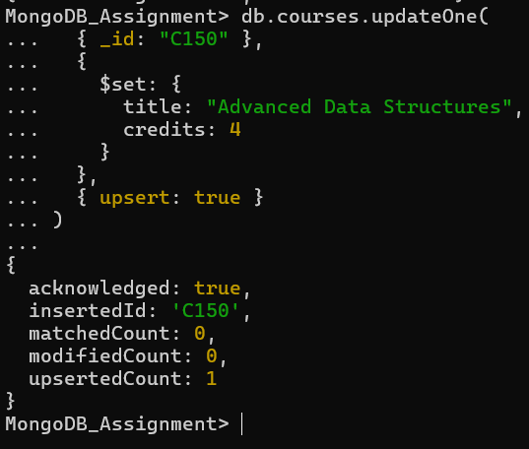

**-Array & Operator Usage**

**Q10. Find all students who have "Python" as a skill but not "C++".**

db.students.find(

{

skills: { $in: ["Python"], $nin: ["C++"] }

},

{

name: 1,

department: 1,

skills: 1,

_id: 0

}

)

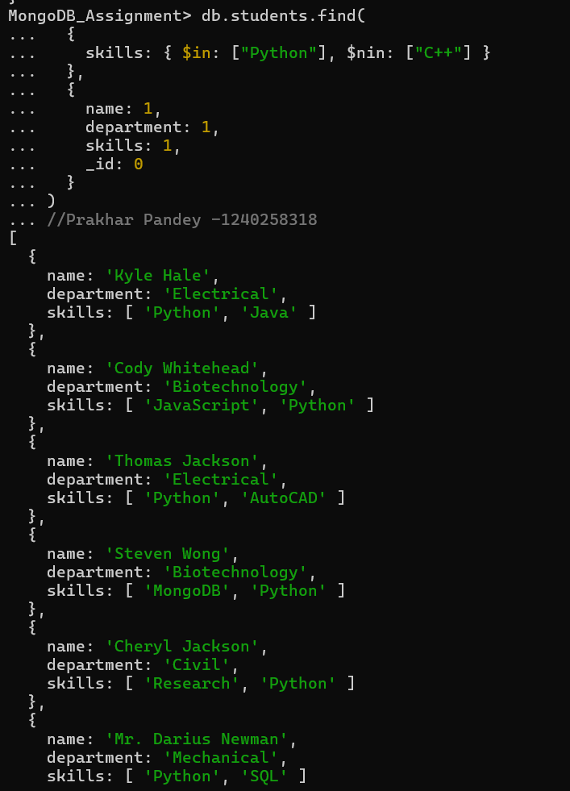

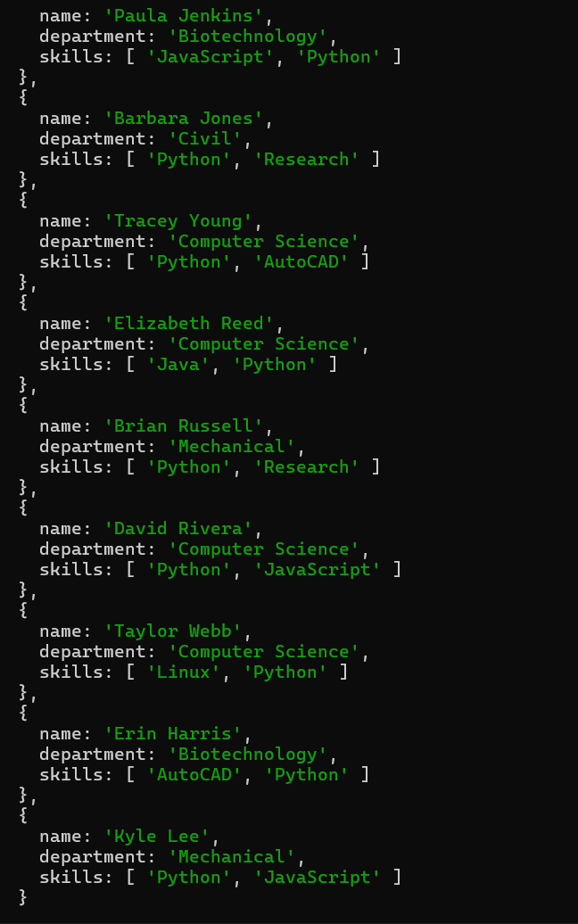

**Q11. Return names of students who participated in "Seminar" and "Hackathon" both.**

***//Step 1: Get student IDs for Seminar***

const seminarIds = db.activities

.find({ type: "Seminar" })

.map(doc => doc.student_id);

***//Step 2: Get student IDs for Hackathon***

const hackathonIds = db.activities

.find({ type: "Hackathon" })

.map(doc => doc.student_id);

***//Step 3: Find intersection and get the students names***

const commonIds = seminarIds.filter(id => hackathonIds.includes(id));

db.students.find(

{ _id: { $in: commonIds } },

{ name: 1, _id: 0 }

);

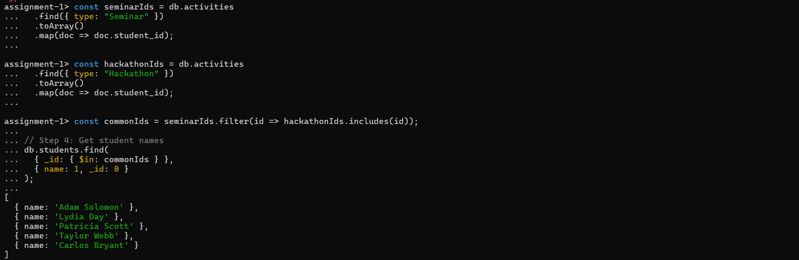

**-Subdocuments and Nested Conditions**

db.enrollment.aggregate([

{

$lookup: {

from: "courses",

localField: "course_id",

foreignField: "_id",

as: "course_info"

}

},

{ $unwind: "$course_info" },

{

$match: {

"course_info.title": "Web Development",

marks: { $gt: 80 }

}

},

{

$lookup: {

from: "students",

localField: "student_id",

foreignField: "_id",

as: "student_info"

}

},

{ $unwind: "$student_info" },

{

$match: {

"student_info.department": "Computer Science"

}

},

{

$project: {

_id: 0,

name: "$student_info.name",

department: "$student_info.department",

marks: 1

}

}

])

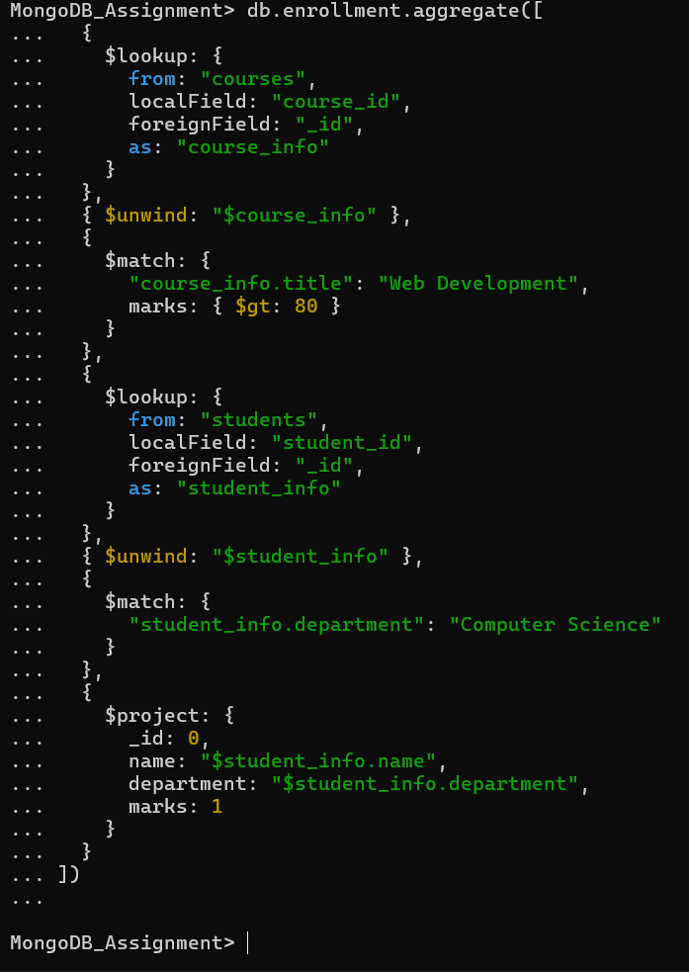

**\***It is not showing any output that means no documents match the condition.

**-Advanced Aggregation (Challenge Level)**

**Q13. For each faculty member, list the names of all students enrolled in their courses along with average marks per student per faculty.**

db.faculty.aggregate([

{

$lookup: {

from: "courses",

localField: "courses",

foreignField: "_id",

as: "courses_info”} },

{ $unwind: "$course_info" },

{

$lookup: {

from: "enrollment",

localField: "course_info._id",

foreignField: "course_id",

as: "enrollment_info"} },

{ $unwind: "$enrollment_info" },

{

$lookup: {

from: "students",

localField: "enrollment_info.student_id",

foreignField: "_id",

as: "student_info"

}

},

{ $unwind: "$student_info" },

{

$group: {

_id: {

faculty_name: "$name",

student_name: "$student_info.name"

},

average_marks: { $avg: "$enrollment_info.marks" }

}

},

{

$project: {

_id: 0,

faculty: "$_id.faculty_name",

student: "$_id.student_name",

average_marks: 1

}

},

{ $sort: { faculty: 1, student: 1 } }

])

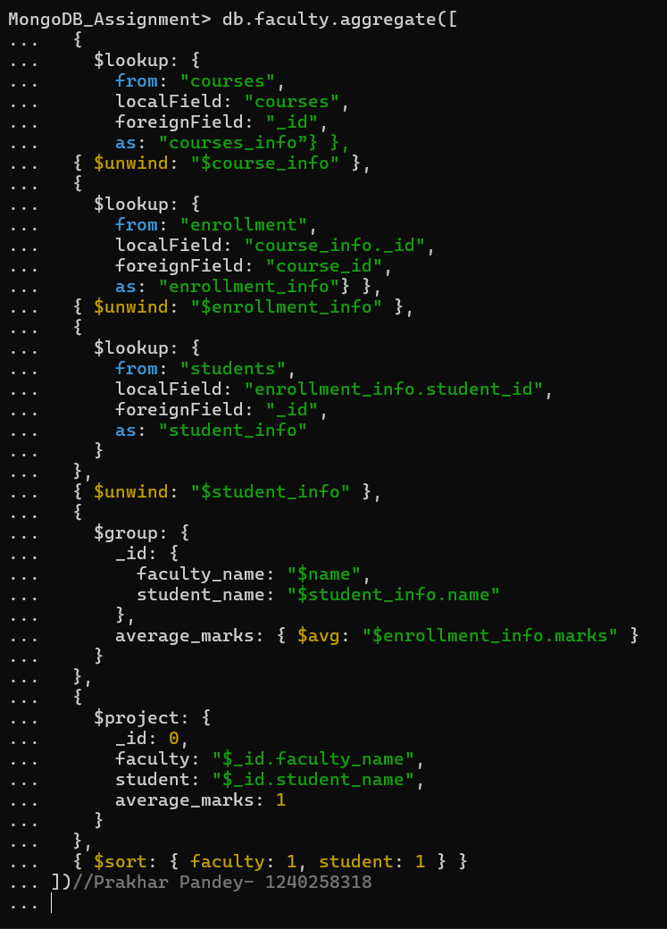

Output

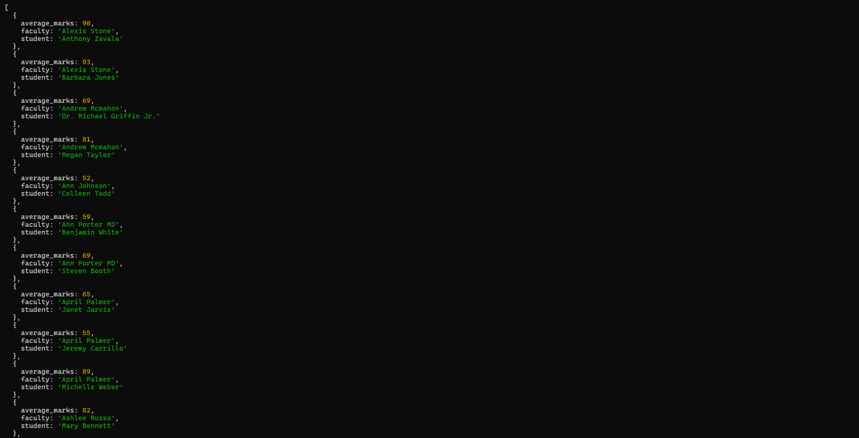

**Q14. Show the most popular activity type (e.g., Hackathon, Seminar, etc.) by number of student participants.**

db.activities.aggregate([

{

$group: {

_id: "$type",

participant_count: { $sum: 1 }

}

},

{ $sort: { participant_count: -1 } },

{ $limit: 1 },

{

$project: {

_id: 0,

activity_type: "$_id",

participant_count: 1

}

}

])

