Olist Marketplace Performance Analysis
A Data-Driven Investigation into Customer Satisfaction Drivers
Prepared for Olist Operations & Customer Experience Leadership
Analysis Period: September 2016 – October 2018

1. Problem Understanding
Olist is a Brazilian e-commerce platform that connects small and medium merchants to major online marketplaces through a single integrated contract. As Olist scales to more sellers and regions, leadership needs a clear, evidence-based understanding of how the marketplace has performed over its available history, and what is genuinely driving customer satisfaction and dissatisfaction.
This analysis covers approximately 99,441 orders placed between September 2016 and October 2018, spanning order, item, payment, product, seller, customer, and review data. The objective is not to prove a single cause of dissatisfaction, but to build a well-evidenced, prioritized picture of what matters most — and what does not — so Olist can act on it.

2. Analytical Approach
The analysis followed a structured pipeline:
- Data Understanding & Cleaning: loaded all nine source tables, converted timestamps, and built a single order-level master dataset by joining orders, customers, payments (aggregated across multi-payment orders), reviews, and item/product/category/seller details (aggregated across multi-item orders).
- Exploratory Data Analysis: examined the distribution of review scores, order statuses, order values, and delivery times to understand the shape of the data before targeted analysis.
- Core Question Analysis: investigated six business questions — marketplace trends, delivery performance, geographic/seller patterns, category performance, payment behavior, and root cause — using group comparisons, correlation analysis, and cross-tabulation.
- Root Cause Synthesis: ranked all measured factors by their relationship with review score to separate primary drivers from secondary or negligible ones.
Non-delivered orders (shipped, canceled, unavailable, etc. — about 3% of orders) were excluded from delivery-timing calculations since they lack a completed delivery date, but were retained for order-status and volume analysis.

3. Key Insights

3.1 Marketplace Performance Over Time
Order volume and revenue grew steadily across the observed period, while average review score remained relatively stable around 4.0–4.1. This means platform growth has not, on average, come at the cost of customer satisfaction — though, as later sections show, satisfaction varies significantly beneath this stable average.
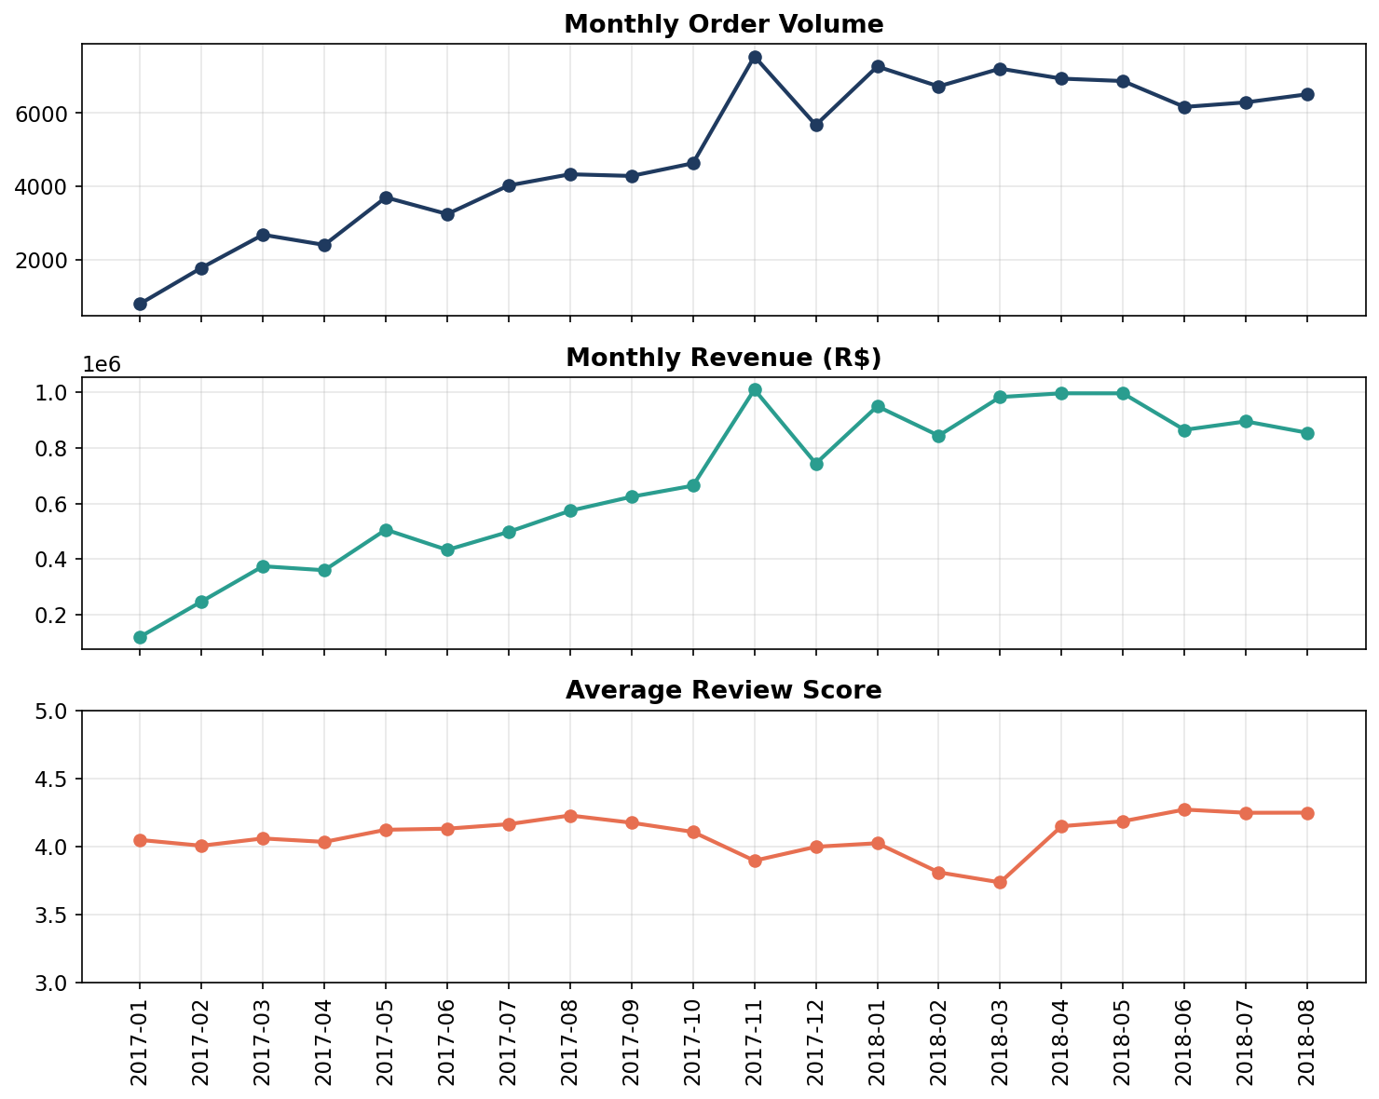
Figure 1: Monthly order volume, revenue, and average review score (2017–2018).

3.2 Delivery Performance and Customer Satisfaction
This is the strongest relationship found anywhere in the dataset. Orders delivered late score dramatically lower than on-time or early orders — and the effect is a smooth dose-response, not a simple cutoff:
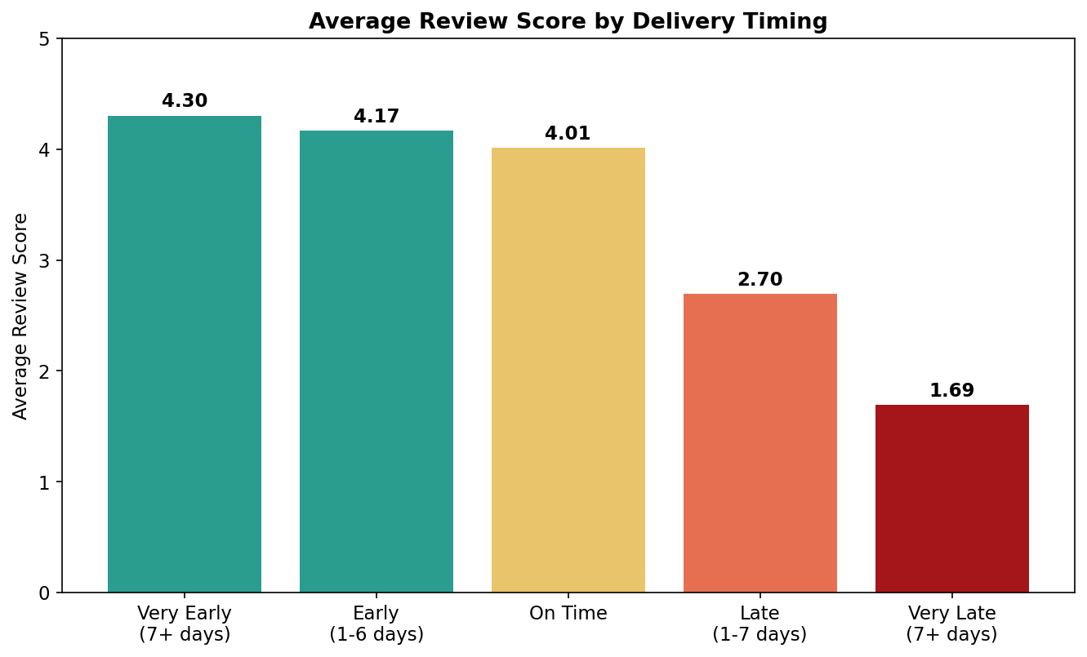
Figure 2: Average review score by delivery timing relative to the estimated delivery date.
On-time/early deliveries: average review score of 4.28.
Late deliveries: average review score of 2.26 — a drop of roughly two full stars.
This pattern holds consistently across every one of the ten highest-volume product categories and across every Brazilian state, though the drop is even more severe in specific states (RN, AC, RR, SE), where the gap between on-time and late reviews exceeds 2.3 points.

3.3 Seller and Geographic Patterns
Sellers on Olist are heavily concentrated in São Paulo (roughly 60% of all sellers), while customers are distributed more broadly across Brazil. This mismatch means the majority of orders ship across state lines, and cross-state shipping is measurably worse on every dimension:
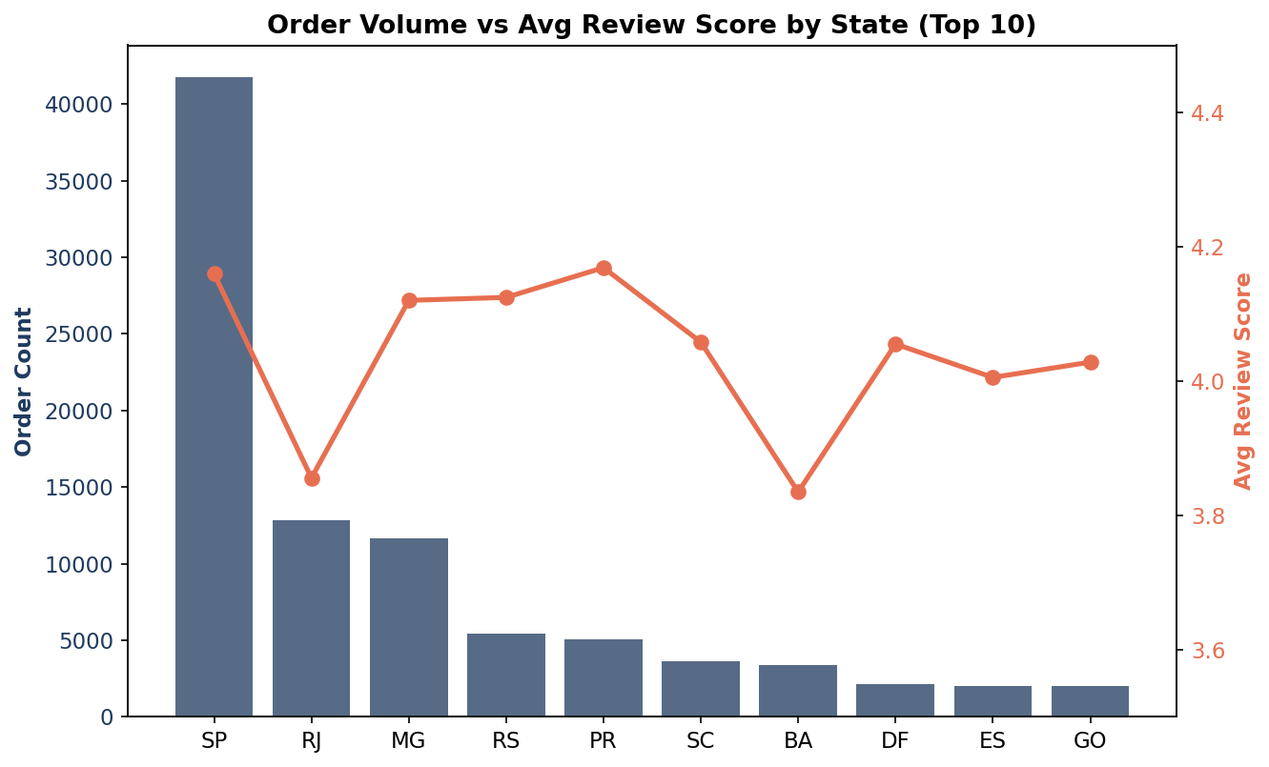
Figure 3: Order volume vs. average review score across the ten highest-volume states.
- Cross-state orders take nearly double the delivery time: 14.7 days vs. 7.5 days for same-state orders.
- Cross-state freight costs ~75% more: R$26.96 vs. R$15.46 on average.
- Cross-state orders score lower on satisfaction: 4.03 vs. 4.19 average review score.
States farthest from the seller hub — particularly Rio de Janeiro (RJ) and Bahia (BA) — show both the slowest delivery and the lowest review scores among high-volume states, reinforcing that geography is a structural contributor to the delivery delays identified above.

3.4 Product Category Performance
Order volume and satisfaction do not move together across categories. The platform's single highest-volume category, bed_bath_table (11,115 orders), scores below the platform average (3.87 vs. 4.01) — meaning the category driving the most revenue is not delivering the best customer experience.
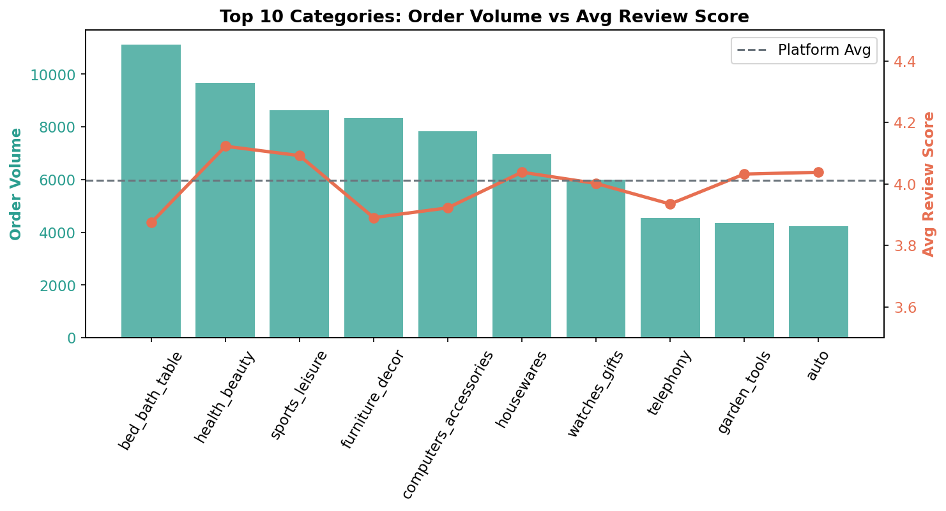
Figure 4: Order volume vs. average review score for the ten highest-volume product categories.
Office furniture stands out as a high-volume (1,691 orders), low-satisfaction category (3.48 average score), likely tied to bulkier or heavier items facing more delivery and handling issues. By contrast, niche low-volume categories such as books and luggage consistently score above 4.3.

3.5 Payment Behavior
Credit card is the dominant payment method (about 77% of orders), followed by boleto (about 20%). The number of installments chosen correlates strongly with order value (r = 0.37) — customers naturally finance larger purchases over more installments, which reflects ordinary financial behavior rather than distress.
However, neither payment type nor installment count shows any meaningful relationship with review score (r ≈ -0.03 to -0.04, and all payment types average within about 0.2 points of one another). Payment behavior is not a driver of customer satisfaction on this platform.

3.6 Root Cause Analysis
Ranking every measured factor by its correlation with review score produces a clear hierarchy:
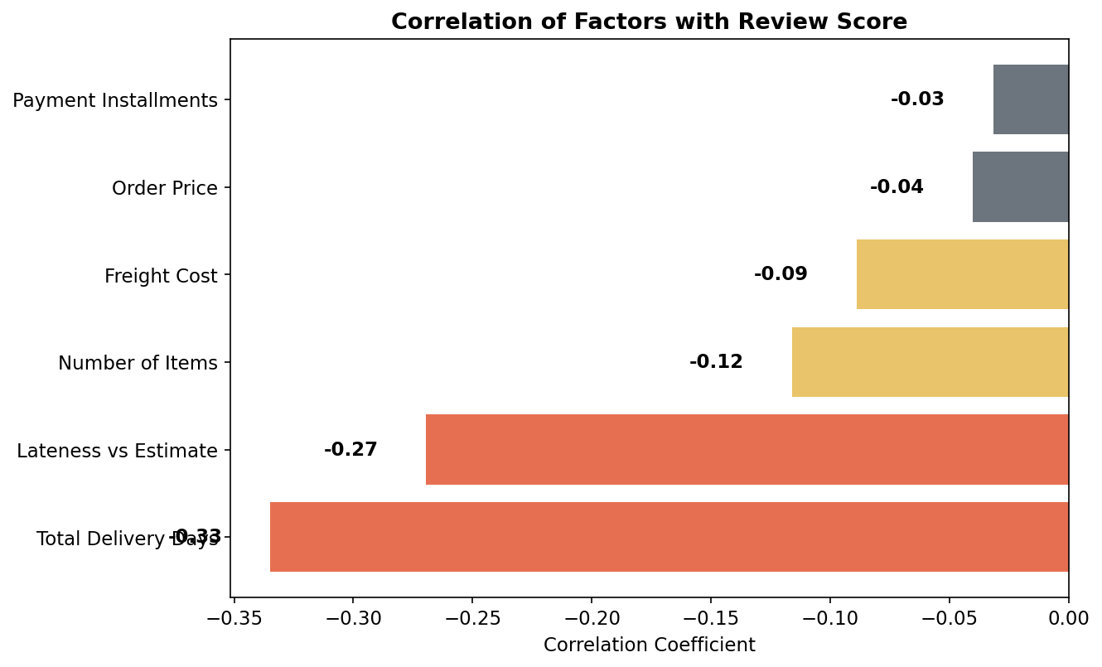
Figure 5: Correlation of measured factors with review score, ranked by strength.
Category | Factors
Primary Driver | Delivery timing — both total transit time (r = -0.33) and lateness vs. the estimated delivery date (r = -0.27)
Secondary / Contributing | Cross-state shipping distance, order fulfillment failures (canceled / unavailable orders), multi-item order complexity
Not Meaningful Drivers | Payment type, installment count, and product price (all r ≈ -0.03 to -0.04)

Critically, these factors compound rather than act independently. Orders that are both late and shipped cross-state average a review score of just 2.14 — the worst outcome anywhere in the dataset — confirming that Olist's geographic seller concentration is not merely a cost issue, but a direct contributor to the delivery delays that primarily drive dissatisfaction.
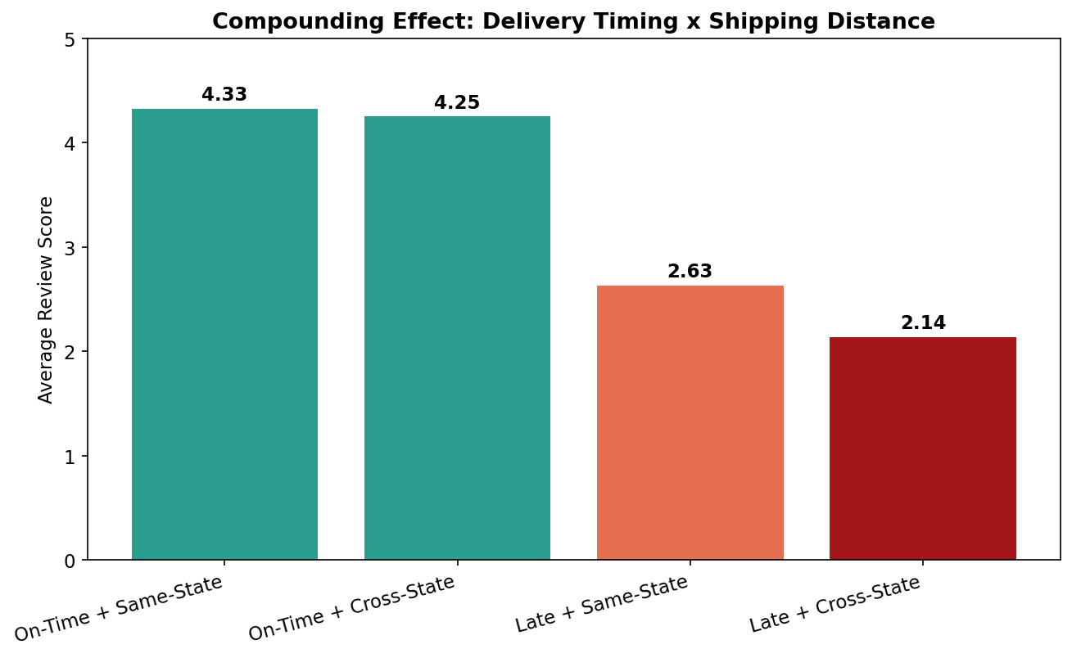
Figure 6: Average review score across combinations of delivery timing and shipping distance.

4. Business Findings Summary
Core Question | Key Finding
1. Trends Over Time | Order volume and revenue grew steadily through the platform's history, while average review score stayed relatively stable (~4.0-4.1). Growth did not come at the cost of satisfaction on average.
2. Delivery vs. Satisfaction | Late deliveries drop average review score from 4.28 to 2.26 — the single largest effect found in the dataset. This pattern holds consistently across every major product category and region.
3. Geographic Patterns | Sellers are concentrated ~60% in São Paulo. Cross-state shipments take nearly double the delivery time (14.7 vs 7.5 days), cost ~75% more in freight, and score lower on satisfaction.
4. Category Performance | High-volume categories like bed_bath_table underperform the platform average. Office furniture is a notable high-volume, low-satisfaction category worth investigating directly.
5. Payment Behavior | Payment type and installment count show negligible correlation with review score (r ≈ -0.03 to -0.04). Payment behavior reflects order size, not customer experience.
6. Root Cause | Delivery timing is the dominant, primary driver of dissatisfaction. Cross-state shipping, order fulfillment failures, and multi-item orders are secondary contributors.

5. Actionable Recommendations
1. Prioritize logistics and carrier performance, especially for cross-state shipments. Delivery timing is the single largest lever identified for improving customer satisfaction. Even modest reductions in late-delivery rate would produce a measurable lift in average review score, given the ~2-point gap between on-time and late orders.
2. Expand seller recruitment outside São Paulo. Reducing the geographic concentration of sellers would shorten shipping distances, lower freight costs, and directly reduce the share of orders exposed to the cross-state delay penalty identified in this analysis.
3. Investigate high-volume, low-satisfaction categories directly. bed_bath_table and office_furniture combine high order volume with below-average review scores — these represent the largest absolute opportunity for improvement given their scale.
4. Revisit how estimated delivery dates are set. Because early delivery consistently scores higher than on-time delivery, current estimates may be padded; more accurate (rather than conservative) estimates, paired with reliable execution, could improve the customer experience without necessarily requiring faster fulfillment.
5. Treat non-delivered orders as a distinct, high-severity segment. Canceled, unavailable, and never-confirmed-delivered orders score extremely low (1.3–2.0 average). Though a small share of volume, these represent the most severe failure mode on the platform and warrant root-cause investigation of their own.
6. Deprioritize payment-related interventions for satisfaction goals. Payment type and installment count show no meaningful link to review score — resources aimed at improving satisfaction are better spent on logistics and fulfillment than on payment experience.

This analysis is based on observational data and does not establish causation. However, the consistency of the delivery-timing effect across categories, regions, and in combination with geographic distance provides strong, convergent evidence that logistics performance — not product quality, pricing, or payment experience — is the primary lever available to Olist for improving customer satisfaction as the platform continues to scale.

