DATA SCIENCE MINOR PROJECT REPORT
DATA ANALYTICS WITH POWER BI
PROJECT REPORT
(Project Semester Oct-Dec 2025)

TITLE :- Car Metrics & Market Trends Dashboard

Submitted by: -

Prakhar Gupta

Registration No: - 12322277

Programme and Section: - BTech CSE, K23HP
Course Code: INT374

Under the Guidance of

Dr. Mrinalini Rana Mam , UID – , Assistant Professor

Discipline of CSE/IT
Lovely School of Computer Science
Lovely Professional University, Phagwara
DECLARATION

I, Prakhar Gupta, student of BTech Computer Science And Engineering under CSE/IT Discipline at, Lovely Professional University, Punjab, hereby declare that all the information furnished in this project report is based on my own intensive work and is genuine.

Date 15/12/25
Signature  Registration No. 12322277 Name Prakhar Gupta

CERTIFICATE

This is to certify that Prakhar Gupta bearing Registration no. 12322277 has completed INT 374 project titled, “Car Metrics & Market Trends Dashboard” under my guidance and supervision. To the best of my knowledge, the present work is the result of his/her original development, effort and study.

Signature and Name of the Supervisor
Designation of the Supervisor
School of Computer Science
Lovely Professional University
Phagwara, Punjab.

Date:

ACKNOWLEDGEMENT

I would like to express my sincere gratitude to Lovely Professional University, Phagwara, for providing me with the opportunity and resources to undertake this Data Science Minor Project titled “Car Metrics & Market Trends Dashboard”. This project has been a valuable learning experience that helped me enhance both my technical knowledge and practical understanding of data analytics, machine learning, and business intelligence tools.
I am deeply thankful to my faculty coordinator and project supervisor, whose guidance, continuous support, and constructive feedback played a crucial role throughout the completion of this project. Their insights and encouragement helped me understand complex concepts related to data preprocessing, exploratory data analysis, predictive modeling, and visualization using Power BI.
I would also like to acknowledge the efforts of all my teachers and mentors from the Discipline of CSE/IT, Lovely School of Computer Science and Engineering, who have imparted valuable knowledge during the course of my academic journey. The concepts learned in subjects such as Data Science, Machine Learning, Statistics, Database Management, and Data Visualization significantly contributed to the successful execution of this project.
I extend my sincere thanks to the Kaggle community for providing an extensive and well-structured dataset, which formed the foundation of this analysis. Working with a real-world dataset containing 50,000 records enabled me to gain hands-on experience in handling large datasets, managing missing values, performing exploratory data analysis, and building regression and classification models.
I am also grateful to my friends and classmates who provided constant motivation, discussions, and suggestions during different stages of the project. Their support made the learning process more engaging and collaborative.
Finally, I would like to express my heartfelt gratitude to my parents and family members for their unwavering encouragement, patience, and moral support throughout this academic endeavor. Their belief in me has always been a source of strength and inspiration.
I sincerely believe that this project has helped me develop a strong foundation in data-driven decision making, predictive analytics, and dashboard creation, which will be beneficial for my future academic and profession.

Table of Contents

INTRODUCTION 7
Source of Dataset 8
Data Preprocessing 9
3.1 Data Cleaning and Transformation Steps in Power BI 9
3.2 Data Quality Assessment After Pre-Processing 10
Analysis on Dataset 12
4.1 Brand-wise Average Price Analysis 12
4.2 Condition vs Price Analysis 14
4.3 Fuel Type Distribution Analysis 15
4.4 Car Age Impact on Price Analysis 17
4.5 City-wise Price Distribution Analysis 19
4.6 Percentage of Cars with Accident History (Gauge Chart Analysis) 20
4.7 Number of Cars by City Analysis (Bar Chart) 22
Conclusion 26
Overall Insight 28
Future Scope 30
LinkedIn Link and Snapshot : 32
REFERENCES 33

Table of Figures

Figure 3.1: Data Preprocessing Steps 11
Figure 4.1: Brand-wise Average Price Analysis………………………………………………………………………………………………………………13
Figure 4.2 Condition vs Price Analysis 15
Figure 4.3 Fuel Type Distribution Analysis 17
Figure 4.4 Car Age Impact on Price Analysis 18
Figure 4.5 City-wise Price Distribution Analysis 20
Figure 4.6 Percentage of Cars with Accident History 22
Figure 4.7 Number of Cars by City Analysis 23
Figure 4.8 Dashboard Page 1 24
Figure 4.9 Dashboard Page 2 25

INTRODUCTION

In recent years, data-driven decision making has become a critical component of modern business strategies. The automobile industry, being one of the most data-intensive sectors, produces large volumes of information related to vehicle specifications, pricing, market demand, fuel efficiency, ownership trends, and geographic distribution. Analyzing this data efficiently helps manufacturers, dealers, buyers, and analysts understand market behavior and make informed decisions.
This project, titled “Car Metrics & Market Trends Dashboard”, focuses on analyzing a large automotive dataset using Microsoft Power BI. The goal of the project is to transform raw car-related data into meaningful insights through data preprocessing, exploratory data analysis, and interactive dashboard visualization, entirely within the Power BI environment.
The project emphasizes business intelligence (BI) techniques rather than traditional programming-based data science. By using Power BI’s built-in tools such as Power Query Editor, DAX (Data Analysis Expressions), and interactive visuals, the project demonstrates how non-programmatic platforms can effectively perform advanced data analysis and reporting.
The dataset used contains detailed information about various cars, including brand, model, year of manufacture, car age, mileage, engine size, fuel type, transmission, accident history, fuel efficiency, and selling price. These attributes play a significant role in understanding pricing patterns, market trends, and vehicle performance.
One of the key motivations of this project is to analyze how different factors influence car prices and market value. Additionally, the project aims to identify trends related to accident history, fuel types, city-wise price distribution, and brand-wise performance. This information is presented through an interactive Power BI dashboard that allows users to filter, slice, and explore the data dynamically.
The dashboard developed in this project is designed for decision-makers and end users, enabling them to quickly interpret insights without requiring technical knowledge. By using visuals such as KPI cards, bar charts, line charts, scatter plots, maps, and gauges, the project enhances data storytelling and business understanding.
Overall, this project serves as a practical demonstration of end-to-end data analysis using Power BI, showcasing how business intelligence tools can be leveraged to analyze real-world datasets and derive valuable insights.

Source of Dataset
Link : https://www.kaggle.com/datasets/mahdimashayekhi/used-car-price

The dataset used for this project was obtained from Kaggle, a widely used platform that provides open-source datasets for data analysis and machine learning projects. Kaggle datasets are commonly used for academic projects, research, and skill development in data analytics and business intelligence.
The dataset consists of 50,000 records and 25 columns, representing detailed information about cars sold in different cities. The data includes both categorical and numerical attributes, making it suitable for exploratory analysis and dashboard creation.
Key Features of the Dataset
- Brand and Model of the car
- Manufacturing Year and Car Age
- Mileage and Fuel Efficiency
- Engine Size, Horsepower, and Torque
- Fuel Type and Transmission
- Accident History
- Insurance and Registration Status
- City-wise distribution
- Price per Kilometer and Final Selling Price
The dataset is realistic and complex, closely resembling real-world automotive sales data. This makes it ideal for developing a Power BI dashboard focused on market trends and performance metrics.

Data Preprocessing

Data pre-processing is a critical phase in any data analytics project, as it ensures that the dataset is clean, consistent, and suitable for meaningful analysis and visualization. In this project, all pre-processing activities were carried out using Power BI Power Query Editor, without using any external programming languages or tools.
The primary objective of the pre-processing stage was to clean the raw dataset, handle inconsistencies, standardize data formats, and create derived columns required for effective analysis. Proper pre-processing ensured that the data model was reliable and ready for building interactive Power BI dashboards.

3.1 Data Cleaning and Transformation Steps in Power BI
The following data pre-processing steps were applied using Power Query Editor, as reflected in the Applied Steps panel:
1. Source
The dataset was imported into Power BI from a structured CSV file obtained from Kaggle. This step established the initial connection between Power BI and the raw dataset.
2. Promoted Headers
The first row of the dataset was promoted to column headers to ensure proper field naming and improve data readability for further transformations and analysis.
3. Changed Data Types
Each column was assigned an appropriate data type based on its nature:
- Numeric fields (Price, Mileage, Engine Size, Fuel Efficiency) were assigned Whole Number or Decimal data types.
- Text-based fields (Brand, Model, Fuel Type, City, Condition) were assigned the Text data type.
- Year and Car Age columns were assigned Whole Number data types.
Correct data typing is essential for accurate calculations, aggregations, and visual representation in Power BI.
4. Trimmed Text
Leading and trailing spaces were removed from textual columns such as Brand, Model, City, and Fuel Type. This step eliminated duplicate values caused by inconsistent spacing.
5. Cleaned Text
Non-printable characters and hidden symbols were removed from text fields to improve data consistency and ensure smooth filtering and slicing in dashboard visuals.
6. Removed Blank Rows
Completely empty or irrelevant rows were removed to prevent inaccurate calculations and ensure the dataset contained only meaningful records.
7. Replaced Values
Categorical values were standardized to maintain uniformity across the dataset.
Examples include:
- Correcting inconsistent naming conventions
- Merging similar categories under a single standardized value
This step significantly improved grouping accuracy in charts, slicers, and filters.
8. Added Conditional Columns
New derived columns were created using conditional logic to support analysis and KPI creation, such as:
- Accident indicator column (Yes/No classification)
- Accident-free vehicle identification
- Additional flags required for KPI and gauge visuals
These derived columns enhanced analytical capability without altering the original data.

3.2 Data Quality Assessment After Pre-Processing
After completing the above pre-processing steps:
- The dataset was clean, well-structured, and consistent
- No critical null or missing values remained
- Categorical fields were standardized and suitable for grouping
- Numeric fields were ready for aggregation and calculation
- The data model was optimized for dashboard-level analysis
This confirmed that the dataset was fully prepared for visual analysis, KPI computation, and interactive reporting in Power BI.

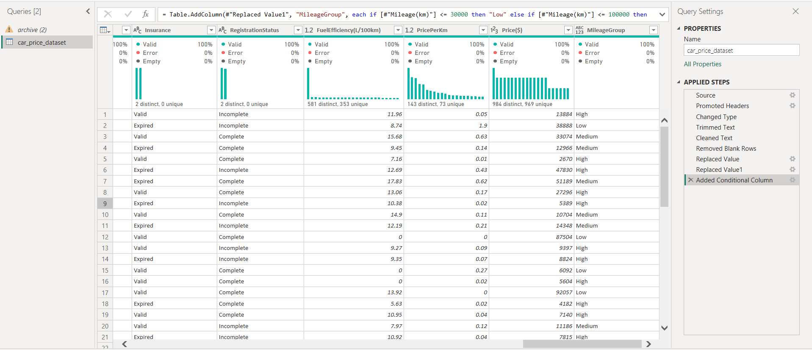

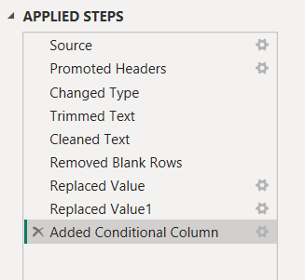
Figure 3.1: Data Preprocessing Steps

Analysis on Dataset

All analyses in this project were performed using Microsoft Power BI. Each analysis follows a structured approach consisting of an introduction, general description, specific requirements, analysis results, and visualization. This systematic format ensures clarity, consistency, and easy interpretation of insights derived from the dataset.

4.1 Brand-wise Average Price Analysis
i. Introduction
The automobile market is highly brand-driven, where the brand name significantly influences customer perception, trust, and pricing. Different brands offer varying levels of quality, technology, performance, and reliability. This analysis aims to evaluate how car prices vary across different brands by calculating the average selling price for each brand. Understanding brand-wise price trends helps identify premium, mid-range, and economy segments in the market.

ii. General Description
Brand reputation plays a crucial role in determining a vehicle’s market value. Premium brands often incorporate advanced technology, superior build quality, and enhanced performance features, which justify higher prices. On the other hand, economy brands focus on affordability, fuel efficiency, and maintenance cost, resulting in lower price ranges.
By analyzing the average price per brand, this study provides insight into:
- Market positioning of different car manufacturers
- Consumer preference trends
- Price differentiation strategies used by brands
This analysis is particularly useful for dealers, buyers, and market analysts to understand brand value in the automobile market.

iii. Specific Requirements, Functions and Formulas
The following Power BI components were used:
- Measure Created (DAX):
- Average Price = AVERAGE(‘CarData’[Price($)])
- Fields Used:
  - Brand
  - Price($)
- Visual Used:
  - Clustered Column Chart
- Filters Applied:
  - Slicers for Fuel Type, Transmission, City, and Condition
The measure calculates the mean price for each brand, enabling fair comparison across manufacturers regardless of the number of cars sold.

iv. Analysis Results
The analysis reveals a clear distinction between premium and economy brands:
- Premium brands consistently show higher average prices due to advanced features and strong brand reputation.
- Mid-range brands occupy the middle price segment, offering a balance between cost and performance.
- Economy brands display lower average prices, appealing to cost-sensitive customers.
This confirms that brand identity is a strong determinant of vehicle pricing in the market.

v. Visualization
The Brand-wise Average Price Clustered Column Chart visually represents:
- Price comparison across brands
- Clear ranking of brands based on average selling price
- Immediate identification of premium and budget segments
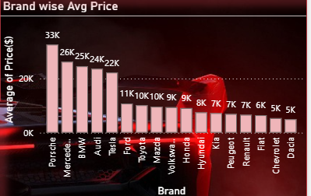
Figure 4.1 Brand-wise Average Price Analysis
Caption:
Clustered column chart showing the average selling price of cars for each brand. Premium brands such as Porsche, Mercedes, BMW, and Audi exhibit higher average prices, whereas economy brands display comparatively lower price ranges.

4.2 Condition vs Price Analysis
i. Introduction
The physical and functional condition of a car is one of the most critical factors affecting its resale value. This analysis examines how different car conditions (such as new, used, or damaged) influence the selling price. Buyers generally prefer well-maintained vehicles, making condition a key pricing factor.

ii. General Description
Car condition reflects factors such as usage, maintenance history, wear and tear, and accident exposure. Vehicles in better condition are more reliable and require fewer repairs, which increases their market value.
This analysis helps:
- Buyers assess price fairness based on condition
- Sellers understand how condition impacts resale value
- Dealers optimize pricing strategies

iii. Specific Requirements, Functions and Formulas
- Measures Used:
  - Average Price = AVERAGE(Price($))
  - Car Count = COUNT(Price($))
- Fields Used:
  - Condition
  - Price($)
- Visual Used:
  - Radar Chart
Radar charts are effective in showing comparative performance across categories, making them suitable for condition-based analysis.

iv. Analysis Results
The analysis clearly shows:
- Cars in excellent or new condition have the highest average prices
- Used cars fall into a moderate price range
- Damaged or poorly maintained cars show significantly lower prices
This highlights the importance of proper maintenance in preserving car value.

v. Visualization
The Condition vs Price Radar Chart provides:
- Clear comparison of average prices across conditions
- Visual emphasis on price gaps between conditions
- Easy interpretation for non-technical users
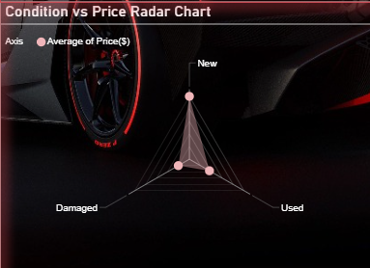
Figure 4.2 Condition vs Price Analysis
Caption:
Radar chart illustrating the variation in average car prices across different vehicle conditions (New, Used, and Damaged). The visualization clearly highlights that new cars command the highest average prices, followed by used cars, while damaged vehicles show significantly lower price values.

4.3 Fuel Type Distribution Analysis
i. Introduction
Fuel type is a crucial factor influencing customer preference, running cost, and environmental impact. This analysis studies the distribution of different fuel types in the dataset to understand market demand patterns.

ii. General Description
With growing concerns over fuel efficiency and emissions, consumer preferences are shifting toward more economical and environmentally friendly options. This analysis provides insight into which fuel types dominate the market.

iii. Specific Requirements and Visuals
- Fields Used: Fuel Type
- Measure Used: Count of Cars
- Visual Used: Donut Chart

iv. Analysis Results
The analysis indicates:
- Certain fuel types dominate the market share
- Alternative fuel options are present but less common
- Market demand reflects fuel availability and running cost considerations

v. Visualization
The Fuel Type Donut Chart effectively displays:
- Proportion of each fuel type
- Quick comparison of fuel popularity
- Clean and intuitive presentation
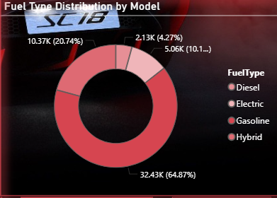
Figure 4.3 Fuel Type Distribution Analysis
Caption:
Donut chart representing the distribution of fuel types across all car models in the dataset. Gasoline-powered vehicles dominate the market, followed by diesel, while electric and hybrid vehicles account for a smaller but emerging share.

4.4 Car Age Impact on Price Analysis
i. Introduction
Car age is a key determinant of depreciation. This analysis evaluates how vehicle price changes with increasing car age.

ii. General Description
As cars age, they experience depreciation due to mechanical wear, outdated features, and reduced resale demand. Understanding this trend helps buyers and sellers make informed decisions.

iii. Specific Requirements
- Fields Used: Car Age, Price($)
- Measure Used: Average Price
- Visual Used: Line Chart

iv. Analysis Results
The analysis shows:
- A consistent decline in price as car age increases
- Sharp depreciation in early years
- Slower price reduction for older vehicles

v. Visualization
The Car Age vs Price Line Chart highlights:
- Clear depreciation trend
- Relationship between age and market value
- Long-term pricing behavior
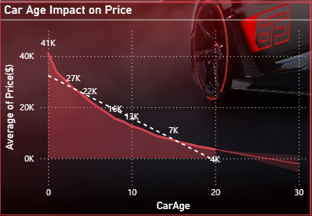
Figure 4.4 Car Age Impact on Price Analysis
Caption:
Line chart showing the relationship between car age and average selling price. The chart demonstrates a clear depreciation trend, where car prices decrease steadily as vehicle age increases, highlighting the impact of aging on resale value.

4.5 City-wise Price Distribution Analysis
i. Introduction
Geographical location plays an important role in determining vehicle prices due to differences in demand, income levels, and market dynamics. This analysis explores city-wise variations in average car prices.

ii. General Description
Urban cities with higher purchasing power often have higher car prices, while smaller cities may show lower average prices. This analysis helps identify regional market trends.

iii. Specific Requirements
- Fields Used: City, Price($)
- Measure Used: Average Price
- Visual Used: Map / Filled Map

iv. Analysis Results
The analysis reveals:
- Significant price variation across cities
- Higher average prices in metropolitan regions
- Lower average prices in less urbanized areas

v. Visualization
The City-wise Price Distribution Map provides:
- Geographical price comparison
- Easy identification of high- and low-price regions
- Interactive exploration using map zoom and tooltips
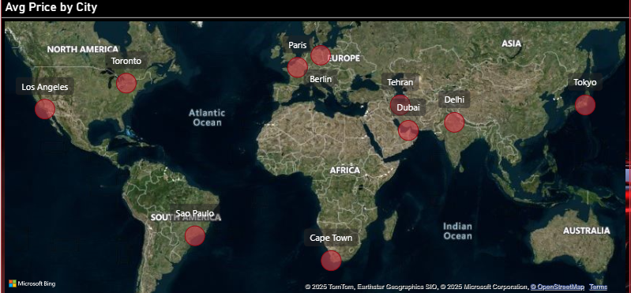
Figure 4.5 City-wise Price Distribution Analysis

Caption:
Map visualization depicting the average selling price of cars across different cities worldwide. The size and intensity of the markers represent price variation, highlighting that metropolitan cities such as Tokyo, Paris, Los Angeles, and Dubai exhibit higher average car prices compared to other regions.

4.6 Percentage of Cars with Accident History (Gauge Chart Analysis)
i. Introduction
Accident history is a crucial factor affecting vehicle resale value and buyer trust. This analysis measures the overall percentage of cars that have a recorded accident history in the dataset.

ii. General Description
Cars with prior accidents generally have lower resale value and higher perceived risk. Understanding the proportion of such vehicles helps:
- Assess overall dataset quality
- Support risk-based decision-making
- Improve transparency for buyers and dealers

iii. Specific Requirements, Functions and Formulas
- Calculated Measure (DAX):
- Accident % =
- DIVIDE(
- COUNTROWS(FILTER(‘CarData’, ‘CarData’[AccidentHistory] = “Yes”)),
- COUNTROWS(‘CarData’),
- 0
- ) * 100
- Visual Used:
  - Gauge Chart
- Gauge Range:
  - Minimum: 0%
  - Maximum: 100%

iv. Analysis Results
- The gauge indicates that approximately 18.9% of cars in the dataset have an accident history.
- This shows that the majority of vehicles are accident-free.
- However, a significant minority still carries accident risk, which must be considered during pricing and purchase decisions.

v. Visualization
The Gauge Chart:
- Provides a quick, high-level summary
- Clearly communicates risk proportion
- Enhances dashboard readability for decision-makers
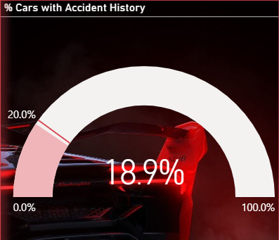
Figure 4.6 Percentage of Cars with Accident History
Caption:
Gauge chart representing the percentage of cars with recorded accident history in the dataset. The visualization indicates that approximately 18.9% of cars have an accident history, while the majority of vehicles are accident-free, suggesting a generally healthy market inventory.

4.7 Number of Cars by City Analysis (Bar Chart)
i. Introduction
This analysis focuses on identifying city-wise distribution of cars in the dataset. Understanding data volume per city helps evaluate market size and representation.

ii. General Description
Cities with higher numbers of listed vehicles represent larger or more active automobile markets. This analysis supports:
- Market comparison
- Regional demand assessment
- Validation of dataset balance

iii. Specific Requirements, Functions and Formulas
- Measure Used:
- Car Count = COUNT(‘CarData’[CarID])
- Fields Used:
  - City
- Visual Used:
  - Horizontal Bar Chart

iv. Analysis Results
- Most cities show a fairly balanced number of cars (around 5,000 entries each).
- Cities such as Tehran, Cape Town, and Dubai slightly lead in vehicle count.
- Balanced distribution ensures unbiased comparative analysis across cities.

v. Visualization
The City-wise Car Count Bar Chart:
- Clearly ranks cities based on number of cars
- Enhances comparison through horizontal layout
- Supports filtering and drill-down analysis

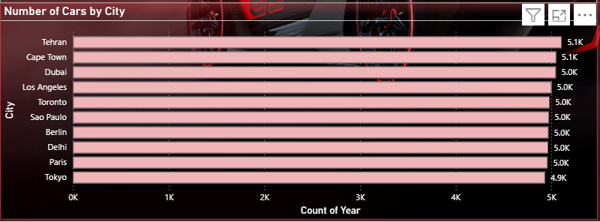
Figure 4.7 Number of Cars by City Analysis
Caption:
Horizontal bar chart illustrating the distribution of cars across various cities in the dataset. The visualization shows a relatively balanced number of cars per city, indicating uniform data representation and comparable market activity across locations.

DASHBOARD SNAPSHOTS

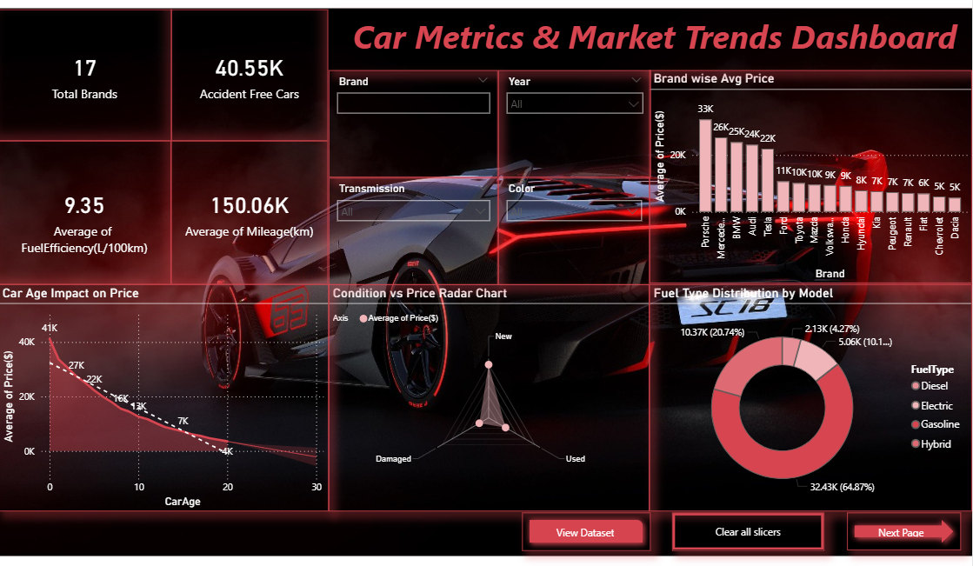
Figure 4.8 Dashboard Page 1

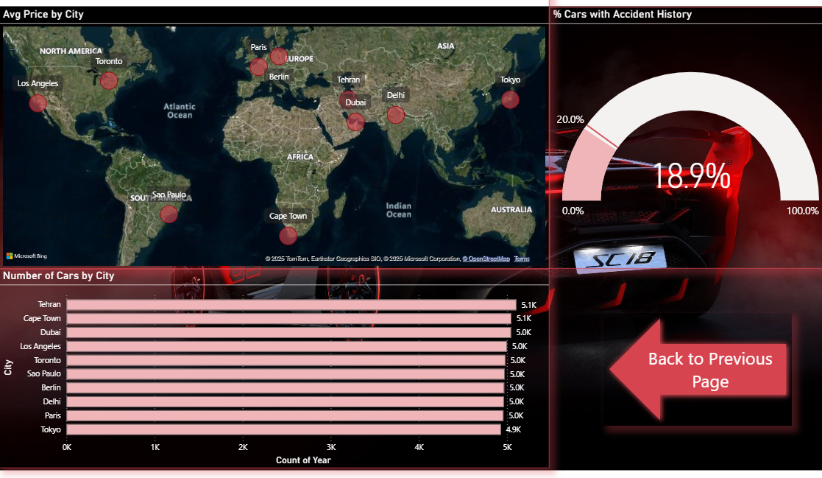
Figure 4.9 Dashboard Page 2

Conclusion

The Car Metrics & Market Trends Dashboard provides a comprehensive and insightful view of the automobile market by integrating multiple analytical perspectives into a single, interactive Power BI report. Based on the visuals and insights presented across both dashboard pages, the project successfully translates raw car market data into meaningful business intelligence that supports informed decision-making.
From the brand-wise average price analysis, it is clearly observed that car brands differ significantly in their pricing strategies and market positioning. Premium brands consistently show higher average prices, reflecting stronger brand value, advanced features, and higher consumer perception, while economy brands remain more affordable and cater to cost-sensitive buyers. This comparison helps users understand competitive pricing and brand dominance in the market.
The condition vs price radar chart reinforces the direct relationship between vehicle condition and resale value. New and well-maintained cars command substantially higher prices compared to used or damaged vehicles. This insight is particularly valuable for sellers, buyers, and dealers, as it highlights how vehicle condition plays a critical role in price determination.
The fuel type distribution analysis reveals clear consumer preferences, with conventional fuel types dominating the market, while electric and hybrid vehicles, although growing, still represent a smaller share. This visualization provides useful insights into current market trends and can support future planning for sustainable and alternative fuel vehicles.
The car age impact on price line chart shows a strong negative correlation between car age and price. As vehicles get older, their value depreciates steadily, especially after certain age milestones. This trend confirms expected depreciation behavior and helps buyers assess fair pricing while enabling sellers to time their resale decisions more strategically.
The city-wise analysis, supported by both the map visualization and the bar chart showing number of cars by city, highlights geographical differences in pricing and market activity. Certain cities exhibit higher average car prices, likely due to higher income levels, demand, or urban preferences. At the same time, the number of cars per city indicates market concentration and regional demand patterns, making this analysis useful for regional market comparison and expansion planning.
The gauge visual representing the percentage of cars with accident history provides a quick and intuitive risk indicator. The relatively low percentage suggests that a majority of cars in the dataset are accident-free, increasing buyer confidence and reflecting market quality. This KPI-style visualization enhances executive-level understanding without requiring detailed data exploration.
Additionally, the KPI cards (Total Brands, Accident-Free Cars, Average Mileage, and Average Fuel Efficiency) summarize critical metrics at a glance, allowing users to quickly grasp the overall dataset health and market characteristics. Interactive slicers for brand, year, transmission, and color further enhance usability, enabling dynamic filtering and personalized analysis.
Overall, this Power BI project demonstrates a strong application of data preprocessing, exploratory analysis, KPI design, advanced visualizations, and interactive reporting. The dashboard effectively answers key business questions related to pricing, condition, fuel preferences, geographic trends, and vehicle reliability. It serves as a powerful analytical tool for stakeholders such as buyers, sellers, dealerships, and market analysts.
In conclusion, the Car Metrics & Market Trends Dashboard successfully transforms complex automotive data into clear, actionable insights, showcasing the practical value of data visualization and business intelligence using Power BI, while laying a solid foundation for future enhancements such as predictive insights and deeper regional or temporal analysis.

Overall Insight

The Car Metrics & Market Trends Dashboard delivers a holistic understanding of the automotive market by combining descriptive statistics, interactive visuals, and KPI-driven insights into a single Power BI solution. By analyzing the dataset from multiple dimensions—brand, price, condition, fuel type, age, city, and accident history—the dashboard uncovers clear patterns that explain how different factors collectively influence car valuation and market behavior.
A key insight from the dashboard is that brand identity plays a dominant role in price determination. Certain brands consistently maintain higher average prices, indicating stronger brand equity, perceived quality, and customer trust. In contrast, budget-oriented brands cluster at lower price ranges, emphasizing affordability and mass-market appeal. This distinction helps explain competitive positioning within the automotive industry and highlights how branding directly impacts market value.
Another major finding is the strong influence of vehicle condition on pricing. The radar chart clearly demonstrates that new and well-maintained cars command premium prices, while damaged or poorly maintained vehicles experience substantial value reduction. This confirms that condition is one of the most critical qualitative factors affecting resale value, often outweighing other attributes such as color or transmission type.
The fuel type analysis reveals current consumer behavior and market readiness for alternative energy vehicles. Conventional fuel types (petrol and diesel) still dominate the dataset, indicating that the market largely relies on traditional fuel options. However, the presence of electric and hybrid vehicles, though smaller in share, signals a gradual shift toward sustainable mobility. This insight can support future market planning and policy-level discussions on green transportation adoption.
The car age impact on price visualization highlights predictable but crucial depreciation trends. Prices decline steadily as cars age, with sharper drops observed after certain age thresholds. This insight is valuable for buyers to identify optimal purchase windows and for sellers to understand depreciation timing. It also reinforces the importance of lifecycle analysis in automotive pricing strategies.
Geographical insights from the city-wise price map and car count bar chart show that regional factors significantly affect car prices and availability. Urban and metropolitan cities often exhibit higher average prices, likely driven by higher demand, purchasing power, and lifestyle preferences. Meanwhile, the number of cars per city indicates market density and regional demand patterns, offering useful guidance for dealerships, logistics planning, and regional marketing strategies.
The accident history gauge provides an important risk-related insight. The relatively low percentage of cars with accident history suggests a healthier market dataset with a majority of accident-free vehicles. This enhances buyer confidence and indicates that accident history is a distinguishing factor rather than a common occurrence. When combined with pricing and condition insights, it allows users to make more informed decisions regarding vehicle reliability and value.
The kpi indicators consolidate complex data into easy-to-understand summaries, offering instant insights into total brands, accident-free cars, average mileage, and fuel efficiency. These metrics help users quickly assess overall market quality and performance without diving into granular details.
Overall, the dashboard demonstrates that car price and market trends are not influenced by a single factor but by a combination of brand reputation, condition, age, fuel type, geography, and accident history. The interactive nature of the report allows users to explore these relationships dynamically, making the dashboard suitable for strategic analysis, academic evaluation, and real-world business applications.
In summary, the Car Metrics & Market Trends Dashboard provides a data-driven narrative of the automotive market. It transforms raw data into actionable insights, supports comparative and regional analysis, and highlights key value drivers in the car resale and sales ecosystem. This project showcases the effective use of Power BI as a business intelligence tool and reflects a strong understanding of data analysis, visualization design, and market interpretation.

Future Scope

- Real-Time Data Integration
The dashboard can be enhanced by connecting it to live data sources such as car dealership systems, online automobile marketplaces, or APIs. This would enable real-time tracking of car prices, availability, and market trends, making the analysis more dynamic and practical.
- Predictive Analytics in Power BI
Future versions can incorporate predictive features using Power BI AI visuals or Azure Machine Learning integration. This would allow forecasting of car prices, demand trends, and accident risk based on historical data patterns.
- Customer Segmentation Analysis
By including buyer-related attributes such as demographics, budget range, or usage purpose, the dashboard can be extended to identify different customer segments and support targeted market strategies.
- Total Cost of Ownership Analysis
Additional variables like insurance cost, maintenance expenses, fuel cost, and depreciation can be added to analyze the overall cost of owning a vehicle, not just the purchase price.
- Expanded Geographical Coverage
The dataset can be extended to include more cities, regions, or countries. This will allow deeper regional comparisons and identification of emerging automobile markets.
- Advanced Interactivity and Drill-Downs
More advanced drill-through pages, tooltips, and bookmarks can be introduced to enhance storytelling and make the dashboard more user-friendly for decision-makers.
- Sustainability and EV Analysis
Future analysis can focus on electric and hybrid vehicles by adding emission data and energy efficiency metrics, supporting insights related to sustainable mobility and green transportation.
- Integration with Business Systems
The dashboard can be integrated with inventory management or sales systems of automobile dealers to assist in pricing strategies, stock optimization, and demand planning.
- Performance Optimization for Large Data
As data volume grows, techniques like data aggregation, incremental refresh, and optimized data models can be applied to improve dashboard performance.
- Enterprise-Level Deployment
With role-based access control and cloud deployment, the dashboard can be scaled for enterprise use, serving management, analysts, and sales teams as a complete business intelligence solution.

LinkedIn Link and Snapshot : https://www.linkedin.com/posts/prakhargupta2005_powerbi-dataanalysis-businessintelligence-activity-7402358922541793281-WVgM?utm_source=share&utm_medium=member_desktop&rcm=ACoAAERosr4BdsbzTXS2zl0Qf5F3p2oOyVHc54I


REFERENCES

- Microsoft Corporation. Power BI Documentation.
Available at: https://learn.microsoft.com/power-bi/
- Microsoft Corporation. Power Query in Power BI – Data Transformation and Cleaning.
Available at: https://learn.microsoft.com/power-query/
- Kaggle. Car Sales and Market Dataset.
Available at: https://www.kaggle.com/
(Dataset used for academic and analytical purposes)
- Power BI Community. Power BI Visualization Best Practices.
Available at: https://community.powerbi.com/
- OpenAI. ChatGPT: Large Language Model for Technical Assistance and Concept Clarification.
Available at: https://chat.openai.com/
(Used for resolving conceptual doubts, report structuring, and documentation guidance)

