DATA SCIENCE MINOR PROJECT REPORT
PREDICTIVE ANALYSIS
PROJECT REPORT
(Project Semester Oct-Dec 2025)

TITLE -: Car Price and Accident Risk Prediction Using Machine Learning

Submitted by :-

Prakhar Gupta

Registration No:- 12322277

Programme and Section :- BTech CSE , K23HP
Course Code: INT234

Under the Guidance of

Dr. Gargi Sharma Mam , UID – , Assistant Professor LPU

Discipline of CSE/IT

Lovely School of Computer Science
Lovely Professional University, Phagwara

DECLARATION

I, Prakhar Gupta, student of BTech Computer Science And Engineering under CSE/IT Discipline at, Lovely Professional University, Punjab, hereby declare that all the information furnished in this project report is based on my own intensive work and is genuine.


Date: 17/12/2025 Signature Registration No. 12322277 Name Prakhar Gupta

CERTIFICATE

This is to certify that Prakhar Gupta bearing Registration no. 12322277 has completed INT 234 project titled, “ Car Price and Accident Risk Prediction Using Machine Learning ” under my guidance and supervision. To the best of my knowledge, the present work is the result of his/her original development, effort and study.

Signature and Name of the Supervisor
Designation of the Supervisor
School of Computer Science
Lovely Professional University
Phagwara, Punjab.

Date:

ACKNOWLEDGEMENT

I would like to express my sincere gratitude to all those who have directly or indirectly contributed to the successful completion of my project titled “Car Price and Accident Risk Prediction Using Machine Learning.” This project has been a valuable learning experience and would not have been possible without the guidance, support, and encouragement received from various individuals and institutions.
First and foremost, I would like to extend my heartfelt thanks to my project supervisor and faculty guide, Dr. Gargi Sharma, Assistant Professor, Lovely Professional University, for her constant guidance, insightful suggestions, and continuous encouragement throughout the duration of this project. Her expertise, patience, and constructive feedback played a crucial role in shaping the direction and quality of this work. Her support helped me understand complex concepts related to data preprocessing, machine learning algorithms, and model evaluation techniques.
I am deeply thankful to the Lovely School of Computer Science and Engineering, Lovely Professional University, Phagwara, for providing a supportive academic environment and necessary academic resources required to carry out this project successfully. The institution’s emphasis on practical learning and analytical thinking significantly contributed to enhancing my technical and problem-solving skills.
I would also like to acknowledge Kaggle, an open data science platform, for providing the automotive dataset used in this project. Access to a large, real-world dataset enabled me to perform meaningful data analysis and build predictive models that closely resemble real-life scenarios in the automobile industry.
I sincerely acknowledge the use of Python programming language and various machine learning libraries such as NumPy, Pandas, Scikit-learn, Matplotlib, and Seaborn, which played a crucial role in data preprocessing, exploratory data analysis, model training, and performance evaluation. These tools enabled me to implement regression and classification algorithms effectively and analyze results using appropriate metrics.
I would also like to express my gratitude to OpenAI’s ChatGPT, which assisted me in resolving conceptual doubts, understanding machine learning techniques, and structuring the project documentation. The guidance provided through this platform helped improve clarity in both implementation and explanation of the project work.
I am grateful to my friends and classmates for their constructive discussions, encouragement, and support throughout the project. Their feedback helped improve the logic, structure, and presentation of the project.
Finally, I would like to express my deepest appreciation to my family, whose constant motivation, encouragement, and emotional support have been instrumental in completing this project successfully.
In conclusion, I sincerely thank everyone who contributed to the successful completion of this project. This experience has significantly enhanced my understanding of machine learning, predictive analytics, and real-world data-driven problem solving, and it will remain an important milestone in my academic journey.
analytical thinking and data-driven decision making.

Table of Contents
Contents
INTRODUCTION 7
Source of Dataset 10
Exploratory Data Analysis (EDA) 11
3.1 Dataset Overview 11
3.2 Missing Value Analysis 11
3.3 Distribution Analysis of Numerical Features 12
3.4 Analysis of Categorical Features 12
3.5 Relationship Analysis Between Features 12
3.6 Accident History Distribution 13
3.7 Insights Gained from EDA 13
Analysis on Dataset 14
4.1 Car Price Prediction Analysis (Regression) 14
4.2 Accident Risk Prediction Analysis (Classification) 15
4.3 Comparative Model Performance Analysis 17
4.4 Key Analytical Findings 17
4.5 Summary of Analysis 17
CONCLUSION 18
FUTURE SCOPE 19
REFERENCES 20
Linkedin Snapshot and Project Snapshot : 21

INTRODUCTION

In recent years, the rapid growth of data generation has significantly transformed the way industries make decisions. The automobile industry, in particular, produces vast amounts of data related to vehicle specifications, pricing, usage patterns, safety records, and market demand. Analyzing this data effectively is essential for understanding market behavior, optimizing pricing strategies, and assessing vehicle risk. Machine learning techniques play a crucial role in extracting meaningful insights from such large and complex datasets.
This project, titled “Car Price and Accident Risk Prediction Using Machine Learning,” focuses on applying supervised machine learning algorithms to analyze automobile data and build predictive models. The primary objective of the project is to predict the selling price of a car and determine the accident risk status of a vehicle based on various features such as brand, model, year of manufacture, mileage, engine specifications, fuel type, transmission, and condition.
Car price prediction is an important problem in the automobile market, as pricing depends on multiple interrelated factors rather than a single attribute. Buyers seek fair market prices, sellers aim to maximize value, and dealers require accurate pricing models to remain competitive. Machine learning regression techniques are well-suited for this task, as they can identify complex relationships between input features and continuous target variables such as price.
Accident risk prediction is another critical aspect of vehicle evaluation. A car’s accident history significantly influences its resale value, reliability, and buyer trust. Predicting whether a vehicle has been involved in an accident is a classification problem, as the outcome is categorical in nature (accident or no accident). By applying classification algorithms, this project aims to identify patterns in vehicle characteristics that are associated with higher accident risk.
The dataset used in this project was obtained from a publicly available source and contains a large number of records with both numerical and categorical attributes. This makes it suitable for machine learning tasks involving data preprocessing, feature encoding, normalization, and model training. Special attention is given to handling missing values, converting categorical data into numerical form, and addressing class imbalance in accident history using appropriate techniques.
Multiple machine learning models are implemented and compared in this project. For price prediction, Linear Regression and Polynomial Regression models are used to analyze both linear and non-linear relationships in the data. For accident risk prediction, classification models such as Logistic Regression, Decision Tree, K-Nearest Neighbors (KNN), and Naive Bayes are employed. Model performance is evaluated using appropriate metrics, including Mean Squared Error (MSE) for regression and accuracy, precision, recall, and F1-score for classification.
The project emphasizes not only model building but also interpretation and evaluation of results, ensuring that predictions are meaningful and explainable. Visualizations are used to support exploratory data analysis and to understand feature relationships, trends, and distributions before applying predictive models.
Overall, this project demonstrates an end-to-end machine learning workflow, starting from data understanding and preprocessing, followed by exploratory analysis, model development, evaluation, and interpretation. It highlights how machine learning techniques can be effectively applied to real-world automotive data to support data-driven decision-making in pricing and risk assessment.

Source of Dataset

The dataset used for this project was obtained from Kaggle, a widely recognized platform that provides open-source datasets for academic research, data analysis, and machine learning projects. The dataset specifically used in this study is titled “Used Car Price”, which contains comprehensive information about various automobile features and their pricing. It is suitable for predictive modeling because it includes both numerical and categorical attributes that influence vehicle price and accident history.
Dataset Link:
🔗 https://www.kaggle.com/datasets/mahdimashayekhi/used-car-price
This dataset consists of 50,000 records and 25 columns and includes a variety of car-related attributes such as brand, model, year of manufacture, mileage, engine size, fuel type, accident history, and selling price. The presence of multiple features allows for both regression-based price prediction and classification-based accident history prediction.
The dataset represents real-world data collected from used car listings, making it a valuable resource for building predictive models that reflect actual market behavior. The diversity of the data enhances the robustness of the analytical findings and ensures that the machine learning models can generalize effectively.

Exploratory Data Analysis (EDA)

Exploratory Data Analysis (EDA) is a fundamental step in any machine learning project, as it helps in understanding the structure, quality, and underlying patterns of the dataset before applying predictive models. The primary purpose of EDA in this project was to gain insights into the automobile dataset, identify relationships among variables, detect missing values or inconsistencies, and prepare the data for effective model training.
The dataset used in this project contains 50,000 records and 25 attributes, including both numerical and categorical features. Since the dataset represents real-world used car data, EDA was essential to ensure data reliability and to understand how different vehicle attributes influence price and accident risk.

3.1 Dataset Overview
The dataset includes the following types of attributes:
- Categorical Features: Brand, Model, Condition, Fuel Type, Transmission, Drive Type, Body Type, Color, City, Accident History, Insurance Status, Registration Status.
- Numerical Features: Year, Car Age, Mileage, Engine Size, Horsepower, Torque, Fuel Efficiency, Price per Kilometer, and Selling Price.
A preliminary inspection of the dataset showed that it contains a mix of high-cardinality categorical variables (such as Model and Options) and continuous numerical variables, making it suitable for both regression and classification tasks.

3.2 Missing Value Analysis
During EDA, the dataset was examined for missing values across all attributes. It was observed that most columns were complete, while a small number of missing values were present in certain numerical fields such as Price per Kilometer.
To ensure consistency and prevent bias during model training:
- Missing values in numerical columns were handled using the median, which is robust to outliers.
- Missing values in categorical columns were handled using the mode, ensuring that the most frequent category was preserved.
After applying these steps, the dataset contained no missing values, making it suitable for machine learning algorithms.

3.3 Distribution Analysis of Numerical Features
EDA involved analyzing the distribution of key numerical variables:
- Selling Price: The price distribution showed a wide range of values, indicating the presence of both budget and premium vehicles. The distribution was slightly right-skewed, reflecting a smaller number of high-priced cars.
- Mileage: Mileage values varied significantly, with higher mileage generally associated with lower selling prices.
- Car Age: The dataset contained cars of varying ages, allowing meaningful analysis of depreciation patterns.
- Engine Size, Horsepower, and Torque: These features showed variability across brands and models, indicating their potential influence on both price and accident risk.
Understanding these distributions helped in selecting appropriate preprocessing techniques such as normalization.

3.4 Analysis of Categorical Features
Categorical variables were analyzed to understand market composition and trends:
- Brand and Model: Some brands appeared more frequently than others, indicating higher market presence.
- Condition: Most cars were categorized as used, with fewer entries marked as new or damaged.
- Fuel Type: Conventional fuel types dominated the dataset, while alternative fuels formed a smaller portion.
- Transmission: The dataset included both automatic and manual transmission vehicles.
- City: Cars were distributed across multiple cities, allowing geographical analysis of price and availability.
This analysis helped identify dominant categories and potential class imbalance issues.

3.5 Relationship Analysis Between Features
EDA also focused on understanding relationships between variables:
- Mileage vs Price: A clear inverse relationship was observed, where higher mileage generally resulted in lower prices.
- Car Age vs Price: Price depreciation was evident as car age increased.
- Engine Size and Horsepower vs Price: Vehicles with larger engines and higher horsepower tended to have higher selling prices.
- Condition vs Price: Car condition showed a strong correlation with selling price, confirming its importance as a predictive feature.
Correlation analysis further supported these observations, highlighting which numerical variables had stronger influence on price.

3.6 Accident History Distribution
The Accident History feature was analyzed separately, as it served as the target variable for the classification task. The dataset showed a class imbalance, with accident-free cars being more frequent than cars with accident history.
To ensure fair model training and avoid bias toward the majority class, class balancing techniques were considered during the modeling phase.

3.7 Insights Gained from EDA
The exploratory analysis provided several important insights:
- Car price is influenced by multiple factors such as age, mileage, engine specifications, and brand.
- Accident history is not randomly distributed and is associated with certain vehicle characteristics.
- Both regression and classification approaches are appropriate for this dataset.
- Proper preprocessing and feature scaling are necessary to ensure optimal model performance.
These insights guided the selection of machine learning algorithms and preprocessing techniques used in the subsequent stages of the project.

Analysis on Dataset

The analysis phase of this project focuses on extracting meaningful insights from the automobile dataset and applying machine learning techniques to predict car prices and accident risk. This section explains each analysis performed in a structured manner, including the objective, methodology, results, and interpretation. The analysis is divided into two major components: regression analysis for price prediction and classification analysis for accident risk prediction.

4.1 Car Price Prediction Analysis (Regression)
i. Introduction
Car price prediction is one of the most important applications of machine learning in the automobile industry. The selling price of a car depends on multiple factors such as age, mileage, engine specifications, brand value, fuel efficiency, and condition. Since price is a continuous numerical value, regression models are appropriate for this analysis.
The objective of this analysis is to build regression models that can accurately predict the selling price of a car based on its attributes.

ii. General Description
In real-world automobile markets, pricing is not determined by a single factor but by a combination of interrelated variables. Traditional rule-based pricing methods often fail to capture these complex relationships. Machine learning regression models can learn patterns from historical data and generalize them to predict prices for unseen data.
This analysis helps:
- Buyers estimate a fair market price
- Sellers set competitive prices
- Dealers automate pricing decisions

iii. Specific Requirements, Functions, and Models Used
- Target Variable:
  - Price ($)
- Input Features:
  - Year, Car Age, Mileage, Engine Size, Horsepower, Torque
  - Fuel Type, Transmission, Condition, Brand, City
  - Fuel Efficiency, Price per Kilometer
- Models Used:
  - Linear Regression
  - Polynomial Regression (Degree = 2)
- Evaluation Metric:
  - Mean Squared Error (MSE)

iv. Analysis Results
The regression analysis produced the following results:
- Linear Regression showed moderate performance, indicating that price is influenced by multiple factors but not strictly in a linear manner.
- Polynomial Regression significantly improved prediction accuracy, achieving a much lower Mean Squared Error compared to Linear Regression.
This indicates that car price follows a non-linear relationship with features such as age, mileage, and engine specifications.

v. Interpretation
The results confirm that:
- Simple linear assumptions are insufficient for modeling car prices.
- Non-linear models better capture depreciation trends and feature interactions.
- Polynomial Regression is more suitable for price prediction in this dataset.

4.2 Accident Risk Prediction Analysis (Classification)
i. Introduction
Accident history is a critical factor affecting a car’s resale value, safety perception, and buyer trust. Predicting whether a car has accident history is a binary classification problem, as the outcome has two possible values:
- 0 → No Accident History
- 1 → Accident History Present
The goal of this analysis is to classify cars based on their likelihood of having an accident history using machine learning models.

ii. General Description
Accident risk is influenced by several vehicle characteristics such as mileage, age, engine power, condition, and usage patterns. Machine learning classification models can identify patterns in these features to distinguish between accident-free and accident-history vehicles.
This analysis supports:
- Risk assessment for buyers
- Transparent resale evaluation
- Improved trust in used car markets

iii. Specific Requirements, Functions, and Models Used
- Target Variable:
  - AccidentHistory (Converted from Yes/No to 1/0)
- Input Features:
  - All remaining vehicle attributes excluding the target
- Class Imbalance Handling:
  - SMOTE (Synthetic Minority Oversampling Technique)
- Classification Models Used:
  - Logistic Regression
  - Decision Tree Classifier
  - K-Nearest Neighbors (KNN)
  - Naive Bayes
- Evaluation Metrics:
  - Accuracy
  - Precision
  - Recall
  - F1-score
  - Confusion Matrix

iv. Analysis Results
The classification models produced the following insights:
- Decision Tree Classifier achieved the highest overall accuracy, indicating strong performance in identifying accident-related patterns.
- Logistic Regression provided stable and balanced results, making it reliable for binary classification.
- KNN performed well in identifying accident cases but showed some trade-offs between precision and recall.
- Naive Bayes showed comparatively lower accuracy, likely due to its assumption of feature independence.
The application of SMOTE significantly improved model fairness by balancing the accident and non-accident classes.

v. Interpretation
The classification results indicate that:
- Accident history is strongly influenced by multiple interacting vehicle features.
- Tree-based models are effective in capturing non-linear decision boundaries.
- Class imbalance must be addressed to avoid biased predictions.

4.3 Comparative Model Performance Analysis
To better understand model effectiveness, regression and classification results were compared:
- Regression Models:
  - Polynomial Regression outperformed Linear Regression.
- Classification Models:
  - Decision Tree provided the best balance of accuracy and interpretability.
This comparative analysis helped identify the most suitable models for each prediction task.

4.4 Key Analytical Findings
From the dataset analysis, the following key findings were observed:
- Car price decreases as mileage and age increase.
- Engine size and horsepower positively influence price.
- Accident history is more common in older and high-mileage vehicles.
- Non-linear models perform better for complex real-world data.

4.5 Summary of Analysis
The analysis on the dataset successfully demonstrated how machine learning models can be applied to solve real-world automotive problems. By separating the analysis into price prediction (regression) and accident risk prediction (classification), the project ensured methodological clarity and accurate modeling.
This structured analytical approach forms the foundation for the conclusions and future scope discussed in the subsequent sections.

CONCLUSION
- The project titled “Car Price and Accident Risk Prediction Using Machine Learning” successfully demonstrates the application of machine learning techniques to analyze real-world automobile data and generate meaningful predictive insights. The primary objectives of the project were to predict the selling price of cars and to assess the accident risk associated with vehicles based on their characteristics. Both objectives were achieved through a systematic and well-structured analytical approach.
- A comprehensive workflow was followed, beginning with data understanding and preprocessing, followed by exploratory data analysis, model building, and evaluation. The dataset, consisting of a large number of records with diverse numerical and categorical features, provided a strong foundation for building robust predictive models. Data preprocessing steps such as handling missing values, encoding categorical variables, normalization, and addressing class imbalance ensured that the dataset was suitable for machine learning algorithms.
- For car price prediction, regression models were implemented and evaluated. The results showed that Polynomial Regression outperformed Linear Regression, indicating that the relationship between car price and features such as mileage, age, engine size, and horsepower is non-linear. This confirms that real-world pricing behavior cannot be accurately captured using simple linear assumptions and requires more flexible models.
- For accident risk prediction, multiple classification models were trained and compared. Among these, the Decision Tree classifier demonstrated the best overall performance, offering both strong accuracy and interpretability. Logistic Regression provided stable results, while K-Nearest Neighbors and Naive Bayes showed moderate performance. The use of class balancing techniques improved the fairness and reliability of classification results.
- The analysis also revealed important insights into the factors influencing car price and accident risk. Features such as mileage, car age, condition, engine specifications, and brand were found to be key contributors to price variation. Similarly, accident history was influenced by usage-related attributes and vehicle characteristics, highlighting the importance of multi-factor analysis in risk assessment.
- Overall, this project highlights the effectiveness of machine learning in solving practical problems in the automobile domain. By separating the problem into regression and classification tasks, the project ensured methodological clarity and accurate prediction outcomes. The findings of this study can assist buyers, sellers, dealers, and analysts in making informed, data-driven decisions.
- In conclusion, the project successfully bridges theoretical machine learning concepts with real-world application, demonstrating how predictive analytics can enhance understanding of market behavior and vehicle risk. The methodologies and insights developed in this project provide a solid foundation for further research and advanced predictive modeling in the automotive industry.

FUTURE SCOPE
While the project “Car Price and Accident Risk Prediction Using Machine Learning” successfully achieved its objectives, there are several opportunities to enhance and extend the work in the future. The following points highlight potential areas for improvement and further development:
- Incorporation of Real-Time Data
Future work can integrate real-time automobile data from online car marketplaces, dealership systems, or APIs. This would allow dynamic price prediction and risk assessment based on current market conditions rather than static historical data.
- Use of Advanced Machine Learning Models
More advanced algorithms such as Gradient Boosting, XGBoost, Support Vector Machines, or Neural Networks can be implemented to improve prediction accuracy and capture more complex patterns in the data.
- Feature Engineering and Selection
Additional derived features such as depreciation rate, ownership duration, maintenance cost, or usage intensity can be created. Feature selection techniques can also be applied to identify the most influential attributes for prediction.
- Time-Series Analysis
Incorporating temporal analysis using historical price trends can help predict future car prices more accurately. Time-series models can analyze seasonal trends and long-term market behavior.
- Explainable AI (XAI)
Future versions of the project can include explainability techniques such as SHAP or LIME to better interpret model decisions and increase transparency, especially for accident risk prediction.
- Multi-Class Accident Risk Classification
Instead of binary classification, accident risk can be categorized into multiple levels such as low, medium, and high risk, providing more detailed insights for buyers and insurers.
- Integration with Decision Support Systems
The predictive models can be integrated into applications or platforms used by car dealers, insurance companies, or resale platforms to support automated decision-making.
- Model Deployment
The trained models can be deployed using web frameworks or cloud platforms, enabling users to input car details and receive real-time predictions through an interactive interface.
- Larger and More Diverse Dataset
Expanding the dataset to include more brands, regions, and vehicle types would improve model generalization and robustness across different markets.
- Performance Optimization
Future improvements can focus on hyperparameter tuning and model optimization techniques to enhance efficiency and scalability for large datasets.

REFERENCES

1. Kaggle
Used Car Price Dataset.
Available at: https://www.kaggle.com/datasets/mahdimashayekhi/used-car-price
(Accessed for academic and machine learning analysis purposes)
2. Scikit-learn Documentation
Machine Learning in Python – Regression and Classification Algorithms.
Available at: https://scikit-learn.org/stable/
(Used for understanding Linear Regression, Logistic Regression, Decision Tree, KNN, Naive Bayes, and model evaluation metrics)
3. Pandas Documentation
Data Analysis and Data Manipulation Library for Python.
Available at: https://pandas.pydata.org/docs/
(Used for data handling, preprocessing, and exploratory analysis)
4. NumPy Documentation
Numerical Computing with Python.
Available at: https://numpy.org/doc/
(Used for numerical operations and data transformation)
5. Matplotlib Documentation
Visualization Library for Python.
Available at: https://matplotlib.org/stable/
(Used for plotting distributions, scatter plots, and model result visualizations)
6. Seaborn Documentation
Statistical Data Visualization in Python.
Available at: https://seaborn.pydata.org/
(Used for advanced visualizations such as heatmaps, boxplots, and pairplots)
7. Imbalanced-learn Documentation
Handling Imbalanced Datasets Using SMOTE.
Available at: https://imbalanced-learn.org/stable/
(Used for addressing class imbalance in accident history prediction)
8. OpenAI – ChatGPT
ChatGPT: Large Language Model for Technical Assistance and Concept Clarification.
Available at: https://chat.openai.com/
(Used for resolving conceptual doubts, understanding machine learning techniques, and structuring documentation)

Linkedin Snapshot and Project Snapshot :
Linkedin link : https://www.linkedin.com/posts/prakhargupta2005_machinelearning-datascience-predictiveanalytics-activity-7404581975195496449-26ZL?utm_source=share&utm_medium=member_desktop&rcm=ACoAAERosr4BdsbzTXS2zl0qF5F3p2oOyVHc54I

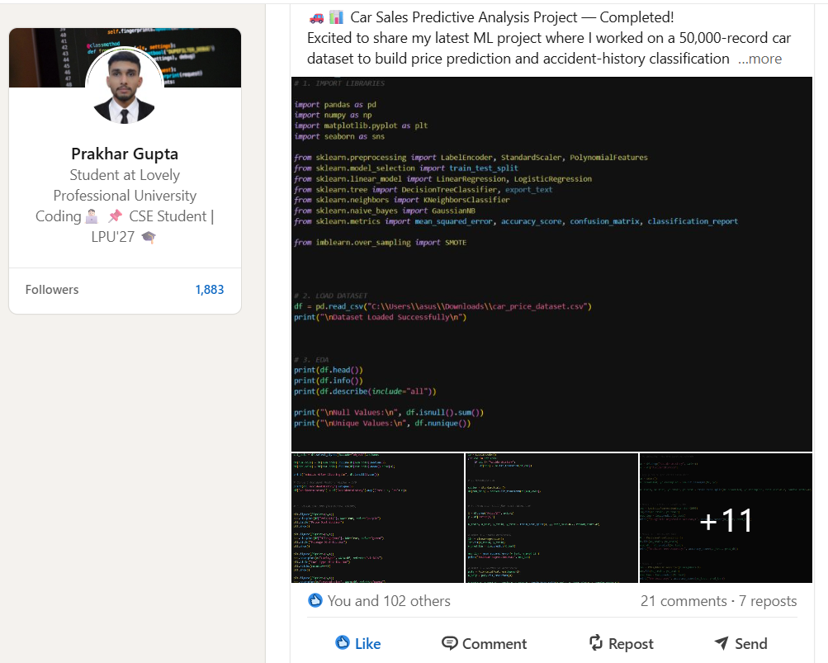
Project Snapshots :
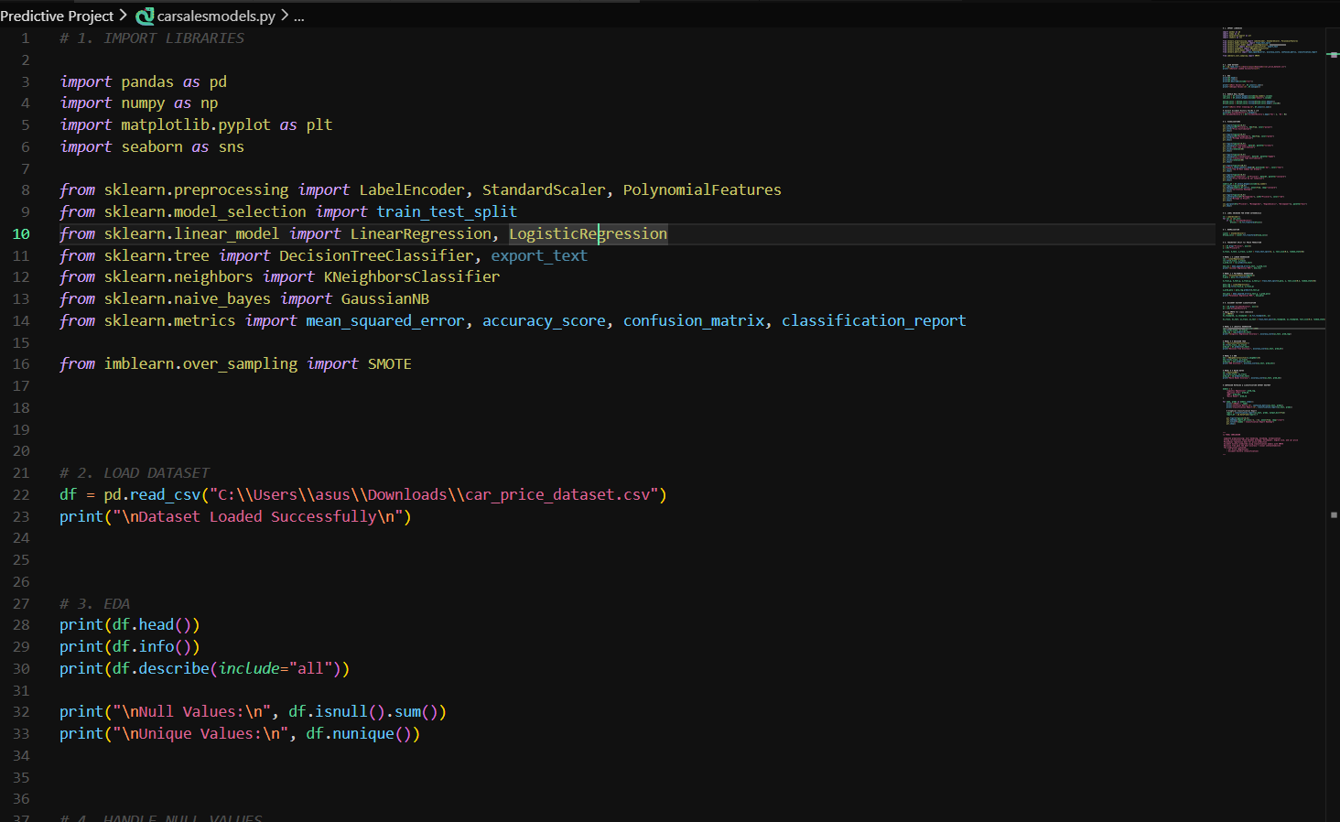
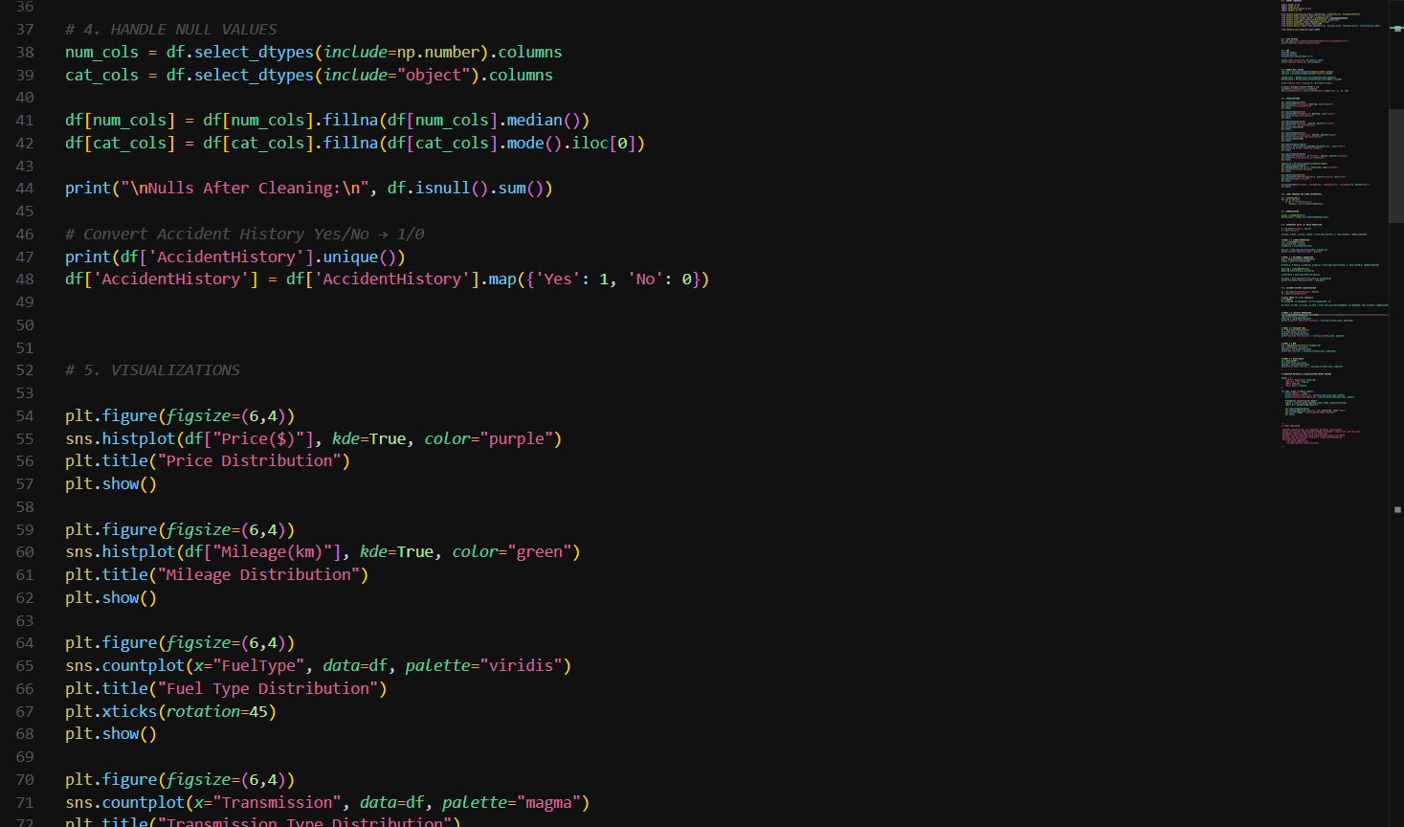

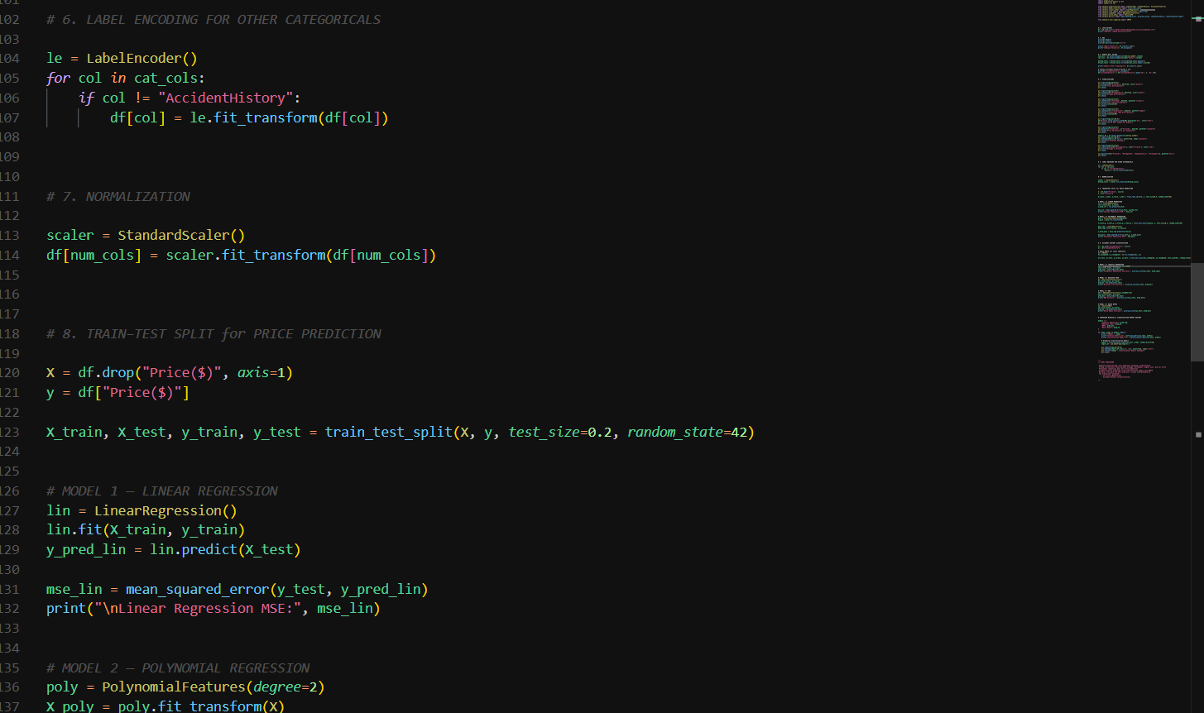
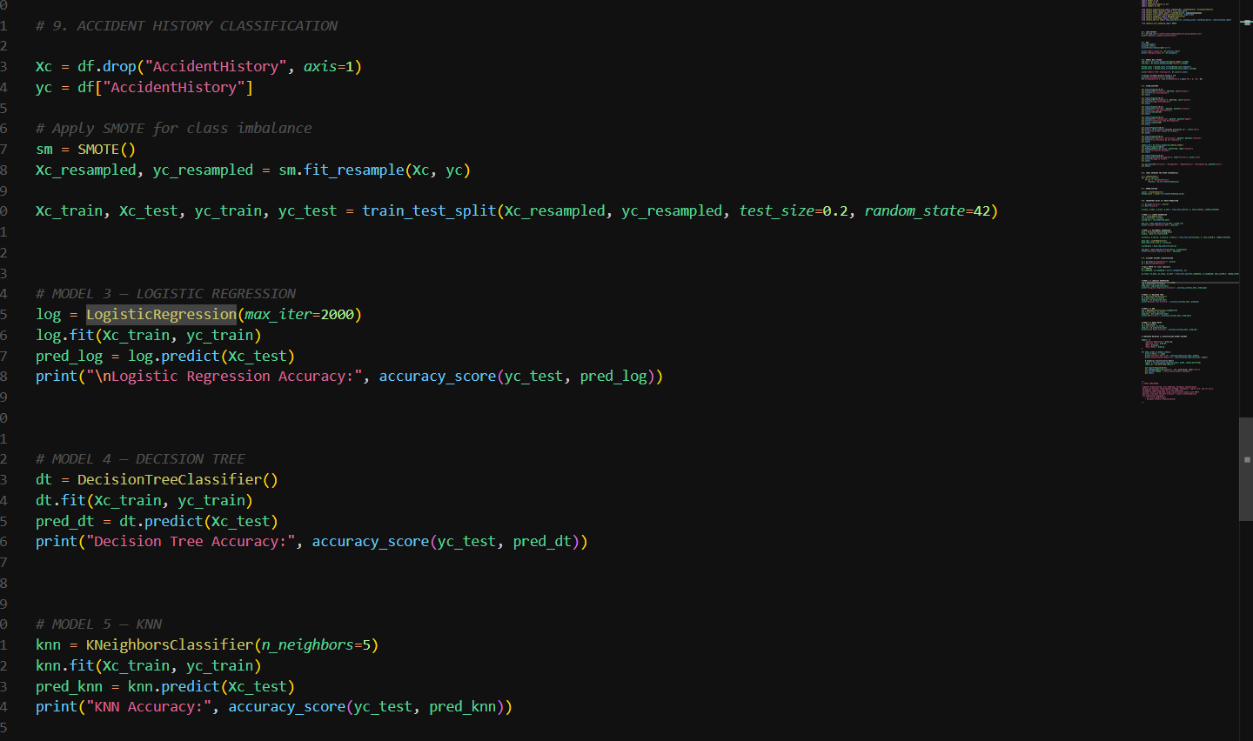
THANK YOU

