EXPLORATORY DATA ANALYSIS (EDA) REPORT

Project: Task 2 – Exploratory Data Analysis & Business Intelligence

Prepared By:
Prakhar Jaiswal

- Objective

The objective of this project is to analyze a cleaned sales dataset using Python and SQL. The analysis includes descriptive statistics, data visualization, SQL queries, and business insights to understand customer behavior and sales performance.

- Dataset Overview

Feature | Value
Number of Rows | 1000
Number of Columns | 13
Dataset Type | Customer Sales Data
The dataset contains customer details, product information, order details, and sales values. It was cleaned in Task 1 and used for analysis in this task.

- Data Cleaning Summary

Cleaning Performed | Description
Missing Age Values | Filled using median
Missing City Values | Replaced with "Unknown"
Date Format | Converted Order_Date into Date format
Feature Engineering | Created Customer_Age_Group

- Descriptive Statistics

Statistic | Value
Number of Records | 1000
Number of Columns | 13
Average Total Sales | 139399.44
Minimum Total Sales | 437.34
Maximum Total Sales | 493677.50
The dataset contains 1000 customer records. The average sales value is ₹139,399.44. The minimum recorded sale is ₹437.34, while the maximum sale is ₹493,677.50.

- Data Visualizations

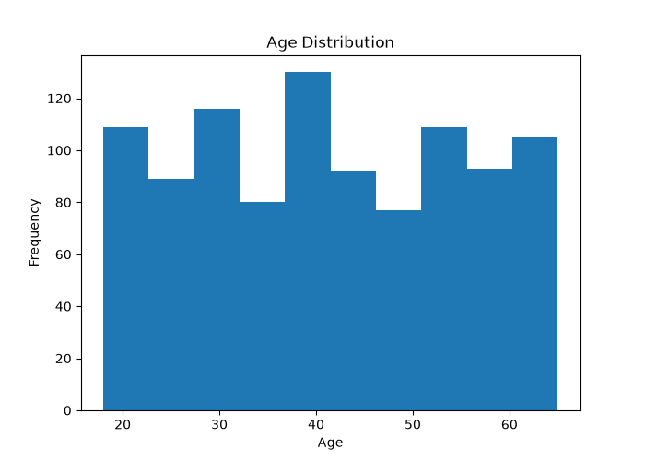

This histogram shows the distribution of customer ages in the dataset. Most customers belong to the middle-age group, indicating that this age range forms the majority of the customer base.

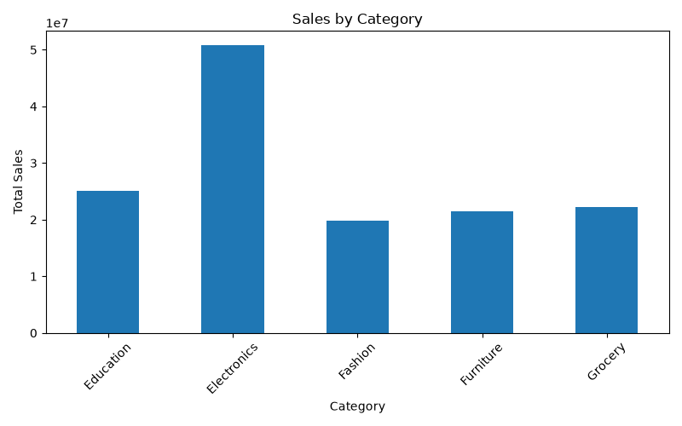

This bar chart compares the total sales across different product categories. It helps identify which categories generate the highest revenue and contribute most to overall sales.

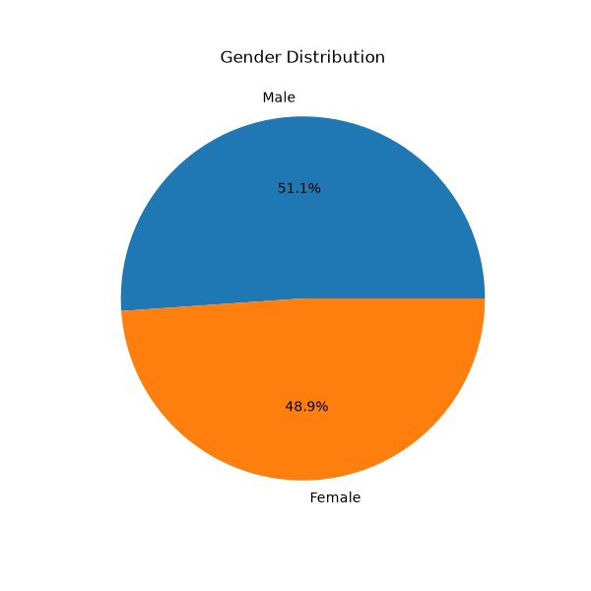

This pie chart illustrates the proportion of male and female customers in the dataset. It provides a quick overview of the customer gender distribution.

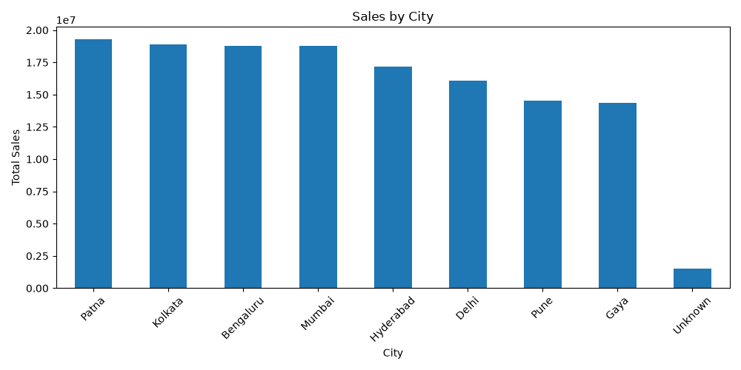

This chart displays the total sales generated from each city. It helps identify the cities with the highest sales and highlights regional sales performance.
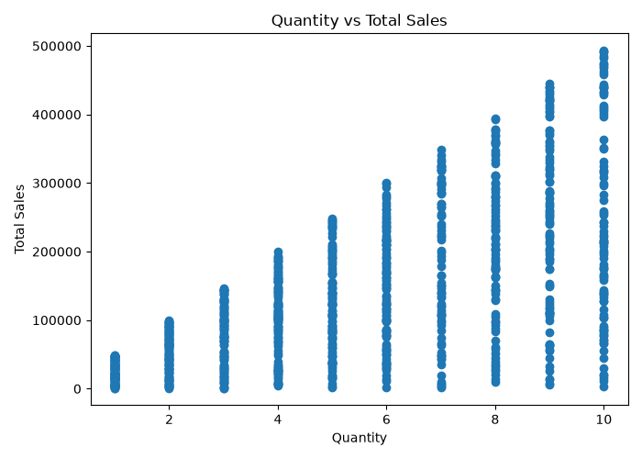

This scatter plot shows the relationship between the quantity of products purchased and the total sales amount. It helps determine whether larger quantities generally result in higher sales.

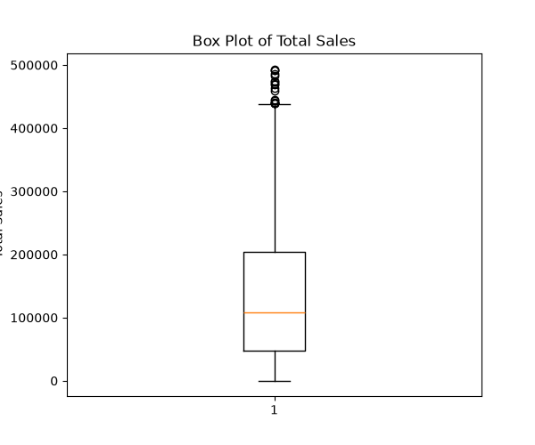

This box plot summarizes the distribution of total sales and helps identify the spread of the data, median sales value, and any unusually high or low sales (outliers).

- SQL Analysis

Query | Purpose
COUNT | Count total records
SUM | Calculate total revenue
AVG | Calculate average age
GROUP BY | Category-wise sales
ORDER BY | Top selling products
SQL queries were executed using SQLite to answer business-related questions such as total revenue, average customer age, category-wise sales, top-selling products, and city-wise revenue.

- Business Insights

- The dataset contains complete records with no missing values.
- Average sales are approximately ₹139,399.
- Some product categories contribute more to total revenue than others.
- Sales vary across different cities.
- Customer age groups can be used for targeted marketing.
- Revenue is concentrated among a limited number of products.

- Conclusion

Exploratory Data Analysis was successfully performed using Python, Pandas, Matplotlib, and SQLite. Statistical analysis, SQL queries, and visualizations helped identify important business insights and prepared the dataset for future decision-making and advanced analytics.

