ONLINE RESTAURANT WEB-APPLICATION

A Report for the Evaluation of MTE PBL Web-Tech

PRAKHAR GUPTA
17SCSE101657

Under the Supervision of
Dr. Sanjeev Kumar Prasad



School of Computing Science and Engineering
Greater Noida, Uttar Pradesh
ABSTRACT

Vintage Bites is an online restaurant management web application This system wake to provide service facility to restaurant and also to the customer. The services that are provided is food ordering and reservation table management by the customer through the system online, customer information management and waiter information management, menu information management and report. Main objective is to build the system to provide ordering and reservation service by online to the customer. With this system online, ordering and reservation management will become easier and systematic to replace traditional system where are still using paper. Furthermore, this system is applicable any time and where also customer. During the development of web-application, the methodology being used is Prototyping model. Each process during the development process is followed by each phases in Prototyping model. Software and hardware used are Microsoft Windows 10, VS Code, Netbeans and MySQL database. Furthermore, this project will develop for restaurants management and enhance business in system business by online. Others, this project to facilitate customer for make online ordering and reservation

INTRODUCTION
Overall Description
We will describe our Web Application in these modules as listed below:-
1)Reservation Module: Here, we make use of the module to book a table at a certain day in a restaurant. It will take the required details from the user and checking the availability of the tables left, the table will be booked for the customer and will receive a email of the confirmation.
2)Order Online Module: Here we have a form where a user can type in the quantity of the required food item he wants which will be added as the customer will go through the entire menu and reaching the end of it. The total will be given at the end and the order details will be saved in our database.
3)Login Module: Here the user can login and can check his/her previous order details. This will be checked from the email he has order the food and a list of past orders will come on the screen.
4)Contact Us Module: This module is used for giving the feedback from the restaurant and share their experience or any discomfort they might have felt or any services they want us to add. This
Module will take the details and store in the data base.

Purpose
The current system is paper based. Papers are used in restaurants for displaying the traditional menu cards, writing down the orders of customers, storing the records of customers. The disadvantages of paper-based system are that papers can get easily damaged by stain marks; they can be lost due to fire or accidents or can get lost in general. Hence, time and money is wasted. As traditional menu cards are paper based, any changes that need to be made in the menu will require reprinting of the entire menu card, leading to wastage. For small changes, reprinting the entire menu card is impossible. Changes in the menu card cannot be made dynamically. It is inefficient to access a particular record from the stack of papers. This system is time consuming. One has to call a waiter number of times till he notices it, and wait for him to arrive at their table to take their order. Also the waiter can misinterpret the customer’s order since he is writing the order on paper, and the case of serving a wrong dish is possible.
1. For placing any orders customers have to visit hotels or restaurants to know about food items and then place order and pay. In this method time and manual work is required.
2. While placing an order over the phone, customer lacks the physical copy of the menu item, lack of visual confirmation that the order was placed correctly.
3. Every restaurant needs certain employees to take the order over phone or in-person, to offer a rich dining experience and process the payment. In today’s market, labor rates are increasing day by day making it difficult to find employees

Scope
The groups of user that had been identified to use the system are customer and administrator.
Customer This user will register to be a member to use the online system of this online restaurant management system (ORMS). This online ordering divided into two type of customer, it is customer dine-in ordering and takeaway ordering. For dine-in ordering, customer will view menu, make online ordering and make a reservation table. But take - away ordering, customer can view menu and online ordering without reservation table. After customer make online ordering, customer can take ordering the date that customer was choose during make online ordering. Event though, customer must confirm online ordering with restaurant three days before customer take the ordering for dine-in customer and for take-away customer will be confirm one hour before it whether by email or phone. Administrator is the person who will manage the entire system. This type of user will also do maintenance and control the application of this system. Administrator takes a responsibility to register new customer, register new waiter, register new menu into database, and etc.

USE-CASE DIAGRAM
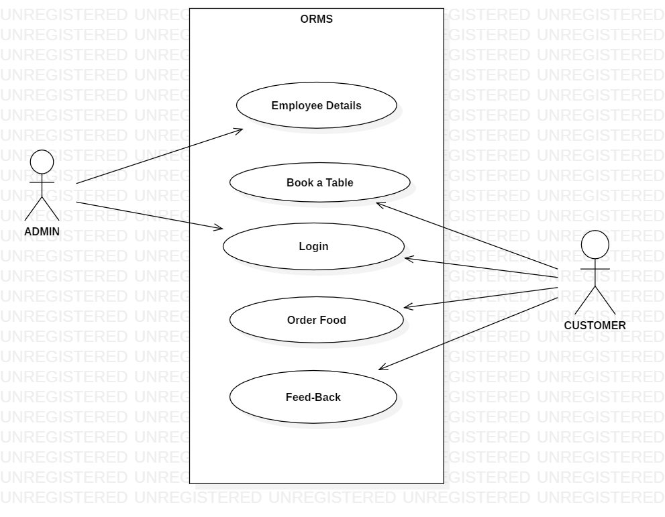
SIMPLE FLOW CHART
