**Q1.The GitHub URL containing the code that was analyzed**

**Ans** <https://github.com/Prakhar564/Static_code>

**Q2.The name and output of the static code analyzer tool you used?**

**Ans** Name-pylint

I**nitial Output: Code rate was 0/10**

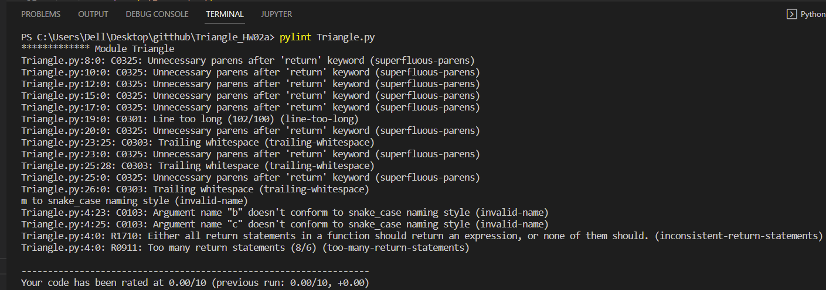

**Final output: Code rate was 9.0/10**

**Q3.The name and output of the code coverage tool you use?**

**Ans** Name-coverage.py

**Initial report: Coverage was 96%**

**Final report: Coverage was 94%**

Q4. Identify both your original test cases and new test cases that you created to achieve at least 80% code coverage.

Ans The original test cases had 96% coverage and after making changes to the code I ran the test cases and they had 94% coverage so I didn’t make changes to the test cases