Deep Learning Architectures for Equitable and Accurate
Skin Disease Diagnosis

Synopsis
Deep Learning Lab Project
[CSE-3223]

Submitted By

Devansh Singh, Reg No: 230962208
Prakhar Umrao, Reg No: 230962210
Komaravolu Aashrith Saradhi , Reg No: 230962196



SCHOOL OF COMPUTER SCIENCE AND ENGINEERING
MANIPAL INSTITUTE OF TECHNOLOGY,
MANIPAL ACADEMY OF HIGHER EDUCATION
15th February 2026

Deep Learning Architectures for Equitable and Accurate Skin Disease Diagnosis

Devansh Singh¹, Prakhar Umrao², Komaravolu Aashrith Saradhi³
¹School of Computer Science and Engineering, MIT Manipal, India
²School of Computer Science and Engineering, MIT Manipal, India
³School of Computer Science and Engineering, MIT Manipal, India
¹devanshs2809@gmail.com; ²prakhar.umrao98@gmail.com; ³saradhiaashrith@gmail.com

Abstract- Skin diseases affect a large portion of the population, yet early diagnosis remains difficult due to limited availability of dermatologists, especially in rural and semi-urban regions. Many individuals rely on self-inspection or delayed medical consultation, which may lead to worsening conditions. Existing automated diagnosis systems often perform well only on high-quality clinical or dermoscopic images and fail when applied to real-world smartphone images captured under varying lighting conditions, camera quality, and diverse skin tones. Moreover, many models are computationally heavy and unsuitable for mobile deployment.
This project proposes a lightweight deep learning-based skin disease pre-screening system designed specifically for real-world usability. The system uses transfer learning on convolutional neural networks trained with smartphone-like augmented images to improve robustness across environments. A confidence scoring mechanism is incorporated to indicate prediction reliability, helping users decide whether professional medical consultation is necessary. The primary goal is to provide an accessible early warning tool that assists in timely medical attention. The proposed framework focuses on deployability, fairness, and practical usability on resource-constrained mobile devices.

Keywords- Skin Disease Detection, Deep Learning, Transfer Learning, Convolutional Neural Networks, Mobile Health, Medical Image Classification, Confidence Scoring, Tele-dermatology

- Introduction

The skin, as the human body’s largest organ, serves as the primary immunological and physical barrier against environmental stressors, pathogens, and ultraviolet (UV) radiation, making it susceptible to a wide range of dermatological conditions ranging from chronic inflammatory disorders such as eczema and psoriasis to life-threatening malignancies such as melanoma. The global burden of skin diseases is substantial, affecting a large proportion of the population across diverse socioeconomic and geographic settings, with early detection playing a critical role in improving treatment outcomes. However, conventional diagnostic pathways rely primarily on visual inspection and dermoscopy conducted by trained dermatologists, a process that is inherently subjective and prone to inter-observer variability. Limited accessibility to specialized dermatological care in rural and low-resource regions further contributes to delayed diagnosis and treatment, creating a persistent diagnostic gap. These limitations have motivated the development of automated screening systems capable of supporting early detection and improving access to preliminary diagnostic assistance outside specialized clinical environments.
To address these challenges, Computer-Aided Diagnosis systems have evolved from traditional machine learning approaches based on handcrafted features toward Deep Learning paradigms capable of automatically learning hierarchical feature representations from raw image data. Convolutional Neural Networks have emerged as the dominant methodology for dermatological image analysis, demonstrating diagnostic performance comparable to expert clinicians when combined with transfer learning and advanced architectural designs [2], [5], [10]. At the same time, the need for real-world deployment has driven research toward efficient and lightweight architectures suitable for Mobile Health applications. Architectures such as MobileNetV3 significantly reduce computational complexity through depth-wise separable convolutions and optimized design strategies, enabling accurate and low-latency inference on mobile devices while maintaining strong classification performance [1], [9]. These developments support the vision of scalable, point-of-care diagnostic tools that extend dermatological screening capabilities to resource-constrained environments.
Despite architectural advances, several challenges continue to limit reliable real-world deployment of automated skin disease diagnosis systems. The sim-to-real gap remains a major concern, as models trained on high-quality dermoscopic datasets often perform poorly on variable-quality smartphone images containing noise, lighting variation, and artifacts. Datasets such as PAD-UFES-20, which consist of smartphone-acquired clinical images accompanied by patient metadata, are therefore essential for improving model generalization in realistic scenarios [12]. Furthermore, clinical diagnosis typically incorporates contextual patient information, motivating multimodal approaches that combine visual features with metadata to improve diagnostic accuracy and better replicate clinical reasoning processes [4]. Additional concerns include data scarcity, class imbalance, and demographic bias, particularly the underrepresentation of darker skin tones in existing datasets, which raises important fairness and reliability issues [6], [7]. Recent work has explored generative data augmentation techniques, including Denoising Diffusion Probabilistic Models, to synthesize diverse training samples and improve performance on underrepresented classes [8], [11]. In this context, the proposed work aims to develop an end-to-end, lightweight, and multimodal deep learning framework for skin disease classification that integrates efficient architectures, smartphone-based datasets, metadata fusion, and synthetic augmentation to provide a reliable and equitable pre-screening tool capable of bridging the gap between expert dermatological care and underserved populations.

- Literature Survey

The landscape of skin disease diagnosis has evolved from traditional image processing to sophisticated deep learning frameworks, characterized by a shift toward hybrid architectures, synthetic data augmentation, and fairness-aware computing. Recent literature demonstrates a concerted effort to optimize computational efficiency for mobile deployment while simultaneously enhancing diagnostic precision through multi-modal data fusion.
Pardede et al. investigated the performance of lightweight architectures for facial skin disorder classification using MobileNetV3, a computationally efficient convolutional neural network (CNN) [1]. Their study classified skin conditions into multiple categories, including oily, dry, and acne-prone skin, and highlighted the importance of preprocessing techniques such as resizing and normalization. The results demonstrated rapid convergence and high accuracy, making MobileNetV3 highly suitable for mobile applications where computational resources are limited.
Building on the need for robust feature extraction, Badr et al. proposed a multi-model deep learning architecture utilizing the Xception network and transfer learning [2]. Their approach addressed a broad range of skin conditions and demonstrated that leveraging pre-trained weights from large-scale datasets such as ImageNet significantly improves performance in medical imaging tasks where labeled data is scarce.
To address the temporal and sequential nature of feature learning, Vasudevan et al. introduced a hybrid model combining MobileNetV3 with Long Short-Term Memory (LSTM) networks [3]. While CNNs effectively extract spatial features, the addition of LSTM layers enabled contextual feature retention during processing. Evaluated on the DermNet dataset, this hybrid approach achieved improved sensitivity and specificity compared to standalone CNN architectures.
In the domain of architecture comparison, Amien et al. conducted a comparative study of ConvNeXt, MobileNetV3, and EfficientNet using the OSEMN framework (Obtain, Scrub, Explore, Model, Interpret) [9]. Their findings indicated that while ConvNeXt achieved high accuracy, MobileNetV3 and EfficientNet offered a better balance between performance and computational efficiency, reinforcing the growing emphasis on lightweight models for clinical support systems.
Addressing the integration of non-visual data, El Mertahi et al. developed a hybrid framework combining Vision Transformers (ViT) with XGBoost using smartphone images and clinical metadata from the PAD-UFES-20 dataset [4]. By integrating image features with patient information such as age and gender, their approach achieved significantly improved diagnostic accuracy, demonstrating the effectiveness of multi-modal data fusion in realistic clinical environments.
Similarly, Gulzar et al. proposed a hybrid deep transfer learning model that fused DenseNet121 and EfficientNetB0 by concatenating feature maps from both architectures [5]. This fusion enabled the model to capture both fine-grained and high-level semantic features, achieving superior performance compared to individual models and highlighting the effectiveness of ensemble and fusion strategies.
Focusing on feature recalibration, Yasir and Kim introduced an Attention-Based Deep Feature Aggregation Network incorporating squeeze-and-excitation (SE) blocks for channel-wise attention [10]. Their approach enabled the network to emphasize discriminative features while suppressing irrelevant information, improving classification performance across datasets such as ISIC-2019 and HAM10000.
To address data scarcity, Kim et al. proposed a diffusion-based data augmentation technique that enhanced Stable Diffusion models to generate high-fidelity synthetic skin disease images [8]. Their work demonstrated that augmenting training datasets with synthetic images improves performance on underrepresented classes, validating generative AI as a powerful tool for mitigating dataset imbalance.
Complementing augmentation strategies, Yang et al. utilized Denoising Diffusion Probabilistic Models (DDPM) for segmentation tasks in a two-stage framework [11]. Synthetic image generation was first used to expand the dataset, followed by segmentation model training, resulting in improved segmentation accuracy even with limited labeled data.
Addressing ethical considerations, Tjiu and Lu conducted a systematic review on the equity and generalizability of AI-based dermatological systems [6]. Their findings highlighted persistent disparities in performance across skin tones and imaging modalities, emphasizing the need for diverse datasets and rigorous external validation. Related work by Ulrich et al. further explored automated skin tone analysis beyond the traditional Fitzpatrick scale, reinforcing the importance of fairness-aware AI development in dermatology [7].
Finally, Pacheco et al. introduced the PAD-UFES-20 dataset, consisting of smartphone-acquired clinical images accompanied by patient metadata [12]. Unlike dermoscopy-focused datasets, this resource enables the development of “sim-to-real” AI systems suitable for teledermatology and primary healthcare environments.
In summary, the literature reveals a mature ecosystem of deep learning models for dermatology, progressing from conventional CNN architectures to hybrid and transformer-based systems. While high accuracy has been achieved on benchmark datasets, current research increasingly focuses on data-centric challenges such as metadata integration, synthetic data generation, and fairness evaluation across diverse populations and imaging conditions.

- Research Gap

- Data Scarcity and Class Imbalance: Existing datasets (e.g., HAM10000) are heavily imbalanced, with rare skin conditions underrepresented. This leads to models becoming biased toward frequently occurring classes and reduces their ability to generalize to less common diseases.
- • Modality Mismatch (Sim-to-Real Gap): Most high-performing models are trained on high-quality dermoscopic images but fail when applied to noisy, variable-quality smartphone images commonly used in real-world tele-dermatology settings.
- • Demographic Bias and Fairness: Current datasets and models predominantly represent fair skin types (Fitzpatrick I–III). There is limited performance validation and optimization for darker skin tones, which may result in inequitable healthcare outcomes.
- • Limited Metadata Integration: While some studies incorporate metadata, robust fusion mechanisms that effectively combine clinical history (e.g., smoking status, family history) with visual data are not yet standard in deployed applications.
- • Lack of Uncertainty Quantification: Many models produce “black box” predictions without confidence calibration. This is critical in clinical decision-support systems, as overconfident predictions on out-of-distribution data may lead to misdiagnoses.

- Objectives

- To develop a smartphone-based skin disease pre-screening system using deep learning for early detection assistance.
- To classify common skin conditions from captured images using a transfer-learning Convolutional Neural Network (CNN).
- To improve robustness of the model by training with smartphone-like augmented images simulating different lighting conditions, backgrounds, and camera qualities.
- To ensure reliable predictions across diverse skin tones and real-world image variations.
- To incorporate a confidence scoring mechanism that indicates prediction reliability and suggests whether medical consultation is necessary.
- To design a lightweight and deployable model suitable for mobile devices and low computational environments.
- To provide users with an accessible preliminary diagnostic aid that supports, but does not replace, professional dermatological evaluation.
.

V. Proposed Methodology

The proposed framework follows a comprehensive 9-phase pipeline engineered to bridge the domain gap between clinical research and real-world tele-dermatology. By integrating rigorous data harmonization, curriculum-based transfer learning, knowledge distillation, and multi-modal feature fusion, the system yields an equitable, lightweight, and highly accurate diagnostic tool.
A. Phase 1: Data Readiness & Splitting:
To ensure robust generalization and prevent model bias, the foundational phase focuses on harmonizing three distinct datasets: HAM10000, Fitzpatrick 17k, and PAD-UFES-20.
Data Harmonization: Images across all datasets undergo standardized resizing and normalization. Labels are mapped to a unified dermatological dictionary to resolve conflicting medical terminologies.
Lesion-Wise Splitting: A critical step to prevent data leakage. Clinical datasets often contain multiple images of the exact same physical lesion from different angles. Standard random splitting could place images of the same lesion in both the training and testing sets, artificially inflating accuracy. A strict lesion-wise split guarantees that the model evaluates entirely unseen cases, ensuring uniform and clinically valid performance metrics.
B. Phases 2-4: The Teacher Pipeline:
To overcome the "sim-to-real gap," a high-capacity CNN (e.g., DenseNet) is trained using a curriculum learning approach before teaching the mobile architecture.
Phase 2 (Pretraining): The Teacher model is initialized with ImageNet weights to leverage foundational feature extraction. It is then trained on the harmonized clinical datasets (HAM10000 + Fitzpatrick 17k). During this phase, heavy image augmentation is applied to simulate smartphone conditions (e.g., adding Gaussian noise, altering brightness, and simulating motion blur).
Phase 3 (Fine-Tuning): The pretrained Teacher is subsequently fine-tuned exclusively on the PAD-UFES-20 smartphone dataset. To address inherent class imbalances (where common lesions heavily outnumber rare malignancies), class weights and Focal Loss are applied. Focal Loss forces the model to heavily penalize misclassifications on hard-to-predict minority classes while down-weighting easy, majority examples.
Phase 4 (Teacher Model): The output of this pipeline is a well-calibrated, high-accuracy Teacher model that acts as an expert in both diverse clinical features and noisy smartphone image domains.
C. Phases 5-6: Distillation & Fusion:
This stage compresses the heavy Teacher model into a deployable format while integrating vital patient context.
Phase 5 (Distillation): A lightweight MobileNet architecture (the "Student") is trained via Knowledge Distillation. The frozen Teacher model processes the PAD-UFES-20 dataset and outputs soft probability distributions (logits). The Student is trained to simultaneously match the ground-truth labels and mimic these logits, transferring the Teacher's "dark knowledge" (complex class relationships) into the efficient mobile network.
Phase 6 (Multi-Modal Fusion): Dermatologists do not diagnose visually in a vacuum; they use patient history. The visual feature vectors extracted by the MobileNet are concatenated with processed clinical metadata from the PAD-UFES-20 dataset (e.g., patient age, lesion location). This fused vector is passed through a final dense classification layer.
D. Phases 7-9: Explainability, Evaluation, and Deployment:
The final stages ensure the model is trustworthy, rigorously tested, and ready for edge devices.
Phase 7 (Explainability): Grad-CAM (Gradient-weighted Class Activation Mapping) is integrated to generate heatmaps over the input images. This provides visual proof of which spatial regions of the skin lesion drove the model's prediction, ensuring the model is not relying on background artifacts.
Phase 9 (Evaluation): Standard accuracy is insufficient for imbalanced medical data. The model is rigorously evaluated using F1-Score, ROC-AUC, and Balanced Accuracy across diverse demographic subgroups to ensure fairness and clinical safety.
Phase 8 (Deployment): Upon passing evaluation, the final MobileNet + Fusion framework undergoes post-training quantization (converting 32-bit floating-point weights to 8-bit integers) to further reduce memory footprint, enabling seamless export for mobile deployment.
VI. Block Diagram
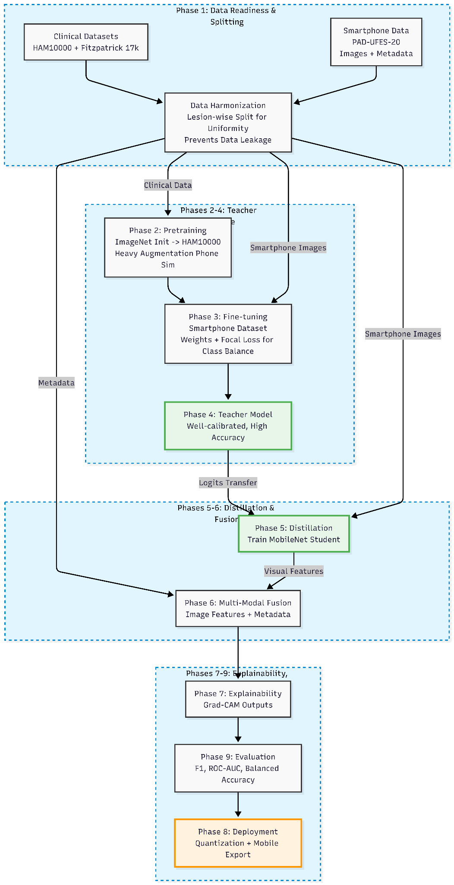
VI. Algorithmic Implementation (Pseudocode)

Dataset:
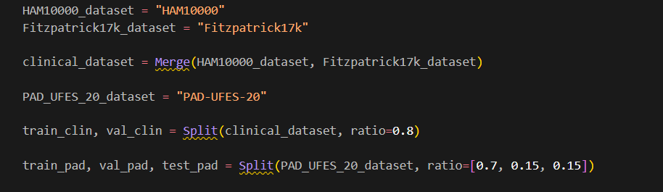

Image transformations:
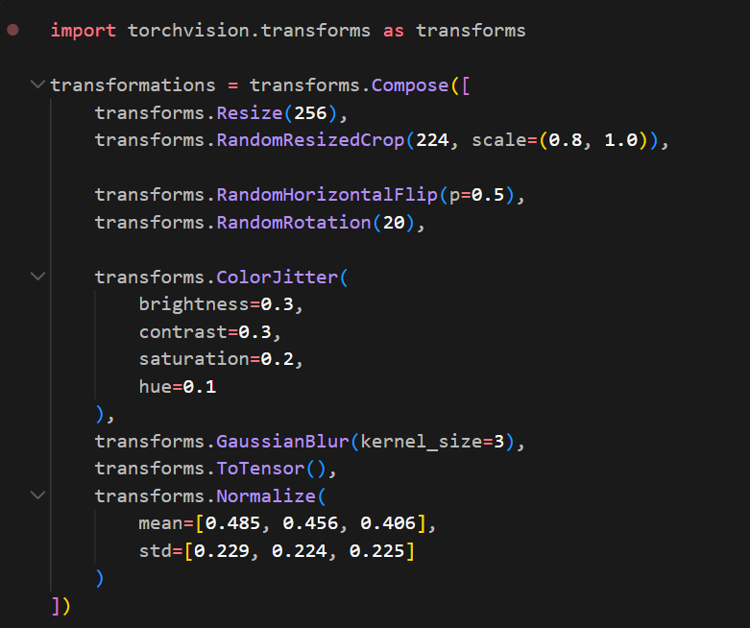

Densenet121 Model (Teacher model):
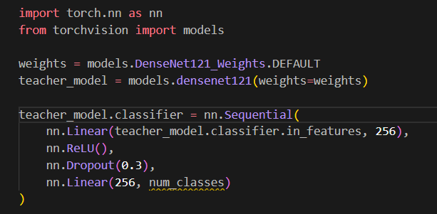
Mobilenet v3 Model (student model):
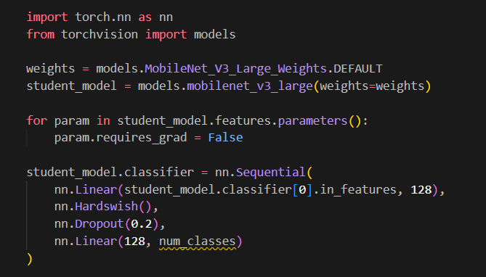

VII. References
[1] H. Pardede, A. S. Dharma, J. Amalia, D. Largo, and C. A. P. Sihite, “Performance Analysis of MobileNetV3-based Convolutional Neural Network for Facial Skin Disorder Classification,” Jurnal RESTI (Rekayasa Sistem dan Teknologi Informasi), vol. 8, no. 6, pp. 701–709, Dec. 2024. https://doi.org/10.29207/resti.v8i6.5982
[2] M. Badr, A. Elkasaby, M. Alrahmawy, and S. El-Metwally, “A Multi-model Deep Learning Architecture for Diagnosing Multi-class Skin Diseases,” Journal of Imaging Informatics in Medicine, vol. 38, no. 3, pp. 1776–1795, Jun. 2025. https://link.springer.com/article/10.1007/s10278-024-01300-w
[3] A. Vasudevan, C. Jackulin, H. Khalingarajah, N. Raja, and R. Prabhakaran, “A Reliable and Effective Approach for Computerized Skin Disease Classification Using MobileNetV3 and LSTM,” Preprints.org, 2025. https://www.preprints.org/manuscript/202508.0242/v1
[4] A. El Mertahi, H. Ezzine, S. Douzi, and K. Douzi, “AI-driven skin cancer detection from smartphone images: A hybrid model using ViT, adaptive thresholding, black-hat transformation, and XGBoost,” PLOS ONE, vol. 20, no. 7, e0328402, Jul. 2025.https://doi.org/10.1371/journal.pone.0328402
[5] Y. Gulzar et al., “Next-generation approach to skin disorder prediction employing hybrid deep transfer learning,” Frontiers in Big Data, vol. 8, 1503883, Feb. 2025.https://doi.org/10.3389/fdata.2025.1503883
[6] J.-W. Tjiu and C.-F. Lu, “Equity and Generalizability of Artificial Intelligence for Skin-Lesion Diagnosis Using Clinical, Dermoscopic, and Smartphone Images: A Systematic Review and Meta-Analysis,” Medicina, vol. 61, no. 12, 2186, Dec. 2025.https://doi.org/10.3390/medicina61122186
[7] P. Ulrich, A. Zink, T. Biedermann, and S. Sitaru, “Beyond Fitzpatrick: automated artificial intelligence-based skin tone analysis in dermatological patients,” NPJ Digital Medicine, vol. 8, no. 378, Jun. 2025.https://doi.org/10.1038/s41746-025-01770-4
[8] M. Kim et al., “Diffusion-based skin disease data augmentation with fine-grained detail preservation and interpolation for data diversity,” PLOS ONE, vol. 20, no. 10, e0331404, Oct. 2025.https://doi.org/10.1371/journal.pone.0331404
[9] F. M. Amien, D. Kurniawan, A. Junaidi, and B. Hermanto, “A Comparative Study of CNN Architectures: ConvNeXt, MobileNetV3, and EfficientNet for Oral Disease Diagnosis,” Jurnal Pepadun, vol. 6, no. 1, pp. 81–91, Apr. 2025.https://doi.org/10.23960/pepadun.v6i1.267
[10] S. M. Yasir and H. Kim, “Attention-Based Deep Feature Aggregation Network for Skin Lesion Classification,” Electronics, vol. 14, no. 12, 2364, Jun. 2025. https://doi.org/10.3390/electronics14122364
[11] P. Yang, Z. Chen, X. Sun, and X. Deng, “Better with Less: Efficient and Accurate Skin Lesion Segmentation Enabled by Diffusion Model Augmentation,” Electronics, vol. 14, no. 17, 3359, Aug. 2025. https://doi.org/10.3390/electronics14173359
[12] A. G. C. Pacheco et al., “PAD-UFES-20: A skin lesion dataset composed of patient data and clinical images collected from smartphones,” Data in Brief, vol. 32, 106221, Aug. 2020. https://doi.org/10.1016/j.dib.2020.106221

