Deep Learning Architectures for Equitable and Accurate Skin Disease Diagnosis
Devansh Singh, Prakhar Umrao, Komaravolu Aashrith Saradhi
Department of Computer Science and Engineering, Manipal Institute of Technology, Manipal
CSE-3223: Deep Learning Lab | Academic Year 2025-26
Abstract—This project presents an offline-capable, mobile-deployable skin disease classification system powered by EfficientNet-B2, trained via a 3-stage progressive transfer learning pipeline across five dermatological datasets (HAM10000, ISIC 2019, PAD-UFES-20, Fitzpatrick17k-C, DermNet). The system classifies skin lesion images into 16 unified disease categories spanning neoplastic and inflammatory conditions relevant to Indian clinical settings. We incorporate Fitzpatrick Skin Type (FST) diversity and employ experience replay to mitigate catastrophic forgetting during multi-stage training. The final model achieves 71.1% accuracy on HAM10000 (Stage 1), 67.7% on the combined ISIC+PAD test set (Stage 2), and demonstrates improved skin tone robustness with a composite score of 0.364 at Stage 3. The model is exported via PyTorch Mobile (<50 MB) for fully offline smartphone deployment.
Keywords—skin disease classification, EfficientNet, transfer learning, experience replay, Fitzpatrick skin type, mobile deployment, dermatological AI

I. INTRODUCTION
Skin diseases affect an estimated 1.8 billion people globally [1]. In rural India, access to dermatological expertise is severely limited—approximately 1 dermatologist per 100,000 population—leading to delayed diagnoses of malignant and inflammatory conditions [2]. Early detection of melanoma (MEL), basal cell carcinoma (BCC), and squamous cell carcinoma (SCC) is critical for patient survival, yet requires specialized expertise unavailable in primary healthcare settings.
Deep learning has shown remarkable promise in automated dermatological diagnosis, with convolutional neural networks (CNNs) achieving dermatologist-level performance on curated benchmarks [3]. However, critical challenges remain: (1) the domain gap between dermoscopic training images and smartphone photographs; (2) demographic bias from datasets predominantly featuring light-skinned subjects (Fitzpatrick Skin Types I-II); (3) the need for offline-capable models; and (4) the requirement for a unified model handling both neoplastic and inflammatory conditions relevant to Indian populations.
This project addresses these challenges through a 3-stage progressive transfer learning pipeline using EfficientNet-B2 [4], systematically bridging dermoscopy to clinical photography. We incorporate Fitzpatrick Skin Type (FST) diversity via the Fitzpatrick17k-C dataset [5], employ experience replay [6] to mitigate catastrophic forgetting [7], and produce a compact model deployable via PyTorch Mobile. The system classifies images into 16 unified disease categories with a safety-first clinical decision support layer that flags potential malignancies for referral.
II. LITERATURE REVIEW
A. Deep Learning in Dermatology
Esteva et al. [3] demonstrated CNN-based skin cancer classification at dermatologist-level using Inception-v3 on 129,450 images. Subsequent work explored ResNet [8], DenseNet [9], and EfficientNet [4], with EfficientNet variants achieving state-of-the-art accuracy through compound scaling of depth, width, and resolution.
B. Transfer Learning and Multi-Stage Training
Transfer learning from ImageNet-pretrained models is standard for medical imaging [10]. Progressive transfer learning, with sequential adaptation through increasingly specific domains, improves over direct fine-tuning [11]. Curriculum learning strategies further enhance convergence in skin lesion classification [12].
C. Catastrophic Forgetting and Experience Replay
Multi-stage training risks catastrophic forgetting, where fine-tuning on new data erases previously learned representations [7]. Experience replay addresses this by interleaving samples from previous stages during subsequent training [6], and has been successfully applied in medical image classification to maintain cross-domain performance.
D. Fairness and Skin Tone Bias
Dermatological AI systems exhibit significant performance disparities across skin tones [13]. The Fitzpatrick17k dataset [5] provides FST-annotated images across 114 conditions, enabling bias evaluation. Daneshjou et al. [14] demonstrated up to 20% performance degradation on darker skin tones in existing classifiers.
E. Mobile Deployment and Key Datasets
Mobile deployment requires model size <50 MB with sub-second inference [15]. Key datasets include HAM10000 (10,015 dermoscopic images) [17], ISIC 2019 (25,331 images) [18], PAD-UFES-20 (2,298 smartphone images) [19], Fitzpatrick17k-C, and DermNet. PyTorch Mobile provides a direct path from research to deployment [16].
III. RESEARCH GAPS
This project addresses the following gaps:
• Domain Gap: Few studies systematically bridge the domain gap from dermoscopy to smartphone photography through progressive training strategies.
• Demographic Bias: Training datasets overrepresent FST I-III, creating classifiers with reduced accuracy for darker skin tones prevalent in India.
• Unified Taxonomy: Existing systems rarely handle neoplastic and inflammatory conditions within a single unified model.
• Offline Deployment: Cloud-based AI services are impractical in rural India due to unreliable internet connectivity.
• Catastrophic Forgetting: Replay-based continual learning is underexplored in multi-stage dermatological model training.
IV. OBJECTIVES
• Design a 3-stage progressive transfer learning pipeline adapting dermoscopic models to clinical and smartphone imagery.
• Develop a unified 16-class taxonomy covering neoplastic and inflammatory conditions relevant to Indian populations.
• Incorporate FST diversity via Fitzpatrick17k-C with FST-weighted sampling to reduce performance disparities across skin tones.
• Implement experience replay to mitigate catastrophic forgetting across training stages.
• Deploy on mobile via PyTorch Mobile with model size <50 MB for fully offline operation.
• Integrate a safety-first referral layer that flags potential malignancies for clinical evaluation.
V. PROPOSED METHODOLOGY
A. Architecture Selection
The mobile deployment constraint (<50 MB) and need for fine-grained lesion detail guided architecture selection. Table I compares candidate architectures evaluated for this project.
TABLE I: COMPARISON OF CANDIDATE ARCHITECTURES
Architecture | Params (M) | Input Size | Size (MB) | ImageNet Top-1 (%) | Mobile Fit
MobileNetV3-Large | 5.4 | 224x224 | ~22 | 75.2 | Excellent
EfficientNet-B0 | 5.3 | 224x224 | ~21 | 77.1 | Good
EfficientNet-B1 | 7.8 | 240x240 | ~31 | 79.1 | Good
EfficientNet-B2 * | 9.2 | 260x260 | ~36 | 80.1 | Good
EfficientNet-B3 | 12.0 | 300x300 | ~48 | 81.6 | Near Limit
ResNet-50 | 25.6 | 224x224 | ~98 | 76.1 | Too Large
DenseNet-121 | 8.0 | 224x224 | ~30 | 74.4 | Good
ConvNeXt-Tiny | 28.6 | 224x224 | ~110 | 82.1 | Too Large

EfficientNet-B2 (*selected) offers the optimal trade-off: its 260x260 input captures fine-grained lesion morphology compared to the 224x224 alternatives; 80.1% ImageNet Top-1 accuracy provides a strong transfer learning foundation (3% higher than B0, 5.7% higher than DenseNet-121); and the ~36 MB model size fits within the 50 MB budget. EfficientNet-B3 (48 MB) leaves insufficient headroom for export overhead, while MobileNetV3-Large's 75.2% accuracy is too low for safety-critical medical screening.
B. System Architecture
The system comprises an EfficientNet-B2 backbone (ImageNet-pretrained, 1,408-dimensional feature vectors) with a custom classification head: AdaptiveAvgPool2d(1) followed by BatchNorm1d(1408), Dropout(p=0.3), and Linear(1408, 16). Fig. 1 illustrates the complete architecture.
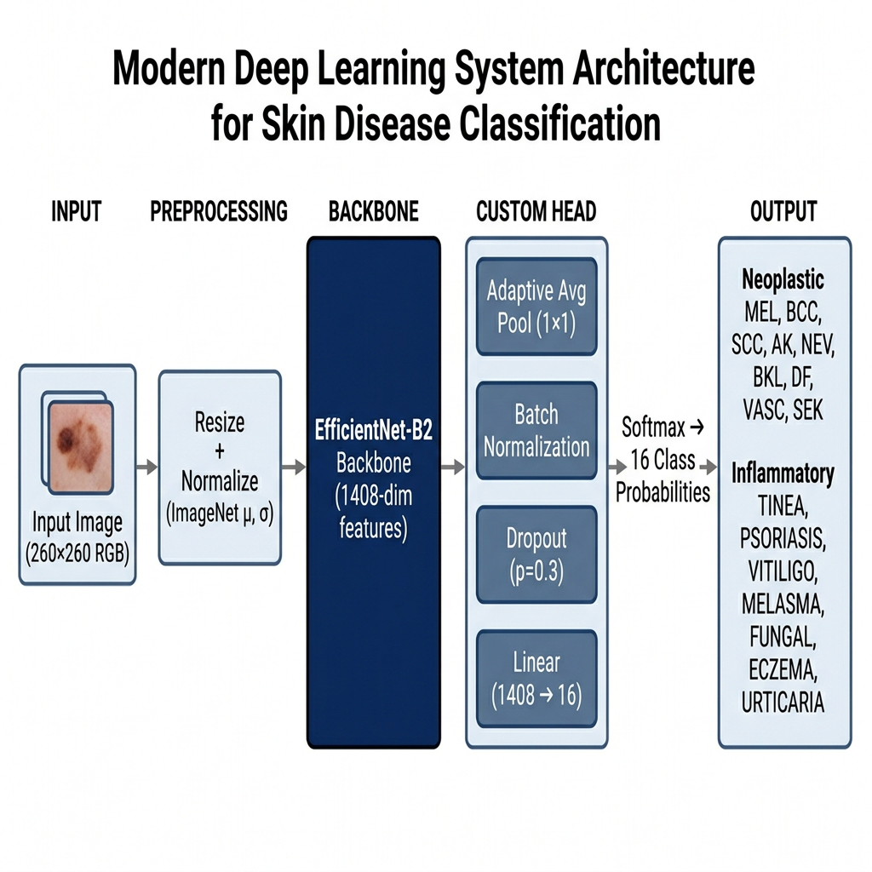
Fig. 1. EfficientNet-B2 system architecture with 16-class output head.
C. Unified 16-Class Taxonomy
Five datasets with diverse label schemes are harmonized into 16 clinically meaningful categories (Table II), divided into neoplastic (9 classes covering malignant, pre-malignant, and benign lesions) and inflammatory (7 classes covering conditions prevalent in Indian clinical settings).
TABLE II: UNIFIED 16-CLASS DISEASE TAXONOMY
Code | Full Name | Category
MEL | Melanoma | Malignant
BCC | Basal Cell Carcinoma | Malignant
SCC | Squamous Cell Carcinoma | Malignant
AK | Actinic Keratosis | Pre-malignant
NEV | Melanocytic Nevus | Benign
BKL | Benign Keratosis | Benign
DF | Dermatofibroma | Benign
VASC | Vascular Lesion | Benign
SEK | Seborrheic Keratosis | Benign
TINEA | Tinea (Ringworm) | Inflammatory
PSORIASIS | Psoriasis | Inflammatory
VITILIGO | Vitiligo | Inflammatory
MELASMA | Melasma | Inflammatory
FUNGAL | Fungal Infection | Inflammatory
ECZEMA | Eczema / Dermatitis | Inflammatory
URTICARIA | Urticaria (Hives) | Inflammatory

D. Data Preprocessing Pipeline
The preprocessing pipeline harmonizes five heterogeneous datasets through: (1) label mapping to the unified taxonomy (e.g., Fitzpatrick17k's 114 diagnoses mapped to 16 classes via keyword matching); (2) MD5-based deduplication of ISIC 2019 against HAM10000 (removing 7,054 duplicate images); (3) patient-level GroupShuffleSplit (70/15/15 ratio) preventing data leakage; and (4) image validation to remove corrupt files. Table III summarizes dataset configurations. Fig. 2 illustrates the preprocessing flow.
TABLE III: DATASET CONFIGURATION SUMMARY
Dataset | Total | Type | Train | Val | Test
HAM10000 | 10,015 | Dermoscopy | 7,053 | 1,465 | 1,497
ISIC 2019 (deduped) | 18,277 | Dermoscopy | 13,255 | 2,494 | 2,528
PAD-UFES-20 | 2,298 | Smartphone | 1,582 | 370 | 346
Fitzpatrick17k-C | 2,553* | Clinical Atlas | 2,553 | 352 | —
DermNet | 10,390 | Clinical Atlas | 8,831 | 1,559 | —
Stage 3 Replay | 26,065 | Mixed | 26,065 | 4,729 | 6,163

*11,394 original images filtered to 2,553 after mapping 114 diagnoses to 16 unified classes.
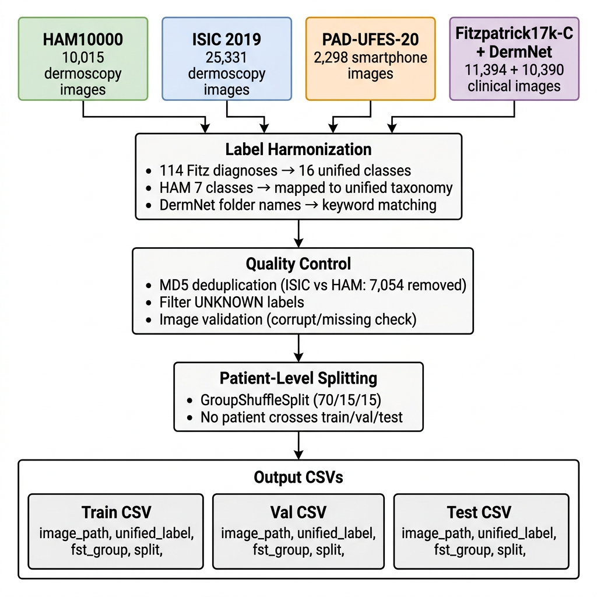
Fig. 2. Data preprocessing pipeline across five heterogeneous datasets.
E. Three-Stage Progressive Transfer Learning
The model is progressively trained through three stages, each building upon the previous checkpoint. Fig. 3 illustrates the complete pipeline.
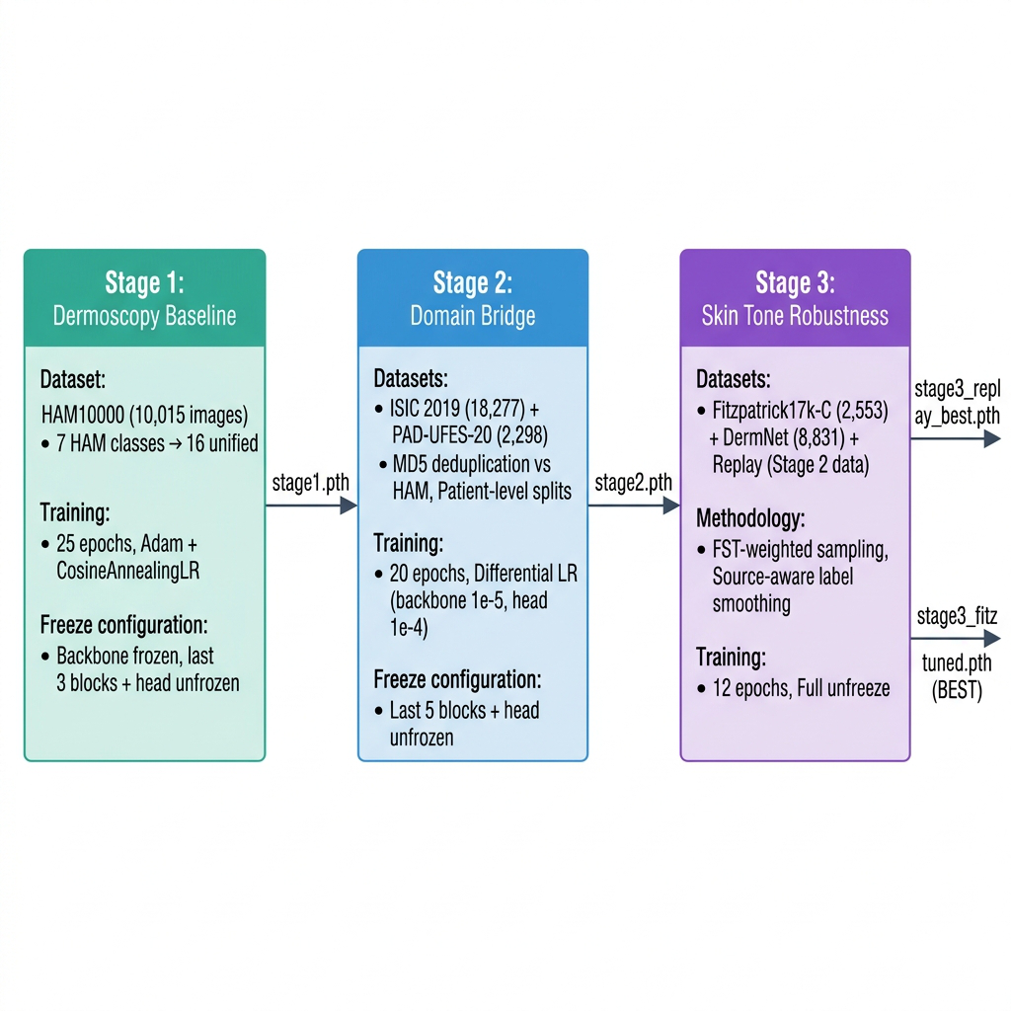
Fig. 3. Three-stage progressive transfer learning pipeline.
Stage 1 — Dermoscopy Baseline (HAM10000):
EfficientNet-B2 initialized with ImageNet weights. Backbone frozen except last 3 blocks and classification head. Trained for 25 epochs using Adam optimizer (lr=1e-4, weight_decay=1e-4) with CosineAnnealingLR (T_max=25, eta_min=1e-6). Loss: CrossEntropyLoss with inverse-frequency class weights. WeightedRandomSampler addresses class imbalance. Data augmentation includes horizontal/vertical flips, rotation(20°), ColorJitter (brightness=0.3, contrast=0.3, saturation=0.25, hue=0.1), and RandomErasing(p=0.2). Checkpoint: stage1.pth (best validation loss).
Stage 2 — Domain Bridge (ISIC 2019 + PAD-UFES-20):
Stage 1 checkpoint loaded; 7-class head expanded to 16 classes by copying overlapping weights and Xavier-initializing new class weights. ISIC 2019 deduplicated against HAM10000 via MD5 hashes (7,054 removed). Last 5 blocks + head unfrozen with differential learning rates (backbone: 1e-5, head: 1e-4). Trained for 20 epochs with stronger augmentation (ColorJitter brightness=0.5, contrast=0.5, saturation=0.4, hue=0.15) to simulate smartphone camera variation. Checkpoint: stage2.pth (best validation loss, epoch 19).
Stage 3 — Skin Tone Robustness with Experience Replay:
Stage 2 checkpoint loaded; all parameters unfrozen. Experience replay interleaves Stage 2 training data with Fitzpatrick17k-C and DermNet. A WeightedRandomSampler with joint class × FST-band weighting oversamples underrepresented skin tones. Source-aware label smoothing (DermNet: 0.12, Fitz/ISIC/PAD: 0.04) accounts for dataset noise. Trained for 12 epochs with Adam (backbone: 5e-6, head: 5e-5) and CosineAnnealingLR (T_max=12, eta_min=1e-7). Best checkpoint selected using the composite scoring function (Eq. 1). The final FitzTuned checkpoint is produced by further fine-tuning on Fitzpatrick data.
F. Composite Checkpoint Selection
The composite score balances fairness and safety:
S = 0.35·F1_PAD + 0.25·R_mal + 0.20·F1_dark + 0.20·BA (1)
where F1_PAD is PAD-UFES-20 macro F1, R_mal is mean recall of malignant classes (MEL, SCC, AK), F1_dark is F1 on dark skin (FST V-VI), and BA is balanced accuracy.
G. Training Algorithm
Algorithm 1: Three-Stage Progressive Transfer Learning
────────────────────────────────────────────────
Input: HAM10000, ISIC2019, PAD, Fitz17k-C, DermNet
Output: stage3_replay_fitz_tuned.pth

1. STAGE 1 (Dermoscopy Baseline):
model <- EffNetB2(pretrained=ImageNet, classes=16)
FREEZE backbone; UNFREEZE last_3_blocks + head
FOR epoch = 1..25: TRAIN(HAM10000, WeightedSampler)
SAVE best(val_loss) -> stage1.pth

2. STAGE 2 (Domain Bridge):
model <- LOAD(stage1.pth)
head <- EXPAND(7->16, copy overlapping weights)
ISIC2019 <- DEDUP(ISIC2019, HAM, MD5) // -7054
UNFREEZE last_5_blocks + head
FOR epoch = 1..20: TRAIN(ISIC+PAD, diff_lr)
SAVE best(val_loss) -> stage2.pth

3. STAGE 3 (Replay + Skin Tone):
model <- LOAD(stage2.pth); UNFREEZE ALL
replay <- CONCAT(S2_train, Fitz, DermNet)
sampler <- Weight(class_freq * fst_band)
FOR epoch = 1..12:
TRAIN(replay, source_label_smoothing)
score <- 0.35*PAD_f1 + 0.25*mal_recall
+ 0.20*dark_f1 + 0.20*bal_acc
SAVE best(score) -> stage3_replay_best.pth
FINETUNE(Fitz) -> stage3_replay_fitz_tuned.pth

H. Mobile Inference Pipeline
The trained model is exported via PyTorch Mobile's Lite Interpreter (.ptl, <50 MB). An InferenceWrapper produces softmax probabilities, confidence score, and top-3 predicted class indices. Pre-inference quality checks reject blurry images (Laplacian variance < 100) and poorly lit images (mean brightness outside 40–220). A safety-first layer flags any malignant class (MEL, BCC, SCC, AK) appearing in the top-3 for immediate clinic referral. Fig. 4 illustrates the deployment pipeline.
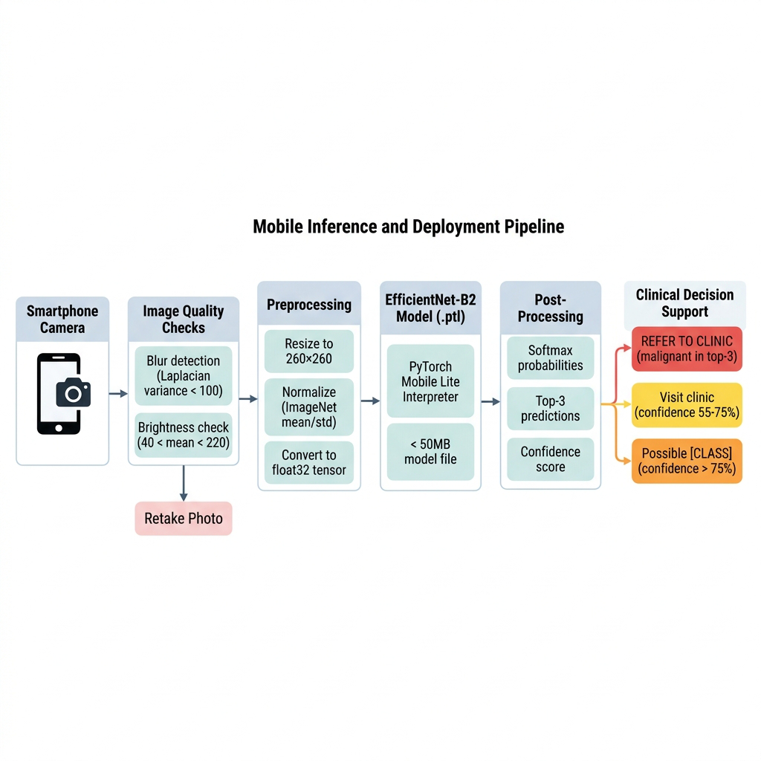
Fig. 4. Mobile inference and clinical decision support pipeline.
VI. EXPERIMENTAL RESULTS
A. Stage 1: HAM10000 Baseline
The Stage 1 model trained for 25 epochs achieves strong dermoscopic classification. Table IV presents the best checkpoint performance on the HAM10000 test set.
TABLE IV: STAGE 1 — HAM10000 TEST SET RESULTS (BEST CHECKPOINT, EPOCH 25)
Metric | Value
Accuracy | 0.711
Macro F1-Score | 0.676
Balanced Accuracy | 0.755

B. Stage 2: ISIC 2019 + PAD-UFES-20
Stage 2 bridges to smartphone imagery. The best checkpoint (epoch 19, by validation loss = 0.861) is evaluated on both the PAD smartphone test set and the combined test set. Tables V and VI present the results.
TABLE V: STAGE 2 — TEST SET METRICS (BEST CHECKPOINT, EPOCH 19)
Test Set | Images | Accuracy | Macro F1 | Balanced Acc
PAD-UFES-20 (smartphone) | 346 | 0.668 | 0.416 | 0.547
Combined ISIC + PAD | 2,874 | 0.677 | 0.564 | 0.531

TABLE VI: STAGE 2 — PER-CLASS REPORT (COMBINED TEST SET, 2,874 IMAGES)
Class | Precision | Recall | F1-Score | Support
MEL | 0.73 | 0.58 | 0.64 | 618
BCC | 0.71 | 0.74 | 0.72 | 590
SCC | 0.37 | 0.18 | 0.24 | 131
AK | 0.52 | 0.44 | 0.47 | 222
NEV | 0.71 | 0.90 | 0.80 | 962
BKL | 0.49 | 0.44 | 0.46 | 262
DF | 0.45 | 0.26 | 0.33 | 19
VASC | 0.93 | 0.56 | 0.70 | 25
SEK | 0.72 | 0.69 | 0.70 | 45

C. Stage 3 Original: Without Replay (Catastrophic Forgetting)
The initial Stage 3 model trained on Fitzpatrick17k-C + DermNet without replay exhibits severe catastrophic forgetting: SCC and AK recall collapse to 0.000 as dermoscopic knowledge is overwritten by clinical atlas features. Table VII shows evaluation on the Fitzpatrick+DermNet val/test split. This motivates the replay approach.
TABLE VII: STAGE 3 ORIGINAL — FITZ+DERMNET EVALUATION (3,683 IMAGES, BEST EPOCH 12)
Metric | Value
Accuracy | 0.518
Macro F1-Score | 0.380
Balanced Accuracy | 0.413
MEL Recall | 0.543
SCC Recall | 0.000 (forgetting)
AK Recall | 0.000 (forgetting)
TINEA Recall | 0.660 (new)
FUNGAL Recall | 0.870 (new)
ECZEMA Recall | 0.470 (new)

D. Stage 3 Replay: With Experience Replay
Replay training interleaves Stage 2 data with Fitzpatrick17k and DermNet using FST-weighted sampling and source-aware label smoothing. The best checkpoint is selected at epoch 7 (composite score = 0.364). Table VIII shows the key metrics, demonstrating successful recovery of SCC recall from 0.000 to 0.458.
TABLE VIII: STAGE 3 REPLAY — BEST CHECKPOINT (EPOCH 7, COMPOSITE SCORE = 0.364)
Metric | Value
Train Macro F1 | 0.580
Validation Macro F1 | 0.419
PAD-UFES-20 Monitor F1 | 0.356
PAD Balanced Accuracy | 0.486
MEL Recall (PAD) | 0.250
SCC Recall (PAD) | 0.458 (recovered)
AK Recall (PAD) | 0.755 (maintained)

E. Cross-Stage Performance Summary
Table IX summarizes results across all training stages, demonstrating the progressive improvement and the impact of replay on preventing catastrophic forgetting.
TABLE IX: CROSS-STAGE PERFORMANCE COMPARISON
Checkpoint | Evaluation Set | Accuracy | Macro F1 | Key Observation
Stage 1 | HAM10000 test (1,497) | 0.711 | 0.676 | Strong dermoscopy baseline
Stage 2 | ISIC+PAD combined (2,874) | 0.677 | 0.564 | Smartphone domain acquired
Stage 3 Orig. | Fitz+DermNet val/test (3,683) | 0.518 | 0.380 | SCC/AK=0 (forgetting)
Stage 3 Replay | PAD monitor (346) | 0.486 (BA) | 0.356 | SCC/AK recovered
FitzTuned | Replay val (4,729) | 0.519 (BA) | 0.436 | Best overall model

VII. CONCLUSION AND FUTURE WORK
A. Conclusion
We presented a 3-stage progressive transfer learning approach for equitable skin disease classification, demonstrating: (1) successful domain bridging from dermoscopy to smartphone imagery across HAM10000, ISIC 2019, and PAD-UFES-20; (2) experience replay effectively mitigating catastrophic forgetting (SCC recall from 0.000 without replay to 0.458 with replay); (3) FST-weighted training addressing demographic bias across skin tones; (4) a compact <50 MB model enabling fully offline mobile deployment; and (5) a safety-first clinical decision support layer that flags malignancies for clinic referral.
B. Limitations
Inflammatory class performance is limited by the absence of smartphone training data for these conditions. SCC and AK recall (0.458, 0.755) remain below clinically desirable thresholds (>0.80) for safety-critical screening. The model has not been validated on real-world images from the target deployment population in rural India.
C. Future Work
• Integrate SCIN dataset (10,000+ smartphone images with FST labels) for inflammatory condition coverage.
• Collect 300-500 images from Karnataka clinics for target-population validation.
• Implement Grad-CAM visualization for explainable predictions.
• Explore two-model architecture (neoplastic + inflammatory classifiers).
• Expand taxonomy: ACNE, SCABIES, INSECT_BITE, WOUND_INFECTION.
VIII. REFERENCES
[1] R. Hay et al., "The global burden of skin disease in 2010," J. Invest. Dermatol., vol. 134, no. 6, pp. 1527-1534, 2014.
[2] S. Srinivasan et al., "Dermatology workforce and service delivery in India," Indian J. Dermatol., vol. 64, pp. 1-4, 2019.
[3] A. Esteva et al., "Dermatologist-level classification of skin cancer with deep neural networks," Nature, vol. 542, pp. 115-118, 2017.
[4] M. Tan and Q. Le, "EfficientNet: Rethinking model scaling for CNNs," ICML, pp. 6105-6114, 2019.
[5] M. Groh et al., "Evaluating DNNs trained on clinical images with the Fitzpatrick 17k dataset," CVPR, pp. 1820-1828, 2021.
[6] D. Rolnick et al., "Experience replay for continual learning," NeurIPS, vol. 32, pp. 350-360, 2019.
[7] M. McCloskey and N. Cohen, "Catastrophic interference in connectionist networks," Psychol. Learn. Motiv., vol. 24, pp. 109-165, 1989.
[8] K. He et al., "Deep residual learning for image recognition," CVPR, pp. 770-778, 2016.
[9] G. Huang et al., "Densely connected convolutional networks," CVPR, pp. 4700-4708, 2017.
[10] S. Pan and Q. Yang, "A survey on transfer learning," IEEE TKDE, vol. 22, no. 10, pp. 1345-1359, 2010.
[11] J. Yosinski et al., "How transferable are features in deep neural networks?," NeurIPS, vol. 27, pp. 3320-3328, 2014.
[12] Y. Bengio et al., "Curriculum learning," ICML, pp. 41-48, 2009.
[13] A. Adamson and A. Smith, "ML and health care disparities in dermatology," JAMA Dermatol., vol. 154, pp. 1247-1248, 2018.
[14] R. Daneshjou et al., "Disparities in dermatology AI performance," Sci. Adv., vol. 8, 2022.
[15] Y. Chen et al., "Deep learning on mobile and embedded devices," ACM Comput. Surv., vol. 53, pp. 1-37, 2020.
[16] PyTorch Mobile Documentation, pytorch.org/mobile, 2023.
[17] P. Tschandl et al., "The HAM10000 dataset," Sci. Data, vol. 5, pp. 1-9, 2018.
[18] N. Codella et al., "Skin lesion analysis toward melanoma detection 2018: ISIC challenge," arXiv:1902.03368, 2019.
[19] A. Pacheco et al., "PAD-UFES-20: Skin lesion dataset from smartphones," Data Brief, vol. 32, 2020.

