OSL LAB 3
Name:Shravan S Rao
Roll No : 22
CSE D
Regno: 240905158

Question 1
#!/bin/bash
read fileName
if [ -d "$fileName" ]; then
echo "It is directory"
elif [ -f "$fileName" ]; then
echo "It is a file"
else
echo "File does not exist"
fi

-d is for directory and -f is for file
When we run this and input practical which is a folder inside current difrectory we get
It is a file

Question 2:
#!/bin/sh
echo "Enter directory:"
read dir
echo "Enter pattern:"
read pattern
for file in "$dir"/*"$pattern"*; do
[ -f "$file" ] && basename "$file"
done

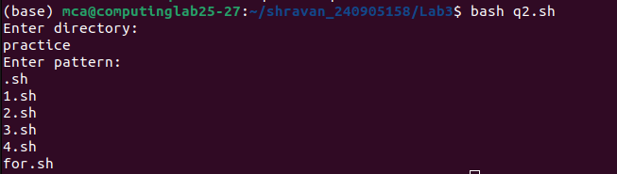

Question 3
#!/bin/sh
for file in *.txt; do
mv -- "$file" "${file%.txt}.text"
done

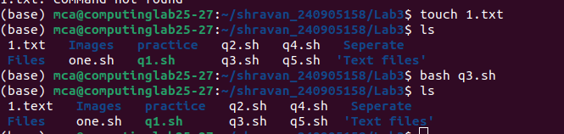

1.txt is renamed as 1.text

Question 4
#!/bin/bash
echo "Enter basics"
read a
echo "Enter Ta"
read b
value=`bc -l <<<$a+$b+0.1*$a`
echo $value

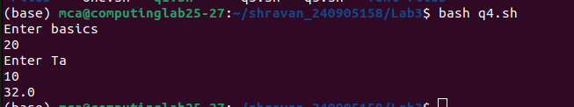
10% of 20 is 2 and 20+10+2=32 i used bc here inorder to perform floating multiplication and addition

Question 5
Part 1
#!/bin/sh
echo "Enter file extension:"
read ext
echo "Enter target folder:"
read target
mkdir -p "$target"
for f in *"$ext"; do
[ -f "$f" ] && mv "$f" "$target/"
done

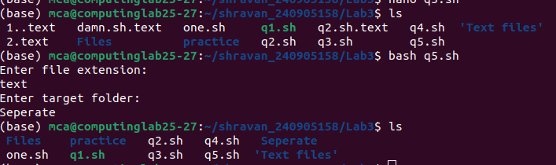
Here all text files and moves into separate folder

Part B
#!/bin/sh

for f in *; do
[ -f "$f" ] || continue
sed -i 's/^ex:/Example:/; s/\. *ex:/. Example:/' "$f"
done

Question 6

#!/bin/sh
echo "Enter filename:"
read file
[ -f "$file" ] && sed -i 'n;d' "$file"

To demonstrate This i created 1.txt file with contents
One
Two
Three
Four
On running the script we get

One
Three

