Lab 3
Name: Prakhar Umrao Reg No.: 230962210

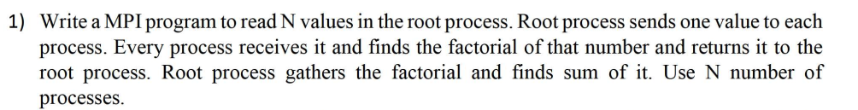

Code:

#include <mpi.h>
#include <stdio.h>

long factorial(int n) {
long f = 1;
for (int i = 1; i <= n; i++) f *= i;
return f;
}

int main(int argc, char** argv) {
int rank, size;
MPI_Init(&argc, &argv);
MPI_Comm_rank(MPI_COMM_WORLD, &rank);
MPI_Comm_size(MPI_COMM_WORLD, &size);

int num;
long fact, sum;

if (rank == 0) {
int arr[size];
printf("Enter %d numbers:\n", size);
for (int i = 0; i < size; i++)
scanf("%d", &arr[i]);

for (int i = 1; i < size; i++)
MPI_Send(&arr[i], 1, MPI_INT, i, 0, MPI_COMM_WORLD);

num = arr[0];
} else {
MPI_Recv(&num, 1, MPI_INT, 0, 0, MPI_COMM_WORLD, MPI_STATUS_IGNORE);
}

fact = factorial(num);

MPI_Reduce(&fact, &sum, 1, MPI_LONG, MPI_SUM, 0, MPI_COMM_WORLD);

if (rank == 0) {
printf("Sum of factorials = %ld\n", sum);
printf("Prakhar Umrao 230962210");
}

MPI_Finalize();
return 0;
}

Output:
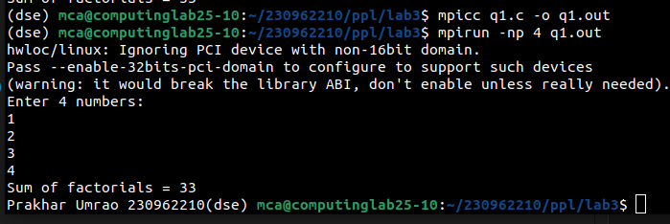

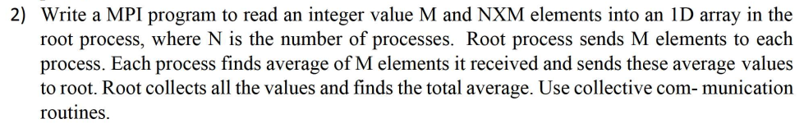

Code:

#include <mpi.h>
#include <stdio.h>

int main(int argc, char** argv) {
int rank, size;
MPI_Init(&argc, &argv);
MPI_Comm_rank(MPI_COMM_WORLD, &rank);
MPI_Comm_size(MPI_COMM_WORLD, &size);

int M;
if (rank == 0) {
printf("Enter M (elements per process): ");
scanf("%d", &M);
}
MPI_Bcast(&M, 1, MPI_INT, 0, MPI_COMM_WORLD);

int arr[M * size];
int recv[M];

if (rank == 0) {
printf("Enter %d integers:\n", M * size);
for (int i = 0; i < M * size; i++)
scanf("%d", &arr[i]);
}

MPI_Scatter(arr, M, MPI_INT, recv, M, MPI_INT, 0, MPI_COMM_WORLD);

float local_avg = 0;
for (int i = 0; i < M; i++) local_avg += recv[i];
local_avg /= M;

float total_avg;
MPI_Reduce(&local_avg, &total_avg, 1, MPI_FLOAT, MPI_SUM, 0, MPI_COMM_WORLD);

if (rank == 0) {
total_avg /= size;
printf("Overall Average = %.2f\n", total_avg);
printf("\nPrakhar Umrao 230962210\n");
}

MPI_Finalize();
return 0;
}

Output:

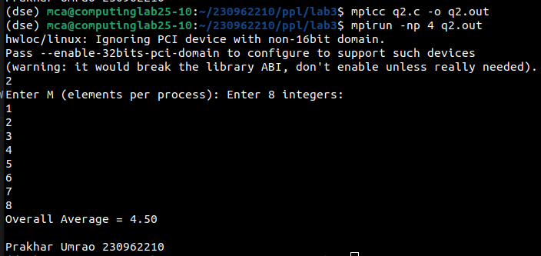

Code:

#include <mpi.h>
#include <stdio.h>
#include <string.h>
#include <ctype.h>

int isVowel(char c) {
c = tolower(c);
return (c=='a'||c=='e'||c=='i'||c=='o'||c=='u');
}

int main(int argc, char** argv) {
int rank, size;
MPI_Init(&argc, &argv);
MPI_Comm_rank(MPI_COMM_WORLD, &rank);
MPI_Comm_size(MPI_COMM_WORLD, &size);

char str[200];
int len;

if (rank == 0) {
printf("Enter a string: ");
fflush(stdout);
fgets(str, sizeof(str), stdin);
str[strcspn(str, "\n")] = '\0';
len = strlen(str);
}

MPI_Bcast(&len, 1, MPI_INT, 0, MPI_COMM_WORLD);

int counts[size], displs[size];

int base = len / size;
int extra = len % size;

for (int i = 0; i < size; i++) {
counts[i] = base + (i < extra ? 1 : 0);
}

displs[0] = 0;
for (int i = 1; i < size; i++)
displs[i] = displs[i - 1] + counts[i - 1];

char local[counts[rank]];

MPI_Scatterv(str, counts, displs, MPI_CHAR,
local, counts[rank], MPI_CHAR,
0, MPI_COMM_WORLD);

int local_count = 0;
for (int i = 0; i < counts[rank]; i++)
if (!isVowel(local[i]))
local_count++;

int total_count = 0;
MPI_Reduce(&local_count, &total_count, 1,
MPI_INT, MPI_SUM, 0, MPI_COMM_WORLD);

if (rank == 0) {
printf("Total non-vowels: %d\n", total_count);
printf("Prakhar Umrao 230962210\n");
}

MPI_Finalize();
return 0;
}

Output:

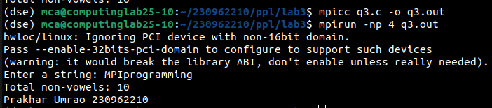

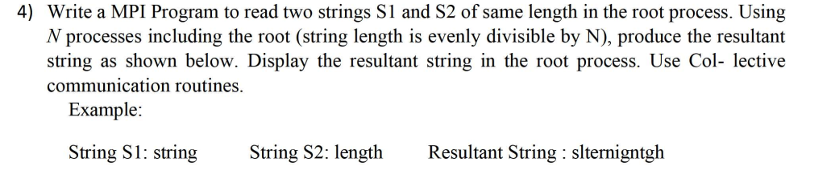

Code:

#include <mpi.h>
#include <stdio.h>
#include <string.h>

int main(int argc, char **argv) {
int rank, size;
MPI_Init(&argc,&argv);
MPI_Comm_rank(MPI_COMM_WORLD,&rank);
MPI_Comm_size(MPI_COMM_WORLD,&size);

char S1[100], S2[100];
int len, chunk;

if(rank == 0) {
printf("Enter S1: "); scanf("%s", S1);
printf("Enter S2: "); scanf("%s", S2);

len = strlen(S1);

if(len != strlen(S2)) {
printf("Error: S1 and S2 must be same length\n");
MPI_Abort(MPI_COMM_WORLD, 1);
}
if(len % size != 0) {
printf("Error: length must be divisible by number of processes\n");
MPI_Abort(MPI_COMM_WORLD, 1);
}
}

MPI_Bcast(&len, 1, MPI_INT, 0, MPI_COMM_WORLD);
MPI_Bcast(S1, len, MPI_CHAR, 0, MPI_COMM_WORLD);
MPI_Bcast(S2, len, MPI_CHAR, 0, MPI_COMM_WORLD);

chunk = len / size;

char p1[chunk], p2[chunk];
MPI_Scatter(S1, chunk, MPI_CHAR, p1, chunk, MPI_CHAR, 0, MPI_COMM_WORLD);
MPI_Scatter(S2, chunk, MPI_CHAR, p2, chunk, MPI_CHAR, 0, MPI_COMM_WORLD);

char local[2 * chunk];
for(int i = 0; i < chunk; i++) {
local[2*i] = p1[i];
local[2*i+1] = p2[i];
}

char result[200];
MPI_Gather(local, 2*chunk, MPI_CHAR, result, 2*chunk, MPI_CHAR, 0, MPI_COMM_WORLD);

if(rank == 0) {
result[2*len] = '\0';
printf("Resultant: %s\n", result);
printf("Prakhar Umrao 230962210\n");
}

MPI_Finalize();
return 0;
}

Output:

