**ABSTRACT**

The polarization of a low-profile multifunctional metasurface for the polarization application of the electromagnetic wave in both cross-polarized and circular-polarized waves is the subject of this article. The polarization of the electromagnetic wave over the Ku and K band range has been given in this work. The wide-band circular polarization, which is right-hand circular polarized with ellipticity (e) roughly equal to -1 is observed over the frequency range of 15.94 – 22.17 GHz, thanks to the design that was derived using copper over the Rogers RT5880 substrate. The circular polarization has an axial ratio (AR) < 3 dB over a range of 15.94 – 22.17 GHz because of the pattern created by cutting two curves on the opposite sides of a square. It provides cross-polarization with a polarization conversion ratio (PCR) > 0.9 spanning the frequency range of 12.32 – 15.46 GHz produced with the split ring resonator (SRR) along with a diagonal extended along the opposite vertex, which makes it multipurpose.

**1. Introduction**

In recent years, there has been an increase in the management and control of a polarization state employing metasurfaces because they allow for unanticipated changes in the amplitude and phase of the dispersed electromagnetic wave in the subwavelength region. Since the circularly polarized (CP) waves have minimal absorption from the surrounding environment, are less susceptible to polarization mismatch, and are insensitive to multipath, they are frequently employed in current wireless communications systems which includes satellite communications and global navigation systems. An alternative method for producing CP waves is to employ a polarization converter, which is used for converting the polarization of an incident

wave from one type to another (e.g., horizontal to vertical or linear to circular). For a variety of applications in the microwave, terahertz, and optical frequency ranges, the polarization state of the electromagnetic wave and its modification, along with frequency and phase, have proven crucial. When compared to the working wavelength, conventional methods for manipulating polarization, particularly in optical crystals, necessitate big, bulky structures. Applications for converters include a wide range of radio transmission, antenna design, radar technology, among other things. Numerous approaches to polarization conversion have been proposed; however, they suffer from volumetric structures, angular dependent

responses, high loss, and restricted bandwidth. Metamaterials have unique qualities that are hard to find in nature, which opens up previously unheard-of prospects in a variety of fields. Controlling EM polarization is one of their most popular uses. The polarization state of electromagnetic waves may be significantly controlled by 2-dimensional and planar variants of metamaterials.

**2. Structure Design Procedure**

The generalized schematic of the multifunctional metasurface is shown in the Figure 1. Three sections make up the design process: a bottom metallic ground, a middle dielectric substrate, and a top patterned metallic surface. Along the xy plane, the metasurface is endlessly stretched, and along the z direction, a plane wave is incident. The proposed meta-atom is a three-layer structure with a low-loss dielectric Rogers RT5880 substrate relative permittivity ${(ϵ}_{r}) of 2.2$ and loss tangent of 0.0009 as the middle layer and a metallic copper layer with a conductivity of 5.8 107 S m-1 as the bottom layer. The Figure 1(a) and 1(b) shows the parameter of the unit cell designed. A composite resonator, including two basic squares with two curves cut on two sides with a radius of 'r,' and a diagonal between the opposite corner of the square split ring resonator (SRR) surrounding it, make up the top layer of the meta-atom. The thickness of the dielectric substrate is ts = 1.6 mm. To stop propagation through the metasurface, the thickness of the metallic layer at both the top and bottom is tm = 0.035 mm, which is multiple times bigger than the skin depth. The front plane in this configuration is z = 0, and the bottom plane is z = -2tm - ts. All of the corners are aligned with the Cartesian coordinate system (x, y, z).

Final parameters of the unit cell are selected as follows: L = 12 mm, g = 0.5 mm,

w1 = 3 mm, w2 = 0.05 mm, w3 = 1 mm,

p = 7.9 mm, the square in which two curves are cut on its opposite sides has a side length of c = 4.5 mm and the cut is made by taking a circle of radius r = 2.5 mm. The unit cell has been designed and stimulated incorporating periodic boundary conditions in CST Microwave Studio 2021.

L

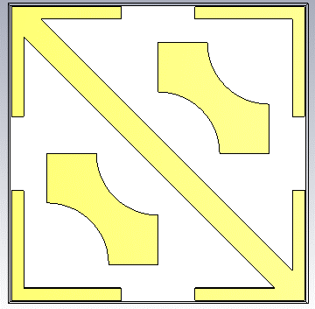

w3

g

r

c

p

w1

(a)



w2

(b)

Figure 1.(a) Top View of the unit cell.

(b) Corner view of the unit cell.

The square ring SRR is used to generate linear to cross polarized waves. The pattern designed on the unit cell formed by cutting two curves on the opposite side of a square are used to realize both linear to cross and linear to circular polarization of waves with increased bandwidth for both polarizations.

**3. Polarization Conversion**

The metasurface's periodicity along both the x and y axes necessitate the representation of the reflected electric field phasor as a doubly infinite series of Floquet harmonics, i.e.,

$$E_{r}= E_{o}\sum_{p∈Z}{\sum_{q∈Z}{\left\{\left[R_{xx}^{p,q}\overset{∧}{u_{x}}+ R_{yx}^{p,q}\overset{∧}{u_{y}}\right]exp⁡[\frac{j\left(px+qy\right)2π}{L}]exp⁡(-jα^{p,q}z)\right\}}}$$

Here, $R_{xx}^{p,q}∈C$ are co polarized reflection coefficients (x to x), $R_{yx}^{p,q}∈C$ are cross polarized reflection coefficients (x to y), L is the side length of the meta-atom, $\overset{∧}{u_{y}}$ is the unit vector along the y axis, $Z$ is the set of all integers and $C$ is the set of all complex numbers.

Phase difference between $R_{yx}^{0,0}$ and $R_{xx}^{0,0}$ is $∆∅$,

${∆∅}^{0,0}=∅_{yx}^{0,0}- ∅_{xx}^{0,0}$,

where $∅_{yx}^{0,0}$ and $∅_{xx}^{0,0}$ are the phases of $R_{yx}^{0,0}$ and $R_{xx}^{0,0}$ respectively. When a linear to circular polarization converter is implemented, $\left|R_{yx}^{0,0}\right|= \left|R_{xx}^{0,0}\right|$ and $∆∅=\left(2n±1\right)\frac{π}{2}, ∀ n∈ Z$. Quantification of the level of cross-polarization on reflection is given by the polarization conversion ratio,

PCR = $\frac{{|R_{xy}^{0,0}|}^{2}}{{|R_{yy}^{0,0}|}^{2}+{|R_{xy}^{0,0}|}^{2} } ϵ [0,1]$.

Parallel to this, the axial ratio in dB characterizes linear to circular polarization,

AR = $20\log_{10}(\frac{|R_{yx}^{0,0}|}{{|R}_{xx}^{0,0}|})$.

A complete circular polarization is reached when AR=0 and $∆∅$ = 90. In this work, we take into account PCR > 0.9 for the conversion of linear polarization and AR < 3 dB for the conversion of circular polarization. For the intended metasurface, the PCR and AR are only important if the total specular reflectance

$$R^{0,0}= {\left|R_{xx}^{0,0}\right|}^{2}+ {\left|R_{xx}^{0,0}\right|}^{2}$$

is sufficiently large. CST MICROWAVE STUDIO 2021, a commercial 3D full-wave simulation programme, was used to determine PCR and AR as functions of linear frequency f.

**4. Results and Discussion**

The frequency response of the magnitude and phase difference between $R_{yx}^{0,0}$ and $R_{xx}^{0,0}$ is displayed in Figure 2. For the frequency range 12.32 – 14.45 GHz, it is noted that the cross – polarized reflection coefficient $R_{yx}^{0,0}$ is significantly high and the co-polarized reflection coefficient $R_{xx}^{0,0}$ is below –10dB. Whereas both $R_{xx}^{0,0}$ and $R_{yx}^{0,0}$ are close to –3 dB for the frequency range of 15.94 – 22.17 GHz.

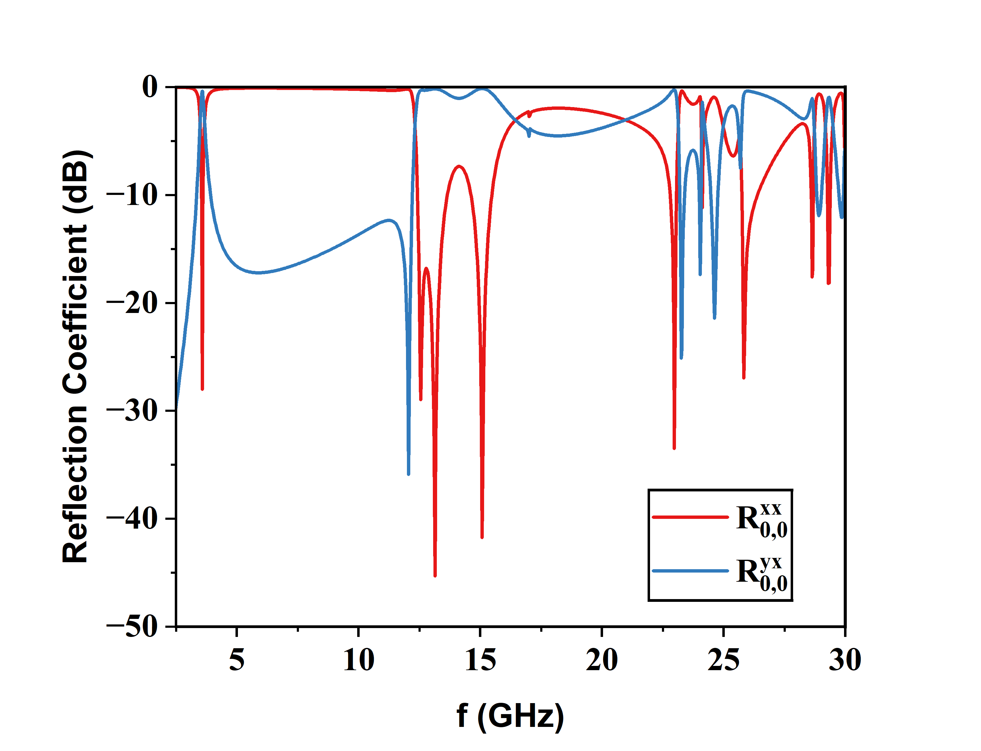

Figure 2

Furthermore, the phase difference ${∆∅}^{0,0}$ between $R_{xx}^{0,0}$ and $R_{yx}^{0,0}$ is approximately constant (2n+1) $\frac{π}{2}$ in the frequency range 15.1 to 22.1 GHz as evident from Figure 3.

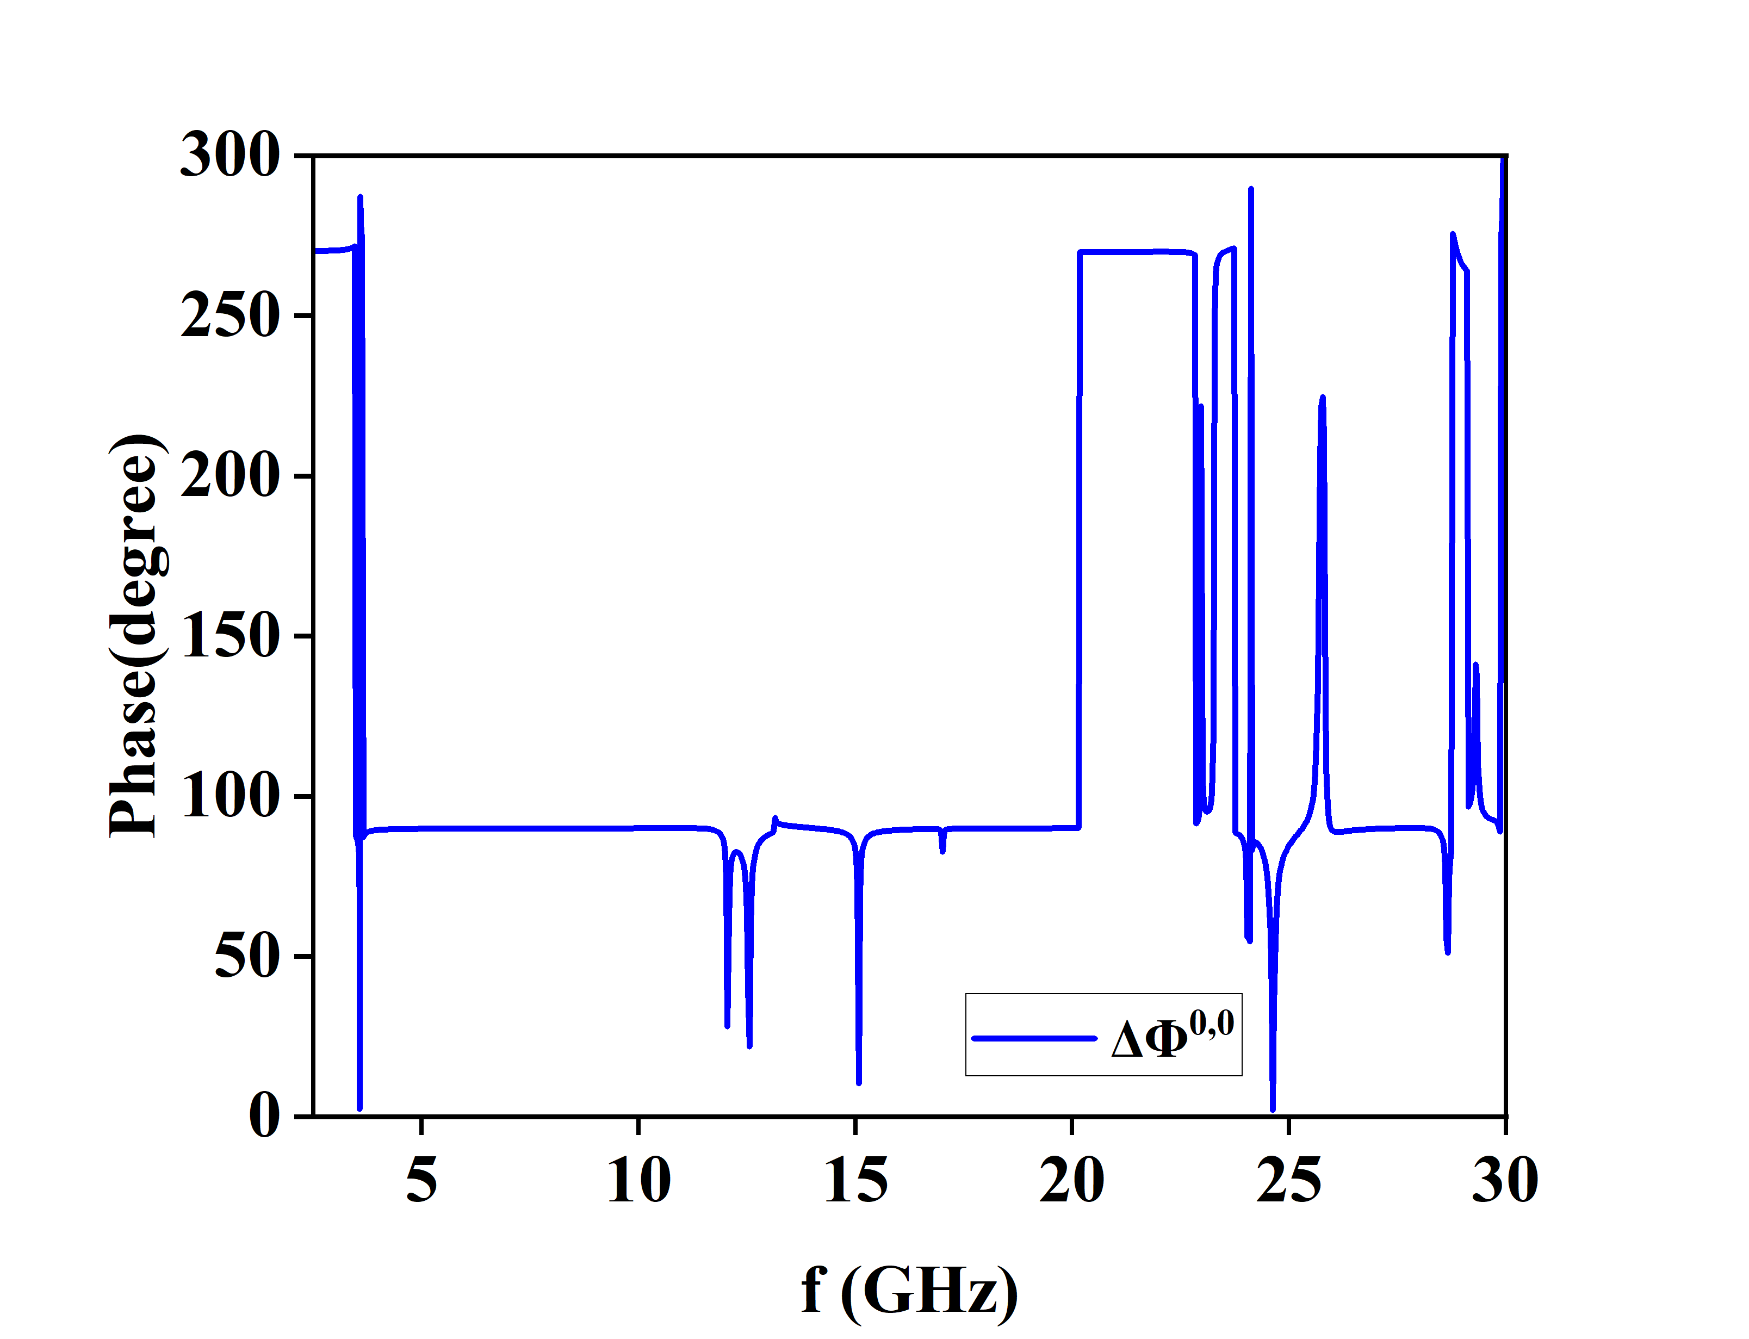

Figure 3

The PCR is substantially more than 0.9 and is seen over the narrow frequency range of 12.32 – 15.46 GHz, as shown in Figure 4. (a). Figure 4. (b) displays the axial ratio (AR) plot, which is found below 3 dB over a broad range of 15.94 – 22.17 GHz.

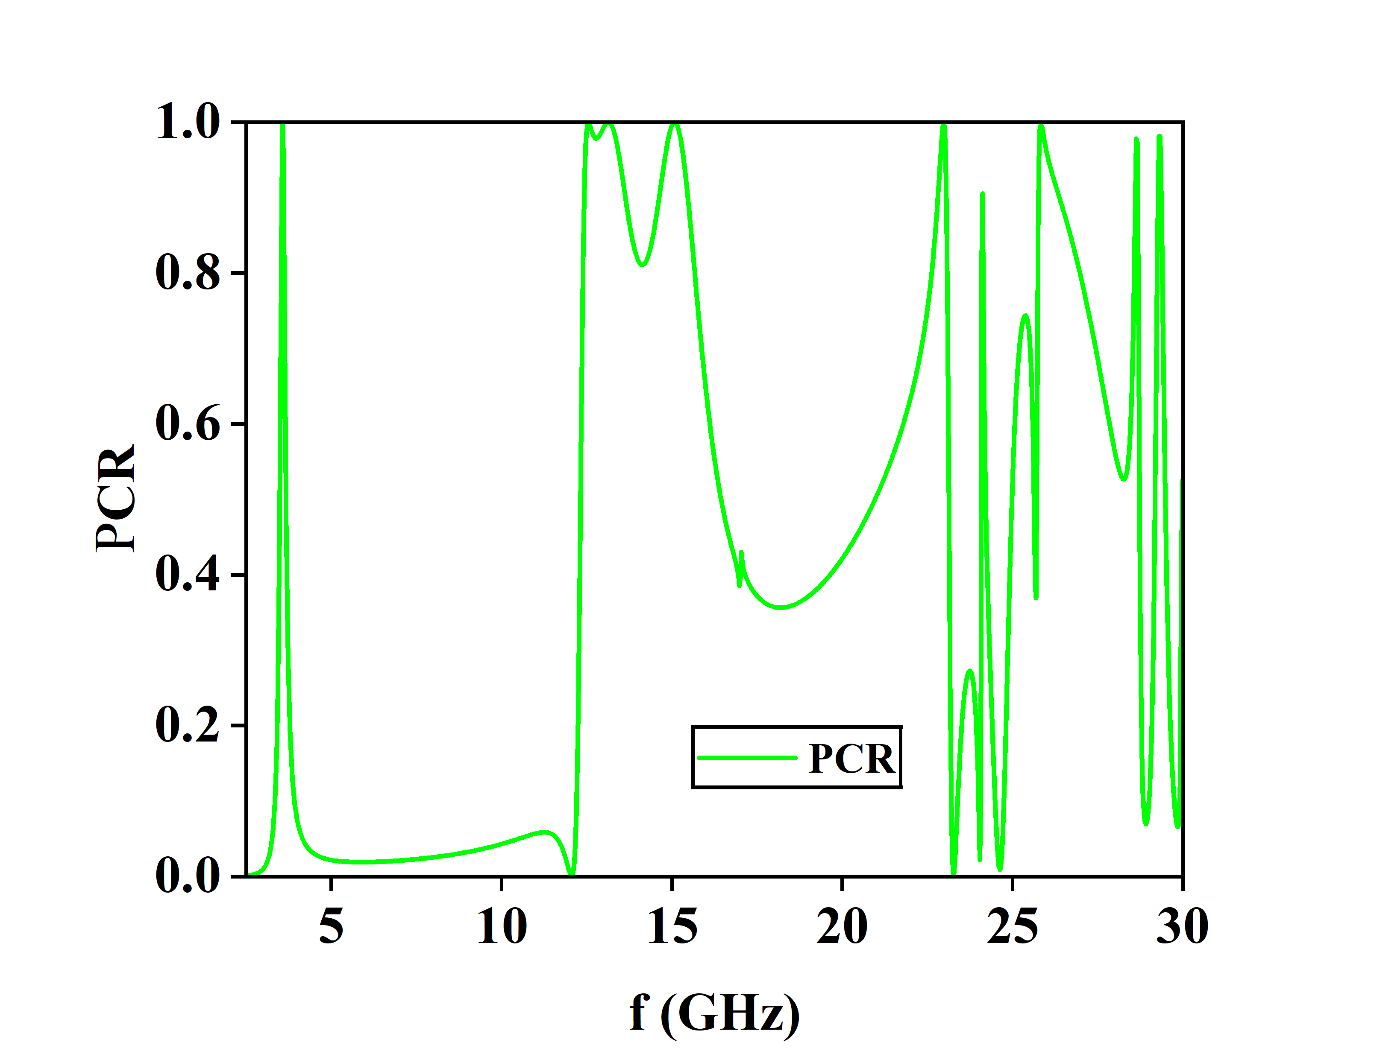

(a)

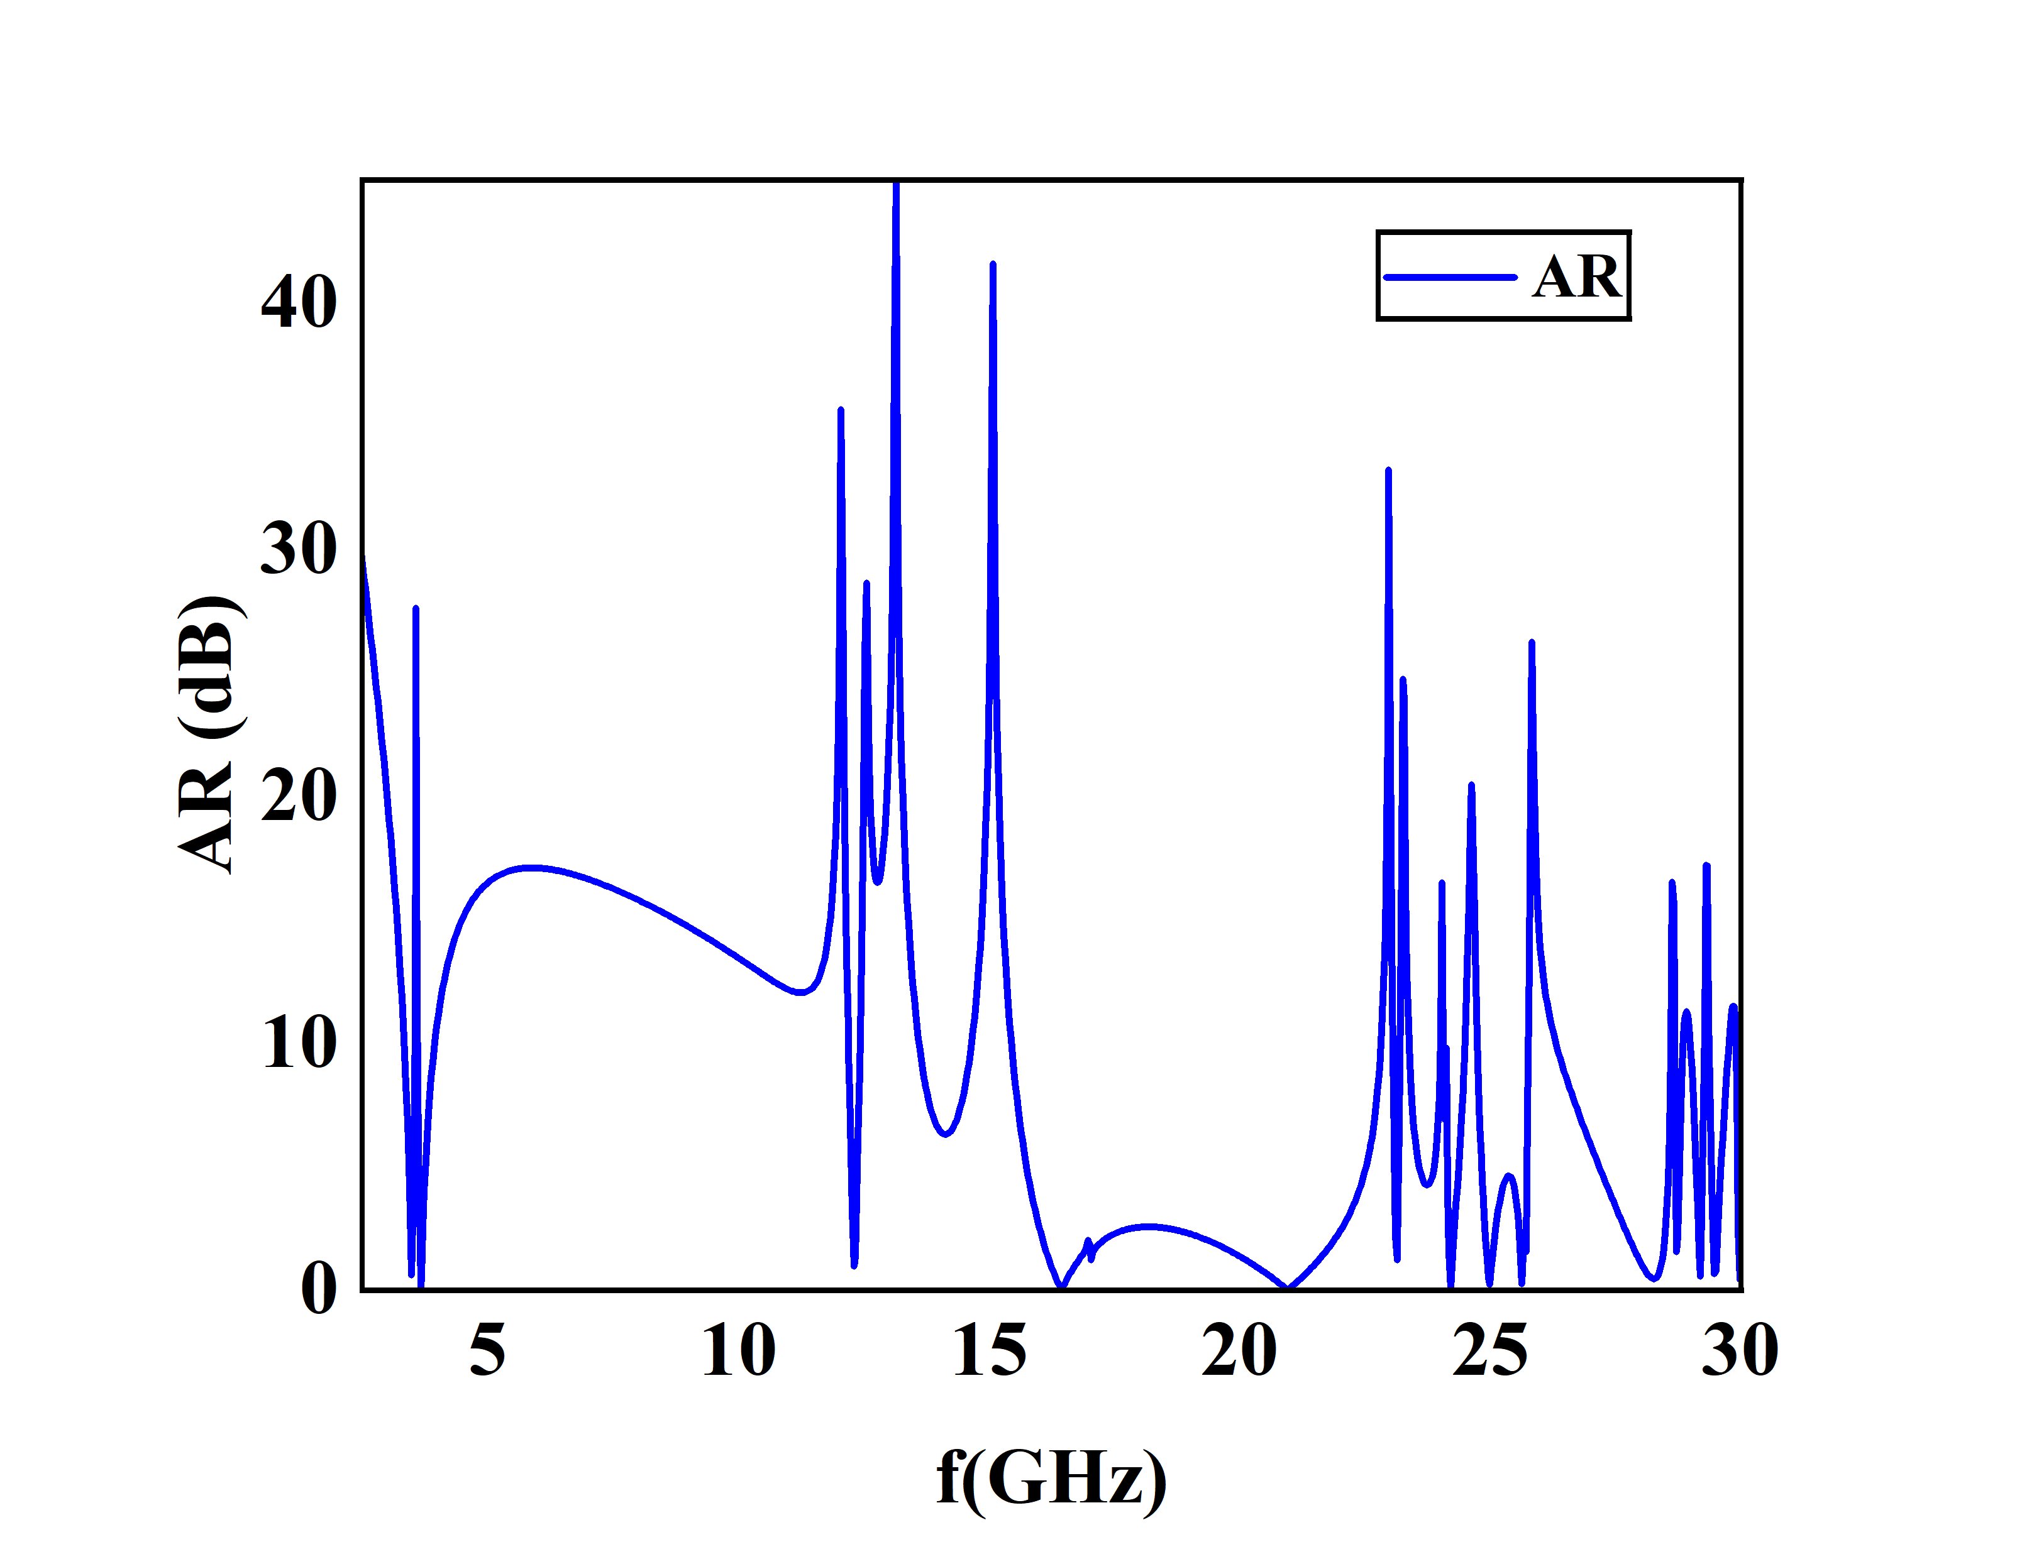

(b)

Figure 4. (a) PCR of the designed meta surface. (b) Axial Ratio of the metasurface.

It is possible to further characterize the circular polarization conversion performance using the normalized ellipticity (e),

$e^{0,0}= \frac{2\left|R_{yx}^{0,0}\right|\left|R_{xx}^{0,0}\right|\sin{{∆∅}^{0,0}}}{R^{0,0}}$,

where $e^{0,0}= -1$ and $e^{0,0}= +1$ signify that the reflected wave is right hand circular polarized (RHCP) and left-hand circular polarized (LHCP), respectively. Figure 5 shows the plot of e and it is observed that e is nearly -1 in the frequency range of 15.69 – 22.64 GHz.

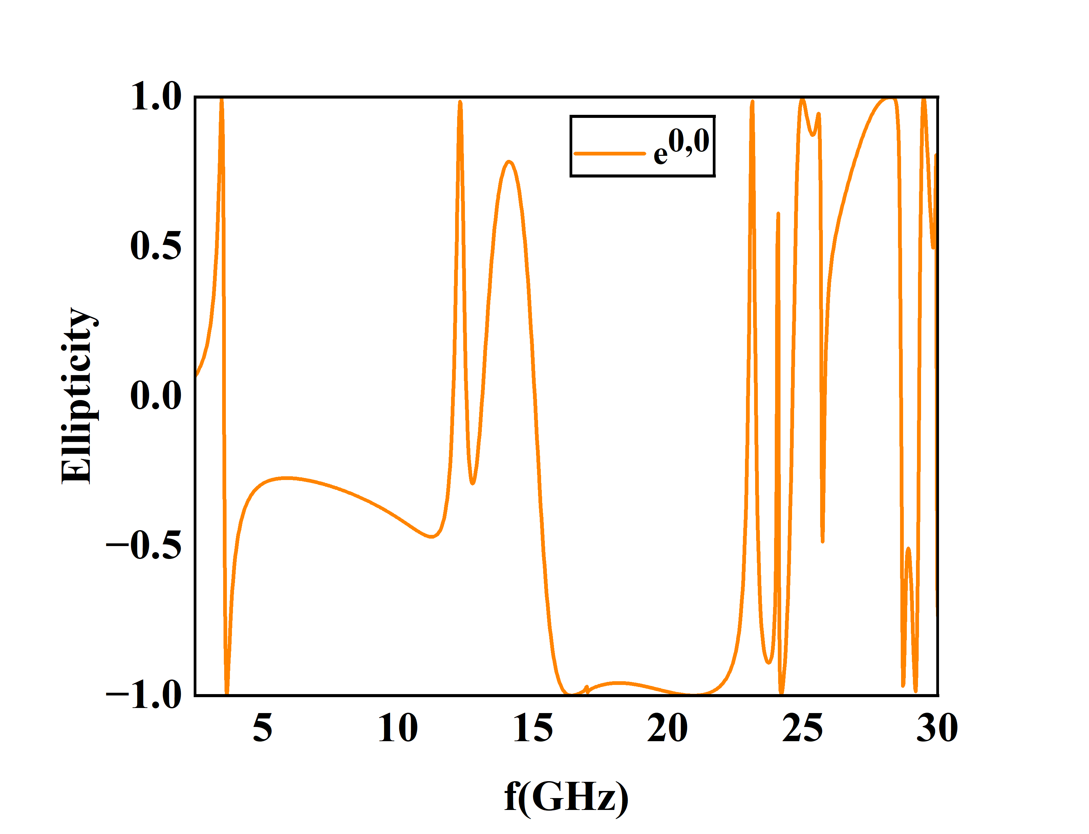

Figure 4

**5. Conclusion**

A simple design of a low profile multifunctional metasurface is presented in this paper. The designed polarizer is able to convert linear to both circular-polarized and cross-polarized over a frequency range of 15.94 – 22.17 GHz and 12.32 – 15.46 GHz respectively. It is observed that 90% of the reflected wave is converted into the cross-polarization state over the range of 12.32 – 15.46 GHz. As a result, a variety of polarization control devices can employ this architecture.

**6. References**

1. Agrahari, R., Singh, S., Samantaray, D., Kumar, B., Bhattacharyya, S., Mahto, M. and Jain, P.K., 2023. Triple‐band metasurface absorber for RF energy harvesting applications. Microwave and Optical Technology Letters.
2. Agrahari, R., Kumar, P. and Kumar, V., 2023. Pixelated metasurface based wideband cross polarization converter. Journal of Electromagnetic Waves and Applications, 37(4), pp.562-574.
3. Agrahari, R., Rajbhar, P.K., Mahto, M. and Jain, P.K., 2023. Metasurface assisted wideband multifunctional polarizer. Journal of applied physics, 133(9)
4. Li, R., Zhou, T., Wang, Q. and Xiao, S., 2022, August. Millimeter Wave Band Left Hand Circular Polarization to Right Hand Circular Polarization Convertor Based on Multilayer Meta-surface. In *2022* International Conference on Microwave and Millimeter Wave Technology (ICMMT) (pp.1-3). IEEE
5. Charola, S., Patel, S.K., Parmar, J. and Jadeja, R., 2022. Multiband Jerusalem cross-shaped angle insensitive metasurface absorber for X-band application. Journal of Electromagnetic Waves and Applications, 36(2), pp.180-192.
6. Xiao, H. and Yan, S., 2021, August. A Polarization Conversion Metasurface for Characterization of Dielectric Materials. In *2021 IEEE 4th International Conference on Electronic Information and Communication Technology (ICEICT)* (pp. 604-606). IEEE.
7. Shah, S.M.Q.A., Shoaib, N., Ahmed, F., Alomainy, A., Quddious, A., Nikolaou, S., Imran, M.A. and Abbasi, Q.H., 2021. A multiband circular polarization selective metasurface for microwave applications. *Scientific reports*, *11*(1), p.1774.
8. Agrahari, R., Dwivedi, S., Jain, P.K. and Mahto, M., 2023. High sensitive metasurface absorber for refractive index sensing. IEEE Transaction on Nanotech.
9. Sharma, S.K., Ghosh, S. and Srivastava, K.V., 2016. An ultra-thin triple - band polarization-insensitive metamaterial absorber for S, C and X band applications. Applied Physics A, 122, pp.1-8.
10. Ling, K., Yoo, M. and Lim, S., 2015. Frequency tunable metamaterial absorber using hygroscopicity of nature cork. IEEE Antennas and Wireless Propagation Letters, 14, pp.1598-1601.
11. Shen, Z. and Lin, X., 2023. A review of metasurface polarization devices. Optical Materials, 146, p.114567.
12. Wei, Y., Duan, J., Jing, H., Lyu, Z., Hao, J., Qu, Z., Wang, J. and Zhang, B., 2022. A multiband, polarization-controlled metasurface absorber for electromagnetic energy harvesting and wireless power transfer. *IEEE Transactions on Microwave Theory and Techniques*, *70*(5), pp.2861-2871.