PRODUCT REQUIREMENTS DOCUMENT
The Closed-Loop Checkout
WhatsApp Pay × Click-to-WhatsApp Ads (India)

Author | [Your Name] — Product Management
Status | Draft v1.0 · For review
Last updated | July 2026
Initiative | Big Bet #1 — Tier-1 solution (RICE 98), WhatsApp Pay India Rejuvenation Strategy
Cross-functional partners | WhatsApp Commerce · Ads (CTWA) · Payments (NPCI/UPI) · Trust & Safety · Legal & Regulatory
Companion artifact | WhatsApp_Pay_CTWA_Wireframes.pptx (screen-by-screen UX)

Confidential — product strategy portfolio case study. Charts are directional / illustrative unless a source is cited.

Document Control

Version history
Version | Date | Author | Summary of changes
v0.1 | May 2026 | [Your Name] | Initial draft derived from Strategy Big Bet #1
v0.5 | Jun 2026 | [Your Name] | Added metric tree, risk register, rollout phases
v1.0 | Jul 2026 | [Your Name] | Restructured to standard PRD format; added assumptions, non-functional requirements, technical architecture, conversion-event schema, experimentation plan, monetization model, competitive teardown, and figures

Reviewers & approvers
Name | Function | Role on this PRD | Status
TBD | WhatsApp Commerce | Engineering lead — reviewer | Pending
TBD | Ads / CTWA | Product — reviewer (value capture) | Pending
TBD | Payments (NPCI/UPI) | Product — reviewer (rails) | Pending
TBD | Trust & Safety | Reviewer (fraud, abuse) | Pending
TBD | Legal & Regulatory | Reviewer (self-preferencing, DPDP) | Pending
TBD | GM, WhatsApp Pay India | Approver — sign-off | Pending

Related documents
Document | Purpose
WhatsApp Pay India — Evidence Dossier | Phase 1: sourced evidence base
WhatsApp Pay India — Diagnosis | Phase 2: root-cause model
WhatsApp Pay India — Rejuvenation Strategy | Phase 3: strategy; this PRD specs Big Bet #1
WhatsApp_Pay_CTWA_Wireframes.pptx | Companion UX: user flow + screens
Case-study one-pager (summary.html) | 90-second executive overview

Contents
Right-click here and choose "Update Field" to build the contents.

1. Overview

1.1 TL;DR
WhatsApp Pay holds under 1% of India's UPI market despite WhatsApp's ~500M-user distribution. The root cause — established in the diagnosis phase of this case study — is not product quality; it is a business-model problem: under India's zero-MDR regime a UPI transaction earns Meta ~₹0, so the payment has near-zero lifetime value (LTV) and Meta has rationally under-invested for eight years.
This PRD specifies the one intervention that changes the unit economics rather than working around them: make WhatsApp Pay the default, in-chat checkout at the bottom of the Click-to-WhatsApp Ads (CTWA) funnel, so the chain ad → chat → catalog → pay → attribution closes entirely inside WhatsApp. Every completed checkout becomes (a) a first-party, deterministic ad-conversion event that makes CTWA ads more effective and more valuable, and (b) commerce GMV that can carry an ad-take / commerce-take. That is what converts a ₹0 payment into a positive-LTV event for Meta — the precondition the diagnosis says was always missing.
The template is proven. WeChat monetizes a zero-MDR-style payment rail not on the transaction but on commerce and ad take (~0.6% mini-program commission on >RMB 2T GMV). The funnel is already here and India-led: CTWA is a ~$1.5B ad business (2025, +80% YoY), India is its #1 market, and 15M+ businesses are on WhatsApp Business.

1.2 Problem statement
WhatsApp has one of the largest daily user bases in India, yet converts almost none of it into payments. The market is a duopoly, and WhatsApp Pay is a rounding error within it.
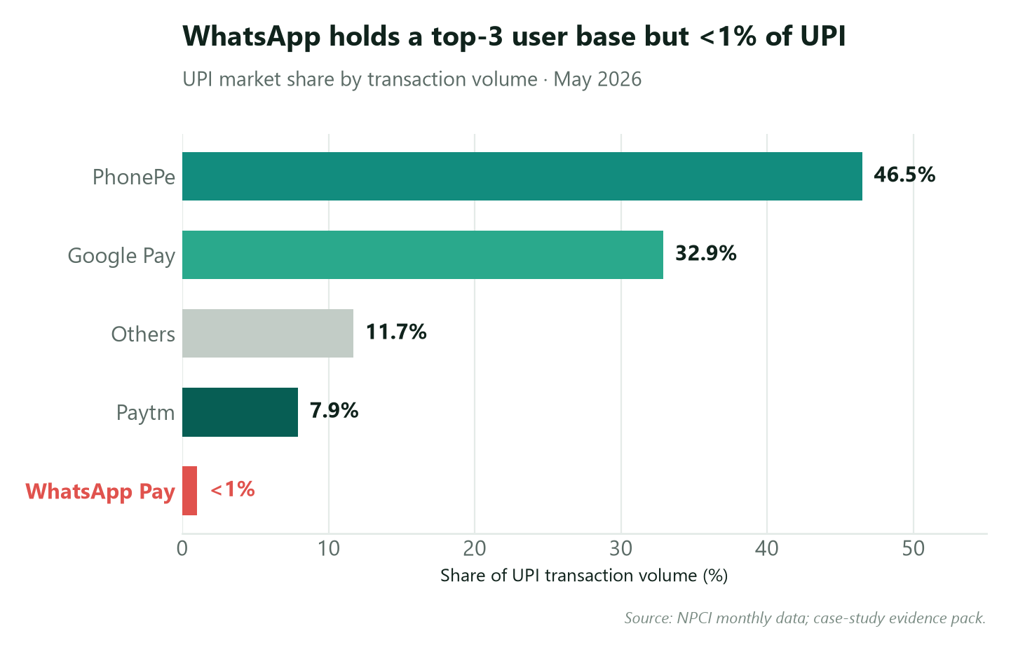
Figure 1. UPI market share by transaction volume, May 2026. WhatsApp Pay holds under 1% despite a top-3 user base.
The natural experiment that isolates the cause: NPCI removed the 30% market-share cap on Dec 31, 2024, and WhatsApp Pay's entire subsequent quarter of growth was +17% against 500M inboxes. This proves the cap was never the binding constraint — Meta's will to invest was, and will-to-invest is a function of LTV. The problem to solve is therefore "how do we make a WhatsApp Pay transaction worth something to Meta?", not "how do we surface it better."

1.3 Background & strategic context — why now
Where the market went. The payments war was won at the merchant counter. P2M (person-to-merchant) overtook P2P in August 2022 and now dominates UPI volume — the high-frequency habit engine that builds a default-app reflex. WhatsApp, restricted to P2P for most of its life, was absent from the surface that mattered.
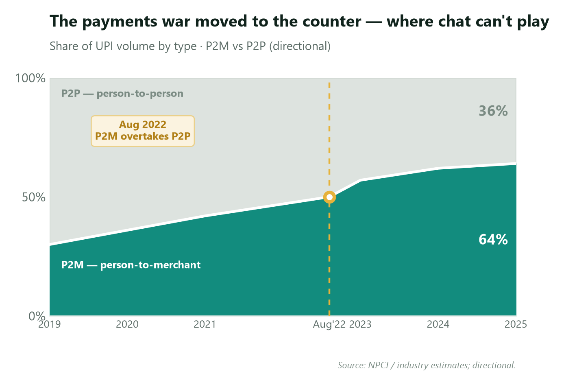
Figure 2. P2M overtook P2P in Aug 2022 and never looked back — the counter is where habit forms.
Why the constraint is now breakable. When WhatsApp Pay launched, Meta had no India monetization stack to attach a payment to. That has changed: CTWA is now Meta's fastest-growing ad product, and India is its single largest and most cost-efficient market.
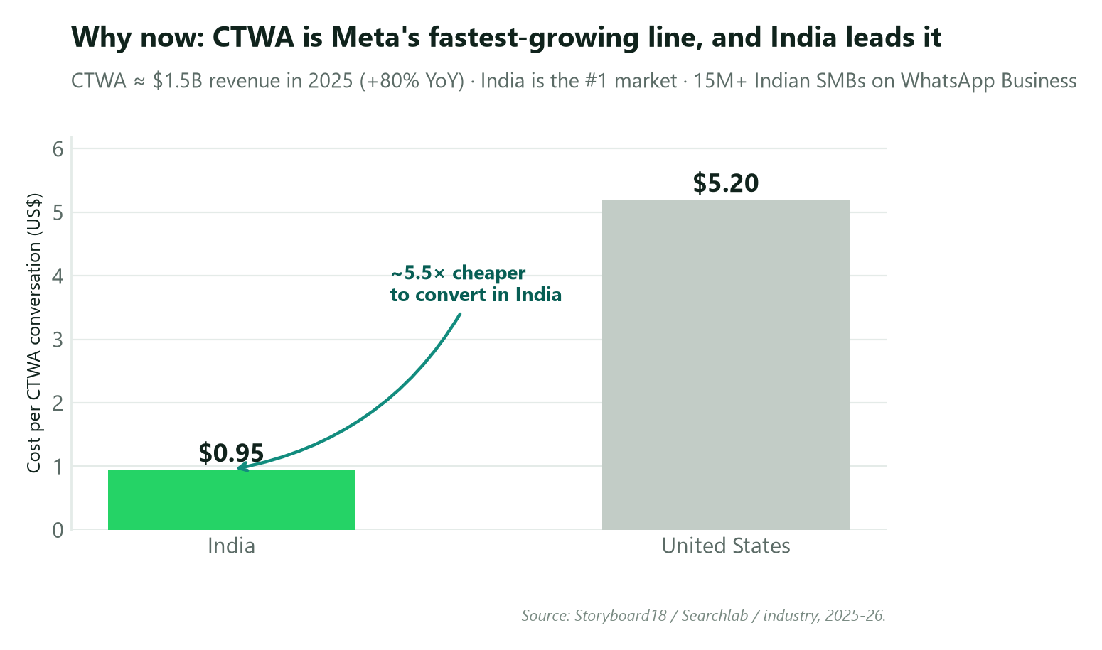
Figure 3. CTWA is Meta's fastest-growing line and India leads it — the monetization surface a payment can attach to.
A first-party checkout signal is the single most valuable thing a performance-ad platform can own. Today a CTWA advertiser's funnel goes dark at the moment of purchase (the sale completes off-platform on a third-party UPI app or website). WhatsApp Pay closing the loop hands Meta a deterministic conversion event to optimize and bid against. The commerce primitive to build on already exists: in Sep 2025 WhatsApp shipped an in-chat QR/UPI payment primitive in India; this PRD productizes it into a catalog → cart → checkout flow defaulted to WhatsApp Pay.
The reframe. Payments stops being a cost center and becomes the measurement-and-conversion layer of CTWA. We are not trying to win P2P. We are making the payment the thing that makes the ad business Meta already runs measurably better.

1.4 Objectives
Business objectives
- Close the loop — make ad → chat → catalog → pay → attribution complete inside WhatsApp, with WhatsApp Pay the default payment method at checkout.
- Generate LTV-to-Meta — emit a first-party, deterministic purchase-conversion event per completed checkout that flows into Ads ranking/optimization and advertiser reporting.
- Grow the North Star — convert CTWA ad-clickers into Monthly Active P2M Payers at the moment of demonstrated purchase intent.
- Stand up commerce GMV that can later carry a commerce-take / ad-take (the zero-MDR-proof monetization path).
User objectives
- Shopper: buy the thing I saw in the ad without leaving the chat or fighting a checkout.
- Merchant: close the sale where the conversation happens, with money settled and the sale attributed to the ad that drove it.

1.5 Assumptions
- Zero-MDR persists. Monetization must not depend on a UPI transaction fee. (If MDR returns for some flows, RuPay-credit-on-UPI upside increases — an upside risk, not a dependency.)
- The Sep-2025 in-chat UPI primitive can be extended to catalog → cart → server-set checkout.
- Ads will ingest and optimize on a first-party purchase-conversion event (see §7.1 — this is the value-capture path and must be committed, not assumed away).
- Meta funds WhatsApp Pay India as a ring-fenced P&L with a multi-year mandate. This is the binding precondition (§7.1); every target below is downstream of it.
- A "default-but-not-exclusive" payment selection is regulatorily defensible (other UPI apps remain selectable). See §8.
- CTWA continues its growth trajectory and India remains the #1 market over the planning horizon.

1.6 Non-goals (out of scope)
- Not a general e-commerce marketplace, storefront host, or logistics/fulfilment product.
- Not consumer lending or insurance here (separate Big Bet #2; this feature feeds its data graph but does not depend on it).
- Not changing UPI economics or seeking MDR — monetization is via ad-take / commerce-take, not a transaction fee.
- Not a P2P / social-payments redesign; scope is P2M commerce checkout originating from CTWA.
- Not international in v1 — India-only (CTWA's #1 market, and where the zero-MDR thesis lives).

2. Success Metrics

2.1 North Star
Monthly Active P2M Payers (MAPP) — unique users completing ≥1 P2M payment in a trailing 28-day window. Baseline is ~0.5–1M today against ~100M registered users. This feature is the highest-leverage MAPP input because it intercepts users at demonstrated purchase intent (they tapped a shopping ad), not cold.

2.2 Metric tree
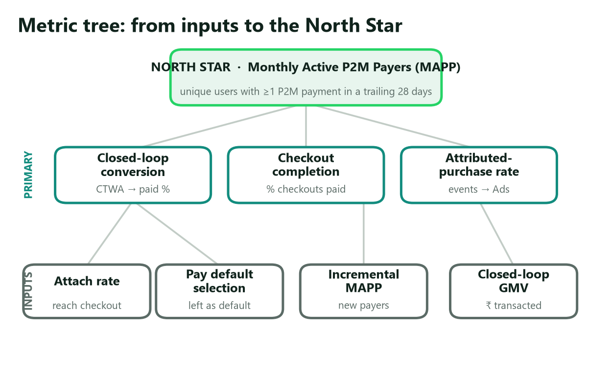
Figure 4. How feature inputs roll up to the North Star. Primary metrics are what this PRD moves directly; inputs are the levers underneath.
Layer | Metric | Definition
North Star | MAPP | Unique users with ≥1 P2M payment in trailing 28 days
Primary (feature) | CTWA→Pay closed-loop conversion | % of CTWA-initiated conversations that complete an in-chat WhatsApp Pay checkout
Primary (feature) | Checkout completion rate | % of initiated checkouts that succeed via WhatsApp Pay
Primary (Meta-side) | Attributed-purchase rate | % of CTWA conversions with a first-party purchase event returned to Ads
Input | Checkout attach rate | % of CTWA conversations reaching a cart/checkout surface
Input | Pay default-selection rate | % of checkouts where WhatsApp Pay is left as the chosen method
Input | Incremental MAPP | New/reactivated P2M payers first transacting via a CTWA checkout
Business | Closed-loop GMV | ₹ value of goods transacted through in-chat checkout
Business | Ad-effectiveness lift | Change in advertiser ROAS / cost-per-purchase from first-party attribution

2.3 Targets (phased, assumption-flagged)
Targets are directional and assume the org-level funding decision (§7.1) is made. They are sized to be defensible, not precise.
Metric | 6 mo (Pilot) | 12 mo (Expand) | 24 mo (Default)
Merchants live with in-chat checkout | ~500 | ~25,000 | 250,000+
Checkout completion rate (WhatsApp Pay) | ≥30% | ≥45% | ≥55%
Pay default-selection rate | ≥70% | ≥80% | ≥85%
Incremental MAPP (cumulative) | +0.3M | +3M | +10M
Closed-loop GMV run-rate | seed | ₹X00 cr/mo | ₹X,000 cr/mo
Advertiser cost-per-purchase | measure | −10% vs off-platform | −20% vs off-platform

2.4 Guardrail metrics (must-not-regress)
- Checkout latency (ad-tap → paid) p90 within budget; payment success rate ≥ NPCI/UPI parity.
- Chat trust: spam/block rate on CTWA business threads; user-reported scam rate on checkout.
- No cannibalization of P2P trust: WhatsApp Pay P2P success rate and NPS unchanged.
- Advertiser quality: merchant fulfilment / dispute / refund rate within thresholds.

3. Users & Use Cases

3.1 Personas
The Shopper (consumer). "I clicked an ad for something I want; let me buy it without leaving the chat or fighting a checkout." Tier 2/3-heavy, mobile-first, often new to formal e-commerce, high trust in WhatsApp as an interface. Pain today: ad → chat → then a hand-off to a clunky external link, a COD form, or a "pay to this UPI ID" message with manual amount entry. Drop-off is brutal.
The Merchant / Advertiser. "I run CTWA ads because they're cheap and they work; I want the sale to close where the conversation happens, with money settled and tracked." One of 15M+ WhatsApp Business accounts; SMB to mid-market; already paying Meta for CTWA. Pain today: manual payment collection, reconciliation overhead, no clean conversion signal to optimize spend, leakage to third-party rails.
The Ads (CTWA) team (internal stakeholder). "Give me a deterministic, first-party purchase event and my ad ranking, optimization, and advertiser ROAS all improve." This persona matters because their value capture (better ads) is what funds the payments investment. The PRD must emit the conversion signal in a form Ads can ingest.

3.2 User stories (JTBD)
Shopper
- As a shopper who tapped a CTWA ad, I can browse the merchant's catalog in the chat so I don't lose context.
- As a shopper ready to buy, I can check out with a pre-filled cart, address, and WhatsApp Pay already selected, so paying is one confident tap + UPI PIN.
- As a shopper, I get an order confirmation and receipt as a chat message I can return to, so I trust the purchase and can re-engage.
Merchant
- As a merchant, I can attach my catalog to a CTWA ad so the ad lands on a shoppable conversation.
- As a merchant, I receive UPI settlement and a clean order record without manual collection or reconciliation.
- As a merchant, I can see which ad drove which sale so I can scale what works.
Ads team
- As the Ads platform, I receive a first-party purchase-conversion event keyed to the originating ad/campaign so I can optimize delivery and report ROAS.

3.3 User journey — current vs proposed
Stage | Today (leaky) | Proposed (closed loop)
See ad | CTWA ad on FB/IG | Same
Enter chat | Lands in business thread | Lands on a shoppable thread with catalog
Browse | Free-text Q&A; no structured catalog | In-chat catalog + cart
Pay | Redirect to external link / "send to this UPI ID" | In-chat checkout, WhatsApp Pay default, UPI PIN in context
Confirm | Manual message / none | Auto receipt + order in thread
Attribution | Funnel goes dark at purchase | First-party purchase event → Ads

4. Solution & Requirements

4.1 Solution overview — the closed loop
The solution wires four stages into a single loop that never leaves WhatsApp. The strategic point sits on the return arrow: the completed payment is the signal that makes the ad valuable. Without stage 3 closing inside WhatsApp, stage 4 cannot fire with first-party certainty — which is exactly why the payment, today worth ₹0, becomes worth something.
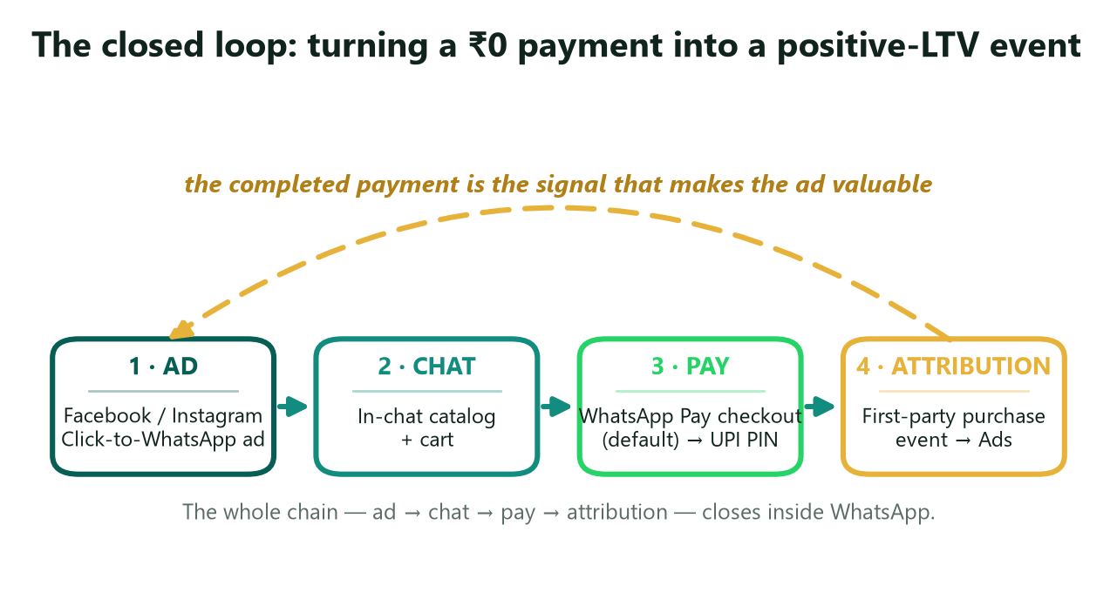
Figure 5. The closed loop. The feedback arrow is the thesis: a completed in-chat payment is a first-party conversion signal that makes CTWA measurably more valuable.

4.2 User experience & flow
The screen-by-screen flow is specified in the companion WhatsApp_Pay_CTWA_Wireframes.pptx. Core principles:
- Zero context switches — catalog, cart, checkout, PIN, and receipt all render inside the conversation.
- Default, not forced — WhatsApp Pay is pre-selected; other UPI apps remain one tap away (see §8 self-preferencing).
- Minimum typing — cart, address, and totals are pre-filled; the only required input is the UPI PIN.
- Trust surfaced — merchant identity, refund/return terms, and a safety badge are visible before payment.

4.3 Functional requirements
Priority: P0 = required for pilot · P1 = required for default rollout · P2 = fast-follow.
A. Ad unit (CTWA entry)
ID | Requirement | Acceptance signal | Pri
A1 | CTWA ad supports a "Shop on WhatsApp" objective that deep-links into a shoppable conversation, carrying campaign/ad/product context | Deep-link opens correct catalog; context present in payload | P0
A2 | Deep-link payload preserves attribution identifiers end-to-end (ad → chat → checkout → purchase event) | click_id survives to the purchase event with >99% join rate | P0
A3 | Ad creative can reference a specific catalog/product so the chat opens on that item | Product-specific ads open on that product card | P1

B. Chat & catalog
ID | Requirement | Acceptance signal | Pri
B1 | On open, business sends a structured greeting + catalog/product card (image, title, price, CTA) | Card renders within latency budget | P0
B2 | Shopper can add items to an in-chat cart; cart state persists in the thread | Cart survives app restart and returns on reopen | P0
B3 | Catalog supports variants (size/qty), stock state, and price; merchant-managed via Business tools | Variant + stock changes reflect at checkout | P1
B4 | Business-AI assistant can answer questions and assemble the cart | AI-assembled carts convert at ≥ manual parity | P2

C. Checkout (the core change)
ID | Requirement | Acceptance signal | Pri
C1 | A checkout bottom-sheet summarizes items, delivery address, and total | Sheet shows correct totals incl. taxes/shipping | P0
C2 | WhatsApp Pay is pre-selected as the default payment method; other UPI apps remain available but are not the default | Default-selection rate meets target; alternates reachable in ≤1 tap | P0
C3 | Address is pre-filled from saved profile; editable; minimal typing | ≥80% of checkouts require no address typing | P1
C4 | Checkout shows merchant identity, refund/return terms, and a safety/trust badge | Badge + terms visible above the Pay button | P0
C5 | Price integrity: amount is server-set from cart; never user-entered | 100% of amounts server-derived; user cannot edit | P0

D. Payment (WhatsApp Pay / UPI)
ID | Requirement | Acceptance signal | Pri
D1 | Tapping Pay invokes the NPCI UPI PIN flow in-context, returning to the chat on completion | PIN sheet returns to thread with status | P0
D2 | Settlement routes to the merchant's account; order record generated automatically | Settlement + order record on every success | P0
D3 | Support RuPay-credit-on-UPI as an eligible instrument where available (the one MDR-bearing UPI flow → commerce-take headroom) | Instrument selectable when eligible | P2
D4 | Idempotent payment handling; safe retry on network failure; no double-charge | Zero double-charge under fault injection | P0

E. Post-purchase
ID | Requirement | Acceptance signal | Pri
E1 | Confirmation + receipt delivered as a chat message (order ID, items, amount, merchant, track CTA) | Receipt message on 100% of successes | P0
E2 | Order/track surface for status updates; merchant can post shipment updates into the thread | Status updates render in thread | P1
E3 | Refund/dispute entry point from the order message | Refund flow reachable from receipt | P1

F. Attribution & measurement (the LTV layer)
ID | Requirement | Acceptance signal | Pri
F1 | On successful payment, emit a first-party purchase-conversion event keyed to the originating CTWA ad/campaign | Event fires within SLA of payment success | P0
F2 | Event flows to Ads optimization (bidding/ranking) and advertiser reporting (ROAS, cost-per-purchase) | Event visible in advertiser reporting | P0
F3 | Funnel instrumentation across all stages (impression → tap → conversation → catalog → add-to-cart → checkout → paid) | All seven stages emit events | P0
F4 | Privacy-compliant data handling per NPCI/RBI/DPDP rules; consent + purpose limitation respected | Passes privacy review; consent enforced | P0

4.4 Non-functional requirements
Category | Requirement
Performance | Catalog card render and checkout-sheet open within a tight p90 budget; ad-tap → paid p90 within target.
Reliability | Payment success rate ≥ UPI/NPCI parity; idempotent, resumable checkout; no double-charge under retry/fault.
Security | Server-set amounts; merchant KYC; encryption in transit/at rest; UPI PIN never handled outside NPCI-certified components.
Privacy | Payment data governed by NPCI/RBI; DPDP consent + purpose limitation; payment data is not fused into the ad graph beyond the consented conversion event (see §8 trust risk).
Accessibility | Screen-reader support; large-text and high-contrast compatibility; minimal-typing flows for low-literacy users.
Localization | 10+ Indian languages across catalog, checkout, and receipt; low-bandwidth and low-end-device rendering.
Scalability | Sustain festival-peak load (order-of-magnitude spikes) without latency or success-rate regression.

4.5 Edge cases & error states
Scenario | Required handling
Payment failure / bank decline | Clear retry with reason; cart preserved; no order created
Network drop mid-PIN | Idempotent resume; single charge; status reconciled
Price/stock change between cart and pay | Re-confirm updated total; block silent overcharge
Out-of-stock / partial availability | Offer edit/remove; recompute total server-side
Duplicate submit / double-tap Pay | Deduplicated by event_id; one charge
Refund / return | Refund from receipt; conversion event marked refunded
Disputed transaction | Dispute entry point; T&S review; merchant notified
Address not serviceable | Flag before payment; suggest edit
Session resumed days later | Cart + attribution context restored from thread

5. Technical Considerations

5.1 High-level architecture
The feature composes existing systems rather than building new rails. Principal components and responsibilities:
- CTWA ad system (Ads) — serves the "Shop on WhatsApp" ad and stamps the deep-link with campaign/ad/product identifiers.
- Attribution / deep-link service — mints a click_id at ad-tap and threads it through conversation → checkout → purchase event.
- Catalog & cart service (WhatsApp Commerce) — merchant-managed catalog, variants, stock, and in-thread cart state.
- Checkout service — server-set totals, address, taxes/shipping; enforces price integrity (C5).
- WhatsApp Pay / UPI integration — NPCI UPI PIN flow via the multi-bank TPAP/PSP model (ICICI/Axis/HDFC/SBI); settlement to merchant.
- Conversion-event pipeline — emits the first-party purchase event to Ads optimization and advertiser reporting.
- Trust & Safety / fraud service — merchant KYC, amount integrity, scam/abuse monitoring on CTWA threads.

5.2 Data model — the conversion-event schema
The entire LTV thesis rests on one artifact: a clean, first-party purchase-conversion event. Specifying it concretely is what makes the "positive-LTV" claim buildable rather than rhetorical.
Field | Type | Example | Notes
event_id | string (uuid) | 9f2c… | Idempotency key; dedupes retries
event_type | enum | purchase | purchase / refund / dispute
occurred_at | timestamp | 2026-07-01T10:15:03Z | ISO-8601, UTC
click_id | string | ctwa_ref_… | Joins ad-tap → conversation → order
campaign_id / adset_id / ad_id | string | … | Attribution keys back to Ads
conversation_id | string (hashed) | … | Privacy-preserving thread reference
merchant_id | string | m_10293 | Settlement + reporting
order_id | string | ord_55f… | Links to receipt and fulfilment
gmv_amount | decimal | 1499.00 | Server-set; currency INR
payment_method | enum | whatsapp_pay | whatsapp_pay / other_upi / rupay_cc_upi
payment_status | enum | success | success / failed / refunded
items_count | int | 3 | Basket size
consent_flags | object | {ads: true} | Purpose limitation / DPDP consent state

Privacy note: only the consented conversion event flows to Ads; raw payment detail is not exposed to the ad graph. This boundary is deliberate and is the mitigation for the trust/monetization tension in §8.

5.3 Analytics & instrumentation plan
Every funnel stage emits a first-party event, so drop-off is observable and optimizable end-to-end. The illustrative target funnel:
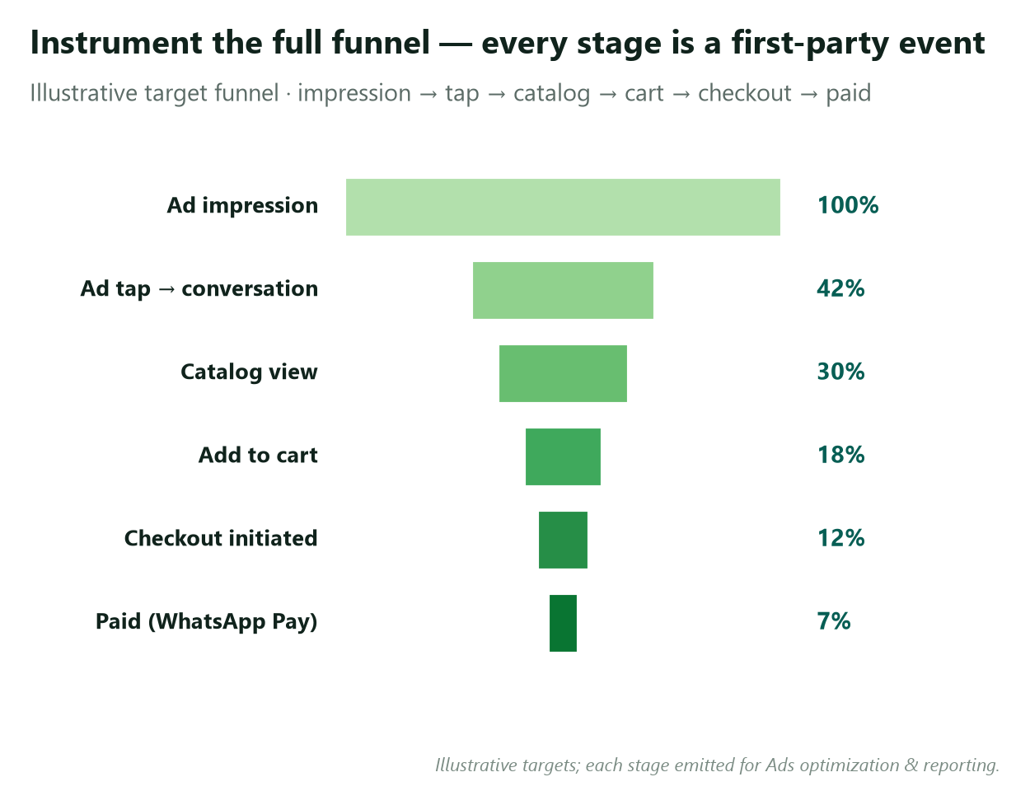
Figure 6. Every stage of the funnel emits a first-party event — impression through paid — so we can optimize each transition and report ROAS deterministically.
Instrumented transitions: impression → ad tap → conversation → catalog view → add-to-cart → checkout initiated → paid; plus post-purchase (receipt viewed, refund, dispute). Each event carries the attribution keys from §5.2.

5.4 Experimentation plan
- Design: merchant/geo-level holdout (randomized), comparing closed-loop checkout vs. today's off-platform hand-off.
- Primary hypothesis: advertisers with closed-loop attribution see lower cost-per-purchase / higher ROAS, and checkout completion beats the off-platform baseline.
- Primary metrics: advertiser cost-per-purchase (holdout vs. treatment), checkout completion rate.
- Guardrails: payment success rate, chat block/spam rate, dispute rate (must not regress).
- Decision rule: proceed to Expand only if completion ≥30% and the holdout shows a statistically significant ROAS lift; otherwise iterate on friction before scaling.
- Why it matters: this is the gate that converts the LTV thesis into a measured result before the org commits to default rollout.

6. Monetization Model
Zero-MDR means the payment itself earns ₹0. The value is created around the payment, and it stacks. The model is deliberately not a transaction fee — it is ad-take + commerce-take + a financial-services ladder, each of which is zero-MDR-proof.
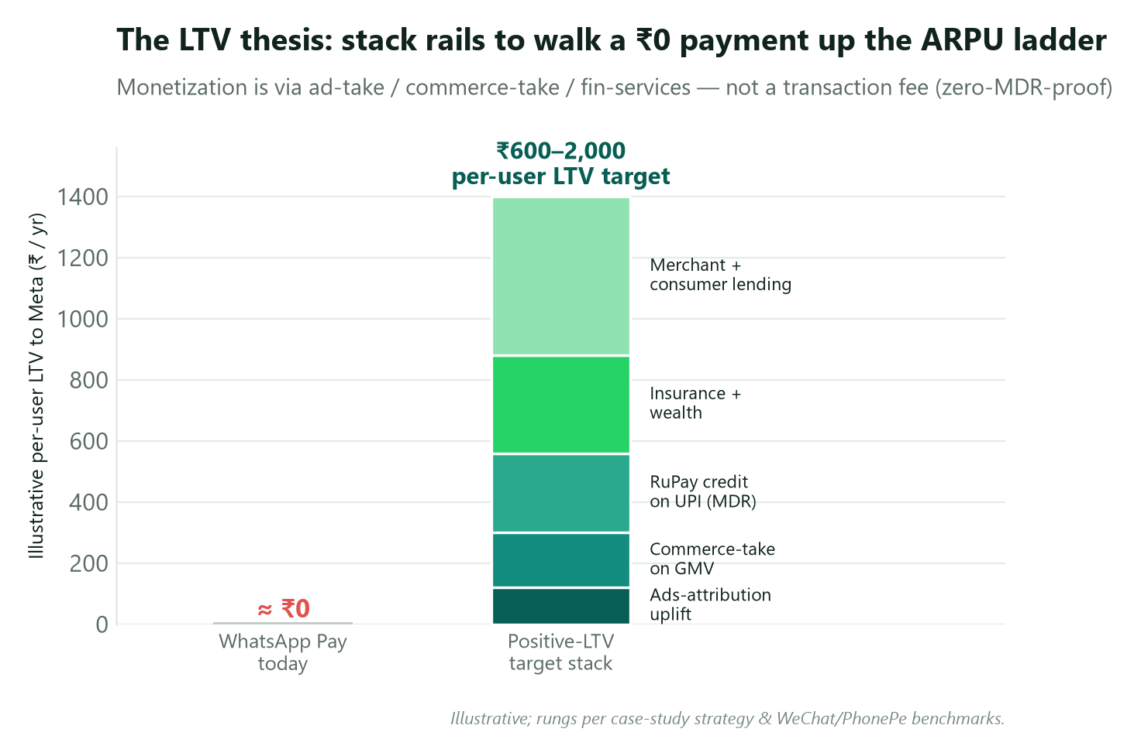
Figure 7. The LTV thesis: stack rails to walk a ₹0 payment up the ARPU ladder. Monetization is indirect (ad-take / commerce-take / fin-services), so it survives zero-MDR.
- Ads-attribution uplift (this PRD). The first-party conversion event raises CTWA ROAS, so advertisers spend more per conversion — value captured rail-agnostically on the ad line Meta already runs.
- Commerce-take on closed-loop GMV. A small take on transacted GMV, WeChat-style (~0.6% reference), introduced only once adoption is durable.
- RuPay-credit-on-UPI. The one MDR-bearing UPI flow — direct, recurring, fee-bearing revenue where eligible.
- Insurance + wealth. Capital-light, license-light ARPU — the fastest, lowest-risk rung.
- Merchant + consumer lending. The highest-LTV rail (Big Bet #2), underwritten on the CTWA/UPI data graph this feature generates.
Sizing note. At an illustrative closed-loop GMV run-rate and a ~0.6% commerce-take, plus measured ROAS uplift on CTWA spend, per-user LTV walks from ~₹0 toward the ₹600–2,000 band that makes the P&L investable. Exact figures are modeled in the strategy appendix; the point is the mechanism, not the precision.

7. Dependencies

7.1 The critical dependency — the funding decision
The diagnosis names this explicitly: Meta must choose to fund WhatsApp Pay as the default CTWA checkout, as a ring-fenced P&L. This is an org-level commitment, not an engineering task, and it is the exact thing that has been missing for eight years. Everything below is downstream of it. This PRD is, in effect, the artifact that makes the funding case investable by showing the LTV mechanism concretely and specifying how it is measured (§5.4).

7.2 Cross-team & external
Dependency | Owner | Note
Catalog + cart + in-chat UPI checkout productization | WhatsApp Commerce | Extends the Sep-2025 QR/UPI primitive
First-party conversion event ingestion & optimization | Ads / CTWA | The value-capture path; must accept and bid on the event
UPI PIN / settlement rails | Payments + NPCI | PSP/bank partners; UPI PIN UX; settlement
Business-AI / agentic commerce | Messaging AI | Accelerant for cart assembly (P2)
Self-preferencing review | Legal / Regulatory | Defaulting Meta's own rail inside an ad funnel (see §8)
Merchant onboarding & enablement | Business Platform / GTM | Catalog setup, KYC, settlement onboarding

8. Risks & Mitigations
A core principle of this case study is that every proposed fix carries its failure case. These are real.
Risk | Severity | Mitigation
Self-preferencing / antitrust. Defaulting Meta's own rail inside Meta's ad funnel may draw CCI / NPCI-fairness scrutiny. | High | Keep other UPI apps selectable (default ≠ exclusive); document consumer benefit (lower friction, fraud protection); proactive regulatory engagement.
Indirect LTV may not convert. Zero-MDR means the payment earns ₹0; if Ads doesn't actually bid up CTWA on the new signal, the thesis doesn't become revenue. | High | Instrument ad-effectiveness lift (§2.2) as a gating metric; run the §5.4 holdout to prove incremental ROAS; commerce-take on GMV as a second path.
Merchant enablement friction. Catalog, KYC, settlement setup is work; SMBs may not adopt. | Med | Templated/AI-assisted catalog import; default-on for advertisers already running CTWA; white-glove for anchor merchants.
Checkout friction / UPI PIN drop-off. A clunky PIN hand-off kills completion. | Med | In-context PIN return-to-chat; pre-filled cart/address; aggressive p90 latency budget; relentless funnel optimization.
Trust & fraud. Shoppable ads + payments invite scam merchants and farming. | High | Server-set amounts (C5); merchant KYC; trust badges; dispute/refund flow; T&S monitoring on CTWA threads.
Trust vs. monetization tension. Fusing payment data into ads to deepen LTV directly contradicts the "chat app shouldn't mine my money" trust concern. | Med | Hard data boundary (§5.2): only the consented conversion event reaches Ads; no raw payment detail; state it publicly.
Habit fragility. Commerce checkout may not generalize to daily P2P habit. | Med | Accept scope: this bet wins commerce, not daily P2P; sequenced with merchant-lending (Bet #2) to deepen the relationship.

9. Go-to-Market & Rollout

9.1 Phased rollout
Each phase ships only if the prior phase clears a hard exit gate — the discipline that prevents "surfacing without funding" from reproducing the +17% flatline.
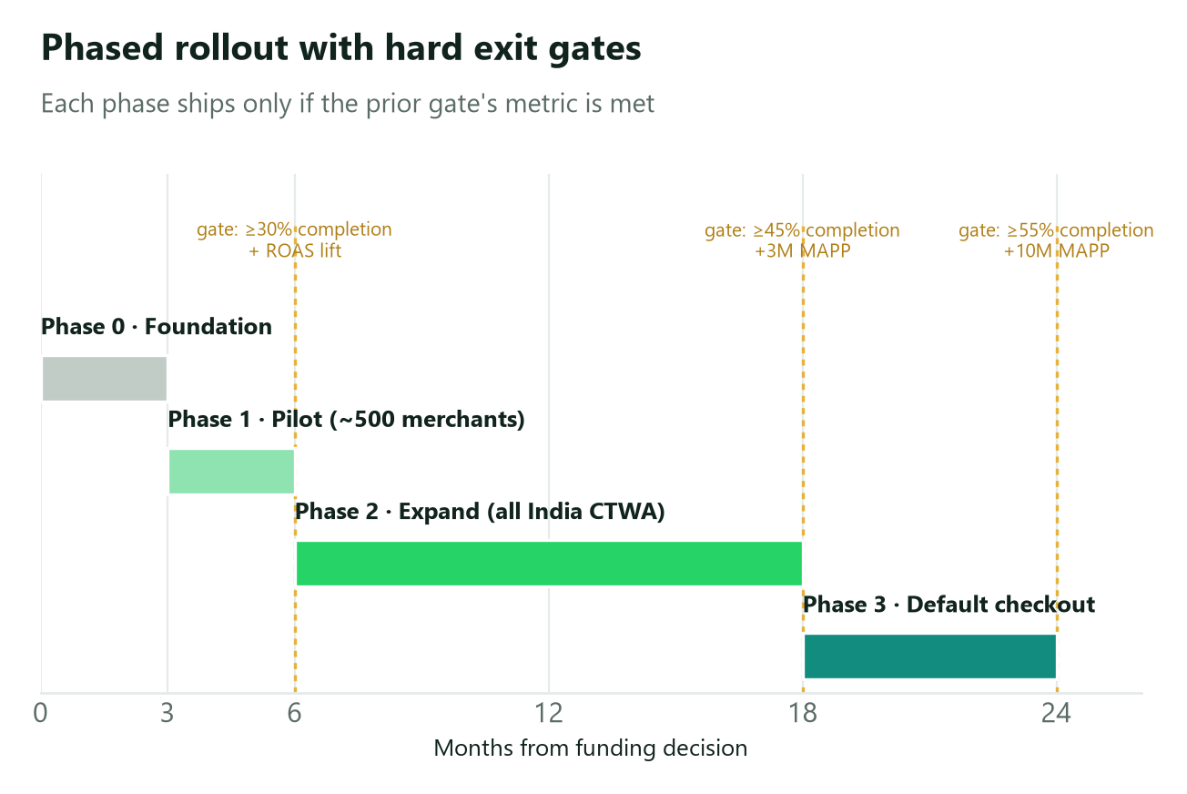
Figure 8. Phased rollout with hard exit gates. A phase advances only when the prior gate's metric is met.
Phase | Timeline | Scope | Exit gate
0 — Foundation | 0–3 mo | Productize catalog→cart→checkout on the Sep-2025 UPI primitive; build the conversion event; instrument the funnel | Internal E2E closed loop works; event lands in Ads reporting
1 — Pilot | 3–6 mo | ~500 invited merchants (incl. 3–5 anchors); WhatsApp Pay default; measure completion + attribution lift | ≥30% completion; demonstrated ROAS lift on holdout
2 — Expand | 6–18 mo | Open to all India CTWA advertisers; AI-assisted cart; RuPay-credit-on-UPI eligibility | ≥45% completion; +3M incremental MAPP; cost-per-purchase −10%
3 — Default | 18–24 mo | In-chat WhatsApp Pay checkout is the standard CTWA endpoint; commerce-take productized | ≥55% completion; +10M MAPP; measurable ad-spend lift; commerce-take live

9.2 GTM motion
Acquisition cost for merchants is near-zero — running a CTWA ad becomes the act of adopting the checkout. That is the structural advantage this feature has over a field-force merchant build (the ~₹3,000–6,000 cr path the diagnosis warns against). Anchor merchants (e.g., a grocery anchor at 10–20M shoppers) seed the volume proof; the long tail adopts through the ad product they already buy.

9.3 Milestones
Milestone | Target | Owner
Funding decision — P&L stood up | M0 | GM / Exec
Internal E2E closed loop | M3 | WhatsApp Commerce Eng
Pilot launch (~500 merchants) | M6 | GTM
ROAS holdout readout | M6 | Ads Data Science
Expand / GA (India CTWA) | M12 | WhatsApp Commerce
Default checkout + commerce-take live | M24 | WhatsApp Commerce + Ads

10. Open Questions
# | Question | Owner
1 | Commerce-take rate & timing — when/at what rate without suppressing adoption? (WeChat ~0.6% reference) | PM + Finance
2 | Attribution windows & model — click vs. view; window length; multi-session purchases | Ads DS
3 | Default-selection policy — exact treatment of competing UPI apps to stay defensible on self-preferencing | Legal + PM
4 | RuPay-credit-on-UPI — prioritize sooner as the one MDR-bearing instrument vs. complexity cost | PM + Payments
5 | Anchor-merchant selection — which 3–5 high-volume merchants seed volume fastest? | GTM + BD

11. Appendix

11.1 Evidence & benchmarks
Claim | Figure | Source basis
CTWA scale & growth | ~$1.5B revenue 2025, +80% YoY; spend +82% YoY Q1'25→Q1'26 | Storyboard18 / Spocket
India is CTWA's #1 market | ~$0.95 cost/conversation (vs ~$5.20 US) | Searchlab / industry
WhatsApp Business base | 15M+ businesses in India | Searchlab
Closed-loop monetization template | WeChat ~0.6% mini-program commission on >RMB 2T GMV; 900M WeChat Pay users | CIW/Tencent; TechBuzzChina
The binding constraint | Cap removed Dec 31 2024 → only +17% growth (natural experiment) | Phase-2 diagnosis
North Star baseline | MAPP ~0.5–1M of ~100M registered | Phase-3 strategy

11.2 Competitive teardown
Dimension | WhatsApp Pay | PhonePe | Google Pay | Paytm
UPI volume share (May 2026) | <1% | 46.5% | 32.9% | 7.9%
Merchant network / offline | Minimal | 47M+ merchants, 98.6% pincodes | Large | Large
Soundbox / POS army | None | 9M+ devices | Limited | Large
Credit-on-UPI / lending | Not yet | Fast-growing | Partner-led | Established
In-chat commerce | Structural advantage (this PRD) | No chat surface | No chat surface | No chat surface
Unique distribution asset | 500M inboxes + 15M Business + CTWA | Merchant density | Android / GPay base | Wallet + merchant base

Read: WhatsApp cannot win the board the duopoly already owns (offline sub-₹500 P2M). It can win the one board no rival has — commerce inside the conversation — which is precisely what this PRD builds.

11.3 Glossary
CTWA = Click-to-WhatsApp Ads · MDR = Merchant Discount Rate (₹0 under India UPI) · MAPP = Monthly Active P2M Payers · P2M = person-to-merchant · P2P = person-to-person · LTV = lifetime value · ROAS = return on ad spend · GMV = gross merchandise value · TPAP = Third-Party Application Provider · CLOU = credit-line-on-UPI · DPDP = Digital Personal Data Protection Act.

11.4 References
Source basis is summarized in §11.1 and detailed in the companion Evidence Dossier, Diagnosis, and Rejuvenation Strategy documents. Market-share and CTWA figures are drawn from NPCI monthly data and industry reporting (Storyboard18, Searchlab, Spocket); benchmark comparisons from Tencent/CIW (WeChat) and PhonePe DRHP.

This PRD specs Tier-1 solution #15 / Big Bet #1 from the WhatsApp Pay India Rejuvenation Strategy. It is a portfolio artifact demonstrating the path from root-cause diagnosis → prioritized strategy → executable product spec. Companion UX: `WhatsApp_Pay_CTWA_Wireframes.pptx`.

