Hey everyone, so me, Brian (President of ISSS (Information Systems and Security Society) and Drew (President of MAD) have drafted up a plan for Freetail Hackers to umbrella over MAD, ISSS, and Competitive Programming. None of these orgs will exist anymore, and will simply become “Freetail Hackers.”

**STRUCTURE**:

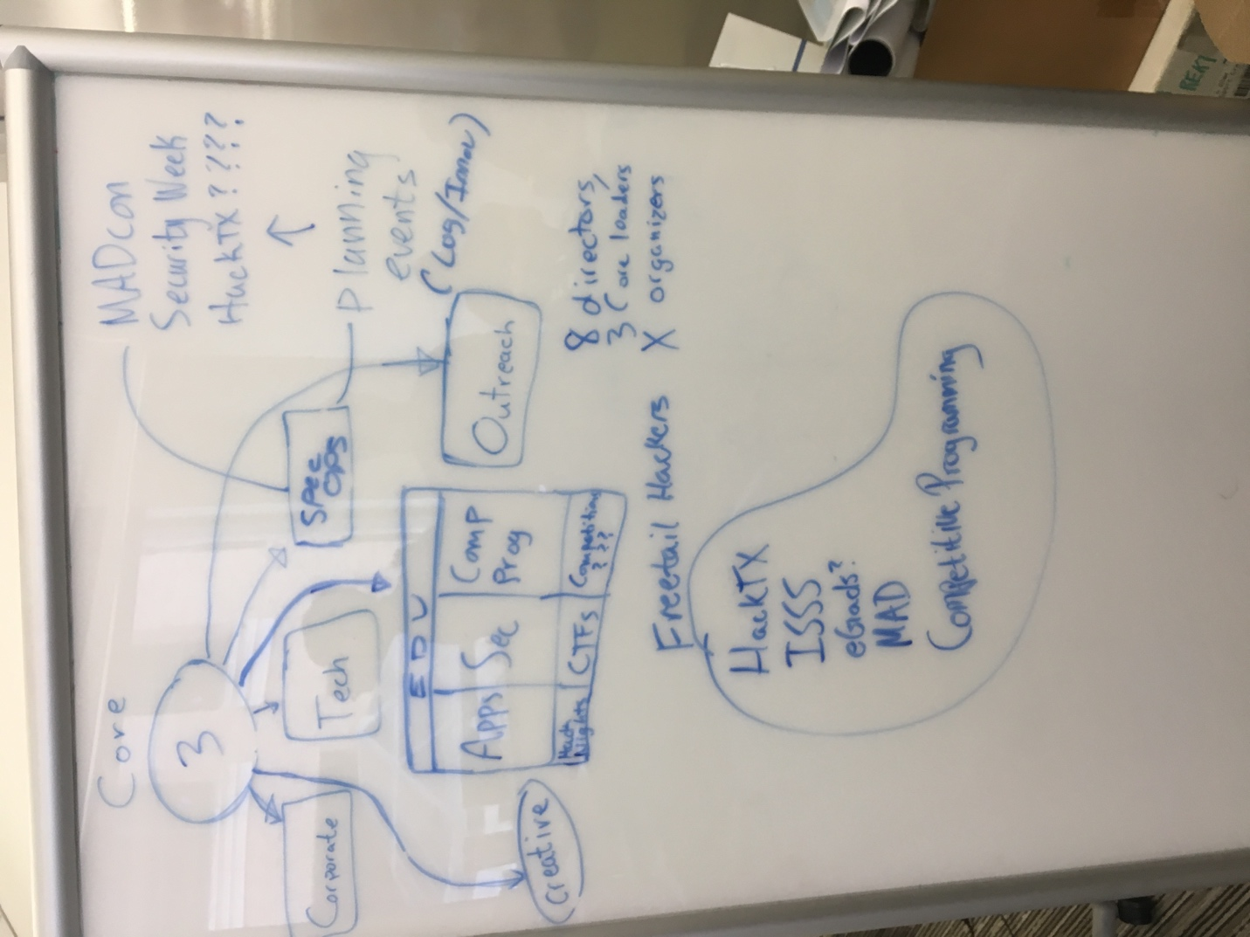

**Board of Directors**: 3 students that are the point of contact for the dept and oversee the general running of the org. They would not be micromanaging, but would rather guide the org in the right direction.

Each of the following teams would be a small self-managed team with a Lead Director and team structure.

**Corporate:** A corporate team that fundraises for the entire org.

**Creative:** A team that controls the creative assets for all events (uMAD, HackTX, etc..)

**Outreach:** Does marketing and social media for entire org

**Tech:** Runs the backend of HackTX, MAD, MAD Labs (they do non-profit work)

**Special Ops:** Responsible for logistics and “innovation” for large events (HackTX, uMAD, Security Day, etc..)

**Education:** Composed of Apps, Security, and Competitive Programming. They do the workshops and lessons that MAD usually does, and the competitions, hack nights, security events, etc…

**WHY?:**

We want to create a central org for education outside of the classroom for all majors. As of right now, HackTX, MAD, and ISSS compete for corporate money, social attention, and membership. A lot of our current members are officers in other orgs. By having Freetail Hackers the central hub, we can provide students with everything they need related to education. We can provide workshops, a place to use their skills (HackTX), a conference to meet other professionals and network (uMAD), and a place to compete on one of the top national programming teams (UT just won 1-4/68). We can also share resources.

**PROS:**

* Be able to raise A LOT more money. We currently do not have sustenance for our “yearly package.” Sure we try and sell our second hackathon, but companies mostly care about HackTX. This way, we have HackTX, uMAD, sponsored workshops, and a programming team. By bringing in ISSS we also gain a wider breadth of possible sponsors.
* //
* We will be the place undergrad students of all majors to learn outside of the classroom. Be it web dev, security, or mobile app dev.
* Reduce overlap between orgs

**CONS:**

* Push out smaller orgs possibly?
* Individual orgs lose some control
* Need a lot more people