Project Title:
Kisan Copilot: Autonomous Multi-Agent AI for Agricultural Decision Support and KCC Financial Assistance

Team Members:
  - Prakhar Gupta (230486)
  - Rishabh Kumar Singh (230468)

Problem Definition
What problem are you addressing?
Small and marginal farmers often need to make interconnected decisions involving weather conditions, crop prices, agricultural credit, and crop insurance. Relevant
information is distributed across different sources and changes over time, making it
difficult for farmers to determine which actions are most appropriate for their current situation.

Kisan Copilot addresses this problem by using a multi-agent AI system that autonomously analyzes a farmer's profile and relevant agricultural signals,
delegates tasks to specialized agents, combines their findings, and generates personalized, explainable recommendations.

Who are the intended users?
- Small and marginal farmers
- Farmers using or eligible for Kisan Credit Card (KCC)-based agricultural finance
- Banking/business-correspondent personnel who may assist farmers
- Agricultural support personnel
For the academic prototype, synthetic farmer profiles will be used instead of real customer/financial data.

Objectives & Expected Outcomes

- Develop a multi-agent AI system capable of autonomously coordinating
specialized agents for weather, mandi prices, agricultural credit, and crop insurance.

Integrate real-world agricultural information sources and tools with
synthetic farmer/KCC profiles to generate personalized and context-aware recommendations.
- Implement explainability and human-in-the-loop safeguards for sensitive financial recommendations and demonstrate agentic planning, tool usage,
delegation, and decision-making.

- Expected outcome: A working prototype where a farmer profile can be selected
and submitted to Kisan Copilot, after which the system determines which agents are relevant, retrieves required information through tools/APIs, reasons over the collected context, and produces prioritized recommendations with supporting
information and confidence/status indicators.

Proposed Methodology

  - Agents and their roles

Agent | Responsibility
Orchestrato r Agent | Understands the farmer's situation, plans the workflow, selects/delegates tasks to relevant agents, and synthesizes the final recommendation
Weather Agent | Retrieves and analyzes weather conditions and forecasts relevant to the farmer's crop/location
Mandi  Intelligence Agent | Retrieves mandi prices and analyzes price trends to provide crop-selling/holding insights
Credit  Lifecycle Agent | Analyzes synthetic KCC information such as credit limit, outstanding amount and repayment timelines
Insurance Agent | Checks PMFBY-related eligibility, enrollment and relevant crop/insurance information
Communica tion Agent | Converts the final recommendation into farmer-friendly communication and, later, Hindi/Indian-language voice output

  - Tools/APIs to be used

IMD / weather data APIs
- AgMarkNet for mandi/market-price information
- PostgreSQL for synthetic farmer and KCC profiles
- Redis for caching frequently accessed information

PMFBY/public government information sources
- Bhashini APIs for speech/language capabilities in later stages
- Optional WhatsApp Cloud API for future farmer communication
- MCP-based tool wrappers as an advanced extension

  - LLM/model and Agentic AI framework

LLM: Llama model accessed through Groq API Agentic AI Framework: CrewAI
Backend: FastAPI
Database: PostgreSQL
Caching: Redis
Frontend: React + Tailwind CSS
Advanced components: LangSmith, pgvector/RAG, MCP

  - Brief workflow of the proposed system

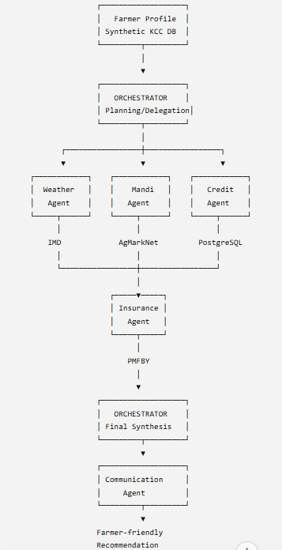

Feasibility & Resources
  - Data sources

    - Synthetic farmer/KCC profiles
    - IMD weather information
    - AgMarkNet mandi prices
    - PMFBY/public agricultural insurance information
    - Government agricultural/KCC documentation for later RAG implementation

  - APIs/tools
    - Groq API
    - IMD/weather APIs
    - AgMarkNet
    - PostgreSQL
    - Redis
    - Bhashini
    - Optional WhatsApp Cloud API
    - MCP tool interfaces

  - Software/frameworks
    - Python
    - FastAPI
    - CrewAI
    - PostgreSQL
    - Redis
    - React
    - Tailwind CSS
    - LangSmith
    - pgvector
    - Git/GitHub
    - Docker
    - WSL2

  - Compute/resources required
The core system is designed to run without a dedicated GPU because the LLM inference is accessed through the Groq API. Development can therefore be
performed on a standard laptop with approximately 12 GB RAM and an Intel i3 processor, while heavier external model inference is handled through cloud
APIs.

Team Members & Individual Understanding

Member | Role/Responsibility | Individual Understanding
Prakhar Gupta | System Architecture, Orchestrator Agent, Backend & Database Integration, Agent  Coordination | Understands the complete system architecture,  CrewAI orchestration,  agent delegation, FastAPI backend, PostgreSQL data flow, tool integration and

 |  | overall Agentic AI workflow
Rishabh Kumar Singh | Specialized Agent  Development, API/Tool Integration, Frontend & Testing | Understands specialized agent implementation, external API/tool  integration, React interface, agent  communication, testing and evaluation of the system

Project Timeline

Activity | Week(s) | Deliverable
Problem & Design | Week 1 | Final problem definition,  architecture, agent roles, technology  selection and database  design
Development /Coding | Week 2–5 | FastAPI backend, PostgreSQL database,  Weather/Man di/Credit/Insu rance agents, tools and  Orchestrator
Integration & Testing/Debugging | Week 5–6 | Multi-agent integration, API  integration, workflow testing and error  handling

Activity | Week(s) | Deliverable
Evaluation & Refinement | Week 6–7 | Scenario-bas ed  evaluation, accuracy/re sponse  analysis, debugging and system refinement
Presentation/Interface UI | Week 6–7 | React  dashboard showing  farmer profile, agent activity and final recommendati ons
Deployment | Week 7 | Local/contai nerized  deployment and final system setup
Final Demo |  | End-to-end demonstration  ,

Activity | Week(s) | Deliverable
 | Week 8 | documentatio n, PPT, report and viva  preparation

Team Responsibility Matrix

Activity | Member 1 | Member 2
Agent Design | Lead —  Orchestrat or &  overall  architectu re | Lead — Specialized agent design
Agent/Tool Development | Orchestrat or, Credit Agent,  database integratio n | Weather, Mandi,  Insurance agents & API tools
Integration & Testing | Lead — backend and multi-agent  integration | Lead — API testing,  UI testing and debugging

Activity | Member 1 | Member 2
Evaluation & Documentation | Evaluation methodol ogy &  technical document ation | Test scenarios, results & project  documentation
Presentation/Interface UI | Backend integration with UI | Lead — React dashboard
Deployment | Lead —  backend/container setup | Support —  frontend/deployme nt testing

