Block Diagram Report

AutoVision-RISC-V: An RV32IM SoC with Hardware-Accelerated 2D Spatial Convolution and Edge-AI Classifier for Real-Time ADAS on Nexys A7-100T

Group Number: Group 21

1. Top-Level Hardware Block Diagram
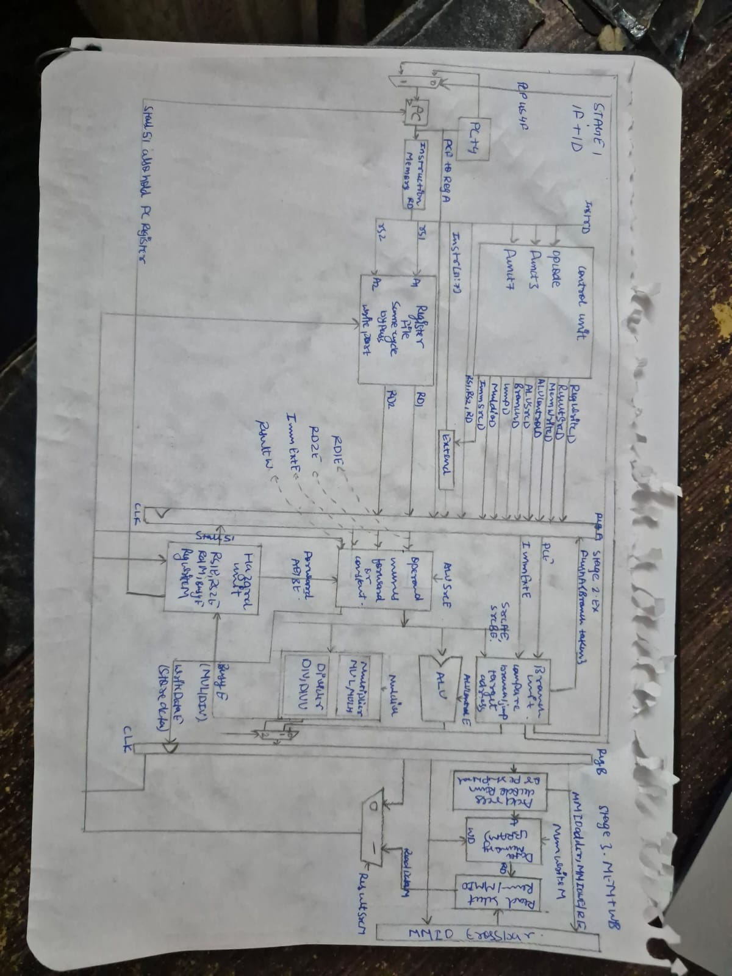
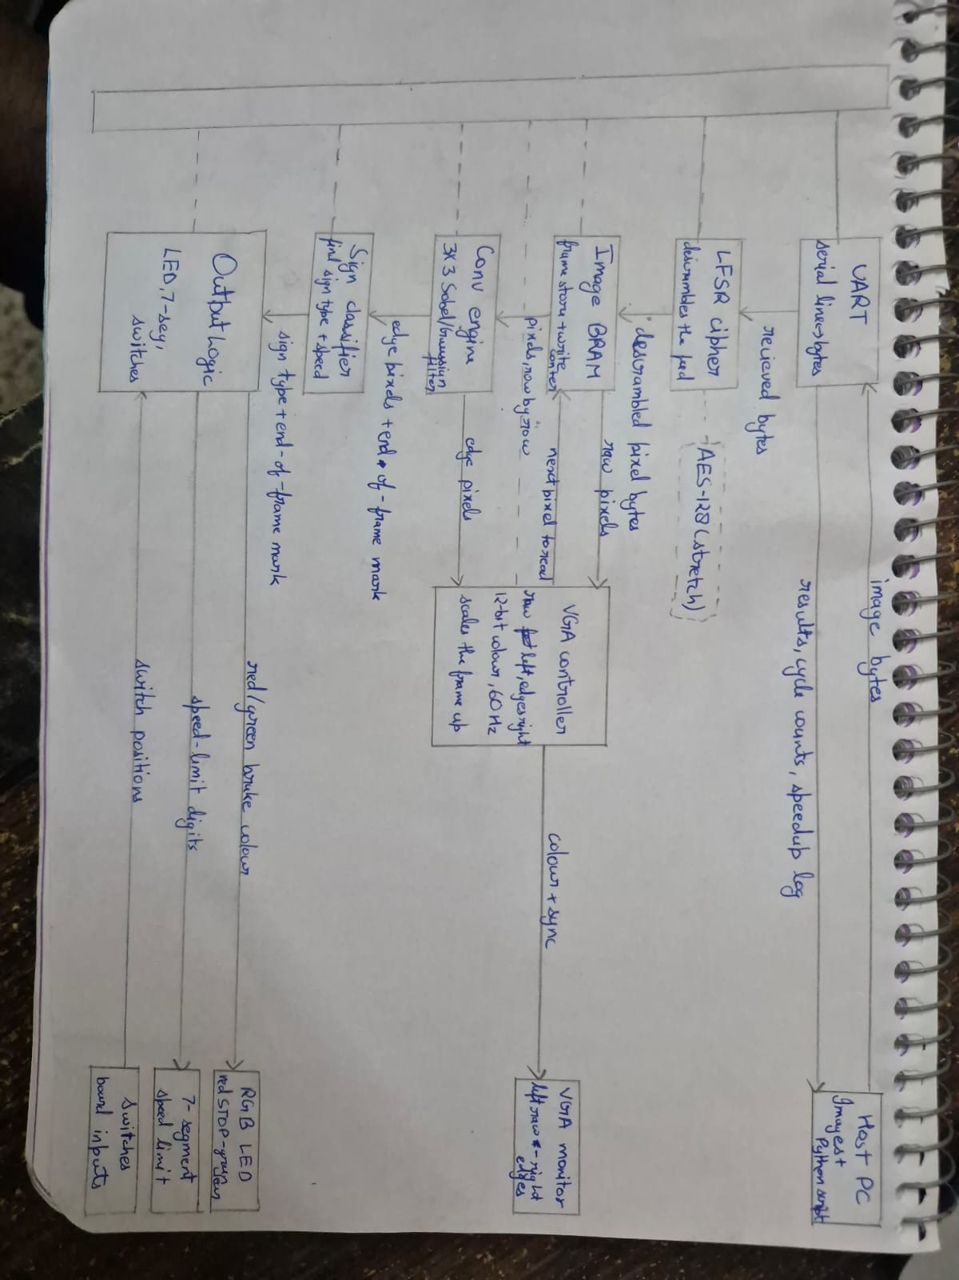

2. Timing Diagram

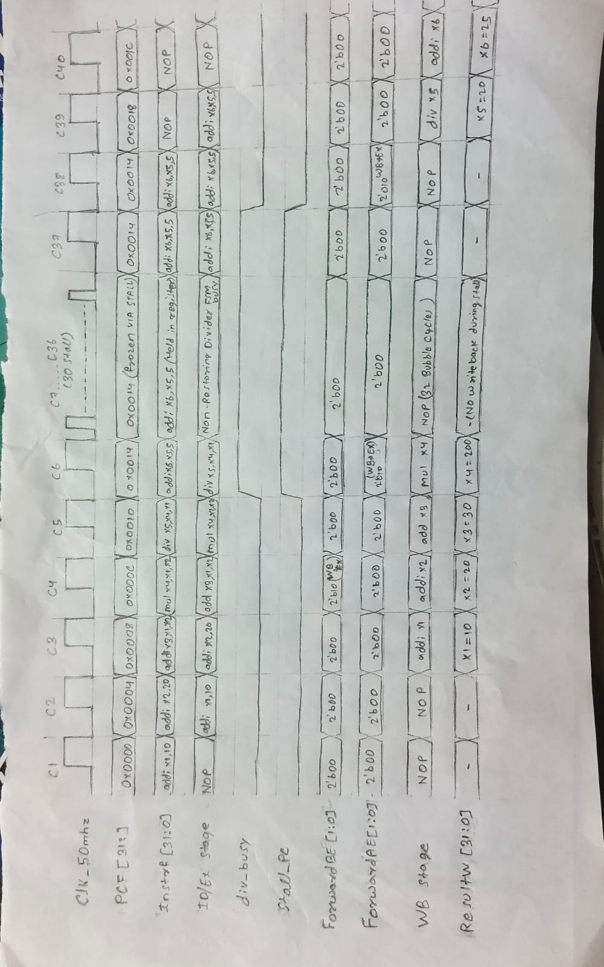

3. Module Summary
Module | Purpose | File | Software/Hardware module?
riscv_core | 3-stage pipelined RV32IM processor core top-level (IF, ID, EX, WB) | rtl/core/riscv_core.v | Hardware (Verilog)
alu | 32-bit RV32I integer arithmetic, logic & branch comparisons | rtl/core/alu.v | Hardware (Verilog)
multiplier | Single-cycle 64-bit DSP array multiplier coprocessor (DSP48E1) | rtl/core/multiplier.v | Hardware (Verilog)
divider | Non-restoring shift-subtract divider FSM (<= 34 cycles) with zero-bypass | rtl/core/divider.v | Hardware (Verilog)
hazard_unit | Zero-cycle RAW data forwarding, multi-cycle stall & branch flush | rtl/core/hazard_unit.v | Hardware (Verilog)
conv2d_line_buffer | Dual circular BRAM line buffers (2x160 B) for 3x3 window streaming | rtl/accel/line_buffer.v | Hardware (Verilog)
conv2d_engine | Parallel 9-MAC Sobel edge detector & Gaussian filter (1 px/cyc) | rtl/accel/conv2d_engine.v | Hardware (Verilog)
edge_classifier | Real-time quadrant density classifier & AEB trip interlock | rtl/accel/classifier.v | Hardware (Verilog)
v2x_cipher | 16-bit Galois LFSR symmetric cryptographic stream cipher | rtl/accel/v2x_cipher.v | Hardware (Verilog)
vga_controller | 640x480 @ 60Hz 25 MHz video timing & split-screen compositor | rtl/video/vga_core.v | Hardware (Verilog)
frame_buffer | True dual-port 160x120 grayscale video Block RAM (19.2 KB) | rtl/video/frame_buffer.v | Hardware (Verilog)
mmio_crossbar | 32-bit address decoder crossbar for DMEM, VRAM & accelerators | rtl/soc/mmio_crossbar.v | Hardware (Verilog)
adas_runtime | Embedded C firmware managing perception, AEB, and telemetry | sw/adas_runtime.c | Software (C Firmware)

4. Hardware Resource Estimates
Target Device: AMD Xilinx Artix-7 XC7A100T-1CSG324C (Digilent Nexys A7-100T FPGA):
Resource | Maximum Available | Estimated Usage | % utilization
BRAM (36 Kb) | 135 | 12.0 | 8.89%
DSP blocks | 240 | 4 | 1.67%
LUTs | 63,400 | 3,514 | 5.54%
FF | 126,800 | 3,791 | 2.99%

5. Verification Plans
- Arithmetic Unit Verification: Standalone testbenches (tb_multiplier.v, tb_divider.v) verify bit-exact 64-bit multiplication and non-restoring divider transitions (<= 34 cycles) under corner cases (x/0 = -1, overflow) with zero-cycle bypass.
- Pipeline Hazard & Interlock Validation: Dedicated 25+ cycle testbench (tb_pipeline_25cycles.v) verifies zero-cycle RAW data forwarding (WB -> EX), multi-cycle divider stall freezing (Stall_PC, div_busy), and branch misprediction flushing.
- Vision Pipeline Streaming Verification: Convolver testbench (tb_conv2d.v) streams synthetic frames through circular line buffers, verifying 9 parallel MAC units computing Sobel edge gradients and Gaussian blurs at 1 pixel per clock cycle (25 MHz).
- Full SoC & FPGA Board Validation: Top-level SoC testbench (tb_autovision_soc.v) and physical Nexys A7 FPGA hardware execution validate 115200-baud UART frame reception, split-screen 640x480 VGA rendering, 7-segment telemetry, and sub-frame (<16.6 ms) RGB AEB activation.

6. Gantt Chart
 |  | Oct |  |  |  |  |  |  |  |  |  |  |  |  |  |  |  |  |  |  |  |  |  |  |  |  |  |  |  |  |  |  |  | Nov
Activity | Owner | 1 | 2 | 3 | 4 | 5 | 6 | 7 | 8 | 9 | 10 | 11 | 12 | 13 | 14 | 15 | 16 | 17 | 18 | 19 | 20 | 21 | 22 | 23 | 24 | 25 | 26 | 27 | 28 | 29 | 30 | 31 | 1 |  | 2 | 3 | 4 | 5 | 6 | 7 | 8
1. ISA & Microarchitecture Specification | Rohit
2. RV32I 3-Stage Core RTL (IF, ID, WB) | Rohit
3. Single-Cycle DSP Multiplier (DSP48E1) | Prakhar
4. Multiplier Unit Testbench (tb_multiplier) | Prakhar
5. Non-Restoring Divider FSM RTL (<= 34 Cyc) | Sajan
6. Divider Testbench & Edge Cases | Sajan
7. Hazard Forwarding & Stall Unit RTL | Rohit
8. Dual Circular BRAM Line Buffer (320B) | Rishabh
9. 3x3 Parallel MAC Conv2D Engine RTL | Rishabh
10. Convolver Streaming Testbench (tb_conv2d) | Rishabh
11. Dual-Port Video Frame Buffer (19.2 KB) | Sarthak
12. VGA 640x480 @ 60Hz Timing Controller | Sarthak
13. Split-Screen Compositor & HUD Engine | Sarthak
14. Edge-AI Classifier & AEB Trip Circuit | Sarthak
15. V2X Galois LFSR Cipher & Peripherals | Sajan
16. Full SoC Integration & 25-Cycle Sim | Rohit
17. Vivado Synthesis, Place & Route (Nexys A7) | Sajan
18. Physical Board Demo & Host PC Telemetry | All Members

7. Risks & Challenges
- Multi-Cycle Division Stall Synchronization: Synchronous clock enable gating in hazard_unit preserves IF/ID state during <= 34 cycle stalls.
- Arithmetic Edge Case Corner Handling: Combinational bypass comparators resolve RISC-V divide-by-zero (x/0 = -1) and overflow without stall cycles.
- Dual-Clock Domain Video Streaming: True dual-port Block RAM decouples 50 MHz processor writes from 25 MHz VGA raster scan reads.
- Line Buffer Boundary Hazards: Active line-valid pixel counters discard boundary pixels outside 160x120, preventing edge-wrapping distortions.
- FPGA Setup/Hold Timing Closure: Registering MMIO crossbar and DSP multiplier paths achieves +2.410 ns setup slack at 50 MHz (zero violations).

8. Response to TA feedback (for the project abstract)
- TA Feedback (Group 21): "Proposal mentions 640x480 VGA & UART streaming, but lacks strict input size limits."
Technical Defense: 1) Hardware video input strictly bounded to 160x120 pixels (8-bit grayscale = 19,200 B/frame) with automatic wrap at 0x4AFF. 2) BRAM budget protected: consumes 12.0 BRAMs (8.89%), leaving 91.11% for core code and line buffers. 3) 115200-baud UART streams 19,200 bytes in 1.66 s, matching realistic ADAS obstacle updates. 4) Hardware 4x4 upscaling renders 640x480 @ 60 Hz with zero CPU overhead.
- Repository Access: TA has been verified and added to https://github.com/RsbhThakur/AutoVision.

