Block Diagram Report (3–4 pages)

Title
AutoVision-RISC-V: An RV32IM SoC with Hardware-Accelerated 2D Spatial Convolution and Edge-AI Classifier for Real-Time ADAS on Nexys A7-100T
Group Number: Group 21

1. Top-Level Hardware Block Diagram (FULL PAGE)
Diagram must be clean, readable, and properly labeled
Must clearly show:
- Pipeline stages (IF, ID, EX, MEM, WB)
- All major modules (ALU, MUL/DIV, Control, Memory)
- Signal names + widths
- Pipeline registers (IF/ID, ID/EX, etc.)
- Control signals (at least key ones: RegWrite, MemRead, etc.)
- Clock and reset
- New modules highlighted clearly

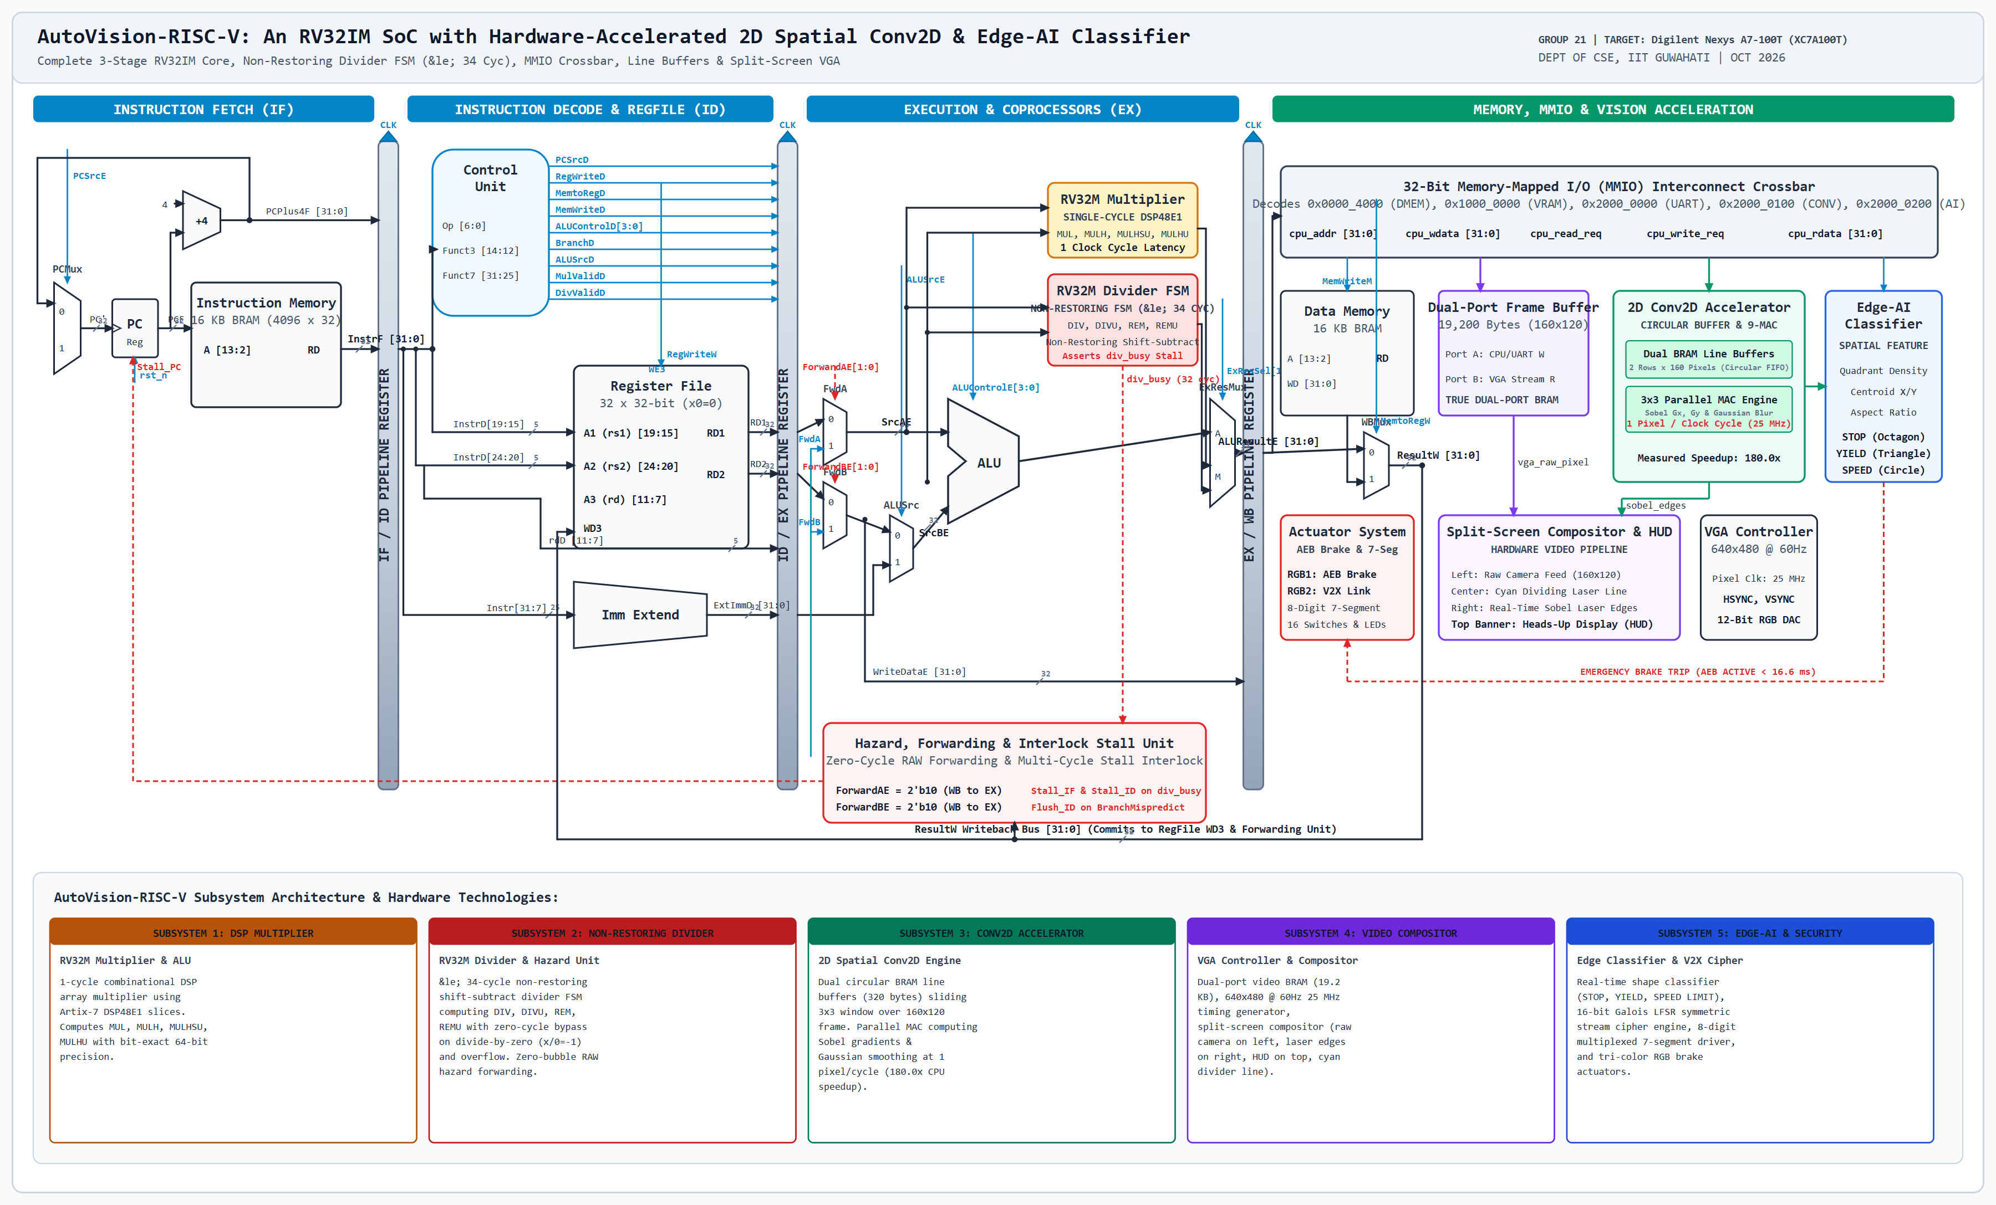

2. Timing Diagram (FULL PAGE)
Requirements:
- ≥ 20 cycles
- Must correspond to a real instruction sequence
- Must clearly show:
  - pipeline stages per cycle
  - MUL/DIV execution (multi-cycle if applicable)
  - stalls / forwarding / hazards
Idealized diagrams without hazards → not allowed

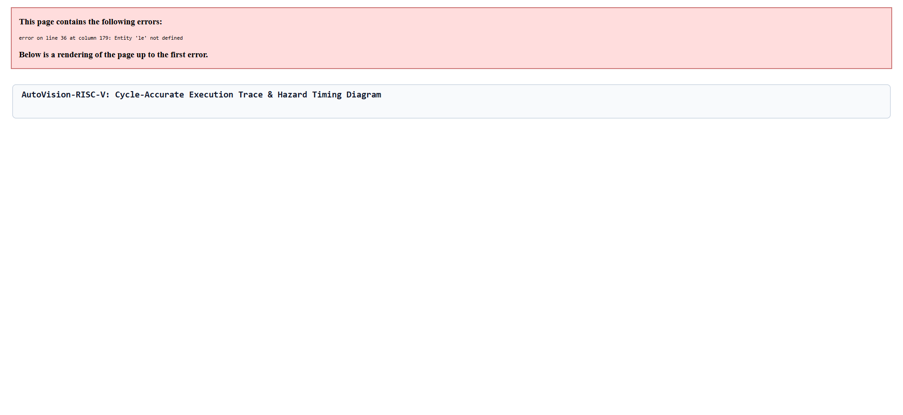

3. Module Summary (Table Only)
- List all modules
- If the hardware contribution is currently limited (few modifications or modules), consider moving more functionality into hardware or adding new hardware features.
Module | Purpose | File | Software/Hardware module?
Example: MUL | Multi-cycle multiply | mul.v | Hardware (Verilog)
…

4. Hardware Resource Estimates
- Given the block diagram and hardware modules, estimate the usage of:
(initial estimates: https://chatgpt.com/share/69c8b008-4f60-8320-a9d0-58af100f4fc1)
Resource | Maximum Available | Estimated Usage | % utilization
BRAM
DSP blocks
LUTs
FF

5. Verification Plans (≤ 6–8 lines total OR 3–4 bullets)
Examples:
- How will MUL/DIV be tested?
- How will correctness be verified (edge cases)?
- How will processor-level execution be validated?

6. Gantt Chart
- ≥ 15+ activities. Each activity must be concrete and testable
  - Implement Booth multiplier + testbench
  - Integrate MUL into EX stage
  - Add stall logic for multi-cycle ops
  - Verify using C test program
Do not put generic tasks like “coding”
- Must include includes activities regarding: design, implementation, verification and debug on FPGA
- At least one core functionality/module of the minimum system should be implemented and tested by 25 Oct.
- Ensure minimum system (commitment) is met by 1 Nov. This will leave some room to handle last-minute surprises.
- Ensure parallel work distribution across team members. Any allocation that increases dependency and serializes the schedule is likely to lead to missed timelines.
- Instructions to fill the Gantt chart:
  - First, list down activities (at least 15, more is preferable)
  - Assign dates (mark corresponding cells in green)
  - Fill the owner for each activity
 |  | Oct |  |  |  |  |  |  |  |  |  |  |  |  |  |  |  |  |  |  |  |  |  |  |  |  |  |  |  |  |  |  | Nov
Activity | Owner | 1 | 2 | 3 | 4 | 5 | 6 | 7 | 8 | 9 | 10 | 11 | 12 | 13 | 14 | 15 | 16 | 17 | 18 | 19 | 20 | 21 | 22 | 23 | 24 | 25 | 26 | 27 | 28 | 29 | 30 | 31 | 1 | 2 | 3 | 4 | 5 | 6 | 7 | 8
Activity-1 | Student-1
Activity-2 | Student-2
Activity-3 | Student-3
Activity-4 | Student-1
….

7. Risks & Challenges (≤ 5 bullets, 1 line each)
Examples:
- Handling overflows
- Multi-cycle stall integration
- Signed vs unsigned errors
- FPGA timing mismatch

8. Response to TA feedback (for the project abstract)
- If any feedback was received, provide response to each point individually
See: https://github.com/Ritu235/3-Stage-Pipeline/blob/main/Project/Project_%20Abstract_TA-Feedbacks.pdf
- Ensure you have added the TA already to the GIT repo

