A Project Report
on
IMPORTANT TOPIC RECOMMENDATION ON THE BASIS
OF CLUSTERING LAST FIVE YEARS QUESTION PAPERS

Bachelor of Technology
IN
ARTIFICIAL INTELLIGENCE

BY

Ram Mittal Saksham Yadav
Enrolment number: GN1887 Enrolment number: GP4237

Under the Guidance of
Mr. Misbah Ul Haque
Interdisciplinary Centre for Artificial Intelligence

Zakir Husain College of Engineering & Technology
Aligarh Muslim University
Aligarh (India)-202002
November, 2025


Dated…………
Declaration

The work presented in project entitled “IMPORTANT TOPIC ECOMMENDATION ON THE BASIS OF CLUSTERING LAST FIVE YEARS QUESTION PAPERS” submitted to the Interdisciplinary Centre for Artificial Intelligence, Zakir Husain College of Engineering and Technology, Aligarh Muslim University Aligarh, for the award of the degree of Bachelor of Technology in Artificial Intelligence, during the session 2025-26, is my original work. I have neither plagiarized nor submitted the same work for the award of any degree.

(Signature)
Ram Mittal
23AIBEA246

(Signature)
Saksham Yadav
23AIBEA144

Dated…………

Certificate

This is to certify that the Project Report entitled “IMPORTANT TOPIC ECOMMENDATION ON THE BASIS OF CLUSTERING LAST FIVE YEARS QUESTION PAPERS”, being submitted by “Ram and Saksham”, in partial fulfillment of the requirements for the award of the degree of Bachelor of Technology in Artificial Intelligence, during the session 2025-26, in the Interdisciplinary Centre for Artificial Intelligence, Zakir Husain College of Engineering and Technology, Aligarh Muslim University Aligarh, is a record of candidate’s own work carried out by him under my (our) supervision and guidance.

Mr. Misbah Ul Haque

Table of Contents
- Abstract 6
- Acknowledgements 7
- Acronyms 8
- Chapter 1: Introduction 9
  - 1.1 Motivation 9
  - 1.2 Objectives and Scope 9
  - 1.3 Organization 10
- Chapter 2: Literature Review 11
  - 2.1 Text Mining and Educational Data Analytics 11
  - 2.2 Semantic Embeddings for Text Representation 11
  - 2.3 Text Clustering for Topic Discovery 11
  - 2.4 Question Paper Analysis and Exam Preparation Tools 11
- Chapter 3: Methods / Implementation 13
  - 3.1 Dataset Description 13
  - 3.2 System Architecture Overview 13
  - System Architecture 14
  - 3.3 Auto Fetch Module (01.py) 15
  - 3.4 OCR and Text Extraction Module (03.py) 15
  - 3.5 Semantic Embedding Generation Module (05.py) 15
  - 3.6 Clustering and Topic Labelling Module (07.py) 16
  - 3.7 Backend Implementation (Flask API) 17
  - 3.8 Frontend GUI Design 17
- Chapter 4: Results and Evaluation 18
  - 4.1 Experimental Setup 18
  - 4.2 Qualitative Analysis of Topic Clusters 18
  - 4.3 Coverage-Based Topic Importance 19
  - 4.4 Observations and Limitations 19
- Frontend GUI And sample view of recommended Topics 21
- Chapter 5: Conclusion and Future Work 22
- Bibliography 24

Abstract
Students often rely on previous years’ question papers (PYQs) to decide what to study before exams. However, manually going through five or more years of papers, identifying repeating patterns, and mapping them to “important topics” is time-consuming and error-prone—especially when papers are scanned PDFs and questions are rephrased every year.
This project presents an AI-based system that automatically recommends important topics on the basis of clustering of last five years’ question papers. The system fetches PYQs directly from the AMU Library website, performs OCR and text extraction, generates dense semantic embeddings for each question using a transformer-based model, and applies clustering algorithms to group semantically similar questions. For each cluster, it computes coverage statistics that indicate in how many different years that topic has appeared.
The pipeline consists of four main scripts—automatic paper fetching, OCR and question extraction, embedding generation, and clustering & report generation—wrapped behind a Flask API. A lightweight web-based GUI allows students to select branch and semester and then view subject-wise topic clusters labelled with representative keywords and coverage such as “appears in 4/5 years”.
The proposed system converts raw, unstructured question papers into structured, interpretable topic recommendations. It reduces the manual effort required for exam analysis and provides a data-driven way for students to prioritize topics while preparing for university examinations.

Acknowledgements
We would like to express our sincere gratitude to our project supervisor, Mr. Misbah Ul Haque, for his constant guidance, constructive feedback, and encouragement throughout the development of this minor project. His suggestions helped in refining both the technical design and the presentation of this work.
We are thankful to the faculty members and staff of Zakir Husain College of Engineering and Technology for providing the academic environment, laboratory facilities, and support that made this project possible.
Our special thanks go to the Aligarh Muslim University Library for maintaining an accessible digital repository of previous years’ question papers, which formed the core dataset for this system.
We would also like to thank our friends and classmates for their continuous motivation, discussions, and help in testing the system from a student’s perspective.
Finally, we are deeply grateful to our families for their unwavering support, patience, and belief in us throughout this journey.
Ram Mittal
Faculty Number: 23AIBEA246
Saksham Yadav
Faculty Number: 23AIBEA144

Acronyms
Acronym | Full Form
AMU | Aligarh Muslim University
API | Application Programming Interface
AHC | Agglomerative Hierarchical Clustering
CO | Course Outcome
CSV | Comma Separated Values
GUI | Graphical User Interface
HTML | HyperText Markup Language
HTTP | HyperText Transfer Protocol
JSON | JavaScript Object Notation
LLM | Large Language Model
NLP | Natural Language Processing
OCR | Optical Character Recognition
OS | Operating System
PCA | Principal Component Analysis
PDF | Portable Document Format
PYQ | Previous Year Question (paper)
REST | Representational State Transfer
TF-IDF | Term Frequency–Inverse Document Frequency
UI | User Interface

Chapter 1: Introduction
1.1 Motivation
For most engineering students, exam preparation starts with collecting previous years’ question papers and trying to guess which topics are “important”. This guesswork becomes difficult when:
- Question papers are available only as scanned PDFs,
- Questions get rephrased across years while testing the same concept, and
- There is no automated tool that summarizes recurring patterns in questions.
At the same time, modern Natural Language Processing (NLP) techniques allow us to represent questions as vectors in a high-dimensional semantic space, where similar questions lie close to one another. Clustering such representations can reveal which conceptual topics keep appearing year after year.
This project is motivated by the idea of using these AI techniques to build a practical tool that helps students identify important topics from the last five years’ AMU question papers in a systematic, data-driven way.
1.2 Objectives and Scope
The main objective of this project is:
To design and implement an automated system that recommends important exam topics by clustering questions from the last five years’ question papers.
Specific objectives include:
- Automate the fetching of question papers from the AMU Library website for a selected branch and semester.
- Perform OCR and text extraction from both digital and scanned PDFs, followed by noise removal and question segmentation.
- Generate semantic embeddings of questions using a transformer-based sentence embedding model.
- Apply clustering algorithms to group similar questions into conceptual topics.
- Compute coverage statistics to show how many years each topic appears in.
- Build a Flask-based backend and a web GUI that present the results in a student-friendly manner.
The current scope is focused on B.Tech branches and semesters whose question papers are available in the AMU Library for roughly the last five years. Support for arbitrary PDF uploads and other universities is considered as future work.
1.3 Organization
This report is organized into five chapters.
Chapter 2 provides the literature review related to text mining, semantic embeddings, and text clustering for topic discovery.
Chapter 3 describes the dataset, system architecture, and implementation details of each module in the pipeline.
Chapter 4 presents the results, including qualitative analysis of clusters, coverage-based topic importance, and limitations.
Chapter 5 concludes the report and suggests future directions.

Chapter 2: Literature Review
2.1 Text Mining and Educational Data Analytics
Text mining focuses on extracting useful patterns from unstructured text. In educational contexts, it has been used for analysing course feedback, modelling learning outcomes, and studying exam patterns. Previous years’ question papers are rich sources of information, but they are typically stored as unstructured PDFs. Techniques such as tokenization, normalization, and question boundary detection are required before any higher-level analysis can be done.
Educational Data Mining (EDM) and Learning Analytics have shown that data-driven tools can assist both teachers and students in understanding assessment patterns and planning learning strategies. This project lies within this area, focusing specifically on question paper analysis for topic importance.
2.2 Semantic Embeddings for Text Representation
Traditional Bag-of-Words and TF-IDF representations treat text mainly as word counts and ignore sentence-level meaning. For question clustering we need representations where questions like
“Explain demand paging in operating systems” and “What is demand paging? Discuss its advantages”
are close to each other even though the wording is different.
Sentence-level transformer models, such as those provided by SentenceTransformers, map each question to a dense vector that captures its semantic content. Models like MPNet-base-v2 are well suited for clustering and semantic similarity tasks and form the backbone of our representation step.
2.3 Text Clustering for Topic Discovery
Clustering is an unsupervised learning approach used to group similar data points. In text applications, clustering helps discover latent topics without labelled data. Methods such as K-Means, Agglomerative Hierarchical Clustering (AHC), and Spectral Clustering are commonly used.
When applied to question embeddings, clustering groups together questions about the same concept (e.g., deadlocks, paging, or routing algorithms). Combining clustering with coverage across years provides a quantitative measure of topic importance. Recent research using LLM-based embeddings has shown that transformer embeddings significantly improve cluster coherence compared to traditional methods.
2.4 Question Paper Analysis and Exam Preparation Tools
Existing exam preparation tools mainly rely on manually curated notes or chapter-wise question banks. Very few leverage automated NLP pipelines or semantic embeddings. Many platforms also ignore university-specific patterns and instead provide generic content.
There is a clear gap for a system that:
- Automatically fetches question papers from the university repository,
- Understands question semantics via embeddings, and
- Produces data-driven topic recommendations.
Our project aims to fill this gap for AMU question papers.

Chapter 3: Methods / Implementation
3.1 Dataset Description
3.1.1 Source of Question Papers
The dataset consists of previous years’ question papers downloaded from the AMU Library website. For each branch and semester, the system targets approximately the last five academic years. Question papers are stored as PDFs, sometimes with multiple subjects combined in a single file and sometimes as separate files for each subject and year.
3.1.2 Subjects and Structure
For a given branch and semester, subjects typically include core courses such as Operating Systems, Computer Networks, Database Management Systems, Microprocessors, and branch-specific electives. Each subject’s questions from all available years are extracted and later clustered into topics.
3.2 System Architecture Overview
The system follows a modular pipeline implemented through four Python scripts and a Flask backend:
- 01.py – Auto Fetch Papers
- 03.py – OCR and Text Extraction
- 05.py – Embedding Generation
- 07.py – Clustering and Report Generation
These modules are orchestrated by Flask APIs and exposed to a web-based frontend. Figure 1 (to be added) shows the high-level data flow from the AMU Library website to the GUI that displays important topics.

System Architecture

AMU Library Website
Auto Fetch Module (01.py)

OCR & Question Extraction Module (03.py)

Embeddings Generation Module (05.py)

Flask Backend (API)
Clustering and Results Module (07.py)

Web GUI (imp topic analyser)

3.3 Auto Fetch Module (01.py)
The Auto Fetch Module automates downloading of relevant PDFs so students do not need to collect them manually. Its main steps are:
- Crawling the AMU Library pages for a selected branch and semester.
- Identifying links corresponding to the last five years.
- Downloading the PDFs and arranging them into a consistent folder structure, e.g., AMU_Papers/<Branch>/<Semester>/<Year>/.
- Logging errors such as missing links or inaccessible files.
This module ensures that the pipeline always operates on the latest available set of question papers.
3.4 OCR and Text Extraction Module (03.py)
Question papers may be either digital PDFs or scanned images. The OCR and Text Extraction Module handles both using:
- PyMuPDF to extract text directly from digital PDFs.
- Tesseract OCR for pages where text extraction fails, treating pages as images.
- Noise removal, which strips headers, footers, marks, course outcomes (COs), and page numbers through custom regular expressions.
- Question segmentation, splitting the cleaned text into individual questions using patterns such as question numbers, option labels, and line breaks.
The final output for each subject and year is a structured JSON file containing question_id, year, and raw question text.
3.5 Semantic Embedding Generation Module (05.py)
This module converts each question into a numerical vector that captures its meaning. It uses a SentenceTransformers model such as MPNet-base-v2 and performs:
- Basic text normalization while preserving technical terms.
- Batch encoding of questions to speed up inference.
- Storage of embeddings in embeddings.npy and a companion index.json mapping row indices to question metadata.
These embeddings form the input to the clustering stage.
3.6 Clustering and Topic Labeling Module (07.py)
The Clustering Module is responsible for grouping similar questions into conceptual topics and computing coverage statistics. Its key components are:
- Dimensionality Reduction (PCA): Reduces embedding dimensionality while preserving most variance, making clustering more efficient.
- Normalization: Normalizes reduced vectors to avoid scale issues.
- Choosing the Number of Clusters (k): Explores multiple k values and selects the one with the best silhouette score.
- Clustering: Uses algorithms such as K-Means, AHC, or Spectral Clustering to form clusters of semantically similar questions.
- Topic Labeling: For each cluster, aggregates all question texts and applies TF-IDF to extract top keywords that serve as the cluster’s topic label.
- Coverage Calculation: Determines in how many unique years each cluster appears, resulting in labels like “found in 4/5 years”.
The module finally generates per-subject reports that list clusters, labels, coverage, and sample questions.
3.7 Backend Implementation (Flask API)
The backend is implemented using Flask and provides REST endpoints such as:
- /api/analyze-fetch?branch=…&semester=… to trigger or reuse the pipeline for a given branch and semester.
- /api/get-subjects to list subjects with available reports.
- /api/get-report?subject=… to return clusters, labels, coverage, and example questions for a chosen subject.
The backend streams logs to the frontend so students can see which stage (fetching, OCR, embeddings, clustering) is currently running.
3.8 Frontend GUI Design
The frontend is a simple, responsive web interface that:
- Allows students to choose branch and semester from dropdown menus.
- Shows a step-wise progress view while the backend runs.
- Displays each subject as a card summarizing number of clusters and overall coverage.
- Lets the user expand a subject card to view topic clusters, with:
  - Topic label (keywords),
  - Coverage like “appears in 5/5 years”,
  - A few sample questions for that topic.
Figures 6 and 7 (to be added) will illustrate the GUI and an example of clustered topics for a subject like Operating Systems.

Chapter 4: Results and Evaluation
4.1 Experimental Setup
The system was tested on multiple subjects across selected branches and semesters. For each subject, about five years of question papers were downloaded, processed by the OCR and extraction pipeline, converted into embeddings, and clustered.
All experiments were run on a standard laptop/desktop setup using CPU for embeddings and clustering. The design, however, is compatible with GPU acceleration if deployed on more powerful hardware.
4.2 Qualitative Analysis of Topic Clusters
Manual inspection of clusters across subjects gave the following observations:
- Operating Systems:
  - Clusters for process scheduling and CPU scheduling algorithms.
  - Clusters for process synchronization and classic synchronization problems.
  - Deadlock-related clusters (conditions, prevention, detection).
  - Memory management topics like paging, segmentation, and demand paging.
- Computer Networks:
  - Clusters around OSI/TCP-IP models, routing algorithms, congestion control, and transport layer protocols.
- Microprocessors and Interfacing:
  - Clusters capturing the 8085 instruction set, addressing modes, simple assembly programs, and interrupt handling.
Within each subject, questions grouped in a cluster were conceptually similar even when phrased differently, confirming the usefulness of semantic embeddings for this task.
4.3 Coverage-Based Topic Importance
For each cluster, coverage is defined as the number of distinct years that contain at least one question from that cluster. This leads to interpretations such as:
- “Process Synchronization – appears in 5/5 years”
- “Deadlocks – appears in 4/5 years”
- “Disk Scheduling – appears in 3/5 years”
Such coverage statistics allow students to:
- Prioritize high-coverage topics during revision.
- Recognize core concepts that are consistently examined.
- Base their preparation on data rather than pure intuition or hearsay.
4.4 Observations and Limitations
Observations
- The pipeline functions robustly across different PDF formats and years.
- Clusters are generally coherent and easy to interpret.
- Coverage statistics often match students’ intuitive understanding of important chapters.
Limitations
- Poorly scanned or low-resolution PDFs reduce OCR quality and may lead to noisy questions.
- Subjects with limited available years provide weaker coverage estimates.
- All questions are currently treated equally; differences in marks or long vs short questions are not yet modelled.
- TF-IDF based topic labels occasionally contain generic verbs (“explain”, “define”) that might require manual cleaning.

Frontend GUI And sample view of recommended Topics
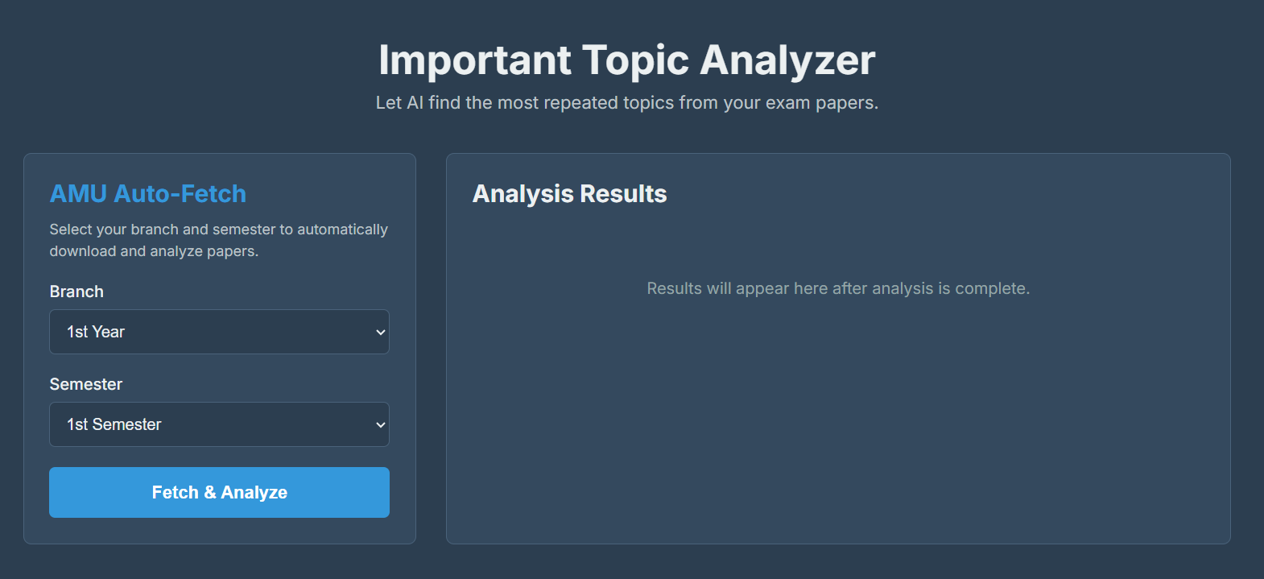
Fig 1. Frontend GUI
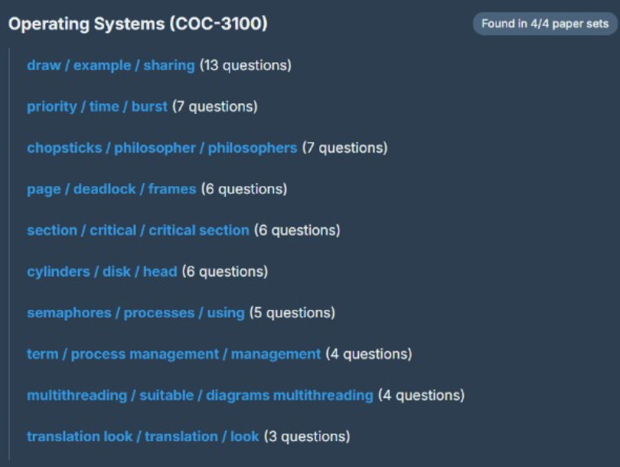
Fig 2. Sample output of recommended imp topics.
Chapter 5: Conclusion and Future Work
Conclusion
This project implemented an AI-based system that automatically discovers important exam topics by clustering questions from the last five years’ AMU question papers. The system fetches PDFs from the AMU Library, performs OCR and text extraction, generates semantic embeddings, clusters similar questions, and computes coverage statistics that quantify how frequently each topic is asked. The results are surfaced through a simple web GUI so that students can quickly see which topics deserve priority during revision.
By transforming unstructured question papers into structured topic clusters with coverage, the system provides a data-driven alternative to manual exam analysis and senior-based guesswork. It demonstrates how modern NLP and unsupervised learning techniques can be used to build practical educational tools.
Future Work
Future improvements to this system may include:
- LLM-based topic summaries: Use large language models to generate short, readable descriptions of each topic cluster instead of relying only on TF-IDF keywords.
- Support for custom PDF uploads: Allow teachers or students to upload their own PDFs and run the same pipeline for other universities or internal tests.
- Weightage-aware analysis: Incorporate marks and question type (short/long) so that clusters reflect both frequency and weightage.
- Richer visualizations: Provide heatmaps, timelines, and word clouds to visualize how topics evolve over years.
- Prediction of likely topics: Experiment with models that, given historical patterns, estimate which topics are more likely to appear in upcoming exams (with appropriate disclaimers).
- Cloud deployment and multi-user access: Host the system online so that multiple students can use it concurrently, with caching and incremental updates as new papers are added.
These directions can help this project mature into a comprehensive, scalable exam-preparation assistant for students across different branches and institutions.

Bibliography
[1] A. Petukhova, J. P. Matos-Carvalho, and N. Fachada, “Text Clustering with Large Language Model Embeddings,” International Journal of Cognitive Computing in Engineering, 2024.
[2] N. Reimers and I. Gurevych, “Sentence-BERT: Sentence Embeddings using Siamese BERT-Networks,” EMNLP, 2019.
[3] T. Chen, S. Kornblith, M. Norouzi, and G. Hinton, “A Simple Framework for Contrastive Learning of Visual Representations,” ICML, 2020.
[4] J. Han, M. Kamber, and J. Pei, Data Mining: Concepts and Techniques, 3rd ed., Morgan Kaufmann, 2011.
[5] R. Feldman and J. Sanger, The Text Mining Handbook: Advanced Approaches in Analyzing Unstructured Data, Cambridge University Press, 2007.
[6] J. R. Quinlan, “Induction of Decision Trees,” Machine Learning, 1(1):81–106, 1986.
[7] F. Pedregosa et al., “Scikit-learn: Machine Learning in Python,” Journal of Machine Learning Research, 12:2825–2830, 2011.

