**TABLE OF CONTENT**

1. Introduction 3
2. Problem Definition 5
   1. Project Objective 5
   2. Proposed Methodology 6
   3. Phases of Iterative Waterfall Model 7
3. Virtual Mouse 10
4. Requirement Analysis 11
5. Module Description 12
6. UML Diagrams 13
7. Applications, Advantages and Limitations 15
   1. Applications 15
   2. Advantages 15
   3. Limitations 15
8. References 16

**CHAPTER 1**

**INTRODUCTION**

In today’s world we see lots of development happened in the field of Technology. Today’s technology is combined with the technique called Artificial Intelligence. This project is also based on small part of AI. This project presents finger movement gesture detection on our computer’s window using camera & handling the whole system by just moving your one finger.

**Virtual mouse** is software that allows users to give mouse inputs to a system without using an actual mouse. Using finger detection methods for instant camera access and user-friendly user interface makes it more easily accessible. The system is used to implement motion tracking mouse, a signature input device and an application selector. This system reduces the use of any physical mouse which saves time and also reduces effort.

In this the hand movements of a user is mapped into mouse inputs. A web camera is set to take images continuously. Most laptops today are equipped with webcams, which have recently been used insecurity applications utilizing face recognition. In order to harness the full potential of a webcam, it can be used for vision based CC, which would effectively eliminate the need for a computer mouse or mouse pad. The usefulness of a webcam can also be greatly extended to other Human Computer Interaction application such as a sign language database or motion controller.

Over the past decades there have been significant advancements in Human Computer Interaction technologies for gaming purposes, such as the Microsoft Kinect and Nintendo Wii. These gaming technologies provide a more natural and interactive means of playing videogames. Motion controls is the future of gaming and it have tremendously boosted the sales of video games, such as the Nintendo Wii which sold over 50 million consoles within a year of its release. Human Computer Interaction using hand gestures is very intuitive and effective for one to one interaction with computers and it provides a Natural User Interface (NUI). There has been extensive research towards novel devices and techniques for cursor control using hand gestures. Besides Human Computer Interaction, hand gesture recognition is also used in sign language recognition, which makes hand gesture recognition even more significant.

**CHAPTER 2**

**PROBLEM DEFINITION**

As modern technology of human computer interactions become important in our everyday lives, varieties of mouse with all kind of shapes and sizes were invented, from a casual office mouse to a hard-core gaming mouse. However, there are some limitations to these hardware as they are not as environmental friendly as it seems. For example, the physical mouse requires a flat surface to operate, not to mention that it requires a certain area to fully utilize the functions offered. Furthermore, some of these hardware are completely useless when it comes to interact with the computers remotely due to the cable lengths limitations, rendering it inaccessible.

Multi-point Interactive Whiteboards are available using the

Wiimote [4]. The components used are IR pen, computer with

Windows XP (installed with Microsoft .NET framework, the

Wiimote Connect program and the Wiimote Whiteboard

software), wiimote controller, a beamer capable of a 1024 x

786 pixel resolution. Here the wiimote controller tracks the

infra-red source on the white board and sends info to PC via

Bluetooth. The teaching platform comprises of a Wii-mote-

based multi-touch teaching station, a Wii-mote-based

interactive whiteboard and a Wii-mote-based stylus input

conversion tool [5]. According to the literature survey, most

people have used the Wii-mote to configure it as a virtual

marker.

Multi-point Interactive Whiteboards are available using the

Wiimote [4]. The components used are IR pen, computer with

Windows XP (installed with Microsoft .NET framework, the

Wiimote Connect program and the Wiimote Whiteboard

software), wiimote controller, a beamer capable of a 1024 x

786 pixel resolution. Here the wiimote controller tracks the

infra-red source on the white board and sends info to PC via

Bluetooth. The teaching platform comprises of a Wii-mote-

based multi-touch teaching station, a Wii-mote-based

interactive whiteboard and a Wii-mote-based stylus input

conversion tool [5]. According to the literature survey, most

people have used the Wii-mote to configure it as a virtual

marker.

The current system is comprised of a generic mouse and trackpad monitor control system, as well as the absence of a hand gesture control system. The use of a hand gesture to access the monitor screen from a distance is not possible. Even though it is primarily attempting to implement, the scope is simply limited in the virtual mouse field. The existing virtual mouse control system consists of simple mouse operations using a hand recognition system, in which we can control the mouse pointer, left click, right click, and drag, and so on. The use of hand recognition in the future will not be used. Even though there are a variety of systems for hand recognition, the system they used is static hand recognition, which is simply a recognition of the shape made by the hand and the definition of action for each shape made, which is limited to a few defined actions and causes a lot of confusion. As technology advances, there are more and more alternatives to using a mouse.

**2.1 Project Objective**

1. To perform operations like clicking and dragging the objects on screen with different hand gestures.
2. To allow users to give mouse inputs to a system without using conventional mouse.
3. To interact with the computer screen without any physical contact.

**2.2** **Proposed Methodology**

Iterative waterfall model is used to develop this project. The iterative waterfall model can be thought of as incorporating the necessary changes to the classical waterfall model to make it usable in practical software development projects. It is almost the same as the classical waterfall model except some changes are made to increase the efficiency of the software development.

The iterative waterfall model provides feedback paths from every phase to its preceding phases, which is the main difference from the classical waterfall model.

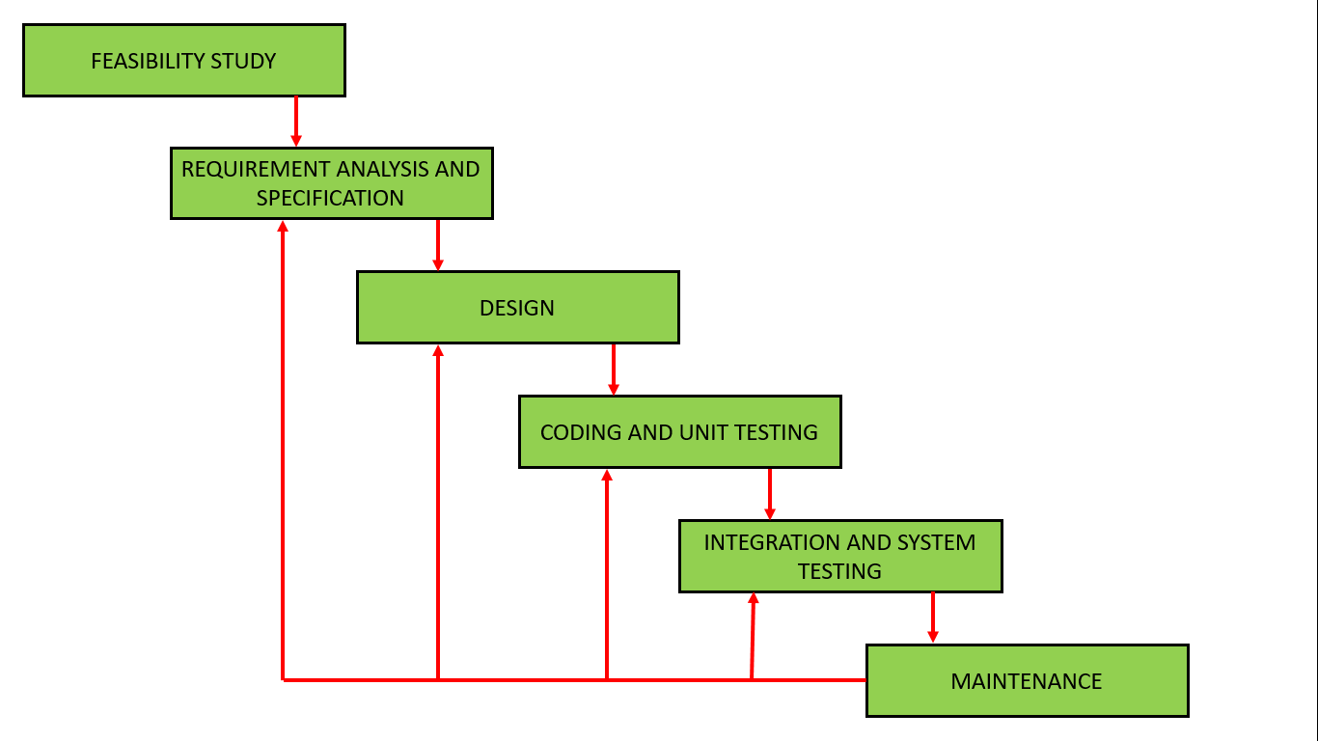

*Figure 2.2.1 Iterative Waterfall Model Diagram [1]*

When errors are detected at some later phase, these feedback paths allow correcting errors committed by programmers during some phase. The feedback paths allow the phase to be reworked in which errors are committed and these changes are reflected in the later phases. But there is no feedback path to the stage – feasibility study, because once a project has been taken, does not give up the project easily.

It is good to detect errors in the same phase in which they are committed. It reduces the effort and time required to correct the errors.

**Reasons to use this Model:**

1. In the iterative waterfall model feedback path from one phase to its preceding phase allows correcting the errors that are committed and these changes are reflected in the later phases.

2. Iterative waterfall model is very simple to understand and use. That’s why it is one of the most widely used software development models.

3. It is highly cost-effective to change the plan or requirements in the model. Moreover, it is best suited for agile organizations.

4. It is highly cost-effective to change the plan or requirements in the model. Moreover, it is best suited for agile organizations.

**2.3 Phases of Iterative Waterfall Model**

**Phase 1: Feasibility Study**

The main goal of this phase is to determine whether it would be financially and technically feasible to develop the software. The feasibility study involves understanding the problem and then determining the various possible strategies to solve the problem. These different identified solutions are analyzed based on their benefits and drawbacks, The best solution is chosen, and all the other phases are carried out as per this solution strategy.

**Phase 2: Requirement analysis and specification**

The aim of the requirement analysis and specification phase is to understand the exact requirements of the customer and document them properly. This phase consists of two different activities.

• **Requirement gathering and analysis:** Firstly, all the requirements regarding the software are gathered from the customer and then the gathered requirements are analyzed. The goal of the analysis part is to remove incompleteness (an incomplete requirement is one in which some parts of the actual requirements have been omitted) and inconsistencies (inconsistent requirement is one in which some part of the requirement contradicts with some other part).

**• Requirement specification:** These analyzed requirements are documented in a software requirement specification (SRS) document. SRS document serves as a contract between development team and customers. Any future dispute between the customers and the developers can be settled by examining the SRS document.

**Phase 3: Design**

The aim of the design phase is to transform the requirements specified in the SRS document into a structure that is suitable for implementation in some programming languages.

**Phase 4: Coding**

In the coding phase software design is translated into source code using any suitable programming language. Thus, each designed module is coded. The aim of the unit testing phase is to check whether each module is working properly or not.

**Phase 5: Testing (Integration and System testing)**

Integration of different modules is undertaken soon after they have been coded and unit tested. Integration of various modules is carried out incrementally over a number of steps. During each integration step, previously planned modules are added to the partially integrated system and the resultant system is tested. Finally, after all the modules have been successfully integrated and tested, the full working system is obtained, and system testing is carried out on this. System testing consists of three different kinds of testing activities as described below:

• Alpha testing: Alpha testing is the system testing performed by the development team.

• Beta testing: Beta testing is the system testing performed by a friendly set of customers.

• Acceptance testing: After the software has been delivered, the customer performed the acceptance testing to determine whether to accept the delivered software or to reject it.

**Phase 6: Maintenance**

Maintenance is the most important phase of a software life cycle. The effort spent on maintenance is the 60% of the total effort spent to develop a full software. There are basically three types of maintenance:

• Corrective Maintenance: This type of maintenance is carried out to correct errors that were not discovered during the product development phase.

• Perfective Maintenance: This type of maintenance is carried out to enhance the functionalities of the system based on the customer’s request.

• Adaptive Maintenance: Adaptive maintenance is usually required for porting the software to work in a new environment such as working on a new computer platform or with a new operating system. *[2]*

**CHAPTER 3**

**VIRTUAL MOUSE**

As computer technology continues to develop, people have smaller and smaller electronic devices. Increasingly we are recognizing the importance of human computing interaction (HCI), and in particular vision-based gesture and object recognition. In our project, we designed and developed a novel approach that uses a video device to control the mouse system (Mouse tasks). We employ several image processing algorithms to implement this. This project allows users to give mouse inputs to a system without using an actual mouse. The objective of this project is to control the position of the cursor with the bare hands without using any electronic device. While the operations like clicking and dragging of objects will be performed with different hand gestures. System will only require a webcam as an input device.

**CHAPTER 4**

**REQUIREMENT ANALYSIS**

**DEVELOPMENT**

**Hardware Platform:**

• Processor: Ryzen 7 or Higher

• RAM: 8GB or above

• GPU: 2GB or above

• Hard Disk: 200 GB or above

**Software Platform:**

• Visual Studio Code

**Operating System:**

• Windows 10 or above.

**CLIENT**

**Hardware Platform:**

• Processor- Intel Core i5 or above /

• RAM: 2GB or above

• ROM: 16GB or above

**Operating System:**

• Windows 10 or above.

**CHAPTER 5**

**MODULE DESCRIPTION**

**User Module:**

1. If it an existing user, then he/she can log in with his mobile number registered earlier.
2. If the user is new, he/she has to fill in his/her details like Name, Contact and Address and then login with his/her mobile number.
3. After logging in, various options are displayed. The user can enter his/her location where the farming has to be done.
4. After entering the location, the application provides the right crop which can be yielded at the location according to the appropriate weather.
5. According to the growth of the crop, the user can search for the right fertilizers and pesticides.
6. The user can check out the policies provided by the government for the farmers. They can be aware of the latest beneficial policies by the government.
7. The user can update the progress of the crops so that they can enhance production and reduce loss.

**Admin Module:**

1. The admin needs to log in with his/her login id and password.
2. The admin can update the weather conditions for the users with the help of weather forecasting.
3. The admin can provide the appropriate fertilizers and pesticides according to the needs of the user.
4. The admin can suggest to the user the right crop in accordance with the weather and location.
5. The updates of the government policies are done by the admin only.

**CHAPTER 6**

**UML DIAGRAMS**

*Figure 6.1 Use Case Diagram of Farmer Buddy*

Administrator

User

Create Account

Updates of latest government policies

Provide right crop according to location

and weather

Provide knowledge of fertilizes

Provide weather forecasting

Enquiring fertilizers

Search for right crop

Check policies

Update Progress

Add location

Update of crop & weather

Government Policies

Farmer info

Crop info

Report of crop & weather

Government Policies Update

Login

Modern Agriculture

Development System

Admin

Farmer

*Figure 6.2 Data Flow Diagram of Virtual Mouse*

**CHAPTER 7**

**APPLICATIONS, ADAVANTAGES AND LIMITATIONS**

**7.1 Applications**

The system can be used by the farmers. This venture can provide an appropriate information of the crops according to the weather. It can provide the accurate quantity of water and fertilizers required for proper production of the crop. It also has the feature of providing the agriculture policies brought by the Government which are beneficial for the farmers. The farmers become aware about their own benefits. The accuracy of weather can reduce the bad weather and diseases in the crop. These advantages can be done by the Farmer Buddy. *[5]*

**7.2 Advantages**

* It reduces the loss of crops due to random changes in the weather with the help of weather forecasting.
* Farmers can save their crops from diseases with the appropriate quantity of fertilizers and pesticides.
* The updated Government policies are beneficial for the farmers as they can be aware about their own welfare.
* All the advantages give us a good yield of crop at the end and the farmers can rely on the application to stay updated.

**7.3 Limitations**

* A good amount of investment is required for the setup.
* Based on mobile application the farmers should have adequate skills to use the application.
* Good internet connectivity must be there in order to use the application in real time.

**REFERENCES**

[1] OpenCV Website – www.opencv.org

[2] MSDN Microsoft developers network – www.msdn.microsoft.com

[3] Code project – www.codeproject.com/Articles/498193/Mouse-Control-via-Webcam

[4] Aniket Tatipamula’s Blog - http://anikettatipamula.blogspot.in/2012/02/hand-gesture-using-opencv.html

[5] Microsoft Research Paper- http://research.microsoft.com/en-us/um/people/awf/bmvc02/project.pdf