UNSUPERVISED CROP STRESS DETECTION FROM SENTINEL-2 SATELLITE TIME SERIES
A PROJECT REPORT
Submitted in partial fulfilment of the
requirement for the award of the degree
of
BACHELOR OF TECHNOLOGY (B.Tech)
in
Information Technology
by
PRAKHAR PAAWAN
(23FE10ITE00150)

Department of Information Technology
MANIPAL UNIVERSITY JAIPUR
JAIPUR-303007
RAJASTHAN, INDIA
Month Year


Manipal University Jaipur

Date:
CERTIFICATE
This is to certify that the project titled UNSUPERVISED CROP STRESS DETECTION FROM SENTINEL-2 SATELLITE TIME SERIES is a record of the bonafide work done by PRAKHAR PAAWAN (23FE10ITE00150) under the Project Based Learning (PBL) programme, submitted in partial fulfilment of the requirements for the award of the Degree of Bachelor of Technology (B.Tech) in Information Technology of Manipal University Jaipur, during the academic year 2026-27.
Ms. Nandani Sharma
PBL Mentor, Department of Information Technology
Manipal University Jaipur
Name of the HOD
HOD, Department of Information Technology
Manipal University Jaipur

ACKNOWLEDGEMENT
I would like to express my sincere gratitude to Name, Dean / Director, School of ..., Manipal University Jaipur, for providing the facilities and the academic environment needed to carry out this project.
I am thankful to Name, Head of the Department of Information Technology, for the support and encouragement given throughout the Project Based Learning (PBL) programme.
I am deeply grateful to my PBL mentor, Ms. Nandani Sharma, Department of Information Technology, for the guidance, the regular reviews and the critical questions that shaped this work, and in particular for encouraging me to test my results rather than accept them.
I also thank the faculty members of the Department of Information Technology and the PBL coordinators for their feedback during the project reviews, and the staff of the department laboratories for their help.
This work relies on Sentinel-2 imagery made freely available by the European Space Agency through the Copernicus programme, and on open-source software developed and maintained by many contributors. Finally, I thank my family and friends for their constant support.
Prakhar Paawan
23FE10ITE00150

ABSTRACT
Crop stress caused by drought, disease, nutrient deficiency or pests reduces yield, often before it is visible from the edge of a field. Free Sentinel-2 satellite imagery revisits every field every few days, but supervised detection needs labels that only field visits by agronomists can provide, and that does not scale to a whole region. The objective of this project was to build and rigorously evaluate a fully unsupervised system that flags stressed observations in satellite time series without using any labels, and to find out which design choices actually drive its accuracy.
The system works on 3,328 Sentinel-2 tiles of 480 m × 480 m in Lombardy, Italy, for the 2019 season, using the MSAVI vegetation index. After cloud screening, 25 passes per tile are kept (83,200 observations) and 16 statistical and temporal features are computed for each. Three unsupervised detectors (Isolation Forest, Local Outlier Factor and an autoencoder) and their score-level ensemble were compared. Each tile receives its own threshold, fitted on clean data with extreme value theory, and an alarm is raised only after two consecutive exceedances. Because no ground truth exists, stress was injected synthetically into 15% of observations, and every number was measured on 832 held-out tiles under a fit / calibration / test split in which nothing is selected on the test tiles.
The final configuration reaches precision 0.876, recall 0.814 and F1 0.844, with 350 false alarms in 20,800 test observations. Two findings stand out. The hybrid ensemble the project was originally built around is harmful: it reaches only F1 0.354 because its recall collapses to 0.230. And where the threshold is computed matters more than which detector is used: calibrating thresholds on clean data instead of on data that already contains the anomalies raised F1 from 0.693 to 0.844 with the detector unchanged (95% CI of the gain [+0.142, +0.159]). The report also states the limits: the method is weak on stress below about 30% severity and on gradual onset (F1 0.614), and all figures rest on synthetic stress.
The system is implemented in Python 3.14, using NumPy, pandas and SciPy for data handling and statistics, rasterio for reading GeoTIFF rasters, scikit-learn for Isolation Forest and LOF, PyTorch for the autoencoder and Matplotlib for all figures. A single script regenerates every table, figure and the results report from one stored results file, using the CPU only.

LIST OF TABLES
Table No. | Table Title | Page No.
Table 2.1 | Technologies used in the project | 5
Table 3.1 | Summary of the dataset | 7
Table 3.2 | The sixteen features computed for each tile-observation | 8
Table 3.3 | The three-way split of tiles | 9
Table 4.1 | Stages of the project | 10
Table 4.2 | Main software modules | 10
Table 5.1 | Final result on the held-out test tiles | 12
Table 5.2 | Detector comparison, each with its own clean-calibrated threshold | 12
Table 5.3 | LOF against rule-based scorers (same threshold and persistence rule) | 13
Table 5.4 | Effect of the threshold rule (same LOF scores, tiles and injections) | 13
Table 5.5 | F1 by stress severity and duration (— : not evaluated) | 14
Table 5.6 | Final rule against the earlier rule, by scenario (F1) | 15
Table 5.7 | Robustness to the stress signature | 15
Table 5.8 | Effect of the persistence rule | 15
Table 5.9 | Multispectral side study (independent pipeline; compare within each pair only) | 16
Table 5.10 | Summary of findings | 17
Table B.1 | Terms used in this report | 21

LIST OF FIGURES
Figure No. | Figure Title | Page No.
Figure 2.1 | Sentinel-2 spectral response of one tile on two dates | 3
Figure 3.1 | Block diagram of the processing pipeline | 6
Figure 3.2 | The study area | 7
Figure 3.3 | One tile through the 2019 season | 7
Figure 3.4 | The seasonal cycle the detector works against | 8
Figure 4.1 | Worked example: one held-out tile, start to finish | 11
Figure 5.1 | Detector comparison | 12
Figure 5.2 | The threshold rule, not the detector, sets the operating point | 14
Figure 5.3 | Precision–recall and ROC curves of the LOF score | 16

TABLE OF CONTENTS
 |  |  | Page No.
Acknowledgement |  |  | i
Abstract |  |  | ii
List of Tables |  |  | iii
List of Figures |  |  | iv
Chapter 1 | INTRODUCTION |  | 1
 | 1.1 | Introduction to Work Done and Motivation | 1
 | 1.2 | Project Statement and Objectives | 1
 | 1.3 | Summary of Contributions | 2
 | 1.4 | Organization of the Report | 2
Chapter 2 | BACKGROUND MATERIAL |  | 3
 | 2.1 | Satellite Data and Vegetation Indices | 3
 | 2.2 | Unsupervised Anomaly Detection | 3
 | 2.3 | Thresholds and Extreme Value Theory | 4
 | 2.4 | Evaluation Metrics | 4
 | 2.5 | Related Work | 4
 | 2.6 | Technologies Involved | 5
Chapter 3 | METHODOLOGY |  | 6
 | 3.1 | Overview and Block Diagram | 6
 | 3.2 | Study Area and Data | 6
 | 3.3 | Screening and Feature Engineering | 7
 | 3.4 | Detectors and Decision Rule | 8
 | 3.5 | Evaluation Protocol | 9
Chapter 4 | IMPLEMENTATION |  | 10
 | 4.1 | Project Evolution | 10
 | 4.2 | Software Modules | 10
 | 4.3 | Working System | 10
 | 4.4 | Problems Found and Fixed | 11
Chapter 5 | RESULTS AND ANALYSIS |  | 12
 | 5.1 | Final Result | 12
 | 5.2 | Detector Comparison: Ensembling Is Harmful | 12
 | 5.3 | Comparison with Hand-Written Rules | 13
 | 5.4 | Effect of the Threshold Rule | 13
 | 5.5 | Detection Limits and Stress Signatures | 14
 | 5.6 | Persistence Rule | 15
 | 5.7 | Other Experiments | 15
 | 5.8 | Summary of Findings | 17
Chapter 6 | CONCLUSIONS AND FUTURE SCOPE |  | 18
 | 6.1 | Conclusions | 18
 | 6.2 | Limitations | 18
 | 6.3 | Future Scope of Work | 18
REFERENCES |  |  | 19
ANNEXURES |  |  | 21
 | A | Reproducing the Results | 21
 | B | Glossary | 21
 | C | Research Paper Draft | 21

CHAPTER 1
INTRODUCTION

1.1 Introduction to Work Done and Motivation
Crop stress is any condition that lowers a plant's health and, in the end, its yield: water shortage, disease, nutrient deficiency, pests or waterlogging. Much of this damage begins before it can be seen from the edge of a field. Satellites make it possible to watch for it across a whole region. The Sentinel-2 mission of the European Space Agency provides free multispectral images at 10–20 m resolution and revisits each location about every five days [1]. Healthy leaves absorb red light and strongly reflect near-infrared light, so vegetation indices computed from these bands follow how green and vigorous a crop is through the season.
The real obstacle is not imagery but labels. A supervised model needs examples of which field was stressed, when, and how badly, and producing them requires field visits by trained agronomists. This cannot be scaled to the tens of thousands of fields in one region, so published supervised results are mostly confined to small, intensively surveyed areas [2], [3]. This project therefore takes the unsupervised route: stress is treated as an anomaly, an observation in which a tile of farmland departs from its own normal seasonal behaviour, and no label is used at any stage. To measure accuracy without ground truth, synthetic stress is injected into clean data and the system is scored on how much of it it recovers [4], [5].
The project began as an attempt to build a hybrid ensemble of three detectors. A careful, controlled evaluation showed that the ensemble was harmful and that the choice of threshold mattered more than the choice of detector. The final system, a single Local Outlier Factor detector with a per-tile threshold, reaches F1 0.844 on tiles that were never used to build it.
Applications. Regional crop monitoring by agencies, early warning for growers and advisory services, and planning field inspections: out of thousands of tiles, the alarms show the few that deserve a visit.
Advantages. No labels are needed; the data is free; each tile is judged against its own history, so naturally variable tiles do not flood the system with alarms; the alarm threshold is a stated false-alarm risk (3%) instead of an arbitrary percentile; and the final detector runs on an ordinary CPU.

1.2 Project Statement and Objectives
Problem statement. Given one season of Sentinel-2 observations for thousands of agricultural tiles and no labels, flag the observations at which a tile shows crop stress, keep false alarms low and known in advance, and measure the accuracy honestly on tiles that were not used to build or tune the system. The objectives were:
- To build a pipeline that screens out cloudy acquisitions and converts MSAVI rasters into per-tile time-series features.
- To implement and compare unsupervised detectors (Isolation Forest, Local Outlier Factor and an autoencoder) and a hybrid ensemble of all three.
- To design a decision rule, a per-tile threshold plus a persistence requirement, that is robust to clouds and to differences between tiles.
- To evaluate the system without ground truth, using synthetic stress and a disjoint fit / calibration / test split of tiles.
- To measure where the method works and where it fails, and to make every result reproducible from one script.

1.3 Summary of Contributions
- A working unsupervised detector: precision 0.876, recall 0.814 and F1 0.844 on 832 held-out tiles, with 350 false alarms in 20,800 test observations.
- A negative result on ensembling: the three-model hybrid reaches only F1 0.354, because its recall collapses to 0.230.
- Threshold placement matters more than detector choice: calibrating each tile's threshold on clean data raised F1 from 0.693 to 0.844 with the detector unchanged.
- A corrected earlier claim: the true cost of held-out evaluation is 0.021 F1, not the large gap previously attributed to it.
- An honest account of limits, and a research paper draft in IEEE format written from the same results.

1.4 Organization of the Report
Chapter 2 explains the background concepts and the technologies used. Chapter 3 describes the data, features, detectors, decision rule and evaluation protocol. Chapter 4 covers how the project evolved, the software modules and the working system. Chapter 5 presents and analyses the results, and Chapter 6 gives the conclusions, limitations and future scope.

CHAPTER 2
BACKGROUND MATERIAL

2.1 Satellite Data and Vegetation Indices
Sentinel-2 is a pair of satellites under the European Union's Copernicus programme. Each records 13 spectral bands from visible light to short-wave infrared at 10, 20 or 60 m resolution [1]. Chlorophyll absorbs red light, the cell structure of healthy leaves reflects near-infrared light, and leaf water absorbs short-wave infrared light, so stress shows up as changes in these bands (Figure 2.1). Vegetation indices turn the bands into one number per pixel. The best known is NDVI [6]:
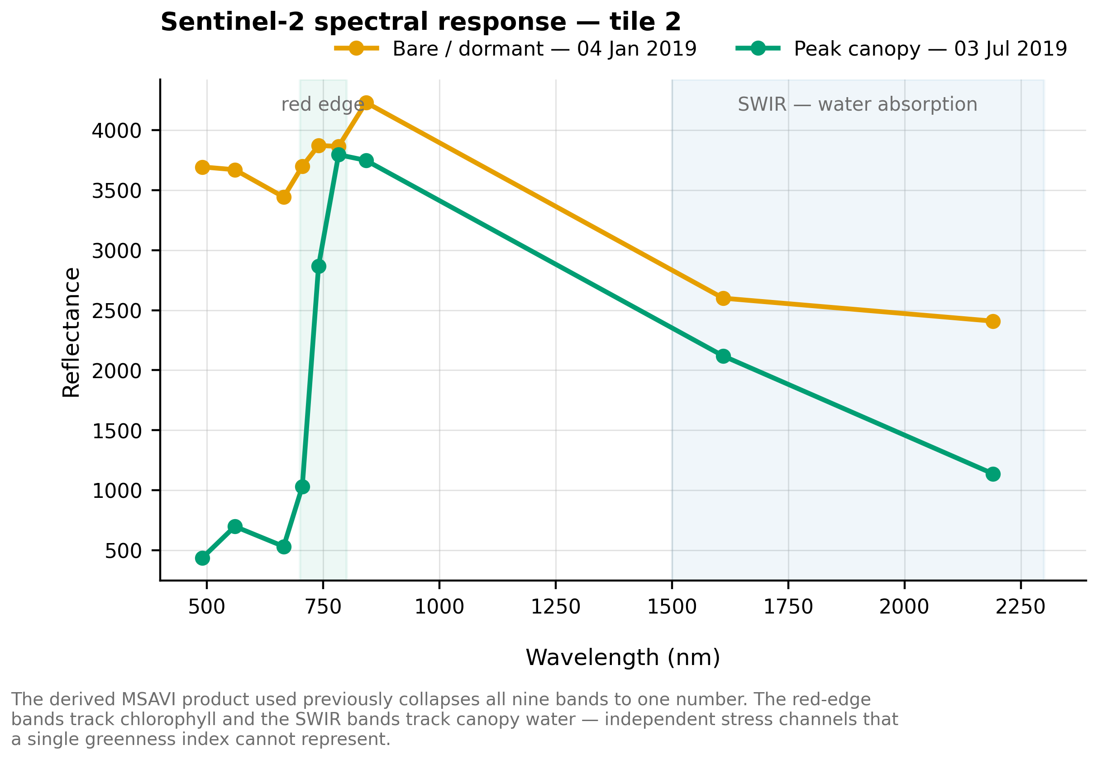
Figure 2.1: Sentinel-2 spectral response of one tile on two dates. At peak canopy in July, visible reflectance drops and the jump across the red edge is large; in January (bare or dormant) the two are similar.
NDVI = (NIR − Red) / (NIR + Red) (2.1)
NDVI is strongly affected by bright soil when the canopy is sparse. SAVI [7] adds a fixed soil factor, and the Modified Soil-Adjusted Vegetation Index (MSAVI) [8] replaces it with one that adjusts itself to the amount of vegetation:
MSAVI = [ 2·NIR + 1 − √( (2·NIR + 1)² − 8·(NIR − Red) ) ] / 2 (2.2)
This project uses MSAVI as its main input, because in Lombardy the early-season signal is dominated by bare soil between sowing and canopy closure. MSAVI is stored as a scaled integer, so the figures show values in the thousands. The side study in Section 5.7 also uses the red-edge index NDRE [9] and the moisture index NDMI [10].

2.2 Unsupervised Anomaly Detection
Unsupervised detectors learn what normal data looks like and give each new observation an anomaly score [11], [12]. Isolation Forest [13] isolates points with random axis-aligned splits; anomalies need fewer splits, so it is good at values that are extreme for the whole dataset. An autoencoder [14] is a neural network trained to compress and rebuild normal data, and its reconstruction error serves as the score. Local Outlier Factor (LOF) [15] compares the density around a point p with the density around its k nearest neighbours N(p):
LOF_{k}(p) = (1/k) · Σ_{o ∈ N(p)} lrd_{k}(o) / lrd_{k}(p) (2.3)
Here lrd_{k} is the local reachability density, the inverse of the average distance to the neighbours. A score near 1 means the point is as dense as its neighbourhood; a score well above 1 means it is unusual relative to its neighbours, even if it is unremarkable globally. Ensembles average the normalised scores of several detectors; they help only when every member is reasonably accurate. A large benchmark found no detector best everywhere, with LOF favoured for local anomalies [16].

2.3 Thresholds and Extreme Value Theory
A score must become a yes/no decision. A percentile threshold (for example, “flag the top 15%”) is an arbitrary choice, and with only 25 observations per tile a high percentile just interpolates between the top one or two scores. Extreme value theory offers a principled alternative: for a wide class of distributions, the excesses over a high level u follow a Generalised Pareto Distribution with shape ξ and scale σ [17], [18]. Inverting it for a target false-alarm probability q, with N_{u} of the n observations above u, gives the threshold [19]:
z_{q} = u + (σ / ξ) · [ (q · n / N_{u})^{−ξ} − 1 ] (2.4)
This replaces “the 85th percentile” with “a 3% false-alarm risk”, a quantity a user can reason about.

2.4 Evaluation Metrics
With true and false positives and negatives counted against the injected stress, the main metrics are:
Precision = TP / (TP + FP), Recall = TP / (TP + FN) (2.5)
F1 = 2 · Precision · Recall / (Precision + Recall) (2.6)
The area under the precision–recall curve (PR-AUC) is reported as a threshold-free summary, along with the absolute number of false alarms, because even a 1% false-alarm rate means hundreds of wasted field visits across a region. Improvements are checked with a bootstrap confidence interval and a paired permutation test.

2.5 Related Work
BFAST [20] and CCDC [21] detect breaks in satellite time series, but they target permanent land-cover change such as deforestation [22]; crop stress is short-lived, partial and sits on top of a strong seasonal cycle. The Savitzky–Golay filter [23] is widely used to remove cloud-induced drops from NDVI series [24] and is used here for one feature. Campos et al. [4] showed that measured performance in unsupervised outlier detection depends heavily on the evaluation protocol, an effect this project tests on its own system (Section 5.7).

2.6 Technologies Involved
Table 2.1: Technologies used in the project
Technology | Version | Role in the project
Python | 3.14 | Programming language for the whole pipeline
NumPy, pandas, SciPy | 2.3.5, 2.3.3, 1.17.1 | Arrays, the 83,200-row feature table, smoothing and Pareto fitting
rasterio | 1.5.0 | Reading the GeoTIFF rasters
scikit-learn [25] | 1.8.0 | Isolation Forest, LOF, scaling and metrics
PyTorch [26] | 2.11.0 (CPU) | The autoencoder
Matplotlib | 3.10.8 | All figures
LaTeX (IEEEtran, Overleaf) | — | The research paper draft

CHAPTER 3
METHODOLOGY

3.1 Overview and Block Diagram
Figure 3.1 shows the pipeline. Sentinel-2 MSAVI rasters are screened for cloud, summarised into statistics for each tile and pass, and extended with temporal features. The tiles are split into three disjoint groups; LOF is fitted on clean observations of the first group, each tile's threshold is calibrated on clean scores, and an alarm is raised only when two consecutive passes exceed it. (The figures use the word field for what this report calls a tile.)
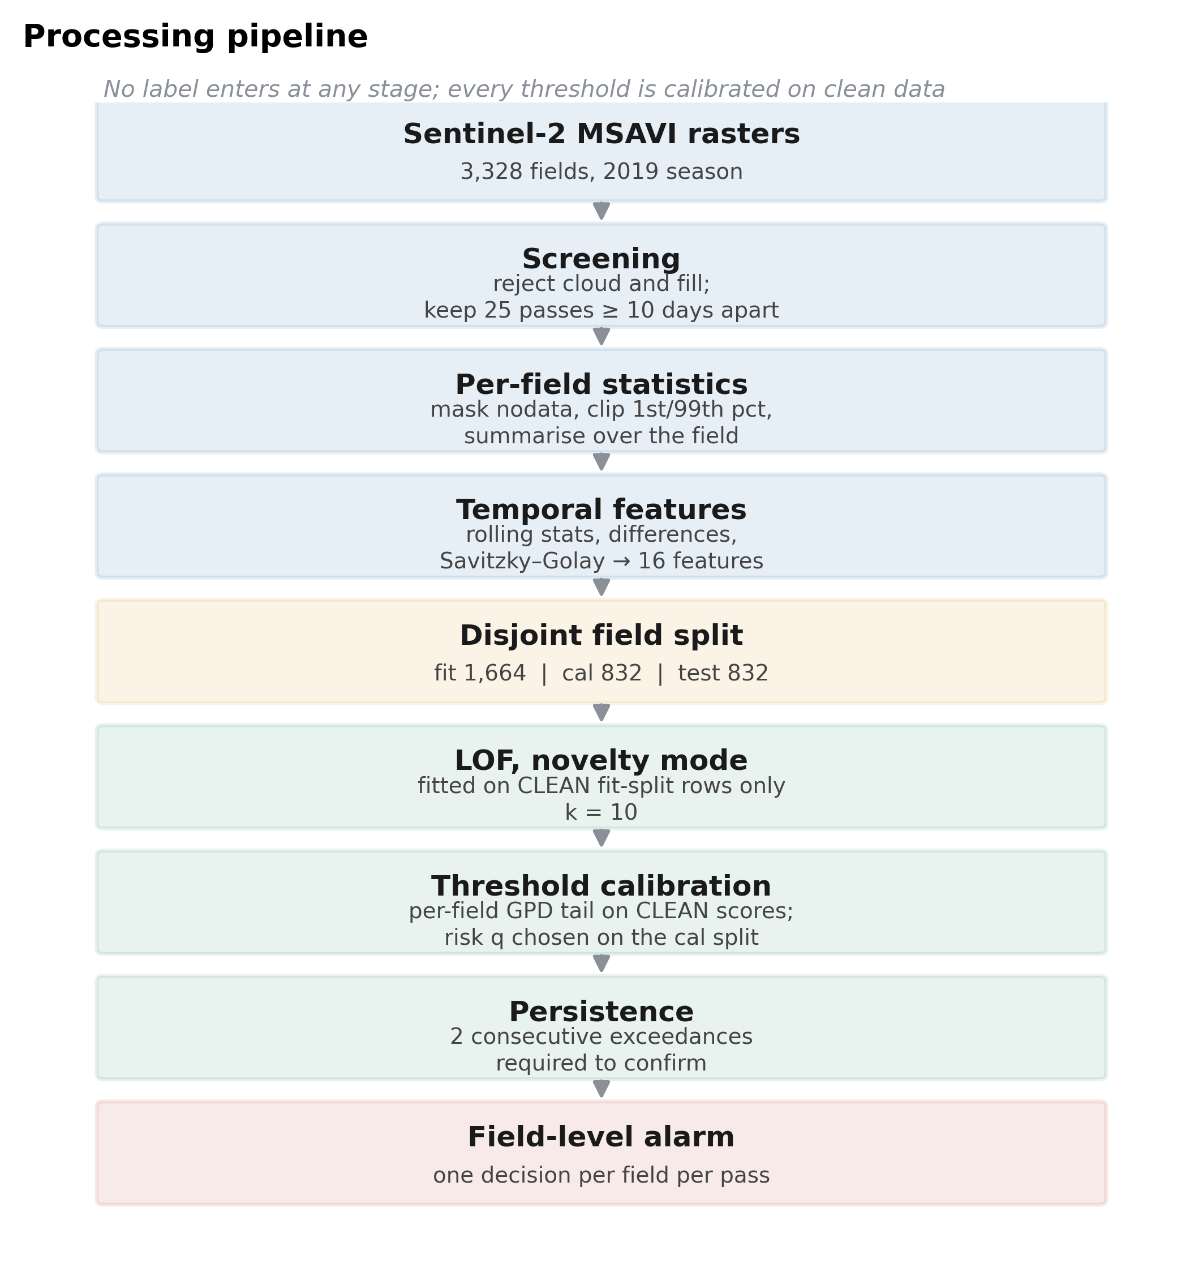
Figure 3.1: Block diagram of the processing pipeline. No label is used at any stage, and every threshold is calibrated on clean data.

3.2 Study Area and Data
The study region is an intensively farmed plain in Lombardy, northern Italy (maize, rice, wheat and forage). The data come from a public Sentinel-2 archive for the region [27]. Each site is a square tile of 48 × 48 pixels at 10 m resolution, so a tile usually contains more than one field (Figure 3.3). The tiles form a near-contiguous block (Figure 3.2), and Table 3.1 summarises the dataset used in the main study.
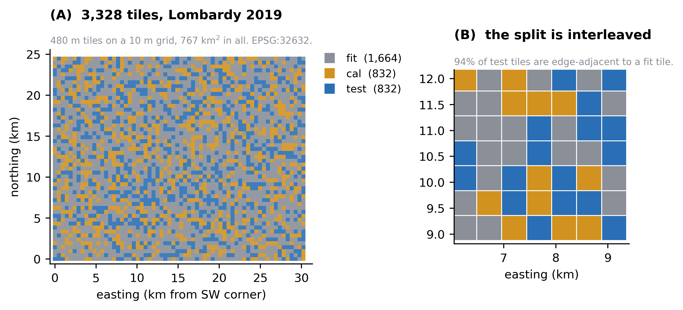
Figure 3.2: The study area. (A) All 3,328 tiles, coloured by split. (B) A detail: held-out tiles are interleaved with the tiles the detector is fitted on.
Table 3.1: Summary of the dataset
Property | Value
Region | Lombardy, Italy; 30.2 × 24.5 km block, 767 km² (EPSG:32632)
Tiles | 3,328, each 480 m × 480 m (23 ha)
Season and input | 2019, MSAVI (one derived band)
Passes kept per tile | 25, at least 10 days apart
Tile-observations | 3,328 × 25 = 83,200

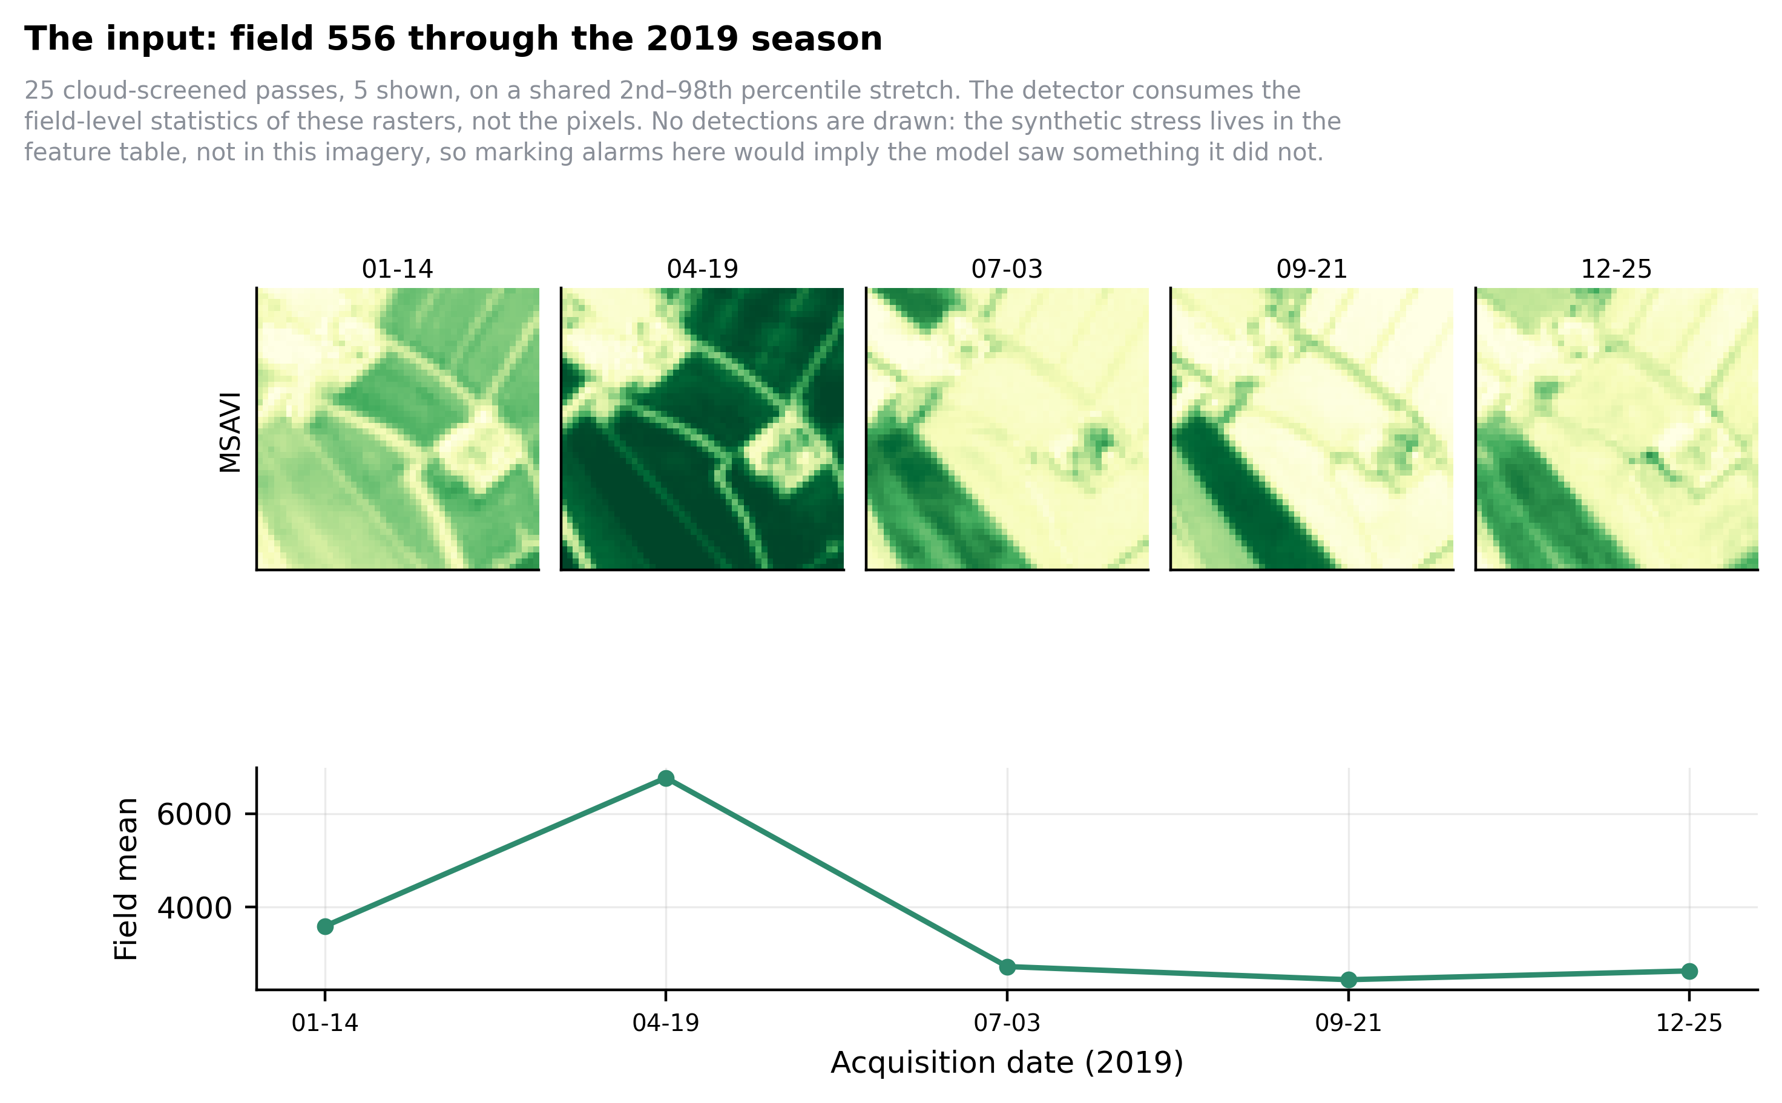
Figure 3.3: One tile through the 2019 season. Five of the 25 retained passes, with the tile-mean MSAVI below.

3.3 Screening and Feature Engineering
A cloud-covered acquisition looks exactly like a crop dying, so every acquisition is rejected if it fails any of four checks: a minimum intensity standard deviation (a uniform raster is cloud or fill), a valid-pixel ratio of at least 0.7, a unique-value ratio of at least 0.05, and a minimum spatial gradient (real fields have texture; cloud tops do not). Twenty-five passes per tile are kept. Each raster is then masked, clipped to its 1st–99th percentiles and summarised into the sixteen features in Table 3.2.
Table 3.2: The sixteen features computed for each tile-observation
Feature | Type | Description
mean, std, min, max | Per pass | Mean, standard deviation, minimum and maximum MSAVI over the tile
p25, p50, p75, iqr | Per pass | Percentiles and the inter-quartile range (p75 − p25)
cv | Per pass | Coefficient of variation, std / mean
valid_pixel_ratio | Per pass | Fraction of valid pixels (always 1.0 after screening)
smoothed_p50 | Temporal | p50 smoothed with a Savitzky–Golay filter (window 5, order 2)
rolling_median, rolling_std | Temporal | Median and spread of smoothed_p50 over the last 3 passes
diff, percent_change | Temporal | Change in smoothed_p50 from the previous pass
diff_from_global_median | Temporal | smoothed_p50 minus the median of all tiles

Because MSAVI swings about 2.7-fold over the season (Figure 3.4), more than the stress being tested for, every temporal feature is measured against the tile's own rolling baseline. valid_pixel_ratio is constant after screening, so the detector effectively sees 15 features. All features are standardised with a scaler fitted on the fit tiles only.
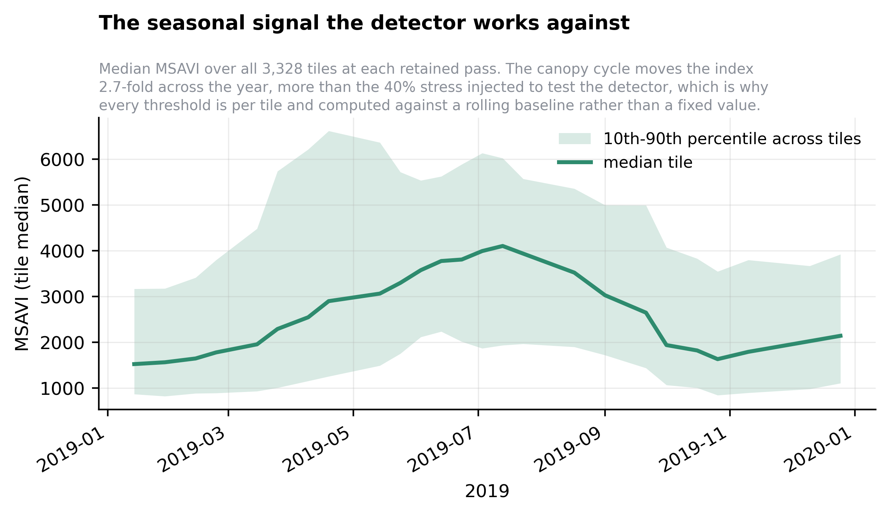
Figure 3.4: The seasonal cycle the detector works against. Median MSAVI across all tiles at each pass, with the 10th–90th percentile band.

3.4 Detectors and Decision Rule
Detectors. Isolation Forest (100 trees), LOF (novelty mode, k = 10) and an autoencoder (16 → 32 → 4 → 32 → 16 units, dropout 0.2, 200 epochs, Adam at 10⁻³) were fitted on clean observations of the fit tiles. Two ensembles min–max normalise and average the scores: ISO + LOF (0.5 / 0.5) and a hybrid of all three (0.33 / 0.33 / 0.34). A PCA step and the libraries' contamination setting exist in the original code but have no effect on any result, so they are not part of the method.
Per-tile threshold. A naturally volatile tile, such as a rice paddy, would alarm on every pass under a global cut-off, so each tile gets its own threshold. u is set to the 80th percentile of the tile's clean scores, and the excesses above it (about five per tile) are modelled with a Generalised Pareto Distribution. Five values are too few to fit a shape per tile, so ξ is fitted once on the pooled excesses of all tiles (ξ = −0.199) and only the scale varies. The threshold comes from Eq. (2.4) with q = 0.03, chosen on the calibration tiles.
Persistence. Real stress lasts across a five-to-ten-day revisit, while a passing cloud usually does not, so an alarm is confirmed only when a tile exceeds its threshold on two consecutive passes. The complete rule for one tile is:
u ← 80th percentile of the tile's clean scores c_1 .. c_n (n = 25)
e ← { c_i − u : c_i > u } # excesses (about 5)
β ← mean(e) · (1 − ξ) # per-tile scale, ξ = −0.199
z ← u + (β / ξ) · ((q · n / |e|)^(−ξ) − 1) # threshold, q = 0.03
for t = 2 .. n:
if s_t > z and s_(t−1) > z: mark passes t−1 and t as stressed

3.5 Evaluation Protocol
Ground truth is created by corrupting a random 15% of observations with one of three synthetic signatures, after which the temporal features are recomputed: a sudden drop (the six level statistics multiplied by 1 − severity), a gradual onset (the same drop ramping in over the event) and a spectral shift (the mean falls while the spread rises, like patchy damage). The baseline is a 40% drop lasting two passes; severity is swept from 10% to 50% and duration from 1 to 3 passes. Every number is the mean over five seeds. Tiles are split into three disjoint groups (Table 3.3), and every threshold is calibrated on clean, pre-injection scores, the most important design decision in the project (Section 5.4).
Table 3.3: The three-way split of tiles
Split | Tiles | Observations | Role
Fit | 1,664 | 41,600 | Detectors fitted here, on clean rows only
Calibration | 832 | 20,800 | Threshold rule and settings chosen here
Test | 832 | 20,800 | Every reported number; nothing selected here

CHAPTER 4
IMPLEMENTATION

4.1 Project Evolution
Table 4.1: Stages of the project
Stage | Scale | What was done
1. Prototype | 4 tiles | Read the rasters; tried change-point detection and Isolation Forest.
2. First hybrid pipeline | 20 tiles | First end-to-end pipeline combining several detectors.
3. Full hybrid pipeline | 3,328 tiles | Nine-step pipeline from raw rasters to evaluation; built the 83,200-row feature table.
4. Ablation study | 3,328 tiles | Compared detectors and rules; F1 0.718 for LOF with a per-tile 85th-percentile threshold; LOF alone beat the hybrid.
5. Controlled re-evaluation (PBL extension) | 3,328 tiles | Three-way split, clean-data and extreme-value thresholds, all experiments at one operating point, a multispectral side study, a merged codebase and a paper draft. Final F1 0.844.

Stage 5 is the final state described in this report. It began with a puzzle from stage 4: recall seemed capped near 0.6 whichever detector was used. Tracing that cap led to the main finding of the project (Section 5.4).

4.2 Software Modules
The code lives in one folder, crop_stress/, with four packages: engine/ (shared machinery and the feature table), study/ (the main study), appendix/ (three supporting experiments) and multispectral/ (the side study). Table 4.2 lists the main modules.
Table 4.2: Main software modules
Module | Responsibility
engine/utils/cleaning.py | The four screening checks; selects 25 passes per tile
engine/utils/feature_extraction.py | Masking, clipping and per-pass statistics
engine/utils/timeseries.py | Savitzky–Golay smoothing and temporal features
engine/utils/models.py | Isolation Forest, LOF and the autoencoder
engine/utils/evaluation.py | The three synthetic stress injectors
study/core.py | Data split, scoring, percentile and extreme-value thresholds, persistence and metrics
study/study.py | Every experiment, operating point first
study/run_all.py | Runs the whole study and writes all tables and figures

4.3 Working System
The complete study runs with one command, cd crop_stress/study followed by python run_all.py. It takes about 34 minutes on a CPU the first time (later runs reuse cached data) and rebuilds every table and figure from one stored file, results.json, so a plotted value and a reported value cannot disagree. All experiments are deterministic given the five seeds.
Figure 4.1 shows the system on one held-out tile. All eight injected observations were confirmed, with no false alarms. One isolated exceedance early in the season crossed the tile's threshold (1.23) but did not recur, so the persistence rule discarded it, exactly as it would discard a passing cloud.
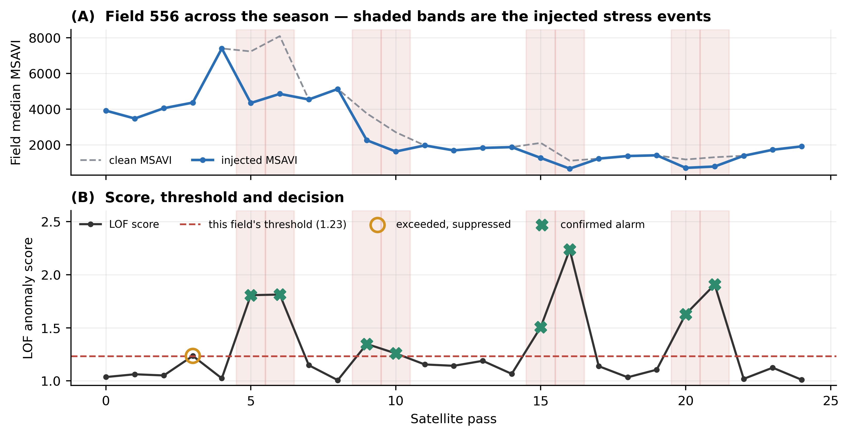
Figure 4.1: Worked example: one held-out tile, start to finish. (A) Tile median MSAVI, clean and with injected stress (shaded). (B) LOF score against the tile's threshold, with the suppressed exceedance (open circle) and confirmed alarms (crosses).

4.4 Problems Found and Fixed
- Threshold computed on contaminated data: moved to clean data, removing a recall ceiling of about 0.6 (Section 5.4).
- Settings chosen while looking at the results: replaced by the three-way split (Table 3.3).
- Inert components: a PCA step, the contamination setting and one constant feature column were found to have no effect and are documented as not part of the method.
- A wrong causality claim: an earlier audit said the sliding 2-of-3 rule looks into the future; the code uses only passes t−2, t−1 and t.
- An uncontrolled comparison: a gap of F1 0.72 against 0.35 between two codebases had been blamed on held-out evaluation; measured properly, the cost is only 0.021 F1.
- A fragmented codebase: four folders with colliding file names were merged into one package, and every result was regenerated and checked.

CHAPTER 5
RESULTS AND ANALYSIS
All results are measured on the 832 held-out test tiles (20,800 observations), averaged over five seeds, for a sudden 40% drop lasting two passes unless stated otherwise. FA is the number of false alarms out of 20,800 observations.

5.1 Final Result
The final configuration is LOF (k = 10) with a per-tile extreme-value threshold at a 3% false-alarm risk and a two-consecutive-pass persistence rule (Table 5.1). When it raises an alarm it is right 87.6% of the time, and it catches 81.4% of the stressed observations.
Table 5.1: Final result on the held-out test tiles
Precision | Recall | F1 | PR-AUC | False alarms
0.876 | 0.814 | 0.844 | 0.904 | 350 / 20,800

5.2 Detector Comparison: Ensembling Is Harmful
Table 5.2: Detector comparison, each with its own clean-calibrated threshold
Detector | Precision | Recall | F1 | PR-AUC | FA
Isolation Forest | 0.661 | 0.104 | 0.179 | 0.200 | 161
LOF | 0.876 | 0.814 | 0.844 | 0.904 | 350
Autoencoder | 0.848 | 0.383 | 0.528 | 0.487 | 209
ISO + LOF | 0.771 | 0.230 | 0.354 | 0.294 | 208
Hybrid (all three) | 0.772 | 0.230 | 0.354 | 0.294 | 207

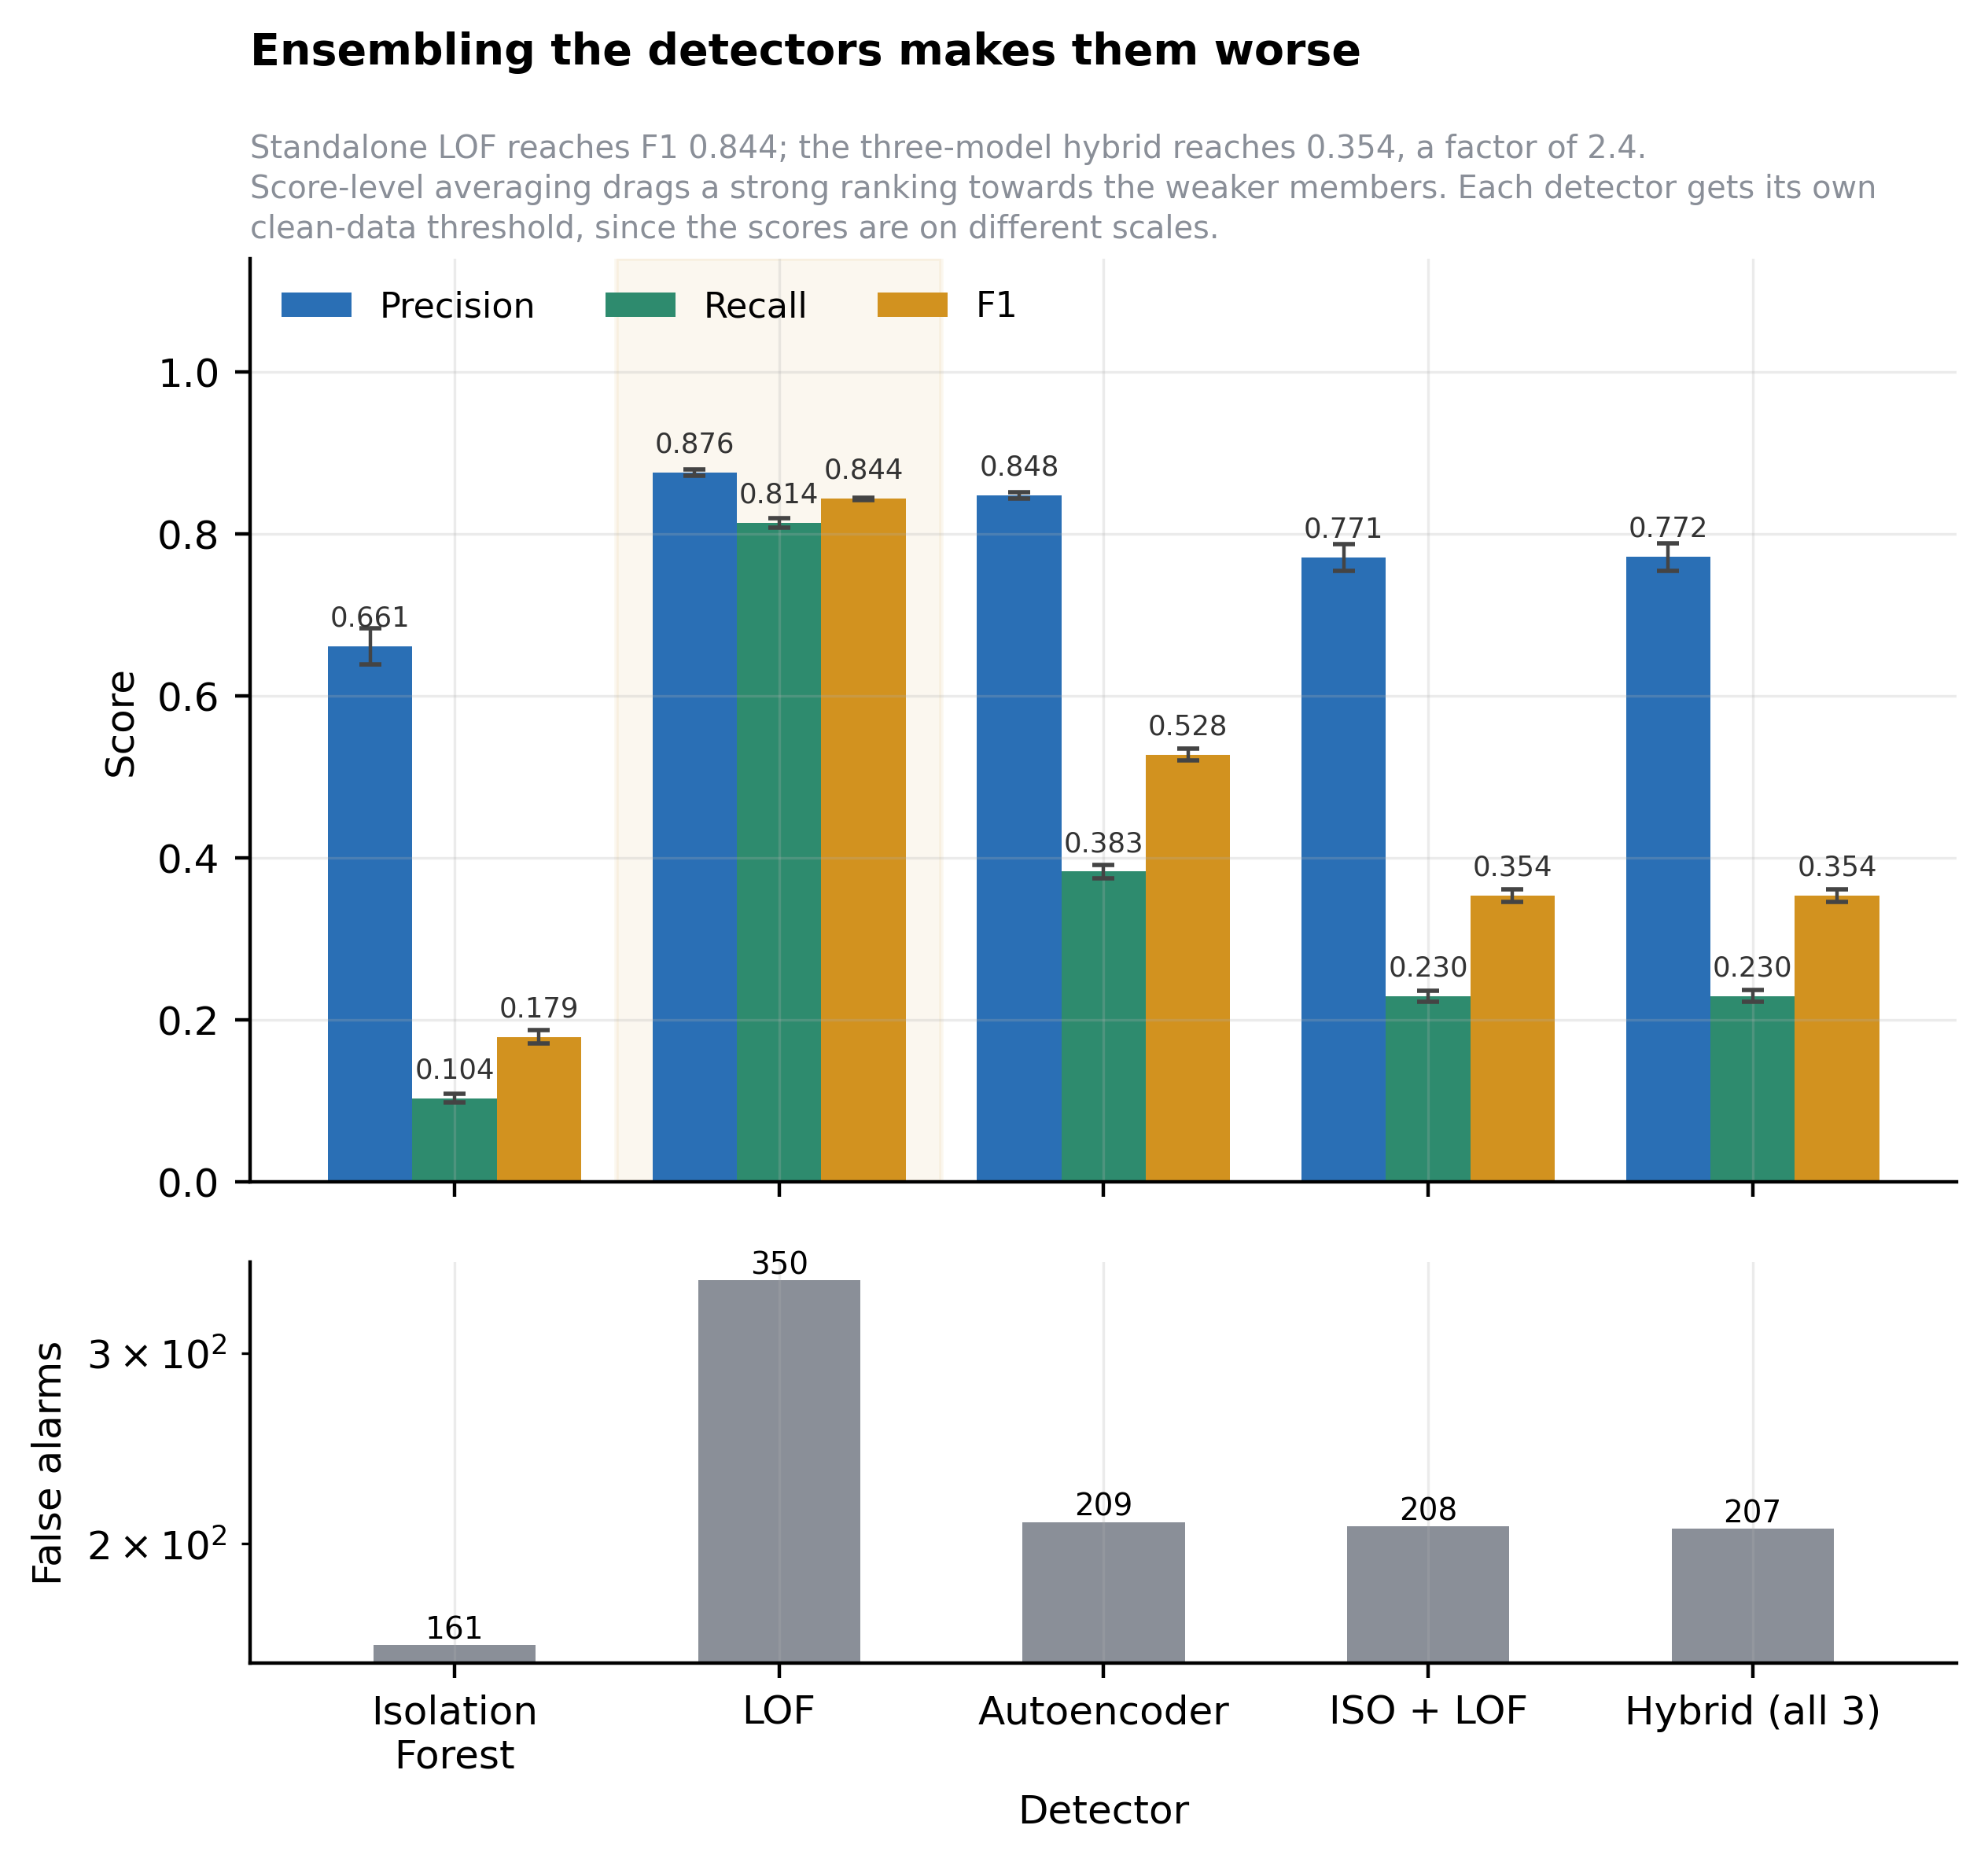
Figure 5.1: Detector comparison. The ensembles keep their precision but lose most of their recall.
This is the opposite of what the system was built to show. LOF alone reaches F1 0.844, while the three-model hybrid reaches 0.354. The ensembles keep respectable precision (0.77) but their recall collapses from 0.814 to 0.230: averaging does not make the alarms wrong, it makes the detector quiet. Averaging a strong ranking (PR-AUC 0.904) with a weak one (0.200) produces a weak ranking, and the per-tile threshold then acts on it. Isolation Forest finds values that are extreme for the whole dataset, but a stressed observation of a naturally low-vigour tile is unusual only compared with its neighbours, which is exactly what LOF measures [16].

5.3 Comparison with Hand-Written Rules
Table 5.3: LOF against rule-based scorers (same threshold and persistence rule)
Method | Precision | Recall | F1 | PR-AUC | FA
LOF (this work) | 0.876 | 0.814 | 0.844 | 0.904 | 350
Per-tile z-score | 0.707 | 0.147 | 0.243 | 0.328 | 185
Fixed percentage drop | 0.633 | 0.131 | 0.217 | 0.286 | 232
Rolling-median deviation | 0.406 | 0.007 | 0.013 | 0.214 | 29

Every rule passed through exactly the same threshold and persistence rule, so only the scoring function differs. LOF reaches F1 0.844 against 0.243 for the best rule, a 3.5× margin, so the gain comes from the density-based scoring itself.

5.4 Effect of the Threshold Rule
Table 5.4: Effect of the threshold rule (same LOF scores, tiles and injections)
Threshold rule | Precision | Recall | F1 | FA
Per-tile P85 on injected data (earlier rule) | 0.825 | 0.597 | 0.693 | 384
Global P90 on injected data | 0.979 | 0.520 | 0.679 | 34
Per-tile P97.25 on clean data | 0.857 | 0.834 | 0.845 | 421
Per-tile EVT, q = 0.03, clean data (final) | 0.876 | 0.814 | 0.844 | 350

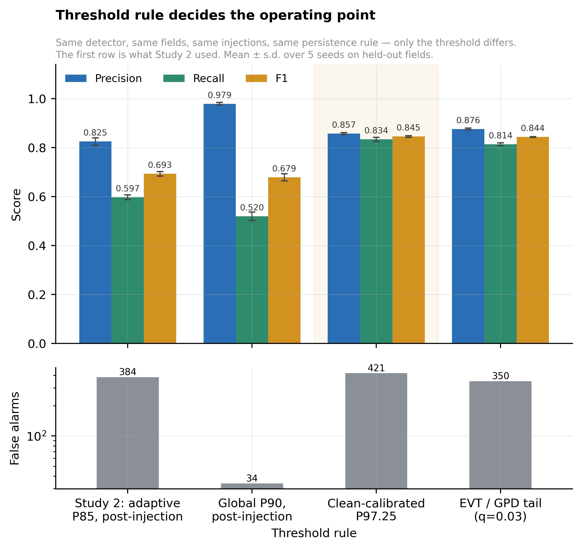
Figure 5.2: The threshold rule, not the detector, sets the operating point. All four rules use the same LOF scores on the same held-out tiles.
Why the earlier rule failed. It computed each tile's 85th percentile on data that already contained the anomalies. With 15% of observations stressed, the top 15% of scores are the anomalies, so the cut lands on their boundary and about half of them fall below it. Recall was capped near 0.6 whatever detector was used.
The fix. Calibrating on clean data removes the cap: F1 rises from 0.693 to 0.844 with the detector unchanged (ΔF1 = +0.151, 95% CI [+0.142, +0.159], paired permutation p < 5 × 10⁻⁴, over 4,160 tile-seed units). The extreme-value rule matches the best percentile rule (0.844 against 0.845) with 17% fewer false alarms and a meaningful setting, and it was chosen on the calibration tiles, not the test tiles. The global P90 rule remains a precision-first option: 0.979 precision with only 34 false alarms, at recall 0.520. Calibrated thresholds span a 4.0-fold range across tiles, which is why a single global cut-off does not work.

5.5 Detection Limits and Stress Signatures
Table 5.5: F1 by stress severity and duration (— : not evaluated)
Duration | 10% | 20% | 30% | 40% | 50%
1 pass | — | — | 0.365 | 0.452 | 0.500
2 passes | 0.077 | 0.482 | 0.755 | 0.844 | 0.859
3 passes | — | — | 0.786 | 0.877 | 0.898

Detection is reliable for stress of at least 30% lasting two or more passes (F1 0.755–0.898). Mild stress (10–20%) is comparable to normal pass-to-pass variation, and single-pass events are filtered out by design. The final rule is not better everywhere: it beats the earlier rule in nine of eleven scenarios but loses on the two weakest (Table 5.6), because its threshold was tuned at 40% severity. For early warning of developing stress, a looser threshold would be the right choice.
Table 5.6: Final rule against the earlier rule, by scenario (F1)
Severity | Duration (passes) | Earlier rule | Final rule | Change
30% | 1 | 0.300 | 0.365 | +0.065
40% | 1 | 0.328 | 0.452 | +0.124
50% | 1 | 0.346 | 0.500 | +0.154
10% | 2 | 0.233 | 0.077 | −0.156
20% | 2 | 0.546 | 0.482 | −0.064
30% | 2 | 0.676 | 0.755 | +0.079
40% | 2 | 0.718 | 0.844 | +0.126
50% | 2 | 0.735 | 0.859 | +0.124
30% | 3 | 0.642 | 0.786 | +0.144
40% | 3 | 0.676 | 0.877 | +0.201
50% | 3 | 0.691 | 0.898 | +0.207
Earlier-rule values are those reported by the stage-4 ablation study.
Table 5.7: Robustness to the stress signature
Signature | Precision | Recall | F1 | PR-AUC | FA
Sudden drop | 0.876 | 0.814 | 0.844 | 0.904 | 350
Spectral shift | 0.868 | 0.757 | 0.809 | 0.854 | 349
Gradual onset | 0.872 | 0.474 | 0.614 | 0.745 | 211

Gradual onset is the weak case (F1 0.614): a slow decline is partly absorbed into the rolling baseline the features are measured against. This matters, because progressive drought and spreading disease are exactly slow-onset events.

5.6 Persistence Rule
Table 5.8: Effect of the persistence rule
Rule | Precision | Recall | F1 | FA
None | 0.755 | 0.870 | 0.809 | 859
Strict 2-consecutive (final) | 0.876 | 0.814 | 0.844 | 350
Sliding 2-of-3 | 0.534 | 0.525 | 0.530 | 1,388
Strict 3-consecutive | 0.762 | 0.335 | 0.465 | 317

Requiring two consecutive exceedances cuts false alarms from 859 to 350 for a loss of only 0.057 recall. The 3-consecutive rule scores low here only because the test events last two passes, so it cannot fire on an event alone.

5.7 Other Experiments
Neighbourhood size. Test F1 varies by only 0.039 across k from 5 to 75, and k = 10, chosen on the calibration tiles, is the original default. Extra trajectory features (a lagged value, cumulative change and acceleration) made results worse: F1 fell from 0.844 to 0.785.
Cost of held-out evaluation. Fitting LOF on all tiles, including the test tiles, gives F1 0.714; fitting on a disjoint half gives 0.693. The cost is only 0.021 F1, which corrects an earlier claim that blamed a much larger gap between two codebases on the protocol, the kind of mistake Campos et al. warn about [4].
Threshold-free performance. On the pooled scores, average precision is 0.900 and ROC-AUC is 0.974 (Figure 5.3), so the ranking itself is strong and the result is not due to a lucky threshold. False alarms concentrate on a minority of tiles: a third of held-out tiles never raise one, while the noisiest tenth account for 37%.
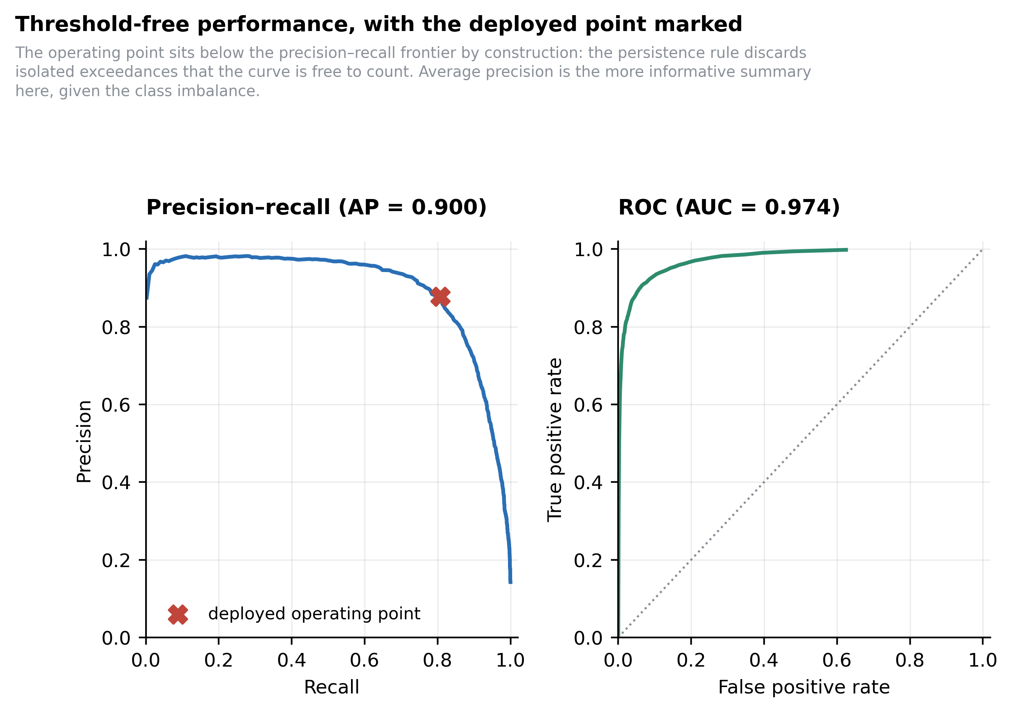
Figure 5.3: Precision–recall and ROC curves of the LOF score. The cross marks the deployed operating point.
Multispectral side study. An independent rebuild from the raw nine-band archive, with its own protocol, compared one index with four (MSAVI, NDVI, NDRE and NDMI). Four indices raised F1 from 0.243 to 0.351, a 44% relative gain (p ≈ 0.065, suggestive rather than conclusive). Using a tile's previous season as its reference scored worse (F1 0.287) than comparing it with other tiles in the same season (0.352), because crop rotation changes what is normal from one year to the next (Table 5.9).
Table 5.9: Multispectral side study (independent pipeline; compare within each pair only)
Question | Configuration | Precision | Recall | F1
Input indices | MSAVI only (1 index) | 0.278 | 0.216 | 0.243
Input indices | MSAVI, NDVI, NDRE, NDMI (4 indices) | 0.315 | 0.396 | 0.351
Reference period | Other tiles, same season (2019) | 0.316 | 0.397 | 0.352
Reference period | Previous season (2018 → 2019) | 0.226 | 0.394 | 0.287

5.8 Summary of Findings
Table 5.10: Summary of findings
Finding | Evidence
LOF alone is the best detector; the hybrid ensemble is harmful | F1 0.844 vs 0.354 (recall 0.814 vs 0.230)
LOF beats hand-written rules | F1 0.844 vs 0.243 (3.5×)
Calibrating thresholds on clean data is the largest single improvement | F1 0.693 → 0.844; 95% CI of gain [+0.142, +0.159]
The extreme-value threshold matches the best percentile with a meaningful setting | F1 0.844 at q = 0.03, 17% fewer false alarms
Two-consecutive persistence is the best rule | F1 0.844 vs 0.809 without; FA 350 vs 859
Reliable above 30% severity for two or more passes; weak on gradual onset | F1 0.755–0.898 vs 0.077 at 10%; gradual onset 0.614
Held-out evaluation costs little | 0.021 F1
More spectral indices help (side study) | F1 0.243 → 0.351

CHAPTER 6
CONCLUSIONS AND FUTURE SCOPE

6.1 Conclusions
This project built and evaluated a fully unsupervised crop stress detector for Sentinel-2 time series that uses no labels at any stage. LOF with a per-tile extreme-value threshold and a two-pass persistence rule reaches precision 0.876, recall 0.814 and F1 0.844 on 832 held-out tiles, with 350 false alarms in 20,800 observations, under a protocol in which nothing reported was selected on the test tiles.
Two findings matter more than that number. The hybrid ensemble the project was built around is harmful: it collapses recall from 0.814 to 0.230. And where the threshold is computed matters more than which detector is used: calibrating on clean data improved F1 by 0.151 with the detector unchanged. The project also corrected its own earlier claims and reports where its recommended configuration is worse than the one it replaced.

6.2 Limitations
- No ground truth: every number rests on synthetic stress, which is cleaner than real stress, so absolute figures are an upper bound.
- Weakest where it matters most: mild stress (F1 0.08–0.48) and gradual onset (0.614).
- A stress-free reference period is assumed for each tile, and last season is a poor reference because of crop rotation.
- Not yet real-time: the Savitzky–Golay smoothing uses a centred five-pass window, so features at pass t also use passes t+1 and t+2.
- One region and one season, with a random split in which 94% of test tiles touch a fit tile, so results may be optimistic for a new area [28], [29].

6.3 Future Scope of Work
- Use more spectral bands: add NDVI, NDRE and NDMI, which gave a 44% relative gain in the side study and may catch gradual stress earlier.
- Validate with real ground truth, such as a small field campaign or official crop-damage records.
- Spatially blocked testing: hold out a whole geographic area to measure transfer.
- Real-time operation: a one-sided smoothing filter and an online extreme-value threshold [19].
- Crop-aware baselines and within-tile localisation, so that alarms point to the part of the tile that needs attention.

REFERENCES
[1] M. Drusch et al., “Sentinel-2: ESA's optical high-resolution mission for GMES operational services,” Remote Sensing of Environment, vol. 120, pp. 25–36, 2012.
[2] M. Weiss, F. Jacob, and G. Duveiller, “Remote sensing for agricultural applications: A meta-review,” Remote Sensing of Environment, vol. 236, Art. no. 111402, 2020.
[3] A.-K. Mahlein, “Plant disease detection by imaging sensors – Parallels and specific demands for precision agriculture and plant phenotyping,” Plant Disease, vol. 100, no. 2, pp. 241–251, 2016.
[4] G. O. Campos et al., “On the evaluation of unsupervised outlier detection: Measures, datasets, and an empirical study,” Data Mining and Knowledge Discovery, vol. 30, no. 4, pp. 891–927, 2016.
[5] A. F. Emmott, S. Das, T. Dietterich, A. Fern, and W.-K. Wong, “Systematic construction of anomaly detection benchmarks from real data,” in Proc. ACM SIGKDD Workshop on Outlier Detection and Description, 2013, pp. 16–21.
[6] J. W. Rouse, R. H. Haas, J. A. Schell, and D. W. Deering, “Monitoring vegetation systems in the Great Plains with ERTS,” in Proc. 3rd Earth Resources Technology Satellite-1 Symposium, NASA SP-351, 1974, pp. 309–317.
[7] A. R. Huete, “A soil-adjusted vegetation index (SAVI),” Remote Sensing of Environment, vol. 25, no. 3, pp. 295–309, 1988.
[8] J. Qi, A. Chehbouni, A. R. Huete, Y. H. Kerr, and S. Sorooshian, “A modified soil adjusted vegetation index,” Remote Sensing of Environment, vol. 48, no. 2, pp. 119–126, 1994.
[9] A. A. Gitelson and M. N. Merzlyak, “Spectral reflectance changes associated with autumn senescence of Aesculus hippocastanum L. and Acer platanoides L. leaves,” Journal of Plant Physiology, vol. 143, no. 3, pp. 286–292, 1994.
[10] B.-C. Gao, “NDWI—A normalized difference water index for remote sensing of vegetation liquid water from space,” Remote Sensing of Environment, vol. 58, no. 3, pp. 257–266, 1996.
[11] V. Chandola, A. Banerjee, and V. Kumar, “Anomaly detection: A survey,” ACM Computing Surveys, vol. 41, no. 3, pp. 1–58, 2009.
[12] L. Ruff et al., “A unifying review of deep and shallow anomaly detection,” Proceedings of the IEEE, vol. 109, no. 5, pp. 756–795, 2021.
[13] F. T. Liu, K. M. Ting, and Z.-H. Zhou, “Isolation forest,” in Proc. 8th IEEE Int. Conf. on Data Mining (ICDM), 2008, pp. 413–422.
[14] M. Sakurada and T. Yairi, “Anomaly detection using autoencoders with nonlinear dimensionality reduction,” in Proc. 2nd Workshop on Machine Learning for Sensory Data Analysis (MLSDA), 2014, pp. 4–11.
[15] M. M. Breunig, H.-P. Kriegel, R. T. Ng, and J. Sander, “LOF: Identifying density-based local outliers,” in Proc. ACM SIGMOD Int. Conf. on Management of Data, 2000, pp. 93–104.
[16] S. Han, X. Hu, H. Huang, M. Jiang, and Y. Zhao, “ADBench: Anomaly detection benchmark,” in Advances in Neural Information Processing Systems 35 (NeurIPS), 2022.
[17] J. Pickands, “Statistical inference using extreme order statistics,” The Annals of Statistics, vol. 3, no. 1, pp. 119–131, 1975.
[18] A. A. Balkema and L. de Haan, “Residual life time at great age,” The Annals of Probability, vol. 2, no. 5, pp. 792–804, 1974.
[19] A. Siffer, P.-A. Fouque, A. Termier, and C. Largouet, “Anomaly detection in streams with extreme value theory,” in Proc. 23rd ACM SIGKDD Int. Conf. on Knowledge Discovery and Data Mining, 2017, pp. 1067–1075.
[20] J. Verbesselt, R. Hyndman, G. Newnham, and D. Culvenor, “Detecting trend and seasonal changes in satellite image time series,” Remote Sensing of Environment, vol. 114, no. 1, pp. 106–115, 2010.
[21] Z. Zhu and C. E. Woodcock, “Continuous change detection and classification of land cover using all available Landsat data,” Remote Sensing of Environment, vol. 144, pp. 152–171, 2014.
[22] Z. Zhu, “Change detection using Landsat time series: A review of frequencies, preprocessing, algorithms, and applications,” ISPRS Journal of Photogrammetry and Remote Sensing, vol. 130, pp. 370–384, 2017.
[23] A. Savitzky and M. J. E. Golay, “Smoothing and differentiation of data by simplified least squares procedures,” Analytical Chemistry, vol. 36, no. 8, pp. 1627–1639, 1964.
[24] J. Chen, P. Jönsson, M. Tamura, Z. Gu, B. Matsushita, and L. Eklundh, “A simple method for reconstructing a high-quality NDVI time-series data set based on the Savitzky–Golay filter,” Remote Sensing of Environment, vol. 91, no. 3–4, pp. 332–344, 2004.
[25] F. Pedregosa et al., “Scikit-learn: Machine learning in Python,” Journal of Machine Learning Research, vol. 12, pp. 2825–2830, 2011.
[26] A. Paszke et al., “PyTorch: An imperative style, high-performance deep learning library,” in Advances in Neural Information Processing Systems 32 (NeurIPS), 2019, pp. 8024–8035.
[27] Dataset: name of the Lombardy Sentinel-2 archive, provider, website and last accessed date (to be confirmed)
[28] D. R. Roberts et al., “Cross-validation strategies for data with temporal, spatial, hierarchical, or phylogenetic structure,” Ecography, vol. 40, no. 8, pp. 913–929, 2017.
[29] P. Ploton et al., “Spatial validation reveals poor predictive performance of large-scale ecological mapping models,” Nature Communications, vol. 11, Art. no. 4540, 2020.

ANNEXURES

Annexure A: Reproducing the Results
Python 3.14 with the libraries in Table 2.1. The data folders dataset_clean_2/ and archive (1)/ must sit above the crop_stress/ folder.
cd crop_stress/study
python run_all.py # all tables, figures and results (about 34 min first time)
python make_figures.py # figures only, from the stored results (seconds)

Annexure B: Glossary
Table B.1: Terms used in this report
Term | Meaning
Tile | One 480 m × 480 m square of farmland; 3,328 in the study (“field” in some figure labels)
Pass / observation | One satellite acquisition of one tile; 25 are kept per tile
Injection | Synthetic corruption of clean data to create a labelled test
Severity / duration | Size of the injected drop (10–50%) and how many passes it lasts (1–3)
Persistence | Rule requiring consecutive exceedances before an alarm is confirmed
EVT / GPD, risk q | Extreme value theory; the Pareto tail fitted to each tile's clean scores, set for false-alarm probability q = 0.03
FA | False alarms out of 20,800 test observations

Annexure C: Research Paper Draft
A paper titled “Unsupervised Crop Stress Detection from Sentinel-2 Time Series: Ensemble Dilution and the Primacy of Threshold Calibration” has been drafted from this work in IEEE conference format, with every number checked against the same results file. It has not yet been submitted for publication.

