In below screen I added PSO (particle Swarm Optimization) Algorithm to optimize dataset features which can help in getting better precision, recall and FSCORE value. Below screen is the normal SVM and Naïve Bayes output. To run project first click on ‘Offline Upload Twitter Dataset’ button to upload dataset and then click on ‘Clean Tweets & extract Features’ button then click on ‘Suspicious Tweets Classification using SVM and Naïve Bayes’ to get below output

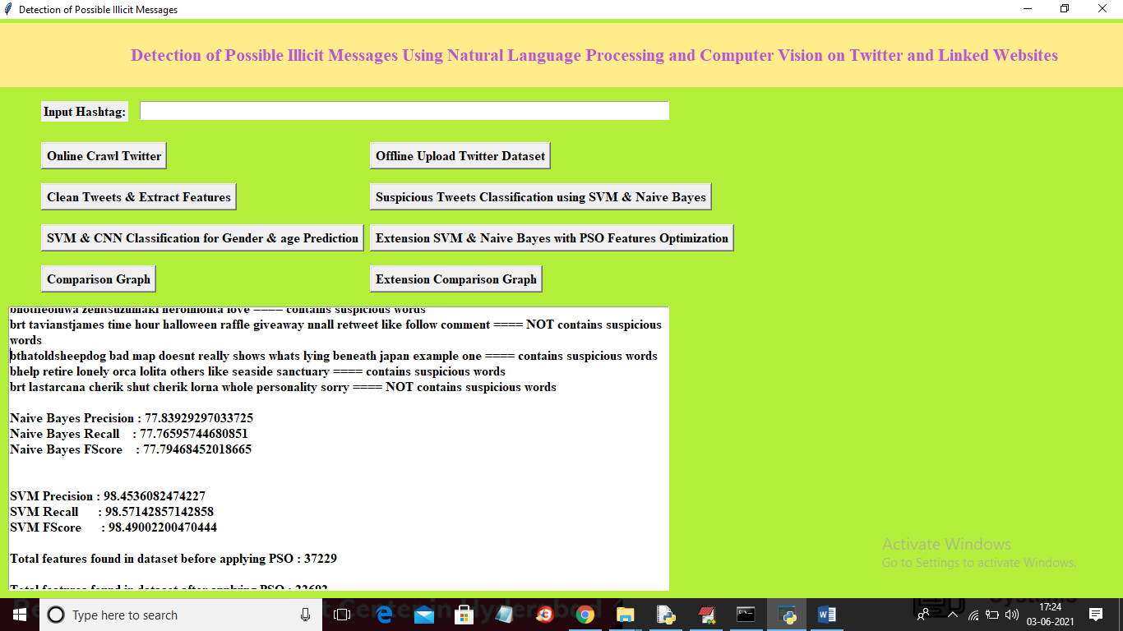

Now in above with Naïve Bayes we got 77% precision, recall and FScore and with SVM we got 98 and now click on ‘Extension SVM & Naïve Bayes with PSO Features Optimization’ button to get below output

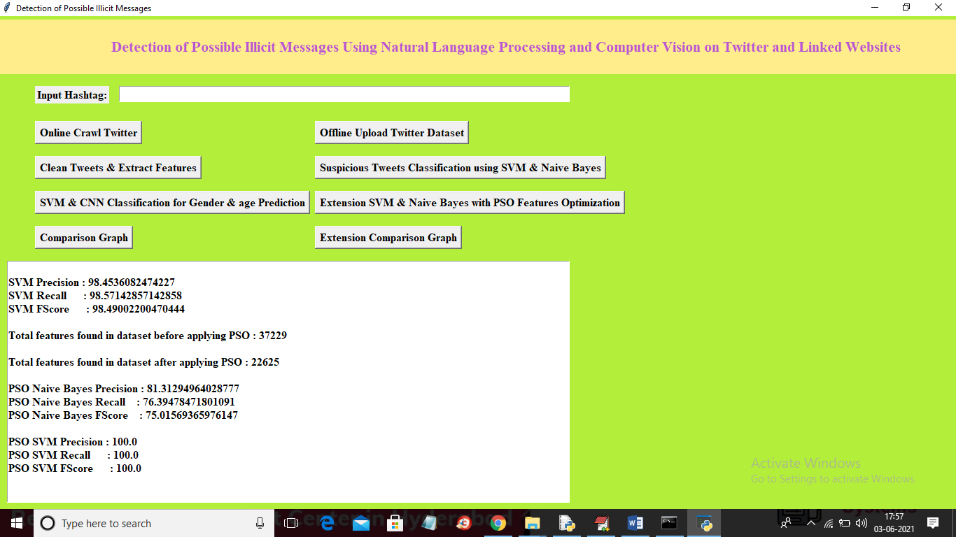

In above screen with PSO naïve bayes we got 81% precision and with PSO SVM we got 100% precision and now click on ‘Extension Comparison Graph’ button to get below graph

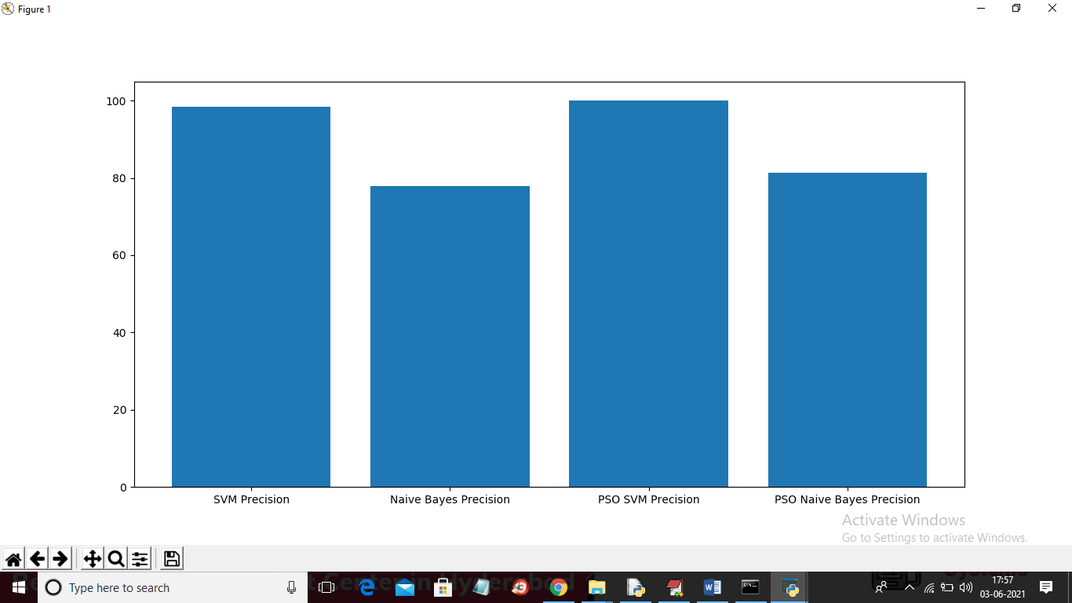

In above graph x-axis represents algorithm name and y-axis represents precision and in all algorithms with PSO giving better precision