Game Design Document

Fill up the following document

1. Write the title of your project.

Right to Live !!!

1. What is the goal of the game?

The goal of the game is to save the Royal Bengal Tiger from humans.

1. Write a brief story of your game

This app spreads awareness to save the Royal Bengal Tiger which has been declared as 'Endangered' as per the recent stats. It is our moral duty to conserve the tigers and save them from getting extinct due to poaching and killing activities of humans.

Save the tiger by making it jump using the arrow keys. My game is a complete app as the introduction screen introduces the theme and the controls to the player while the restart button allows the player to continue enjoying the game even if it's over.

1. Which are the playing characters of this game?

* Playing characters are the ones who respond to the user based on the input from the user.
* Cars, monkeys, dinos, wizards, etc., are the playing characters in the game.

|  |  |  |
| --- | --- | --- |
| Number | Character Name | What can this character do? |
| 1 | Tiger | It will be able to run, jump and protect itself from the arrows. |
| 2 | Hunter | Shoots the bow and arrow |
| 3 |  |  |
| 4 |  |  |
| 5 |  |  |
| 6 |  |  |
| 7 |  |  |
| 8 |  |  |

1. Which are the Non-Playing Characters of this game?

* Non-Playing characters are the ones that don't have an action or behavior when the user interacts with the game.
* Hurdles, stones, bananas, coins, etc., are non-playing characters in the game.

|  |  |  |
| --- | --- | --- |
| Number | Character Name | What can this character do? |
| 1 | Background | It’s the infinite scrolling ground |
| 2 | arrows | It kills the tiger |
| 3 |  |  |
| 4 |  |  |
| 5 |  |  |
| 6 |  |  |
| 7 |  |  |
| 8 |  |  |

Draw your imagination of this game. What does this game look like?

* Draw the game either on your computer or on paper.
* Add images of the game scenes to show each of the playing and non-playing characters at least once.

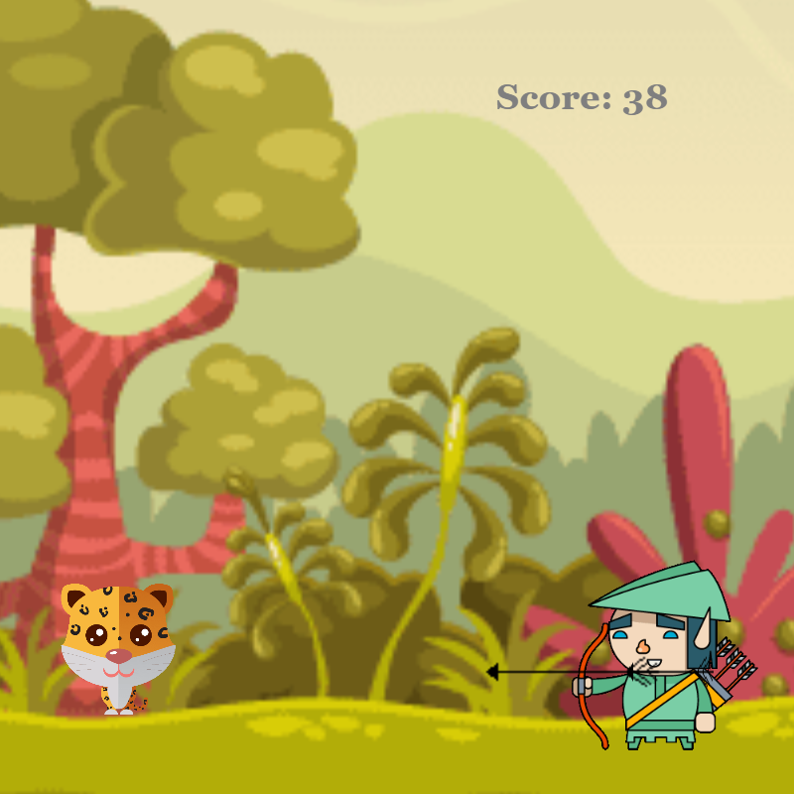 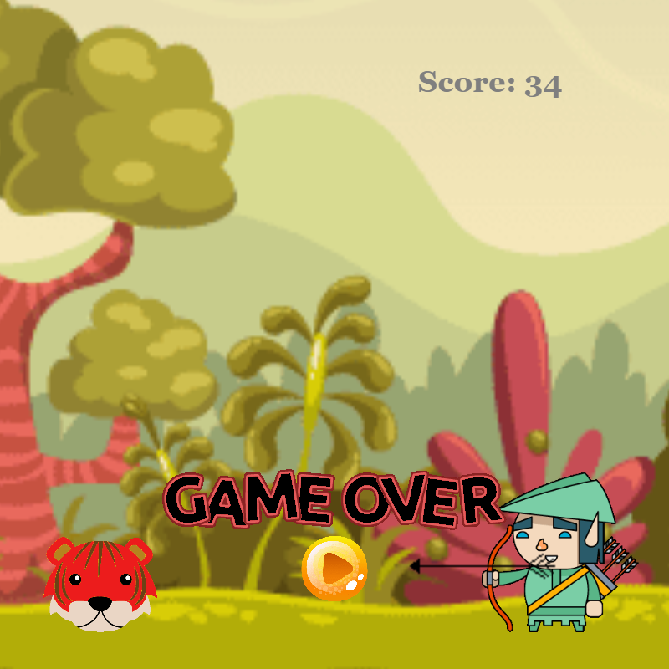

How do you plan to make your game engaging?

By involving the players to continue saving the tigers from getting killed.