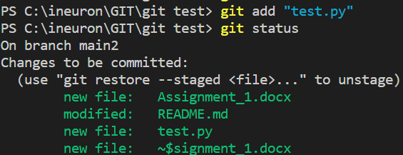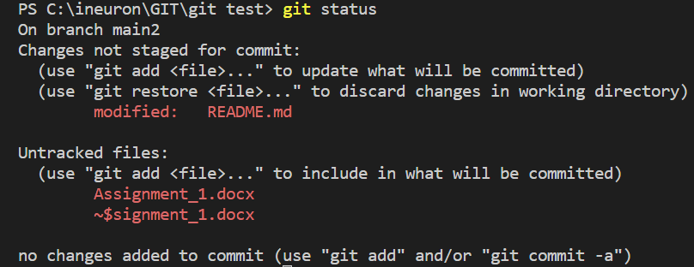

**git add:**

This command is used to add one or more files to staging (Index) area.

**git config:**

This command configures the user. The Git config command is the first and necessary command used on the Git command line. This command sets the author name and email address to be used with your commits.

**git status:**

The status command is used to display the state of the working directory and the staging area. It allows you to see which changes have been staged, which haven't, and which files aren?t being tracked by Git.

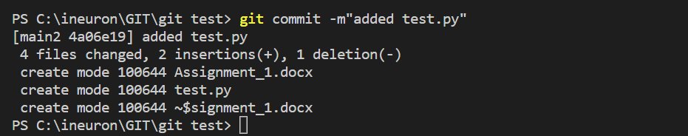

**git commit:**

This command changes the head. It records or snapshots the file permanently in the version history with a message.

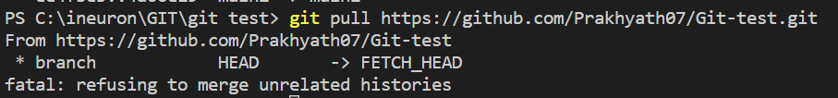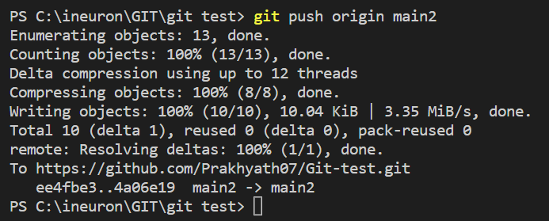

**git pull:**

Pull command is used to receive data from GitHub. It fetches and merges changes on the remote server to your working directory.

**git push:**

It is used to upload local repository content to a remote repository. Pushing is an act of transfer commits from your local repository to a remote repo.

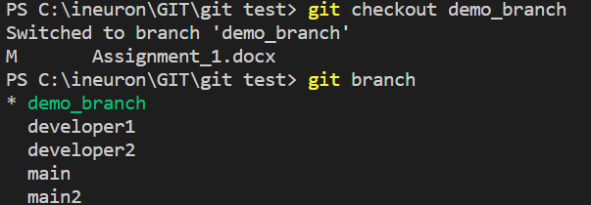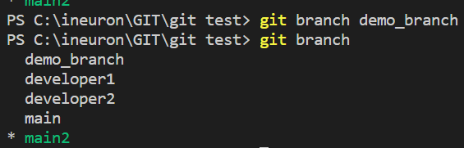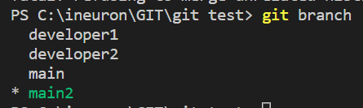

**git checkout branch (new name):**

This command creates a new branch.

**git checkout branch (new name):**

This command creates a new branch.

**git branch (new name):**

This command creates a new branch.

**git branch:**

This command lists all the branches available in the repository.