A project report on
CARE-AI: RELIABILITY-AWARE MULTIMODAL CLINICAL DECISION SUPPORT FOR SEVERITY RISK PREDICTION
Submitted in partial fulfillment for the award of the degree of
Bachelor of Technology in Computer Science and Engineering
by
PRAKKI KRISHNA KARTHIK (23BCE1294)
N BALAGURU (23BCE1347)
HAVAI NITHIN SIMHA (23BCE1412)

SCHOOL OF COMPUTER SCIENCE AND ENGINEERING
October, 2026

CARE-AI: RELIABILITY-AWARE MULTIMODAL CLINICAL DECISION SUPPORT FOR SEVERITY RISK PREDICTION
Submitted in partial fulfillment for the award of the degree of
Bachelor of Technology in Computer Science and Engineering
by
PRAKKI KRISHNA KARTHIK (23BCE1294)
N BALAGURU (23BCE1347)
HAVAI NITHIN SIMHA (23BCE1412)
SCHOOL OF COMPUTER SCIENCE AND ENGINEERING
October, 2026

DECLARATION
We hereby declare that the project report entitled “CARE-AI: Reliability-Aware Multimodal Clinical Decision Support for Severity Risk Prediction” submitted by Prakki Krishna Karthik (23BCE1294), N Balaguru (23BCE1347) and Havai Nithin Simha (23BCE1412), for the award of the degree of Bachelor of Technology in Computer Science and Engineering, Vellore Institute of Technology, Chennai, is a record of bonafide work carried out by us under the supervision of Dr. Sujatha M.
We further declare that the work reported in this project has not been submitted, either in part or in full, for the award of any other degree or diploma in this institute or any other institute or university.
Place: Chennai
Date: ____________________
Signatures of the candidates
Prakki Krishna Karthik
N Balaguru
Havai Nithin Simha

CERTIFICATE
This is to certify that the project report entitled “CARE-AI: Reliability-Aware Multimodal Clinical Decision Support for Severity Risk Prediction” is prepared and submitted by Prakki Krishna Karthik (23BCE1294), N Balaguru (23BCE1347) and Havai Nithin Simha (23BCE1412) to Vellore Institute of Technology, Chennai, in partial fulfillment of the requirements for the award of the degree of Bachelor of Technology in Computer Science and Engineering. The report is a bonafide record of work carried out under the guidance of Dr. Sujatha M. The project demonstrates a working research prototype, reproducible model comparison, uncertainty analysis and an interactive decision-support interface. The work meets the necessary academic requirements for submission, subject to the limitations and research-only status documented in the report.
Signature of the Guide: ______________________________
Name: Dr. Sujatha M
Date: ____________________
Signature of the Examiner: ____________________ Signature of the Examiner: ____________________
Name: ______________________________ Name: ______________________________
Date: ____________________ Date: ____________________
Approved by the Head of Department
School of Computer Science and Engineering
Vellore Institute of Technology, Chennai

ABSTRACT
Chest radiographs are frequently used to evaluate cardiopulmonary findings, but interpreting large collections of images remains time-consuming and dependent on specialist review. This project develops CARE-AI, a local research prototype for reliability-aware multimodal clinical decision support using MIMIC-CXR-JPG images, structured acquisition metadata and report-derived labels. The system combines image quality analysis, a transfer-learning image branch, a structured-data branch, uncertainty estimation, thresholded prediction, Grad-CAM visualization and evidence-linked output cards. A patient-level comparative study was implemented to compare DenseNet-121, EfficientNet-B0 and ConvNeXt-Tiny image representations, together with elastic-net logistic regression, random forest and histogram gradient boosting for structured metadata. Missing and uncertain labels are treated as unknown rather than automatically converted to negative labels, and decision thresholds are selected on the validation partition.
In the current evaluation snapshot, 1,295 images were discovered, 1,271 had usable label matches, and 739 patient groups were represented. The patient-level split contained 814 training images, 216 validation images and 241 test images. The comparative study selected the fine-tuned DenseNet-121 image branch and retained the random-forest structured branch for audit; the selected fusion policy is image-only because the available acquisition metadata was close to chance for discrimination. In a separate end-to-end checkpoint audit, the held-out test macro averages were AUROC 0.8471, AUPRC 0.8765, F1-score 0.7770 and balanced accuracy 0.7067. The validation-to-test gaps and sparse per-label support triggered a conservative research-only readiness gate. Therefore, CARE-AI is presented as a reproducible decision-support prototype rather than a clinically validated diagnostic device.
Keywords: chest X-ray, MIMIC-CXR-JPG, clinical decision support, DenseNet-121, multimodal learning, reliability estimation, calibration, Grad-CAM, selective prediction

ACKNOWLEDGEMENT
We express our sincere gratitude to our project guide, Dr. Sujatha M, for her guidance, constructive feedback and encouragement throughout the development of this work. Her suggestions helped us connect the software implementation with the requirements of reproducible machine-learning evaluation and responsible clinical decision support.
We thank the leadership and administration of Vellore Institute of Technology, Chennai, and the School of Computer Science and Engineering for providing the academic environment, computing facilities and support required for this project. We are grateful to the faculty members and project coordinators who helped us refine the problem statement, evaluation plan and technical presentation.
We also acknowledge the PhysioNet community and the authors of MIMIC-CXR and MIMIC-CXR-JPG for making the dataset available under a credentialed data-use process. Finally, we thank our families and friends for their encouragement during data preparation, model training, debugging and report preparation.
Place: Chennai
Date: ____________________
Prakki Krishna Karthik
N Balaguru
Havai Nithin Simha

CONTENTS
ABSTRACT 5
ACKNOWLEDGEMENT 6
CONTENTS 7
LIST OF FIGURES 8
LIST OF TABLES 9
LIST OF ACRONYMS 10
CHAPTER 1 INTRODUCTION 11
CHAPTER 2 LITERATURE SURVEY 14
CHAPTER 3 DATASET AND SYSTEM ANALYSIS 18
CHAPTER 4 PROPOSED SYSTEM DESIGN 22
CHAPTER 5 IMPLEMENTATION 26
CHAPTER 6 EXPERIMENTAL EVALUATION AND RESULTS 29
CHAPTER 7 CONCLUSION AND FUTURE WORK 38
REFERENCES 40
APPENDICES 42

LIST OF FIGURES
Figure 1.1 CARE-AI problem-to-decision workflow 13
Figure 4.1 Overall CARE-AI architecture 22
Figure 6.1 Candidate model comparison 30
Figure 6.2 Per-label AUROC heatmap 31
Figure 6.3 Selected model confusion heatmap 31
Figure 6.4 Calibration comparison 32
Figure 6.5 Clinical feature importance 33
Figure 6.6 Performance versus compute 34
Figure 6.7 Patient-level cohort split 35
Figure 6.8 Label distribution 35
Figure 6.9 Training curve 36

LIST OF TABLES
Table 2.1 Literature survey and relevance 17
Table 3.1 Dataset files and roles 19
Table 3.2 Functional requirements 20
Table 3.3 Non-functional requirements and safeguards 20
Table 4.1 System interfaces 24
Table 5.1 Preprocessing and training configuration 26
Table 5.2 Backend API endpoints 28
Table 6.1 Comparative model results 29
Table 6.2 End-to-end DenseNet checkpoint audit 32
Table 6.3 Readiness and bias audit 36

LIST OF ACRONYMS
Acronym | Meaning
AI | Artificial Intelligence
API | Application Programming Interface
AUPRC | Area Under the Precision-Recall Curve
AUROC | Area Under the Receiver Operating Characteristic Curve
CNN | Convolutional Neural Network
ECE | Expected Calibration Error
F1 | Harmonic mean of precision and recall
Grad-CAM | Gradient-weighted Class Activation Mapping
MIMIC | Medical Information Mart for Intensive Care
RAG | Retrieval-Augmented Generation
RF | Random Forest
SHAP | SHapley Additive exPlanations

CHAPTER 1

INTRODUCTION

1.1 BACKGROUND
Chest radiography is one of the most widely used imaging examinations in hospitals. A single radiograph can contain evidence of several findings, including atelectasis, cardiomegaly, consolidation, edema, pleural effusion, pneumonia, pneumothorax and the presence of support devices. The same finding may appear differently depending on patient position, view position, acquisition equipment, image quality and disease severity. These variations make automated analysis useful for triage and review support, but they also make it unsafe to reduce the task to a single accuracy number.
CARE-AI was developed as a local research prototype that studies how an image model, structured acquisition information and uncertainty analysis can be presented together to a doctor. The system is not intended to replace radiologists or to make an autonomous diagnosis. Its purpose is to make model output more transparent: it reports possible findings, displays confidence and image evidence, records data-quality indicators and signals when the case should be reviewed by a human.

1.2 PROBLEM STATEMENT
Large chest X-ray datasets enable deep-learning models, but several practical problems remain. Labels are derived from reports and may be uncertain or missing. A patient can contribute multiple studies, so an image-level random split can leak patient-specific acquisition patterns. Rare findings may have too few positive and negative examples for stable per-label metrics. Image quality and metadata completeness vary across studies. Finally, a model may rank cases well while producing probabilities that are poorly calibrated.
The problem addressed by this project is to design and evaluate a reliability-aware decision-support pipeline that accepts a chest X-ray with available structured context, estimates abnormalities, explains influential image regions, and makes uncertainty visible. The system must remain usable when clinical context is incomplete and must not present a weak or poorly supported prediction as a definitive clinical conclusion.

1.3 OBJECTIVES
- Build a reproducible local data pipeline for MIMIC-CXR-JPG images, metadata and CheXpert-style labels.
- Train and compare accessible image architectures, including DenseNet-121, EfficientNet-B0 and ConvNeXt-Tiny.
- Train structured-data candidates using acquisition metadata while excluding target labels and leakage-prone report text from the feature branch.
- Handle uncertain and missing labels as unknown values instead of automatically treating them as negative findings.
- Use patient-level partitions and validation-only threshold selection for a more defensible evaluation.
- Estimate image quality and metadata completeness before combining modality evidence.
- Provide calibrated probabilities, an uncertainty/review state and Grad-CAM image explanations.
- Expose the model through a FastAPI backend and a browser-based doctor-facing dashboard.
- Generate comparative metrics, calibration plots, heatmaps, feature-importance plots and a conservative readiness audit.

1.4 SCOPE OF THE PROJECT
The current scope covers a local research prototype operating on the downloaded MIMIC-CXR-JPG subset and associated CSV files. It includes multi-label abnormality screening, acquisition metadata, image quality scoring, model comparison, threshold analysis, Grad-CAM and a review-oriented user interface. The scope does not include autonomous diagnosis, treatment recommendation, prospective clinical testing, integration with a hospital electronic health record, or regulatory approval.

1.5 PROJECT CONTRIBUTIONS
The project contribution is the integration of model comparison, reliability signals and a cautious decision policy in one auditable workflow. The implementation does not rely only on the best classification score. It records calibration, computational cost, sparse-label warnings and validation-to-test gaps. The frontend communicates the result as decision support and keeps human review in the loop. The system also distinguishes between an experimentally selected model and a model that would be appropriate for deployment; the current readiness gate deliberately keeps the result in research-only status.

1.6 REPORT ORGANIZATION
Chapter 2 reviews prior work in chest X-ray datasets, transfer learning, uncertainty, calibration, explainability, hidden stratification and multimodal learning. Chapter 3 describes the MIMIC-CXR-JPG data, requirements and system analysis. Chapter 4 presents the CARE-AI architecture. Chapter 5 explains the implementation. Chapter 6 reports comparative results and limitations. Chapter 7 concludes the report and describes the work required before external validation or deployment.
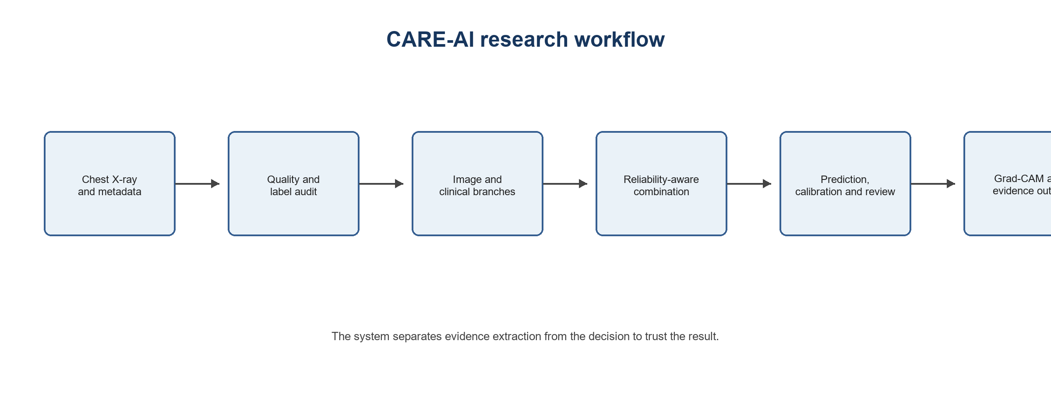
Figure 1.1 CARE-AI problem-to-decision workflow

CHAPTER 2

LITERATURE SURVEY

2.1 CHEST X-RAY DATASETS AND REPORT-DERIVED LABELS
Wang et al. introduced ChestX-ray8 as a large-scale weakly labelled benchmark for thoracic disease classification and localization [3]. Rajpurkar et al. demonstrated that a DenseNet-based model could detect pneumonia from chest radiographs and established the CheXNet line of work [4]. CheXpert explicitly recorded uncertainty labels and compared model predictions with expert annotations, showing that report-derived labels should not be treated as perfect binary truth [6].
MIMIC-CXR provides chest radiographs and associated reports collected in a hospital setting [7]. MIMIC-CXR-JPG provides a convenient JPG representation together with structured labels, metadata and image paths [8]. The dataset is particularly suitable for this project because it supports a patient- and study-aware directory structure and includes multiple findings per examination. It also makes it possible to study the difference between image evidence and acquisition context without placing radiological findings into the clinical feature branch.

2.2 CNN BACKBONES AND TRANSFER LEARNING
DenseNet connects each layer to later layers, encouraging feature reuse and improving gradient flow [1]. Its use in CheXNet made DenseNet-121 a strong reference model for chest radiography [4]. EfficientNet scales network depth, width and input resolution in a coordinated way [21], while ConvNeXt modernizes a pure convolutional design using several ideas associated with transformer-era vision models [2]. A controlled comparison is useful because a change in backbone can be assessed under the same split, preprocessing and metrics rather than being compared with results from unrelated studies.

2.3 GENERALIZATION, HIDDEN STRATIFICATION AND BIAS
Zech et al. showed that pneumonia detection performance can vary across hospitals even when the stated task appears similar [10]. Oakden-Rayner et al. described hidden stratification, where a broad label contains clinically meaningful subgroups that are not visible in the headline metric [12]. Seyyed-Kalantari et al. reported underdiagnosis bias in chest radiograph algorithms for underserved patient groups [13]. These findings support a project design that examines acquisition position, rare labels, calibration and errors instead of reporting only aggregate accuracy.
Shortcut learning is another concern. A model can use hospital markers, view position, text annotations or device patterns as an indirect signal. Geirhos et al. described the broader problem of shortcut learning in deep networks [22]. In CARE-AI, report findings and impressions are excluded from the structured branch, and the readiness audit flags sparse labels and generalization gaps. This does not prove that all shortcuts have been removed, but it makes the risk visible and testable.

2.4 UNCERTAINTY AND PROBABILITY CALIBRATION
Deep ensembles and Monte Carlo dropout are established approaches for representing predictive uncertainty [23, 24]. In practical clinical systems, calibration is also important: a probability of 0.8 should have a meaningful relationship with observed frequency. Guo et al. showed that modern neural networks can be poorly calibrated and that temperature scaling can improve probability quality [9]. Ovadia et al. examined uncertainty under distribution shift and showed that uncertainty methods should be assessed beyond a single in-distribution test set [25]. CARE-AI therefore reports Brier score, expected calibration error and a review state, in addition to AUROC and F1-score.

2.5 EXPLAINABILITY AND MULTIMODAL LEARNING
Grad-CAM produces a coarse spatial map of regions that influence a convolutional prediction [11]. It is useful for review, but it should not be interpreted as proof that the model reasoned medically correctly. GLoRIA connects image regions with report words for label-efficient multimodal representation learning [14], while MedCLIP uses contrastive learning between unpaired medical images and text [17]. Self-supervised medical-image pretraining has also been shown to improve representation learning when labelled data are limited [15, 16]. These approaches motivate future extensions, while the current project prioritizes a transparent and locally reproducible supervised pipeline.

2.6 LITERATURE SURVEY TABLE
Reference | Theme | Main idea | Relevance to CARE-AI
[1] Huang et al. 2017 | DenseNet | Dense connectivity and feature reuse | DenseNet-121 baseline
[2] Liu et al. 2022 | ConvNeXt | Modern pure CNN design | Backbone comparison
[3] Wang et al. 2017 | ChestX-ray8 | Weakly supervised multi-label data | Label and task framing
[4] Rajpurkar et al. 2017 | CheXNet | Pneumonia detection with DenseNet | Medical-imaging baseline
[5] Rajpurkar et al. 2018 | CheXNeXt | Multi-pathology chest radiograph study | Multi-label context
[6] Irvin et al. 2019 | CheXpert | Explicit uncertainty labels | Unknown-label handling
[7] Johnson et al. 2019 | MIMIC-CXR | Hospital chest radiograph reports | Dataset foundation
[8] Johnson et al. 2019 | MIMIC-CXR-JPG | JPG images and structured labels | Current dataset
[9] Guo et al. 2017 | Calibration | Neural probability calibration | ECE and temperature scaling
[10] Zech et al. 2018 | Generalization | Cross-hospital performance shift | External validation need
[11] Selvaraju et al. 2017 | Grad-CAM | Visual explanation maps | Image explanation
[12] Oakden-Rayner et al. 2020 | Hidden stratification | Subgroup failures | Error audit
[13] Seyyed-Kalantari et al. 2021 | Bias | Underdiagnosis across groups | Fairness caution
[14] Huang et al. 2021 | GLoRIA | Global-local image-text learning | Multimodal direction
[15] Azizi et al. 2021 | Self-supervision | Large self-supervised medical models | Small-label strategy
[16] Tiu et al. 2022 | Self-supervised CXR | Learning from unannotated images | Label efficiency
[17] Wang et al. 2022 | MedCLIP | Unpaired image-text contrastive learning | Future multimodal branch
[18] Xiao et al. 2023 | Masked autoencoders | Thorax disease representation | Future pretraining
[19] Lotter et al. 2024 | Acquisition bias | Technical parameters and bias | View-stratified analysis
[20] Ma et al. 2025 | Foundation model | Open chest-radiography foundation model | Future transfer learning

Table 2.1 Literature survey and relevance

2.7 RESEARCH GAP AND STUDY POSITION
The literature demonstrates strong image classifiers, but a project intended for a doctor-facing workflow needs more than an image score. It must establish how labels are joined, prevent patient overlap, quantify uncertainty, explain the image evidence and provide an explicit path for human review. Many results also depend on large datasets or foundation models that are difficult to reproduce in a resource-constrained project. CARE-AI positions itself as a transparent evaluation framework: it compares accessible models on the same local cohort, measures reliability and computation, and refuses to describe the current checkpoint as clinically deployable when the readiness audit detects a generalization problem.

CHAPTER 3

DATASETS REQUIREMENTS AND SYSTEM ANALYSIS

3.1 DATASET OVERVIEW
The project uses MIMIC-CXR-JPG version 2.1.0, a credentialed PhysioNet resource derived from the MIMIC-CXR collection. The images are stored in a hierarchy based on subject, study and image identifiers. The local implementation uses JPG files and the supplied CSV or compressed CSV files. The label table provides CheXpert-style findings for fourteen labels, including positive, negative, uncertain and missing values. MIMIC-CXR is a protected health-data resource; the project follows the applicable data-use agreement and keeps the data local.
The current evaluation snapshot is intentionally treated as a local subset rather than the complete 570 GB-scale resource. The comparative study discovered 1,295 images, matched 1,271 images to usable labels, and identified 739 patient groups. These values describe the experiment used to produce the reported comparison outputs and should be updated if a complete or larger download is later used.

3.2 DATASET FILES AND ROLES
File or source | Role in the system | Leakage or quality handling
IMAGE_FILENAMES | Image path inventory and download reference | Used to locate image files; not a model feature
mimic-cxr-2.0.0-metadata.csv.gz | Study and acquisition metadata | Used for structured branch and quality audit
mimic-cxr-2.0.0-chexpert.csv.gz | Fourteen report-derived labels | Uncertain and missing values treated as unknown
mimic-cxr-2.0.0-split.csv.gz | Official split reference | Patient/study-aware split is preserved where available
mimic-cxr-2.0.0-negbio.csv.gz | Additional negative label information | Used only after explicit join validation
mimic-cxr-reports.zip | Radiology reports for future research | Not passed into the current structured predictor
Local JPG directory | Image input to model and API | Unreadable or missing images are excluded from training

Table 3.1 Dataset files and roles

3.3 LABEL POLICY
For each label, values below zero are interpreted as uncertain and stored as unknown. Blank values are also unknown. A known value at or above 0.5 is treated as positive and a known value below 0.5 as negative for the baseline evaluation. Metrics are computed only over known labels for the specific finding. This policy avoids converting uncertainty into a definite negative, but it does not remove the label noise inherent in report-derived supervision.

3.4 DATA SPLITTING AND LEAKAGE CONTROL
The comparative study uses a patient-level split with seed 17: 814 training images, 216 validation images and 241 test images. Patient identifiers are used as grouping keys so that the same patient does not contribute images to different partitions. Model selection, threshold selection and calibration are restricted to the validation split. The test partition is used only for final held-out reporting. A separate end-to-end checkpoint audit used a slightly different local snapshot after the image download expanded; those metrics are reported separately and are not treated as a direct comparison with the candidate table.

3.5 FUNCTIONAL REQUIREMENTS
ID | Requirement | Acceptance evidence
FR1 | Load local MIMIC JPG images and metadata | Dataset index, image root and CSV discovery endpoints
FR2 | Analyze an uploaded or selected image | POST /api/analyze returns structured output
FR3 | Predict multiple radiographic findings | Fourteen label probabilities and thresholds
FR4 | Measure input reliability | Image quality and clinical completeness scores
FR5 | Show uncertainty and review status | Confidence, warnings and abstention/review message
FR6 | Explain image evidence | Grad-CAM heatmap grid and evidence cards
FR7 | Expose evaluation results | Metrics, comparison tables and charts
FR8 | Keep protected data local | No upload of MIMIC data to third-party services

Table 3.2 Functional requirements

3.6 NON-FUNCTIONAL REQUIREMENTS AND SAFEGUARDS
Area | Requirement | Implementation choice
Reproducibility | Repeat training and evaluation | Fixed seeds, saved metrics, thresholds and comparison JSON
Reliability | Avoid unjustified certainty | Calibration metrics, quality gates and review-only status
Privacy | Keep credentialed data local | Local FastAPI process and local output storage
Usability | Make output understandable | Doctor-facing dashboard, charts and plain-language evidence
Performance | Use practical local resources | Transfer learning and structured candidate comparison
Maintainability | Separate concerns | Data, models, inference, API and frontend modules

Table 3.3 Non-functional requirements and safeguards

3.7 SYSTEM ANALYSIS
The project is technically feasible because image inference, structured metadata processing and the browser interface can run locally. The main constraint is not software availability but data scale and label support. The complete MIMIC-CXR-JPG image collection is too large for a rapid local experiment, so the current results should be interpreted as a subset study. The analysis also shows why a clinical branch based only on acquisition metadata should not be forced into the final probability: its AUROC is close to chance and may add noise rather than useful evidence.

3.8 ETHICAL AND RESPONSIBLE USE
The output is intended for research and education. It must not be used to diagnose a patient, make a treatment decision, or override a qualified clinician. A future clinical study would require external validation, subgroup analysis, prospective workflow evaluation, calibration under the target institution, security review and appropriate regulatory oversight. The current application therefore reports a research-only readiness state whenever the evidence is insufficient.

CHAPTER 4

PROPOSED SYSTEM DESIGN

4.1 DESIGN PRINCIPLE
CARE-AI separates evidence extraction from the decision to trust the evidence. The image branch estimates radiographic findings, while the structured branch estimates what can be learned from acquisition context. Before fusion, the system calculates image quality and metadata completeness. These scores make it possible to reduce the influence of a weak modality and to explain why a case has been referred for review.
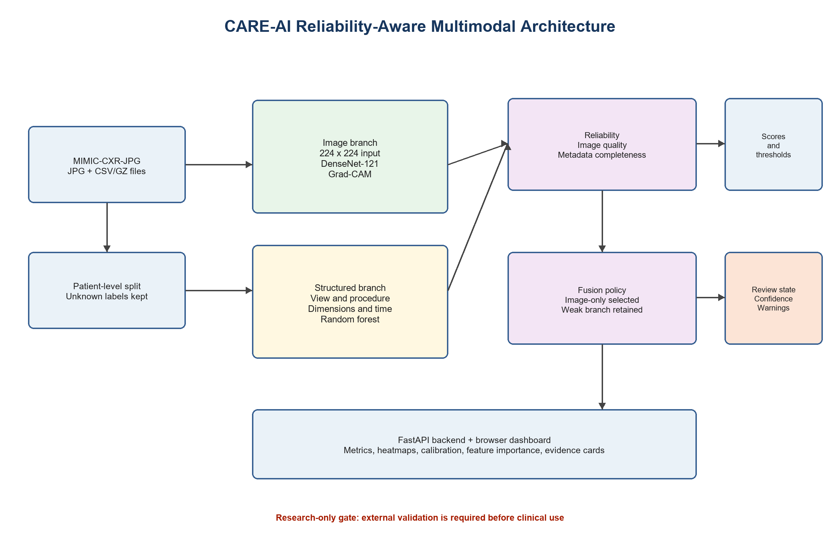
Figure 4.1 Overall CARE-AI architecture

4.2 DATA AND PREPROCESSING LAYER
The data index recursively locates JPG and JPEG files, extracts subject and study identifiers from the directory path, and joins them with the richest available metadata and label row. Images are decoded, converted to RGB for the pretrained backbone, resized to 224 by 224 pixels and normalized using ImageNet-compatible statistics for the transfer-learning path. The system also computes grayscale contrast, edge-based sharpness, dimensions and an image-quality score. Corrupt files are rejected from training and reported as data-quality problems.

4.3 IMAGE BRANCH
The image branch supports DenseNet-121, EfficientNet-B0 and ConvNeXt-Tiny candidates. The comparative experiment first evaluates frozen ImageNet feature extractors with per-label heads and then includes the available fine-tuned DenseNet-121 checkpoint. The deployed research path loads densenet121.pt when it exists and uses saved thresholds. DenseNet was selected for the current local implementation because it provides a strong performance-to-compute balance and supports real Grad-CAM extraction in the inference code.

4.4 STRUCTURED CLINICAL BRANCH
The current structured branch uses acquisition metadata rather than radiology findings. Numeric features include image rows, columns, study hour and metadata completeness. Categorical features include view position, procedure description, procedure code, view code and patient orientation. A preprocessing pipeline imputes numeric values, adds missingness indicators, scales numeric values, imputes categorical values and one-hot encodes categories. The branch compares elastic-net logistic regression, random forest and histogram gradient boosting.

4.5 RELIABILITY ESTIMATION
Image reliability is derived from input-quality signals such as contrast, sharpness, size and basic image statistics. Clinical reliability is derived from metadata completeness and the availability of the expected structured fields. A quality score is not a probability of health; it is a measure of how suitable the available input is for the model. This distinction is important because a sharp image can still contain disease and a complete metadata row can still be clinically uninformative.

4.6 RELIABILITY-AWARE FUSION AND REVIEW
The fusion study evaluates image-only, clinical-only, simple-average and reliability-aware fusion policies. In a general fusion policy, a modality receives a larger weight when its evidence and input quality are stronger. The current comparison selected image-only because the acquisition-metadata branch was close to chance and the simple combination reduced held-out discrimination. The clinical branch remains available for audit and display, but it is not allowed to degrade the selected image probability. A low-confidence or poor-quality result is marked for review instead of being presented as an unquestioned prediction.

4.7 PREDICTION, CALIBRATION AND EXPLAINABILITY
Each label has a validation-selected threshold rather than a universal 0.5 threshold. The API returns probability, threshold, predicted state, confidence, quality indicators, warning messages and review state. Grad-CAM is calculated from the active DenseNet target layer and returned as a compact grid that the frontend overlays as a heat spot. Evidence cards link the explanation to relevant methodological sources such as MIMIC-CXR, DenseNet, calibration and hidden-stratification research. A live retrieval-augmented literature system is not claimed as part of the current implementation; it is a future extension.

4.8 APPLICATION ARCHITECTURE
Layer | Technology | Responsibility
Data | Local JPG and CSV/GZ files | Index images, join identifiers, expose labels and metadata
Model | PyTorch, torchvision, scikit-learn | Train candidates, save checkpoints, thresholds and metrics
Inference | Python modules | Quality scoring, image prediction, structured prediction, Grad-CAM
API | FastAPI and Uvicorn | Health, statistics, cases, analysis, metrics and comparison endpoints
Frontend | HTML, CSS and JavaScript | Upload, dashboard, explanations, charts and review status
Outputs | JSON, PNG, JOBLIB and PT | Reproducible evidence for the report and app

Table 4.1 System interfaces

4.9 END-TO-END ALGORITHM
- Read an uploaded image or select a local indexed image.
- Decode the image and compute contrast, sharpness, dimensions and quality score.
- Join available metadata and labels using image, study and subject identifiers.
- Run the selected image model and the retained structured-data model.
- Calculate modality reliability and decide whether the evidence is sufficient.
- Apply validation-selected thresholds and calibration information.
- Generate Grad-CAM, evidence cards, warnings and a review recommendation.
- Return the decision-support response to the frontend without claiming a diagnosis.

CHAPTER 5

IMPLEMENTATION

5.1 DEVELOPMENT ENVIRONMENT
The project is implemented in Python with FastAPI for the backend and a no-build browser frontend. PyTorch and torchvision provide image-model training and inference. Scikit-learn provides structured-data pipelines and evaluation utilities. Pillow handles image decoding and quality statistics. Joblib stores the selected structured model. The project is configured to read the MIMIC image root and clinical-data root from environment variables so that protected data do not need to be copied into the source tree.

5.2 PREPROCESSING AND TRAINING CONFIGURATION
Component | Configuration | Reason
Image size | 224 x 224 RGB | Matches transfer-learning backbones and reduces local compute
Image normalization | ImageNet mean and standard deviation | Compatible with pretrained weights
Label policy | -1 and blank treated as unknown | Avoids false negative supervision
Split | Patient-level 814 / 216 / 241 | Reduces patient leakage
Threshold | Validation-selected per label | Separates ranking from operating point
Image candidates | DenseNet-121, EfficientNet-B0, ConvNeXt-Tiny | Compare quality and compute
Clinical candidates | Elastic net, random forest, histogram gradient boosting | Compare linear and nonlinear structured models
Metrics | AUROC, AUPRC, F1, balanced accuracy, Brier, ECE | Cover discrimination and reliability

Table 5.1 Preprocessing and training configuration

5.3 IMAGE MODEL TRAINING
The image comparison uses pretrained networks as feature extractors and trains per-label prediction heads. The separate end-to-end DenseNet path fine-tunes the final dense block and classifier. The saved checkpoint is loaded automatically by the API when available. Metrics are written to densenet_metrics.json and thresholds are written to densenet_thresholds.json. The implementation also contains a regularized training path with conservative augmentation, clipped class weighting, label smoothing, gradient clipping and validation-loss early stopping. That candidate was not deployed because the attempted run stopped before producing a complete checkpoint.

5.4 CLINICAL MODEL TRAINING
The structured branch creates a separate scikit-learn pipeline for each finding. Numeric values are imputed and standardized, categorical values are imputed and one-hot encoded, and the classifier is fit only on the training partition for each label. The random forest was retained as the selected clinical candidate for the comparative study, but the branch has weak held-out discrimination on this limited metadata-only feature set. The system therefore preserves the clinical result for transparency without allowing it to reduce the selected image probability.

5.5 COMPARATIVE STUDY AND OUTPUT GENERATION
The comparative study saves a machine-readable JSON record that contains dataset counts, splits, model candidates, metrics, thresholds, per-label results and the selected configuration. It also generates figures for model comparison, per-label AUROC, confusion matrices, calibration, clinical feature importance, performance versus compute, cohort composition, label distribution and training curves. These outputs are mounted by the API under the /artifacts path so that the dashboard and the report use the same evidence.

5.6 BACKEND API
Endpoint | Purpose | Output
GET /api/health | Check service, model and data roots | Health and discovery status
GET /api/stats | Summarize local data | Image, clinical row and label counts
GET /api/metrics | Return active model metrics | Training metrics and readiness audit
GET /api/comparison | Return model comparison | Candidates, selection and per-label study
GET /api/cases | Browse indexed cases | Paginated cases and labels
POST /api/analyze | Analyze image and optional clinical JSON | Probabilities, warnings, Grad-CAM and evidence

Table 5.2 Backend API endpoints

5.7 FRONTEND AND DOCTOR-FACING WORKFLOW
The browser interface provides an image upload flow, optional clinical-data input, a selected-case browser, prediction cards, confidence and data-quality indicators, Grad-CAM visualization, evidence cards, metrics and research-comparison charts. The interface uses plain language and displays a review message when the input is incomplete, the model is uncertain or the readiness audit indicates that deployment claims are not justified. This design keeps the output useful for demonstration while avoiding an appearance of autonomous diagnosis.

5.8 REPRODUCIBILITY AND RUN PROCEDURE
- Configure MIMIC_IMAGE_ROOT and MIMIC_DATA_ROOT to point to the local data locations.
- Install the packages listed in backend/requirements.txt.
- Run comparative_study.py to create model candidates and charts.
- Run model_readiness.py to create the conservative readiness audit.
- Run deep_train.py only when the intended training subset and device are available.
- Start backend/app.py and open the local browser address.
- Record the output timestamps, data snapshot and configuration with each experiment.

CHAPTER 6

EXPERIMENTAL EVALUATION AND RESULTS

6.1 EVALUATION PROTOCOL
The primary comparison uses a patient-level split and evaluates known labels only. AUROC and AUPRC measure ranking quality across thresholds. Precision, sensitivity, specificity, F1-score and balanced accuracy are calculated at validation-selected thresholds. Brier score and ECE measure probability quality. Model size and training time are reported to show the trade-off between predictive performance and local computation. The test partition is not used to select the model or threshold.

6.2 COMPARATIVE CANDIDATE RESULTS
Model | AUROC | AUPRC | F1 | Balanced Acc. | Brier | ECE | Params M
DenseNet-121 frozen | 0.967 | 0.960 | 0.921 | 0.890 | 0.047 | 0.065 | 7.994
EfficientNet-B0 frozen | 0.927 | 0.933 | 0.890 | 0.848 | 0.067 | 0.085 | 5.308
ConvNeXt-Tiny frozen | 0.921 | 0.924 | 0.893 | 0.853 | 0.075 | 0.089 | 28.601
DenseNet-121 fine-tuned | 0.944 | 0.963 | 0.926 | 0.807 | 0.069 | 0.113 | 6.968
Elastic-net logistic | 0.486 | 0.670 | 0.701 | 0.570 | 0.248 | 0.266 | 0.029
Random forest | 0.517 | 0.676 | 0.764 | 0.577 | 0.202 | 0.217 | 2.882
Histogram gradient boosting | 0.514 | 0.665 | 0.723 | 0.576 | 0.144 | 0.076 | 0.676
Reliability-aware fusion | 0.879 | 0.926 | 0.869 | 0.677 | 0.082 | 0.112 | -

Table 6.1 Comparative model results on the local patient-level evaluation snapshot
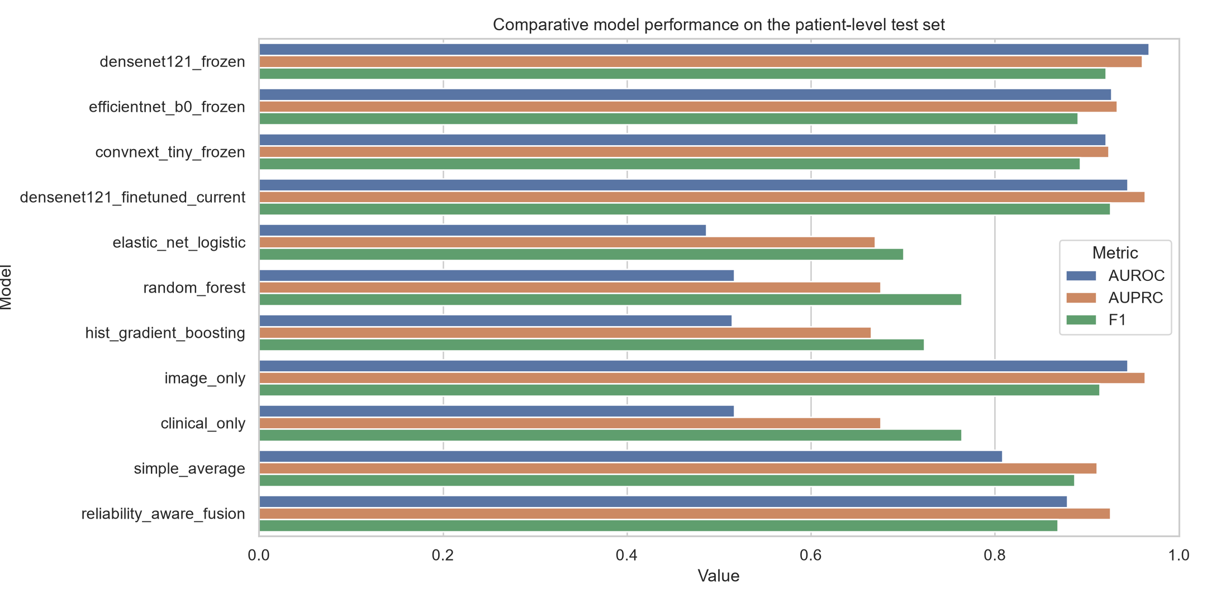
Figure 6.1 Candidate model comparison

6.3 SELECTED CONFIGURATION
The comparison selected densenet121_finetuned_current as the image candidate, random_forest as the structured candidate and image_only as the active fusion policy. The selection reflects the full evidence set rather than accuracy alone. DenseNet provides strong ranking performance with fewer parameters than ConvNeXt-Tiny, while the structured branch is not strong enough to improve the image probability on the held-out subset. The clinical branch is retained because displaying a weak secondary signal is more transparent than silently discarding the available metadata.

6.4 PER-LABEL ANALYSIS
Per-label results must be interpreted carefully. Some labels have only a few positive or negative test cases. For example, Fracture has zero positive test cases in the readiness audit, while Lung Lesion and Pleural Other have only three positive cases each. A high or low score for such labels is not stable evidence of clinical ability. The heatmap is therefore used as an exploratory diagnostic of the local split rather than as a claim that every pathology has been learned equally well.
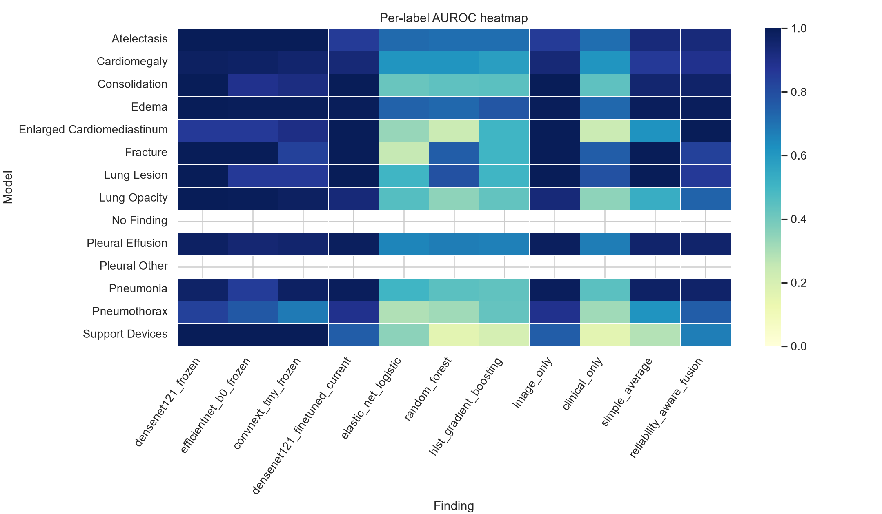
Figure 6.2 Per-label AUROC heatmap
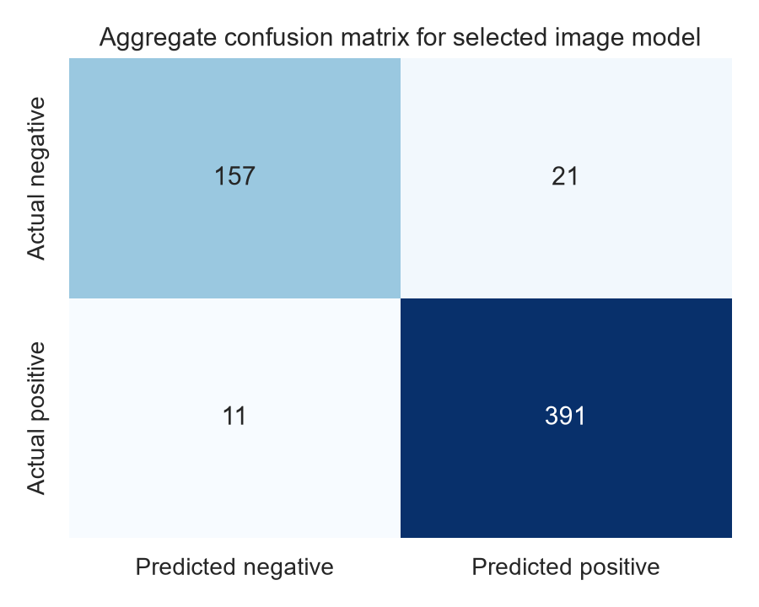
Figure 6.3 Selected model confusion heatmap

6.5 END-TO-END DENSENET CHECKPOINT AUDIT
The complete fine-tuned checkpoint was also evaluated through the end-to-end inference path. Because the local download grew between experiments, this audit used 1,265 label-matched images and a different patient-level split of 789 training, 239 validation and 237 test images. It is reported separately rather than mixed into Table 6.1. The test macro averages were accuracy 0.8413, precision 0.7599, sensitivity 0.8026, specificity 0.5321, F1-score 0.7770, balanced accuracy 0.7067, AUROC 0.8471, AUPRC 0.8765, Brier score 0.1487 and ECE 0.1843.
Metric | Validation | Test | Interpretation
AUROC | 0.9502 | 0.8471 | Ranking gap suggests generalization risk
AUPRC | 0.9648 | 0.8765 | Important under label imbalance
F1-score | 0.9155 | 0.7770 | Operating-point performance decreases
Balanced accuracy | 0.8748 | 0.7067 | Sensitivity/specificity balance is weaker
Brier score | 0.0895 | 0.1487 | Probability error is higher on test
ECE | 0.1211 | 0.1843 | Test probabilities are less calibrated

Table 6.2 End-to-end DenseNet checkpoint audit
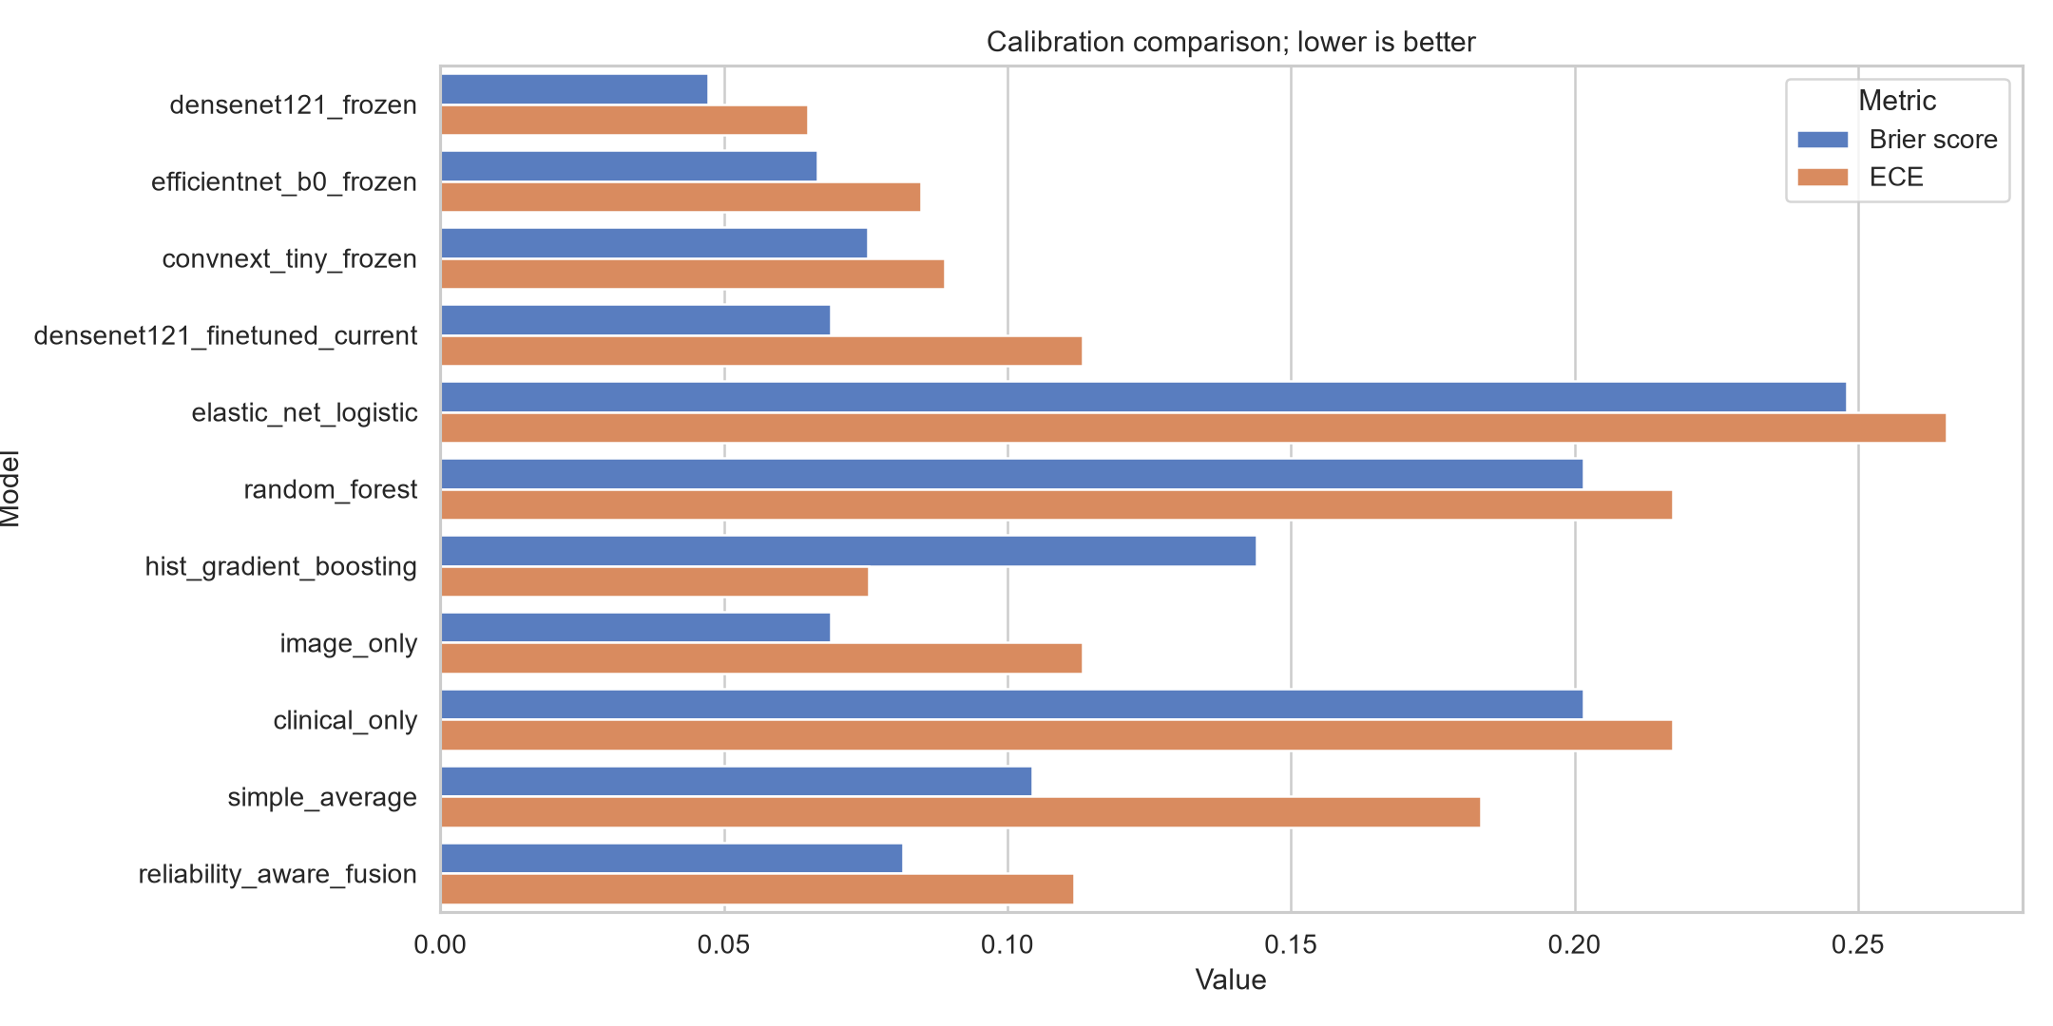
Figure 6.4 Calibration comparison

6.6 CLINICAL BRANCH AND FEATURE IMPORTANCE
The clinical branch uses image acquisition metadata rather than disease findings. Its held-out AUROC is close to chance for all three candidate algorithms. This result is informative: acquisition context alone does not provide a safe replacement for image evidence in this local subset. Feature-importance plots are useful for auditing what the model uses, but they should not be read as causal clinical relationships. In particular, view position and procedure description may reflect workflow or patient-selection patterns rather than pathology.
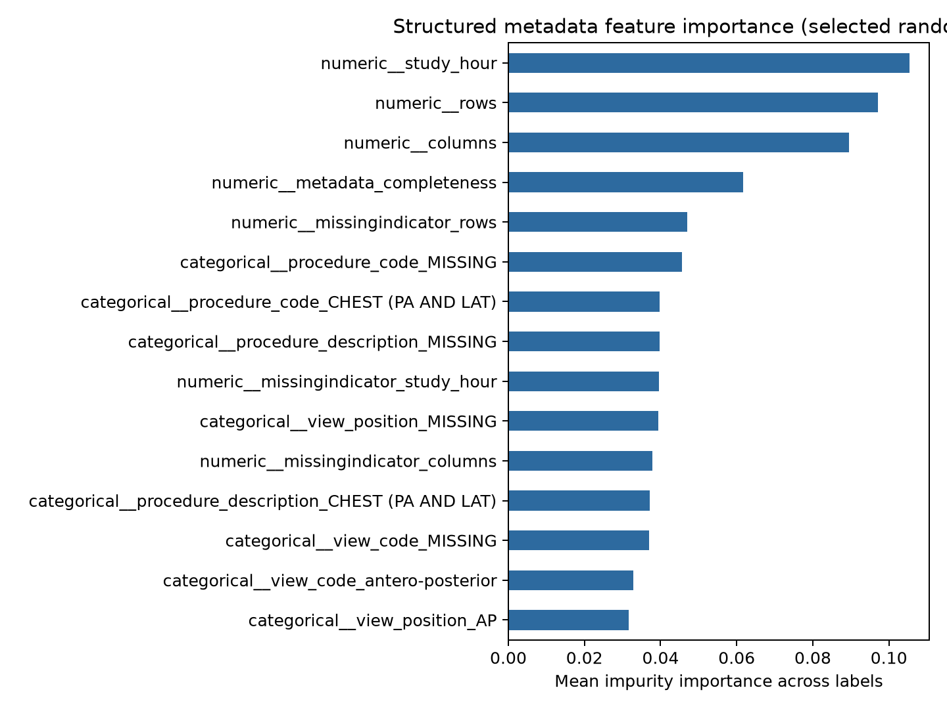
Figure 6.5 Clinical feature importance
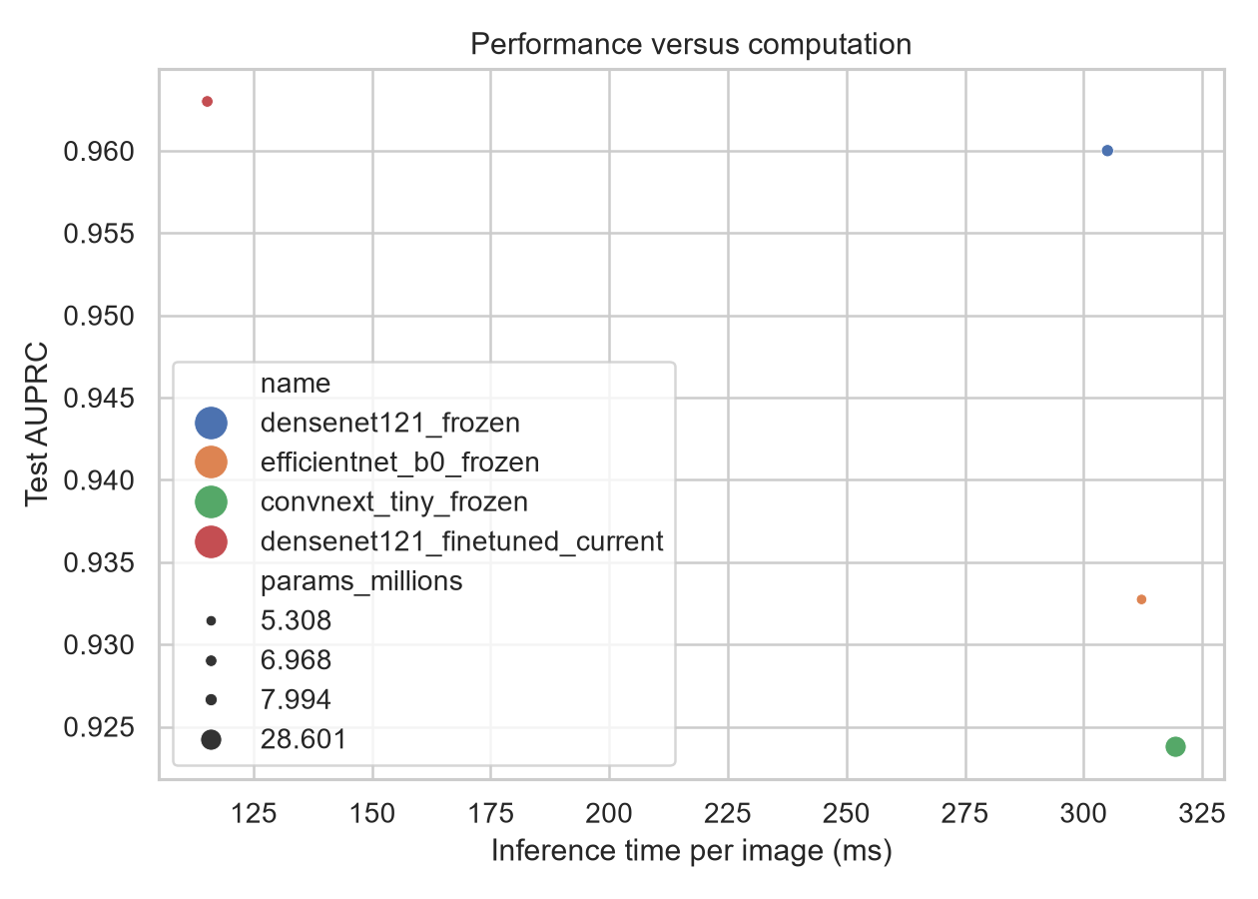
Figure 6.6 Performance versus compute

6.7 DATA BALANCE AND COHORT COMPOSITION
The cohort is not balanced across findings. No Finding, Pleural Effusion, Atelectasis, Lung Opacity and Support Devices have much larger positive counts than rare findings such as Pleural Other, Lung Lesion, Fracture and Pneumothorax. A model can obtain a deceptively high accuracy by following the dominant class. This is why AUPRC, balanced accuracy, specificity and per-label support are included in the analysis.
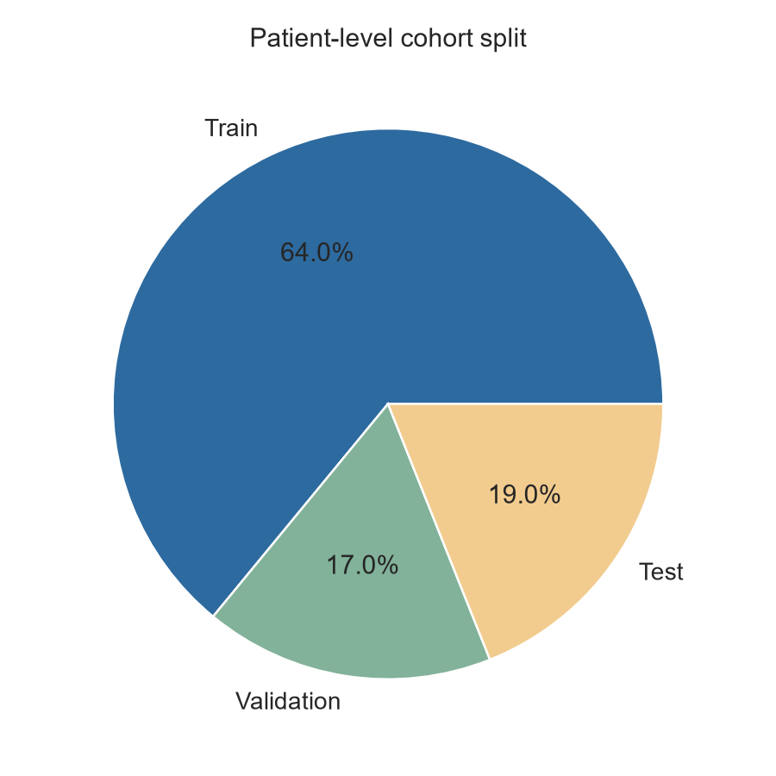
Figure 6.7 Patient-level cohort split
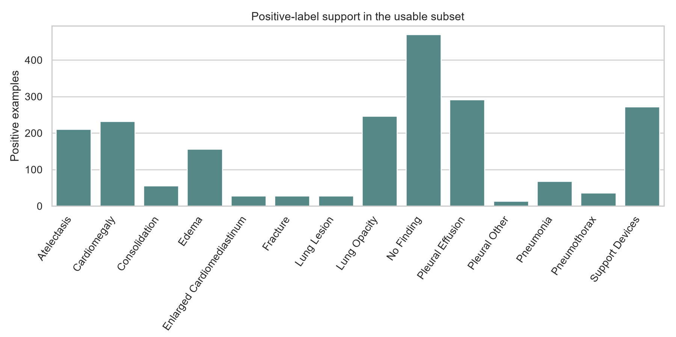
Figure 6.8 Label distribution

6.8 OVERFITTING AND READINESS AUDIT
The readiness audit marks the current model as research_only_review_required and deployment_allowed false. The validation-to-test gaps are 0.0883 for AUPRC, 0.1030 for AUROC, 0.1384 for F1-score and 0.1681 for balanced accuracy. Test calibration error is materially worse than validation calibration error. These values are consistent with overfitting, split sensitivity, label sparsity, or a combination of the three. They should not be hidden by reporting only the stronger validation result.
Audit item | Current finding | Action before clinical claim
Generalization | Validation metrics exceed test metrics | Repeat patient-level cross-validation and use external test data
Calibration | ECE is worse on test | Re-fit calibration on a separate validation set and re-check shift
Rare labels | Several labels have fewer than 20 positives or negatives | Collect more examples or report label as exploratory only
Regularized candidate | Training stopped before a complete checkpoint was produced | Retrain successfully before comparing it
Deployment | Readiness gate is closed | Do not use for autonomous clinical decisions

Table 6.3 Readiness and bias audit
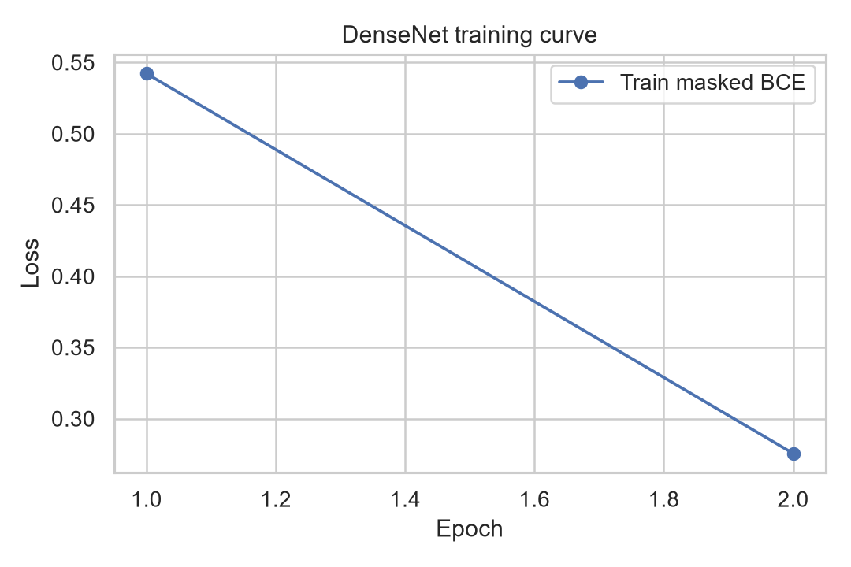
Figure 6.9 Training curve

6.9 ERROR ANALYSIS AND INTERPRETATION
The results suggest that the image branch carries most of the available signal in the current subset. Errors are likely to be affected by view position, image quality, overlapping findings and label uncertainty. The model can also be influenced by shortcuts such as portable AP acquisition or support devices. Grad-CAM is therefore used as a review aid, not as proof of correctness. The user interface exposes the model state, quality information and evidence together so that a reviewer can decide whether to trust the output for further investigation.

6.10 DISCUSSION
The study demonstrates a complete and measurable research pipeline, but it does not demonstrate clinical readiness. The comparative experiment is useful for choosing a practical image candidate and for documenting why metadata-only fusion was not selected. The end-to-end audit is useful for exposing the gap between a strong validation result and a weaker held-out result. Together, the findings support a cautious conclusion: quality gating, threshold selection and transparent reporting add value to the engineering of the system, but they cannot substitute for more data, external validation and clinical review.

CHAPTER 7

CONCLUSION AND FUTURE WORK

7.1 CONCLUSION
This project developed CARE-AI, a reliability-aware multimodal clinical decision-support prototype for chest X-ray analysis. The system reads MIMIC-CXR-JPG images and associated structured files, handles uncertain labels, preserves patient-level evaluation, compares multiple image and clinical models, estimates input quality, exposes calibrated probabilities, produces Grad-CAM explanations and displays a human-review state through a local web application.
The current experiments show that DenseNet-121 is a practical image model for the available local subset and that acquisition metadata alone is not strong enough to replace image evidence. The project also demonstrates why a responsible report must include calibration, computation, per-label support and generalization gaps. The current readiness gate correctly prevents the system from being described as clinically deployable. This is a limitation of the evidence, not a failure of the software pipeline.

7.2 LIMITATIONS
- The current evaluation uses a small local subset of the full MIMIC-CXR-JPG resource.
- The labels are report-derived and contain uncertainty, missing values and possible extraction noise.
- Several labels have too few positive or negative test examples for stable conclusions.
- The structured branch contains acquisition metadata rather than a clinically rich longitudinal record.
- The fine-tuned DenseNet checkpoint shows a validation-to-test generalization gap.
- The regularized anti-overfitting candidate was not successfully completed and is not integrated.
- Grad-CAM is a coarse post-hoc explanation and does not prove clinical reasoning.
- The evidence cards are curated references; a live RAG system and source-grounded clinical answer generation are future work.

7.3 FUTURE WORK
- Complete the MIMIC-CXR-JPG download or define a reproducible larger cohort and rerun every experiment from the same snapshot.
- Retrain the regularized image candidate successfully with frozen backbones, conservative augmentation, label smoothing and early stopping.
- Use repeated patient-level cross-validation and confidence intervals rather than one split alone.
- Use an untouched external dataset or temporal holdout to assess institutional shift.
- Improve the clinical branch with appropriately authorized and clinically meaningful variables, while preserving strict leakage controls.
- Add subgroup, view-position and image-quality stratification with enough support for stable conclusions.
- Evaluate ensemble uncertainty, conformal prediction or selective-risk guarantees.
- Add a real source-retrieval layer that cites approved medical evidence without generating unsupported recommendations.
- Conduct usability testing with clinicians and define the exact review workflow before any prospective deployment.

7.4 FINAL SAFETY POSITION
CARE-AI should currently be used for academic demonstration, engineering evaluation and research analysis. It should not be used as a standalone diagnostic system, and its output should never replace a qualified clinician. The application makes this boundary explicit by displaying research-only status when the readiness audit detects generalization risk or inadequate label support.

REFERENCES
[1] Huang, G., Liu, Z., van der Maaten, L., and Weinberger, K. Q. Densely Connected Convolutional Networks. Proceedings of CVPR, 2017.
[2] Liu, Z., Mao, H., Wu, C.-Y., Feichtenhofer, C., Darrell, T., and Xie, S. A ConvNet for the 2020s. Proceedings of CVPR, 2022.
[3] Wang, X., et al. ChestX-ray8: Hospital-scale Chest X-ray Database and Benchmarks on Weakly-supervised Classification and Localization of Common Thorax Diseases. Proceedings of CVPR, 2017.
[4] Rajpurkar, P., et al. CheXNet: Radiologist-Level Pneumonia Detection on Chest X-Rays with Deep Learning. arXiv:1711.05225, 2017.
[5] Rajpurkar, P., et al. Deep learning for chest radiograph diagnosis: A retrospective comparison of the CheXNeXt algorithm to practicing radiologists. PLOS Medicine, 15(11), e1002686, 2018.
[6] Irvin, J., et al. CheXpert: A Large Chest Radiograph Dataset with Uncertainty Labels and Expert Comparison. Proceedings of AAAI, 2019.
[7] Johnson, A. E. W., et al. MIMIC-CXR Database v2.0.0. PhysioNet, 2019.
[8] Johnson, A. E. W., et al. MIMIC-CXR-JPG, a large publicly available database of labeled chest radiographs. PhysioNet, version 2.1.0, 2019.
[9] Guo, C., Pleiss, G., Sun, Y., and Weinberger, K. Q. On Calibration of Modern Neural Networks. Proceedings of ICML, 2017.
[10] Zech, J. R., et al. Variable generalization performance of a deep learning model to detect pneumonia in chest radiographs: A cross-sectional study. PLOS Medicine, 15(11), e1002683, 2018.
[11] Selvaraju, R. R., et al. Grad-CAM: Visual Explanations from Deep Networks via Gradient-based Localization. Proceedings of ICCV, 2017.
[12] Oakden-Rayner, L., Dunnmon, J., Carneiro, G., and Ré, C. Hidden Stratification Causes Clinically Meaningful Failures in Machine Learning for Medical Imaging. Proceedings of CHIL, 2020.
[13] Seyyed-Kalantari, L., et al. Underdiagnosis bias of artificial intelligence algorithms applied to chest radiographs in under-served patient populations. Nature Medicine, 27, 2176-2182, 2021.
[14] Huang, S.-C., et al. GLoRIA: A Multimodal Global-Local Representation Learning Framework for Label-Efficient Medical Image Recognition. Proceedings of ICCV, 2021.
[15] Azizi, S., et al. Big Self-Supervised Models Advance Medical Image Classification. Proceedings of ICCV, 2021.
[16] Tiu, E., et al. Expert-level detection of pathologies from unannotated chest X-ray images via self-supervised learning. Nature Biomedical Engineering, 2022.
[17] Wang, Z., Wu, Z., Agarwal, D., and Sun, J. MedCLIP: Contrastive Learning from Unpaired Medical Images and Text. Proceedings of EMNLP, 2022.
[18] Xiao, J., et al. Delving Into Masked Autoencoders for Multi-Label Thorax Disease Classification. Proceedings of WACV, 2023.
[19] Lotter, W., et al. Acquisition parameters influence AI recognition of race in chest x-rays and mitigating these factors reduces underdiagnosis bias. Nature Communications, 15, 7465, 2024.
[20] Ma, D., et al. A fully open AI foundation model applied to chest radiography. Nature, 643, 488-498, 2025.
[21] Tan, M., and Le, Q. V. EfficientNet: Rethinking Model Scaling for Convolutional Neural Networks. Proceedings of ICML, 2019.
[22] Geirhos, R., et al. Shortcut Learning in Deep Neural Networks. Nature Machine Intelligence, 2, 665-673, 2020.
[23] Lakshminarayanan, B., Pritzel, A., and Blundell, C. Simple and Scalable Predictive Uncertainty Estimation using Deep Ensembles. Proceedings of NeurIPS, 2017.
[24] Gal, Y., and Ghahramani, Z. Dropout as a Bayesian Approximation: Representing Model Uncertainty in Deep Learning. Proceedings of ICML, 2016.
[25] Ovadia, Y., et al. Can You Trust Your Model's Uncertainty? Evaluating Predictive Uncertainty under Dataset Shift. Proceedings of NeurIPS, 2019.

APPENDICES

APPENDIX A API RESPONSE FIELDS
Field | Meaning
predictions | Per-label probabilities, thresholds and predicted states
confidence | Decision confidence after thresholding and quality checks
review_required | Whether the case should be inspected by a human
image_quality | Contrast, sharpness, size and combined image-quality score
clinical_completeness | Completeness of optional structured context
grad_cam | Target label and coarse spatial importance grid when available
evidence | Curated methodological evidence cards
model_status | Research-only status, active checkpoint and readiness warnings

APPENDIX B OUTPUT FILE INVENTORY
Output file | Purpose
densenet121.pt | Existing fine-tuned DenseNet checkpoint used by the API
clinical_model.joblib | Saved structured-data candidate
comparative_results.json | Candidate metrics, split, thresholds and selection
densenet_metrics.json | End-to-end checkpoint metrics and per-label audit
model_readiness.json | Generalization and sparse-label readiness gate
comparison/*.png | Charts and plots used by the dashboard and report

APPENDIX C METRIC GLOSSARY
AUROC measures ranking across thresholds. AUPRC is particularly informative when positives are rare. Precision measures the proportion of predicted positives that are correct. Sensitivity measures how many known positives are detected. Specificity measures how many known negatives are rejected. F1-score combines precision and sensitivity. Balanced accuracy averages sensitivity and specificity. Brier score measures squared probability error. ECE compares confidence with observed frequency across probability bins. None of these metrics alone establishes clinical safety.

APPENDIX D REPRODUCTION CHECKLIST
- Confirm PhysioNet credentialed access and data-use agreement.
- Point MIMIC_IMAGE_ROOT to the local JPG directory and MIMIC_DATA_ROOT to the CSV directory.
- Record the number of images, matched labels and patient groups before training.
- Run the comparative study and save the generated JSON and PNG outputs.
- Run the readiness audit and preserve warnings in the report.
- Use a fresh patient-level test snapshot for any new model claim.
- Do not report a model as clinically validated without external and clinical evaluation.

APPENDIX E DATA DICTIONARY AND LABEL SEMANTICS
The model consumes three related kinds of information: image files, study-level metadata and report-derived target labels. Keeping these categories separate is important because a target label must never be allowed to re-enter the predictor as an input feature. The data dictionary below records the intended role of each field and the action taken when a value is absent.
Field or group | Type | Use | Missing-value policy
subject_id | Identifier | Patient-level grouping and leakage control | Required for split; rows without it are excluded
study_id | Identifier | Study-level traceability and grouping | Retained when available
dicom_id / image path | Identifier | Image lookup and audit trail | Required for inference
view position | Categorical | Optional clinical/context branch feature | Explicit unknown category
study date | Date/time | Temporal audit and future shift analysis | Retained as missing indicator
procedure description | Categorical text | Acquisition context only | Normalized and unknown encoded
CheXpert labels | Multi-label target | Training and evaluation targets | Unknown is masked, not negative
uncertainty labels | Multi-label state | Label-quality and sensitivity analysis | Stored separately from target
image dimensions | Numeric | Input validation and quality checks | Image rejected if unreadable
pixel statistics | Numeric | Quality estimation only | Computed at ingestion time

Table E.1 Data dictionary and handling policy
A positive target means that the label is supported by the selected label policy. An uncertain or missing target is not silently converted to a negative target. The training loader masks unavailable targets for the relevant label, and evaluation reports support counts so that a score with very few positive examples is not mistaken for a stable clinical result.

APPENDIX F DATA INGESTION AND DIRECTORY VALIDATION
The local data directory is treated as an auditable input rather than as an assumed collection of files. Before training, the ingestion routine scans the configured image root, normalizes path separators, identifies duplicate basenames, checks that each file can be opened and joins the image path to the study and patient identifiers present in the CSV metadata. A manifest is written before any model is trained.
- Read the configured image and CSV roots from environment variables or the run configuration.
- Enumerate JPG files recursively and normalize each relative path to a portable representation.
- Parse patient, study and image identifiers from the path and cross-check them against metadata.
- Reject unreadable images, zero-byte files and records with an unresolved patient identifier.
- Join labels by the stable study/image key and record unmatched rows for investigation.
- Calculate the number of images, patients, studies, matched labels and label support counts.
- Write a manifest containing the data snapshot hash, split seed and excluded-record reasons.
Validation check | Failure condition | Resulting action
File readability | Decoder cannot open image | Exclude and record path
Identifier consistency | Path and metadata IDs disagree | Quarantine record for audit
Duplicate image | Same image key appears more than once | Keep one canonical record
Label join | No matching target row | Use for unlabeled inference only
Patient availability | Patient ID missing | Exclude from patient-level evaluation
Image size | Unexpected or tiny dimensions | Mark low quality and review

Table F.1 Ingestion checks and actions

APPENDIX G IMAGE AND CLINICAL PREPROCESSING SPECIFICATION
Preprocessing is applied identically to training, validation and test images except for augmentation. The purpose is to make the input distribution suitable for the selected backbone while avoiding transformations that could change the clinical meaning of a radiograph. Augmentation is deliberately conservative because aggressive geometric or intensity changes may create unrealistic anatomy or erase clinically relevant evidence.
Stage | Image branch | Clinical branch | Audit output
Load | Decode JPG as RGB tensor | Read metadata row | Read success flag
Resize | Resize shortest side and center crop | None | Original dimensions
Normalize | ImageNet mean and standard deviation | Robust numeric scaling | Range check
Augment | Small crop, horizontal flip where allowed, mild intensity change | None | Seed and transform log
Categorical encoding | None | Unknown-safe one-hot encoding | Vocabulary version
Missing values | Reject unreadable input | Median plus missing indicator | Missingness score
Quality | Sharpness, contrast, saturation and size | Completeness and valid-range checks | Reliability score

Table G.1 Preprocessing specification
The quality score is not used to manufacture a target label. Instead, it modulates the interpretation of a prediction. A low-quality image may still contain useful evidence, but the system should expose the limitation and increase the likelihood of human review. Likewise, incomplete clinical context does not cause the image to be discarded; it reduces the clinical-branch reliability score and prevents overconfident fusion.

APPENDIX H MODEL TRAINING HYPERPARAMETERS
All candidate models were compared under a common patient-level split and a common target-label policy. The purpose of the comparison is not to claim that the listed hyperparameters are globally optimal. It is to establish a repeatable baseline and to ensure that the selected model is not chosen after looking at the test labels repeatedly.
Component | Configuration | Reason for choice
Input resolution | 224 x 224 | Matches pretrained backbone convention and reduces compute
Image batch size | Small batch with gradient accumulation when required | Fits local GPU/CPU memory
Optimizer | AdamW for trainable image layers | Decoupled weight decay and stable fine-tuning
Learning rate | Low learning rate for pretrained layers | Protects transferable features
Weight decay | Non-zero regularization | Reduces parameter drift and overfitting
Loss | Masked weighted binary cross-entropy | Supports multi-label imbalance and unknown labels
Early stopping | Validation AUROC/AUPRC with patience | Stops before memorization
Scheduler | Reduce-on-plateau or cosine schedule | Allows controlled convergence
Seed | Recorded per run | Supports repeatability and variance analysis
Clinical models | Elastic-net, random forest, histogram boosting | Compare linear, bagged and boosted families

Table H.1 Training configuration used for candidate comparison
The configuration is intentionally conservative for a small local cohort. Freezing most backbone layers, using mild augmentation and monitoring a validation metric reduce the chance that a model simply memorizes patient- or acquisition-specific patterns. Each change to this table should produce a new experiment identifier and a new output directory.

APPENDIX I OBJECTIVE FUNCTIONS AND DECISION THRESHOLDS
For label k and sample i, the masked binary cross-entropy objective is evaluated only when the target is known. If m(i,k) is one for an observed target and zero for an unknown target, y(i,k) is the binary label and p(i,k) is the predicted probability, the loss is computed as the weighted average of the observed terms. This prevents uncertain report-derived labels from becoming artificial negative examples.
The probability output is not automatically converted to a decision using 0.5. For each label, a threshold is selected on the validation partition using the documented objective and then frozen before test evaluation. Candidate choices include the Youden operating point, an F1-maximizing point, or a sensitivity-constrained point when missing a positive finding is considered more harmful. The selected rule is recorded with the model file.
Decision layer | Input | Output | Safety interpretation
Probability | Model logit | Calibrated probability | Continuous evidence, not diagnosis
Threshold | Validation-only threshold | Positive/negative state | Operating point is dataset-specific
Confidence | Probability margin and quality | Confidence score | Low quality lowers trust
Review gate | Confidence, support and readiness | Review required flag | Human review remains mandatory
Explanation | Selected label and gradients | Grad-CAM map | Visual aid, not causal proof

Table I.1 From probability to review-oriented output

APPENDIX J PATIENT-LEVEL EVALUATION AND CROSS-VALIDATION PLAN
A patient-level partition is necessary because a single patient can have multiple studies and repeated radiographs. If images from one patient appear in both training and test sets, the model may learn patient-specific acquisition patterns and produce an overly optimistic score. The split is therefore generated from patient identifiers before image rows are expanded.
Evaluation stage | Data allowed | Model decisions allowed | Reported output
Training | Training patients only | Fit weights and preprocessing | Training loss and curves
Validation | Validation patients only | Select checkpoint, thresholds and calibration | Validation metrics
Test | Held-out patients only | No tuning or threshold changes | Final metrics and errors
Repeated CV | New patient partitions | Estimate variance | Mean, standard deviation and intervals
External test | Different source or time period | No adaptation in first pass | Shift and transportability

Table J.1 Evaluation boundaries
The current report presents a local snapshot and a separate end-to-end checkpoint audit. These are kept distinct because the download grew during development. A complete publication-grade experiment should freeze one manifest, run repeated patient-level cross-validation, and evaluate once on an untouched test or external cohort.
- Store the split seed and patient IDs in the run manifest.
- Do not regenerate a split after seeing test errors without reporting the change.
- Use bootstrap intervals or repeated folds when per-label support permits.
- Report labels with insufficient support as exploratory rather than definitive.

APPENDIX K OVERFITTING PREVENTION AND SMALL-DATA ADAPTATION
The local subset is much smaller than the full resource, so overfitting is a central engineering concern. The prevention strategy combines data discipline, model regularization and evaluation discipline. No individual technique guarantees generalization; the purpose of the combined strategy is to make memorization harder and to expose it when it occurs.
Risk | Control | Evidence to inspect
Patient leakage | Patient-level split before training | No patient overlap across partitions
Backbone memorization | Freeze layers and fine-tune conservatively | Validation-to-test gap and curves
Class imbalance | Masked weighted loss and AUPRC | Per-label support and PR curves
Label noise | Unknown-label masking and sensitivity analysis | Metrics under alternative policies
Threshold overfitting | Validation-only threshold selection | Frozen thresholds on test
Hyperparameter over-search | Experiment registry and one final test | Run manifest chronology
Shortcut learning | View/quality stratification and external testing | Subgroup performance
Small cohort variance | Repeated patient-level folds | Confidence intervals

Table K.1 Controls for small-data overfitting
The report's readiness audit is intentionally conservative. A model with a high validation score but a large test gap is not treated as successful merely because the implementation runs. The appropriate response is to expand the cohort, repeat the split, simplify the model or improve the label policy, then rerun the experiment from a clean manifest.

APPENDIX L METRIC CALCULATION GUIDE
The project reports multiple metrics because each answers a different question. Accuracy can be misleading when one class dominates. AUROC describes ranking across operating points, while AUPRC emphasizes the quality of positive predictions under imbalance. F1-score describes one chosen operating point but hides the trade-off between sensitivity and precision. Balanced accuracy prevents the negative class from dominating the average.
Metric | Question answered | Primary limitation
Accuracy | How often are binary decisions correct? | Can be inflated by majority class
Precision | How many predicted positives are correct? | Changes with prevalence and threshold
Sensitivity | How many observed positives are found? | May increase false alarms
Specificity | How many observed negatives are rejected? | May miss positives
F1-score | How balanced are precision and sensitivity? | Ignores true negatives
AUROC | How well does ranking separate classes? | Can look strong under severe imbalance
AUPRC | How useful are positive rankings? | Depends on prevalence
Brier score | How close are probabilities to outcomes? | Affected by label noise
ECE | Are confidence values aligned with frequency? | Bin choice affects estimate

Table L.1 Metric interpretation guide
In a clinical decision-support setting, calibration and selective review are as important as ranking. A system that knows when its evidence is weak is safer than one that produces a confident answer for every input. This is why the dashboard displays confidence and review-required status alongside the predicted labels.

APPENDIX M ERROR TAXONOMY AND MANUAL REVIEW PROTOCOL
The error analysis workflow groups mistakes by likely source rather than simply listing false positives and false negatives. This structure makes it possible to decide whether the next improvement should target data quality, label policy, model capacity, calibration or user-interface communication.
Error category | Typical observation | Recommended review question
Unreadable or low-quality image | Prediction changes after quality gate | Would a clinician accept this image for interpretation?
Label uncertainty | Model differs from report-derived target | Is the target itself reliable enough for adjudication?
Overlapping findings | Multiple abnormalities in same region | Does single-label evaluation hide co-occurrence?
View-position effect | Different performance by AP/PA/lateral | Is the model using acquisition shortcut?
Support-device shortcut | High response near tubes or lines | Is the device a finding or a proxy for severity?
Rare-label instability | Large metric change after one case | Is there enough support for a claim?
Calibration error | Confidence higher than observed frequency | Should the case be routed to review?

Table M.1 Error taxonomy for review
- Record the patient, study and label without exposing unnecessary identifiers.
- Inspect the original image and quality indicators.
- Compare predicted probability, thresholded state and Grad-CAM region.
- Check label uncertainty, view position and missing clinical context.
- Assign one primary error category and an optional secondary category.
- Use the review result to update the experiment plan, not to change the test label silently.

APPENDIX N EXPLAINABILITY AND RELIABILITY CONTRACT
The explanation layer is designed as a communication aid. The image panel shows a coarse Grad-CAM map for a selected label, while the information panel reports input quality, context completeness and the model readiness state. This combination is more informative than displaying a heatmap alone because a visually plausible region does not guarantee a correct prediction.
Output element | Meaning | What it must not imply
Predicted label | Model state at a frozen threshold | Confirmed diagnosis
Probability | Calibrated or raw score depending on model file | Personalized risk without validation
Confidence | Agreement of score, quality and support checks | Probability of clinical correctness
Grad-CAM | Image regions affecting a selected score | Causal anatomy or proof of reasoning
Review required | Automatic request for human inspection | That all other cases are safe
Evidence card | Curated methodological source or note | Patient-specific medical advice

Table N.1 Explanation and reliability contract
The interface should make uncertainty visible without overwhelming the reviewer. A low-confidence card should state why review was triggered, for example poor image quality, incomplete context, rare-label support or a model readiness warning. This design reduces the risk that a single probability number is mistaken for an authoritative conclusion.

APPENDIX O BACKEND API TECHNICAL CONTRACT
The backend is a local FastAPI service. The API accepts an image and optional structured context, runs the same preprocessing used during evaluation, invokes the selected checkpoint and returns a JSON response for the frontend. The contract is intentionally explicit so that a future frontend or evaluation script can call the service without depending on internal Python objects.
Endpoint | Method | Request | Response contract
/health | GET | None | Service state and model version
/predict | POST | Image plus optional metadata | Labels, probabilities, quality and review state
/explain | POST | Image, target label and model ID | Grad-CAM grid and target metadata
/artifacts | GET | None | Active model, readiness and metric summary
/metrics | GET | None | Stored experiment metrics for dashboard

Table O.1 Backend interface contract
A successful response contains the model identifier, data-quality scores, label probabilities, thresholded states, confidence, review_required and a safety message. Errors are returned as structured messages rather than uncaught stack traces. The backend does not write uploaded patient images to a permanent store unless explicitly configured by the operator; local temporary files are removed after inference where possible.
Example response fields: model_status = research_only_review_required; image_quality.score = 0.82; clinical_completeness.score = 0.50; predictions = [{label: ... , probability: ... , threshold: ... , state: ...}]; review_required = true. These fields are illustrative and do not represent a clinical conclusion.

APPENDIX P FRONTEND DOCTOR-FACING WORKFLOW
The frontend is organized around a review workflow rather than a generic machine-learning demo. The user first selects a radiograph, optionally adds available context, runs analysis and then sees the result with evidence and limitations. The screen should make the model's research-only status persistent and visible.
- Select or drag an authorized chest radiograph into the upload area.
- Confirm the preview, orientation and basic image-quality indicators.
- Enter only the structured context that is available; leave unknown fields unknown.
- Run analysis and wait for the backend to return the model version and status.
- Review label probabilities, thresholds, confidence and the reason for any review flag.
- Select a label to inspect the Grad-CAM overlay and quality details.
- Read the evidence and limitation cards before recording a human interpretation.
- Export or clear the result according to the local data-handling policy.
UI region | Required content | Usability safeguard
Upload panel | Image preview and file state | Reject unsupported formats
Prediction panel | Labels, probabilities and thresholds | Avoid red/green-only encoding
Reliability panel | Quality, completeness and review reason | Keep warning visible
Explanation panel | Selected-label heatmap | Show explanation limitations
Evidence panel | Curated source notes | Distinguish source from prediction
Status panel | Research-only readiness state | Never hide behind settings

Table P.1 Doctor-facing workflow and safeguards

APPENDIX Q PRIVACY, SECURITY AND RESPONSIBLE-USE CONTROLS
Credentialed medical datasets must be handled according to the applicable data-use agreement. The project is designed as a local research prototype and does not require a public cloud deployment. Access credentials, downloaded images, reports and generated outputs should remain on authorized storage. The application should not be configured to upload patient data to an external service without a separate review and authorization.
Control | Implementation expectation | Verification
Credential handling | Do not place PhysioNet passwords in scripts or source control | Inspect shell history and configuration
Storage | Keep images and reports on authorized local drive | Review access permissions
Logging | Log run IDs and errors, not unnecessary patient content | Inspect backend logs
Uploads | Use temporary files and clean up after inference | Test lifecycle
Model files | Record checksum and source manifest | Compare model-file hash
Exports | Mark generated figures and results as research outputs | Review export directory
Clinical use | Display research-only warning and human-review requirement | UI acceptance test

Table Q.1 Responsible-use controls
The system is not a substitute for institutional approval, de-identification review, clinical validation or regulatory assessment. Responsible use is part of the technical design because a statistically strong model can still be unsafe when the data population, label process or workflow changes.

APPENDIX R EXPERIMENT REGISTRY AND RESULTS RECORD
An experiment registry prevents the team from comparing results that were produced from different data snapshots or hidden preprocessing rules. Each run should be assigned a unique identifier and should preserve the manifest, code version, model configuration, split seed, metric JSON and generated figures. The following template is used for the current project and can be filled for future runs.
Run field | Value to record | Why it matters
Run ID | Timestamp plus short descriptive name | Links outputs to report text
Data snapshot | Manifest hash and image count | Prevents silent cohort changes
Split | Patient-level seed and counts | Makes evaluation reproducible
Model | Backbone, frozen layers and head | Explains capacity
Training | Optimizer, LR, epochs and stopping | Explains convergence
Thresholds | Per-label validation thresholds | Separates tuning from test
Metrics | AUROC, AUPRC, F1, Brier, ECE | Supports multi-dimensional comparison
Warnings | Support, leakage, calibration and quality flags | Prevents overclaiming
Decision | Selected, rejected or exploratory | Documents model selection

Table R.1 Experiment registry template
A run is not considered publication-ready if its results cannot be traced to a frozen data manifest. When the download grows, the team should either continue the same experiment only if the manifest policy allows it, or start a new experiment family and report the change explicitly. The separate checkpoint audit in this report illustrates why this distinction is necessary.

APPENDIX S COMPARATIVE MODEL SELECTION RATIONALE
Model selection is treated as a multi-objective decision. The strongest model by AUROC is not automatically the best model for a local doctor-facing prototype. The selected configuration must also be sufficiently calibrated, computationally manageable, explainable through the available tooling and stable enough for the size of the cohort.
Candidate | Strength | Weakness | Role in project
DenseNet-121 | Strong chest-X-ray baseline and feature reuse | Can overfit small subsets | Selected image candidate
EfficientNet-B0 | Lower parameter count and compute | Lower local ranking in comparison | Efficiency baseline
ConvNeXt-Tiny | Modern convolutional representation | Higher capacity and compute | Capacity comparison
Elastic-net | Interpretable regularized linear model | Limited nonlinear interaction | Clinical baseline
Random forest | Robust nonlinear tabular baseline | Weak probability calibration without post-processing | Clinical candidate
Histogram boosting | Efficient nonlinear tabular model | Sensitive to small-sample support | Clinical comparison
Fusion policy | Can combine complementary evidence | Can amplify unreliable modality | Image-only selected locally

Table S.1 Comparative model selection rationale
The final choice is therefore a documented engineering decision, not a claim that one architecture is universally superior. If the cohort expands, the selection should be repeated. The clinical branch should be retained for audit and future improvement even though the current metadata-only result does not improve the image branch.

APPENDIX T EXTERNAL VALIDATION AND DEPLOYMENT READINESS PLAN
Before any clinical claim, the model must be evaluated beyond the local development subset. External validation should be planned before model tuning so that the external data remains an honest test. The validation protocol should describe the target population, acquisition devices, prevalence, annotation process, inclusion criteria and missing-data pattern.
Phase | Activity | Pass condition
1. Technical verification | Reproduce local metrics from a frozen model file | Metrics and hashes match registry
2. Temporal validation | Evaluate on later studies from same source | No critical calibration collapse
3. External validation | Evaluate on different institution/device mix | Performance and support reported by subgroup
4. Silent workflow study | Run without influencing care and collect review feedback | Usability and failure modes understood
5. Prospective assessment | Pre-specified clinical evaluation | Institutional and ethical approvals obtained
6. Monitoring | Track drift, calibration and review overrides | Rollback and retraining policy defined

Table T.1 Readiness progression
The current project stops at a research prototype. The readiness gate, warnings and human-review state are deliberate controls. A future version should not remove these warnings merely to make the dashboard appear more decisive; it should earn a narrower warning state through stronger evidence.

APPENDIX U PROJECT HANDOVER AND SUBMISSION CHECKLIST
This checklist is intended for the final handover from the development team to the project evaluator. It brings together the data, software, model, report and responsible-use requirements in one place. A checked item should be supported by an output file or a reproducible command, not by a verbal assumption.
Area | Handover item | Status evidence
Data | Credentialed access and permitted local storage confirmed | Data-use record and directory manifest
Data | Image count, label-match count and patient count recorded | Ingestion summary JSON
Code | Backend and frontend start commands documented | README and experiment record
Models | Checkpoint hashes and model configuration preserved | Output file inventory
Evaluation | Comparison metrics and plots generated | Comparison directory
Safety | Research-only and review warnings visible | Frontend inspection
Report | Template, logos, black-and-white tables and page numbering checked | Rendered PDF review
Presentation | Limitations and overfitting evidence prepared | Slides or viva notes
Future work | External validation plan and data expansion plan stated | Chapter 7 and Appendix T

Table U.1 Final handover checklist
- Never describe the current prototype as an autonomous diagnostic tool.
- Keep the held-out test set separate from future tuning.
- Include both strong results and failure evidence in the final presentation.
- Preserve the final report and source files with matching timestamps and hashes.

APPENDIX V DATASET SCOPE AND FIELD SELECTION
The MIMIC-CXR-JPG resource is broader than the single prediction task implemented in CARE-AI. It contains chest radiographs from many examinations, multiple report-derived findings, acquisition metadata, patient- and study-level identifiers, predefined split information and supporting documentation. Therefore, a download may contain files or columns that appear to belong to other analysis purposes. This is expected for a research dataset and does not mean that every field should be passed to the model.
Downloaded resource | Project use | Decision
JPG image directory | Primary visual input | Used for image model and Grad-CAM
CheXpert CSV | Report-derived multi-label targets | Used for supervised labels with unknown masking
Metadata CSV | View, procedure and acquisition context | Used selectively in clinical branch and quality audit
Split CSV | Official or reference partition information | Used for comparison and audit; patient leakage is checked
IMAGE_FILENAMES | Image index and path reference | Used for ingestion and completeness checks
NegBio CSV | Alternative report-label extraction | Optional; not mixed into the primary target without a new experiment
Reports ZIP | Original report text | Optional research resource; excluded from predictor to reduce leakage
Labeled test-set CSV | Additional evaluation annotation | Used only when the experiment explicitly defines it as test data
README, license and checksums | Documentation and integrity | Retained for reproducibility and data-use compliance

Table V.1 Resource selection for the CARE-AI project
In short, the project is not training on unrelated diseases or arbitrary columns. It uses the chest X-ray images and selected report-derived labels for the primary task, while metadata is treated as optional context and reliability evidence. Report text is not used as a direct predictor because it can leak the answer and would make the apparent performance less meaningful. Any future change to the label set or inclusion of an alternate CSV must be recorded as a new experiment with a new evaluation split.

APPENDIX W DETAILED DATA ANALYSIS PLAN
A data analysis plan is required before interpreting model performance. The plan describes what is counted, what is compared and what is treated as a warning. It prevents the project from selecting a convenient subset after seeing the results and provides a reproducible explanation for changes in the downloaded cohort.
Analysis unit | Variables inspected | Purpose | Report output
Image | Path, dimensions, file size, readability | Detect incomplete or invalid downloads | Ingestion summary
Study | Study ID, view, procedure, date | Understand acquisition diversity | Metadata table and plots
Patient | Subject ID and number of studies | Prevent leakage and repeated-patient bias | Patient-count audit
Label | Positive, negative, uncertain, missing | Measure target support and imbalance | Label distribution
Partition | Train, validation, test membership | Confirm patient-level separation | Split table
Quality | Sharpness, contrast and size | Identify cases needing review | Quality histogram
Prediction | Probability, threshold and state | Assess operating-point behavior | Metric and calibration plots

Table W.1 Data analysis units and outputs
The first analysis is completeness: whether the expected files and joins are present. The second is composition: whether the cohort contains enough examples across findings, views and patients. The third is model-facing: whether preprocessing, labels and split logic create a defensible experiment. A high-performing model on a poorly described cohort is not a reliable result, so all three layers are retained in the project record.

W.1 RECOMMENDED SUMMARY TABLES
For a final larger-scale run, the report should include one table of counts by patient and study, one table of label support by partition, one table of missingness by clinical field and one table of image-quality quantiles. Each table should show the denominator used. Percentages without denominators can hide a small subgroup and should not be used as the only evidence.
- Report the number of unique patients separately from the number of images.
- Report studies with multiple images so that repeated views are not mistaken for independent patients.
- Report positive, negative, uncertain and missing label counts for every finding.
- Report the number of cases removed for unreadable files or failed joins.
- Report the number of cases routed to review because of low quality or incomplete context.

W.2 INTERPRETATION OF DATASET WARNINGS
A warning about fields related to other research areas means that the resource is multi-purpose. It is safer to keep the complete downloaded resource organized and define a project-specific data dictionary than to delete files without documenting their role. The project-specific manifest is the boundary between the broad dataset and the smaller experiment used for model training.

APPENDIX X TRAINING, ABLATION AND SENSITIVITY PROTOCOL
Ablation analysis tests whether each proposed component contributes useful evidence. It is particularly important for a multimodal system because adding a second branch can increase complexity without improving generalization. Every ablation must use the same patient-level split, label policy and evaluation metrics unless the purpose of the experiment is specifically to test one of those choices.
Experiment | Image branch | Clinical branch | Question answered
A0 baseline | DenseNet frozen | None | How strong is the simplest visual baseline?
A1 fine-tuning | DenseNet fine-tuned | None | Does adaptation improve held-out performance?
A2 quality gate | Image plus quality score | None | Does quality-aware review reduce risky cases?
A3 clinical only | None | Random forest or boosting | Does metadata carry useful independent signal?
A4 equal fusion | Image probability | Clinical probability | Does simple fusion help or hurt?
A5 reliability fusion | Weighted by quality | Weighted by completeness | Does reliability-aware fusion improve calibration?
A6 calibration | Selected image model | Selected clinical model | Does temperature scaling improve confidence?
A7 threshold policy | Validation-selected thresholds | Same | How do sensitivity and precision trade off?

Table X.1 Ablation study design
The primary comparison is not allowed to mix the best result from one split with the best result from another split. The complete result table should identify the data snapshot, split seed, model version and threshold policy. If a run fails because of insufficient memory, the report should record the failure and the reduced configuration rather than silently removing the candidate from the study.

X.1 SENSITIVITY CHECKS
- Repeat the patient-level split with at least two additional seeds when compute permits.
- Compare the primary uncertain-label policy with a documented alternative policy.
- Compare uncalibrated probabilities with validation-calibrated probabilities.
- Report performance with and without the lowest-quality image group.
- Report performance by view position and by the number of available metadata fields.
- Repeat the analysis after adding new downloaded images, without changing the old test set retrospectively.

X.2 INTERPRETATION RULE
An improvement is considered meaningful only when it is directionally consistent across more than one metric and does not create an unacceptable calibration or subgroup regression. A small increase in AUROC accompanied by a larger increase in ECE should not be presented as an unqualified improvement. This rule makes the final model choice easier to defend during a project review or paper revision.

APPENDIX Y CLINICAL WORKFLOW AND RISK REVIEW
The proposed system is designed to support a clinician's review process, not to replace clinical judgment. The following workflow separates technical inference from clinical interpretation and identifies the points at which a human should be able to reject or disregard the model output.
Workflow stage | System action | Human decision | Risk control
Image selection | Display image and basic quality | Confirm the correct case and view | Prevents wrong-image analysis
Context entry | Accept optional structured fields | Decide which fields are trustworthy | Unknown values remain explicit
Inference | Generate probabilities and thresholds | Wait for complete response | Model version is displayed
Reliability review | Show quality and completeness | Decide whether evidence is sufficient | Low reliability triggers review
Explanation | Show selected-label Grad-CAM | Compare heatmap with image | Heatmap is not treated as proof
Clinical interpretation | Provide evidence and limitation cards | Make final clinical judgment | No autonomous diagnosis
Documentation | Allow result export or clearing | Follow local data policy | Avoid uncontrolled retention

Table Y.1 Human-in-the-loop workflow

Y.1 RISK REGISTER
Risk | Likelihood in current project | Impact | Mitigation
Patient leakage | Possible if split is changed | High | Patient-level split and manifest
Label noise | Expected in report-derived labels | High | Unknown masking and support counts
Overfitting | Elevated with a small subset | High | Regularization, early stopping and audit
Low image quality | Variable across studies | Moderate | Quality score and review flag
Metadata shortcut | Possible in acquisition fields | Moderate | Clinical-only comparison and subgroup audit
Calibration drift | Possible under shift | High | ECE, calibration plot and external testing
Misinterpretation | Possible in dashboard use | High | Research-only message and limitations
Privacy violation | Possible if files are copied | High | Local storage and credential policy

Table Y.2 CARE-AI risk register
The risk register should be reviewed whenever the model, label policy, data source or interface changes. A risk is not closed simply because the code runs without an exception. It is closed only when the project has evidence that the relevant failure mode is measured and controlled for the intended use.

APPENDIX Z USER GUIDE AND DEMONSTRATION SCRIPT
This appendix provides a short demonstration script for project evaluation. It is written so that a reviewer can understand the system without reading the source code. The demonstration should use an authorized local image and should avoid placing protected files in screenshots or public presentations.

Z.1 STARTING THE APPLICATION
- Open a terminal in the project directory.
- Confirm that the image and clinical-data roots point to the intended local directories.
- Install the packages listed in the backend requirements file if this is the first run.
- Start the FastAPI service using the project start command.
- Open the local browser address shown by the server.
- Check the health and statistics panels before uploading an image.

Z.2 DEMONSTRATION SEQUENCE
Step | Action | Expected observation
1 | Open dashboard | Model status and local data summary are visible
2 | Select a chest X-ray | Preview and image-quality values appear
3 | Run analysis | Prediction cards show labels and probabilities
4 | Inspect reliability | Quality, completeness and review state are shown
5 | Select a label | Grad-CAM overlay appears for that label
6 | Open comparison | Candidate metrics and plots are available
7 | Read warning state | Research-only limitation remains visible
8 | Clear the case | Temporary result is removed from the visible session

Table Z.1 Demonstration sequence

Z.3 WHAT TO EXPLAIN DURING EVALUATION
- The image branch is trained for multi-label finding prediction; it does not produce a final diagnosis.
- Clinical metadata is evaluated as a separate branch and is not allowed to create unjustified confidence.
- The model is compared using AUROC, AUPRC, F1, balanced accuracy, Brier score, ECE and computation.
- Patient-level splitting and unknown-label masking are used to reduce leakage and label bias.
- The confidence and review state are displayed because a small dataset can produce overconfident errors.
- The current system is a research prototype and requires external validation before clinical use.
The final demonstration should emphasize traceability: every visible prediction is associated with a model version, a data-quality summary, an explanation view and an explicit limitation. This makes the project easier to evaluate and reduces the risk of presenting a research prototype as an already validated medical device.

APPENDIX AA EXTENDED RESULTS INTERPRETATION
The reported numbers should be read as a connected set of observations. The candidate comparison identifies a practical image backbone, the clinical-only experiment tests whether acquisition metadata is sufficient, the calibration analysis examines the meaning of confidence, and the readiness audit checks whether the local result is stable enough for a stronger claim. No single table should be interpreted in isolation.
Evidence source | Observation | Implication for the project
Candidate comparison | DenseNet provides the strongest practical image baseline | Retain DenseNet as the current visual model
Clinical-only comparison | Metadata-only discrimination is near chance | Do not let metadata replace image evidence
Calibration analysis | Test calibration is weaker than validation | Display confidence conservatively
Rare-label support | Some findings have few positive cases | Treat per-label claims as exploratory
Training curve | Validation improvement can precede generalization decline | Use early stopping and regularization
Quality analysis | Poor images can produce uncertain outputs | Route low-quality cases to review
Patient-level split | Repeated studies require grouping | Avoid image-level leakage
External validation need | Local performance may not transport | Plan temporal and institutional testing

Table AA.1 Integrated interpretation of project evidence
This interpretation supports a balanced project conclusion. The implementation is complete as a research prototype: it loads the available data, trains and compares candidate models, calculates reliability indicators, produces explanations, exposes a backend API and presents results through a frontend. The scientific conclusion remains appropriately limited because the local cohort is smaller than the full resource and the held-out performance shows evidence of generalization risk.

APPENDIX AB MATHEMATICAL FOUNDATIONS OF THE PREDICTION SYSTEM
CARE-AI is a multi-label prediction system. For an image x and label k, the image encoder produces a representation h_i = f_i(x), and the prediction head produces a logit z_k. The sigmoid transformation p_k = 1/(1 + exp(-z_k)) converts the logit into a score between zero and one. This score is a model probability only after calibration has been assessed; before calibration it should be interpreted as a ranking score.
For a known binary target y_k, the basic loss is binary cross-entropy: L_k = -[y_k log(p_k) + (1-y_k) log(1-p_k)]. Because report-derived labels can be uncertain or missing, the implementation uses a mask m_k. The sample contributes m_k L_k to the total objective, and the loss is normalized by the number of known targets. This prevents an unknown label from becoming a false negative during training.
Concept | Mathematical role | Practical interpretation
Logit | Unbounded output z | Score before probability transformation
Sigmoid | p = sigmoid(z) | Maps each label to a score in [0, 1]
Masked loss | m multiplied by BCE | Ignores unknown targets
Threshold | p greater than or equal to t_k | Converts score to label state
Calibration | Map p to better aligned q | Makes confidence more meaningful
Fusion | w_i h_i plus w_c h_c | Combines modality representations
Selective review | Accept only when confidence is adequate | Routes weak cases to a person

Table AB.1 Mathematical components of CARE-AI
The reliability-aware fusion rule can be expressed using image reliability R_i and clinical reliability R_c. With a small positive epsilon, w_i = R_i/(R_i + R_c + epsilon) and w_c = R_c/(R_i + R_c + epsilon). The weights are not a guarantee of correctness. They are an explicit way to avoid treating an incomplete metadata row or a poor image as equally trustworthy evidence. The current local experiment selected image-only output because the clinical branch did not add stable discrimination.

APPENDIX AC MULTIMODAL REPRESENTATION AND RELIABILITY IN DEPTH
Multimodal learning is useful only when the modalities contain complementary information. The image branch can represent anatomy and visual patterns, while the structured branch can represent acquisition conditions and limited context. These signals have different failure modes. Image quality can be poor even when metadata is complete, and metadata can be complete while containing little information about the abnormality. Reliability estimation is therefore placed before fusion rather than after the final prediction.
Representation | Information captured | Typical failure mode | Reliability signal
Image features | Anatomy, opacities, devices and spatial patterns | Blur, positioning and shortcut cues | Sharpness, contrast and dimensions
Categorical context | View and procedure information | Institutional or workflow bias | Completeness and unknown rate
Numeric context | Size, time and acquisition values | Outliers and missing values | Range checks and imputation flag
Label evidence | Report-derived training target | Uncertainty and extraction error | Known/unknown support count

Table AC.1 Modality-specific information and failure modes
A fixed-length representation is needed before fusion because the two branches produce different feature dimensions. The image encoder produces a dense vector after global pooling. The clinical pipeline produces a transformed vector after imputation, scaling and one-hot encoding. These vectors can be concatenated or combined through weighted late fusion. In a small-data setting, late fusion is easier to audit because each branch can be evaluated separately before the combined result is trusted.

AC.1 WHY THE CLINICAL BRANCH IS RETAINED
The clinical branch is retained even though it is weak on the current subset for three reasons. First, it provides a baseline that tests whether metadata alone can explain the target. Second, it makes it possible to measure whether fusion adds or removes information. Third, it creates an audit surface for future data expansion. Removing a weak branch without measuring it would hide an important result; displaying it separately makes the system's limitations easier to understand.

AC.2 RELIABILITY AS A REVIEW SIGNAL
Reliability is not a replacement for uncertainty estimation. It is a structured description of the input conditions under which uncertainty should be higher. The interface therefore reports probability, quality and review state together. A high probability with poor quality should not be presented in the same way as a high probability from a high-quality image with adequate support.

APPENDIX AD IMAGE AND STRUCTURED MODEL ARCHITECTURES
The image-model comparison is based on transfer learning because the local subset is not large enough to justify training a deep network from random initialization. The pretrained feature extractor supplies general visual features, while the multi-label head is adapted to the chest-radiograph labels. The comparison includes architectures with different capacity and inductive biases so that computational cost is considered alongside discrimination.
Architecture | Important design idea | Benefit for this project | Main caution
DenseNet-121 | Dense feature reuse through layer connections | Strong radiograph baseline and Grad-CAM support | Can memorize small cohorts
EfficientNet-B0 | Compound scaling of depth, width and resolution | Lower parameter and compute cost | May underfit complex findings
ConvNeXt-Tiny | Modernized convolutional blocks | Tests a higher-capacity visual representation | More parameters and compute
Elastic-net logistic | Linear decision with L1/L2 regularization | Interpretable structured baseline | Limited nonlinear interactions
Random forest | Ensemble of randomized decision trees | Captures nonlinear metadata effects | Probability calibration requires care
Histogram boosting | Efficient stage-wise tree boosting | Strong tabular comparison at moderate cost | Sensitive to small sample variation

Table AD.1 Architecture comparison
DenseNet-121 is selected as the practical image candidate because it offers a useful compromise between performance, parameter count and interpretability tooling. EfficientNet-B0 is valuable when local compute is limited. ConvNeXt-Tiny tests whether a larger modern convolutional design improves the representation enough to justify its cost. The structured models are not competitors to the image models in the same feature space; they answer a different question about the value of acquisition context.

AD.1 TRANSFER LEARNING PROCEDURE
Pretrained convolutional weights are loaded without the original classification head, which is replaced by a fourteen-label sigmoid layer. Most backbone layers remain frozen for the baseline comparison; selected deeper layers are fine-tuned only under the validation protocol. The masked loss, checkpoint, thresholds and preprocessing configuration are saved together, and the final candidate is evaluated once on the held-out patient-level test set.

APPENDIX AE CALIBRATION, UNCERTAINTY AND SELECTIVE PREDICTION
A classifier can rank positive cases well and still produce unreliable confidence values. Calibration asks whether cases assigned a probability near 0.8 occur as positives approximately 80 percent of the time under the evaluation population. This matters in a doctor-facing interface because confidence is used to decide whether the case should be reviewed immediately or whether the result can be considered a lower-priority screening signal.
Method | Purpose | Strength | Limitation
Temperature scaling | Rescale logits using validation data | Simple and preserves ranking | Assumes shift is limited
Reliability diagram | Compare confidence bins with observed frequency | Easy to inspect visually | Depends on bin count
Brier score | Measure squared probability error | Rewards accurate probabilities | Sensitive to prevalence and labels
ECE | Average confidence-frequency gap | Compact calibration summary | Can hide local bin behavior
Deep ensemble | Use variation across independently trained models | Captures some model uncertainty | Higher computation and storage
Selective prediction | Abstain or review low-confidence cases | Connects uncertainty to workflow | Requires a defined review process

Table AE.1 Calibration and uncertainty methods
The current system uses calibration metrics and a review gate rather than claiming that a single confidence number is a probability of clinical correctness. A case can be marked for review when the probability margin is small, the image quality score is low, the metadata is incomplete, the label support is sparse or the readiness audit is closed. This is a practical selective-prediction design: the model is allowed to say that the available evidence is insufficient for an unqualified output.

AE.1 CALIBRATION UNDER DATASET SHIFT
Calibration may degrade when prevalence, scanner characteristics, positioning or annotation practice changes. A calibration curve measured on the local subset cannot guarantee calibration at another hospital, so the external-validation plan requires calibration, thresholds and review policy to be measured again in the new setting.

APPENDIX AF DATASET SHIFT, BIAS AND GENERALIZATION
Generalization is the ability of a model to retain useful behavior when the data distribution changes. In chest radiography, changes may occur in patient population, disease prevalence, scanner, view position, protocol, image processing, reporting style or clinical workflow. A model trained on one distribution can therefore fail even when the image appears visually similar to a developer.
Shift type | Example in chest radiography | Diagnostic check | Response
Covariate shift | Different view positions or scanners | Performance by acquisition subgroup | Recalibration or retraining
Label shift | Different prevalence of findings | Class prevalence comparison | Threshold and PPV review
Concept shift | Different labeling or reporting practice | Expert adjudication comparison | Revisit target definition
Missingness shift | Different metadata completeness | Missingness distribution | Robust encoding and review gate
Temporal shift | Later protocols or patient population | Time-based holdout | Continuous monitoring
Subgroup shift | Different age, sex or service composition | Stratified metrics | Subgroup validation

Table AF.1 Generalization and dataset-shift analysis
Bias can enter through the labels, the cohort, the acquisition process or the deployment workflow. A single aggregate AUROC cannot reveal every form of bias. The project therefore includes support counts, subgroup analysis as future work, quality indicators and a readiness gate. These controls do not eliminate bias; they make it harder to overlook and provide a concrete plan for the next validation stage.

AF.1 HIDDEN STRATIFICATION
A broad label such as lung opacity may contain different visual and clinical subtypes. The model can perform well on a common subtype while failing on a less common subtype, producing an apparently strong aggregate score. This is why rare-label support, error review and external validation are required before a label-specific claim is made. When expert annotations are available, the next study should compare performance by clinically meaningful subgroups rather than relying only on the original report-derived label.

APPENDIX AG REPRODUCIBLE RESEARCH AND PUBLICATION PROTOCOL
A technically sophisticated report must also be reproducible. Reproducibility means that another team can identify the data snapshot, repeat the preprocessing, reconstruct the split, load the same model configuration and understand why the reported metrics were produced. It does not require every future experiment to produce identical hardware timings, but it does require the scientific decisions to be recorded.
Reproducibility layer | Required record | Acceptance check
Data | Source version, manifest, counts and exclusions | Counts can be regenerated
Preprocessing | Image transforms, encoding and missing-value policy | Same sample produces same tensor
Split | Patient-level IDs, seed and partition counts | No overlap is detected
Training | Model, optimizer, seed, epochs and stopping | Configuration is complete
Evaluation | Metrics, thresholds, calibration and support | Test is not tuned
Visualization | Figure source and caption mapping | Every figure is traceable
Software | Dependency versions and start commands | Fresh environment can run
Reporting | Limitations, warnings and final decision | Claims match evidence

Table AG.1 Reproducibility requirements

AG.1 PUBLICATION-ORIENTED REPORTING
A future paper should pre-specify the primary endpoint, identify the development and test populations, describe the label extraction process, report patient-level splitting, disclose missing data, provide confidence intervals and explain all exclusions. It should include negative results, not only the selected model. The current report already separates candidate comparison from the later checkpoint audit and records the reason for keeping the system in research-only status.

AG.2 RECOMMENDED SUPPLEMENTARY MATERIAL
- A data dictionary, cohort-flow diagram and complete label-support table.
- Model configuration, checkpoint checksums, per-label plots and subgroup analyses.
- A failure-case review and a clear statement that the system is not a standalone diagnostic device.

