A project report on
GRAPH BASED PREDICTIVE AND PRESCRIPTIVE ANALYTICS FOR CROSS BORDER POWER GRID NETWORKS
Submitted as part of the Predictive Analytics course
Bachelor of Technology in Computer Science and Engineering
by
Prakki Krishna Karthik (23BCE1294)
Vasudev (23BCE1496)
Shubham Bhuyan (23BCE1809)

SCHOOL OF COMPUTER SCIENCE AND ENGINEERING
Faculty: Pattabiraman V
October 2026

ACKNOWLEDGEMENT
We express our sincere gratitude to Pattabiraman V, faculty for the Predictive Analytics course, for the guidance and evaluation framework that shaped this project. The course topics on preprocessing, model comparison, time-series forecasting, classification metrics, class imbalance, and decision support were used to design the complete workflow.
We thank the project data providers represented by the supplied dynamic_with_flows.csv and power_flow.csv files. These files allowed us to construct a country-interconnector graph, replay historical hourly observations, compare forecasting models, and study the relationship between prediction and recommended action.
We also acknowledge the research community whose work on gated recurrent units, diffusion convolutional recurrent neural networks, graph time-series forecasting, and power-system graph learning informed the design. The report distinguishes ideas adopted from prior work from the applied integration implemented in GridPulse.
Finally, we acknowledge the importance of stating limitations clearly. The project is a research and course prototype. It does not replace a power-flow solver, protection study, N-1 security analysis, or the decisions of a qualified grid operator.

ABSTRACT
Cross-border power grids are naturally represented as networks: countries or grid areas form nodes, while interconnectors form edges over which power moves. This project develops GridPulse, an explainable predictive and prescriptive analytics prototype that uses two supplied datasets to forecast next-hour country net flow, classify stress, estimate a transparent distance-based loss proxy, and test whether a stressed connection has a lower-risk alternate route.
The pipeline processes 315,598 dynamic country records and 1,262,592 directional power-flow records covering 12 countries and 24 canonical links from 2022 to 2024. It validates missing values, duplicates, aliases, and timestamp gaps; creates a common hourly history; builds local, global, and graph features; and evaluates models using chronological holdout data. The saved comparison reports Persistence RMSE of 580.3 MW, Fusion GRU RMSE of 570.5 MW, and DCRNN RMSE of 634.0 MW. Fusion GRU is the research winner by RMSE, while the operational dashboard keeps Persistence as the selected baseline because its production artifact uses the lowest pooled chronological RMSE and is simpler to audit.
The prescriptive module does not switch the grid. It estimates moved megawatts, searches alternate paths, rejects links with insufficient proxy headroom or Critical screening state, ranks feasible candidates by distance, utilization, risk, and proxy loss, and reports best-effort bottlenecks when a fully feasible path does not exist. The main contribution is an auditable integration of data quality, graph features, predictive evaluation, distance-loss assumptions, and recommendation guardrails rather than an unsupported claim of a new neural architecture.

KEYWORDS
Predictive analytics; prescriptive analytics; cross-border power flow; graph time series; Fusion GRU; DCRNN; rerouting; physical-loss proxy; explainable decision support; model evaluation.

CONTENTS
KEYWORDS 3
LIST OF FIGURES 7
LIST OF TABLES 7
ABBREVIATIONS 7
CHAPTER 1 INTRODUCTION 9
1.1 Background 9
1.2 Motivation 9
1.3 Objectives 9
1.4 Scope 9
1.5 Research questions 9
CHAPTER 2 DOMAIN AND PROBLEM FORMULATION 10
2.1 Cross-border power-flow domain 10
2.2 Predictive formulation 10
2.3 Prescriptive formulation 10
2.4 User and system requirements 10
2.5 Assumptions 10
CHAPTER 3 LITERATURE REVIEW 11
3.1 Recurrent neural forecasting 11
3.2 Diffusion convolutional recurrent networks 11
3.3 Adaptive graph forecasting 11
3.4 Power-system graph learning 11
3.5 Comparison of existing approaches 11
3.6 Identified gap 11
CHAPTER 4 DATASET AND PREPROCESSING 12
4.1 Data sources 12
4.2 Dataset schema 12
4.3 Preprocessing workflow 12
4.4 Data quality results 12
4.5 Samples and labels 13
4.6 Leakage controls 13
CHAPTER 5 FEATURE ENGINEERING AND GRAPH CONSTRUCTION 14
5.1 Graph construction 14
5.2 Feature groups 14
5.3 Feature catalog 14
5.4 Distance and physical loss proxy 14
CHAPTER 6 PREDICTIVE METHODOLOGY 16
6.1 End-to-end analytical workflow 16
6.2 Model families 16
6.3 Training protocol 16
6.4 Classical forecasting models 16
Persistence 16
Twenty four hour moving average 16
Seasonal naive 17
Clamped linear trend 17
Why baselines matter 17
6.5 Fusion GRU 17
6.6 Diffusion Convolutional Recurrent Neural Network 17
6.7 Why DCRNN can lag 17
6.8 Evaluation metrics 18
CHAPTER 7 SYSTEM ARCHITECTURE AND TECHNOLOGY STACK 19
7.1 Architecture 19
7.2 Technology stack 19
7.3 Backend and frontend integration 19
7.4 Live replay behavior 19
7.5 Security and validation posture 20
CHAPTER 8 IMPLEMENTATION AND EXPERIMENTAL DESIGN 21
8.1 Pipeline implementation 21
8.2 Experiment implementation 21
8.3 Reproducibility 21
8.4 Frontend implementation 21
8.5 Explainability principles 21
8.6 Testing 21
CHAPTER 9 RESULTS AND EVALUATION 22
9.1 Model comparison 22
9.2 Training and validation curves 22
9.3 ROC AUC and precision recall analysis 23
9.4 Feature interpretation and error analysis 24
9.5 Learned-state projection and confusion matrix 25
DCRNN confusion matrix 25
9.6 Metric interpretation 25
9.7 Results summary 26
CHAPTER 10 PRESCRIPTIVE ANALYTICS AND REROUTING 27
10.1 Decision sequence 27
10.2 Why this is prescriptive 27
CHAPTER 11 DISCUSSION NOVELTY LIMITATIONS AND ETHICS 28
11.1 What is new in this project 28
11.2 Technical limitations 28
11.3 Ethical and operational safeguards 28
CHAPTER 12 CONCLUSION AND FUTURE WORK 29
12.1 Conclusion 29
12.2 Team contribution 29
12.3 Future work 29
REFERENCES 30
APPENDIX A COMPLETE FEATURE INVENTORY 30
APPENDIX B PROJECT ARTIFACT MAP 30
APPENDIX C DCRNN TRAINING OUTPUT 32

LISTS AND ABBREVIATIONS

LIST OF FIGURES
- Figure 1 Project end-to-end workflow
- Figure 2 Original model comparison figure
- Figure 3 Fusion GRU training curves
- Figure 4 DCRNN training curves
- Figure 5 ROC and precision-recall curves
- Figure 6 DCRNN ROC and precision-recall curves
- Figure 7 Feature importance and ablation evidence
- Figure 8 Fusion GRU test-error distribution
- Figure 9 t-SNE projection of learned states

LIST OF TABLES
- Table 1 Dataset profile
- Table 2 Preprocessing and split configuration
- Table 3 Engineered feature catalog
- Table 4 Forecasting model comparison
- Table 5 Confusion matrix values
- Table 6 Technology stack and uses

ABBREVIATIONS
Abbreviation | Meaning
AI | Artificial intelligence
API | Application programming interface
DCRNN | Diffusion Convolutional Recurrent Neural Network
F1 | Harmonic mean of precision and recall
GRU | Gated Recurrent Unit
MAE | Mean absolute error
MAPE | Mean absolute percentage error
RMSE | Root mean square error
SSE | Server-sent events
t-SNE | t-distributed stochastic neighbor embedding

CHAPTER 1 INTRODUCTION

1.1 Background
Modern electricity systems are not isolated time series. Power is generated, consumed, and exchanged over interconnected networks. A change in one country can alter flows in neighboring countries, and a stressed transfer can make alternate paths important. This motivates a graph-based view in which the node state contains recent load and net flow while the edge state contains interconnector direction, magnitude, utilization, and distance.
Predictive analytics asks what may happen in the next period. Prescriptive analytics follows with a constrained question: if the predicted condition is undesirable, what action should an operator investigate? These questions are related but not identical. A model can forecast a high flow without proving that a switch or dispatch action is safe. GridPulse therefore separates prediction from recommendation and places engineering validation checks beside every route result.

1.2 Motivation
Graph neural-network research shows why topology can matter for spatio-temporal forecasting. DCRNN models diffusion on a directed graph and combines it with recurrent temporal dynamics [4]. Graph WaveNet shows an alternative in which hidden spatial dependencies are learned alongside temporal convolutions [5]. Power-system surveys identify forecasting, state estimation, fault diagnosis, and topology management as important graph-learning applications while also emphasizing robustness and domain knowledge [7, 8].
Project motivation. Create a transparent course-scale system that shows how the data, graph, model, evaluation evidence, physical assumptions, and recommended route connect end to end.

1.3 Objectives
1. Build a reproducible preprocessing pipeline for the supplied country and interconnector CSV files.
2. Represent the cross-border network as canonical nodes and edges while preserving alias information.
3. Create time-series and graph features for next-hour net-flow forecasting.
4. Compare transparent classical baselines with Fusion GRU and DCRNN under the same chronological protocol.
5. Evaluate both continuous prediction error and Normal, Warning, and Critical stress classes.
6. Calculate a clearly labeled distance-based resistance and I²R loss proxy using constant assumptions.
7. Provide a recommendation-only rerouting studio with headroom and risk guardrails.
8. Expose results through a browser dashboard with live historical replay and explainable values.

1.4 Scope
The scope includes historical replay, model training artifacts, a lightweight Python backend, a browser frontend, evaluation figures, and what-if route search. The scope excludes automatic generation dispatch, automatic switching, protection coordination, guaranteed thermal limits, real-time utility telemetry, market optimization, and engineering-grade AC power-flow validation.

1.5 Research questions
- Does a trained temporal model improve on a persistence baseline for next-hour net flow?
- Does preserving the country graph through diffusion improve forecasting on this dataset?
- Which features most influence the saved validation error?
- Can a stressed link be mapped to a candidate route without hiding infeasible or unsafe conditions?

CHAPTER 2 DOMAIN AND PROBLEM FORMULATION

2.1 Cross-border power-flow domain
The project treats each country code as a node. Each power-flow record contains a timestamp, interconnector label, source, target, and power flow in megawatts. Multiple directional records can refer to one physical connection. The pipeline converts them into a sorted canonical edge such as DE-FR while retaining the raw alias mapping for audit. At each time point, forward and reverse values are combined into a signed net value and an observed magnitude used for screening.

2.2 Predictive formulation
For a country i and time t, let xᵢ,t contain recent net flow, load, imbalance, load residual, shared network context, and static graph properties. The model receives a 24-hour window and predicts the next-hour net flow ŷᵢ,t+1. The output is continuous in megawatts and is also converted to a screening class by comparing absolute flow magnitude with training-derived warning and critical thresholds.
The graph G is used explicitly by DCRNN and indirectly through engineered centrality features in Fusion GRU.

2.3 Prescriptive formulation
If the selected edge e is stressed, the what-if module chooses a reduction percentage p and computes the amount of flow to investigate. It then removes the selected edge from the visible graph, searches connected paths between the same endpoints, applies hard proxy guardrails, and ranks surviving paths. The output is a recommendation with status, route nodes, route edges, bottlenecks, loss comparison, reason, and required engineering checks.

2.4 User and system requirements
Requirement group | Implemented behavior
Graph representation | Country nodes, canonical interconnector edges, direction, magnitude, coordinates, and risk colors
Data validation | Missing cells, duplicates, country codes, timestamp gaps, aliases, and engineering assumptions are recorded
Prediction | Classical baselines plus Fusion GRU and DCRNN research artifacts
Risk classification | Normal, Warning, and Critical states from training quantiles and screening utilization
Prescriptive analysis | Alternate-path search, headroom checks, critical-link rejection, cost ranking, and best-effort bottlenecks
Interface | Animated topology, replay stream, forecast, metrics, physical-loss lens, and reroute studio

2.5 Assumptions
- All timestamps are parsed as UTC and aligned on an hourly basis.
- Country centroids approximate interconnector distance when surveyed line geometry is absent.
- Observed 95th percentile flow magnitude acts as a capacity proxy for screening only.
- Warning and Critical thresholds are the 75th and 90th training quantiles of absolute net flow.
- The stream is a historical replay that demonstrates the interface without claiming live telemetry.

CHAPTER 3 LITERATURE REVIEW

3.1 Recurrent neural forecasting
The gated recurrent unit was introduced as part of an RNN encoder-decoder framework that learns sequence representations through update and reset gates [6]. A GRU is useful for this project because hourly load and flow exhibit temporal dependence, while the gated state can retain recent information without requiring a large architecture. GridPulse uses a compact Fusion GRU over engineered local, global, and static features.

3.2 Diffusion convolutional recurrent networks
DCRNN was proposed for traffic forecasting as a model that represents spatial dependence as diffusion on a directed graph and temporal dependence through a recurrent architecture [4]. The central idea transfers naturally to the project graph: information from neighboring countries can influence the next-hour estimate. The implementation uses forward and reverse row-normalized transition matrices and two diffusion steps before each recurrent update.

3.3 Adaptive graph forecasting
Graph WaveNet argues that a known topology may not capture every dependency and proposes an adaptive dependency matrix together with dilated temporal convolutions [5]. This is relevant as future work. The current project deliberately keeps the topology inspectable and fixed so that the route planner, graph visualization, and physical assumptions remain understandable to a non-specialist audience.

3.4 Power-system graph learning
Recent reviews describe applications of graph computing and GNNs in power-system forecasting, state estimation, fault diagnosis, topology identification, and decision support [7, 8]. These reviews support using a graph representation but also motivate transparent validation, robustness analysis, and incorporation of engineering constraints rather than reporting accuracy alone.

3.5 Comparison of existing approaches
Approach | Strength | Limitation for this project
Classical persistence | Very fast, strong for autocorrelated short-horizon flow, easy to audit | Does not use graph or exogenous context
Moving average and seasonal naive | Simple reference rules for time-series behavior | Smooth or lag abrupt changes and may fail near sign changes
Fusion GRU | Learns nonlinear temporal relationships from engineered local and global inputs | Does not directly diffuse hidden state over graph edges
DCRNN | Combines directed graph diffusion with recurrent temporal memory | More compute and may not improve when local history dominates
Graph WaveNet style models | Can learn hidden dependencies and long temporal receptive fields | More complex; requires stronger audit and ablation evidence

3.6 Identified gap
Many forecasting papers optimize prediction error on curated benchmarks. A deployable-looking course prototype must also answer less glamorous questions: were directional aliases normalized, are the timestamps complete, which outputs are measured versus estimated, what happens when physical line parameters are missing, and does a complex graph model actually beat a simple baseline on this dataset? GridPulse addresses this gap by making data quality, assumptions, model selection, failure cases, and route guardrails visible.
Novelty position. The defensible novelty is the auditable integration of data quality, graph features, evidence-driven model selection, proxy physics, and stress-aware counterfactual routing. It is not a claim of a new neural layer.

CHAPTER 4 DATASET AND PREPROCESSING

4.1 Data sources
The project uses two supplied CSV files. The dynamic file contains country-level hourly variables such as actual load, day-ahead load forecast, net flow, flow imbalance, renewable generation, weather variables, socio-economic variables, and graph centralities. The power-flow file contains timestamped directional interconnector records. The two datasets are joined by time and network identifiers after validation and canonicalization.
Dataset property | Value
Dynamic records | 315,598
Dynamic columns | 37
Power-flow records | 1,262,592
Power-flow columns | 5
Countries or nodes | 12
Canonical links or edges | 24
Time range | 2022-01-01T00:00:00Z to 2024-12-31T22:00:00Z
Retained history per country | 960 points

4.2 Dataset schema
The principal dynamic fields are datetime, country, Actual_Total_Load_MW, Day_ahead_Total_Load_Forecast_MW, load_residual, net_flow, flow_imbalance_ratio, renewable generation fields, calendar encodings, weather fields, location, socio-economic fields, and graph centralities. The power-flow schema is datetime, interconnector, source, target, and power_flow_mw. The complete column inventory is retained in results/dataset_profile.json and is summarized in Appendix A.

4.3 Preprocessing workflow
Step | Operation | Purpose
1 | Parse | Read UTF-8 BOM-safe CSV files and parse UTC timestamps
2 | Validate | Count missing cells, duplicates, invalid codes, and hourly gaps
3 | Canonicalize | Map raw interconnector labels to sorted endpoint IDs while retaining aliases
4 | Align | Retain common recent history and align country features by hourly timestamp
5 | Scale | Fit means and standard deviations on training data only
6 | Split | Hold out the final 168 hours chronologically without random leakage
7 | Evaluate | Compare baselines, Fusion GRU, and DCRNN on the same target and horizon

4.4 Data quality results
- Dynamic missing cells: 0; power-flow missing cells: 0.
- Dynamic duplicate keys: 0; power-flow duplicate keys: 0.
- Country timestamp gaps: 38 hours across several countries.
- Interconnector aliases normalized: 7.
Why chronological splitting matters. Randomly mixing future and past rows would allow future operating patterns to influence training. The project uses a final 168-hour chronological holdout so the evaluation resembles forecasting unseen future hours.

4.5 Samples and labels
Configuration | Value
Sequence length | 24 hours
Window stride | 4 hours
Test horizon | 168 hours
Fusion GRU train samples | 1,800
Fusion GRU validation samples | 504
Fusion GRU test samples | 2,016
Warning threshold | 3550.44 MW
Critical threshold | 5941.40 MW

The label is not an externally certified protection state. It is a three-class screening label derived from the absolute net-flow magnitude. Values below the 75th training quantile are Normal, values between the 75th and 90th quantiles are Warning, and values at or above the 90th quantile are Critical. This makes the class metrics useful for model comparison while preserving the distinction between analytics and engineering certification.

4.6 Leakage controls
- Feature and target scalers are fit on the training window only.
- Validation and test values are transformed using training statistics.
- The final 168 hours are never used to construct training windows.
- The same chronological test horizon is used for the trained model comparison.

CHAPTER 5 FEATURE ENGINEERING AND GRAPH CONSTRUCTION

5.1 Graph construction
The graph G = (V, E) contains 12 country nodes and 24 canonical interconnector edges. Country centroids from the dynamic file supply latitude and longitude. Each raw direction is stored for audit, while the canonical edge is built by sorting its endpoints. This prevents the system from treating DE-FR and FR-DE as unrelated physical assets.

5.2 Feature groups
Feature group | Features | Role
Local time series | local net flow, local load, local imbalance, local load residual | Recent behavior and country-specific operating pressure
Network context | global net flow, global load, global imbalance, global residual | Shared system conditions across countries
Static graph | degree, closeness, betweenness centrality | Connectivity and bridge-node context

5.3 Feature catalog
Feature | Construction | Why it is used
local net flow | observed country net flow at t | The target's recent history gives the model an autoregressive anchor.
local load | observed country load at t | Demand pressure changes the likely transfer requirement.
local imbalance | inflow/outflow imbalance signal | Large imbalance separates stable transfer from directional stress.
local load residual | actual load - day-ahead forecast | Forecast misses can precede unexpected flow changes.
global net flow | mean(net flow across countries) | A node's forecast is conditioned on the system-wide state.
global load | mean(load across countries) | Shared demand conditions propagate through interconnectors.
global imbalance | mean(abs(imbalance) across countries) | System-wide directional pressure provides context around a node.
global residual | mean(abs(residual) across countries) | Collective forecast error can signal an unstable operating period.
degree centrality | degree(node)/(N-1) | A node with more neighbors has more pathways for pressure to move.
closeness centrality | inverse mean shortest-path distance | A node's graph proximity gives a compact connectivity context.
betweenness centrality | fraction of shortest paths through node | Bridge nodes can matter to rerouting decisions.

5.4 Distance and physical loss proxy
The datasets do not provide surveyed line corridors, conductor material, conductor cross-section, actual voltage, power factor, or thermal capacity. The project therefore calculates a transparent scenario proxy. Haversine distance is applied between country centroids. Resistance is derived from assumed resistivity, length, and area. Apparent power and current are then estimated from observed active power, power factor, and line voltage.
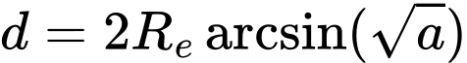
Haversine distance in kilometres after unit conversion.
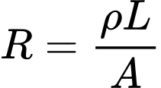
Resistance in ohms, where ρ is resistivity, L is length, and A is conductor area.
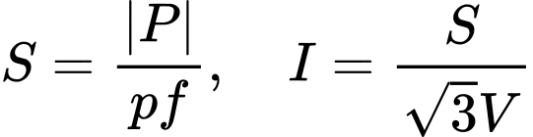

Simplified three-phase resistive loss estimate.
Assumption | Value
Line voltage | 400 kV
Power factor | 0.95
Copper resistivity | 1.68 × 10⁻⁸ Ω m
Cross-sectional area | 2,000 mm²
Length | Haversine centroid-to-centroid distance

Interpretation. This output is a distance-based flow-loss estimate, not a substitute for an AC power-flow solver. The report keeps the assumptions visible so they can be replaced when engineering data becomes available.

CHAPTER 6 PREDICTIVE METHODOLOGY

6.1 End-to-end analytical workflow
Stage | Input | Output
Ingest | Two CSV files | Parsed dynamic and directional rows
Validate | Rows and keys | Quality counts, aliases, gaps, and limitations
Graph | Countries and interconnectors | 12-node, 24-edge canonical graph
Features | History and graph metadata | 12 × 960 × 11 feature tensor
Forecast | 24-hour windows | Next-hour net-flow prediction
Classify | Actual and predicted flow | Normal, Warning, or Critical
Prescribe | Selected stressed edge | Route candidates and guardrails
Present | Saved artifacts and APIs | Animated browser dashboard

6.2 Model families
The study deliberately compares models of increasing complexity. Persistence provides an autoregressive baseline. Moving average and seasonal naive provide transparent alternatives. Linear trend tests whether a recent slope is enough. Fusion GRU learns temporal relationships from the engineered tensor. DCRNN adds directed graph diffusion before recurrent memory updates. This design prevents the project from assuming that the most complex model must win.

6.3 Training protocol
- Random seed: 42.
- Epochs: 40 for trained research models.
- Training-only standardization and chronological train, validation, and test windows.
- The same 24-hour lookback and 168-hour test horizon for Fusion GRU and DCRNN.
- Saved JSON, CSV, PNG, and checkpoint artifacts for reproducibility.

6.4 Classical forecasting models

Persistence
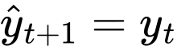
The next hour is predicted as the latest observed flow.

Twenty four hour moving average
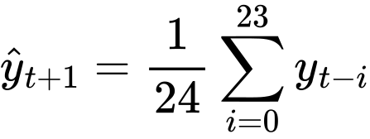

Seasonal naive
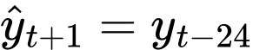
The same hour from the previous day is used when available.

Clamped linear trend
A least-squares line is fitted over the recent 24 observations. The extrapolated value is clamped to a margin around the observed window so a short data gap cannot create a runaway recommendation.

Why baselines matter
The selected dashboard baseline is Persistence because the production selection artifact chooses the lowest pooled chronological RMSE and because the rule is fast and easy to audit. Fusion GRU is still the research winner among the saved trained models by RMSE. Reporting both avoids conflating operational simplicity with research-model performance.

6.5 Fusion GRU
The Fusion GRU receives a 24-hour sequence for each country. At every hour the input combines four local signals, four global signals, and three static centrality values. The GRU updates a hidden state through gates, and a normalized linear head maps the final hidden state to the next-hour flow estimate. The model is called Fusion because local time-series information, global network context, and static graph information are concatenated before the recurrent layer.
Simplified GRU gate notation; the implementation uses PyTorch GRU cells.
The update gate controls how much new information is used. The reset gate controls how much previous state contributes to the candidate state. This lets the model preserve stable flow patterns while adapting when load, imbalance, or network context changes.

6.6 Diffusion Convolutional Recurrent Neural Network
DCRNN keeps the node axis intact. Instead of flattening the 12 countries into one vector, the model stores a hidden state for every country. Before the recurrent update, the graph convolution propagates each node's features through forward and reverse row-normalized transitions. Two diffusion steps allow information from immediate and second-order neighbors to influence the node representation.
Forward and reverse diffusion features are concatenated before the recurrent gates.
In simple terms, Fusion GRU asks: what happened recently at this country and in the overall system? DCRNN asks the same question while also passing information along the known country-interconnector graph. The project uses DCRNN as a fair benchmark, not as a dispatch solver or a replacement for physical power-flow equations [4].

6.7 Why DCRNN can lag
- Recent local net flow is overwhelmingly the strongest saved feature, so additional diffusion can add noise rather than useful signal.
- The graph is a canonical country-interconnector topology, not a complete electrical admittance model.
- The dataset lacks validated line ratings, dispatch constraints, voltage states, and market shocks.
- DCRNN has higher inference time and more moving parts than Persistence or Fusion GRU.
- A weaker score is useful evidence: topology alone did not guarantee an advantage under this protocol.

6.8 Evaluation metrics
The report uses regression metrics for MW error and classification metrics for stress-state behavior. Because net flow can approach zero or change sign, MAPE is reported for course completeness but is not treated as the primary decision metric.
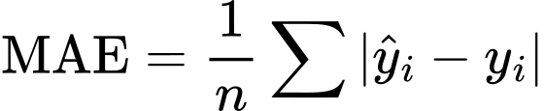
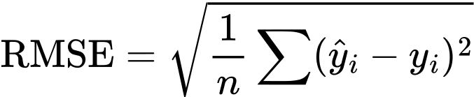
RMSE penalizes large errors more heavily than MAE.
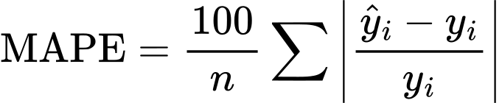
Unstable when actual values are near zero.
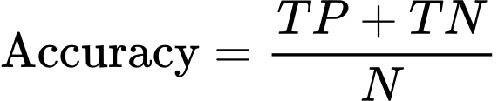
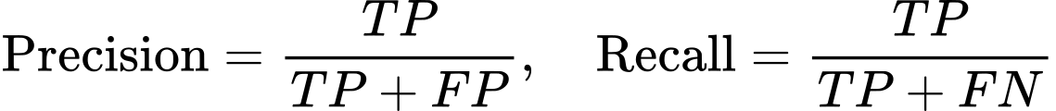
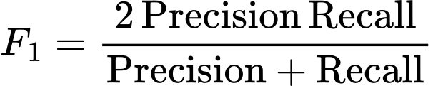
The classification metrics are macro-averaged across Normal, Warning, and Critical classes. The confusion matrix is retained because a single accuracy value can hide whether Warning or Critical states are being confused with Normal. This follows the practical emphasis on class-aware evaluation in the course syllabus and the standard metric definitions used by machine-learning tooling [9].

CHAPTER 7 SYSTEM ARCHITECTURE AND TECHNOLOGY STACK

7.1 Architecture
The project is organized into four layers. The data layer stores the supplied CSV files and compact processed artifacts. The analytical layer contains the standard-library preprocessing pipeline and the optional research experiment runner. The service layer exposes REST-style JSON endpoints and a server-sent event replay stream. The presentation layer uses HTML, CSS, and JavaScript to render the graph, animations, charts, metrics, and route what-if result.
The architecture intentionally keeps the production dashboard independent of the optional heavy experiment dependencies. This makes the dashboard runnable with the Python standard library while allowing NumPy, PyTorch, scikit-learn, and Matplotlib to be used for training and research artifact generation.

7.2 Technology stack
Technology | Use in the project
Python | Data ingestion, preprocessing, model evaluation, physics proxy, routing, and HTTP backend
NumPy | Tensor preparation, numerical calculations, and experiment arrays
PyTorch | Fusion GRU, DCRNN, training loop, checkpoints, and hidden-state extraction
scikit-learn | t-SNE projection and evaluation utilities
Matplotlib | Saved result figures for the report and presentation
HTML and CSS | Responsive dashboard structure and visual design
JavaScript | API polling, SSE replay, charts, network animation, and reroute interactions
JSON and CSV | Reproducible artifacts, API payloads, input data, and evaluation outputs

7.3 Backend and frontend integration
API route | Purpose
/api/health | Check service availability
/api/metadata | Return dataset, model, assumptions, and limitation metadata
/api/topology | Return nodes, edges, aliases, coordinates, and graph properties
/api/snapshot | Return a historical replay state at the selected time
/api/forecast | Return next-hour or multi-hour forecast values
/api/metrics and /api/validation | Return saved comparison and validation evidence
/api/physical-loss | Return distance, resistance, current, and proxy loss values
/api/route-plan and /api/what-if | Return alternate paths, bottlenecks, and loss comparison
/api/stream | Replay historical observations as a live-looking stream

7.4 Live replay behavior
The dashboard updates the visible snapshot, graph edge colors, flow particles, current metrics, and recommendation queue as replay time advances. The values change because the frontend requests different historical timestamps from the backend or consumes the replay stream. This is a real-time interface demonstration, not a live connection to a transmission system. The interface surfaces Fusion GRU as the research model and labels Persistence as the lightweight operational baseline; this distinction prevents a presentation label from misrepresenting which endpoint is executing.

7.5 Security and validation posture
- What-if percentages are clamped before route calculation.
- Unknown edge identifiers are rejected.
- Route output is labeled recommendation-only.
- The interface exposes engineering checks instead of hiding missing parameters.

CHAPTER 8 IMPLEMENTATION AND EXPERIMENTAL DESIGN

8.1 Pipeline implementation
backend/pipeline.py performs two CSV passes. The first builds country histories and metadata. The second groups directional power-flow records by timestamp and canonical edge, computes forward, reverse, net, and magnitude values, and stores compact edge histories. It then derives the observed 95th percentile capacity proxy, distance, resistance, loss, utilization, and screening class.

8.2 Experiment implementation
backend/experiments.py loads processed artifacts, constructs the 12-node feature tensor, makes chronological samples, trains Fusion GRU and DCRNN, computes regression and classification metrics, produces ROC/PR curves, saves confusion matrices, runs permutation and ablation analysis, creates a t-SNE projection, and exports the light-background PNG figures used in this report.

8.3 Reproducibility
- Seed: 42.
- Configuration and feature names are saved in results/run_metadata.json.
- Every figure has a corresponding JSON or CSV source artifact.
- The saved model checkpoints are stored in results/models.
- Unit and smoke tests cover pipeline, routing, and API behavior.
Reproducibility rule. The report does not invent graph values in the document. The result figures and numerical tables are based on the saved artifacts produced by the project experiment layer.

8.4 Frontend implementation
The frontend is organized as a dashboard with overview, forecast, model evidence, physical-loss, and rerouting views. The graph view draws nodes and links, colors them by screening state, and animates moving particles to communicate direction. The forecast view plots recent history and future values. The model evidence view explains the saved metrics rather than treating a single accuracy value as sufficient. The physics view exposes the assumed voltage, power factor, resistivity, area, and derived distance. The reroute studio accepts a selected edge and reduction percentage, then displays the route status and bottlenecks returned by the backend.

8.5 Explainability principles
- Every major value is accompanied by a unit or interpretation.
- Measured, estimated, and proxy values are distinguished.
- A recommendation includes a reason and validation checks.
- The user can trace a route from selected edge to candidate path and bottleneck.
- Model comparison includes both simple baselines and neural models.

8.6 Testing
Test file | Coverage
tests/test_pipeline.py | Distance-loss calculation, thresholds, preprocessing and artifact behavior
tests/test_routing.py | Path search, guardrails, no-change, feasible, and best-effort cases
tests/test_api.py | Endpoint smoke tests and response structure

CHAPTER 9 RESULTS AND EVALUATION

9.1 Model comparison
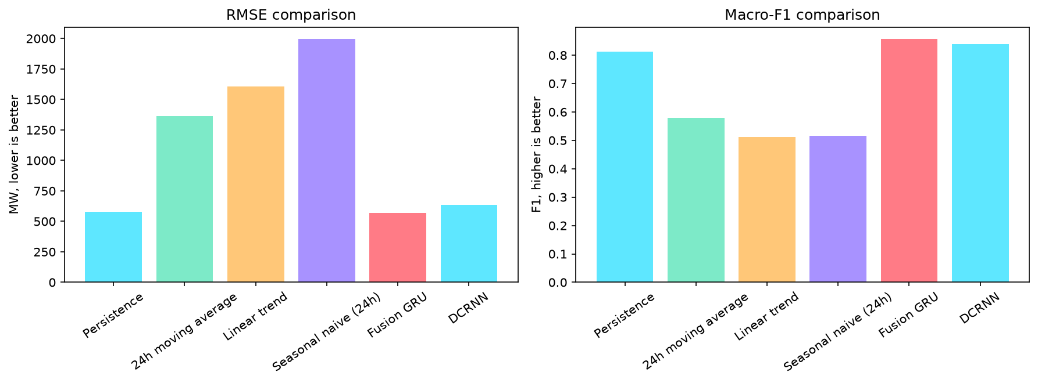
Figure 2 Original saved model comparison figure showing RMSE and macro F1.
Model | RMSE MW | MAE MW | Accuracy | Precision | Recall | F1 | Time ms
Persistence | 580.3 | 375.8 | 91.4% | 81.3% | 81.1% | 81.2% | 0.4
24h moving average | 1363.4 | 947.1 | 81.3% | 61.5% | 55.5% | 57.9% | 12.8
Linear trend | 1604.8 | 1156.9 | 74.4% | 49.7% | 54.1% | 51.2% | 78.0
Seasonal naive (24h) | 1994.7 | 1310.5 | 75.4% | 51.3% | 51.9% | 51.6% | 0.6
Fusion GRU | 570.5 | 400.3 | 92.7% | 85.2% | 86.2% | 85.6% | 34.7
DCRNN | 634.0 | 436.2 | 92.5% | 85.3% | 82.7% | 83.8% | 63.6

Fusion GRU has the lowest saved RMSE among the trained research models at 570.5 MW and the highest F1 at 85.6%. Persistence has a slightly higher RMSE at 580.3 MW but is much faster and simpler. DCRNN has RMSE 634.0 MW and F1 83.8%, so graph diffusion did not improve this run. The dashboard selection artifact keeps Persistence as the operational baseline while the research comparison identifies Fusion GRU as the trained-model winner.

9.2 Training and validation curves
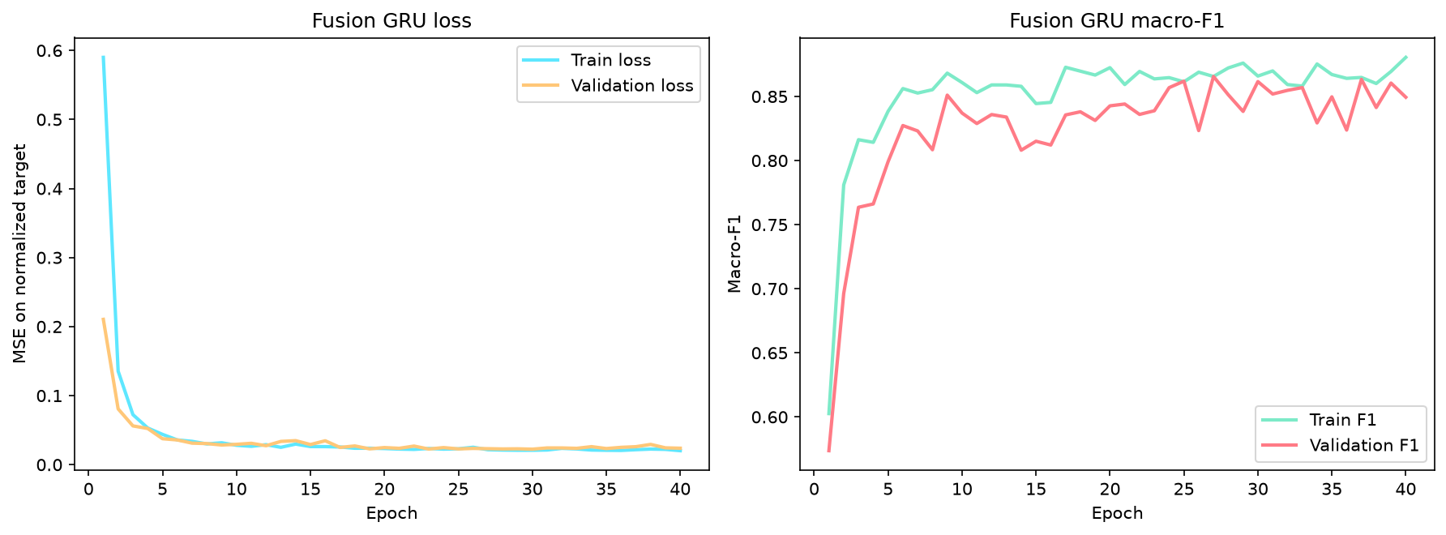
Figure 3 Original Fusion GRU training and validation loss and macro F1 curves.
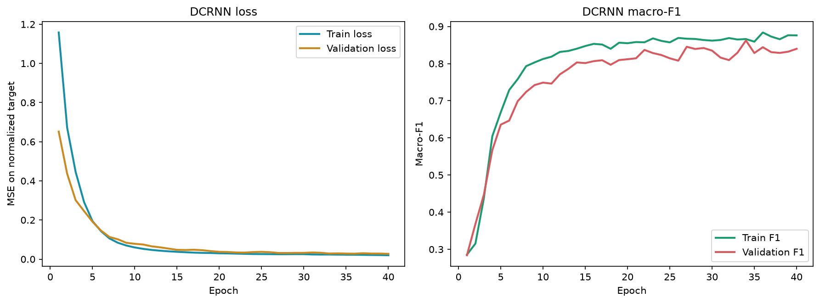
Figure 4 Original DCRNN training and validation loss and macro F1 curves.
The curves show that both trained models learn rapidly during the early epochs. Loss falls sharply, while macro F1 rises. The validation curves remain broadly aligned with training behavior, which is evidence against a severe training collapse in this run. The final test comparison is still more important than a visually good training curve because the holdout is chronological and represents unseen future-like hours.
Interpretation. A learning curve explains how the model learned; it does not prove that the model is engineering-safe. The saved test metrics and failure examples must be considered together.

9.3 ROC AUC and precision recall analysis
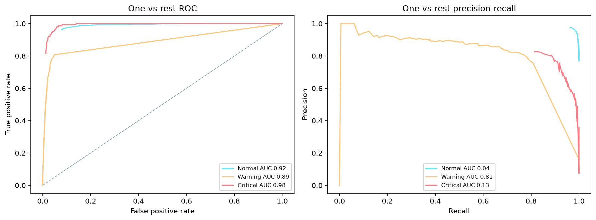
Figure 5 Original Fusion GRU ROC and precision-recall curves.
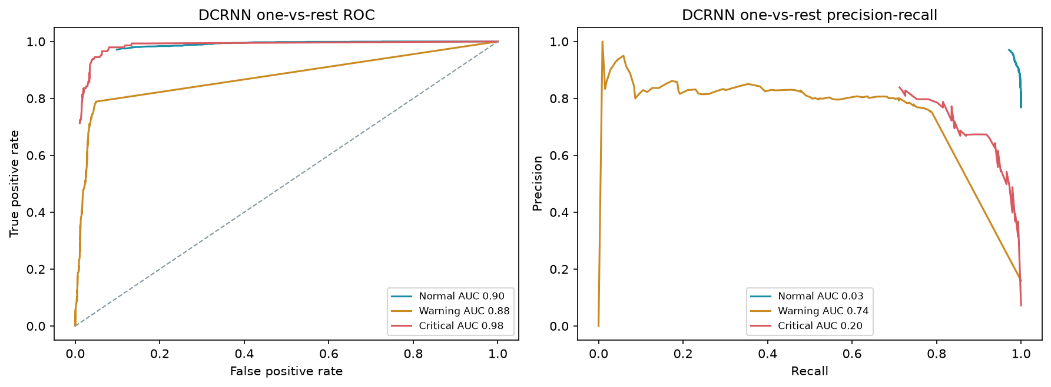
Figure 6 Original DCRNN ROC and precision-recall curves.
The ROC curves show the trade-off between true-positive rate and false-positive rate as the threshold changes. Precision-recall curves are particularly useful for Warning and Critical classes because those states are less frequent than Normal. A high area under a curve suggests good separability across thresholds, but the operating threshold still depends on the cost of missed stress versus false alarms. The dashboard therefore keeps the class thresholds explicit and includes a confusion matrix.

9.4 Feature interpretation and error analysis
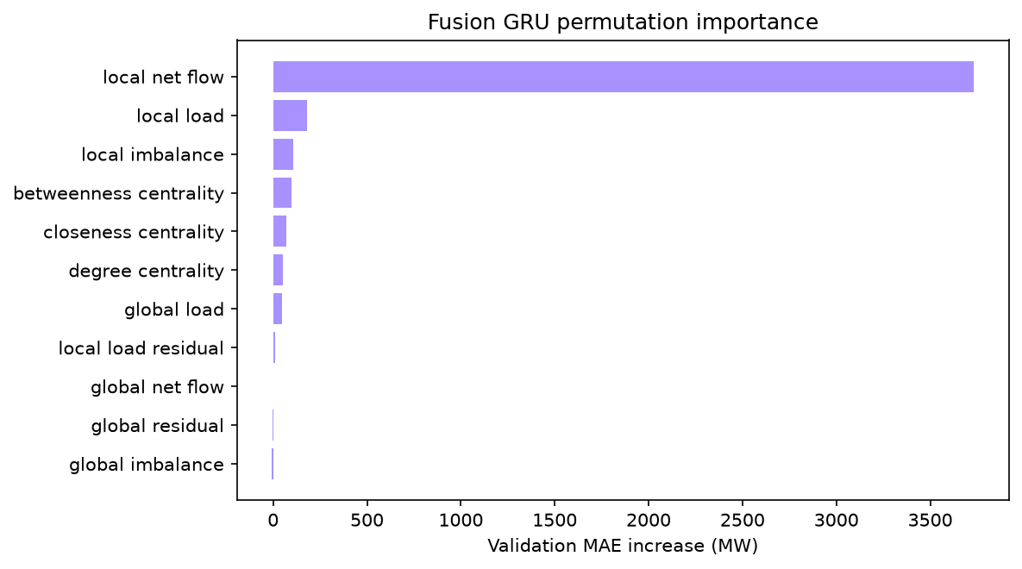
Figure 7 Original permutation-importance figure. Larger delta MAE means the model depends more on that feature.
The saved baseline validation MAE for the feature study is 374.9 MW. Shuffling local net flow increases MAE by 3733.1 MW, far more than any other feature. This supports the interpretation that recent local flow is the dominant predictive signal in this run. Centrality features contribute smaller but positive permutation deltas, while some global context features do not improve the validation MAE when shuffled. These results are model-specific evidence, not causal proof.
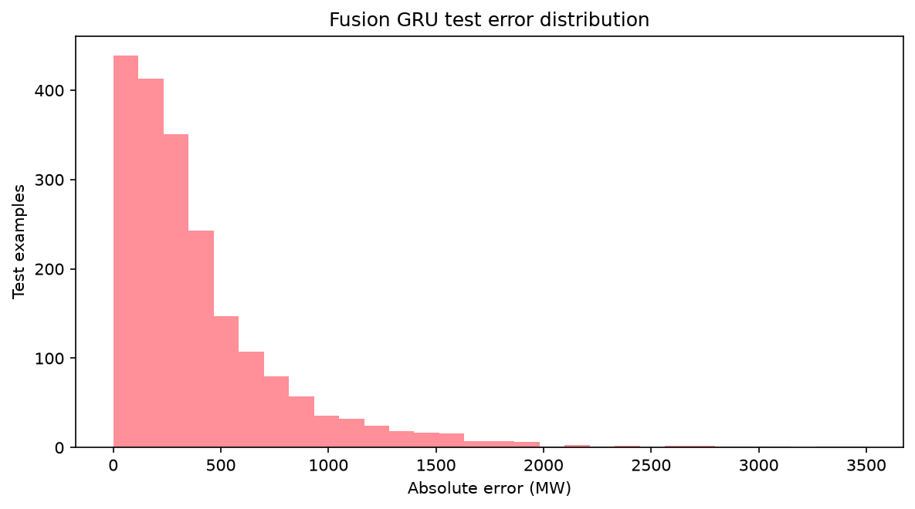
Figure 8 Original Fusion GRU test error distribution.
The error distribution is concentrated at smaller absolute errors with a long tail. The saved qualitative failures include a German Critical flow of 7,484.5 MW predicted as 3,986.7 MW, and a French Normal flow of -1,662.5 MW predicted as -5,030.8 MW. Sudden movements and class-boundary changes are therefore important failure cases.

9.5 Learned-state projection and confusion matrix
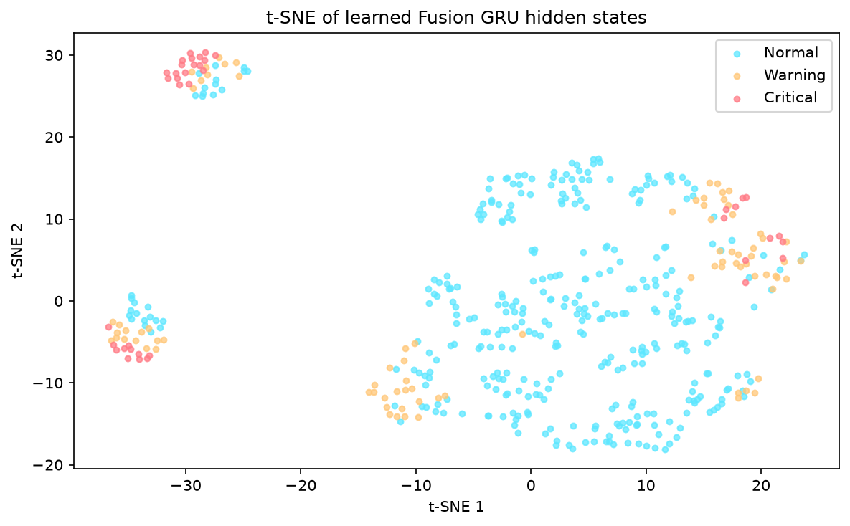
Figure 9 Original t-SNE projection of learned hidden states.
The t-SNE projection provides a two-dimensional view of hidden states and can show whether similar operating conditions form neighborhoods. It is exploratory: distance in a t-SNE plot does not prove physical similarity or causality. Its value is qualitative inspection alongside the numeric metrics and error examples.

DCRNN confusion matrix
Actual / Predicted | Normal | Warning | Critical
Normal | 1504 | 44 | 0
Warning | 45 | 257 | 20
Critical | 1 | 41 | 104

For DCRNN, most Normal cases are correctly identified: 1,504 of 1,548 Normal examples. Critical cases are correctly identified 104 times, but 41 are predicted as Warning. This is a more informative view than accuracy alone because it shows the severity of the confusion. Fusion GRU has a similar pattern but captures more Critical cases in the saved matrix.

9.6 Metric interpretation
Metric | What it answers | Project reading
RMSE | How large are errors, with large mistakes emphasized? | Fusion GRU is lowest among trained models; Persistence is close and simpler
MAE | What is the average absolute MW error? | Persistence is 375.8 MW; Fusion GRU is 400.3 MW
Accuracy | What fraction of stress labels are correct? | Fusion GRU 92.7%, DCRNN 92.5%, Persistence 91.4%
Precision | When the model predicts a class, how reliable is it? | Macro precision is around 85% for trained models
Recall | How many actual class cases were found? | Fusion GRU recall is 86.2%; DCRNN recall is 82.7%
F1 | What is the balanced class score? | Fusion GRU has the best saved F1 at 85.6%
Inference time | How quickly can one prediction be produced? | Persistence is fastest; DCRNN is slower at 63.6 ms

9.7 Results summary
The results answer the research questions with a nuanced conclusion. A trained temporal model can improve RMSE and class metrics over Persistence, but the gain is small in RMSE and comes with additional complexity. Graph diffusion is measurable and reproducible but does not win here. Feature importance indicates that local recent history dominates. The prescriptive layer is therefore valuable mainly because it connects forecast evidence to a transparent what-if action, not because the model has proven operational control.

CHAPTER 10 PRESCRIPTIVE ANALYTICS AND REROUTING

10.1 Decision sequence
1. Select a visible interconnector and inspect its current flow, utilization, risk class, distance, and proxy loss.
2. Choose a reduction percentage p, clamped between 0% and 60%.
3. Compute the amount of flow to investigate moving.
4. Remove the selected link from the working graph and search paths between the same endpoints.
5. Reject or penalize links that lack enough proxy headroom or are Critical.
6. Rank candidates using distance, utilization, warning/critical penalties, and estimated loss.
7. Return route status, route nodes, route edges, bottlenecks, baseline loss, rerouted loss, and validation requirements.

10.2 Why this is prescriptive
Forecasting reports a likely future value. The route planner evaluates a possible intervention under constraints. It is prescriptive because it compares alternatives and explains the preferred candidate, but it remains a recommendation because it does not know verified thermal ratings, voltage stability, N-1 contingencies, protection settings, or operator priorities.

CHAPTER 11 DISCUSSION NOVELTY LIMITATIONS AND ETHICS

11.1 What is new in this project
- Canonical edge audit that exposes directional aliases instead of hiding them.
- Data-quality-aware risk screen combining utilization, imbalance, and load residual.
- Evidence-driven model router that compares simple and neural approaches under chronological validation.
- Explicit separation of measured flow, estimated capacity, and distance-based loss proxy.
- Counterfactual headroom and stress-aware route search with best-effort bottlenecks.
- Action queue that includes reasons, confidence, and validation checks.

11.2 Technical limitations
- The physical-loss calculation uses centroid distance and assumed voltage, power factor, resistivity, and area.
- The capacity proxy is derived from observed flow and is not a thermal rating.
- The historical replay is not live telemetry.
- The graph does not contain full electrical admittance, phase, voltage, or reactive-power information.
- The model comparison has one supplied network and one evaluation protocol.
- Uncertainty bands are not calibrated probability intervals.
- No automatic dispatch or switching action is permitted.

11.3 Ethical and operational safeguards
The main ethical risk is overtrust: a polished dashboard may be mistaken for an operational authority. The system counters this by labeling proxy values, naming missing parameters, showing failure cases, retaining baseline comparisons, and displaying engineering checks beside routes. A future operational version would require asset validation, secure telemetry, access control, audit logs, calibrated uncertainty, N-1 analysis, and approval by qualified grid personnel.

CHAPTER 12 CONCLUSION AND FUTURE WORK

12.1 Conclusion
GridPulse demonstrates a complete predictive and prescriptive analytics workflow for cross-border power-flow data. It begins with two raw CSV datasets, validates and canonicalizes them, builds a 12-node and 24-edge graph, extracts local, global, and graph features, constructs 24-hour windows, forecasts next-hour country net flow, evaluates continuous and class-aware performance, estimates a transparent distance-based loss proxy, and tests alternate routes under visible guardrails.
The saved results show that Fusion GRU is the strongest trained research model by RMSE and F1, while Persistence remains a competitive and simpler operational baseline. DCRNN is successfully implemented and measured but lags the other trained model on this dataset, which is an informative result rather than a failure of the project. The project contribution is an auditable system integration that helps a new user understand not only what the model predicts but also how the recommendation is formed and where engineering validation is still required.

12.2 Team contribution
Member | Explanation responsibility
Prakki Krishna Karthik | Problem, datasets, preprocessing, graph and feature engineering, physical assumptions
Vasudev | Forecasting models, evaluation equations, APIs, loss calculation, and route decision logic
Shubham Bhuyan | DCRNN, saved figures, comparative interpretation, frontend integration, novelty, and limitations

12.3 Future work
1. Add verified voltage, conductor, route geometry, thermal rating, reactive power, and N-1 security data.
2. Compare GCN, GAT, GraphSAGE, Graph WaveNet, and stronger spatio-temporal baselines under the same split.
3. Add calibrated conformal or quantile prediction intervals and evaluate coverage and width.
4. Add weather, market, outage, and renewable forecast scenarios without leakage.
5. Validate route recommendations against an engineering power-flow solver and operator constraints.
6. Replace historical replay with a secure Kafka, MQTT, or utility API adapter after governance review.

REFERENCES
[1] Supplied project dataset, dynamic_with_flows.csv, hourly country-level dynamic records, 2022–2024.
[2] Supplied project dataset, power_flow.csv, directional interconnector flow records, 2022–2024.
[3] GridPulse Software Requirements Specification, project artifact, docs/SRS.md.
[4] Y. Li, R. Yu, C. Shahabi, and Y. Liu, Diffusion Convolutional Recurrent Neural Network Data Driven Traffic Forecasting, ICLR 2018. https://arxiv.org/abs/1707.01926.
[5] Z. Wu, S. Pan, G. Long, J. Jiang, and C. Zhang, Graph WaveNet for Deep Spatial Temporal Graph Modeling, Proceedings of IJCAI 2019, pp. 1907–1913. https://arxiv.org/abs/1906.00121.
[6] K. Cho et al., Learning Phrase Representations using RNN Encoder Decoder for Statistical Machine Translation, EMNLP 2014, pp. 1724–1734. https://arxiv.org/abs/1406.1078.
[7] J. Lu, H. Tan, R. Zhao, W. Guo et al., Applications of Graph Computing and Graph Neural Networks in Power Systems A Survey, CICED 2024, DOI 10.1109/CICED63421.2024.10754312.
[8] A Survey on Graph Neural Networks for Time Series Forecasting Classification Imputation and Anomaly Detection, IEEE TPAMI, 2024, DOI 10.1109/TPAMI.2024.3443141.
[9] scikit-learn User Guide, Classification metrics and model evaluation. https://scikit-learn.org/stable/modules/model_evaluation.html.
[10] PyTorch Documentation, Recurrent layers and neural-network modules. https://pytorch.org/docs/stable/nn.html.
[11] GridPulse research review and novelty rationale, project artifact, docs/RESEARCH_NOTES.md.

APPENDIX A COMPLETE FEATURE INVENTORY
Name | Group | Source or construction
local net flow | local time series | net_flow
local load | local time series | Actual_Total_Load_MW
local imbalance | local time series | flow_imbalance_ratio
local load residual | local time series | load_residual
global net flow | network context | all country net_flow
global load | network context | all country load
global imbalance | network context | all country imbalance
global residual | network context | all country load residual
degree centrality | static graph | canonical graph
closeness centrality | static graph | canonical graph
betweenness centrality | static graph | canonical graph

APPENDIX B PROJECT ARTIFACT MAP
Artifact | Purpose
backend/pipeline.py | Standard-library preprocessing, canonicalization, baseline evaluation, graph and physical-loss artifacts
backend/experiments.py | Fusion GRU and DCRNN training, evaluation, figures, and checkpoints
backend/server.py | REST and SSE services for the dashboard
backend/physics.py | Haversine, resistance, current, and loss-proxy calculations
backend/routing.py | Alternate-path search, headroom checks, cost ranking, and bottlenecks
frontend/app.js | Dashboard state, charts, replay animation, and what-if interaction
results/figures | Saved original result figures used in this report and presentation
results/models | Saved Fusion GRU and DCRNN checkpoints

APPENDIX C DCRNN TRAINING OUTPUT
The DCRNN experiment was trained for 40 epochs using a 24-hour lookback, 12 country nodes, 11 engineered features, two diffusion steps, and a hidden size of 24. The training and validation records below are read from the saved experiment artifact rather than reconstructed for this report.
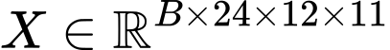
DCRNN input tensor: batch, lookback, nodes, and features.
Graph-informed recurrent update.
Training output | Value
Epochs | 40
Final training loss | 0.01998
Final validation loss | 0.02712
Final training accuracy | 93.06%
Final validation accuracy | 90.67%
Final training macro F1 | 87.60%
Final validation macro F1 | 83.99%
Test RMSE | 633.96 MW
Test MAE | 436.22 MW
Test inference time | 63.63 ms

Figure 10 Original saved DCRNN training output with loss and macro F1 traces.
The final DCRNN result is useful even though it does not beat Fusion GRU on this dataset. It demonstrates a complete graph-recurrent implementation, produces a saved checkpoint at results/models/dcrnn.pt, and provides evidence about the current topology and feature contract. Its lower score is interpreted as a dataset and topology finding, not as evidence that graph learning is universally ineffective.

