# **🚀 Cold Email Automation Tool – Complete Beginner Setup Guide**

Build and run your own AI-powered cold email tool with Python, Google Sheets, SheetDB, Groq, and optionally Ollama.

## **⚠️ Requirements Overview**

* Works best with a **Gmail** account (only Gmail is supported for SMTP).
* Groq API key (free, no Bearer auth required).
* SheetDB API connected to Google Sheets.
* Python installed on your system.
* Optionally: Ollama for local AI generation (requires 4GB+ free RAM).

## **🧩 Step 1: Install Python**

### **▶️ For Windows:**

1. Go to <https://www.python.org/downloads/>
2. Download and run the latest Python installer.
3. IMPORTANT: During installation, check the box that says **"Add Python to PATH"**.
4. Finish installation.

To verify:  
Open **Command Prompt** and run:

bash

CopyEdit

python --version

### **🍏 For Mac:**

1. Open **Terminal**.
2. Run:

bash

CopyEdit

brew install python

(Install [Homebrew](https://brew.sh/) first if not installed.)

To verify:

bash

CopyEdit

python3 --version

## **🛠️ Step 2: Install an IDE**

We recommend **Visual Studio Code (VS Code)**:

Download here: [https://code.visualstudio.com](https://code.visualstudio.com/)

Once installed, open your project folder in VS Code.

## **📦 Step 3: Install Required Python Libraries**

1. In your project folder, you should see a file called requirements.txt.
2. In your **Terminal** or **Command Prompt**, navigate to the project folder:

### **Windows:**

bash

CopyEdit

cd path\to\your\project

### **Mac:**

bash

CopyEdit

cd /path/to/your/project

1. Then run:

bash

CopyEdit

pip install -r requirements.txt

## **🔑 Step 4: Get Your SheetDB API Key**

### **1. Go to** [**https://sheetdb.io**](https://sheetdb.io/)

1. Log in or sign up.
2. Click **"Create API"** and connect it with your **Google Sheet**.
3. Copy the SheetDB API URL.

If your Google Sheet is created from a different Gmail account than the one used on SheetDB:

* Open the Google Sheet.
* Click **"Share"** → Add the email used on SheetDB with **Editor** permission.

## **📄 Step 5: Create and Format Your Google Sheet**

The sheet must include the following headers:

* name
* company
* email
* message
* status

Ensure your Sheet is **Published to Web** in Google Sheets:

1. Click File → Share → Publish to web.
2. Choose the correct sheet tab and publish.

## **🤖 Step 6: Get and Use Your Groq API Key**

1. Go to [https://console.groq.com](https://console.groq.com/)
2. Create an account.
3. Get your **API key**.

You **do NOT** need Bearer token authentication—just the raw API key is fine.

## **🧠 (Optional) Step 7: Install and Run Ollama Locally**

Requires at least **4GB free RAM**. Optional if Groq is working fine.

### **Install Ollama:**

#### **Windows:**

Download and install from https://ollama.com/download

#### **Mac:**

Install via Terminal:

bash

CopyEdit

brew install ollama

### **Setup Your Model:**

1. Go to your **project directory**.
2. Run the following command to create your custom model:

bash

CopyEdit

ollama create email-bot -f Modelfile

1. Then run the model in background:

bash

CopyEdit

ollama run email-bot

## **📧 Step 8: Enable Gmail App Password (for sending emails)**

This allows your Python app to use Gmail SMTP securely.

### **Step-by-step:**

1. **Enable 2-Step Verification**:
   * Go to https://myaccount.google.com/security
   * Under “Signing in to Google”, click **2-Step Verification** → Set it up.
   * 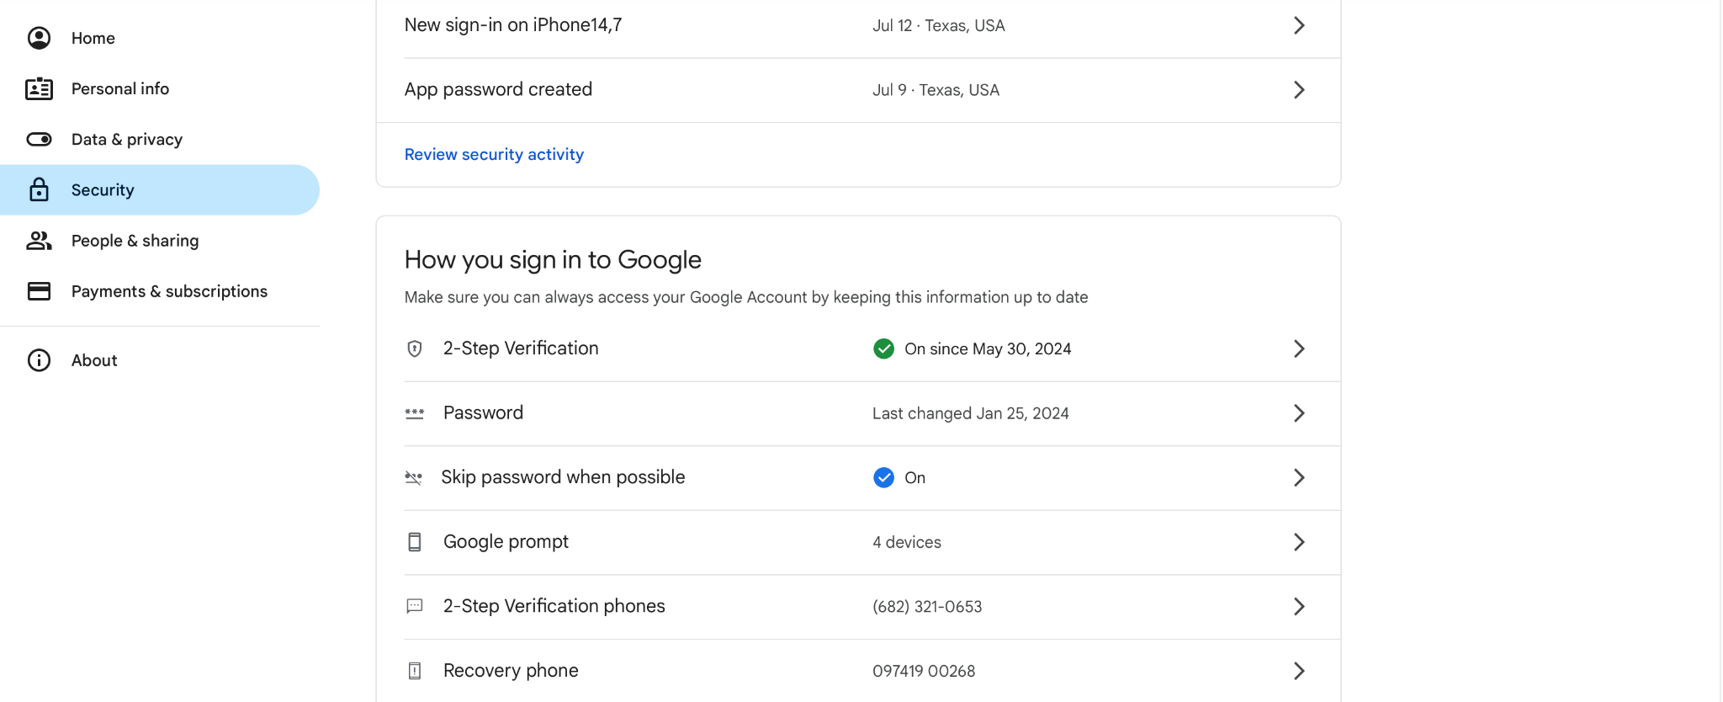
2. **Create App Password**:
   * After enabling 2FA, go back to <https://myaccount.google.com/apppasswords>
   * 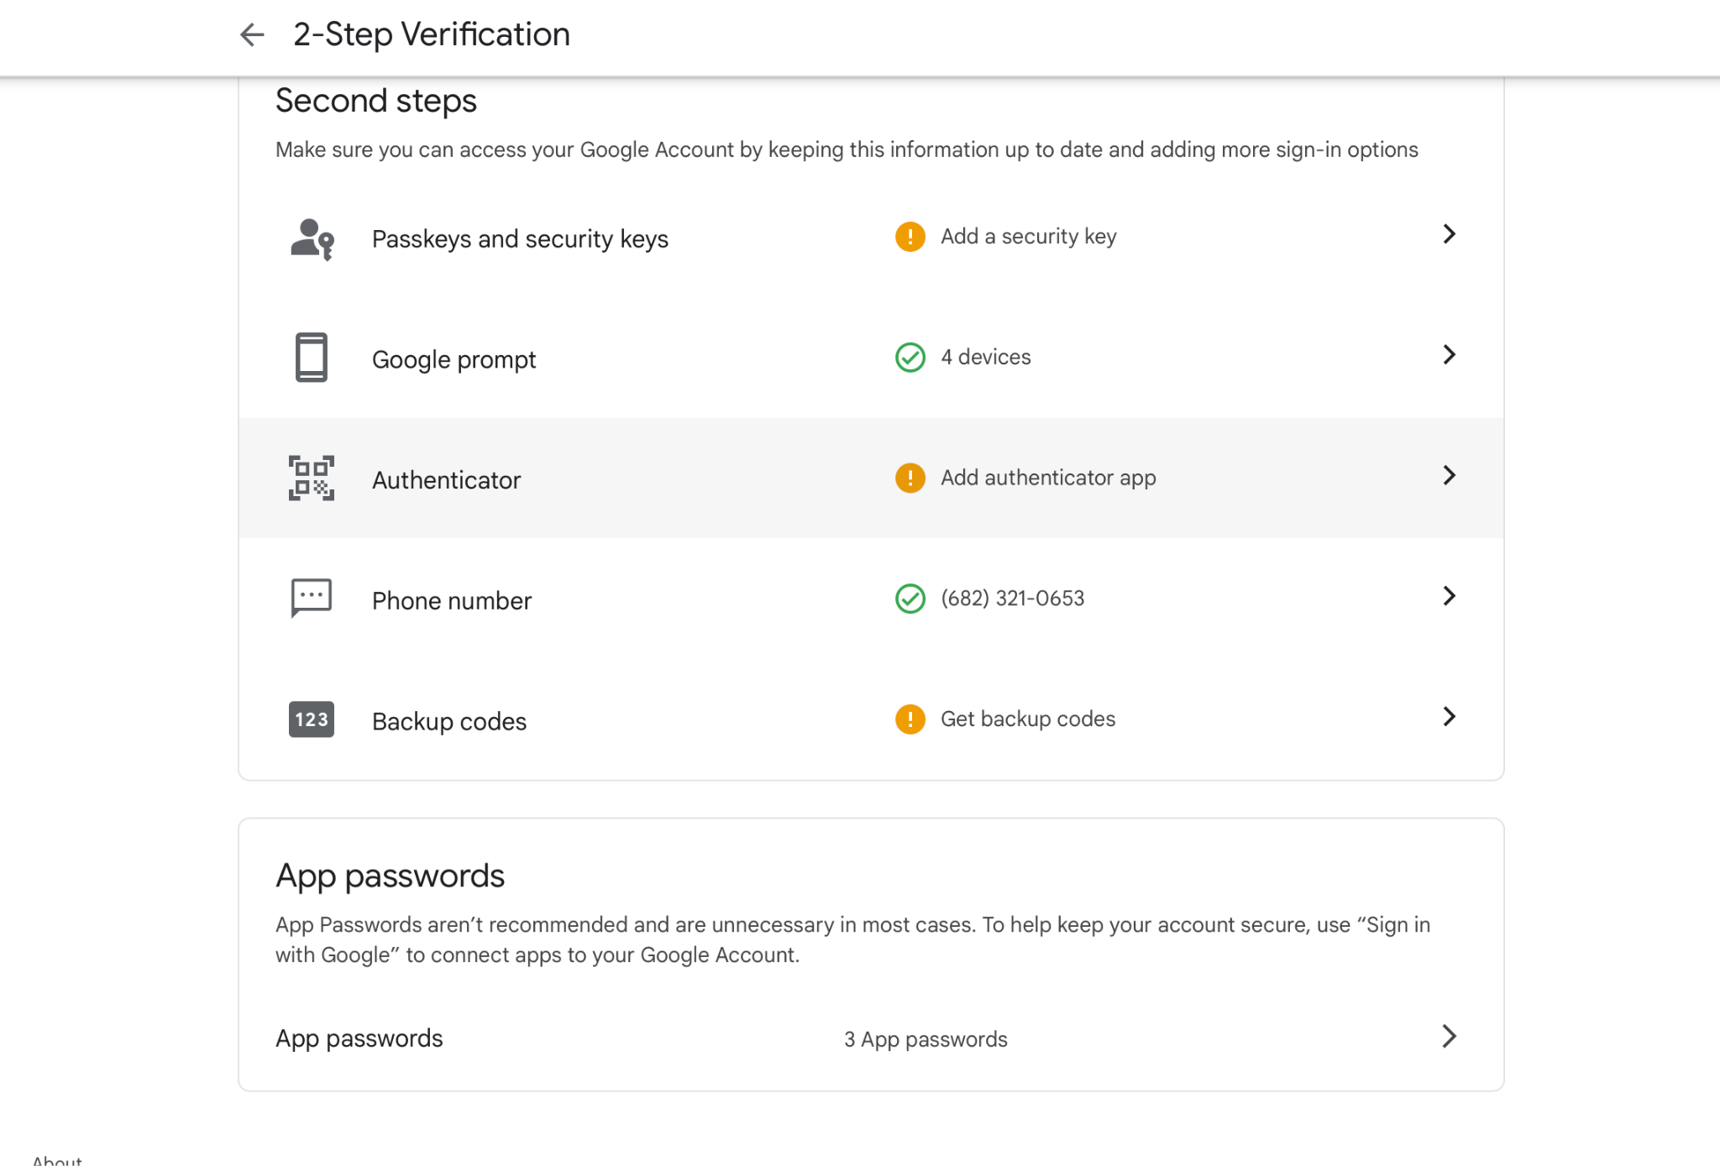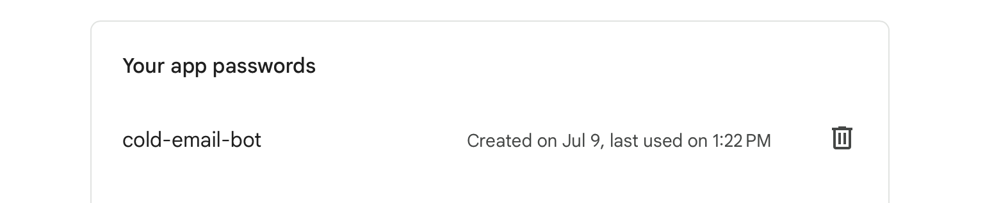
   * Choose **Mail** and **Other (Custom)**, name it something like ColdEmailBot.
   * Copy the 16-character app password (you’ll need this in your code).

✅ Note: This only works with **Gmail** accounts.

## **🏃 Step 9: Run Your Code**

Make sure Ollama is running (if using it).  
Then in your terminal:

bash

CopyEdit

python main.py

## **📌 Notes**

* Make sure your spreadsheet has **rows filled** with Name, Role, Email, and Website Column

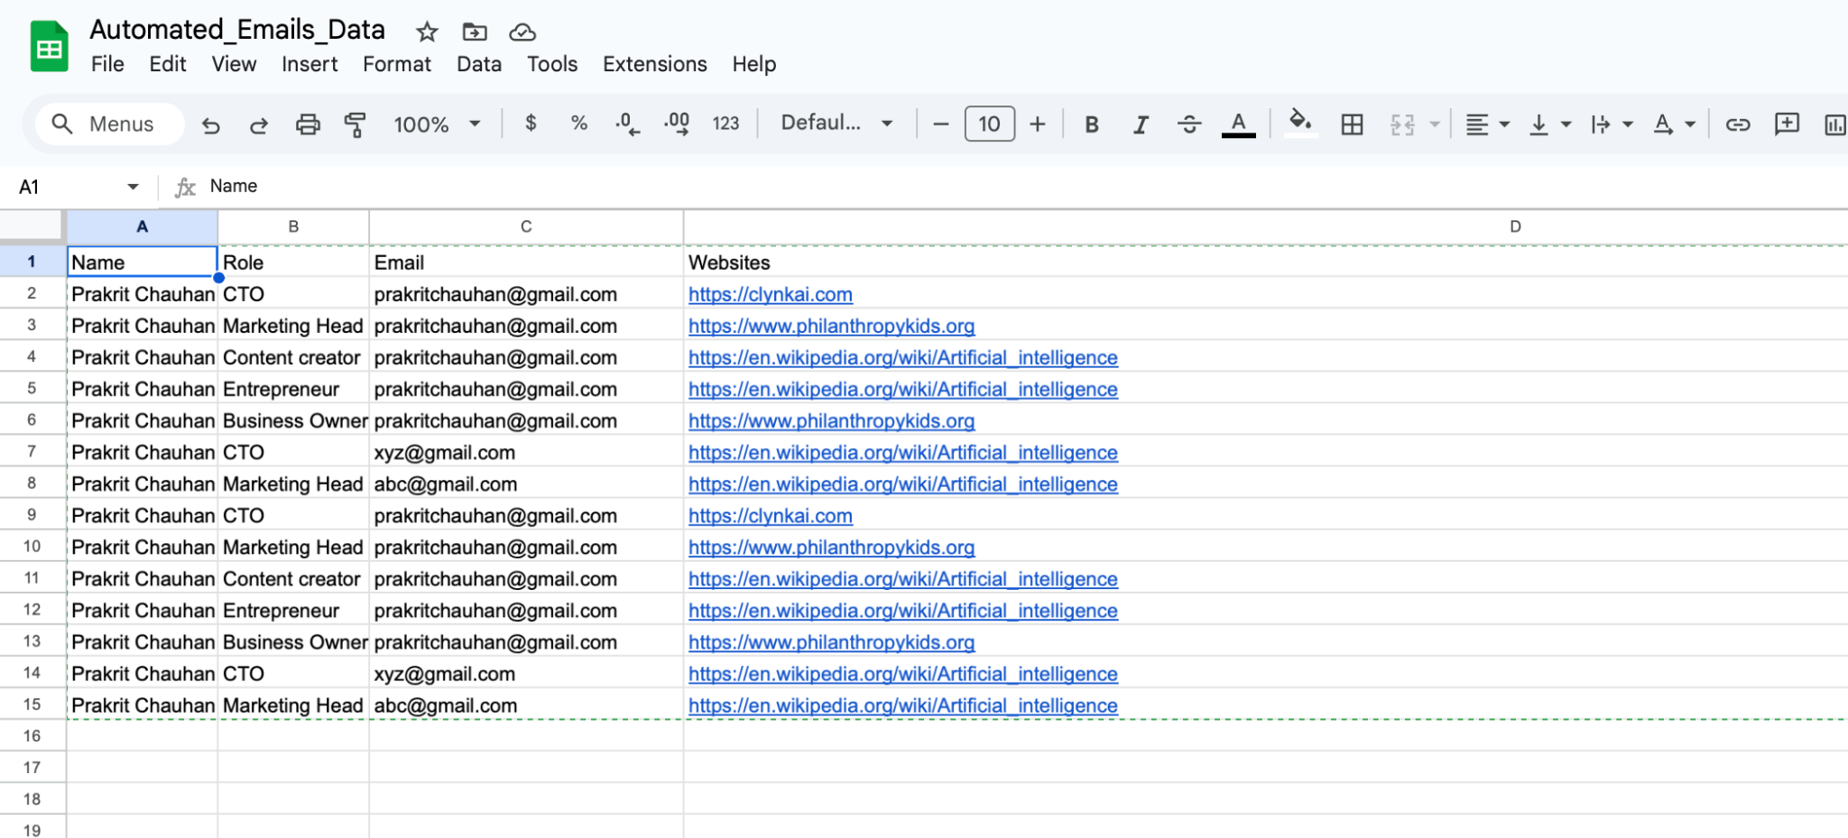

* Find websites with information on recipient and paste it into website Column with commas to separate. NOTE: find articles or wikipedia or business website. Linkedin won’t work due to restrictions.
* If your email is short, Groq might return smaller responses—edit prompts to your needs using gemini or chatgpt.
* Updates to spreadsheet statuses happen automatically—ensure the internet connection is active and SheetDB link is valid.