
CAP455 – OBJECT-ORIENTED PROGRAMMING USING C++
MINOR PROJECT – CA1 REPORT
NEIGHBOURHOOD TOOL-LENDING SYSTEM
Particulars | Details
Student Name | Prakriti Kumari
Registration / Roll Number | 12609979
Programme | MCA – Core
Course Code and Name | CAP455 – Object-Oriented Programming Using C++
CA Phase | CA1
Github Link | https://github.com/Prakriti998/NeighbourhoodToolLending.git
Faculty Name | Adarsh Singh
Academic Session | 2026–2027
Submission Date | 06-11-2026

DeclarationI, Prakriti Kumari, bearing Registration/Roll Number 12609979, hereby declare that this CA1 project report titled “Neighbourhood Tool-Lending System” has been prepared for the course CAP455 – Object-Oriented Programming Using C++. I confirm that I will review, compile, test and explain the submitted program and documentation. Any assistance or tools used during preparation are disclosed in accordance with the instructions of the university and the faculty

Student Signature: Prakriti Kumari

Date: 05-11-2026

Acknowledgement

I express my sincere gratitude to my course faculty, Mr. Adarsh Singh, for the guidance and support extended during the development of this CA1 project. I also acknowledge the learning resources and programming tools that helped me understand the C++ concepts, design the program and prepare this documentation.

Table of content
1. Introduction 4
2. Aim and Objectives 4
3. Scope and Limitations 4
4. Feasibility and Requirements 5
5. System Analysis and Design 6
6. Data Dictionary 7
7. Algorithms and Program Flow 7
8. C++ Concepts Used 8
9. Implementation Details 9
10. Testing and Test Cases 10
11. Source Code and Sample Output 11
12. Future Enhancements 16
13. Conclusion 17

1. Introduction
Tools are used for repair, maintenance, gardening, construction and many other everyday activities. Within a neighbourhood, tools can be shared instead of every household purchasing the same equipment. A simple record system helps keep basic information about such tools organised and accessible.
The Neighbourhood Tool-Lending System is developed as a beginner-level console application in C++. The CA1 version is deliberately limited to adding tool records and viewing them. Lending transactions, returns, damage or loss reporting, fines and permanent storage are not part of this phase.

2. Aim and Objectives
Aim: To develop a simple C++ console application that creates and displays tool records with basic input validation.
Objectives:
- To store a tool’s ID, name, category and type.
- To ensure that no tool ID is duplicated.
- To prevent required text fields from being left empty.
- To allow the user to select Hand Tool or Power Tool as the tool type.
- To display all tool records entered during the current run, along with the total count.
- To demonstrate the object-oriented programming concepts required in CA1.

3. Scope and Limitations

3.1 Included in CA1
- Add Tool (Create) and View All Tools (Read).
- Unique Tool ID validation.
- Non-empty validation for tool name and category.
- Tool type selection: Hand Tool or Power Tool.
- Automatic count of the total number of tools.
- Fixed-size array with a maximum capacity of 100 tool objects.

3.2 Not Included in CA1
- Borrowing and returning transactions, and borrower or member details.
- Due dates and overdue tracking.
- Damage, breakage or loss reporting, and fine calculation.
- Editing or deleting records.
- File handling, database connectivity or permanent storage.
- Login, network access or a graphical user interface.
Note: The program stores records in memory only. When the program exits, all records are lost, and no files are created or accessed.

4. Feasibility and Requirements

4.1 Hardware Requirements
- A computer or laptop capable of running a C++ compiler, with keyboard and display.

4.2 Software Requirements
- Operating system: Windows, Linux or macOS.
- Compiler: g++ or any IDE with a C++ compiler (C++11 or later).
- Editor/IDE: Visual Studio Code, Code::Blocks or Visual Studio.

4.3 Functional Requirements
ID | Requirement
FR1 | The system shall display a menu with Add Tool, View All Tools and Exit.
FR2 | The system shall accept a Tool ID, tool name, category and tool type.
FR3 | The system shall reject an empty Tool ID, name or category.
FR4 | The system shall reject a Tool ID that already exists.
FR5 | The system shall accept only Hand Tool or Power Tool selections.
FR6 | The system shall store successfully entered tools in an array of objects.
FR7 | The system shall display all tools stored in the current run.
FR8 | The system shall display the total number of tools successfully added.
FR9 | The system shall prevent more than 100 tools from being added.

4.4 Non-Functional Requirements
- The menu and prompts shall be simple and easy to understand.
- The program shall compile with a standard C++ compiler.
- Existing array entries shall not be overwritten when capacity is reached.
- The code shall be readable and divided into functions.

5. System Analysis and Design

5.1 User and Use Cases
The CA1 program has a single console user, who can choose Add Tool, View All Tools or Exit. Adding a tool involves entering and validating the tool fields; viewing displays all records added during the current execution.
Use case | Input / action | System response
Add Tool | Select option 1 and enter tool details | Validates fields and unique ID, stores the object and increments the total
View All Tools | Select option 2 | Displays all stored records, or a message if the list is empty
Exit | Select option 3 | Ends the program

5.2 Menu Design
--------------------------------
NEIGHBOURHOOD TOOL-LENDING SYSTEM
----------------------------------
1. Add Tool
2. View All Tools
3. Exit

Enter your choice:

5.3 UML Class Diagram
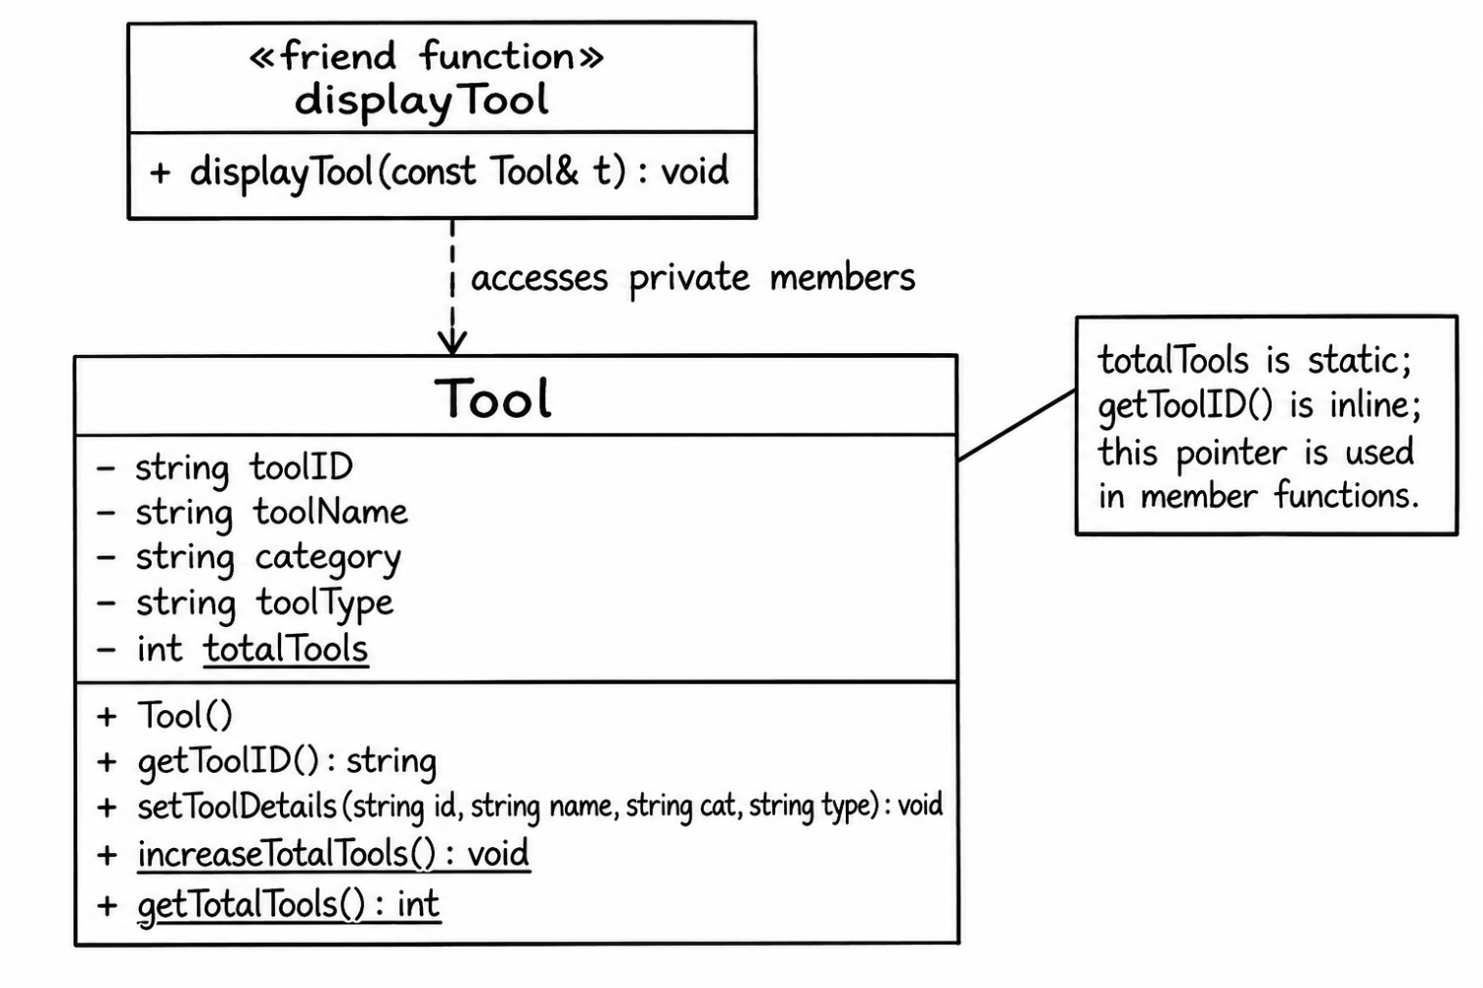
Figure 1: UML class diagram of the Tool class

6. Data Dictionary
Field / variable | C++ type | Description / validation
toolID | std::string | Unique identifier of a tool; cannot be empty or duplicated.
toolName | std::string | Name of the tool; cannot be empty.
category | std::string | Category of the tool; cannot be empty.
toolType | std::string | Must be Hand Tool or Power Tool.
totalTools | static int | Shared count of tools successfully added in this run.
tools | Tool[100] | Fixed-size array of Tool objects.
count | int | Number of occupied array positions; starts at 0 and cannot exceed 100.
choice | std::string | Menu selection: 1, 2 or 3.

7. Flowchart
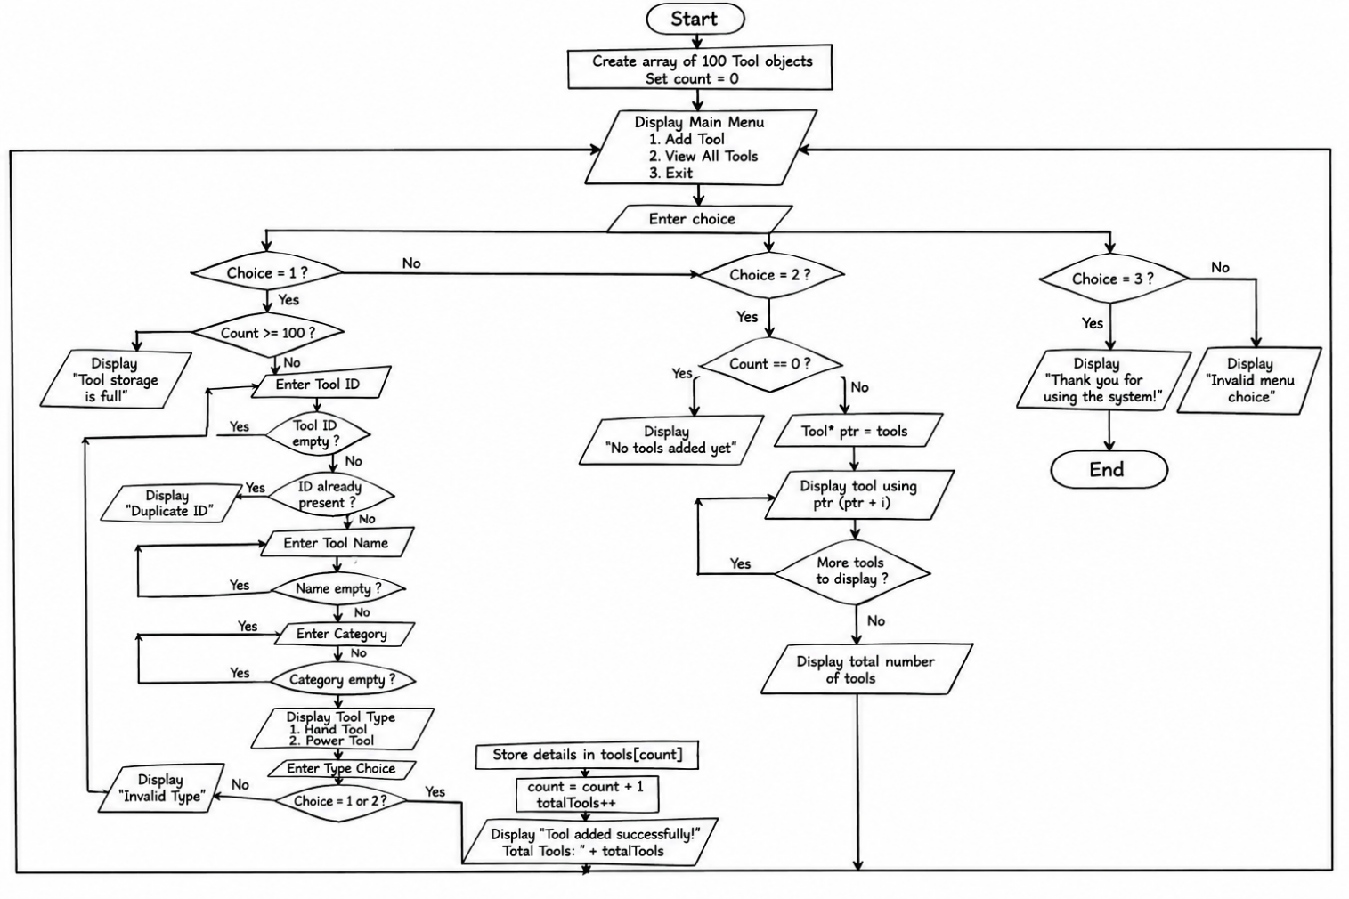
Figure 2: Flowchart of the Neighbourhood Tool-Lending System

8. C++ Concepts Used
Concept | Where / how it is demonstrated
Class | class Tool defines the structure and behaviour of a tool object.
Objects | The array contains individual Tool objects.
Default constructor | Tool() initialises all fields to empty strings.
Static data member | static int totalTools stores a count shared by all objects.
Static member functions | increaseTotalTools() and getTotalTools() access the static count.
Inline function | getToolID() is defined inline within the class.
Friend function | displayTool(const Tool&) accesses private fields for display.
Array of objects | Tool tools[MAX_TOOLS] stores up to 100 objects.
Pointer and pointer arithmetic | Tool *ptr points to the first object; *(ptr + i) accesses the object at position i.
this pointer | this->toolID and related expressions refer to the current object.
std::string | Stores the ID, name, category and type.
Create and Read | addTool() creates records; viewAllTools() displays them.
Validation | Checks empty fields, duplicate IDs and tool-type selection.

9. Implementation Details

9.1 Header Files
The program includes <iostream> for console input and output and <string> for the text fields. <fstream> is not included because file handling is outside the scope of CA1.

10.2 The Tool Class
The Tool class keeps toolID, toolName, category and toolType private, protecting them from direct access outside the class. Public member functions set the details, return the ID and update or read the static count.
class Tool {
private:
string toolID, toolName, category, toolType;
static int totalTools;
public:
Tool();
inline string getToolID() const { return this->toolID; }
void setToolDetails(string id, string name,
string cat, string type);
static void increaseTotalTools();
static int getTotalTools();
friend void displayTool(const Tool &t);
};

9.2 Duplicate ID Validation
The isDuplicateID() function compares the entered ID with the IDs of all stored objects and returns true if a match is found. In that case, addTool() asks the user for another ID instead of storing a duplicate.

9.3 Input Handling
The program uses getline() for all text input, including menu choices, so that names and categories containing spaces are read correctly. Because every entry is read as a line of text and then compared, invalid entries such as letters in the menu do not disturb the input stream.

10.Testing and Test Case
The program was tested manually using the following test cases. Each test compares the expected result with the actual behaviour observed in the console.
Test ID | Test input / action | Expected result | Actual result | Status
TC01 | Choose View All Tools before adding anything | No-tools message is displayed | “No tools have been added yet.” | Pass
TC02 | Add ID 101, Hammer, Construction, type 1 | Tool added; total becomes 1 | “Tool added successfully!” Total Number of Tools: 1 | Pass
TC03 | Add ID 102, Electric Drill, Construction, type 2 | Tool added; total becomes 2 | “Tool added successfully!” Total Number of Tools: 2 | Pass
TC04 | Add an existing ID (101) | Duplicate rejected; total unchanged | “This Tool ID already exists! Enter a unique ID.” | Pass
TC05 | Enter a blank Tool ID | Program asks for the ID again | “Tool ID cannot be empty. Try again.” | Pass
TC06 | Enter a blank tool name | Program asks for the name again | “Tool name cannot be empty. Try again.” | Pass
TC07 | Enter a blank category | Program asks for the category again | “Category cannot be empty. Try again.” | Pass
TC08 | Enter tool type 3 | Invalid type; asks for 1 or 2 | “Invalid choice! Please enter 1 or 2.” | Pass
TC09 | Choose View All Tools after adding records | Each stored tool and the total are displayed | All records listed with the total number of tools | Pass
TC10 | Choose menu option 9 | Invalid menu choice message | “Invalid choice! Please select 1, 2 or 3.” | Pass
TC11 | Add 100 tools, then try to add another | Storage-full message; no overwrite | “Tool storage is full!” | Pass
TC12 | Exit and restart, then view tools | Previous records are not present | “No tools have been added yet.” | Pass

11. Source Code and Sample Output

11.1 Complete Source Code
The complete C++ source code of the CA1 program (ca1_project.cpp) is given below.
#include <iostream>
#include <string>
using namespace std;

// Maximum number of tools that can be stored in the array
const int MAX_TOOLS = 100;
class Tool
{
private:
string toolID;
string toolName;
string category;
string toolType;

// Static data member shared by all objects
static int totalTools;
public:

// Default constructor
Tool()
{
toolID = "";
toolName = "";
category = "";
toolType = "";
}
// Inline function to return Tool ID
inline string getToolID() const
{
return this->toolID;
}
// Function to store tool details using this pointer
void setToolDetails(string id, string name,
string cat, string type)
{
this->toolID = id;
this->toolName = name;
this->category = cat;
this->toolType = type;
}
// Static function to increase total tools
static void increaseTotalTools()
{
totalTools++;
}

// Static function to return total tools
static int getTotalTools()
{
return totalTools;
}

// Friend function to display tool details
friend void displayTool(const Tool &t);
};

// Definition of static data member
int Tool::totalTools = 0;

// Friend function
void displayTool(const Tool &t)
{
cout << "\n-----------------------------";
cout << "\nTool ID : " << t.toolID;
cout << "\nTool Name : " << t.toolName;
cout << "\nCategory : " << t.category;
cout << "\nTool Type : " << t.toolType;
cout << "\n-----------------------------";
}

// Function to check whether Tool ID already exists
bool isDuplicateID(Tool tools[], int count, string id)
{
for (int i = 0; i < count; i++)
{
if (tools[i].getToolID() == id)
{
return true;
}
}
return false;
}

// Function to add a new tool
void addTool(Tool tools[], int &count)
{
if (count >= MAX_TOOLS)
{
cout << "\nTool storage is full!";
return;
}
string id, name, category, type;
cout << "\n---- ADD NEW TOOL ----";

// Enter and validate Tool ID
while (true)
{
cout << "\nEnter Tool ID: ";
getline(cin, id);
if (id == "")
{
cout << "Tool ID cannot be empty. Try again.\n";
}
else if (isDuplicateID(tools, count, id))
{
cout << "This Tool ID already exists! Enter a unique ID.\n";
}
else
{
break;
}
}

// Enter and validate Tool Name
while (true)
{
cout << "Enter Tool Name: ";
getline(cin, name);

if (name == "")
{
cout << "Tool name cannot be empty. Try again.\n";
}
else
{
break;
}
}

// Enter and validate Category
while (true)
{
cout << "Enter Tool Category: ";
getline(cin, category);
if (category == "")
{
cout << "Category cannot be empty. Try again.\n";
}
else
{
break;
}
}

// Enter and validate Tool Type
while (true)
{
cout << "\nSelect Tool Type:";
cout << "\n1. Hand Tool";
cout << "\n2. Power Tool";
cout << "\nEnter your choice: ";
getline(cin, type);
if (type == "1")
{
type = "Hand Tool";
break;
}
else if (type == "2")
{
type = "Power Tool";
break;
}
else
{
cout << "Invalid choice! Please enter 1 or 2.\n";
}
}

// Store details in the array
tools[count].setToolDetails(id, name, category, type);

// Increase the number of tools
count++;

// Update static total
Tool::increaseTotalTools();
cout << "\nTool added successfully!";
cout << "\nTotal Number of Tools: "
<< Tool::getTotalTools() << "\n";
}

// Function to display all tools
void viewAllTools(Tool tools[], int count)
{
cout << "\n---- ALL AVAILABLE TOOLS ----";
if (count == 0)
{
cout << "\nNo tools have been added yet.\n";
return;
}

// Pointer pointing to the first object of the array
Tool *ptr = tools;
for (int i = 0; i < count; i++)
{

// Access objects using pointer arithmetic
displayTool(*(ptr + i));
}
cout << "\nTotal Number of Tools: "
<< Tool::getTotalTools() << "\n";
}

// Main function
int main()
{
// Array of Tool objects
Tool tools[MAX_TOOLS];
int count = 0;
string choice;
while (true)
{
cout << "\n\n--------------------------------";
cout << "\n NEIGHBOURHOOD TOOL-LENDING SYSTEM";
cout << "\n----------------------------------";

cout << "\n1. Add Tool";
cout << "\n2. View All Tools";
cout << "\n3. Exit";

cout << "\n\nEnter your choice: ";
getline(cin, choice);

if (choice == "1")
{
addTool(tools, count);
}
else if (choice == "2")
{
viewAllTools(tools, count);
}
else if (choice == "3")
{
cout << "\nThank you for using the system!";
cout << "\nProgram closed successfully.\n";
break;
}
else
{
cout << "\nInvalid choice! Please select 1, 2 or 3.\n";
}
}
return 0;
}

11.1 Main Menu
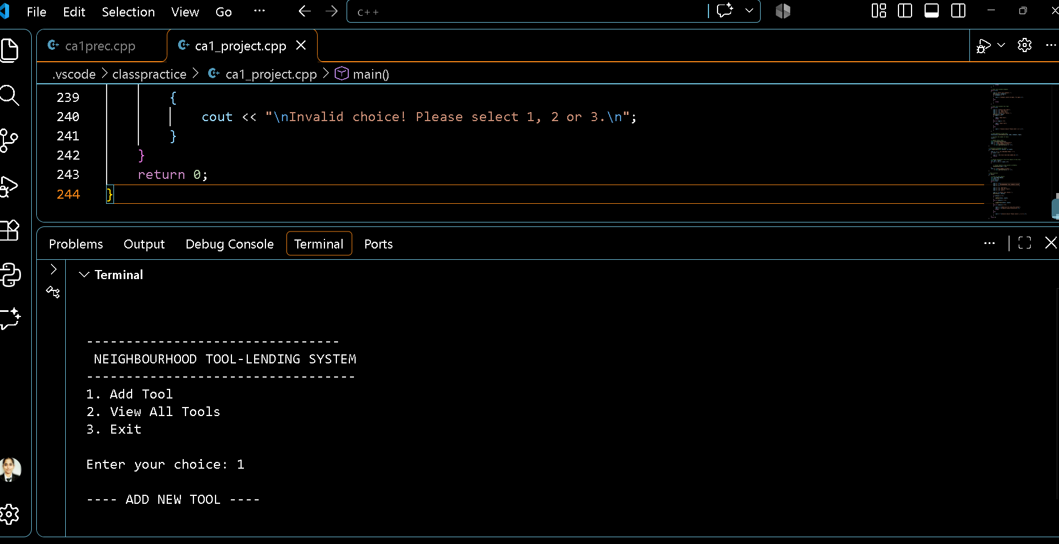
Figure 3: Main menu and Add Tool prompt

11.2 Successful Addition of a Tool
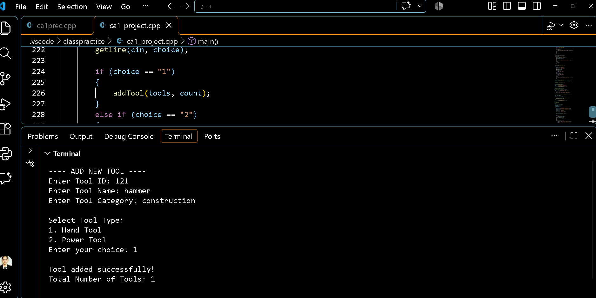
Figure 4: Tool added successfully with updated total

11.3 Duplicate ID Rejection
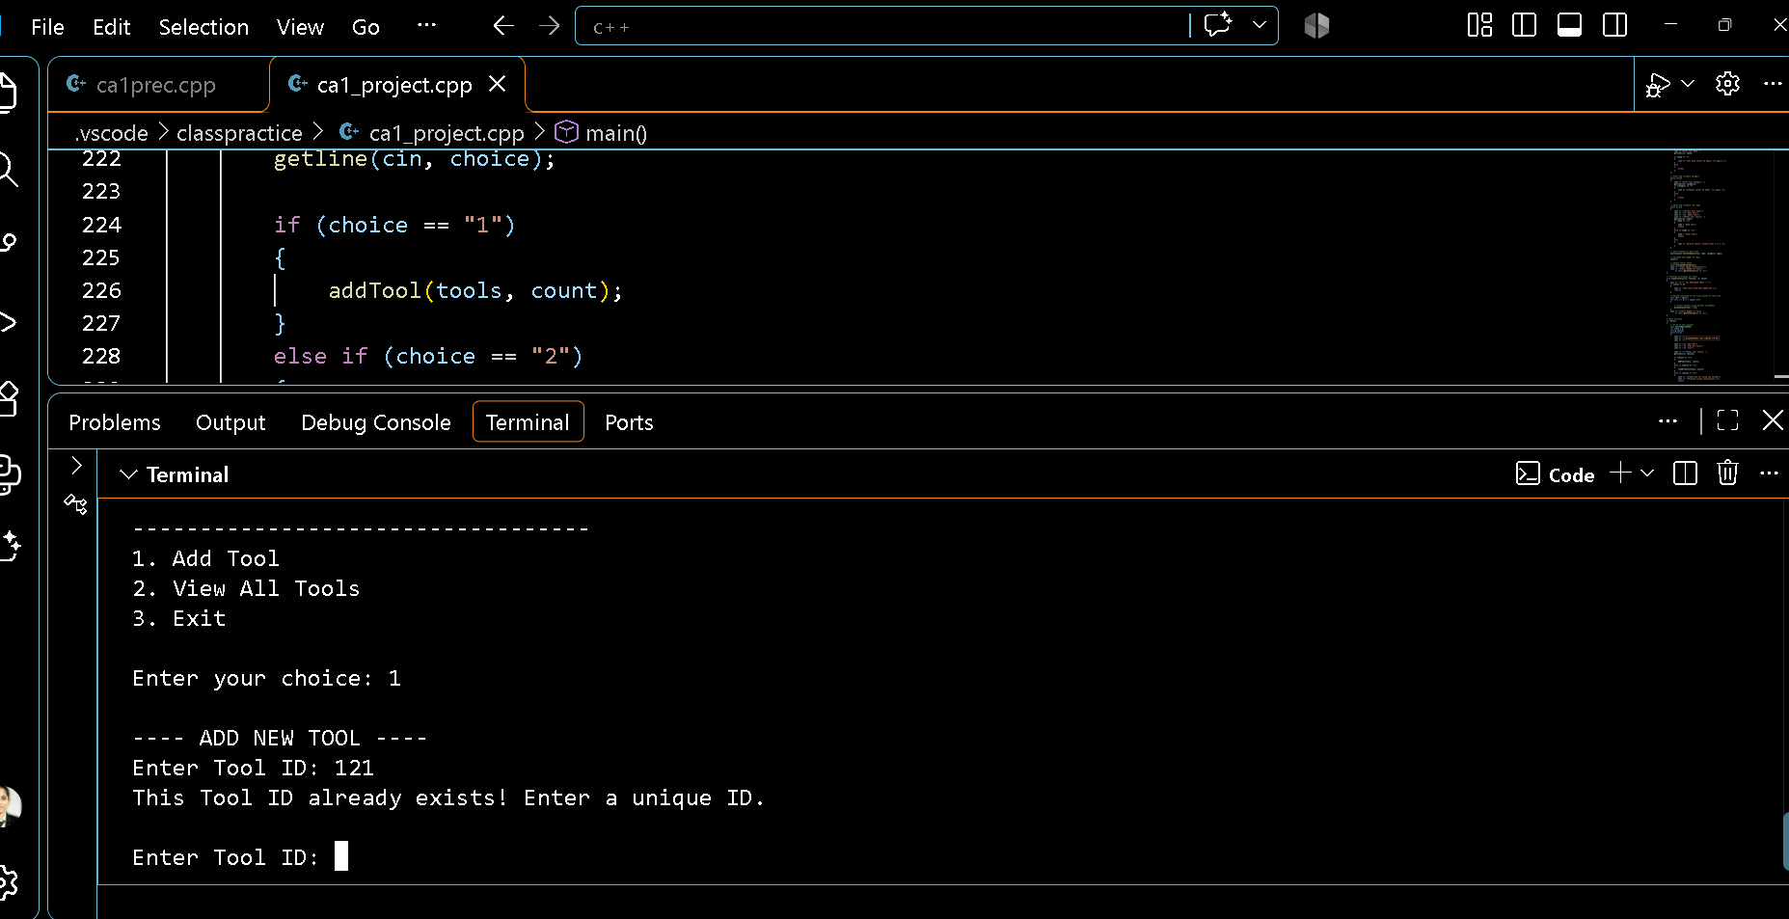
Figure 5: Duplicate Tool ID rejected

11.4 View All Tools
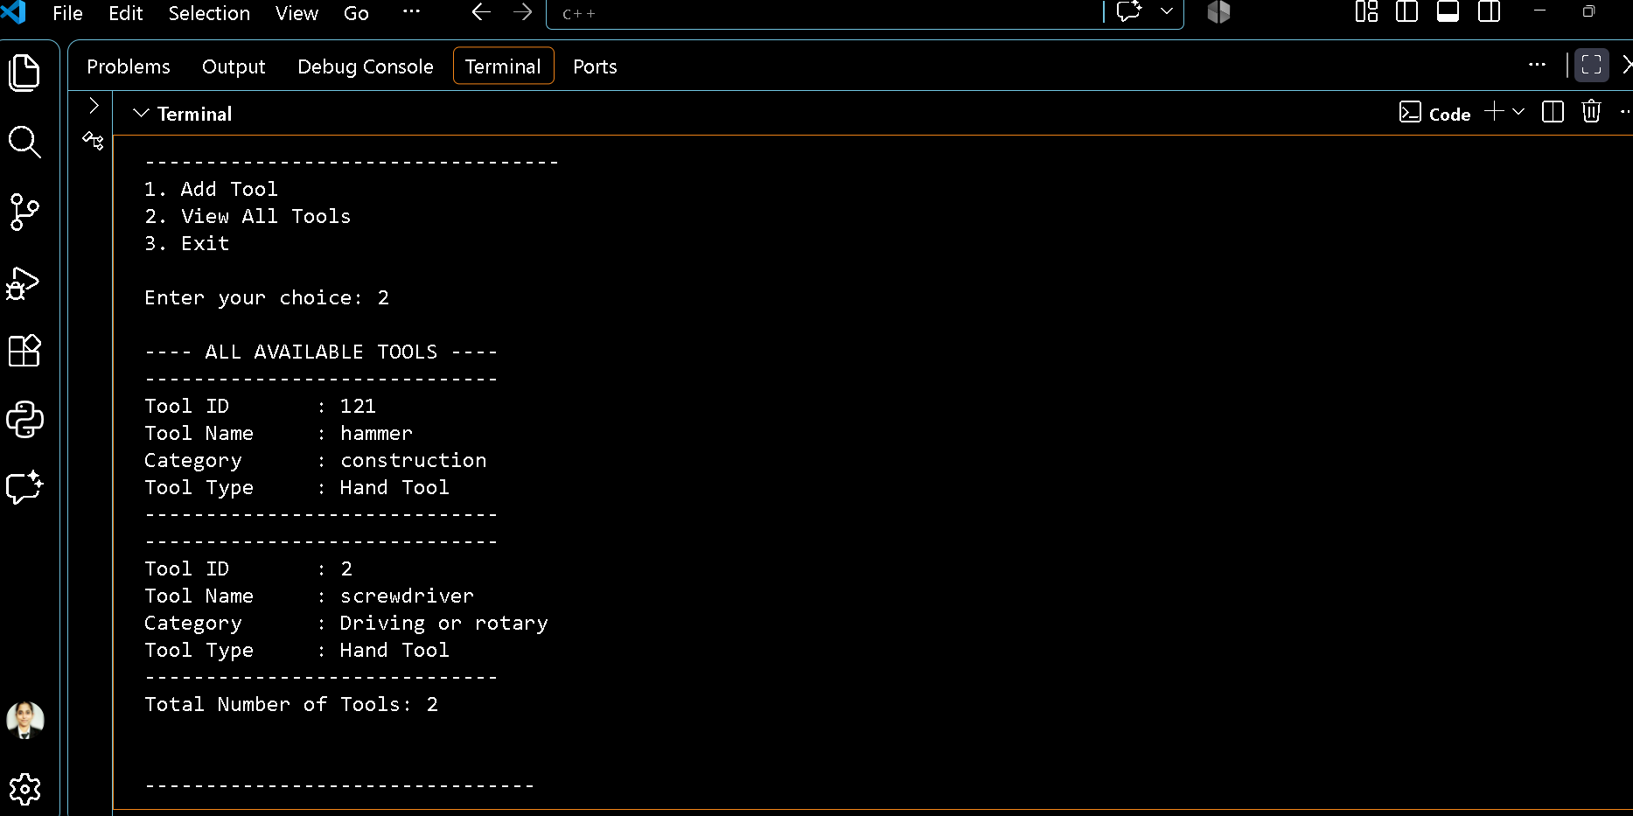
Figure 6: Display of all stored tools with total count

12. Future Enhancements
- CA2: Add constructors and a destructor as required, and introduce file handling using fstream and binary records so that data remains available after the program restarts.
- CA3: Introduce inheritance, operator overloading, type conversion, dynamic memory, virtual functions and safe update and delete operations.
- CA4: Provide complete CRUD operations, exception handling, templates, STL containers and algorithms, and an advanced feature such as backup or CSV export.
- Later application features: borrower details, issue and return dates, condition reporting, lost or broken tool status and fine calculation.

13. Conclusion
The CA1 version of the Neighbourhood Tool-Lending System provides a reliable way to add and display tool records in a console environment. It validates required fields and prevents duplicate tool IDs. The implementation demonstrates key C++ concepts, including classes, objects, static members, inline functions, friend functions, arrays of objects, pointers, the this pointer and strings.
The current phase is limited to in-memory Create and Read operations. Permanent file storage and lending-related features are planned for later phases and form the basis for future development.

