# Assignment: Calculator Microservices on Kubernetes

## 1. Introduction

we demonstrate the deployment of a calculator application split into five microservices (home, add, sub, mul, div), containerized using Docker, and orchestrated with Kubernetes on Minikube.

## 2. Prerequisites

- Docker Desktop (or Docker CLI)

- Minikube CLI

- kubectl

- (Optional) Apache Benchmark (ab) or PowerShell for stress testing

## 3. Steps

### 3.1 Build Docker Images

Run the following commands from the project root:

```  
docker build -t calc-home:v1 ./home  
docker build -t calc-add:v1 ./add  
docker build -t calc-sub:v1 ./sub  
docker build -t calc-mul:v1 ./mul  
docker build -t calc-div:v1 ./div  
```

Screenshot:

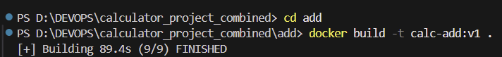

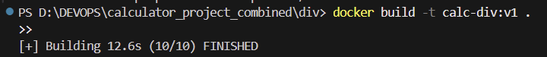

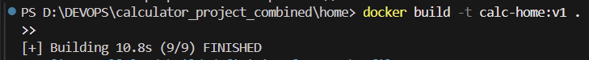



### 3.2 Deploy to Kubernetes

Apply all YAML files in the k8s directory:

```  
kubectl apply -f k8s/  
```

Screenshot:

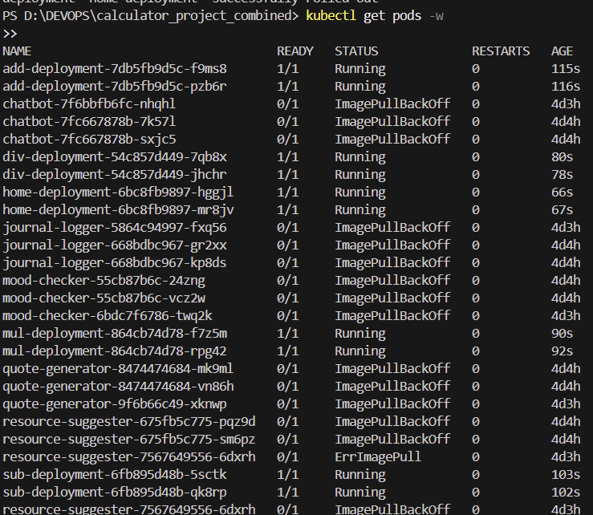

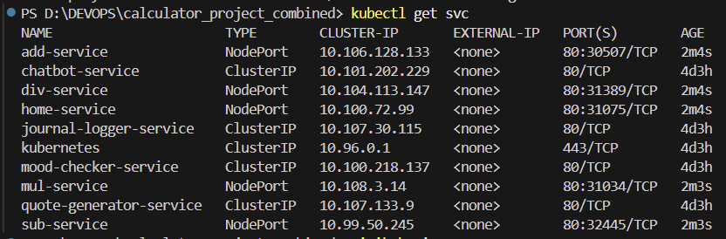

### 3.3 Expose Services

Use minikube service to access each microservice:

```  
minikube service add-service  
minikube service sub-service  
minikube service mul-service  
minikube service div-service  
minikube service home-service  
```

Screenshot: 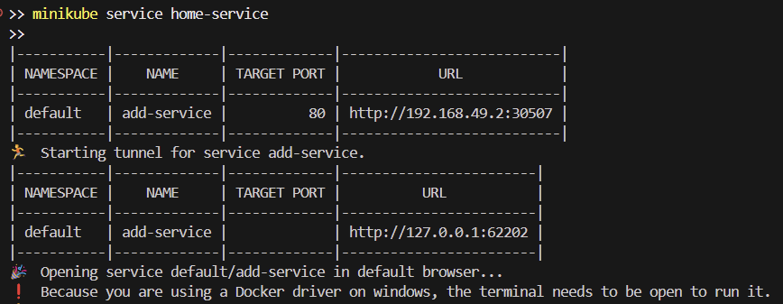

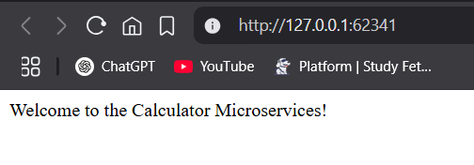

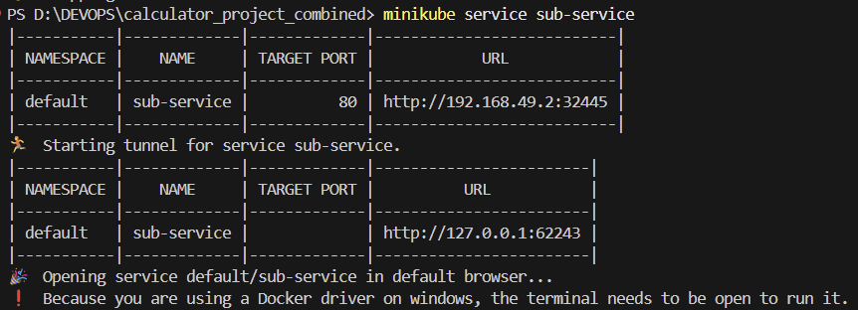

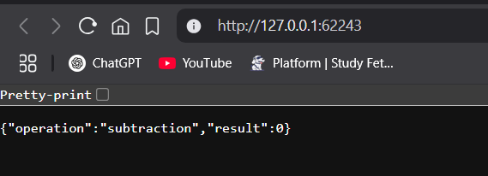

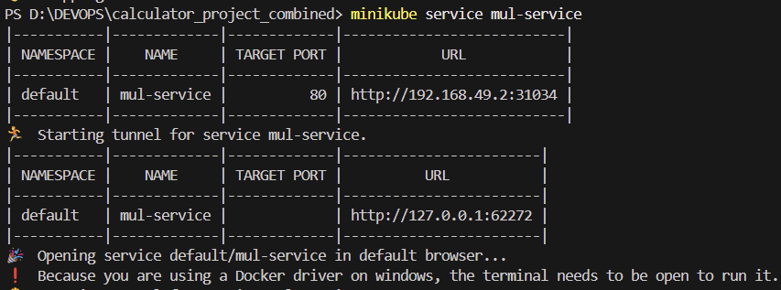

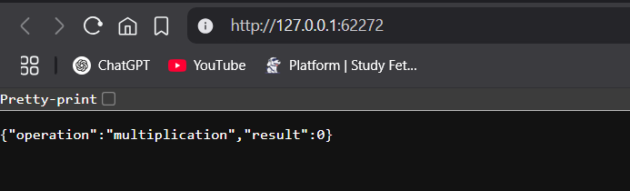

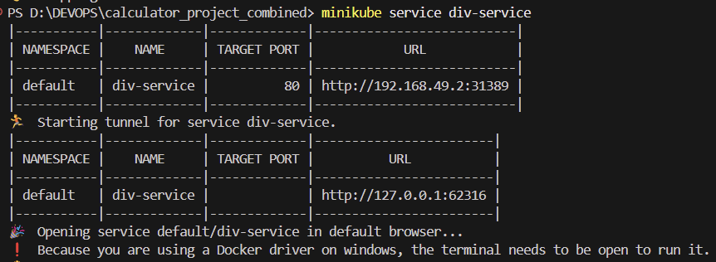

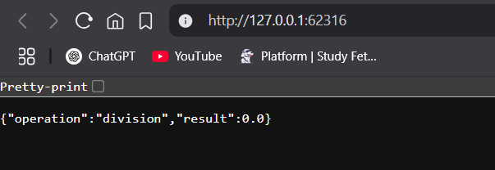

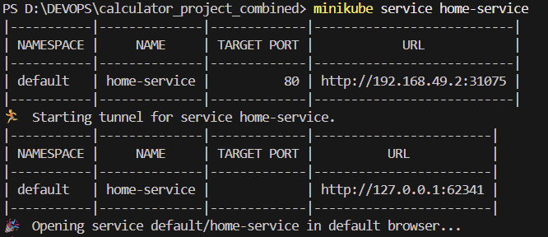

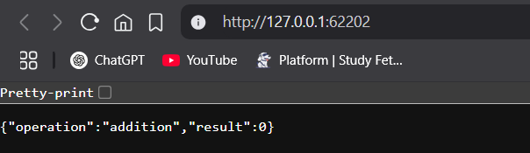

### 3.4 Enable Horizontal Pod Autoscaler (HPA)

Enable metrics-server and apply autoscaling:

```  
minikube addons enable metrics-server  
kubectl autoscale deployment add-deployment --cpu-percent=50 --min=2 --max=5  
```

Screenshot: 

### 3.6 Cleanup

Delete resources and stop Minikube:

```  
kubectl delete hpa add-deployment  
kubectl delete -f k8s/  
minikube stop  
minikube delete  
```