Lab 3a: Cryptography Lab
In this lab, you will be using the Ubuntu 23 VM (the same as in the previous lab). The credentials are:
Username: osboxes
Password: osboxes.org (The superuser password is the same: “osboxes.org”.)

NOTE: Ignore/reject the suggestions on software updates for the VM.

NOTE: Address all the questions (Q1, Q2, etc.) marked in bold. When a screenshot is requested, try to fit all the results in one image. If this is not possible, then attach multiple screenshots.

When a question is asked, e.g. “Who is the owner of the file?”, type your answer, do not simply provide a screenshot.

IMPORTANT NOTE: Before starting the lab, you must customize your command prompt as described in the Command Prompt Customization Manual. This customization manual directs you to place your EUID (Enterprise User ID) into the command prompt. Submissions which do not comply with this requirement will receive no credit.

Introduction

The learning objective of this lab is to get some hands-on experience with the basic cryptographic primitives: symmetric encryption, public-key encryption, and digital signatures.
Also, you will get familiar with two applications: public-key certificates, and SSH authentication. This lab is mainly based on OpenSSL (https://www.openssl.org/)—a toolkit for the Transport Layer
Security (TLS) protocol, and a general-purpose cryptographic library. It is pre-installed on Ubuntu.

Section 1: Symmetric Encryption using OpenSSL

In this section, let us work with the AES cipher (symmetric encryption algorithm). In OpenSSL, symmetric encryption is performed using the “openssl enc” command and the option “-d” is used for decryption. You may type “man openssl” to learn more.

- In your home directory, create a text file plaintext.txt and write a sentence “This is my secret message” into it (make sure to close the file). To confirm, type:
cat plaintext.txt

Save a screenshot of the result.

- Let us now encrypt this file using a password. Read the below explanation first, and then type: openssl enc -aes-256-ctr -pass pass:euid -pbkdf2 -in plaintext.txt -out ciphertext.bin
The first option requests to use the AES-256 cipher in the counter (CTR) mode. The second option defined a password to be used for encryption, and the next option requests to use
the PBKDF2 algorithm for generating a key from the password.
In this exercise, for simplicity, use your EUID as a password (for example, if your EUID is “aa0001”, then the respective option will be written as “-pass pass:aa0001”). Note that in practice, such a password should never be used as it is very weak (i.e., too short and too easy to guess). The remaining options define the filenames for input (the plaintext) and output
(the ciphertext).
Note: If the “-pass” option was not used, then utility would request the password to be entered manually (two times – the second one for confirmation). Alternatively, the user may supply the key, initialization vector, and any other required parameters: type “man openssl” for details.

- Display the contents of the ciphertext file: hexdump -C ciphertext.bin
Save a screenshot of the result.

Q1: Attach the following screenshots:
- The screenshot showing the plaintext created in Step 2.
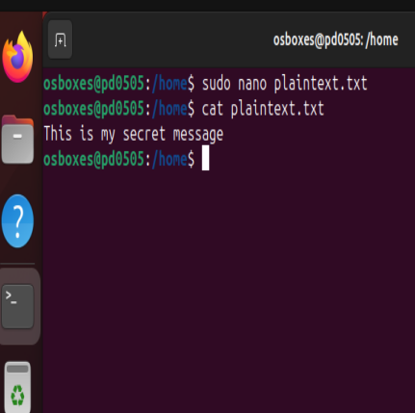

The screenshot showing the ciphertext created in the above step.

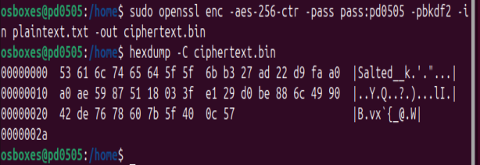

- For decryption:
openssl enc -aes-256-ctr -pass pass:euid -pbkdf2 -d -in ciphertext.bin -out plaintext_dec.txt

Note: If the “-pass” option was not used, then the utility would request the password to be entered manually.

- To confirm, type: cat plaintext_dec.txt
Note that the original message has been decrypted.

Q2: Attach a screenshot of the result.

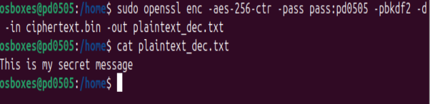

- It is possible to encode the ciphertext using Base64 (with “-a” option), in order to have it in the text format:
openssl enc -aes-256-ctr -a -pass pass:euid -pbkdf2 -in plaintext.txt -out ciphertext.txt

- Type:
cat ciphertext.txt

- Verify that decryption works correctly:
openssl enc -aes-256-ctr -d -a -pass pass:euid -pbkdf2 -in ciphertext.txt -out plaintext_dec2.txt

Note: If the option “-out” is omitted, the standard output is used.

- Run the encryption again with the same password, but write the output into ciphertext2.txt: openssl enc -aes-256-ctr -a -pass pass:euid -pbkdf2 -in plaintext.txt -out ciphertext2.txt
- Note that the decryption works correctly again:
openssl enc -aes-256-ctr -d -a -pass pass:euid -pbkdf2 -in ciphertext2.txt

- Now, note that the ciphertexts are different. To verify, type: cat ciphertext.txt ciphertext2.txt

Q3: Attach a screenshot of the result of the above step.
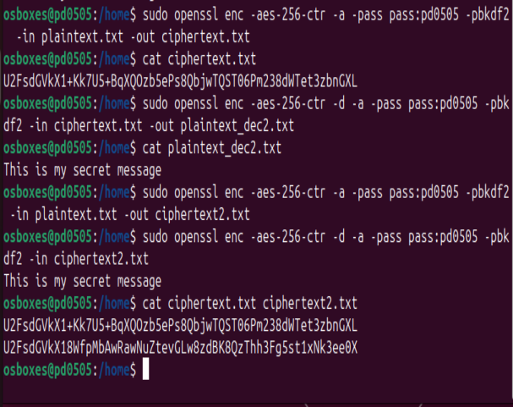

Explain why the ciphertexts in ciphertext.txt and ciphertext2.txt are different, even though the same password was used for encryption.
Hint: To get a better idea of how the encryption/decryption works, run the decryption of both files again, but now add the “-p” option to the original command.
Answer: While decrypting the files using -p command displays the salt value the key and IV, all of them being different among two files as shown in the screen shot below:

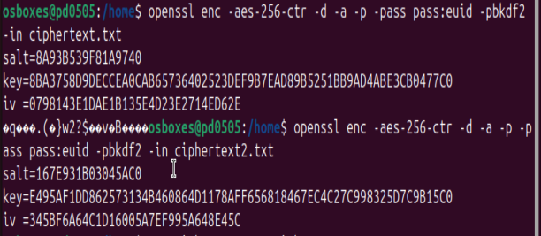
According to research, PBKDF2 stands for Password-Based Key Derivation Function, a function where a key is generated from the password. (Vettivel, 2022). Each time the encryption is run, a new salt is randomly generated, this random salt results in different encryption keys and initialization vectors. (Why Does Openssl Derive IVs From a Password?, n.d.). This ensures that, even when a user uses the same password on multiple occasions, the ciphertext produced will always be unique.

Section 2: Public Key Encryption and Digital Signatures Using OpenSSL
Let us focus on the RSA algorithm in this section.

- First, let us generate an RSA private key.
Note: actually, we will generate the public/private key pair, but a private key file in OpenSSL also contains the public key.
Type:
openssl genrsa -out euid.key 3072

As usual, replace “euid” with your actual EUID.

This command generates the RSA private key and outputs it to the file euid.key. The key is stored in the PEM format. Display it:
cat euid.key

Save a screenshot of the result.

- Next, we extract and display the public key: openssl rsa -in euid.key -pubout -out euid_pk.key cat euid_pk.key
Q4: What security level does 3072-bit RSA Key Offer?
Answer: According to Table 2 of NIST SP-800 56B, 3072-bit RSA offer 128-bit level security. (Barker et al., 2018/2018).

Attach the following screenshots:
- A screenshot showing the result of Step 12.
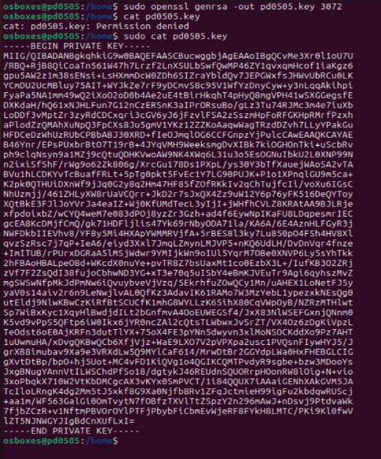

A screenshot showing the result of the above step.
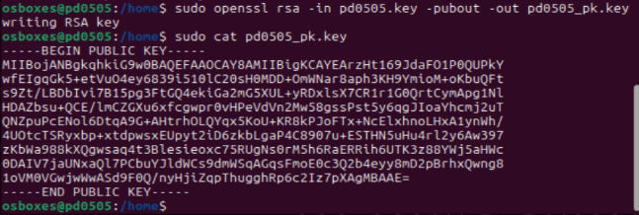

- For encrypting the plaintext.txt, type:
openssl pkeyutl -encrypt -pubin -inkey euid_pk.key -in plaintext.txt -out rsa_ciphertext.bin

- For decryption, type:
openssl pkeyutl -decrypt -inkey euid.key -in rsa_ciphertext.bin -out rsa_plaintext_dec.txt cat rsa_plaintext_dec.txt

Q5: Attach a screenshot of the result.

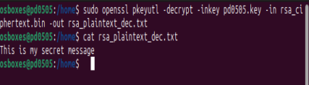

Note: The above method is suitable for encryption of short messages (up to about 1 kilobyte), for longer messages a hybrid encryption (KEM/DEM) should be used.

- To digitally sign the file plaintext.txt, type:
openssl dgst -sign euid.key -out sig.bin plaintext.txt

Note: As of version 1.1.1, OpenSSL signs messages directly when using the rsautl or pkeyutl commands. For this reason, it is simpler to deploy the dgst command, in order to hash and sign the message with one command.

Display the signature:
hexdump sig.bin

- To verify the signature:
openssl dgst -verify euid_pk.key -signature sig.bin plaintext.txt Save a screenshot of the result.
- Any changes in the message will invalidate the signature. Let us replace the last letter in our message:
echo "That is my secret message" > plaintext.txt cat plaintext.txt
- Now, verification will fail:
openssl dgst -verify euid_pk.key -signature sig.bin plaintext.txt
Q6: Attach the following screenshots:
- The screenshot showing the result of Step 17.
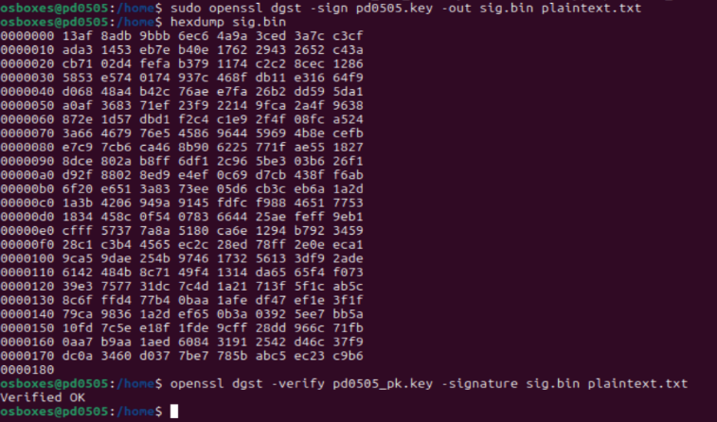

- The screenshot showing the result of the above step.
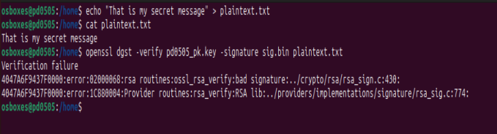

Section 3: Public Key Certificates Using OpenSSL
Let us now study handling of X.509 public key certificates using OpenSSL.
Suppose that we would like to create a certificate signing request (CSR) to the Certificate Authority for the RSA key, which we generated earlier. The following command can be used (do not type it yet):

openssl req -key euid.key -new -out euid_domain.csr

Then, the utility will request some additional information, which is called a Distinguished Name (DN). An important field in the DN is the Common Name (CN) —it should be the exact domain name of the host for which the certificate will be used. Below is an example of the prompt:

Country Name (2 letter code): The two-letter country code where your company/organization is legally located. Example: US
State or Province Name (full name): Example: Texas Locality Name (e.g., city): Example: Denton
Organization Name (e.g., company): University of North Texas
Organizational Unit Name (e.g., section): Department of Computer Science and Engineering (this field is optional)
Common Name (e.g. server FQDN): Fully Qualified Domain Name; Example: www.unt.edu Email Address: Example: webmaster@unt.edu (this field is optional)

It is possible to enter all of the above information from the command line as described below.

- Type:
openssl req -key euid.key -new -out euid_domain.csr \
-subj "/C=US/ST=Texas/L=Denton/O=UNT/OU=CSE/CN=www.euid.edu"
- Let us verify the result:
openssl req -text -in euid_domain.csr -noout -verify

Q7: Attach a screenshot of the result.

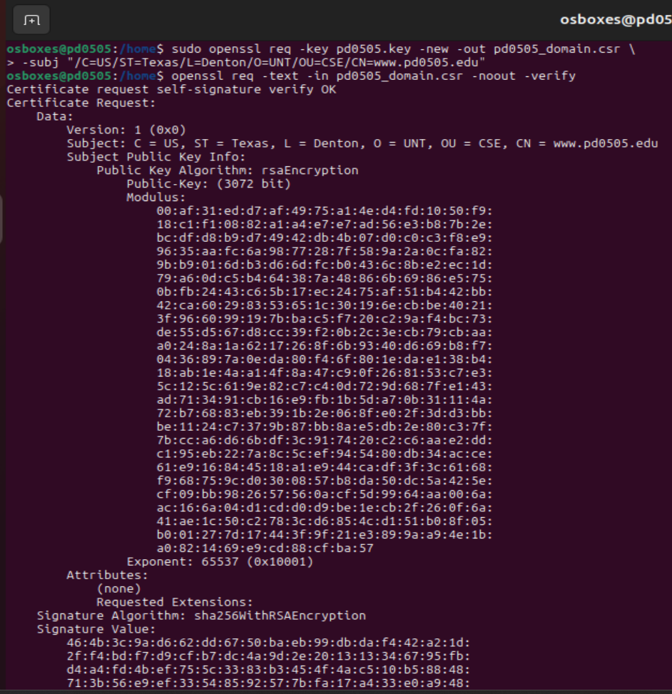
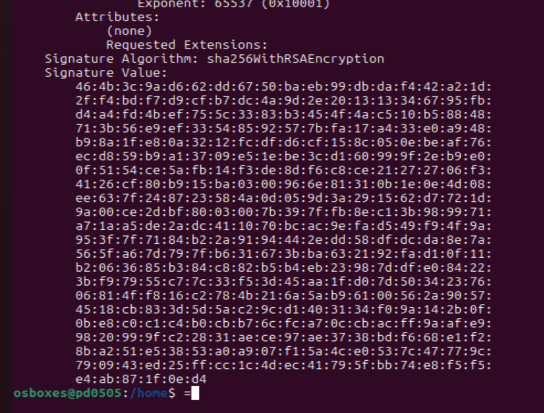

Note: The CSR file “euid_domain.csr” will need to be sent to CA that will check the user information. If the check is successful, CA will issue the certificate file. We will omit this step in this lab. Instead, we will obtain and verify the certificate of the Google webserver. For that, we will use the s_client utility (a part of the OpenSSL suite) which implements a generic SSL/TLS client.

- Type:
openssl s_client -connect google.com:443 < /dev/null

Note: The redirection from the null device immediately closes the s_client program, as in general it expects commands to establish the TLS connection.

- In order to display the whole certificate chain, type:
openssl s_client -connect google.com:443 -showcerts < /dev/null

- Since the output of the previous command takes several screens to be displayed, making
a picture of the last screen may not be very informative. The “more” command will be helpful in this case. Type:
openssl s_client -connect google.com:443 -showcerts < /dev/null | more
Note: Scrolling is done by pressing “Space” to advance the whole screen down, or “Enter” to advance one line.

Q8: Attach the following two screenshots: The first and the last screen displayed as a result of the above command.
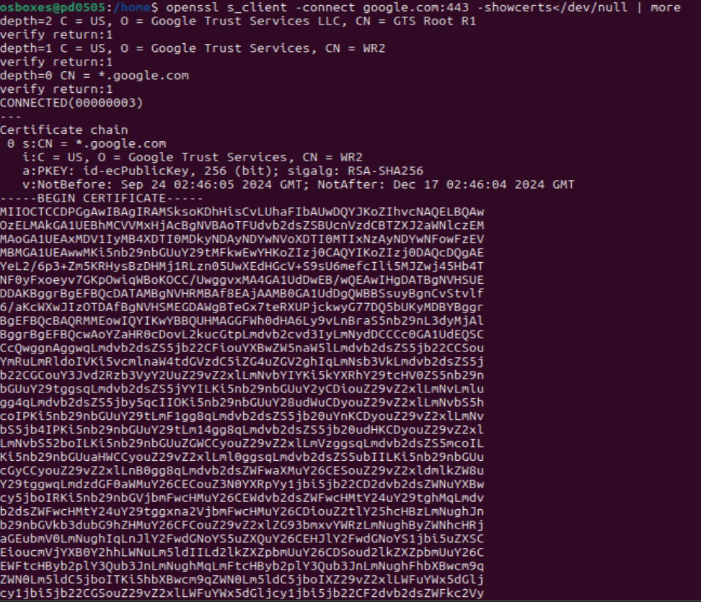

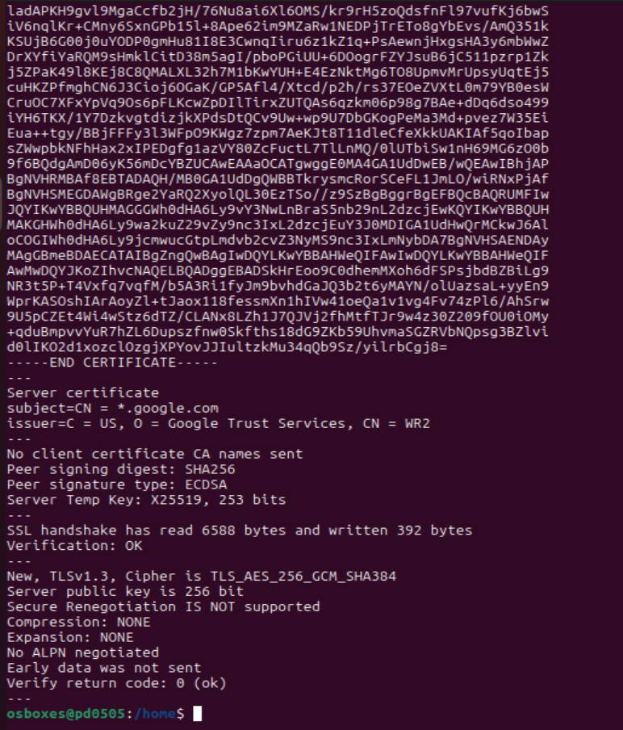

Section 4: SSH Authentication Using Public Keys
OpenSSH can use public key cryptography for authentication. We will use a freshly generated RSA key pair. (Remark: We could have also used the RSA key from the previous steps, but we will not do it in this lab.)

- Type:
ssh-keygen -t rsa

Note: You will see the following prompts—you may just press “Enter” for all of them—and the following messages will be displayed:

Enter file in which to save the key (/home/sec-lab/.ssh/id_rsa):
Enter passphrase (empty for no passphrase):
Enter same passphrase again:
Your identification has been saved in /home/sec-lab/.ssh/id_rsa
Your public key has been saved in /home/sec-lab/.ssh/id_rsa.pub The key fingerprint is:
SHA256:lsfwRd7HQmfPZ+rjQOGjLkyr+M67/xImKZRtVD31T9s sec-lab@vm1

(Note: The above value and the below “randomart” image will be different each time for each student. The randomart image is a visualization of the SHA256 hash value to make it easier to compare.)

The key's randomart image is:
+---[RSA 3072] +
|  |  | | ... .o . o|  . oo + =.|  + . .+ + O|
| | o o = o . B+|
| | . . .S + + ..E|
| | . o.+. o o |
| | . = o. . o |
| | o =. o . |
| | .oB=.+o . |
+----[SHA256] +

Note: In practice, the passphrase should be chosen as a secure password in order to restrict usage of the private key. In this lab, we use an empty password for simplicity.

Q9: Attach a screenshot of the result.
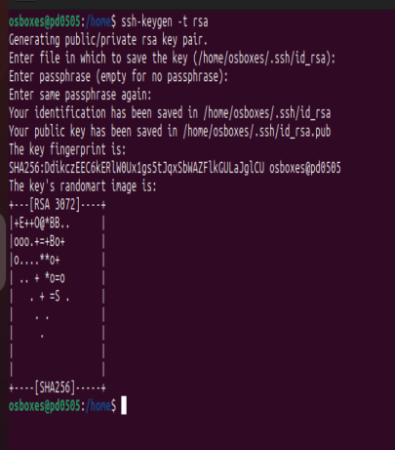

- Let us verify the result: ls ~/.ssh/
You may expect to see two files: id_rsa and id_rsa.pub, which should contain the private and public keys, respectively.

- Let us try to establish an SSH connection (for simplicity, we will connect to our own host):
ssh localhost

The SSH server will request a password. Press “Control+Z” to escape. Suppose that we want to allow trusted users to access our host without entering a password. Such a user needs to possess a private key corresponding to the public key communicated to the server in a trusted manner. Such the public keys are called “authorized keys”.

- Designate your public key as the OpenSSH authorized key as follows: cp ~/.ssh/id_rsa.pub ~/.ssh/authorized_keys
- This should allow us to establish an SSH connection (to our own host) without the use of passwords:
ssh localhost // if the prompt about adding to the known hosts appears, then accept it (If successful, a welcome message will be displayed.)
Close the SSH connection:
exit

Q10: Attach a screenshot of the result.
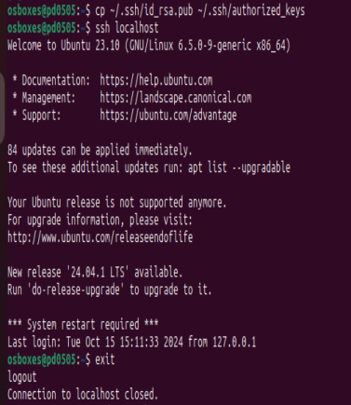

References:

- OpenSSL documentation: https://docs.openssl.org/master/
- Using AES with OpenSSL to Encrypt Files: https://devops.datenkollektiv.de/using-aes-with- openssl-to-encrypt-files.html
- OpenSSL Cookbook, 3ed online: https://www.feistyduck.com/library/openssl-cookbook/online/
- OpenSSL Quick Reference Guide:
https://www.digicert.com/kb/ssl-support/openssl-quick-reference-guide.htm
- M. Anicas: OpenSSL Essentials: Working with SSL Certificates, Private Keys and CSRs: https://www.digitalocean.com/community/tutorials/openssl-essentials-working-with-ssl- certificates-private-keys-and-csrs
- Wikibook on OpenSSH/Cookbook/Public Key Authentication: https://en.wikibooks.org/wiki/OpenSSH/Cookbook/Public_Key_Authentication
Additional Reference:
- Barker, E., Chen, L., Roginsky, A., Vassilev, A., Computer Security Division, Davis, R., Simon, S., & National Security Agency. (2018). Recommendation for Pair-Wise Key-Establishment Using Integer Factorization Cryptography. In NIST Special Publication (SP) 800-56B Revision 2 [Recommendation]. National Institute of Standards and Technology. https://csrc.nist.gov/CSRC/media/Publications/sp/800-56b/rev-2/draft/documents/sp800-56Br2-draft.pdf (Original work published 2018)
- Vettivel, N. (2022, January 5). PBKDF2 Hashing Algorithm - Nishothan Vettivel - Medium. Medium. https://nishothan-17.medium.com/pbkdf2-hashing-algorithm-841d5cc9178d
- Why does openssl derive IVs from a password? (n.d.). Cryptography Stack Exchange. https://crypto.stackexchange.com/questions/51482/why-does-openssl-derive-ivs-from-a-password

