Lab 3b: Password Cracking Lab
In this lab, you will be using the Ubuntu 23 VM (the same as in the previous lab). The credentials are:
Username: osboxes
Password: osboxes.org (The superuser password is the same: “osboxes.org”.)

NOTE: Ignore/reject the suggestions on software updates for the VM.

NOTE: Address all the questions (Q1, Q2, etc.) marked in bold. When a screenshot is requested, try to fit all the results in one image. If this is not possible, then attach multiple screenshots.

When a question is asked, e.g. “Who is the owner of the file?”, type your answer, do not simply provide a screenshot.

IMPORTANT NOTE: Before starting the lab, you must customize your command prompt as described in the Command Prompt Customization Manual. This customization manual directs you to place your EUID (Enterprise User ID) into the command prompt. Submissions which do not comply with this requirement will receive no credit.

Section 1: Password Cracking with JtR
The objective of this lab is to apply both brute-force and dictionary attacks using a popular password cracker tool, John the Ripper (we will call it “JtR” for short). This software is commonly used for offline attacks, when the password hash is available to the attacker.

The attacker will be logged in with the usual credentials (osboxes/osboxes.org). Now, let us create the victim’s account.
- Add a user “test” and set its password as “smile”. You may refer to the manual of Lab 0 for the help on how to add a user in Linux. (Ignore the system warning that the password is too short.)
Save the screenshot of the result. Next, we install JtR.
- Run the following command: sudo apt install john
We will also need a utility called “Crunch”. It will be used to generate a list of passwords to be checked.

- Run the following command: sudo apt install crunch

Q1: Attach the following screenshots:
- The screenshot showing the result of Step 1.
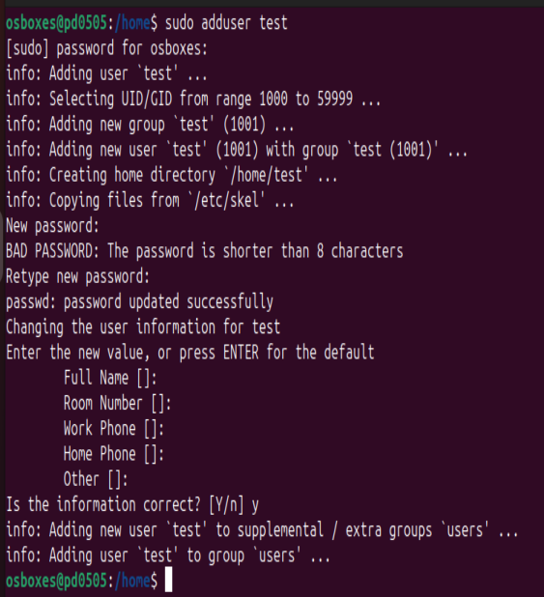

The screenshot showing the result of the previous step.
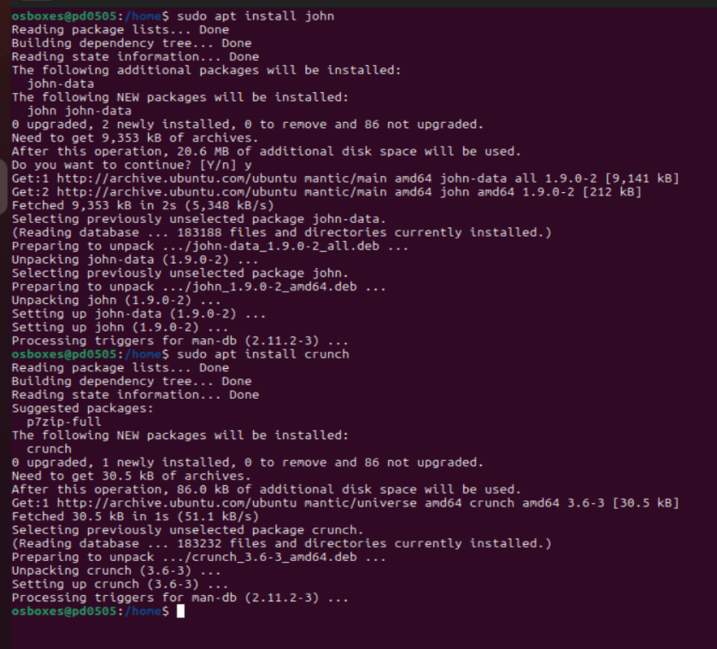

Our scenario will be as follows: suppose that the user “osboxes” is an attacker who has access to the password file. The attacker is interested in finding the password of the user “test”.

Let us first run a dictionary attack. For that, we will need a list of the commonly used passwords. We will use the one from the RockYou 2009 security breach. It contains about 32 million passwords. (The current version of this list contains billions of passwords, but we will not use it to make our job simpler.)

- Download the archive file “rockyou.txt.gz” from https://gitlab.com/kalilinux/packages/wordlists, unpack it, create the folder “plist” in your home folder and copy the password list “rockyou.txt” to “~/plist”.

We can check the 10 most popular passwords on the RockYou 2009 list.

- Run the following command: head -n 10 ~/plist/rockyou.txt
Save a screenshot of the result.

We know that the user information is stored in the file /etc/passwd but the password hashes are stored in the file /etc/shadow. Let us combine them first:

- Run the following command (you will need the superuser privilege): unshadow /etc/passwd /etc/shadow > john.txt
Now, the combined password file is in “john.txt”, but we only want to attack the last created user “test”. So, we will place its information into a separate file.

- Run the following command: tail -n -1 john.txt > test.txt
Let us check that we got the correct data:

- Run the following command:

cat test.txt

Save a screenshot of the result.

You may expect to see something like this:

test:$y$j9T$F5Jx5fExrKuPp53xLKQ..1$X3DX6M94c7o.9agCG9G317fhZg9SqC.5i5rd.RhAtQ7:19982:0:99999:7:::

It is important to verify that the fist name is “test”. The contents between the next two colons is the hash of the password, followed by the system parameters.

Let now run the password attack.

- Run the following command:

john --format=crypt --wordlist=plist/rockyou.txt test.txt

Now, the attacker “osboxes” can gain privileges of the victim “test” by switching to this user.

- Run the following commands:

su test (and then enter the password of the user “test”.) whoami

Q2: Attach the following screenshots:
- The screenshot showing the result of Step 5.

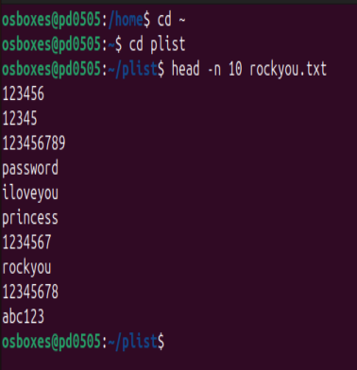

The screenshot showing the result of Step 8.

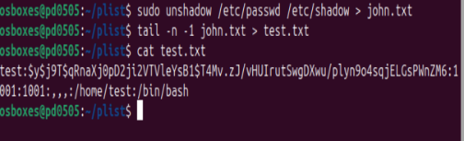

- The screenshot showing the result of Step 9.
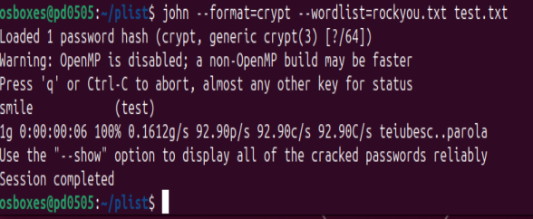

The screenshot showing the result of the previous step.

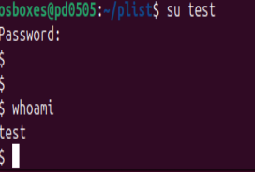

Notice the execution time of the attack in Step 9. The password was found quite quickly. Now, suppose that the dictionary attack was unsuccessful. This means that the password was not in the list. Of course, the attacker may try different lists and try to physically steal the password like look over the victim’s shoulder or steal the physical media on which the password is stored (such as a notebook or a USB drive). Suppose that this is not possible, then the remaining option is to try all possible password till the correct one is found – this is called the “brute-force attack”. Note that it may take a very long time depending on the password choice, because the size of the list is growing exponentially with the password length. Still, note that the attacker may run it for a long time, like months and even years. Therefore, it is a good practice to change one’s password for critical resources at least once in a year or two.
First, let us try a very simple example: a two-letter password “fg”.

- Change the password of the user “test” to “fg”, and repeat Steps 5-6 to update the password file.

The following command will take a password list generated by the Crunch utility, which contains all two-letter passwords (in lowercase).

- Run the following command:

crunch 1 2 | john --format=crypt --stdin test.txt

Q3: Attach a screenshot of the result. Compare the execution time with that of Step 9.

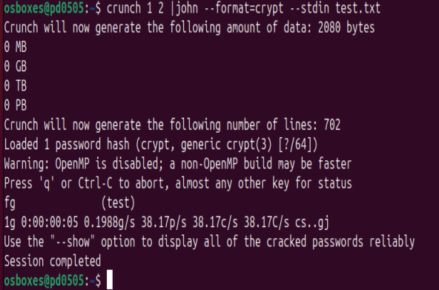

This time password was cracked in 5 seconds whereas in the previous attempted it took 6 seconds.

Again, the password was found quite quickly. Let us now increase the password length and notice the change in the running time of the attack.

- Change the password of the user “test” to “fgh” and repeat Steps 5-6 to update the password file.

- Run the following command:

crunch 1 3 | john --format=crypt --stdin test.txt

(You may need to wait some time till the password is found.)

Q4: Attach a screenshot of the result. Compare execution time with those of Step 9 and Step 11.

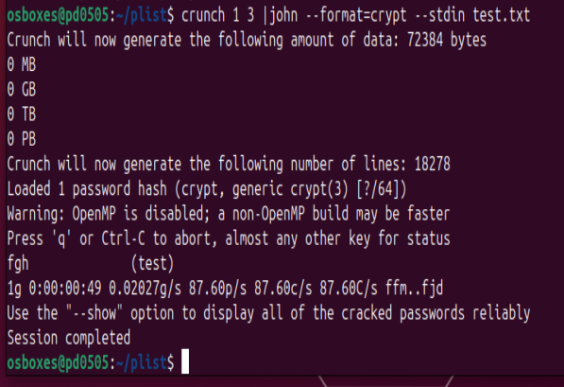

This time the password was cracked in 49 seconds taking much longer time compared to the previous one where it took 6 seconds.

Of course, the password consisting of only three letters is very insecure. Even though it may take a very long time to test all possible N-letter passwords on our computer, it is not evidence that N is a secure password length. This is because an attacker may have access to substantial computing resources such as supercomputers. In particular, the Payment Card Industry Data Security Standard (PCI DSS) version
4.0 required the passwords of at least 12 characters.

JtR provides a lot of options which optimize the password search. For example, it allows a search for the strings which are similar to a known password. Full details can be found here: https://www.openwall.com/john/

Section 2: Password Cracking with Hydra
Next, let us consider online attacks. Suppose that you are an attacker who has access to some service, and you are interested in finding the password of another user. The password cracking tool called Hydra can be used in this scenario. Hydra supports many protocols, including (but not limited to) FTP, HTTP, HTTPS, MySQL, MSSQL, Oracle, Cisco, IMAP, VNC, and many more. One should note however that this type of attack may be detected due to multiple login attempts.
We can use Hydra through the terminal or the GUI application (xHydra); however, the terminal gives us more flexibility and control. Therefore, we will use the latter option in this lab.

Hydra runs as follows: hydra <parameters> <IP> <PROTOCOL>. In this lab, we will login as the user “osboxes” and will run an attack against the SSH password of the user “test” on the same host. Hence, we will use 127.0.0.1 for IP and for the PROTOCOL, we will use SSH. (You can find all the detais on Hydra using the “man hydra” command.) In this lab, we will use multiple threads (-t <#THREADS>, specifically, we can use 4), and specify the username of the target (-l <USERNAME>).
The online attacks runs substantially slower as compared to the offline attacks in the previous session. For this reason, just to demonstrate the concept, we will run a brute-force attack against a very short password.

- Change the password of the user “test” to “bc”.

In our brute-force attack, we will have Hydra generate all the two-letter combinations for us using -x parameter (-x MIN:MAX:LETTERS format, where min and max number of letters are given and then the type of the letters are provided). In our case, we will set both min and max to 2. The parameter “a” will define the search for lowercase letters. Hence, our options will be set as “2:2:a”.
Remark: If we had upper case only, then it would be 2:2:A, or if we had both, it would be 2:2:aA. One could also include numbers, such as 2:2:aA1. For now, we will not use these options for the simplicity sake.
Hydra does not automatically provide the execution time of the attack, so we use the “time” command. The option “-f” will have Hydra stop once the password is found.

- Run the following command:

time hydra -f -t 4 -l test -x 2:2:a 127.0.0.1 ssh

Now, the attacker “osboxes” can login as the user “test” via SSH.

- Run the following commands: ssh test@127.0.0.1
(Answer “yes” to the question about the fingerprint and enter the password of the user “test”.) exit (To exit the remote shell.)

Q5: Attach the following screenshots:
- The screenshot showing the result of Step 16.

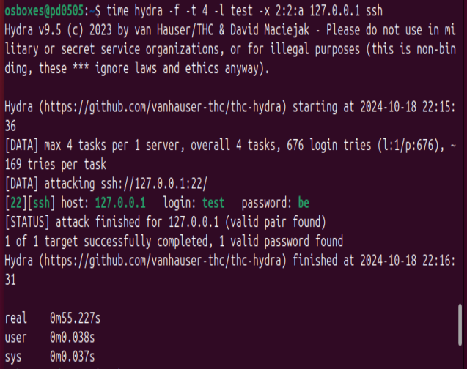

The screenshot showing the result of the previous step.

