Lab 5:

Cross-Site Request Forgery (CSRF) Attack Lab
This lab will be based on the SEED Lab (https://seedsecuritylabs.org/Labs_16.04/Web/Web_CSRF_Elgg/),
which uses the SEEDUbuntu-16.04-32bit VM (https://seedsecuritylabs.org/lab_env.html). See https://seedsecuritylabs.org/Labs_16.04/Documents/SEEDVM_VirtualBoxManual.pdf for the manual on importing the SEEDUbuntu VM into VirtualBox.
Follow the 7 steps in “How to Use Virtualbox to Run SEEDUbuntu VM”.
For this lab, you do not need to configure the network (as explained in the Appendix B). In VirtualBox, for the SEED Ubuntu VM, click in the menu Machine → Settings…, “Network” section, in “Attached to”, set “NAT”.

This document contains customizations, questions, and additional instructions specific to how this SEED lab is conducted for this course.

NOTE: Before running this lab, you must read the original SEED lab description:
https://seedsecuritylabs.org/Labs_16.04/PDF/Web_CSRF_Elgg.pdf
and also, you may consider having this description opened in another window. (Ignore Sec. 4.1 of that description as we will not use the HTTP Header Live add-on.)

IMPORTANT NOTES:
- URLs (www.csrflabelgg.com and www.csrflabattacker.com) in the below tasks should only be accessed from inside of the SEEDUbuntu-16.04-32bit VM.

The /etc/hosts file is modified to map the domain name of each URL to the virtual machine’s local IP address (127.0.0.1).
  - Make sure to use the website names EXACTLY as they are shown above, otherwise you may get the wrong website.

DO NOT access these URLs from your host machine or from other VM’s as the actual Internet domains are not controlled by UNT.

NOTE: Address all the questions (Q1, Q2, etc.) marked in bold. When a screenshot is requested, try to fit all the results in one image. If this is not possible, then attach multiple screenshots.
When a question is asked, e.g. “Who is the owner of the file?”, type your answer, do not simply provide a screenshot.

IMPORTANT NOTE: Before starting the lab, you must customize your command prompt as described in the Command Prompt Customization Manual. This customization manual directs you to place your EUID (Enterprise User ID) into the command prompt. Submissions which do not comply with this requirement will receive no credit.

IMPORTANT NOTE: This lab contains additional customizations.
In several places, you must add your EUID such that it will appear on
the screenshots. Submissions which do not comply with this requirement will receive no credit.

Each question will be considered as 12 points.

Task 1: Observing HTTP Requests
In Cross-Site Request Forget attacks, we need to forge HTTP requests. Therefore, we need to know what a legitimate HTTP request looks like and what parameters it uses. We will use Firefox’s Web Console for this purpose. In this task, we will capture an HTTP GET request and an HTTP POST request in Elgg.

- Start the Firefox Browser and open the “Network” tab of the Web Console:
Tools → Web Developer → Network. Click “HTML” and “XHR” buttons in the console. This way, only relevant requests will be displayed.

- Access the website (http://www.csrflabelgg.com/) in Firefox. Do not login.

- Use the Web Console’s “Network” tab to observe an HTTP GET request for the website (http://www.csrflabelgg.com/). Note that you can change the size of the Web Console by moving its upper border according to your convenience.

Note: You need to reload the webpage to see the request, if you open the Web Console after accessing the webpage. To see the parameters, use the “Params” tab on the right.
Save a screenshot of the result. Observe what parameters were used in this request (if any).

- Login to the website (http://www.csrflabelgg.com/) as Charlie (username: charlie, password: seedcharlie). Do not close the Web Console.

- Use the Web Console’s “Network” tab to observe an HTTP POST request for (http://www.csrflabelgg.com/). Do not close the Web Console.

Q1. Attach the following screenshots:
- The screenshot showing the results of Step 3. What parameters were used in this request (if any)?

- No parameters were found in this request.
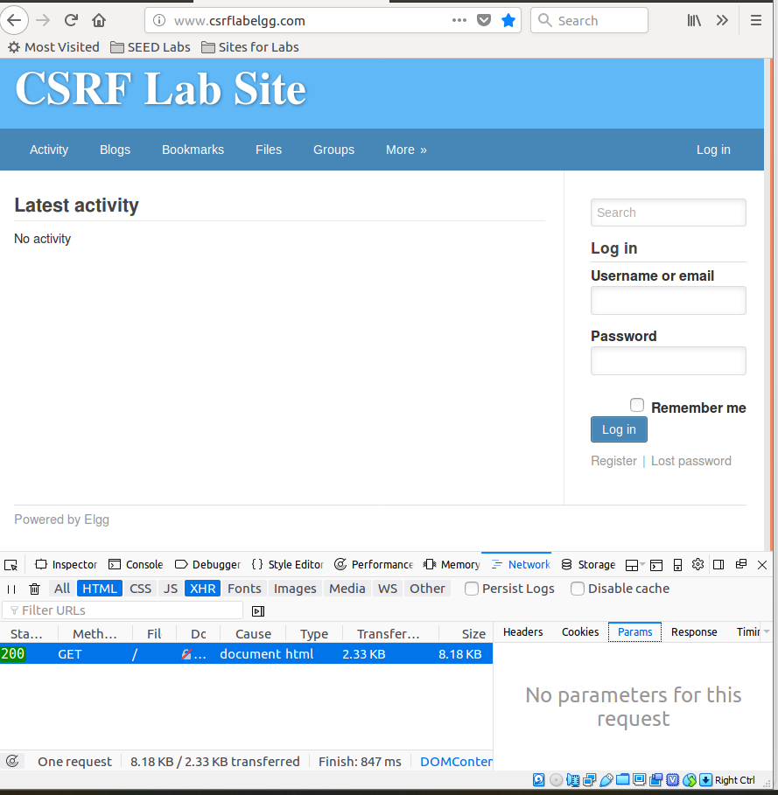

- The screenshot showing the results of the above step. What parameters were used in this request (if any)?
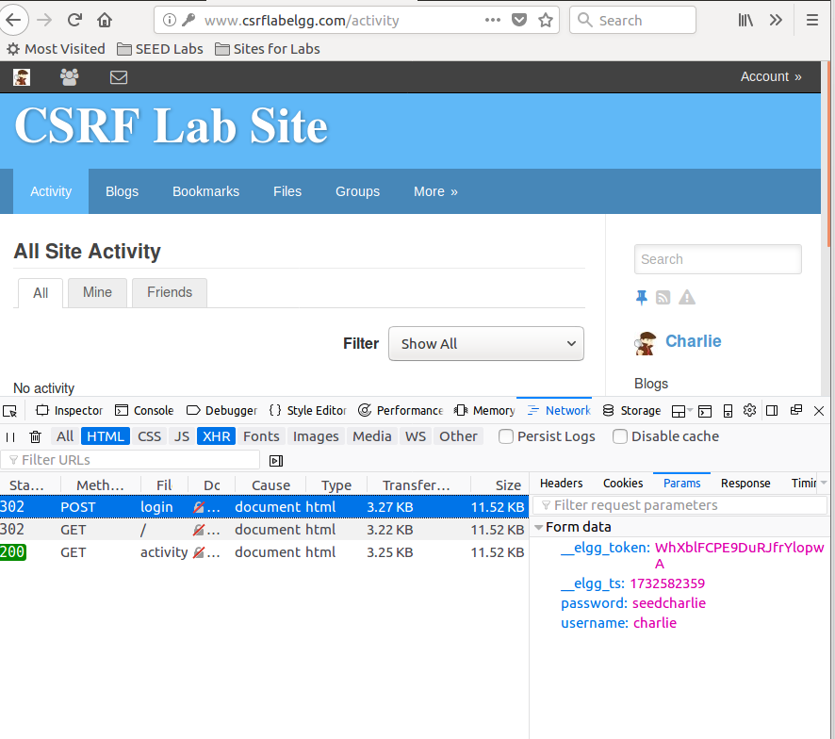

- The parameters used in this request were:
__elgg_token, __elgg_ts, password, username

Task 2: CSRF Attack with GET Request
In this task, we consider two people in the Elgg social network: Alice and Boby. Boby wants to become a friend to Alice, but Alice refuses to add him to her Elgg friend list. Boby decides to use the CSRF attack to achieve his goal. He sends Alice an URL (via an email or a posting in Elgg); Alice, curious about it, clicks on the URL, which leads her to Boby’s website: (www.csrflabattacker.com). As Boby, you will construct the content of this website, so that as soon as Alice visits the web page, Boby is added to the friend list of Alice, if Alice has an active session with Elgg.
To add a friend to the victim, we need to identify what the legitimate HTTP request (a GET request) for adding friends looks like. We will use the Web Console (as in the previous task) to do the investigation. Note that in this task, you are not allowed to write JavaScript code to launch the CSRF attack.
First, let us investigate the legitimate HTTP requests by adding friends when working as a user Charlie, and comparing the results.
- Make sure that you are logged in as Charlie (username: charlie, password: seedcharlie). Click on “More” → “Members”. Click on Alice’s name.
Make sure that the Web Console Network tab is open so that you can see the request you are about to make.
Click on “Add Friend” (the button on the left).
Save a screenshot of the details of the “Add Friend” request to add Alice as one of Charlie’s friends. Observe what parameters are sent in this request and what URL the request is being sent to?

- Go back to the “Members” list. Click on “Boby”.
Make sure that the Web Console Network tab is open so that you can see the request you are about to make.
Click on “Add Friend” (the button on the left).

Q2: Attach the following screenshot(s) and answer the respective questions.
- Attach a screenshot(s) showing the results of Step 6. What parameters are sent in this request? What URL is the request being sent to?
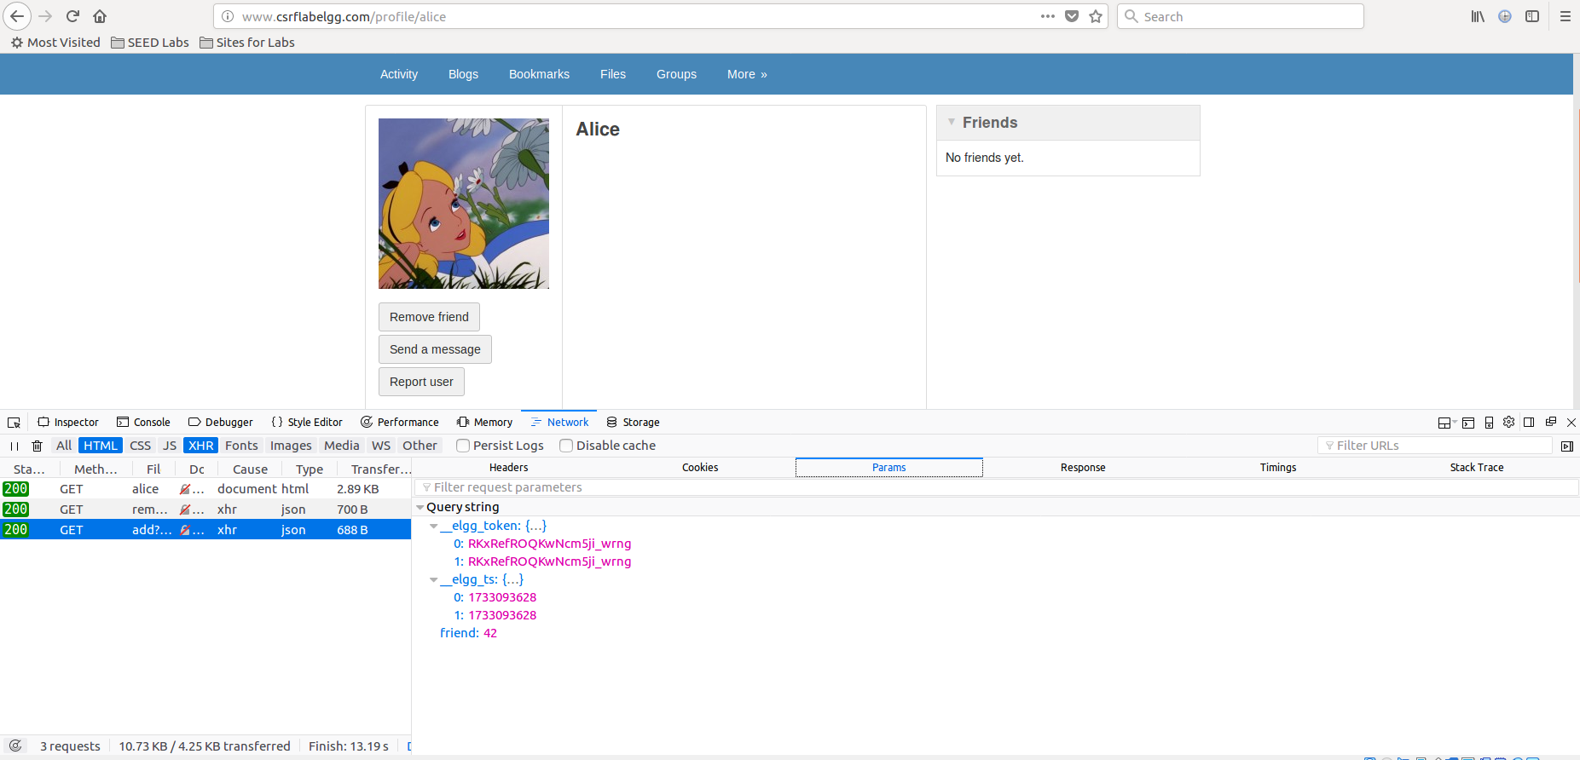

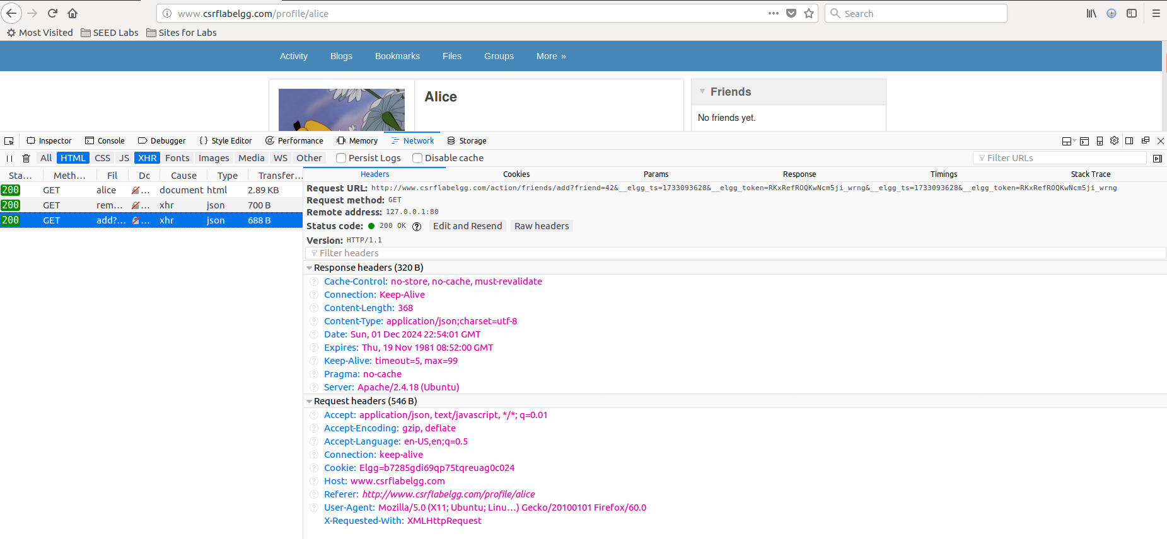
- The parameters being used: _elgg_token, __elgg_ts, friend
- The URL request is being sent to:
http://www.csrflabelgg.com/action/friends/add?friend=42&__elgg_ts=1733093628&__elgg_token=RKxRefROQKwNcm5ji_wrng&__elgg_ts=1733093628&__elgg_token=RKxRefROQKwNcm5ji_wrng

For the above step, attach a screenshot of the details of the “Add Friend” request to add Boby as one of Charlie’s friends. What parameters are sent in this request?

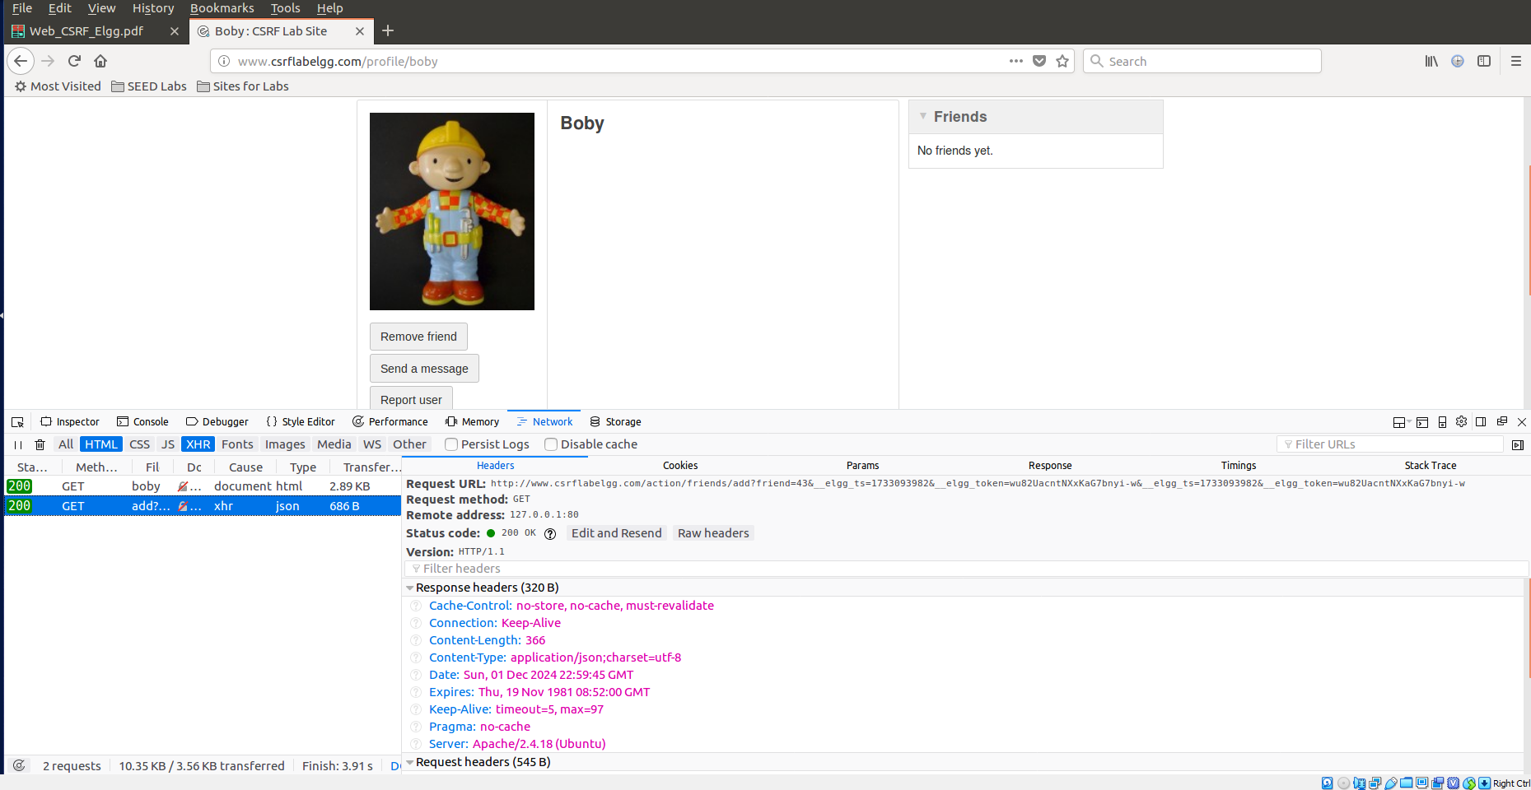

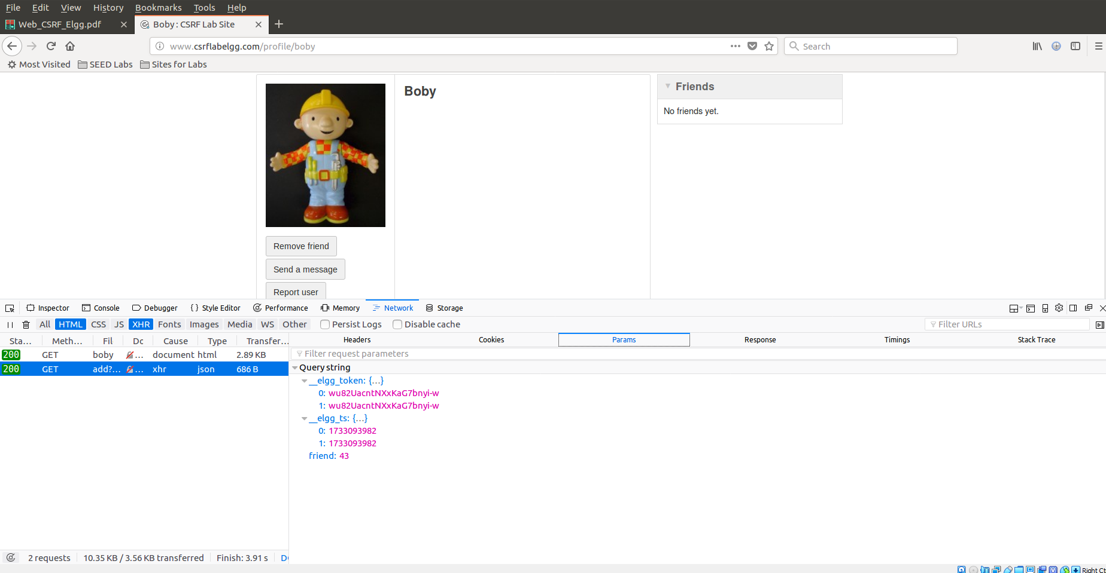

The URL is: http://www.csrflabelgg.com/action/friends/add?friend=43&__elgg_ts=1733093982&__elgg_token=wu82UacntNXxKaG7bnyi-w&__elgg_ts=1733093982&__elgg_token=wu82UacntNXxKaG7bnyi-w

The parameters are same as alice ( _elgg_token, __elgg_ts, friend ) but with difference in value of the parameters for instance, friend parameter that is 43 for Boby while 42 for Alice.

Next, you need to consider how the results of the above experiments help Boby to craft a CSRF request to add Alice as a friend even though she does not want to become his friend.

Consider the index page of Boby’s attacking website (www.csrflabattacker.com). Decide what URL (i.e., CSRF request) should this page contain for Boby’s attack to succeed.

NOTE: In the “Add Friend” HTTP requests, you may notice that each request includes two parameters,
elgg_ts and elgg_token. They are used as a countermeasure against CSRF attacks. Specifically, if these parameters do not contain correct values, the request will not be accepted by Elgg. We have disabled the countermeasure for this lab, so there is no need to include these two parameters in
the CSRF requests. In particular, there is no need to include these two parameters into your answer to the above question.
- Create an index.html file inside the attacker’s website (www.csrflabattacker.com; /var/www/CSRF/Attacker folder).
Design this page so that anyone with an active Elgg session that visits the page will automatically become Boby’s friend whether that person wants to or not.
Notes: This page should achieve the stated goal without use of JavaScript. Moreover, the attack should work as soon as Alice visits the index page, without even making any clicks on it.
Customization: This index page MUST contain your EUID somewhere in the visible text.
Example: “Welcome to the site of aa0001!”. (Replace “aa0001” with your actual EUID.)
Hint for the attack: The “img” tag automatically triggers an HTTP GET request whether the image exists or not.

NOTE: Create a backup copy of this file because you will need to overwrite and then restore this file in later steps.

Q3:

What URL (i.e., CSRF request) should the index.html page of the Boby’s website contain for his attack to succeed?

"http://www.csrflabelgg.com/action/friends/add?friend=43"
- Attach the source code of this page. (Either the screenshot or the html file is acceptable.)

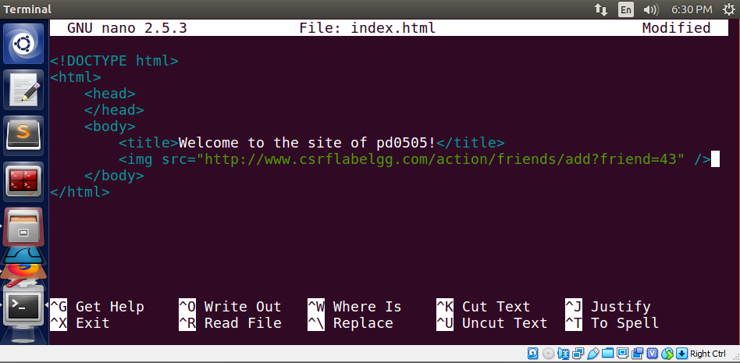

Next, Boby will send a message to Alice with a link to his attacking website. We will assume that Alice is not careful (maybe, she did not take a CSCE 5550 course :-), so she will click on the link.

- Log in as Boby (http://www.csrflabelgg.com/, username: boby, password: seedboby). Go to the “Members” list. Click on “Alice”.
Save a screenshot proving that Alice is not friends with Boby.

- Click on “Send a message”.
Send a message to Alice with a link to the www.csrflabattacker.com website.
Customization: The message MUST contain your EUID somewhere in the visible text.
Example: “Hi, this is aa0001! Check my website: www.csrflabattacker.com”. (Replace “aa0001” with your actual EUID.)

Note: The message subject must be non-empty, otherwise the website will throw an error. (This is an unintentional bug in the website implementation.)
- Log in as Alice. Click on the envelope to view your messages.

Q4: Attach the following screenshots:
- The screenshot saved after Step 9.
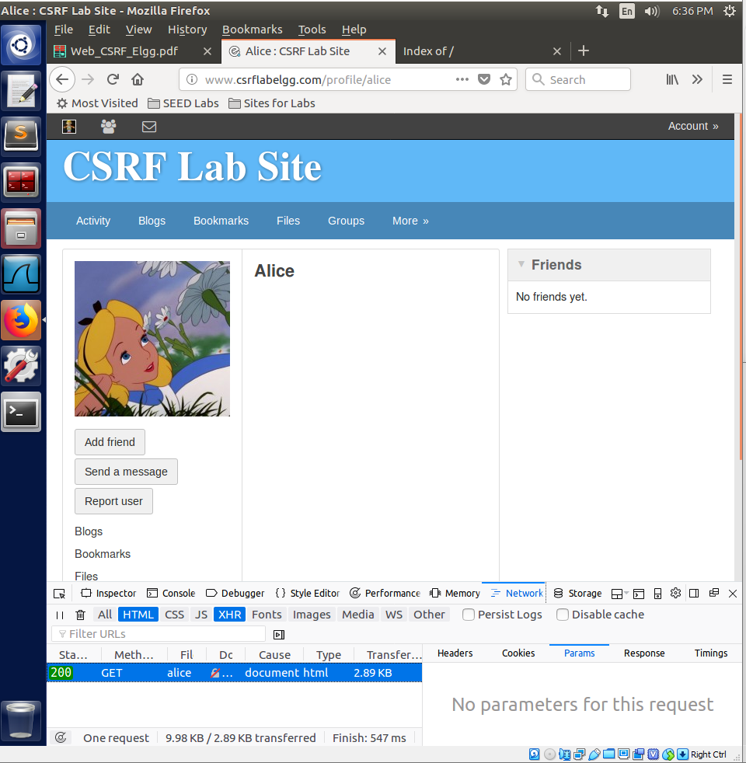

A screenshot of the message sent to Alice (displayed in the above step).
Make sure that it includes your EUID and a link to the www.csrflabattacker.com website.

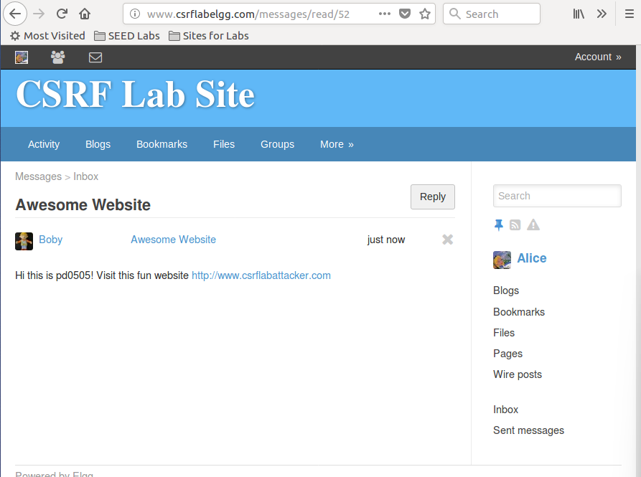

- Click on the link in Boby’s message.

Save a screenshot of how the webpage looks when Alice views it.

- Go back to www.csrflabelgg.com in your browser.

Q5: Attach the following screenshots:
- The screenshot saved after Step 12.
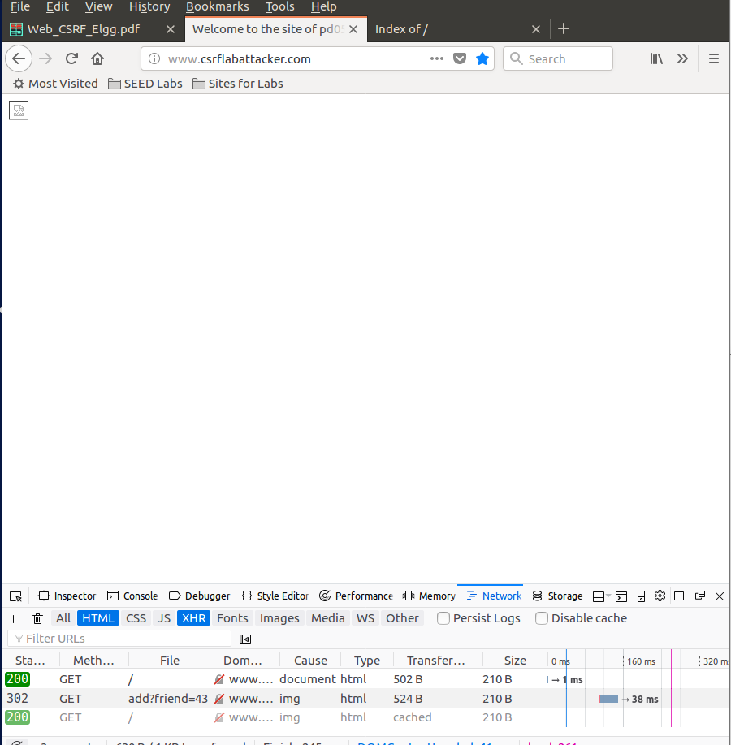
- The screenshot of the browser in the above step.

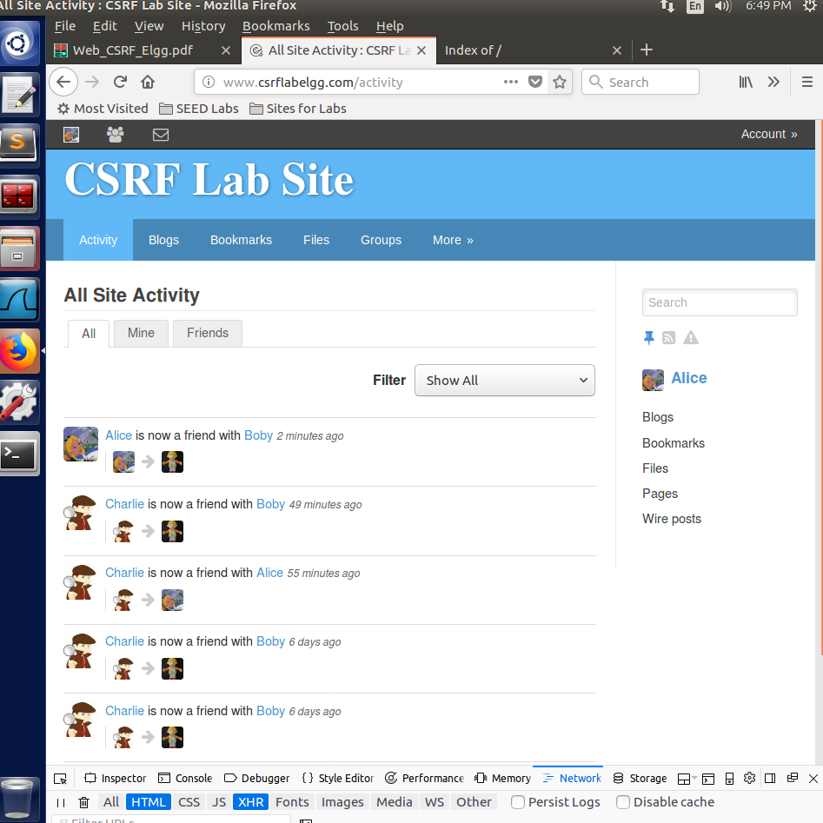

Task 3: CSRF Attack Using POST Request
In this part of the lab, Bob will run another CSRF attack with a goal to deface Alice’s profile so that it reads “Boby and ${Your_EUID} are MY HEROES!!” (replace ${Your_EUID} with your actual EUID).
- Log in as Alice (http://www.csrflabelgg.com/, username: alice, password: seedalice).
- Click on “Edit profile”.
- Open the Web Console Network tab so that you can see the request you are about to make. Fill out the form with some information (this information can be arbitrary) and click “Save”.

Remember that Boby wants to run a CSRF attack to deface Alice’s profile so that it reads “Boby and ${Your_EUID} are MY HEROES!!”. (Replace ${Your_EUID} with your actual EUID.)

Q6: Attach a screenshot of the details of the request to update Alice’s profile. What parameters will Boby need to pass for such the CSRF attack to succeed? How must he pass them?
Answer: There are lots of different parameters but in order to succeed for this attack Boby needs to pass name, accesslevel, description and guid.
These parameters need to be passed as a POST request using a form submitted to the website.

- Edit the index.html file inside the attacker’s website (www.csrflabattacker.com;
/var/www/CSRF/Attacker folder) so that the page will launch a CSRF attack to deface Alice’s profile to read “Boby and ${ Your_EUID} are MY HEROES!!”.
(Replace ${Your_EUID} with your actual EUID.)

Hint: A sample code that you can modify is given in the original SEED lab.
(The use of Javascript is allowed in this task. The sample code uses it.)

NOTE: Create a backup copy of this version of the file because you will need to overwrite and then restore this file in later steps.

Save a screenshot showing the contents of the attacker’s index.html file.

- Log in as Boby and send another message to Alice with the link to the attacker’s webpage that you created above.

Customization: The message MUST contain your EUID somewhere in the visible text.

- Log in as Alice and click on “My Profile”.

Q7: Attach the following screenshots:
- A screenshot showing the contents of the attacker’s index.html file.
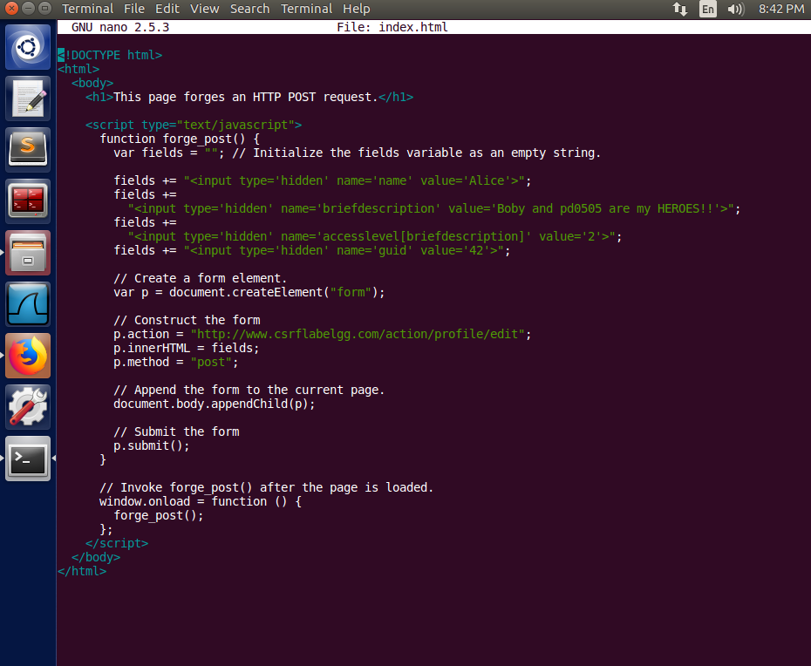

A screenshot of Alice’s profile at this point.

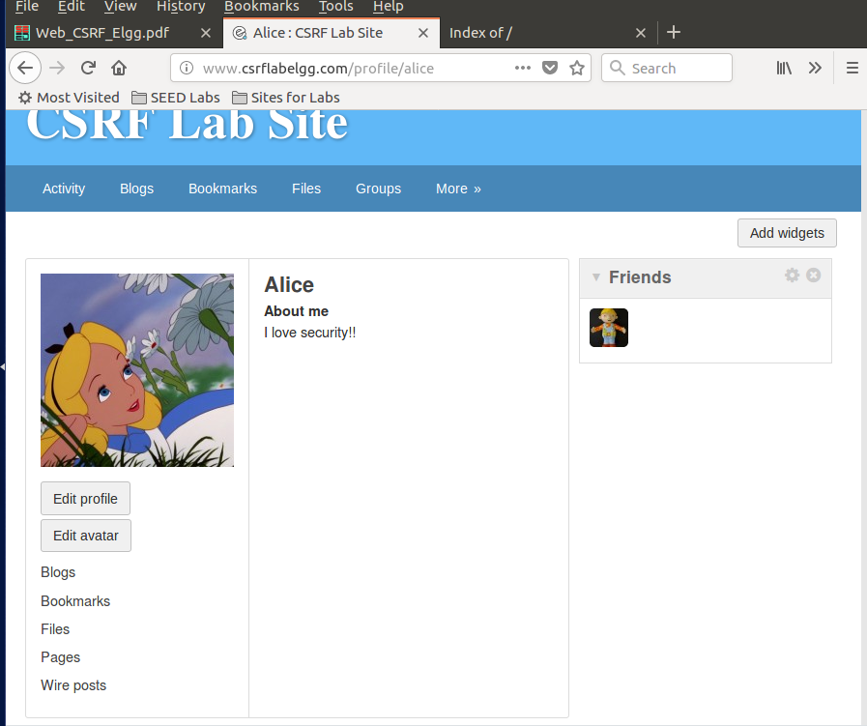

- Click on the envelope to view the messages.

Save a screenshot of the message with the link.
Make sure it includes your EUID and a link to the www.csrflabattacker.com website.

- Open the Web Console, Network tab so that you can see the request which you are about to make.
- Then, click on the link in the message to launch the attacker’s webpage.

Q8: Attach the following screenshots:
- The screenshot of the message with the link from Step 20.
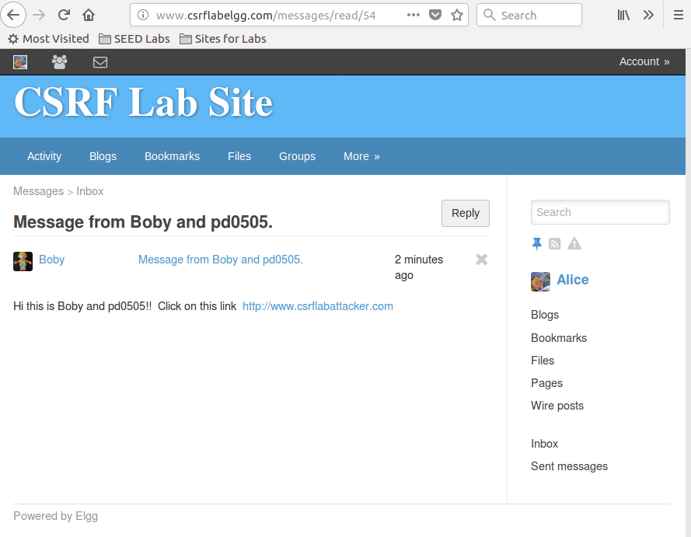

A screenshot of the network traffic in the Web Console, Network tab.

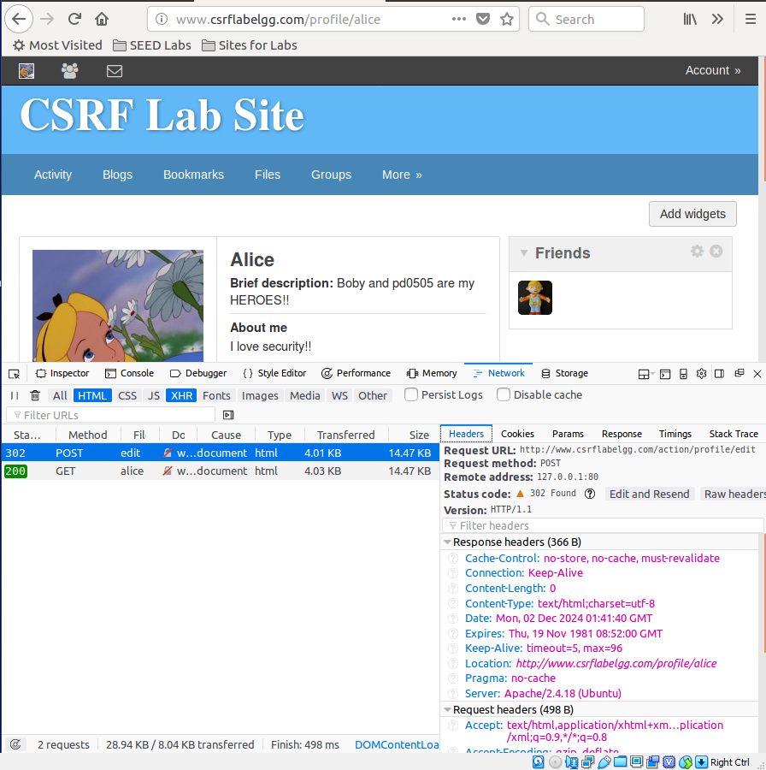
- A screenshot of the result of the above step. Describe what happened.
Answer:
The website got defaced because it exploited the Alice running session. The index.html page contained some modified parameters that are automatically passed to the HTTP POST request submitting a form to the profile edit page.
The attack succeeded because it was using Alice's current login session to send the request. It made it look like she had edited her profile and then submitted it herself. It worked because it utilized her own login session, Alice, to send the request looking exactly like she had updated her profile and clicked the Submit button all by herself.
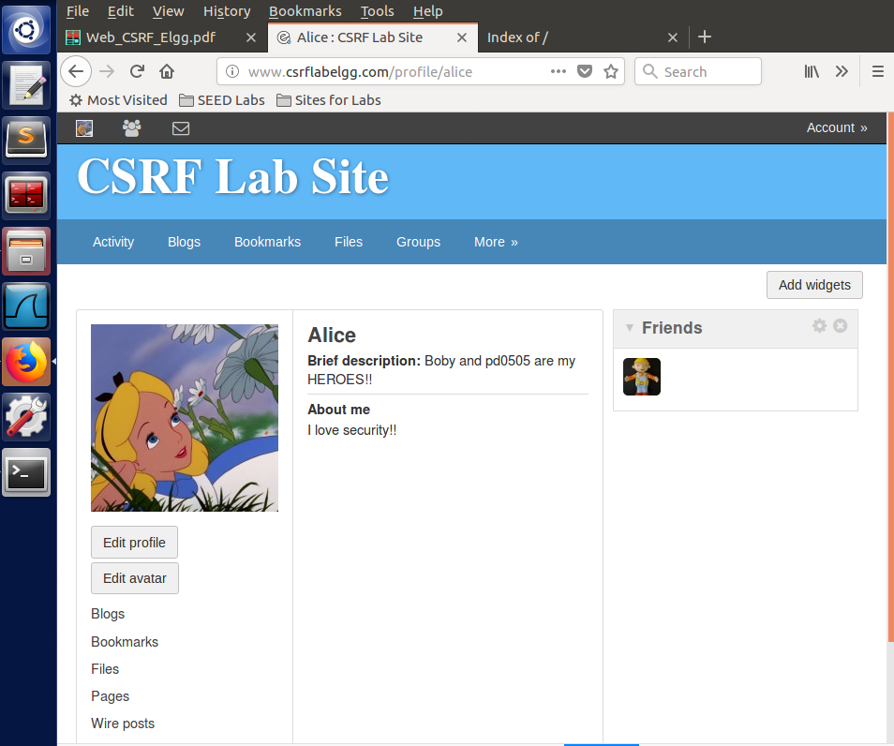

Note the above attack requires Boby to know Alice’s user ID in advance (so that he can prepare the code on his attacker website page accordingly). Consider how he can learn Alice’s user ID by investigating the Elgg website in advance.

Q9(1): Describe how Boby can find out Alice’s user ID before running the attack.

Now, suppose that Boby wants to modify the CSRF attack so that he can deface the profile of any Elgg user that goes to Boby’s site. For that, Boby will need to find out the user ID of a visitor. One approach could be to try and access the visitor’s Elgg page contents, Elgg cookies, etc.
Answer:
Bod can add Alice as a friend, the application typically generates a GET request. This request often includes Alice's user ID as a parameter in the URL or payload. He can record the parameters used in the GET request to identify Alice’s user ID before running the attack.

Q9(2): Will the above approach work considering the Same Origin Policy? Explain your answer.
Answer:
No, the above approach will not work considering the same origin policy. Same origin policy prevents websites from being accessed by outside domains or different origins. In this case, it will prevent Boby from accessing Alice elgg page contents or cookies.
If elgg has implemented same origin policy, then Cookies are protected meaning that Boby cannot access www.csrflabelgg.com cookies directly from www.csrfattackers.com. In case of using <iframe>, the content of the page will still be blocked by the browser because the request comes from a Boby’s site which is different origin.

Task 4: Implementing a Countermeasure for Elgg

Enable the Countermeasure
- Go to the /var/www/CSRF/Elgg/vendor/elgg/elgg/engine/classes/Elgg directory. In the “ActionsService.php” file, find the “gatekeeper” function.
Comment out the “return true;” at the top of this function.

Undo the Previous CSRF Attacks
NOTE: The next 3 steps are very important step. If you skip them, the results of the next section cannot be confirmed, and hence they will receive no credit.

- Log in as Alice.
- Click on the second-to-the-left icon (“Friends”) on the top (black) bar. If Boby is here, click on Boby and click “Remove friend”.
- Click on the leftmost icon (“Profile”) on the top (black) bar.
Click on “Edit profile” and undo the results of the CSRF attack on the profile.

Repeat the CSRF Attacks Again
- Restore the attacker’s “index.html” file from Task 2.
- Log in as Alice, go to the message from Boby with the link, and click on the link.
- Then, go back to the www.csrflabelgg.com website.

Q10(1): Describe what happens when you try to repeat the attack from Task 2. Why does this happen? Attach a screenshot.

NOTE: The webpage may get into infinite loop of redirecting and loading. If a regular screenshot cannot be taken, you may use your phone to take a photo of the screen.

Answer: When I tried to repeat the attack at this point, I failed. The elgg website displayed an error message of form missing _elgg_token and _elgg_ts fields as shown in the screenshot below.

This has happened because the elgg website has used secret token approach that embeds two parameters _elgg_ts and _elgg_token in the HTTP requests as a countermeasure to CSRF attack. The secret token's purpose is to ensure that every action made by the user was intentional and is from their browser, not from some malicious website performing an unauthorized action. Moreover, the token is unique to each user session. After commenting return true; line from the gatekeeper() function in ActionService.php file, the authentication checks are fully enforced, preventing unauthorized actions. The gatekeeper() function performs token validation to see if the token matches the one issued for that user session. Without the return true; line, the action will fail if token is missing or invalid.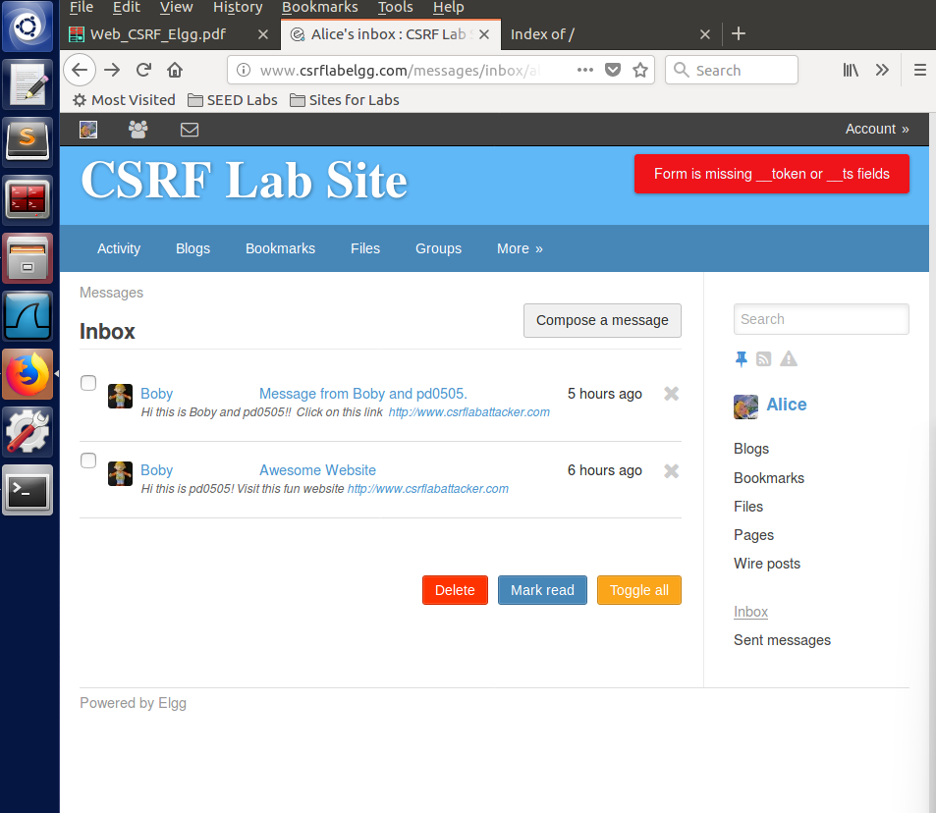

- Restore the attacker’s “index.html” file from Task 3.
- Log in as Alice, go to the message from Boby with the link, and click on the link.

Q10(2): Describe what happens when you try to repeat the attack from Task 3. Why does this happen? Provide a screenshot if you can.
NOTE: The webpage may get into infinite loop of redirecting and loading. If a regular screenshot cannot be taken, you may use your phone to take a photo of the screen.
Answer: When I tried to repeat the attack from Task 3, it failed as shown in the screenshot below. The error message with missing tokens is displayed in a running loop.
This likely happened due to the continuous redirection or repeated failure to pass the token validation or authentication in the gatekeeper function.

