SQL Injection Attack Lab
This lab is based on the SEED Lab (https://seedsecuritylabs.org/Labs_16.04/Web/Web_SQL_Injection/)
which uses the SEEDUbuntu-16.04-32bit VM (https://seedsecuritylabs.org/lab_env.html). See https://seedsecuritylabs.org/Labs_16.04/Documents/SEEDVM_VirtualBoxManual.pdf for the manual on importing the SEEDUbuntu VM into VirtualBox.
Follow the 7 steps in “How to Use Virtualbox to Run SEEDUbuntu VM”.
For this lab, you do not need to configure the network (as explained in the Appendix B). In VirtualBox, for the SEED Ubuntu VM, click in the menu Machine → Settings…, “Network” section, in “Attached to”, set “NAT”.

This document contains customizations, questions, and additional instructions specific to how this SEED lab is conducted for this course.

NOTE: Before running this lab, you must read the original SEED lab description:
https://seedsecuritylabs.org/Labs_16.04/PDF/Web_SQL_Injection.pdf

and also, you may consider having this description opened in another window.

IMPORTANT NOTE 1: All the URLs in the below tasks should only be accessed

from inside of the VM.
- Make sure to use the website names EXACTLY as they are provided in the lab, otherwise you may get the wrong website.

DO NOT access these URLs from your host machine or from other VM’s
as the actual Internet domains are not controlled by UNT.

IMPORTANT NOTE 2: Type the commands in the terminal manually (rather than copy-paste them) because you may have issues with encoding of some special characters such as quotation marks. In particular, note that the straight (neutral) quotation marks (') must be used in the SQL commands.

IMPORTANT NOTE 3: Before starting the lab, you must customize your command prompt as described in the Command Prompt Customization Manual. This customization manual directs you to place your EUID (Enterprise User ID) into the command prompt.
This lab contains additional customizations. In several places, you must add your EUID or some values derived from it, such that it will appear on the screenshots.

Submissions which do not comply with the above two requirements will receive no credit.

Each question will be considered as 12 points.

Task 1: Getting Familiar with SQL Statements

- Open the terminal and type: mysql -u root -p
then enter the password: seedubuntu

Note: In the SEED manual, the above command has a typo (there should be a space in between the -p flag and the password).
The following commands will be run in the SQL interpreter. You will see that after running the above command, the prompt will change to “mysql>”.

- Change database to “Users” with the following command: use Users;

- Type:
show tables;

- Type your EUID in the command prompt. (Do not press “Enter”.)

Save a screenshot of the result. (This screenshot must have your EUID visible.)

- Delete your EUID from the command prompt.

- Write an SQL command to print Alice’s profile information from the table shown in the previous command. The command should look as follows:
SELECT * FROM table_name WHERE name=’person_name’\G (the strings in bold must be replaced with actual names).
- Type your EUID in the command prompt. (Do not press “Enter”.)

Q1: Attach the following screenshots:
- A screenshot of the result of Step 4.

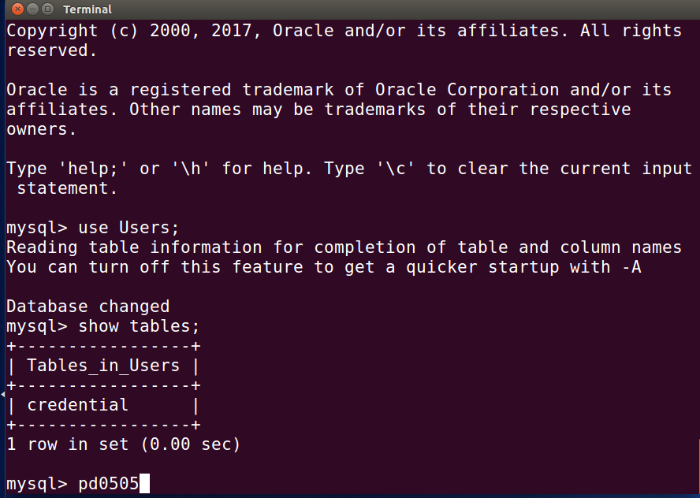

A screenshot of the result of the above step. (This screenshot must have your EUID visible.)

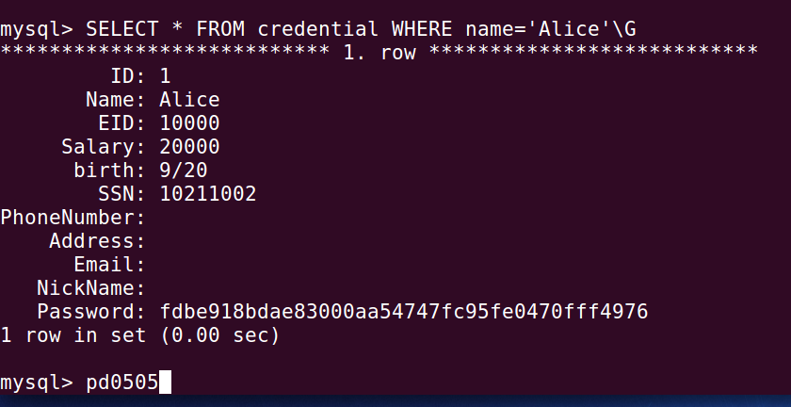

- Delete your EUID from the command prompt.

Note: The \G command displays the row entries vertically. When using \G, the semicolon (;) after
the command should be omitted. Try the same command as above replacing \G with “;”—you will see that the entries are shifted due to wrapping in the terminal window. This can be fixed by formatting the output of SQL commands, but this topic is out of scope of this lab.

Task 2: SQL Injection Attack on SELECT Statement

Task 2.1 Attack via Webpage
Your task is to login to a page www.SEEDLabSQLInjection.com with admin credentials, when you only know that the username is “admin” (but not the password). For your attack, you need to know how the user authentication works. Refer to the original SEED Lab description, Section 3.2 for that.
Hint: The authentication script uses (a hash of) the password which you do not know. Therefore, as the username, you need to provide a string of characters, which will result in excluding the hash check from the SQL statement constructed by the script.
- Open the page www.SEEDLabSQLInjection.com in the browser, type your input to the username field. Before clicking “Login”, save the screenshot—it must show your input to the username field.

- Click the “Login” button.

Q2: Attach the following screenshots:
- A screenshot from Step 9.

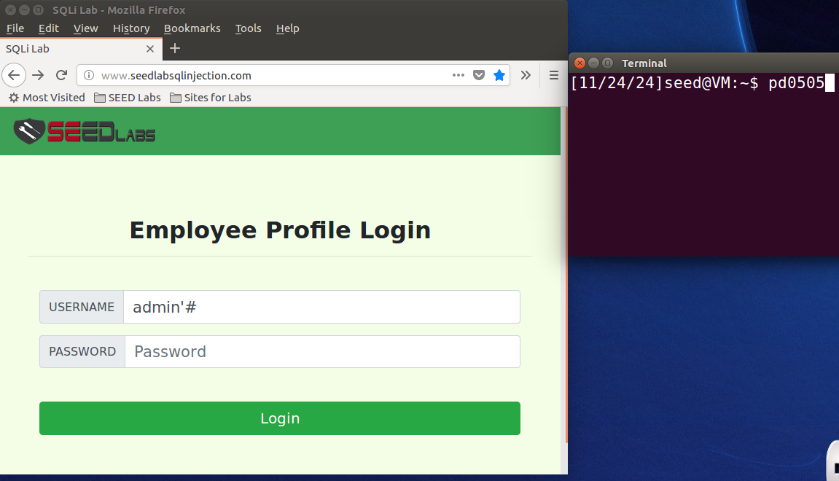

A screenshot of the result of the above step.

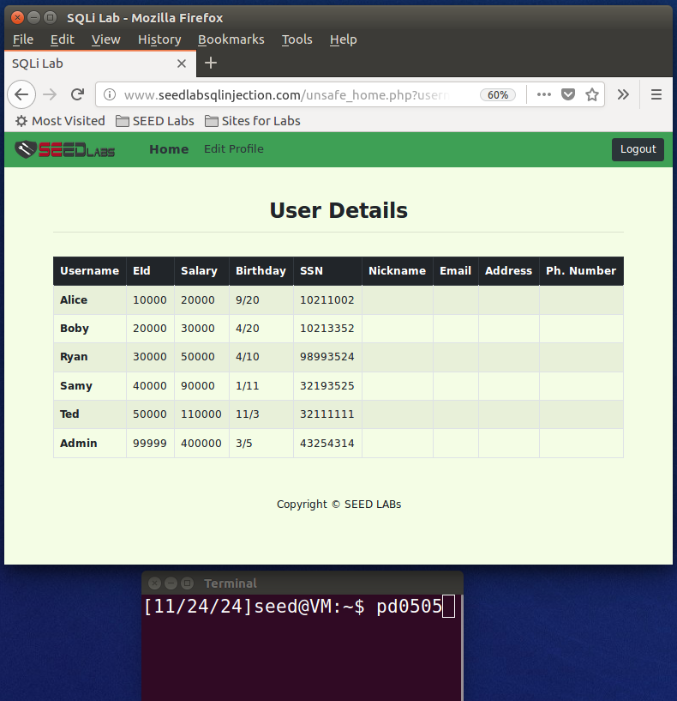

Note: If the attack was successful, you will login and see the “User Details” table. If not, then go to the beginning of this task and repeat until the attack works.

Q3: Explain why your attack was successful. Specifically, you must write the SQL statement generated as the result of your attack.
Hint: Inspect the SQL query produced by authentication script (see the code snippet in the original SEED Lab, Sec. 3.2) and then explain why the login was successful.

Answer: The attack was successful due to the use of admin’# in the username field. After the injection, the query becomes:
SELECT * FROM credential WHERE username = ‘admin’# and password = ‘’;
To illustrate, the # sign after admin’ is a comment sign used in mysql DBMS. As a result, everything after the # sign was ignored by the database. The syntax after # sign is commented leaving only the username part which bypassed the password authentication allowing the attacker to authenticate as an admin.

Task 2.2 Attack via Command Line
Next, you will run the same attack from the command line. For that, you will need the URL encoding of special characters that you used when providing the username in the previous task.

Q4(1): Below, write the URL encoding for the string, which you provided as a username in Task 2.1.

Answer: Encoded string: username=admin%27%23&Password=

The curl command tool allows us to send HTTP requests. Let us run the same attack as in the previous task. We know that the name of the script responsible for authentication on the webserver is “unsafe_home.php”. For the hint on constructing the curl command, which implements this attack, refer to the description of Task 2.2 in the original SEED Lab manual, Sec. 3.2.

- Type “exit” to leave the SQL command prompt and return to the shell.

- Run the curl command with the needed parameters in the terminal.

Q4(2): Attach a screenshot(s) of the result.

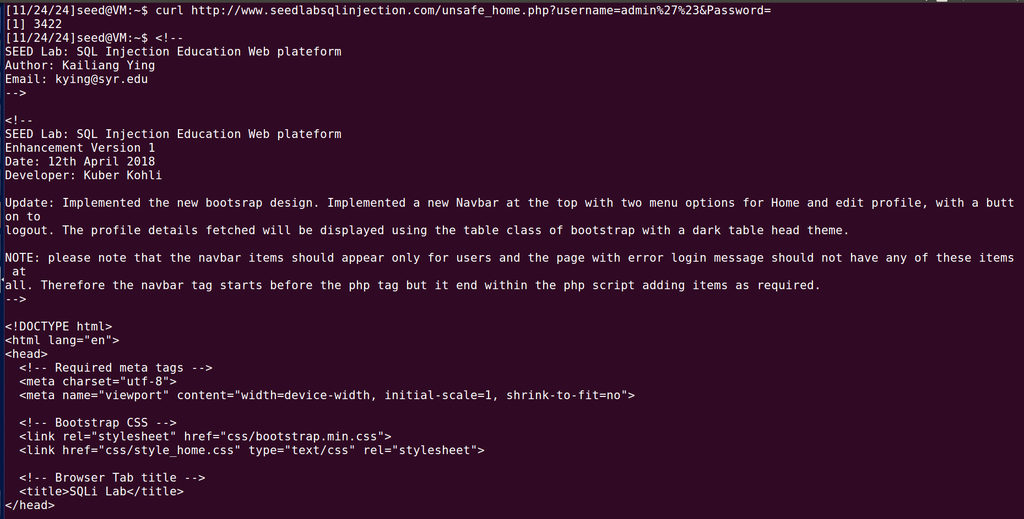
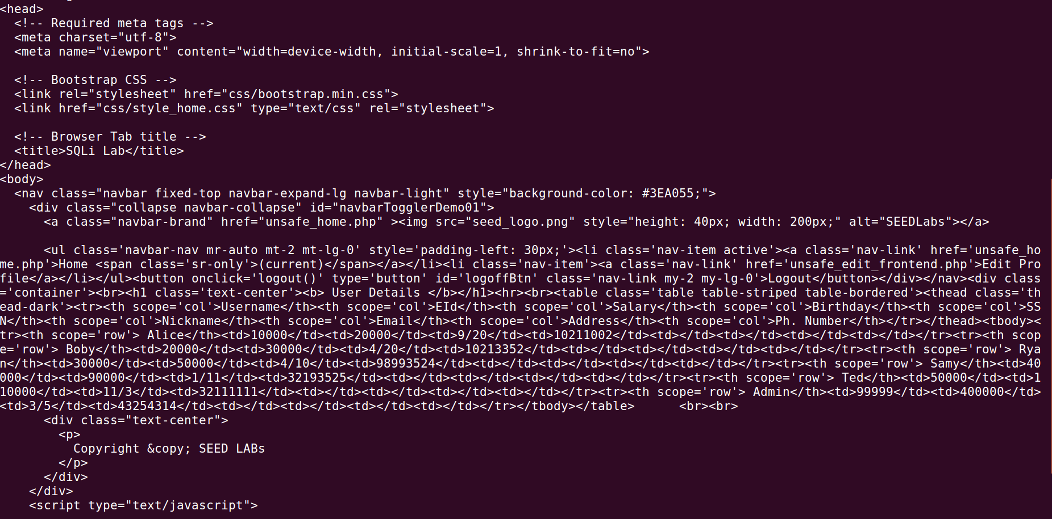
Note: If the attack was successful, you will login and see the “User Details” table. If not, then go to the beginning of this task and repeat the attack until it works.

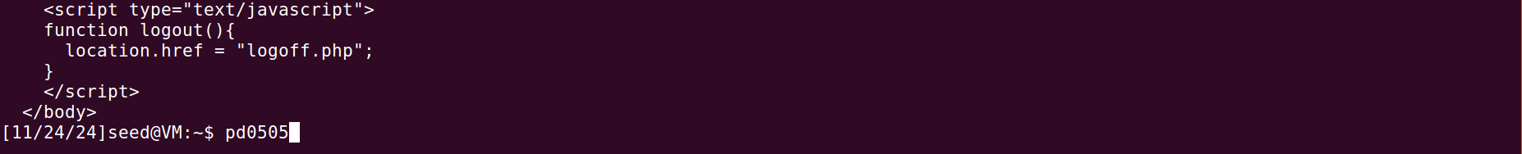

Q4(3): Explain why your attack was successful. Specifically, you must write the SQL statement generated as the result of your attack.

Answer: curl http://www.seedlabsqlinjection.com/unsafe_home.php?username=admin%27%23&Password=
The curl command is a tool that makes HTTP requests using the command line interface. In this case, it is making a request to a unsafe_home.php in website http://www.seedlabsqlinjection.com. We have used it to bypass login interface of admin account. The value of the username parameter is admin%27%23. Here, admin is the username we are trying to login with, %27 is the encoded version of single quote (‘). Similarly, %23 is a encoded version of hash (#) sign used for commenting in MySQL DBMS. Therefore the username will be admin ‘ #. Rest is the password parameter. Since it is commented out the value of password is not required for successful attack.

The SQL statement generated as the result of the attack is SELECT * FROM credential WHERE username = ‘admin’ # AND password = ‘’;

Task 3: SQL Injection Attack on UPDATE Statement

Task 3.1: Modify Your Own Salary
- Log in as Alice to www.SEEDLabSQLInjection.com (user: alice; pass: seedalice).

Q5(1): Attach a screenshot of Alice’s current profile.
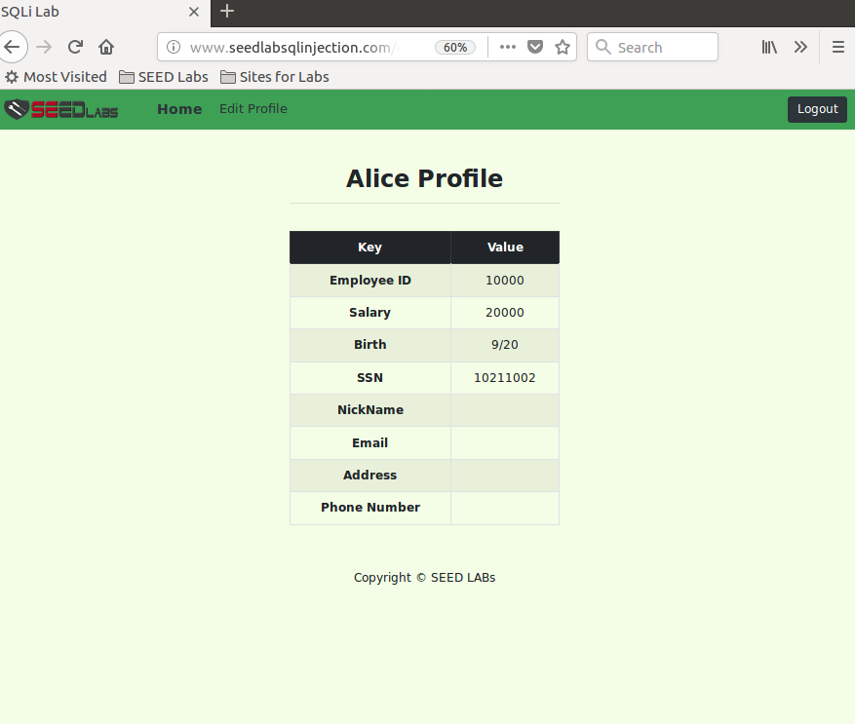

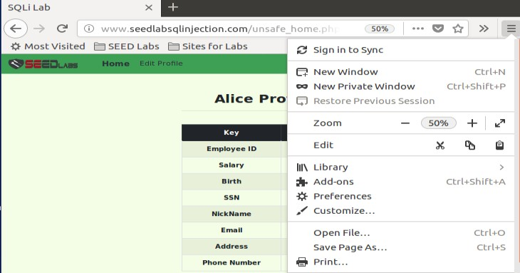
Use zoom in/out feature (see the picture on the right) to find the “Edit Profile” button,
it is located at the top of the page.

In this task, a malicious user Alice (think of her as a disgruntled employee) will run an SQL injection attack to modify her salary. Her interface for profile editing does not include an access to the “salary” column in the table. However, knowing that such a column exists in the table and knowing how
the profile editing script works (see the description in the original SEED Lab, Sec. 3.3), she will be able to input a string into the Edit Profile form such that her salary will be modified. For simplicity, let Alice use the “Nickname” field and leave the other fields bank.
Hint: Inspect the code snippet in the SEED Lab description, and use an approach similar to that of the previous tasks to engineer the UPDATE statement, which would modify Alice’s salary.
Customization: Alice’s salary will be set to the following value: In your EUID, replace the letters with digits “1”. For example, for a EUID “ab1234”, Alice’s salary will be set to “111234”.

Q5(2): Write the string of characters to be entered into the field “Nickname” for the successful attack.
Answer: ', salary = 110505 where EID = 10000;#

- Click the “Edit Profile” button.

Q6(1): Attach a screenshot of the filled-out profile update form.

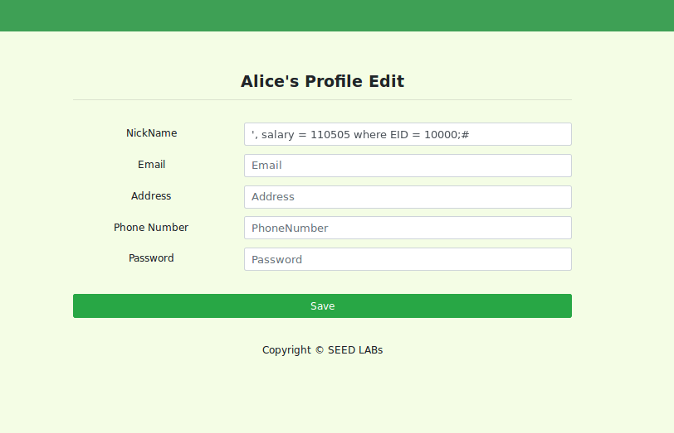

- Submit the form.

Q6(2): Attach a screenshot of the result.

Note: If the attack was successful, you will see Alice’s salary changed to the customized value, which you defined above. If not, then go to the beginning of this task and repeat the attack until it works.

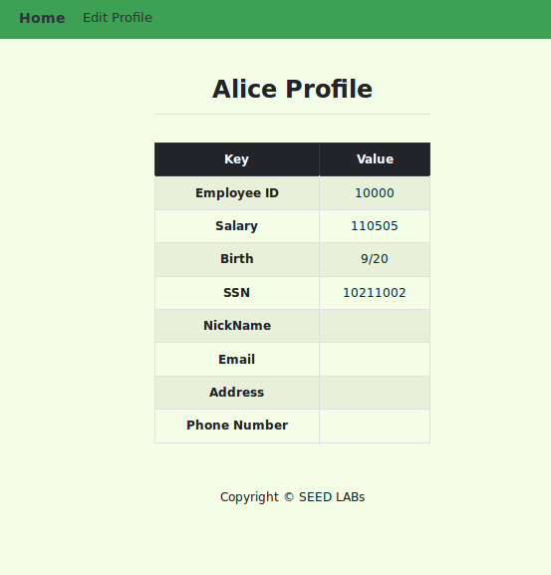

Q6(3): Explain why you got this result. Specifically, you must write the SQL statement generated as the result of your attack.
Answer: Input: ', salary = 110505 where EID = 10000;#
SQL statement generated:
SELECT * FROM credential WHERE username = '' AND password = ''', salary = 110505 WHERE EID = 10000;#
In the above query, the username is interpreted as empty by the database, moves on to the password section. Here, the password fields end up with three single quotes, the first two quotes in the password field indicates empty password. The third quote closes the string for password by simply ending the password string and everything after it is treated as normal SQL commands. Even though there are three quotes in the after the password, the actual password value is empty (''), and the rest of the SQL injection code (salary = 110505 WHERE EID = 10000) is executed as part of the query. And # sign at the end comments the rest of the query. The query has modified the salary of an employee whose EID is 10000, which in this case is Alice.

Task 3.2: Modify Salary of Others
In this task, you will change Boby’s salary to be lower than Alice’s. (Suppose that an employee Alice wants to get revenge on her boss Boby).
- Log in as Boby to www.SEEDLabSQLInjection.com/unsafe_home.php (user: boby; pass: seedboby).

Q7(1): Attach a screenshot of Boby’s profile.

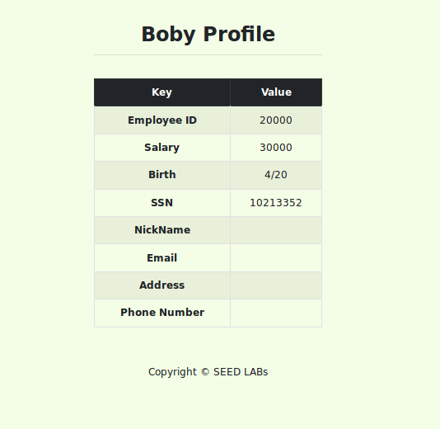

- Log out.

- Log in as Alice to www.SEEDLabSQLInjection.com (user: alice; pass: seedalice).

Use the same approach as in the previous task. Again, for simplicity, let Alice use the “Nickname” field and leave the other fields bank.
Customization: Boby’s salary will be set to the following value: use only the digits in your EUID. For example, for a EUID “ab1234”, Boby’s salary will be set to “1234”.

Note: If the attack was successful, you will see Boby’s salary changed to the customized value, which you defined above. If not, then go to the beginning of this task and repeat the attack until it works.

Q7(2): Write a string of characters to be entered into the field “Nickname” for the successful attack.
Answer: ', salary = 0505 where EID = 20000;#

- Click “Edit Profile”.

- Fill out the form and submit it.
- Log out.

- Log in as Boby to www.SEEDLabSQLInjection.com (user: boby; pass: seedboby).

Q8(1): Attach a screenshot of Boby’s profile after the attack.

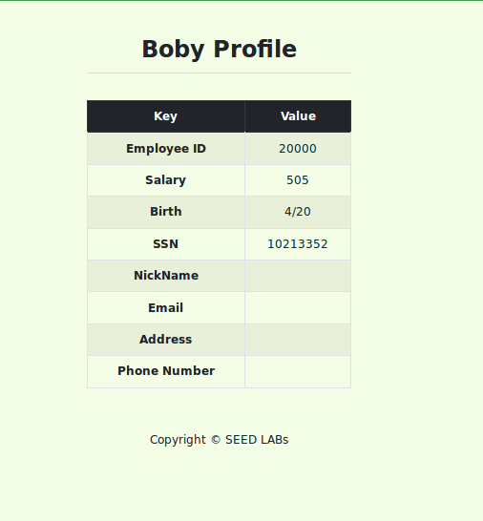
My EUID is pd0505, after removing the digits it becomes 0505, here the database did not take the first zero as result the salary is 505.

Q8(2): Explain why you got this result. Specifically, you must write the SQL statement generated as the result of your attack.

Note: In a similar manner, an attacker can modify other Boby’s records, e.g., his password hash—this will effectively change his password.
Answer:
SQL statement generated by the SQL injection:
SELECT * FROM credential WHERE username = '' AND password = ''', salary = 0505 WHERE EID = 20000;#
In the above query, the username is interpreted as empty by the database, moves on to the password section. Here, the password fields end up with three single quotes, the first two quotes in the password field indicates empty password. The third quote closes the string for password by simply ending the password string and everything after it is treated as normal SQL commands. Even though there are three quotes in the after the password, the actual password value is empty (''), and the rest of the SQL injection code (salary = 0505 WHERE EID = 20000) is executed as part of the query. And # sign at the end comments the rest of the query. The query has modified the salary of an employee whose EID is 20000, which in this case is Boby.

Task 4: Countermeasure: Prepared Statements
Change the code in /var/www/SQLInjection/unsafe_home.php and
/var/www/SQLInjection/unsafe_edit_backend.php so that they use prepared statements (see the description in the original SEED Lab, Section 3.4).
Then, repeat the attacks specified in Tasks 2.1 and 3.1 and observe the results.

Hint: Inspect the code in the files “safe_home.php” and “safe_edit_backend.php” located in the same directory /var/www/SQLInjection/ to conclude what changes to their unsafe versions are needed.
Note: Normally, you will need the root privileges to modify files in the above-mentioned directory. The SEED Ubuntu VM is configured such that you do not need to enter the root password to run privileged commands. (Still, just in case, the root password is “seedubuntu”.)

Q9(1): Attach a screenshot showing the changes, which you made to “unsafe_home.php”.

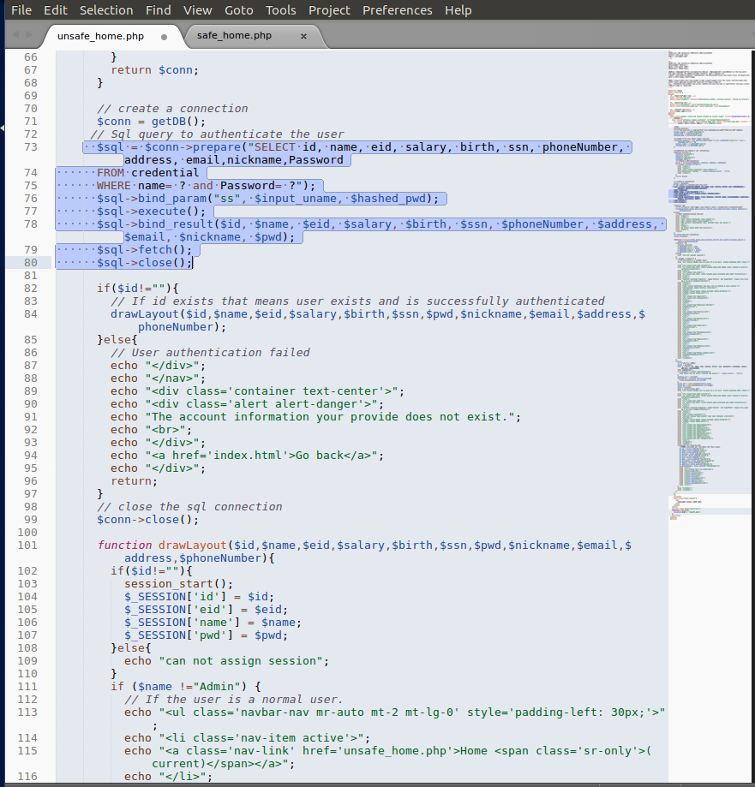

- Repeat the attack from Task 2.1.

Q9(2): Attach the resulting screenshot(s). Explain your observations. Specifically, you must explain why the attack did not work.
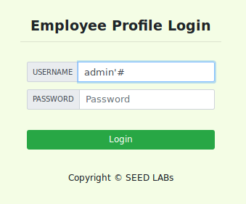

I have tried login in using the same above method using admin’# in the username filed keeping the password field empty.
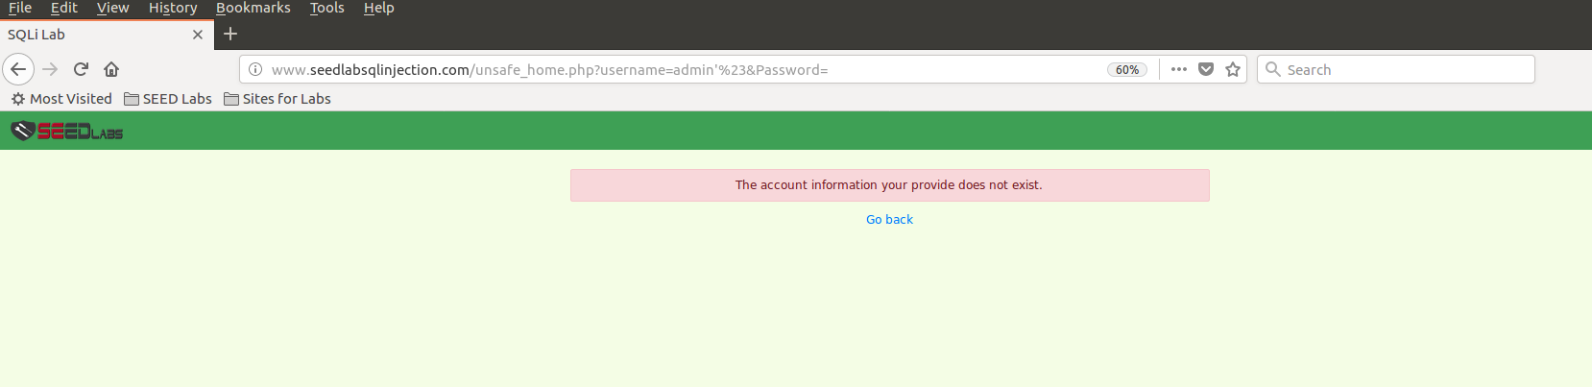

But the attack was unsuccessful as shown in the screenshot above.

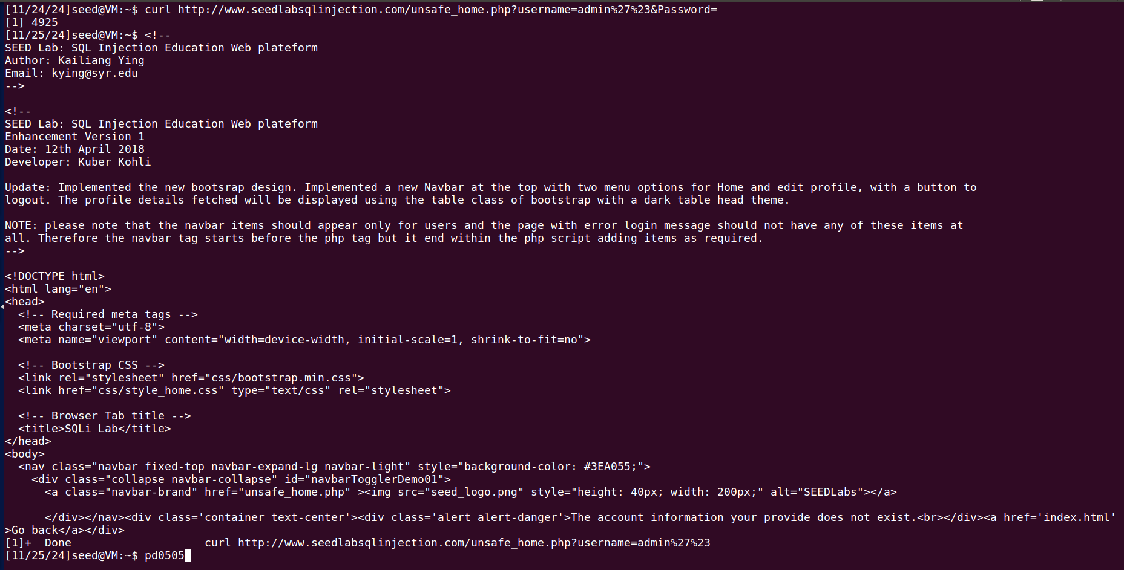

Here, I have tried the attack again using curl command from the command line but the results says, the information provided does not exist, meaning the attack failed.
The above attacks did not work because the original database connection was replaced by the prepared statement countermeasures in unsafe_home.php. Prepared statement acts are a countermeasure for preventing SQL injection attacks. It separates the SQL code with user input where the input from the user is strictly treated as data instead of SQL code.
Here is how the code modification in unsafe_home.php works:
$sql = $conn->prepare("SELECT id, name, eid, salary, birth, ssn, phoneNumber, address, email, nickname, Password FROM credential WHERE name =? and Password=");
This line prepares the SQL query with a placeholder (?) for user inputs and binds the actual values to those placeholders (?) before executing the query. In short, the database knowns what the query looks like, but it does not the actual values yet.

$sql->bind_param("ss", $input_uname, $hashed_pwd);

After the query is prepared the user provided values are binded to the placeholders, here the first argument “ss” means both parameters $input_username and $hashed_pws are string. The function bind_param() associates the user values within the placeholders.

$sql->execute();
This line runs the prepared query with the bound parameters. Now, the user input cannot change the query structure anymore.

$sql->bind_result($id, $name, $eid, $salary, $birth, $ssn, $phoneNumber, $address, $email, $nickname, $pwd);
This line defines where to store the values returned from the database after the query has been executed.

$sql->fetch();

The fetch() method is used to retrieve the data and place it into variables that we defined earlier using bind_result().

$sql->close();
Finally this line closes the sql statement after the execution and the results have been fetched.
To summarize, using prepared statements with parameter binding, the above code takes the user input as a data instead of SQL query separating the logic of the query from actual data preventing SQL injection attacks.

Q10(1): Attach a screenshot show the changes, which you made to “unsafe_edit_backend.php”.

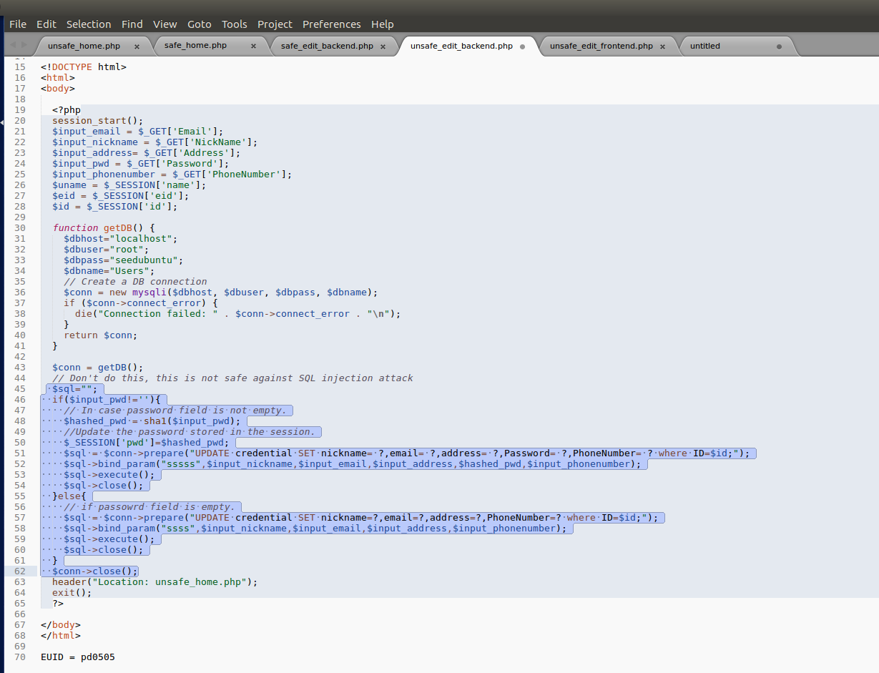
Inserted EUID in the last line of this image

- Repeat the attack from Task 3.1.

Q10(2): Attach the resulting screenshot(s) and explain your observations. Specifically, you must explain why the attack did not work.

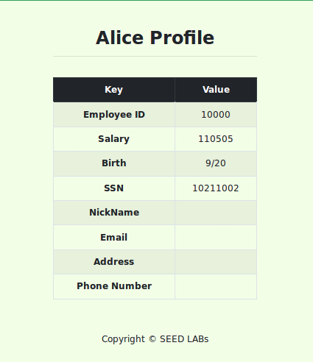

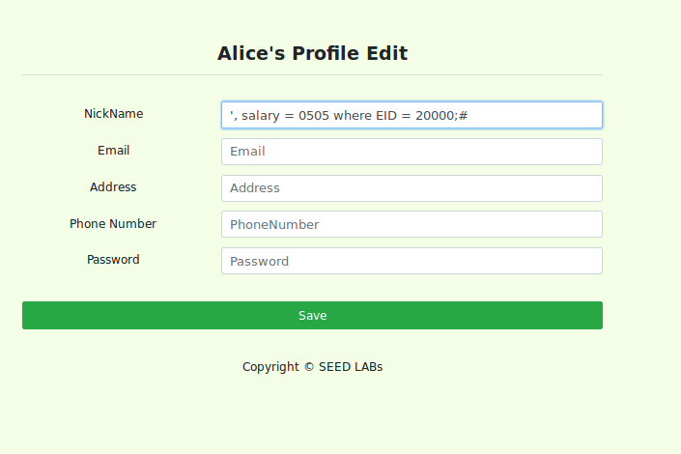
This is the current profile of Alice before inserting the SQL query.

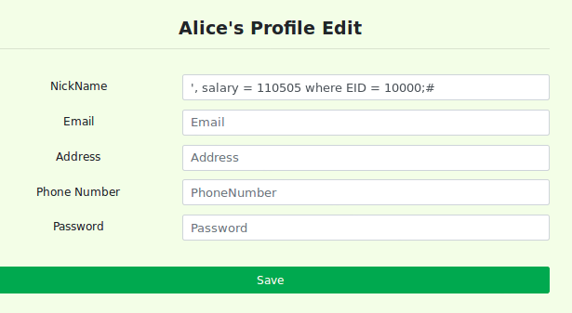

Here, we insert the query like we have done before from Alice profile page nickname filed. Using the same query we used above before applying countermeasures.

Result:

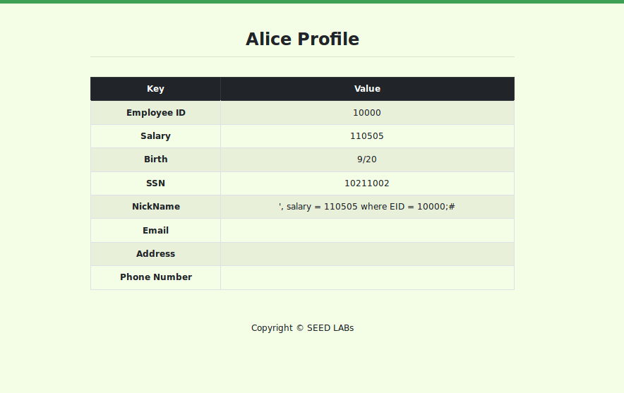

But this time we failed in modifying his own salary. As shown in the screen shot above, the query inserted into the nickname filed has been interpreted as a string value of the same field by the database and has displayed according on the website.

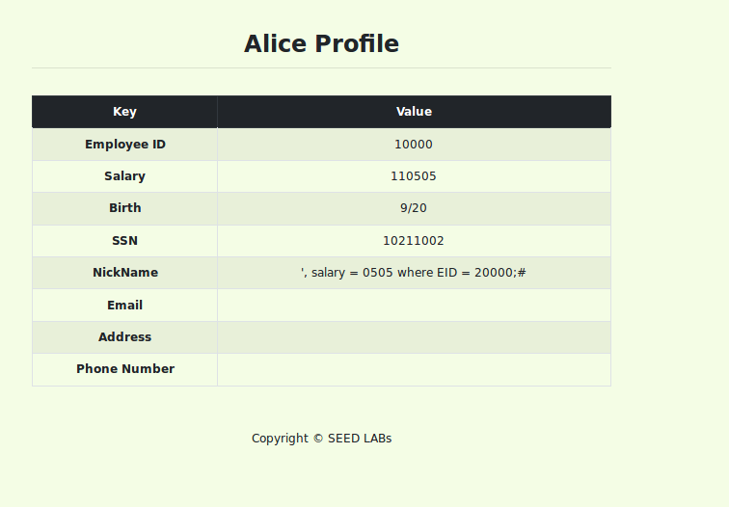
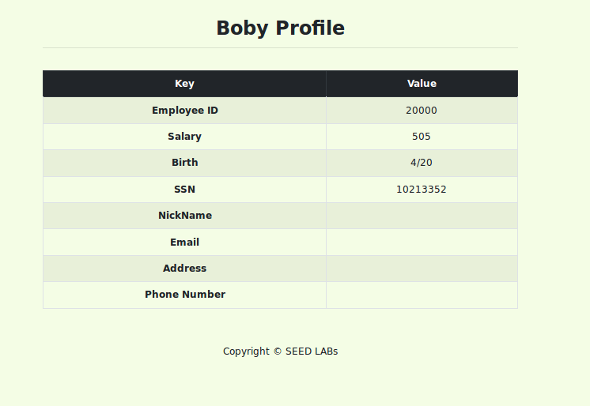

I tried to modify Boby’s salary from the Alice profile as well but, could not succeed as shown in the screenshots above. The nickname field for Boby is blank and instead the query for modifying Boby’s salary is display in Alice’s profiles as his nickname.

The above attacks did not work because of the prepared countermeasures we have used in unsafe_edit_backend.php.

$sql="";
if($input_pwd!=''){
// In case password field is not empty.
$hashed_pwd = sha1($input_pwd);
//Update the password stored in the session.
$_SESSION['pwd']=$hashed_pwd;
$sql = $conn->prepare("UPDATE credential SET nickname= ?,email= ?,address= ?,Password= ?,PhoneNumber= ? where ID=$id;");
$sql->bind_param("sssss",$input_nickname,$input_email,$input_address,$hashed_pwd,$input_phonenumber);
$sql->execute();
$sql->close();
}else{
// if passowrd field is empty.
$sql = $conn->prepare("UPDATE credential SET nickname=?,email=?,address=?,PhoneNumber=? where ID=$id;");
$sql->bind_param("ssss",$input_nickname,$input_email,$input_address,$input_phonenumber);
$sql->execute();
$sql->close();
}

The main reason the above attacks failed in editing the profile information is because the code has properly used prepared statements with parameterized queries. As shown in the code above, it is using a placeholder, represented by the question mark symbol (?), for different values, including the user inputs from $input_nickname, $input_email, $input_address, $input_phonenumber, etc. The bind_param method then comes into operation and safely binds the user inputs defining its type as string ‘sssss’ to these reserved slots at the point when actual data are provided. The inputs are treated purely as data, not mistaken for some executable code. Because of this strong protection mechanism in place, we as an attacker manipulate the structure of a query won't have the capability to change or modify the underlying logic of the query in any possible way. More safety precautions have been added to this code, so that apart from the already implemented measures, it will also check whether password field is empty using if else statements this way, the entered data will be verified that no unauthorized changes occur otherwise.

