Lab 1b: Packet Sniffing
This lab uses the Kali 2024 virtual machine (VM). The credentials are:
Username: kali Password: kali
NOTE: Address all the questions (Q1, Q2, etc.) marked in bold. When a screenshot is requested, try to fit all the results in one image. If this is not possible, then attach multiple screenshots.
When a question is asked, e.g., “Who is an owner of the file?”, type your answer, do not simply provide a screenshot.
IMPORTANT NOTE: Before starting the lab, you must customize your command prompt as described in the Command Prompt Customization Manual. This customization manual directs you to place your EUID (Enterprise User ID) into the command prompt. Submissions which do not comply with this requirement will receive no credit.
- Login to Kali.
- Open the terminal and start Wireshark.
Select the interface eth0 in the window and click Capture → Start (or the blue fin button – as shown on the screenshot below) to start sniffing.
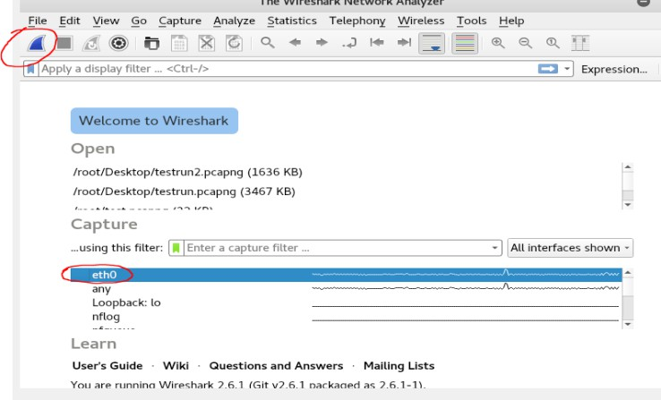

Note: If no network applications are running on your VM, no packets will be captured.

Task 1: Interception of Login Credentials for Basic HTTP authentication
- Open Firefox (Application → Favorites → Web Browser), browse the website http://httpbin.org/basic-auth/foo/bar and login with the following credentials: username: foo
password: bar
Now, assume that a hacker is sniffing the network traffic using Wireshark. Your task (as a hacker) is to find the above credentials (i.e., the username and password) in the intercepted data.
Note: If you want to repeat the above login step, but instead you get the window with the following contents:
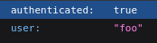
then you need to close the browser (all windows) and start over.

- Stop the packet capture in Wireshark using the red square button.

Q1: Attach a screenshot of the Wireshark window.
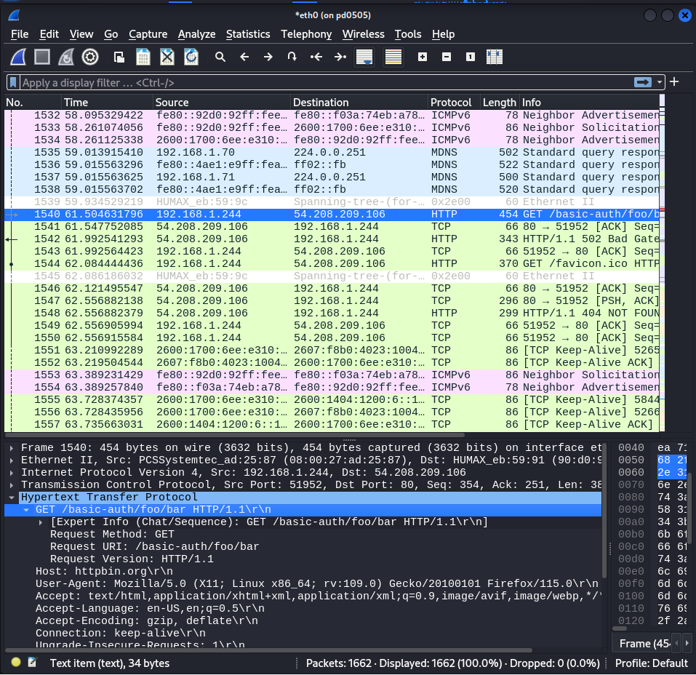

- Filter packets with: http.host = = httpbin.org
(as shown on the screenshot below)
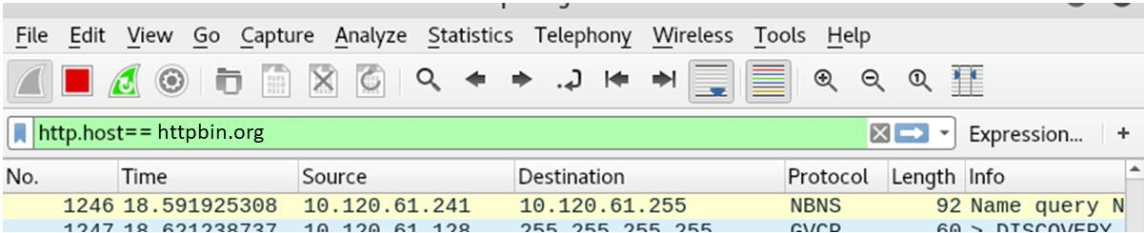

- Left-click on the HTTP packets to display their contents in the lower window.
- Explore these contents to find the line “Authorization: Basic”. The credentials follow in
the Base64 encoding. Actually, you can readily find the credentials in the HTTP header data.

Q2: Attach a screenshot of the Wireshark window which shows the intercepted credentials.

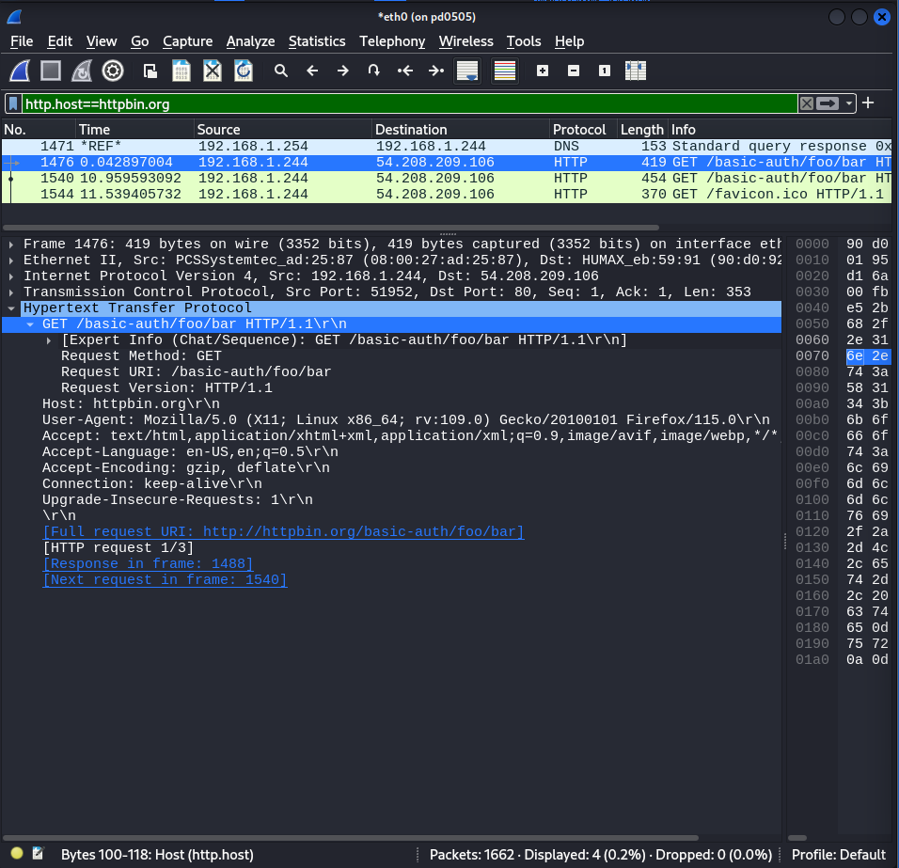

Q3: Explain why your interception attack was successful.
(You may consider discussing whether HTTP protocol provides confidentiality or not.)

Answer: The attack was successful because the website is hosted using http protocol with port number 80, which means there is no TLS protocol used or SSL certificate in it unlike https. Hence, we were able to hijack an active session because of unsafe session identifiers, the information used for the authentication are displayed in a plain text format and confidentiality was violated. (Educative, n.d.).

Task 2: Interception Attempt of Login Credentials for Canvas
- Start a new capture in Wireshark.
- Browse the website “canvas.unt.edu” and login to Canvas with your EUID and password.
- Stop the packet capture in Wireshark.
Now, suppose that a hacker was trying to intercept your credentials. Let us see if they can succeed.

- Apply the following filter: http.host = = canvas.unt.edu
- You may not see many packets (maybe just one) but you can see the destination IP address which you may for filtering. Suppose that the IP address is 129.120.108.147 (it may be different in your case).
- Apply the filter: ip.dst = = 129.120.108.147
Let us try to find the credentials now.
- Search the intercepted packets: Edit → Find Packet…, then type your EUID in the search field and click the “Find” button.
Q4: Attach a screenshot of the resulting Wireshark window.
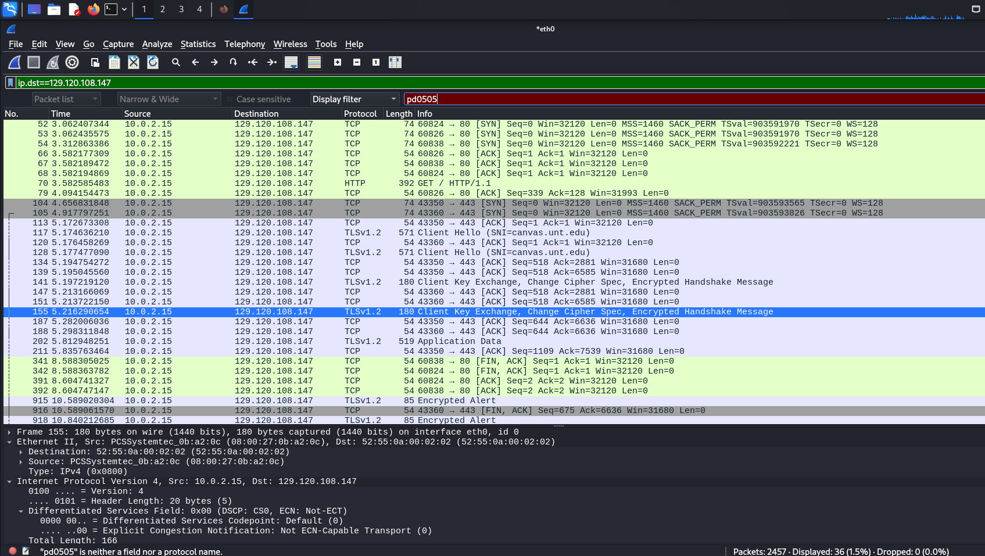

Let us figure out why the interception was not successful. Notice that for some of the packets, the protocol is: TLS (which is Transport Layer Security). Inspect the TLS headers of the filtered packets, and also perform the Internet search about the TLS protocol.
Q5: Explain why your interception attack was not successful.
Answer: canvas.unt.edu have used TLS (Transport Layer Security) protocol for secure communication, unlike http://httpbin.org/basic-auth/foo/bar that used http protocol. TLS is a cryptographic protocol that ensures data integrity and confidentiality for web-based communication. It secures HTTP for web based and SMTP for email using three primary functions encryption, authentication and integrity. (Entrust, n.d.) At first, the client (10.0.2.15) sends “client hello” message to the server including information about SSL/TLS versions it supports, and cypher suits it uses. The server response back with the strongest SSL/TLS versions and cipher suits suited for both the parties along with its digital certificate, verified by CA. The client’s browser validates the server’s certificate, uses the servers public key to encrypt a unique session key and sends back to the server. The server decrypts the session key with its private key and establishes a secure connection. (SSL Corp, 2024)
Therefore, due to the safe and encrypted communication between the client and the server, the interception was not successful.

References:
- https://www.entrust.com/resources/learn/what-is-tls
- SSL Corp. (2024, May 23). SSL/TLS Handshake: Ensuring Secure Online Interactions - SSL.com. SSL.com. https://www.ssl.com/article/ssl-tls-handshake-ensuring-secure-online-interactions/
- Educative. (n.d.). What are HTTP protocol vulnerabilities? https://www.educative.io/answers/what-are-http-protocol-vulnerabilities

