Prakriti Dhungel | CSCE 5214
Assess the architecture of an AI-based system

Assignment 4 Report

Section 1 – Generated Plot

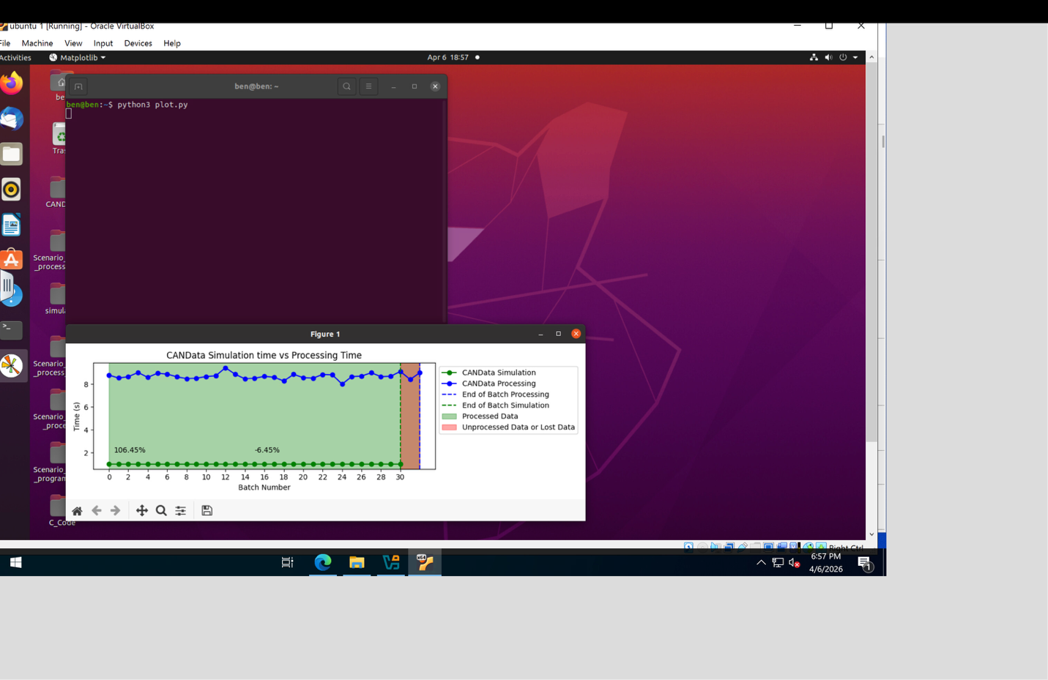

Plot Description

The generated plot in Step 6 is referred to as CANData Simulation time vs Processing Time. It shows two lines that actually exceed 31 batch numbers in the x-axis and time which is measured in seconds in the y-axis. The green dashed line is the simulation time of CANData that is relatively independent and is around 1 second per batch. The blue line is the CANData processing time that ranges around about 8-9 seconds per batch. The green stipulated area depicts processed data (about 106.45) and the orange stipulated area is unprocessed or lost data (about -6.45).

The most important Information and Patterns.

The highest trend that can be observed in the plot is the vast difference between the processing time and the simulation time. Each batch of CAN data is sent by the simulator after about 1 second and the Random Forest model processes a batch after 8-9 seconds. This implies that the model is about 8 and 9 times slower than the rate at which the data comes. Nonetheless, the plot indicates that the vast majority of batches were processed, and the percentage of data processed was more than 100, which means that the system was able to process the data by means of queuing, but with a high delay.

Observations concerning Model Performance.

The trade-off in speed vs. accuracy of real-time AI systems is clearly shown in the plot. The model of the Random Forest is correct in the classification of the CAN bus attacks, however, it is computational expensive and is not able to support the real-time data stream. This delay can be important in a real-life vehicle cybersecurity system since unprocessed CAN messages may carry attack signals that may not be detected. The problem in the plot is that a lighter and faster model is necessary when implementing machine learning in time-sensitive settings.

Section 2 – Reflection
Why do you think there is data loss?
The lack of correspondence between the rate of CAN data generation by the simulator and the rate at which the machine learning model can process the data is the main cause of the loss of data in this experiment. The ECU simulator transmits batches of CAN messages at a frequency in the range of 1 second, whereas the Random Forest classifier takes 8-9 seconds to process one batch. It implies that each batch that the model is working with, a number of new batches have already come and are in the queue. The processing script is single-threaded and in the sequential mode, therefore, it is not able to process several batches at the same time, and as a result, the backlog is high and results in loss of data.
Is the data loss significant? Explain.
Any loss of data is important in the case of vehicle cybersecurity. The CAN bus is the main communication system in a car and every message contains very important data concerning the engine RPM, speed, steering and other safety-related issues. In case an attack is injected at a time when the system is overloaded and is not in a position to handle the incoming data, the attack might not be detected at all. The processing time in our experiment was approximately 8 to 9 times than the simulation time, and this implies that the system might miss several consecutive batches of attacks. Such amount of data loss is inadmissible in a real automotive intrusion detection system because prompt detection is critical to the safety of vehicles.
What could be done to reduce or prevent such data loss?
There are various measures that can be used to minimize or avoid loss of data. To start with, a better substitute to the Random Forest model that would be both much lighter and faster, like either a Logistic Regression or a shallow Decision Tree, would greatly decrease the time spent on processing, yet with an acceptable accuracy level. Second, multi-threading or multi-processing the Python script could have enabled several batches to be processed at a time thereby enhancing throughput. Third, the Random Forest model can be hyperparameter tuned e.g. by cutting down the number of estimators or restricting the depth of the tree, to run more quickly without causing a significant decrease in accuracy. Fourth, hardware acceleration like the inference of the model might significantly decrease the processing time of complex models. Lastly, implementing a sliding window model or real-time stream processing model like Apache Kafka has the potential to support the efficient management of data flow and prevent the loss of batches.

