Q1 (10 pts):

Homework 3: (Optional) Bonus Homework

Homework 3

In this assignment, you need to show passwordless SSH using public and private keys. You need to use your VM (make sure you have the right username/EUID set).
For every single step, you need to show your work using screenshots. Also, you need to explain each step (and each decision) clearly.

- First, on your VM, you will create your public and private keys.

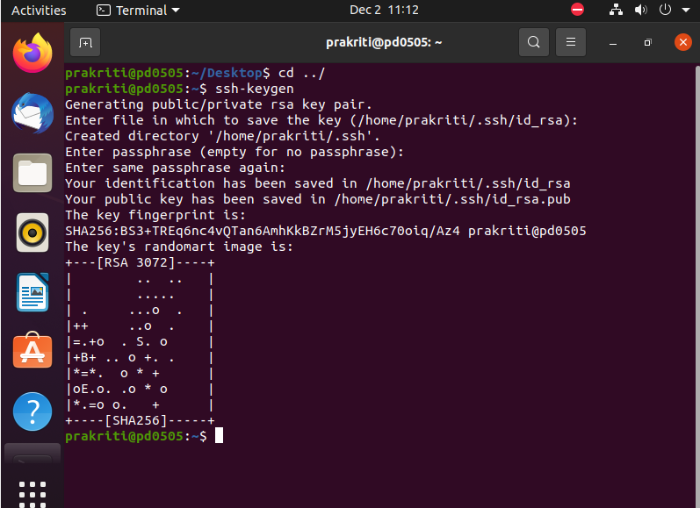

The public and private keys are generated using ssh-keygen as shown in the screenshot above. ssh-keygen is a command line tool used to create authentication keys for ssh connections. Where, id_rsa is a private key and id_rsa.pub is a public key.

- You will edit SSH's authorized keys accordingly.

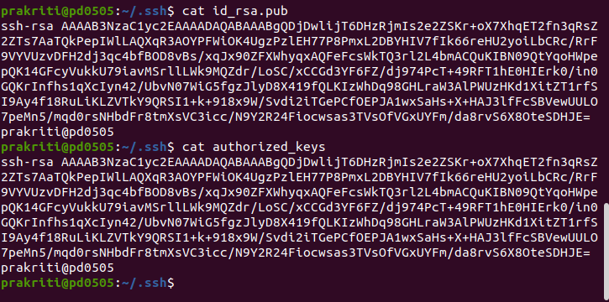

Id_rsa.pub was copied into authorized_key to enable password less ssh.

- You will SSH to your own VM (from the VM) using terminal without using password.

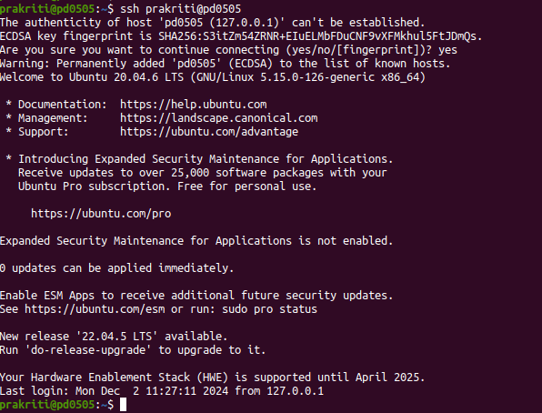

Here, I have established a ssh connection to my own vm without needing a password.

Q2 (10 pts):

Generate a random key using /dev/urandom file in Linux with a size of 512 ASCII characters. Show your code, an output, and explain how your code works.
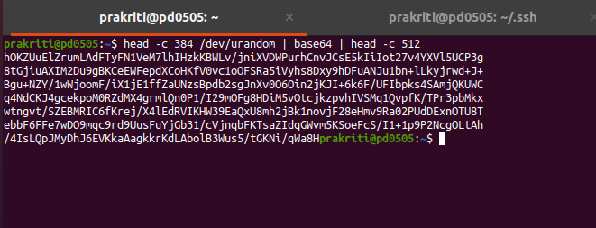

The code used is head -c 384 /dev/urandom | base64 | head -c 512

head -c 384 /dev/urandom reads 384 bytes of random data from the /dev/urandom device, base64 encodes those random bytes into Base64 which ensures that the output is composed of ASCII characters and head -c 512 truncates the Base64 output to 512 chracters.

Q3 (10 pts):

Download Lubuntu 24.04.1 iso using https://cdimage.ubuntu.com/lubuntu/releases/24.04.1/release/

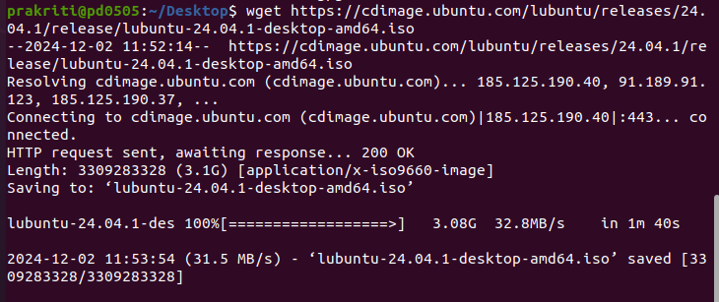
The lubuntu iso file has been downloaded as shown in the screenshot above using wget command.
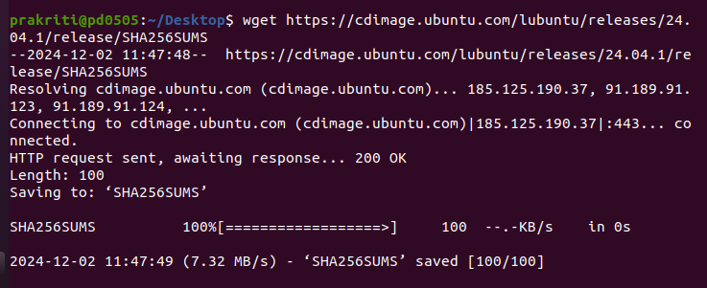

Similarly, the SHA-256SUM of the iso is also downloaded from the same website to compare the hash values.

After downloading, check and compare the hash values. Explain how you calculate it and show a screenshot.

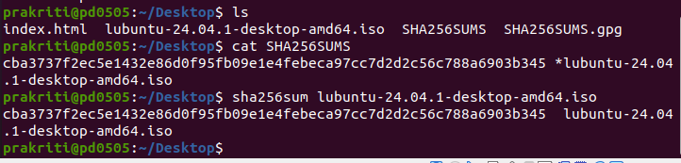

The above screenshot displays the calculation of hash values. First hash value shown using cat SHA256SUMS has downloaded one as shown in the previous step. Then, I calculated the hash value using sha256sum lubuntu-24.04.01-desktop-amd.iso which gives the same output. Obviously, because we have not altered it yet. SHA256sum is a cryptographic hash function in Linux used to calculate and verify the SHA-256 hash of the file.

As a next step, corrupt the iso image (explain how you are corrupting) and recalculate the hash using the same method (show a screenshot).
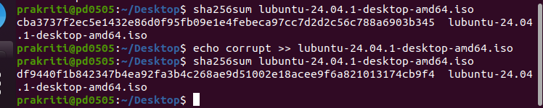

Here I have appended word corrupt in the file by using echo corrupt >> lubuntu-24.04.1-desktop-amd64.iso command where echo command is used for appending text. And calculated the hash value again after the alteration.

What has changed and why?
Answer:
The lubuntu-24.04.1-desktop-amd64.iso file has been corrupted by appending corrupt to the iso file.
The hash value of file lubuntu-24.04.1-desktop-amd64.iso before corrupting the file is different from the hash value after the corruption. This is due to the hashing algorithm nature that provides unique fixed output for every input, anything altered in the file will produce a different hash value again. The main purpose of hashing is to ensure data integrity by detecting any alteration to the file.

