**MULTIMEDIA – CA2**

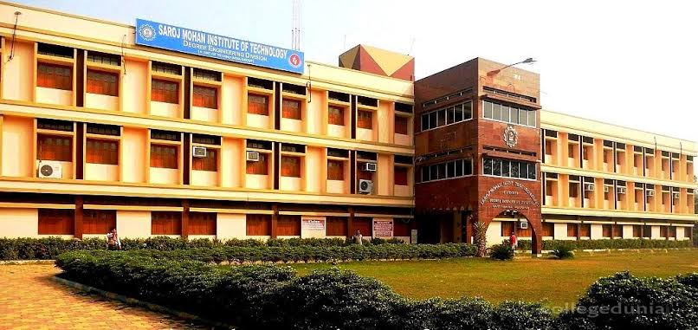

**Name -> Prakriti Mukherjee**

**Roll no -> 16800119023**

**College -> Saroj Mohan Institute of Technology**

**Department -> CSE**

**Year-> 4th Year, 7th Sem**

**Paper -> Multimedia Technology (oEC CS701b)**

**Topic-> file systems – Multimedia and Traditional**

***Index-***

|  |  |
| --- | --- |
| **TOPIC** | **Pages** |
| 1. **File Systems** | **3** |
| 1. **Characteristics of Multimedia Files** | **4** |
| 1. **Multimedia and File System** | **5** |
| 1. **Multimedia Files and Traditional Files** | **6-7** |
| 1. **Conclusion** | **8** |

***File Systems***

Silberschatz and Galvin (2009) explained that file system within any operating system provides the mechanism for storing and accessing a file contents which including data and programs. With the bulk storage that can exist in the secondary storage (the disk), the file system plays a big role in maintaining such storage. To improve the efficiency of I/O in transferring files from the disk to the memory, the transformation is performed in units of blocks, where each block has one or more sectors and each sector can contains from 32 bytes to 4,096 bytes of information. On the other hand, file systems provides efficient access to the disk by allowing data to be stored, retrieved, and located easily. However, the file system faces two problems when it comes to dealing with files:

* Defining how file system should look to the eyes of the users i.e. defining the file and its attributes, the operation allowed on the files and the directory structure that host such files.
* Defining the algorithm and that data structure that can map the logical file system into the physical storage device (the disk).

 Once the above problems are tackled through the implementation of the file system design, the file system needs to only be able to issue generic commands to the appropriate device driver to read and write physical blocks on the disk (Silberschatz and Galvin, 2009).

Marshall (2001) explained that in modern computing systems, operating system are not only required to handle conventional data such as text files, programs and others via their file system implementation, but also to handle a new kind of data types such as multimedia data where data consist of continuous-media (such as audio and video) data as well as conventional files.

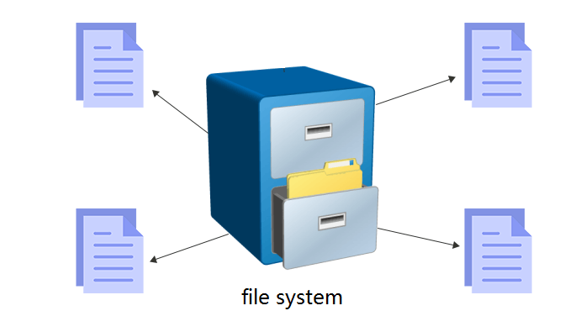

*****Characteristics of Multimedia Files*****

The term multimedia describes a wide range of applications that are in use in today’s modern computing systems and these include audio and video files, and most of the time multimedia files include a combination of both. As any data stored in the file system, multimedia data is no different, however, the only difference between the regular file and a multimedia file is that the multimedia file must be accessed at a specific timing. For example, the video file must be accessed from the file system at a rate that is consistent with the rate at which the video is being displayed. Such requirements that should be handled by the file system mechanism implemented within an operating system are known as a continuous-media data.



The multimedia data can be delivered to the user from the local file system or from a remote server. In the first case where data is delivered from the local file, such delivery is called local playback. On the other hand, the multimedia files delivered to the user over the network is known as streaming. Some of the characteristics of multimedia systems are:

* Multimedia files can be quite large.
* Continuous media may require very high data rate.
* Multimedia files/applications are very critical with timing delays during the playback.

***Multimedia and File System***

For computer systems to deliver continuous media data, it must provide the specific rate and timing requirements associated with such data known as quality of services. For the computing system to be able to deliver such requirements, several components with such system will be affected such as CPU scheduling, network managements, and disk scheduling; and some of such examples are:

* Decoding and compression may require significant CPU processing.
* Processes scheduling algorithm must change for multimedia tasks to meet the deadline requirements of continuous media.
* File systems must be efficient to meet the rate requirements of continuous media.
* Network protocols must support bandwidth requirements to support the streaming technique while minimizing delay in data transformation.

As a result of the characteristics described above, multimedia applications/files require levels of services from the operating system that differ from the traditional applications, such as spreadsheets or word processor. The most important fact of such requirements is the timing, and the rate where the playback of audio and video data demand that the data should be delivered within a certain deadline and at a continuous fixed rate. Such case with the traditional application is not valid since the time and the rate is not considered as constraints for such traditional files (Galli, 1999).

Silberschatz and Galvin (2009) explained that to provide the quality of service to the multimedia data, operating system often uses an admission control, which is a practice of admitting a request of service only if the system has sufficient resources to satisfy the request. Multimedia data (also known as continuous-media files) have two constraints that are not valid in the conventional data file: timing deadlines and rate requirements. To satisfy both constraints required by the multimedia data, disk scheduling algorithm must be optimized for such constraints. Also, these two constraints are usually in conflict with one another i.e. continuous-media files (multimedia files) require very high-disk bandwidth rates to satisfy such requirements, and disks usually have relatively low transfer rates and high latency rates, and to satisfy the requirements for multimedia data, disk schedulers must reduce the latency time to ensure high bandwidth.

To satisfy the above challenges for the multimedia data, some of the following features are required in the modern computing systems:

* **High processing power** – to deal with large data in the multimedia files, and deliver the data within the time constraints required to deliver in a real time.
* **Multimedia capable file system** – needed to deliver the data within the time constraints.
* **Data representation/ file formats that support multimedia** – multimedia data should have the format that can be easily handled, and also be able to be compressed- decompressed.
* **Efficient and high I/O** – the file subsystems within the file system implemented within the operating system must be efficient and fast.
* **Special operating system** – to be able to handle the file manipulation with multimedia data operating systems must provide the capabilities to access the file system and process data efficiently and quickly by providing the support for direct transfers to disk, fast interrupt processing, real-time scheduling, and I/O streaming.
* **Storage and memory** – to handle multimedia data, large storage and large memory is required.

***MULTIMEDIA FILES VS TRADITIONAL FILES***

| **Basis** | **Traditional File System** | **Multimedia Files** |
| --- | --- | --- |
| **Data Redundancy** | Redundant data can be present in a file system. | Multimedia files can or cannot have is redundant data as per user setting. |
| **Backup and Recovery** | It doesn’t provide backup and recovery of data if it is lost. | It provides backup and recovery of data even if it is lost. |
| **Query processing** | There is no efficient query processing in the file system. | Efficient query processing is there to find multimedia files. |
| **Consistency** | There is less data consistency in the file system. | There is more data consistency because of the process of normalization. |
| **Complexity** | It is less complex. | It has more complexity in handling as compared to the traditional file system. |
| **Security Constraints** | File systems provide less security. | They have more security mechanisms. |
| **Cost** | It is less expensive. | It has a comparatively higher cost than a traditional file system. |
| **User Access** | Only one user can access data at a time. | Multiple users can access data at a time. |
| **Sharing** | Data is distributed in many files. So, not easy to share data | Due to centralized nature sharing is easy. |
| **Data Abstraction** | It gives details of storage and representation of data | It hides the internal details. |
| **Integrity Constraints** | Integrity Constraints are difficult to implement | Integrity constraints are easy to implement. |

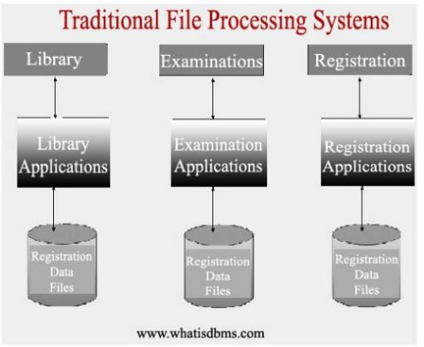

***CONCLUSION-***

A computer system organizes data in a hierarchy that starts with bits and bytes and progresses to fields, records, files, and databases. Traditional file management techniques make it difficult for organizations to keep track of all of the pieces of data they use in a systematic way and to organize these data so that they can be easily accessed. Different functional areas and groups were allowed to develop their own files independently. Over time, this traditional file management environment creates problems such as data redundancy and inconsistency, program-data dependence, inflexibility, poor security, and lack of data sharing and availability.

Multimedia files/applications are in common use in the modern computing systems where the multimedia files include video and audio. The main distinction between multimedia data and conventional data is that multimedia data have a specific rate and deadline requirements that file systems have to handle within the operating system.

Multimedia data may be delivered either from the local file system, or over the network using a technique known as streaming. The observation is that file system switching might be needed and useful. The major direction is to adapt these ideas to a file service that supports a more appropriate security model. One part of an ‘appropriate'' security model is support for cross-domain authentication such that a party from one domain can relocate to another domain and become authenticated in that domain. Thus, this report describes the taking over of multimedia file systems over the age-old traditional file systems and the old practices associated with it. Multimedia file systems have been a boom to the computer and digital society and seems to increase its uses in the coming years as more and more people are getting computer educated and the advantages that multimedia files provide is truly a blessing.