
VISVESVARAYA TECHNOLOGICAL UNIVERSITY JNANA SANGAMA, BELAGAVI - 590018



A Mini Project Report on

“VENDING MACHINE USING VERILOG”

Submitted in partial fulfilment of the requirements for the award of the degree of

Bachelor of Engineering
In
Department of Electronics Engineering (VLSI Design and Technology)

for the Academic Year: 2024-25

Submitted by
Prakruthi .s.nivas. 1NT23VL037
Vaishnavi .k. Ujja 1NT23VL062
Swati Salmani. 1NT23VL059

Under the Guidance of

Dr/Prof. Rekha Phadke
Designation


YELAHANKA, BENGALURU- 560064


Department of Electronics Engineering (VLSI Design and Technology)
Certificate
This is to certify that the group project/mini project work entitled “Title of the Project” has been carried out by prakruthi .s.nivas. (1NT23VL037), Vaishnavi .k. Ujja (1NT23VL062), and Swati Salmani. (1NT23VL059), bonafide students of Nitte Meenakshi Institute of Technology, in partial fulfillment of the requirements for the award of the degree of Bachelor of Engineering in the Department of Electronics Engineering (VLSI Design and Technology) …………………………………., under Visvesvaraya Technological University, Belagavi, during the academic year 2024–2025.
The project report has been examined and approved as it meets the academic requirements specified under the autonomous scheme of Nitte Meenakshi Institute of Technology for the said degree.

Signature of the Guide | Signature of the HoD | Signature of the Principal
Dr./Prof.rekha phadke  Designation  Nitte Meenakshi Institute of Technology, Bengauru-560064 | Dr./Prof.parameshachari BD  Designation  Nitte Meenakshi Institute of Technology, Bengauru-560064 | Dr. H C. Nagaraj  Principal  Nitte Meenakshi Institute of Technology, Bengauru-560064

External Viva-Voce

Name of Examiners Signature with Date

- …………………………….. …………………………..

- …………………………….. …………………………..

contents

Acknowledgement
Abstract
CHAPTER 1 Introduction
CHAPTER 2 Design methodology
CHAPTER 3 Block diagram and flowchart
CHAPTER 4 Verilog code
CHAPTER 5 Test bench
CHAPTER 6 Result and waveform
CHAPTER 7 Application
CHAPTER 8 Future scope

Conclusion

Acknowledgement
The successful execution of our project has been a significant milestone, and we take this opportunity to express our heartfelt gratitude to all those who have supported and guided us throughout this journey. Whatever we have achieved is the result of their encouragement and help, and we remain deeply thankful to each one of them.
We express our sincere thanks and seek the blessings of Dr. N. R. Shetty, Advisor, Nitte Meenakshi Institute of Technology, for his vision and emphasis on project-based learning and constructivist principles that have greatly enriched our academic experience. We are grateful to Mr. Rohit Punja, Administrator, Nitte Education Trust, and Dr. Sandeep Shastri, Vice President, Bangalore Campus, Nitte University, for their strategic leadership and continued support in fostering academic excellence.
We extend our special thanks to our beloved Principal, Dr. H. C. Nagaraj, for providing us with the necessary resources, facilities, and motivation to carry out our project successfully. Our sincere gratitude goes to Dr. J. Sudheer Reddy, Dean – Academics, and Dr. Kiran Aithal, Dean – Research & Development, for their guidance, encouragement, and for creating an environment that promotes innovation and academic growth.
We also convey our deep appreciation to Dr Parameshachari B D Head of the Department, for his constant encouragement, valuable guidance, and for fostering a vibrant learning environment. We extend our heartfelt thanks to our project guide, Dr./Prof. [Name], [Designation], Department of …………………….., for his/her unwavering support, timely feedback, and insightful mentorship throughout the project. We are also indebted to our parents for their unconditional love, support, and encouragement throughout our academic journey at Nitte Meenakshi Institute of Technology, Bengaluru. Finally, we would like to express our appreciation to all those—named and unnamed—who contributed in any way to our learning and success.

prakruthi .s.nivas. 1NT23VL037
Vaishnavi .k. Ujja 1NT23VL062
Swati Salmani. 1NT23VL059
Place: Bengaluru
Date:

Abstract
This paper proposes the design, implementation, and verification of a vending machine using the Finite State Machine (FSM) methodology in Verilog HDL. The FSM is used to manage the multiple states of the vending machine, including “idle,” “accepting coins,” “dispensing item,” and “returning change.” The implementation of the vending machine is done in Verilog HDL, and the FSM is implemented as a state diagram. The design is then synthesized using the Genus synthesis tool and implemented using the Encounter implementation tool. The Genus tool uses advanced optimization techniques, such as timing-driven placement and clock tree synthesis, to improve the design’s performance and area. The Encounter tool performs physical design, including placement and routing, to meet the design’s timing, power, and area constraints. To validate the design’s correctness and functionality, a test bench is created to simulate the behavior of the vending machine. The simulation results are then used to verify that the design meets the required specifications and that the FSM behaves as expected. The proposed design is then can be implemented on a Field Programmable Gate Array (FPGA) to demonstrate its effectiveness in a real-world scenario. The results of the implementation are presented and analyzed to validate the design’s performance, power consumption, and area. Overall, the vending machine using FSM in Verilog HDL, implemented in Genus and Encounter, provides a reliable and efficient solution for users to purchase items from the machine. The proposed design and implementation demonstrate the feasibility and effectiveness of this approach, and the results show that the design meets the required specifications and performs well in a real-world scenario.

Introduction
The Vending Machine is an automatic machine that sells food such as canned soups and packaged sandwiches, snacks such as potato chips, chocolate bars, and candy); hot drinks (coffee, tea, and hot chocolate); cold drinks (juice, bottled water, soft drinks, and in some cases, milk or chocolate milk); or other items such as newspapers or tickets. The machines usually work when a product is selected and some money (usually coins or paper money) is put in a slot. Then, a button needs to be pushed, or a lever pulled. If there is enough money, the selected item will be dropped to a tray, where it can be taken out by the person making the purchase. From 2000-2010, the specialization of vending machines became more common. Vending extended increasingly into non-traditional areas like electronics, or even artwork or short stories. Machines of this new category are generally called Automated retail kiosks. When using an automated retail machine, consumers select products, sometimes using a touch screen interface, pay for purchases using a credit or debit card and then the product is dispensed, sometimes via an internal robotic arm in the machine. The trend of specialization and proliferation of vending machines is perhaps most apparent in Japan where there is 1 vending machine for 23 people. Apparently similar to the development of traditional mobile phones into smartphones, vending machines have also progressively, though at a much slower pace, evolved into smart vending machines. Newer technologies at a lower cost of adoption, such as the large digital touch display, internet connectivity, cameras and various types of sensors, more cost effective embedded computing power, digital signage, various advanced payment systems, and a wide range of identification technology (NFC, RFID, etc) have contributed to this development.. Integrated sensors and cameras also represent a source of such data as customer demographics, purchase trends, and other locality-specific information. It also enables better customer engagement for the brands through interactive multimedia and social media connectivity. Smart vending machines were #79 by JWT Intelligence on its list of 100 Things to Watch in 2014. According to market research by Frost & Sullivan, global shipments of smart vending machines are forecasted to reach around 2 million units by 2018 and further to 3.6 million units by 2020 with penetration rate of 20.3 percent.

Design methodology

Designing a vending machine using Verilog with a Moore finite state machine (FSM) involves defining states, inputs, outputs, and transitions. A Moore machine's outputs depend only on the current state, not the inputs.
A finite-state machine (FSM) or finite-state automaton (FSA, plural: automata), finite automaton, or simply a state machine, is a mathematical model of computation. It is an abstract machine that can be in exactly one of a finite number of states at any given time. The FSM can change from one state to another in response to some inputs; the change from one state to another is called a transition. An FSM is defined by a list of its states, its initial state, and the inputs that trigger each transition. Finite-state machines are of two types—deterministic finite-state machines and non-deterministic finite-state machines. For any non-deterministic finite-state machine, an equivalent deterministic one can be constructed.

Block diagram and flow chart
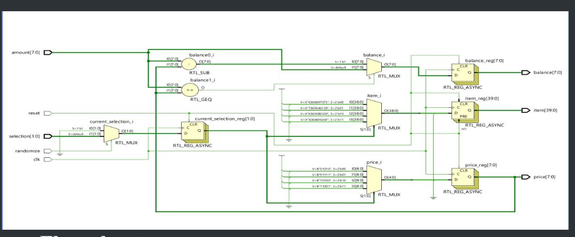
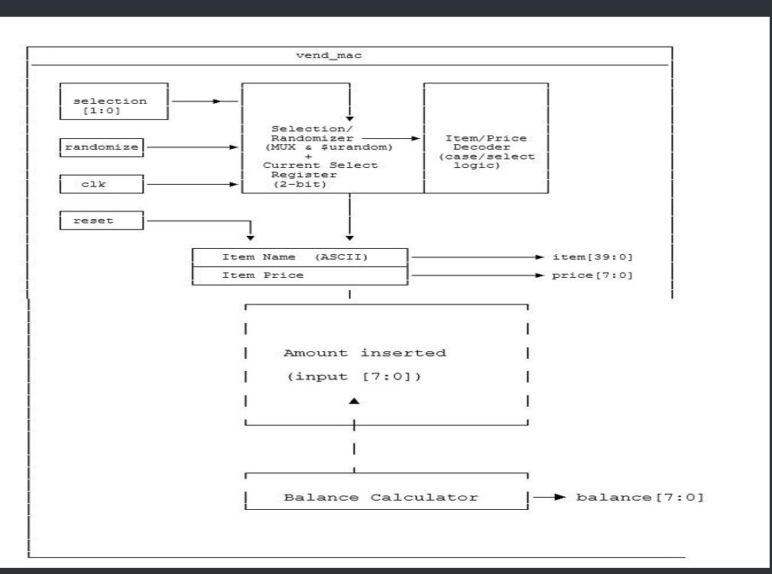

Verilog code

module vend_mac(
input logic [1:0] selection,
input logic clk,
input logic reset,
input logic randomize,
input logic [7:0] amount,

output logic [39:0] item,
output logic [7:0] price,
output logic [7:0] balance
);

parameter CHIPS = "chips";
parameter SODA = "soda ";
parameter COKE = "coke ";
parameter CHOCOLATE = "choco";

parameter PRICE_CHIPS = 8'd10;
parameter PRICE_SODA = 8'd15;
parameter PRICE_COKE = 8'd20;
parameter PRICE_CHOCOLATE = 8'd25;

parameter SEL_CHIPS = 2'b00;
parameter SEL_SODA = 2'b01;
parameter SEL_COKE = 2'b10;
parameter SEL_CHOCOLATE = 2'b11;

logic [1:0] current_selection;

always @(posedge clk or posedge reset)
begin
if (reset)
begin
item <= " ";
price <= 8'd0;
balance <= 8'd0;
current_selection <= 2'b00;
end
else
begin
if (randomize)
current_selection <= $urandom % 4;
else
current_selection <= selection;

case (current_selection)

SEL_CHIPS:
begin
item <= CHIPS;
price <= PRICE_CHIPS;
end

SEL_SODA:
begin
item <= SODA;
price <= PRICE_SODA;
end

SEL_COKE:
begin
item <= COKE;
price <= PRICE_COKE;
end

SEL_CHOCOLATE:
begin
item <= CHOCOLATE;
price <= PRICE_CHOCOLATE;
end

default:
begin
item <= " ";
price <= 8'd0;
end

endcase

if (amount >= price)
balance <= amount - price;
else
balance <= amount;
end
end

endmodule

Test bench

module vend_mac_tb;

reg [1:0] selection;
reg clk;
reg reset;
reg randomize;
reg [7:0] amount;

wire [39:0] item;
wire [7:0] price;
wire [7:0] balance;

vend_mac uut (
.selection(selection),
.clk(clk),
.reset(reset),
.randomize(randomize),
.amount(amount),
.item(item),
.price(price),
.balance(balance)
);

// Clock generation
initial
begin
clk = 0;
forever #5 clk = ~clk;
end

// Test sequence
initial
begin
reset = 1;
selection = 2'b00;
randomize = 0;
amount = 8'd0;

#20;
reset = 0;

// Test 1
selection = 2'b01;
amount = 8'd20;
randomize = 0;
#20;

// Test 2
selection = 2'b11;
amount = 8'd10;
randomize = 0;
#20;

// Test 3
randomize = 1;
amount = 8'd30;
#10;
randomize = 0;
#20;

// Test 4
randomize = 1;
amount = 8'd5;
#10;
randomize = 0;
#20;

// Test 5
repeat (5)
begin
randomize = 1;
amount = $urandom % 40;
#10;
randomize = 0;
#20;
end

// Test 6
reset = 1;
#10;
reset = 0;
#20;

$finish;
end

initial
begin
$display("Time\tItem\tPrice\tBalance");
$monitor("%0t\t%s\t%0d\t%0d", $time, item, price, balance);
end

endmodule

Result and waveform
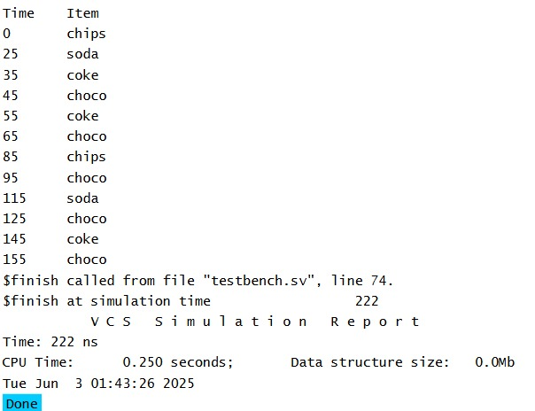

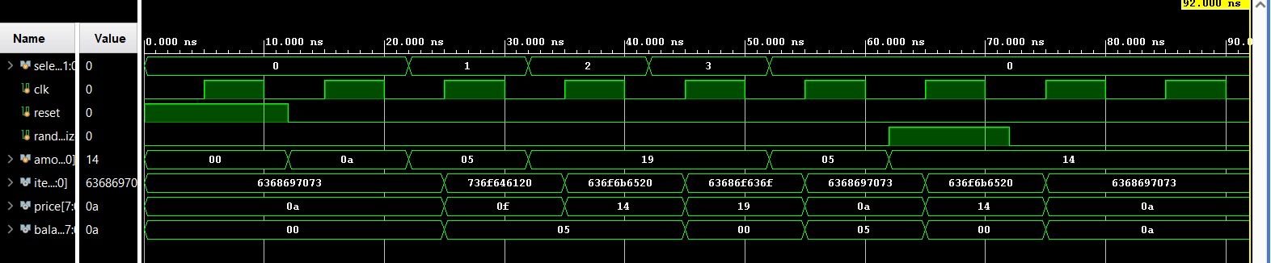

Applications
• Real-world vending machines can serve:
• Retail (snacks/beverages)
• Healthcare (PPE, medicine)
• Transportation hubs
• Offices, schools, events, and industrial environments
• IoT-enabled smart vending for tracking and automation

Future Scope
• The project envisions advanced features including:
• AI/ML: Predicting user behavior and optimizing inventory
• IoT Integration: Remote monitoring and analytics
• Contactless payments: QR, NFC, biometrics
• Eco-Friendly Design: Energy and waste-efficient systems
• Robotics & E-commerce: Robotic arms and online ordering
Integration
• Accessibility Enhancements: Voice and multi-language
Interfaces

Conclusion

This project serves as an excellent introductory digitaLDesign exercise, integrating FSm principles with practical Hardware modelling using Verilog. Its implementation is Clear and efficient for simulation, with applications Extending to numerous real-world automated systems. With Further enhancements, especially regarding synthesis Compatibility and UI/UX, it holds potential for deployment In modern smart vending scenarios.

