Week 5: Machine Learning Algorithms and Model Evaluation
Titanic Survival Prediction using Python
1. Objective
The objective of this project is to implement machine learning algorithms for a classification problem using the Titanic dataset. The analysis predicts whether a passenger survived based on selected passenger characteristics. The project also evaluates and compares the performance of Logistic Regression and Decision Tree models.
2. Dataset Description
The project uses the Titanic training dataset, train.csv. The dataset contains 891 passenger records and 12 columns. The target variable is Survived, where 1 represents a passenger who survived and 0 represents a passenger who did not survive.
- Rows: 891
- Columns: 12
- Target variable: Survived
- Predictive features: Pclass, Sex, Age, SibSp, Parch, Fare, Embarked
- Excluded columns: PassengerId, Name, Ticket, Cabin
3. Data Validation
The dataset was checked before machine learning model preparation. The validation step examined the dataset shape, missing values, duplicate records, and data types.
- Dataset shape: 891 rows and 12 columns.
- Duplicate rows found: 0.
- Missing values were found in Age, Cabin, and Embarked.
- No missing values were found in PassengerId, Survived, Pclass, Name, Sex, SibSp, Parch, Ticket, and Fare.
- The data types of the columns were checked before selecting the model features.
4. Target Variable
The target variable is Survived. A value of 1 represents a passenger who survived, while 0 represents a passenger who did not survive. In the dataset, 549 passengers did not survive and 342 passengers survived.
5. Feature Selection
Seven features were selected for the machine learning models: Pclass, Sex, Age, SibSp, Parch, Fare, and Embarked. PassengerId, Name, Ticket, and Cabin were excluded from the model because they were not used as direct predictive features in this analysis.
6. Model Preparation
The selected features were assigned to X, while Survived was assigned to y. The resulting feature matrix contains 891 records and 7 selected features. The target vector contains 891 records.
7. Machine Learning Algorithms
Two classification algorithms were implemented and evaluated.
- Logistic Regression: used as a classification model for predicting the binary survival outcome.
- Decision Tree: used as a tree-based classification model for predicting the binary survival outcome.
8. Model Evaluation
The models were evaluated using accuracy, precision, recall, F1-score, and confusion matrices. The results from the notebook are shown below.
Metric | Logistic Regression | Decision Tree
Accuracy | 80.45% | 76.54%
Precision | 79.31% | 75.47%
Recall | 66.67% | 57.97%
F1 Score | 72.44% | 65.57%
9. Confusion Matrices
Logistic Regression confusion matrix:
 | Predicted 0 | Predicted 1
Actual 0 | 98 | 12
Actual 1 | 23 | 46
Decision Tree confusion matrix:
 | Predicted 0 | Predicted 1
Actual 0 | 97 | 13
Actual 1 | 29 | 40
10. Model Performance Comparison
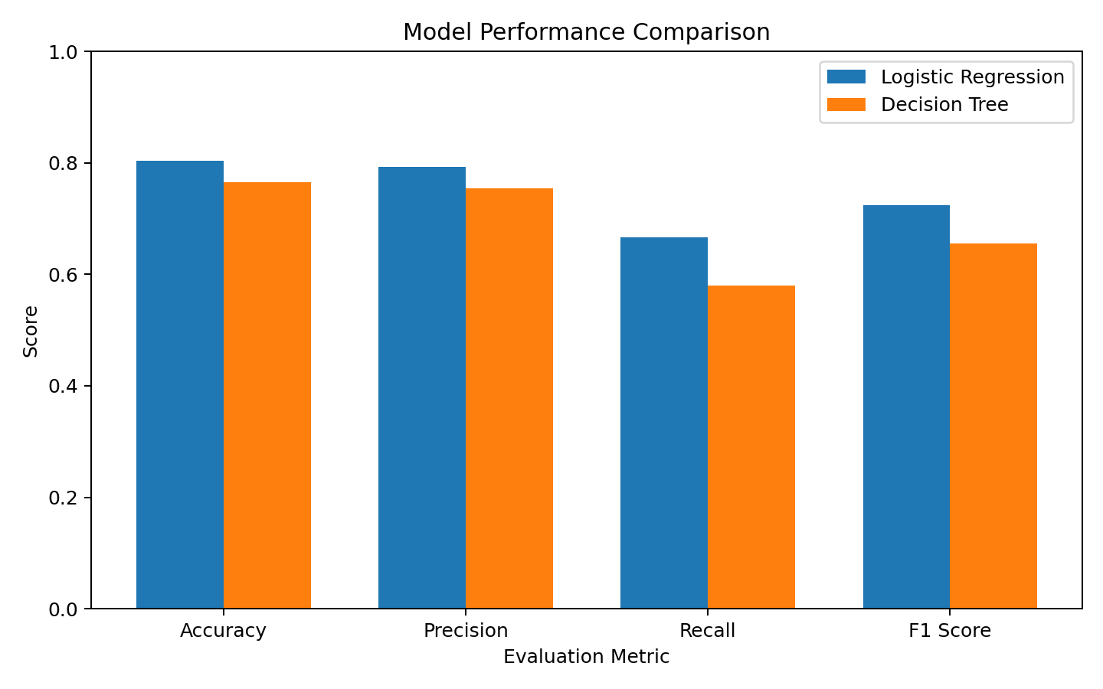
11. Interpretation
Logistic Regression performed better than the Decision Tree model across all four evaluation metrics. Logistic Regression achieved an accuracy of 80.45%, precision of 79.31%, recall of 66.67%, and F1-score of 72.44%. The Decision Tree achieved an accuracy of 76.54%, precision of 75.47%, recall of 57.97%, and F1-score of 65.57%. Based on these test results, Logistic Regression was selected as the better-performing model for this analysis.
12. Conclusion and Recommendations
This project implemented machine learning classification models using the Titanic dataset to predict passenger survival. The workflow covered data loading, data validation, target variable identification, feature selection, model training, and model evaluation. Two algorithms, Logistic Regression and Decision Tree, were compared using accuracy, precision, recall, F1-score, and confusion matrices.
The results show that Logistic Regression produced better scores across all four evaluation metrics. It achieved 80.45% accuracy compared with 76.54% for the Decision Tree. Logistic Regression also produced higher precision, recall, and F1-score. Therefore, Logistic Regression was selected as the better-performing model for this analysis.
The analysis shows that the selected passenger characteristics provide useful information for survival prediction. Future work could include feature engineering, hyperparameter tuning, and testing additional classification algorithms to compare model performance further.
13. Tools and Technologies
- Python
- Pandas
- NumPy
- Matplotlib
- Seaborn
- Scikit-learn
- Jupyter Notebook

