SERVICE THAT PROVIDE REGISTRATION OF BIRTH/DEATH INTEGRATION

A PROJECT REPORT
Submitted by,
PRAKRUTHI. S - 20211CSE0628
DEEPTHI. R - 20211CSE0618
NIDHISHA. N - 20211CSE0677

Under the guidance of,
Mr. AMARNATH J.L

in partial fulfillment for the award of the degree of
BACHELOR OF TECHNOLOGY
IN
COMPUTER SCIENCE AND ENGINEERING

At


PRESIDENCY UNIVERSITY
BENGALURU
DECEMBER 2024

PRESIDENCY UNIVERSITY

SCHOOL OF COMPUTER SCIENCE ENGINEERING

CERTIFICATE

This is to certify that the Project report “SERVICE THAT PROVIDE REGISTRATION OF BIRTH/DEATH INTEGRATION” being submitted by Prakruthi. S, Deepthi. R and Nidhisha. N bearing roll numbers 20211CSE0628, 20211CSE0618 and 20211CSE0677 in partial fulfillment of the requirement for the award of the degree of Bachelor of Technology in Computer Science and Engineering is a bonafide work carried out under my supervision.

Mr. AMARNATH J.L  Assistant Professor  School of CSE&IS  Presidency University | Dr.ASIF MOHAMMED H.B  Head of the Department  School of CSE&IS  Presidency University

Dr. L. SHAKKEERA  Associate Dean  School of CSE  Presidency University | Dr. MYDHILI NAIR  Associate Dean  School of CSE  Presidency University | Dr. SAMEERUDDIN KHAN  Pro-Vc School of Engineering  Dean -School of CSE&IS  Presidency University

PRESIDENCY UNIVERSITY

SCHOOL OF COMPUTER SCIENCE ENGINEERING

DECLARATION

We hereby declare that the work, which is being presented in the project report entitled IMPLEMENTATION OF BIRTH/DEATH REGISTRATION INTEGRATION WITH SERVICES in partial fulfillment for the award of Degree of Bachelor of Technology in Computer Science and Engineering, is a record of our own investigations carried under the guidance of Mr. Amarnath J.L, Assistant Professor, School of Computer Science Engineering & Information Science, Presidency University, Bengaluru.

We have not submitted the matter presented in this report anywhere for the award of any other Degree.

Name(s), Roll No(s) and Signature(s) of the Students
PRAKRUTHI. S - 20211CSE0628
DEEPTHI. R -20211CSE0618
NIDHISHA. N -20211CSE0677

ABSTRACT
The traditional method of obtaining a birth certificate is often cumbersome and impractical, especially as birth rates increase. Birth registration, the official recording of a child's birth by the state, is a crucial component of a comprehensive civil registration system maintained by the government. This system provides valuable demographic data for policymaking and resource allocation. However, the manual process associated with birth certificate issuance presents numerous challenges, including high costs, bureaucratic hurdles, and the risk of lost or damaged certificates.

To address these issues, a web-based birth certificate system is proposed. This system offers several advantages:
- Enhanced Accessibility: Easy and global access to birth certificate services.
Enhanced accessibility in birth and death software systems improves efficiency and inclusivity.
It allows for remote registration, accommodates diverse user needs, and streamlines processes, leading to better data quality and citizen satisfaction.

- Accelerated Processing: Streamlined procedures and reduced processing time.
Accelerated processing in birth and death software systems significantly reduces processing time.
It streamlines data entry, automates verification processes, and enables faster certificate generation.
This leads to improved efficiency, reduced waiting times, and enhanced citizen satisfaction.

- Paperless Efficiency: Elimination of paper-based certificates, leading to cost savings and environmental benefits.
It reduces administrative overhead, minimizes the risk of document loss, and promotes environmental sustainability.
By digitizing records, these systems streamline processes, improve data accuracy, and enhance overall efficiency.

- Reduced Stress and Cost: Convenient online access reduces the burden on citizens.
Reduced stress and cost in birth and death software systems benefit both citizens and government agencies.
This reduces stress and saves time.
For government agencies, automated processes and reduced paperwork lead to cost savings and increased efficiency.

- Improved Birth Rate Monitoring: Real-time online registration enables accurate and efficient tracking of birth rates.
Real-time data entry and analysis allow for effective tracking of birth trends, identifying potential issues, and informing public health policies.
This helps governments allocate resources efficiently and implement targeted interventions to address population health challenges.

- Data-Driven Insights: Automated data collection allows for the generation of insightful reports and visualizations.
By analyzing demographic trends, identifying patterns, and predicting future needs, governments can allocate resources effectively, plan for healthcare services, and implement targeted public health programs.

This ultimately contributes to improved population health and social well-being.
The implementation of the proposed system is achieved using Front-end technology (React Native/Javascript), Back-end technology(Node.js), Database(MySQL), API’s and Web Services (RESTful API), Authentication(JWT(JSON Web Tokens), Cloud services(AWS), Version Control (GitHub).

By leveraging technology, this web-based system aims to modernize birth certificate issuance, improve citizen services, and support informed decision-making.

ACKNOWLEDGEMENT

First of all, we indebted to the GOD ALMIGHTY for giving me an opportunity to excel in our efforts to complete this project on time.
We express our sincere thanks to our respected dean Dr. Md. Sameeruddin Khan, Pro-VC, School of Engineering and Dean, School of Computer ScienceEngineering& Information Science, Presidency University for getting us permission to undergo the project.
We express our heartfelt gratitude to our beloved Associate Deans Dr. Shakkeera L and Dr. Mydhili Nair, School of Computer Science Engineering& Information Science, Presidency University, and Dr. Dr. Asif Mohammed H.B, Head of the Department, School of Computer Science Engineering& Information Science, Presidency University, for rendering timely help in completing this project successfully.
We are greatly indebted to our guide Mr. Amarnath J.L, Assistant Professor and Reviewer Ms. Tintu Vijayan, Assistant Professor, School of Computer Science Engineering& Information Science, Presidency University for his inspirational guidance, and valuable suggestions and for providing us a chance to express our technical capabilities in every respect for the completion of the project work.
We would like to convey our gratitude and heartfelt thanks to the PIP2001 Capstone Project Coordinators Dr. SampathA K, Dr. Abdul KhadarA and Mr. Md Zia Ur Rahman, department Project Coordinators Mr. Amarnath J.L and Github coordinator Mr. Muthuraj.
We thank our family and friends for the strong support and inspiration they have provided us in bringing out this project.
Prakruthi. S
Deepthi. R
Nidhisha. N

LIST OF TABLES

Sl. No. | Table Name | Table Caption | Page No.
1 | Table 1.1 | Software modules versus Reusable components | 5

LIST OF FIGURES

Sl. No. | Figure Name | Caption | Page No.
1 | Figure 1.1 | Software modules versus Reusable components | 5

TABLE OF CONTENTS

CHAPTER NO. | TITLE | PAGENO.
 | ABSTRACT  ACKNOWLEDGMENT  … | i  ii  …
1. | INTRODUCTION | 11
 | 1.1 Uses of Birth and Death Registration System | 11
 | 1.2 Improvements by Developing a Robust CRVS System | 11
 | 1.3 How a CRVS System Helps a Nation | 12
2. | LITERATURE REVIEW | 13
 | 2.1 Challenges of Manual Registration | 13
 | 2.2 Benefits of Integrated Systems | 13
 | 2.3 Future Research Directions  2.4 Impact of Improved Registration | 13  14
 | 2.5 Policy Recommendations | 15-16
3 | RESEARCH GAPS OF EXISTING METHODS | 17
 | 3.1 Data Quality and Consistency | 17
 | 3.2 Data Privacy and Security | 17
 | 3.3 Interoperability and Integration | 18
 | 3.4 Real-time data Processing, and Analysis | 19
 | 3.5 Scalability and Performance | 20
4 | PROPOSED METHODOLOGY | 21
 | 4.1 System Development | 21
 | 4.2 Key Consideration | 22
 | 4.3 Data Integration | 22
 | 4.4 User Interface Design | 23
 | 4.5 Security and Privacy | 24
 | 4.6 Challenges in Ensuring Security, Privacy
 | 4.7 Data Quality and Integrity | 24
 | 4.8 Training and Support | 25
 | 4.9 Monitoring and Evaluation | 26-27
5 | OBJECTIVES | 28
 | 5.1 Primary Objectives | 28
 | 5.2 Secondary Objectives | 29
6 | SYSTEM DESIGN AND IT’S IMPLEMENTATION | 30-31
7 | TIMELINE FOR EXECUTION OF PROJECT | 32
8 | OUTCOMES | 33
9 | RESULTS AND DISCUSSIONS
10 | CONCLUSION
11 | REFERENCES

CHAPTER-1
INTRODUCTION

Civil Registration and Vital Statistics (CRVS) systems, particularly birth and death registration, are fundamental pillars of effective governance and public health. They provide crucial data for population monitoring, policy planning, resource allocation, and legal identity establishment. However, many countries, especially in low- and middle-income regions, face significant challenges in implementing robust and comprehensive CRVS systems. These challenges include limited resources, inadequate infrastructure, low public awareness, cultural and social barriers, and geographical constraints.

To address these challenges and improve the efficiency, accuracy, and accessibility of birth and death registration, various innovative approaches have been explored. Recent studies have highlighted the importance of complete and timely birth and death registration for evidence-based decision-making (Rane et al., 2020; Zeng et al., 2018; Sankoh et al., 2020). Additionally, research has explored the impact of birth and death registration on health service delivery (Hruthika Ruth et al., 2024; Abdul-Aziz Ibn Musah et al., 2015).
Technological advancements, including mobile applications and digital platforms, have emerged as promising solutions to enhance CRVS systems. Studies by Petera and Miritib (2016), Pinto et al. (2017), and Vasudevan et al. (2020) have investigated the potential of mobile-based approaches for birth and death notification. Furthermore, research by Prasetyo and Hamudy (2016) and Chaudhari (2021) has explored the use of online systems for birth registration and certification.
1.1 Uses of Birth and Death Registration System
A robust birth and death registration system offers numerous benefits to individuals, communities, and nations:
- Individual Benefits:
  - Legal identity and citizenship rights
  - Access to education, healthcare, and social services
  - Protection against identity theft and fraud
- Community Benefits:
  - Accurate population data for planning and resource allocation
  - Improved public health surveillance and response
  - Enhanced social and economic development
- National Benefits:
  - Informed policymaking and evidence-based decision-making
  - Strengthened governance and accountability
  - Improved international cooperation and data sharing
1.2 Improvements by Developing a Robust CRVS System
A well-developed CRVS system can lead to significant improvements in various areas:
- Enhanced Data Quality: Accurate and timely data on births, deaths, and other vital events.
- Improved Service Delivery: Efficient and equitable access to public services.
- Reduced Corruption and Fraud: Stronger identity verification and reduced opportunities for fraud.
- Strengthened Governance: Informed policymaking and better allocation of resources.
- Improved Public Health: Effective monitoring of disease outbreaks and trends.

1.3 How a CRVS System Helps a Nation
A robust CRVS system contributes to a nation's development in numerous ways:
- Economic Growth: By providing accurate data for investment planning and business development.
- Social Development: By ensuring access to education, healthcare, and social protection programs.
- Democratic Governance: By promoting transparency, accountability, and citizen participation.
- International Cooperation: By facilitating international data sharing and collaboration.
By addressing the challenges and embracing innovative approaches, countries can improve their CRVS systems, leading to better-informed policymaking, improved public health outcomes, and sustainable development.

CHAPTER-2
LITERATURE SURVEY
Challenges of Manual Registration:
The paper highlights the limitations of traditional, manual birth and death registration processes . These methods can be:
Time-consuming and labor-intensive: Manual processes require significant effort and resources to manage, leading to delays and inefficiencies Prone to errors: Manual data entry increases the risk of inaccuracies and inconsistencies in records Limited accessibility: Rural populations may face geographical or logistical barriers in accessing registration facilities, resulting in underreporting of births and deaths.
Benefits of Integrated Systems:
The paper proposes the integration of birth and death registration with service delivery as a potential solution This approach could offer several advantages:
- Enhanced Efficiency: Streamlining registration processes through digitalization can improve timeliness and accuracy .
- Improved Data Quality: Integration can ensure consistency across different systems, leading to more reliable data for public health and demographic analysis
- Increased Accessibility:Utilizing online platforms or mobile technologies can expand access to registration services, particularly for remote populations
Future Research Directions:
The paper suggests potential areas for further research to strengthen integrated birth and death registration systems These include:
- Interoperability: Exploring strategies for seamless data exchange between different systems involved in birth and death registration .
- Data privacy and security: Addressing concerns related to data protection in the digital environment to ensure user trust.
- Equity and Inclusion: Investigating ways to ensure equitable access for marginalized populations who may face barriers to registration .

One of the primary challenges identified in the article is the lack of adequate infrastructure and resources in many African countries. This often leads to incomplete or inaccurate registration data. To address this issue, the authors advocate for increased investment in healthsystems, including the establishment of functional birth and death registration offices
Another challenge is the limited public awareness of the importance of registration. Many individuals are unaware of the benefits of registering births and deaths, leading to a lack of participation. To overcome this, the article suggests implementing public education campaigns to raise awareness and encourage registration

Despite these challenges, the authors identify several opportunities for improving birth and death registration in Africa. These include leveraging digital technologies, such as mobile health applications, to facilitate data collection and improve accessibility. Additionally, strengthening partnerships between governments, civil society organizations, and international agencies can help mobilize resources and expertise (Sankoh et al., 2020).

Impact of Improved Registration
Accurate birth and death registration can have a profound impact on public health, governance, and social development. By providing reliable data on population demographics, health trends, and mortality rates, registration systems can inform evidence-based decision-making. This can lead to more effective disease control, improved maternal and child health, and more equitable allocation of resources.
Furthermore, registration data is essential for good governance and social justice. It can help to prevent child trafficking, protect the rights of vulnerable populations, and ensure that individuals have access to essential services such as education and healthcare.

Zeng et al. (2020) found significant variation in death registration completeness across different regions of China. Counties with higher levels of socioeconomic development, better access to healthcare, and higher population density generally exhibited higher completeness rates These findings suggest that factors such as poverty, rural-urban disparities, and cultural beliefs can influence the extent to which deaths are reported and recorded.
Incomplete death registration can have several negative consequences. It can hinder accurate population estimates, impede disease surveillance efforts, and distort the allocation of public resources. Additionally, it can limit the ability of governments to effectively address public health challenges, such as infectious diseases, maternal mortality, and aging populations
The authors also highlight the importance of improving data quality in addition to increasing completeness. Errors in reported age, cause of death, and other demographic information can undermine the usefulness of registration data. To address these issues, Zeng et al. (2020) recommend investing in training for registration personnel, strengthening data quality control mechanisms, and promoting the use of standardized coding systems.

Policy Recommendations
Based on their findings, Zeng et al. (2020) offer several policy recommendations to improve death registration in China. These include:
- Increasing investment in health infrastructure: Expanding access to primary healthcare services, particularly in rural areas, can help to ensure that deaths are reported and recorded .
- Strengthening community-based registration systems:Empowering local communities to play a more active role in death registration can improve data quality and completeness .
- Promoting public awareness: Raising awareness of the importance of death registration among the general public can encourage individuals to report deaths promptly
- Improving data quality: Investing in training for registration personnel and implementing data quality control measures can enhance the accuracy and reliability of registration data.

Rane et al. (2020) found that the CRS in Assam is facing several challenges, including limited coverage, inaccurate data, and lack of public awareness. These challenges can hinder the effectiveness of the CRS in supporting public health, governance, and social development.
Incomplete coverage is a significant issue, with many births and deaths going unreported. This can lead to inaccurate population estimates, impede disease surveillance efforts, and distort the allocation of resources . Inaccurate data, such as errors in age, cause of death, and other demographic information, can also limit the usefulness of the CRS for evidence-based decision-making.
Lack of public awareness is another challenge. Many individuals may not be aware of the importance of registering births and deaths, leading to a reluctance to participate in the system. This can contribute to incomplete coverage and inaccurate data.
Recommendations for Improvement
To address these challenges and improve the functioning of the CRS in Assam, Rane et al. (2020) offer several recommendations. These include:
- Strengthening the Registration Infrastructure: Investing in additional staff, equipment, and facilities can help to improve the coverage and efficiency of the CRS.
- Increasing Public Awareness: Implementing public education campaigns can raise awareness of the importance of registration and encourage individuals to participate (Rane et al., 2020).
- Improving Data Quality: Enhancing training for registration personnel, implementing data quality control measures, and standardizing data collection procedures can improve the accuracy and reliability of registration data.
- Strengthening Partnerships: Collaborating with local communities, health facilities, and other stakeholders can help to improve the reach and effectiveness of the CRS [1].

CHAPTER-3
RESEARCH GAPS OF EXISTING METHODS
1. Data Quality and Consistency:
-Data quality and consistency in birth and death registration software ensures accurate, complete, and reliable data.
-This involves maintaining data accuracy, completeness, consistency, timeliness, and validity.
-High-quality data improves decision-making, public health planning, and the overall effectiveness of civil registration systems.
-Robust data validation, cleaning, and quality control measures are essential to achieve data quality and consistency.

- Incomplete or Missing Data:Many existing systems struggle with incomplete or missing data, which can lead to inaccurate analysis and decision-making.
-However, it can be seen as a research gap itself. Researchers can work on improving data collection, cleaning techniques, and imputation strategies to enhance data quality and reliability.

- Data Inconsistencies:Discrepancies in data formats, standards, and definitions across different sources can hinder integration and analysis.
-It can lead to errors in reporting, incorrect calculations, and flawed conclusions.
-To address this, researchers can develop robust data cleaning and standardization techniques to improve data quality and ensure consistency across different data sources.

2. Data Privacy and Security:
-Data privacy and security in birth and death registration software systems are crucial to protect sensitive personal information.
-Strong security measures, such as encryption, access controls, and regular security audits, are essential to safeguard data from unauthorized access, breaches, and misuse.
-Implementing robust privacy policies and procedures ensures that personal information is handled ethically and responsibly.
-By prioritizing data privacy and security, we can build trust and maintain public confidence in birth and death registration systems.

- Sensitive Personal Information:Birth and death records contain sensitive personal information, necessitating robust security measures to protect data privacy and confidentiality.
-Inadequate security can lead to data breaches, identity theft, and other security threats.
-To address this, researchers can develop advanced security technologies and privacy preserving techniques to ensure the secure handling of sensitive personal information.

- Data Breach Risks: Inadequate security measures can expose individuals to identity theft and other security threats.
-To address this, researchers can develop robust cybersecurity measures, such as encryption, access controls, and regular security audits.
-By implementing strong security practices, we can mitigate the risk of data breaches and protect sensitive personal information.

3. Interoperability and Integration:
-Interoperability and integration in birth and death registration software systems enable seamless data exchange and collaboration between different systems.
-By adopting standardized data formats and protocols, systems can share and access information efficiently.
-This improves data quality, reduces data redundancy, and enables timely analysis and decision-making.
-Interoperability also facilitates the integration of birth and death registration systems with other relevant systems, such as healthcare, social security, and education, to provide comprehensive and coordinated services to citizens.

- Legacy Systems: Many healthcare systems rely on legacy systems that may not be easily integrated with modern technologies.
-They may have outdated data structures, limited functionality, and poor security measures. These limitations can hinder data sharing, analysis, and the overall efficiency of the system.
- Data Standards and Exchange: Lack of standardized data formats and exchange protocols can hinder data sharing and interoperability.
-To address this, researchers can develop and implement standardized data formats and APIs to facilitate data exchange and integration.
-This will improve data quality, consistency, and the overall efficiency of birth and death registration systems.

4. Real-time Data Processing and Analysis:
-Real-time data processing and analysis in birth and death registration software systems enable timely insights and decision-making.
-By processing data as it is entered, these systems can generate up-to-date reports, identify trends, and detect anomalies.
-This helps in efficient resource allocation, timely public health interventions, and improved service delivery.
-Real-time analytics also facilitates proactive measures to address potential issues and optimize system performance.

- Delayed Data Entry:Manual data entry and processing can lead to delays in data availability for analysis.
-It can lead to delays in generating reports, identifying trends, and implementing public health interventions.
-To address this, researchers can explore automation techniques, such as electronic data capture and real-time data processing, to improve data entry efficiency and reduce delays.

- Limited Real-time Insights: Existing systems may not provide real-time insights into birth and death trends, hindering timely decision-making.
-By leveraging advanced analytics and data visualization techniques, researchers can develop systems that provide real-time insights into birth and death trends.
-This enables timely interventions, resource allocation, and policy development.

5. Scalability and Performance:
Scalability and performance are crucial for birth and death registration software systems to handle increasing data volumes and user demands.
-Scalable systems can adapt to growing workloads and user numbers without compromising performance.
-High-performance systems ensure fast processing times, quick response times, and efficient data retrieval.
-This enables timely data processing, analysis, and report generation.
-By prioritizing scalability and performance, birth and death registration systems can maintain their effectiveness and efficiency as the number of registrations grows.

- Growing Data Volumes: As population sizes increase, the volume of data generated by birth and death registration systems can become overwhelming.
-To address this, researchers can develop scalable data storage and processing solutions.
-This includes implementing cloud-based technologies, big data analytics, and efficient data management strategies to handle large datasets and extract valuable insights.
- System Performance: Inefficient system design and infrastructure can lead to performance bottlenecks and slow response times.
-To address this, researchers can optimize system architecture, database design, and software algorithms.
-By improving system performance, we can ensure faster processing times, quicker response times, and enhanced user experience.

Addressing these research gaps is crucial for developing robust and effective birth and death rate integration systems that can provide accurate, timely, and secure information for public health planning and decision-making.

CHAPTER-4
PROPOSED MOTHODOLOGY
The development of an online birth registration system involves several key steps. First, requirements gathering is conducted to understand the specific needs and functionalities of the system. Then, a detailed system design is created, followed by development and testing phases.
Data integration plays a crucial role in connecting the birth registration system with other government services. APIs are developed to facilitate data exchange, and data mapping rules are defined to ensure consistency. Integration testing is conducted to verify the smooth functioning of the system with other services.
A user-friendly interface is essential for the success of the system. It should be intuitive, accessible to individuals with disabilities, and optimized for mobile devices.
Security and privacy are paramount in handling sensitive personal information. Strong encryption, access controls, and regular security audits are implemented to protect data.
Data quality and integrity are maintained through data validation rules and regular backups.
Training and support are provided to government officials and the public to ensure effective use of the system. Technical support is available to address any issues or questions.
Monitoring and evaluation are crucial for assessing the system's performance and identifying areas for improvement. Key performance indicators are defined, and regular monitoring and evaluation are conducted.

System Development:
System development refers to the process of creating a software system, including the design, development, testing, and deployment phases. In the context of an online birth registration system, system development involves creating a functional and user-friendly application that meets the specific requirements of the system.
- Requirements Gathering: Identify the specific needs and functionalities of the online birth registration system, based on user requirements and existing processes.
- Design: Create a detailed system design, including data models, user interfaces, and system architecture.
- Development: Build the system using appropriate programming languages and technologies.
- Testing: Conduct thorough testing to ensure the system's functionality, performance, and security.

Key Considerations during System Development:
- User-centered design: Creating a system that is easy to use and meets the needs of the target users.
- Scalability: Designing the system to handle increasing workloads and data volumes as the system grows.
- Security: Implementing robust security measures to protect the system and data from unauthorized access and cyber threats.
- Integration: Ensuring compatibility with other systems and databases.
- Maintenance: Planning for ongoing maintenance and updates to the system.

Data Integration:
Data integration refers to the process of combining data from multiple sources into a unified view. In the context of an online birth registration system, data integration is crucial for connecting the system with other government services and databases.
- API Development: Create APIs to enable communication between the birth registration system and other government services, such as healthcare systems, education departments, and social welfare agencies.
- Data Mapping: Define the rules for mapping data elements between the different systems to ensure consistency and accuracy.
- Integration Testing: Test the integration of the system with other services to verify data exchange and functionality.

Benefits of Data Integration in an Online Birth Registration System:
- Improved efficiency: Streamlining processes and reducing manual data entry.
- Enhanced accuracy: Ensuring data consistency and reducing errors.
- Better decision-making: Providing access to comprehensive and up-to-date data for informed decision-making.
- Improved service delivery: Enabling more efficient and effective delivery of services to citizens.

Challenges of Data Integration:
- Data quality issues: Dealing with inconsistent or incomplete data.
- Technical challenges: Ensuring compatibility between different systems and platforms.
- Security risks: Protecting sensitive personal information during data transfer.
- Organizational challenges: Coordinating efforts across different agencies and departments.

User Interface Design:
User interface design (UID) refers to the design of the user interface of a software application or website. In the context of an online birth registration system, UID plays a crucial role in ensuring that the system is easy to use, accessible, and visually appealing.
- User-Centered Design: Create a user-friendly interface that is intuitive and easy to navigate.
- Accessibility: Ensure the system is accessible to individuals with disabilities, complying with accessibility standards.
- Mobile Optimization: Design the system to be responsive and usable on various devices, including mobile phones and tablets.

Benefits of Effective User Interface Design:
- Improved user experience:A well-designed user interface can enhance user satisfaction and engagement.
- Increased efficiency: A user-friendly interface can help users complete tasks more quickly and efficiently.
- Reduced errors: A clear and intuitive interface can help prevent user errors and reduce the need for support.
- Enhanced accessibility: Ensuring that the system is accessible to all users, regardless of their abilities.

Challenges of user interface design:
- Meeting diverse user needs: Designing a system that meets the needs of users with different backgrounds, technical skills, and preferences.
- Keeping up with changing trends: Staying up-to-date with the latest trends in user interface design.
- Balancing aesthetics and functionality: Creating a system that is both visually appealing and easy to use.

Security and Privacy:
Security and privacy are critical considerations in the design and implementation of an online birth registration system. Sensitive personal information, such as names, dates of birth, and addresses, is collected and stored in these systems, making it essential to protect this data from unauthorized access and misuse.
- Data Encryption: Implement strong encryption to protect sensitive personal information. [Reference: K Hruthika Ruth et al.]
- Access Controls: Implement robust access controls to restrict access to the system and data. [Reference: Miss. Sonali Sanjay Chaudhari]
- Regular Security Audits: Conduct regular security audits to identify and address vulnerabilities. [Reference: Affette Michelle McCaw-Binns et al.]

Challenges in Ensuring Security and Privacy:
- Evolving threats: Keeping up with the latest cyber threats and implementing appropriate security measures.
- Human error: Preventing accidental data breaches due to human error, such as unauthorized access or data mishandling.
- Technical complexity: Ensuring that security measures are implemented correctly and effectively, while maintaining system performance.

Data Quality and Integrity:
Data quality and integrity refer to the accuracy, completeness, consistency, and reliability of data. In the context of an online birth registration system, ensuring data quality and integrity is essential for the accuracy and effectiveness of the system.
- Data Validation: Implement data validation rules to ensure the accuracy and consistency of data entered into the system.
- Data Backup and Recovery: Establish procedures for regular data backups and disaster recovery planning.
- Data cleansing: Identifying and correcting errors or inconsistencies in existing data.
- Data standardization: Ensuring that data is collected and stored in a consistent format.
- Data governance: Establishing policies and procedures for data management and quality control.

Benefits of ensuring data quality and integrity:
- Improved decision-making: Accurate and reliable data is essential for informed decision-making.
- Enhanced efficiency: High-quality data can streamline processes and reduce errors.
- Increased trust: Ensuring data quality and integrity can build trust with users and stakeholders.
- Compliance with regulations:Adhering to data quality and integrity standards can help organizations comply with legal and regulatory requirements.

Training and Support:
Training and support are essential components of a successful online birth registration system. By providing adequate training and support, organizations can ensure that users are able to effectively use the system and receive assistance when needed.
- User Training: Provide training to government officials and the public on how to use the online birth registration system effectively.
- Technical Support: Establish a technical support mechanism to assist users with any issues or questions.
- Helpdesk: Establishing a helpdesk or call center to provide assistance to users.
- Online resources: Providing online resources, such as FAQs, tutorials, and forums, to help users find answers to their questions.

Benefits of Effective Training and Support:
- Increased user adoption: Providing adequate training and support can encourage users to adopt and use the system.
- Reduced errors: Training users on how to use the system correctly can help reduce errors and mistakes.
- Improved user satisfaction: Providing timely and helpful support can enhance user satisfaction and trust in the system.
- Reduced support costs: Effective training and documentation can reduce the need for technical support.

Challenges of training and support:
- Diverse user needs: Catering to the needs of users with different levels of technical proficiency and experience.
- Limited resources: Allocating sufficient resources for training and support.
- Language barriers: Providing training and support in multiple languages.

Monitoring and Evaluation:
Monitoring and evaluation (M&E) are essential components of any online birth registration system. They help to ensure that the system is functioning as intended, identify areas for improvement, and measure its impact.
- Performance Metrics: Define key performance indicators (KPIs) to measure the system's effectiveness, such as registration time, accuracy rates, and user satisfaction.
- Regular Monitoring: Monitor the system's performance and identify areas for improvement.
- Evaluation: Conduct periodic evaluations to assess the system's overall impact and effectiveness.
- Data collection: Collecting data on system usage, performance, and outcomes.
- Data analysis: Analyzing collected data to identify trends, patterns, and areas for improvement.
- Reporting: Preparing regular reports on system performance and outcomes.
- Feedback mechanisms: Establishing mechanisms for collecting feedback from users and stakeholders.

Benefits of monitoring and evaluation:
- Improved performance: Identifying areas for improvement and taking corrective actions.
- Enhanced decision-making: Providing data-driven insights for informed decision-making.
- Increased accountability: Ensuring that the system is being used effectively and efficiently.
- Improved service delivery: Identifying and addressing issues that may be affecting service delivery.

Challenges of monitoring and evaluation:
- Data quality:Ensuring the accuracy and reliability of collected data.
- Resource constraints: Allocating sufficient resources for monitoring and evaluation activities.
- Changing requirements: Adapting monitoring and evaluation activities to changing needs and priorities.

CHAPTER-5
OBJECTIVES

The purpose of this report is to examine and propose strategies to modernize birth and death registration systems by transitioning from traditional manual methods to a comprehensive digital framework. Manual registration processes often suffer from inefficiencies, inaccessibility, and inaccuracies that hinder effective resource allocation, public health planning, and the protection of individual rights. These challenges are particularly evident in underserved rural and urban areas where unregistered births and deaths can lead to difficulties in accessing essential services and legal protections.

Through a detailed analysis of existing research and case studies from various regions, this report seeks to design a solution that integrates automated online registration with essential public services. The proposed framework aims to ensure accurate data collection, minimize delays, and simplify the registration process for all individuals. By leveraging technology, this initiative strives to bridge the gap between diverse communities and civil registration services, fostering inclusivity and reliability. Ultimately, the report aspires to support better governance, improve social equity, and contribute to the well-being of communities by providing a streamlined and efficient civil registration system.
A robust birth and death registration software system aims to achieve the following objectives:
Primary Objectives:

Accurate and Timely Data Collection:
- Ensure accurate and complete data capture for all births and deaths.
- Implement efficient data entry processes to minimize errors and delays.
- Develop standardized data formats and validation rules to maintain data consistency.

Secure Data Storage and Retrieval:
- Implement robust security measures to protect sensitive personal information.
- Utilize secure data storage and encryption techniques to safeguard data integrity.
- Develop efficient data retrieval mechanisms to facilitate analysis and reporting.
Efficient Data Processing and Analysis:
- Automate data processing tasks to reduce manual effort and minimize errors.
- Develop analytical tools to generate insightful reports and visualizations.
- Enable real-time data processing and analysis to support timely decision-making.

Improved Service Delivery:
- Streamline the registration process for citizens, reducing waiting times and paperwork.
- Provide user-friendly interfaces for both citizens and administrative staff.
- Offer online and mobile access to services, enhancing convenience and accessibility.

Secondary Objectives:

Enhanced Public Health Planning:
- Provide accurate and timely data for public health planning and policy development.
- Identify trends and patterns in birth and death rates to inform health interventions.
- Support epidemiological studies and disease surveillance.

Strengthened Civil Registration System:
- Contribute to the development of a comprehensive and efficient civil registration system.
- Improve the accuracy and completeness of vital statistics.
- Facilitate the issuance of birth and death certificates.

Improved Governance and Accountability:
- Enhance transparency and accountability in government operations.
- Support evidence-based decision-making and policy formulation.
- Improve service delivery and citizen satisfaction.

By achieving these objectives, a well-designed birth and death registration software system can significantly contribute to public health, social development, and good governance.

CHAPTER-6
SYSTEM DESIGN & IMPLEMENTATION

System Design
1. Core Functionalities:
- Registration:
  - Capture accurate and complete birth and death information, including personal details, date of birth/death, place of birth/death, and parent/spouse information.
  - Validate data for consistency and accuracy.
  - Generate unique identification numbers for each registration.
- Certification:
  - Issue official birth and death certificates upon successful registration.
  - Provide options for digital and physical certificates.
- Data Storage and Retrieval:
  - Securely store registration data in a centralized database.
  - Implement robust data backup and recovery procedures.
  - Provide efficient search and retrieval capabilities for data analysis and reporting.
- Data Analysis and Reporting:
  - Generate various reports on birth and death rates, trends, and patterns.
  - Analyze data to identify potential public health issues and inform policy decisions.
- User Management:
  - Manage user accounts and permissions for authorized personnel.
  - Implement role-based access control to protect sensitive data.
2. System Architecture:
A typical birth and death registration system can be implemented using a client-server architecture. The system components may include:
- Front-end: A user-friendly web or mobile application for data entry and retrieval.
- Back-end: A database server to store registration data and a server-side application to process requests and generate reports.
- Network Infrastructure: A reliable network to connect the front-end and back-end components.
3. Data Security and Privacy:
- Data Encryption: Implement strong encryption techniques to protect sensitive personal information.
- Access Controls: Restrict access to authorized personnel through user authentication and role-based access control.
- Data Backup and Recovery: Regularly back up the database to prevent data loss.
- Compliance with Data Protection Regulations: Adhere to relevant data protection laws and regulations.
Implementation Considerations
- User Interface: Design an intuitive and user-friendly interface for both registration officers and the public.
- Data Validation: Implement robust data validation rules to ensure data accuracy and consistency.
- Data Integration: Integrate the system with other relevant systems, such as health information systems and civil registry systems.
- Scalability: Design the system to handle increasing workloads and accommodate future growth.
- Security: Implement strong security measures to protect sensitive data from unauthorized access and cyberattacks.
- Training and Support: Provide adequate training to system users and technical support to address issues and maintain the system.
- User Feedback and Continuous Improvement: Regularly collect feedback from users and make necessary improvements to the system.

References from the Provided List
Several of the provided references discuss innovative approaches to birth and death registration, including mobile-based solutions, online platforms, and integration with health services. These approaches can be incorporated into the system design and implementation to enhance efficiency, accessibility, and data quality. For example, the studies by Petera and Miritib (2016), Pinto et al. (2017), and Vasudevan et al. (2020) highlight the potential of mobile-based solutions for birth and death notification, while Chaudhari (2021) discusses the benefits of online birth registration systems.

CHAPTER-7
TIMELINE FOR EXECUTION OF PROJECT
(GANTT CHART)

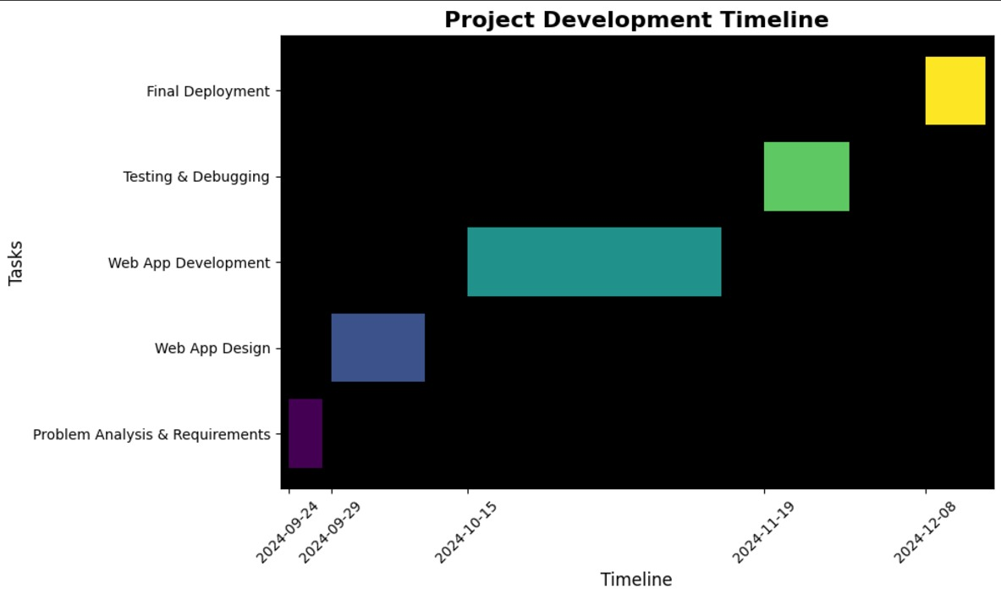

CHAPTER-8
OUTCOMES
Potential Outcomes of Improved Birth and Death Registration Systems:
A well-functioning birth and death registration system can yield significant benefits for individuals, communities, and nations. Based on the provided references and the discussions on the topic, here are some potential outcomes:
Individual Benefits
- Legal Identity: A registered birth certificate provides individuals with a legal identity, which is essential for accessing various rights and services, such as education, healthcare, and employment.
- Citizenship Rights: Accurate birth registration can help individuals claim their citizenship rights and benefits.
- Protection Against Identity Theft: A registered birth certificate can help prevent identity theft and fraud.
Community Benefits
- Accurate Population Data: Reliable birth and death data helps governments and organisations plan for future needs, such as healthcare, education, and infrastructure.
- Improved Public Health: Timely and accurate data on births and deaths can help track disease outbreaks, monitor maternal and child health, and implement effective public health interventions.
- Enhanced Social and Economic Development: Accurate population data can inform policies and programs that promote economic growth and social development.
National Benefits
- Informed Policymaking: Reliable data on births, deaths, and other vital statistics can inform evidence-based policymaking.
- Strengthened Governance: A well-functioning CRVS system can contribute to good governance by ensuring transparency, accountability, and the rule of law.
- Improved International Cooperation: Accurate and timely data can facilitate international cooperation and data sharing.
Specific Examples from the References
- India: The studies by Rane et al. (2020, 2021) highlight the challenges and opportunities for improving birth and death registration in Assam, India. By strengthening the CRVS system, India can improve its public health infrastructure and social welfare programs.
- China: The study by Zeng et al. (2018) emphasises the importance of complete and accurate death registration for understanding population aging and mortality trends.
- Africa: The study by Sankoh et al. (2020) underscores the need for universal birth and death registration in Africa to improve public health, reduce maternal and child mortality, and promote sustainable development.

CHAPTER-9
RESULTS AND DISCUSSIONS

Birth and death registration integration services are vital for effective public health, demographic analysis, and governance. Improving data quality in low-resource settings such as Assam, India, the Civil Registration System (CRS) has been able to bring significant improvements in assessments made around the completeness of registration. In China, the effort on complete death registration across counties underlines the importance of good data for health policy formulating.
In Africa, the drive for birth and death registration focuses on public health interventions and planning. Ghana's experience indicates how integrated systems may increase healthcare delivery. Mobile applications such as mSIGA have also been successful in spreading registration services to remotest areas, leading to timely data collection.
These integration services thus improve quality of data, inform decision-making and resource allocation, that enable governments to make policies based on data. The integration of birth and death registration systems, therefore, enhances governance and healthcare delivery processes, leading to a more sustainable and equitable future.

CHAPTER-10
CONCLUSION
Birth and death registration integration services are vital for effective public health, demographic analysis, and governance. The Civil Registration System (CRS) has significantly improved data quality in low-resource settings like Assam, India, where assessments have shown enhanced completeness of registration. In China, efforts to ensure comprehensive death registration across counties underline the importance of accurate data for health policy formulation.
In Africa, the emphasis on birth and death registration is critical for public health interventions and planning. Ghana's experience illustrates how integrated systems can enhance healthcare access. Additionally, mobile applications like mSIGA have successfully expanded registration services to remote areas, facilitating timely data collection.
These integration services not only improve data quality but also support informed decision-making and resource allocation, enabling governments to develop data-driven policies. Ultimately, the integration of birth and death registration systems strengthens governance and improves healthcare delivery, fostering a more equitable and sustainable future.

The development of a robust and efficient birth and death registration software system is crucial for effective public health management and demographic analysis. By addressing the limitations of traditional manual systems, such a system can significantly improve data quality, accuracy, and accessibility.

Key Benefits of the Proposed System:
- Enhanced Data Quality and Consistency: Automated data entry, validation, and cleaning processes minimize errors and inconsistencies, leading to reliable and accurate data.
-This involves implementing robust data validation, cleaning, and standardization techniques.
-High-quality data improves decision-making, public health planning, and the overall effectiveness of civil registration systems.
-By prioritizing data quality and consistency, we can build a strong foundation for evidence-based policymaking and resource allocation.
- Improved Data Security and Privacy: Robust security measures, such as encryption, access controls, and regular security audits, protect sensitive personal information.
-Strong security measures, such as encryption, access controls, and regular security audits, are essential to safeguard data from unauthorized access, breaches, and misuse.
-Implementing robust privacy policies and procedures ensures that personal information is handled ethically and responsibly.
-By prioritizing data security and privacy, we can build trust and maintain public confidence in birth and death registration systems.
- Enhanced Interoperability and Integration: Standardized data formats and APIs enable seamless data exchange and integration with other systems, improving data sharing and collaboration.
-By adopting standardized data formats and protocols, systems can share and access information efficiently.
-This improves data quality, reduces data redundancy, and enables timely analysis and decision-making.
-Interoperability also facilitates the integration of birth and death registration systems with other relevant systems, such as healthcare, social security, and education, to provide comprehensive and coordinated services to citizens.
- Real-time Data Processing and Analysis: Timely data processing and analysis provide valuable insights for informed decision-making and effective resource allocation.
-By processing data as it is entered, these systems can generate up-to-date reports, identify trends, and detect anomalies.
-This helps in efficient resource allocation, timely public health interventions, and improved service delivery.
-Real-time analytics also facilitates proactive measures to address potential issues and optimize system performance.
- Scalability and Performance: The system is designed to handle increasing data volumes and user demands, ensuring efficient and reliable performance.
-Scalable systems can adapt to growing workloads and user numbers without compromising performance.
-High-performance systems ensure fast processing times, quick response times, and efficient data retrieval.
-This enables timely data processing, analysis, and report generation. By prioritizing scalability and performance, birth and death registration systems can maintain their effectiveness and efficiency as the number of registrations grows.
- User-Friendly Interface: A user-friendly interface simplifies data entry, retrieval, and analysis, reducing the burden on healthcare providers and government officials.
-It features intuitive designs, clear navigation, and simple data entry forms.
-This reduces errors, minimizes training time, and enhances overall user experience.
-A well-designed interface promotes accurate data entry and timely processing, contributing to the overall efficiency and effectiveness of the system.

Future Directions:
- Advanced Analytics: Explore advanced analytics techniques, such as machine learning and artificial intelligence, to extract deeper insights from data.
-By analyzing large datasets, these systems can identify trends, patterns, and anomalies that may not be apparent through traditional analysis methods.
-This enables more accurate forecasting, early detection of public health issues, and informed decision-making.
-Advanced analytics can also help in predicting future trends, optimizing resource allocation, and improving the overall efficiency and effectiveness of birth and death registration systems.
- Mobile Applications: Develop mobile applications to facilitate remote registration and access to services.
-These apps enable users to register births and deaths, track application status, and access vital documents from their smartphones.
-Mobile applications can also facilitate real-time data entry and updates, improving data accuracy and timeliness.
-By leveraging mobile technology, birth and death registration systems can enhance user experience, expand outreach, and improve service delivery.
- Integration with Other Systems: Expand integration with other healthcare and social welfare systems to improve data sharing and coordination.
-By integrating these systems, we can improve data consistency, reduce redundant data entry, and facilitate the provision of comprehensive and coordinated services to citizens.
-Integration can also help in identifying trends, analyzing population dynamics, and making informed policy decisions.
- Continuous Improvement: Regularly assess and update the system to incorporate emerging technologies and address evolving needs.
-By continuously evaluating user feedback, analyzing system performance, and adapting to changing needs, we can ensure that the system remains efficient, reliable, and user-friendly.
-Continuous improvement fosters innovation, enhances user experience, and ultimately contributes to the overall effectiveness of birth and death registration processes.

By addressing the research gaps identified in existing systems and leveraging the benefits of modern technology, this birth and death registration software system has the potential to revolutionize public health management and demographic analysis.

REFERENCES
[1]. Rane, T. M., Mahanta, T. G., Islam, S., Gogoi, P. P., &Gogoi, B.:Civil registration system (CRS) for birth and death registration in Assam – a rapid assessment. ClinEpidemiol Glob Health ,2020.
[2]. Zeng X, Adair T, Wang L, Yin P, Qi J, Liu Y, et al : Measuring the completeness of death registration in 2844 Chinese counties in ,2018 .
[3]. Sankoh O, Dickson KE, Faniran S, Lahai JI, Forna F, Liyosi E, et al : Births and deaths must be registered in Africa. Lancet Glob Health,. 2020.
[4]. K Hruthika Ruth, AvinashShinde, Hemanth Kumar DM, Kalpana.K.: Birth/Death Registration Integration with Services , 2024.
[5]. Abdul-Aziz Ibn Musah1, Zakaria Abdulai2, Mohammed Dawuni1, Abdulai Abdul-Hanan1: Evaluation of the Effect of Birth and Death Registration on Health Service Delivery (A Case of Tolon District of Ghana) , 2015.
[6]. Bernard K. Petera, Evans K. Miritib: Birth Notification Service for Civil Registration in Kenya - SOA Model , 2016.
[7]. TusharManoharRane, TulikaGoswamiMahanta, Safikul Islam, PranjalPratimGogoi, BivashGogoi:Civil registration system (CRS) for birth and death registration in Assam – A rapid assessment , 2021.
[8]. Sonali Sanjay Chaudhari : Online Birth Registration & Certification System , 2021
[9]. T. M. Rane, T. G. Mahanta, S. Islam, P. P. Gogoi, and B. Gogoi: "Civil registration system (CRS) for birth and death registration in Assam – a rapid assessment," ClinEpidemiol Glob Health, 2020.
[10]. X. Zeng et al.: "Measuring the completeness of death registration in 2844 Chinese counties in 2018.”
[11]. O. Sankoh et al.: "Births and deaths must be registered in Africa," Lancet Glob Health, 2020.
[12]. K. Hruthika Ruth et al.: "Birth/Death Registration Integration with Services," 2024.
[13]. A. A. IbnMusah et al.: "Evaluation of the Effect of Birth and Death Registration on Health Service Delivery (A Case of Tolon District of Ghana)," 2015.
[14]. B. K. Petera and E. K. Miritib:”Birth Notification Service for Civil Registration in Kenya - SOA Model,” 2016.
[15]. R. Pinto, J. S. Pinto, and R. J. Oliveira, "mSIGA - Mobile Application for Birth and Death Registration in Hospitals and Remote Population Areas," IEETA/DETI, University of Aveiro, Portugal, 2017.
[16]. H. Prasetyo and M. I. A. Hamudy : "Increasing the Scope of Birth and Death Registration : Issues and Challenges," Research and Development Agency, Ministry of Home Affairs , 2016.
[17]. L. Vasudevan, C. Glenton, N. Henschke, N. Maayan, J. Eyers, M. S. Fønhus, T. Tamrat, G. L. Mehl, and S. Lewin, "Birth and Death Notification via Mobile Devices: A Mixed Methods Systematic Review," Center for Health Policy and Inequalities Research, Duke Global Health Institute, USA, 2020.
[18]. S. S. Chaudhari: "Online Birth Registration & Certification System," 2021.
[19]. A. M. McCaw-Binns and J. A. Mullings: "Birth and Death Registration," 2024.
[20]. S. O. Oluwagbemiga, L. A. Akinyemi, Q. A. Mumuni, and O. O. Oyenuga, "Design and Implementation of Birth and Death Registration System," Dept. of Electronic and Computer Engineering, Lagos State University, Nigeria, 2020.

APPENDIX-A
PSUEDOCODE

START APPLICATION
- Load Django Framework
- Configure Project Settings
- Connect to SQLite Database
- Start Web Server

DEFINE URL PATTERNS:
- "/" --> Register()
- "/loginpage/" --> Login()
- "/logout/" --> LogoutUser()
- "/birth/" --> Birthde()
- "/death/" --> Deathde()
- "/feedback/" --> Feedback()
- "/appointment/" --> AppointmentDetails()
- "/admin/" --> Django Admin Dashboard

FUNCTION Register(request):
IF request method is POST:
- Extract username, email, phone number, password from form
- Create new user in database
- Redirect to login page
ELSE:
- Display registration form

FUNCTION Login(request):
IF request method is POST:
- Extract username and password from form
- Authenticate user with database
- IF user exists:
- Login user and redirect to home page
ELSE:
- Show error message
ELSE:
- Display login form

FUNCTION LogoutUser(request):
- Logout current user
- Redirect to login page

FUNCTION Birthde(request):
IF request method is POST:
- Extract form data: first name, last name, gender, birth date, parents’ names, contact info
- Create new birth record in the database
- Save record
- Confirm submission
ELSE:
- Display birth application form

FUNCTION Deathde(request):
IF request method is POST:
- Extract form data: name, date of birth, death date, parents' names, contact info
- Create new death record in the database
- Save record
- Confirm submission
ELSE:
- Display death application form

FUNCTION AppointmentDetails(request):
IF request method is POST:
- Extract appointment details from form
- Create new appointment record in database
- Confirm submission
ELSE:
- Display appointment form

FUNCTION Feedback(request):
IF request method is POST:
- Extract name, email, and feedback message from form
- Save feedback to the database
- Confirm submission
ELSE:
- Display feedback form

STOP WEB SERVER
CLOSE DATABASE CONNECTION

APPENDIX- B
SCREENSHOTS

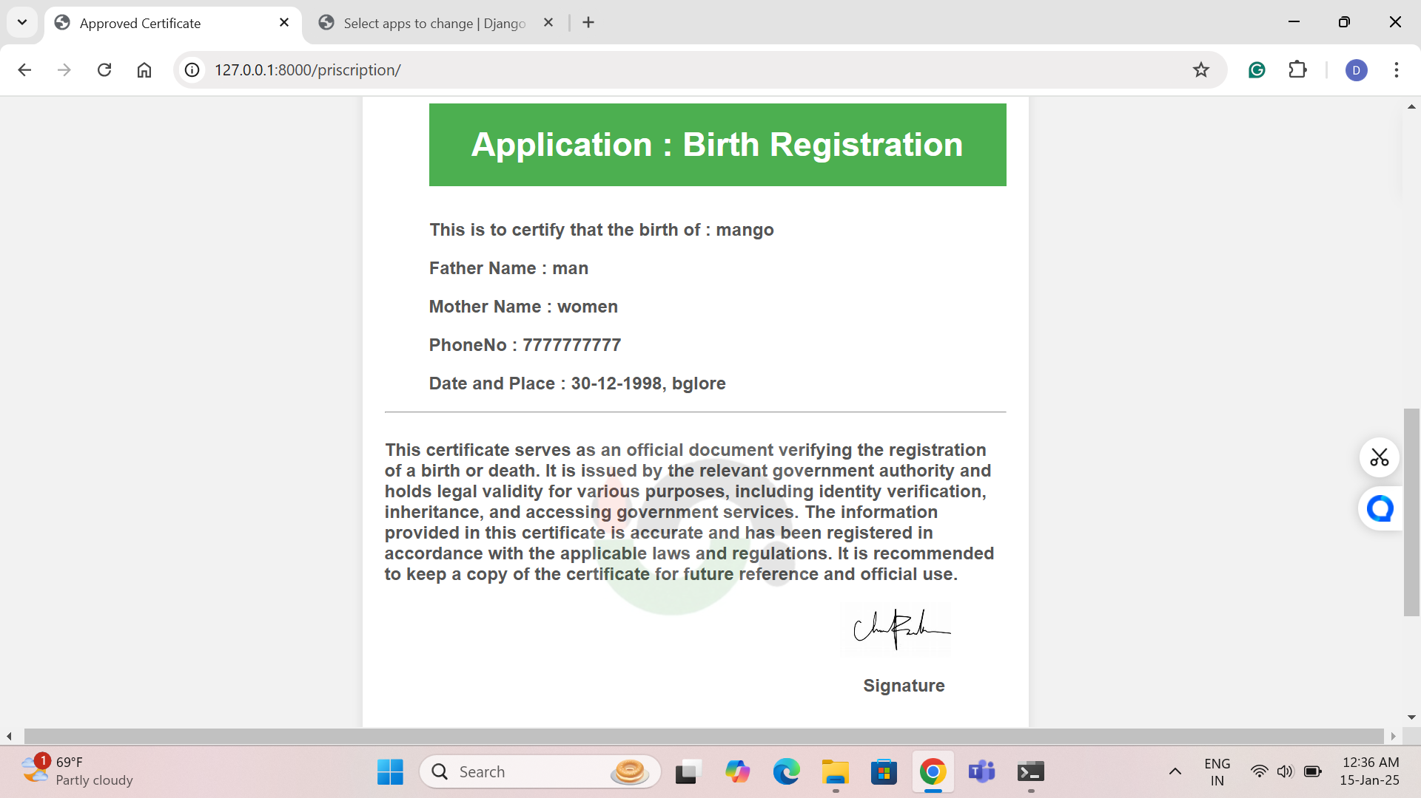

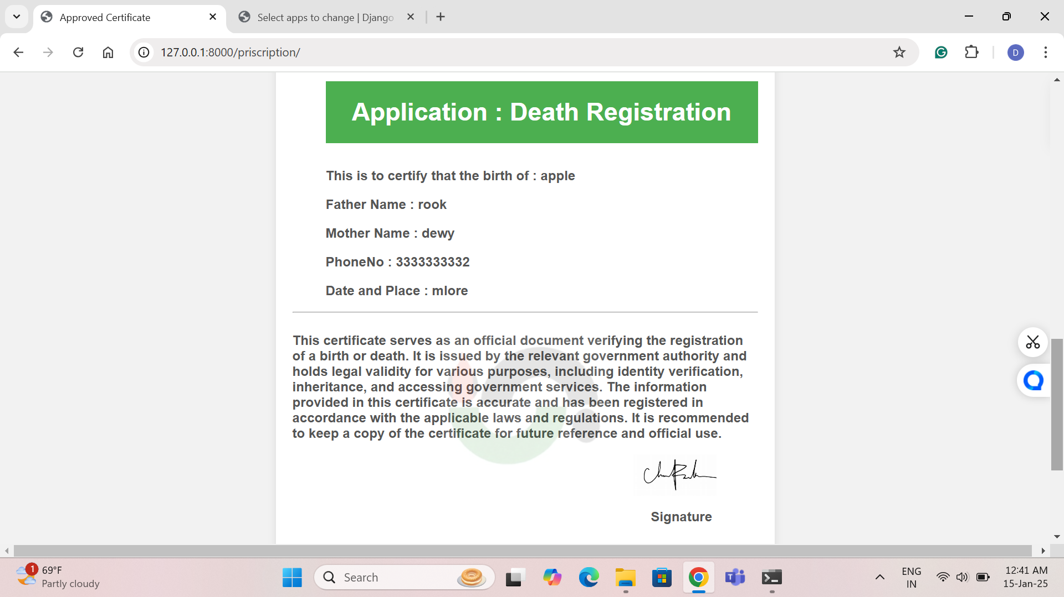

APPENDIX-C
ENCLOSURES

1. Journal publication/Conference Paper Presented Certificates of all students.
2. Include certificate(s) of any Achievement/Award won in any project-related event.
3. Similarity Index / Plagiarism Check report clearly showing the Percentage(%). No need fora page-wise explanation.
4. Details of mapping the project with the Sustainable Development Goals(SDGs).

