**USE CASES:**

1. **Display Controls (Main Panel)**

**Use Case:** *Display Control*

**Id**: 1

**Level:** *High*

**Description**

*The user inputs number of generations and length of stem followed by selecting a rule from the rule dropdown (Rule 1,2,3). Based on the inputs entered, a creeper like stem growth with respective number of generations, stem length and rule of growth is displayed.*

**Actor(s)**

*Users who run the application.*

**Stakeholders and Interests**

*Users who run the application.*

**Pre-Conditions**

* *Angles for each rule must be assigned in advance.*

**Trigger**

1. *Enter the number of generations in the text box of “Input generations”.*
2. *Enter the length of stem in text box of “Enter stem length”.*
3. *Select a rule from the “Select rule” dropdown (Rule 1, 2 or 3).*
4. *Click on “Start” button to start the simulation.*

**Post-Conditions**

*A creeper like stem growth is displayed that adheres to the number of generations, stem length and rule entered.*

1. **Rule Selection**

**Use Case:** *Rule Selection*

**Id**: 2

**Level:** *Medium*

**Description**

*The users select a rule from the “Select rule” dropdown which displays stem growth that adheres to the respective rule.*

**Actor(s)**

*Users who run the application.*

**Stakeholders and Interests**

*Users who run the application.*

**Pre-Conditions**

* *Input number of Generations.*
* *Input stem length*

**Trigger**

1. *Select a rule from the “Select rule” dropdown.*
2. *Click on start to run the selected rule.*
3. *A creeper like stem growth is displayed for the number of generations and length entered.*

**Post-Conditions**

*A creeper like stem growth is displayed that adheres to the number of generations, stem length and rule entered.*

**Main scenario – Creeper like stems displaying stem growth of each generation starting from a point.**

**1. Rule1:**

* Displays 3 initial stems of different color depicting first generation.
* From 2nd generation onwards, main stem growth is shown in green color and its forks are shown in white and magenta colors.

**2. Rule 2:**

* Displays 2 initial stems of different color depicting first generation.
* From 2nd generation onwards, main stem growth is shown in green color and its forks are shown in magenta color.

**3. Rule 3:**

* Displays generation 1 in magenta color.
* Further generations are shown in magenta color. No forks are displayed.

**Alternate Scenario: With higher generations, stem growth is displayed in a circular spiral structure increasing in radius. (As shown below)**

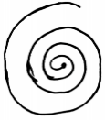

1. **Start**

**Use Case:** *Start Process*

**Id**: 3

**Level:** *Medium*

**Description**

*The user clicks on start button to start the simulation of stem growth which displays generations of stem growth.*

**Actor(s)**

*Users who run the application.*

**Stakeholders and Interests**

*Users who run the application.*

**Pre-Conditions**

* Generation number and stem length inputs are entered.
* Rule is selected.

**Trigger**

1. Start button is clicked once the required inputs are entered.

**Post-Conditions**

*A creeper like stem growth is displayed that adheres to the number of generations, stem length and rule entered.*

1. **Pause/Resume**

**Use Case:** *Pause/Resume process*

**Id**: 4

**Level:** *Medium*

**Description**

*The user clicks on start button to start the simulation of stem growth which displays generations of stem growth. When the simulation is running and user clicks on pause/resume button, the application pauses the simulation and resumes when clicked on pause/resume button again.*

**Actor(s)**

*Users who run the application.*

**Stakeholders and Interests**

*Users who run the application.*

**Pre-Conditions**

* *For pause - Running simulation*
* *For resume – paused simulation*

**Trigger**

1. *User clicks on the start button to start the simulation.*
2. *User clicks on pause/resume button to pause the simulation.*
3. *User clicks on pause/resume button again to resume the simulation.*

**Post-Conditions**

*A creeper like stem growth is displayed that adheres to the number of generations, stem length and rule entered.*

1. **Stop**

**Use Case:** *Stop process*

**Id**: 5

**Level:** *Medium*

**Description**

*The user clicks on start button to start the simulation of stem growth which displays generations of stem growth. When the simulation is running and user clicks on stop button, the application stops the simulation. User can also stop the simulation after pause/resume state.*

**Actor(s)**

*Users who run the application.*

**Stakeholders and Interests**

*Users who run the application.*

**Pre-Conditions**

* *Running simulation*
* *Resumed simulation.*

**Trigger**

1. *User clicks on the start button to start the simulation.*
2. *User clicks on stop button to stop the simulation.*
3. *User clicks on pause/resume button again to resume the simulation.*
4. *User clicks on stop button to stop the simulation.*

**Post-Conditions**

*Simulation of stem growth stops.*

***Contd…..***

**How stem growth is shown:**

*Expected growth:*

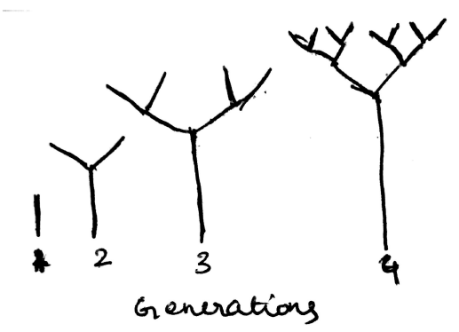

*Actual growth:*

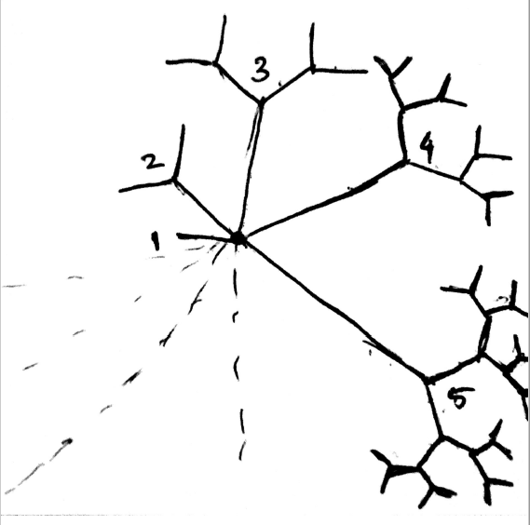

*Pros of the design:*

* *Looks attractive with multiple colors.*
* *Forms creeper like pattern for fewer generations and a circular spiral pattern for higher generations.*

*Cons of the design:*

* *Does not show continuous vertical linear growth.*
* *Looks crowded with higher generations.*
* *Becomes messy with the use of line strokes.*
* *Statistics visible for only initial generations*