**Assignment 17.2**

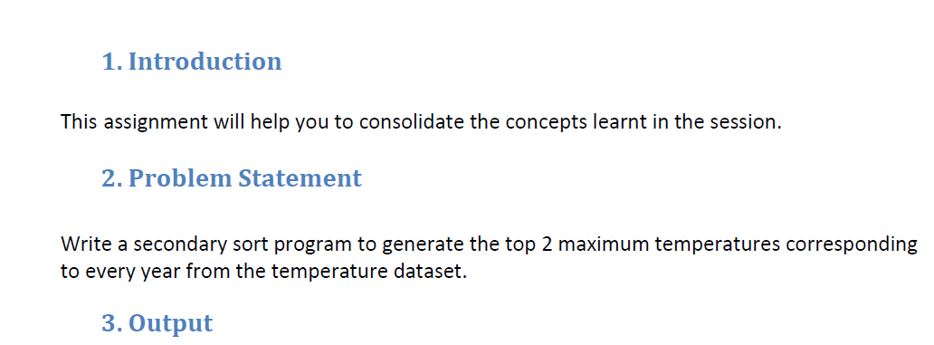

**Driver Class:**

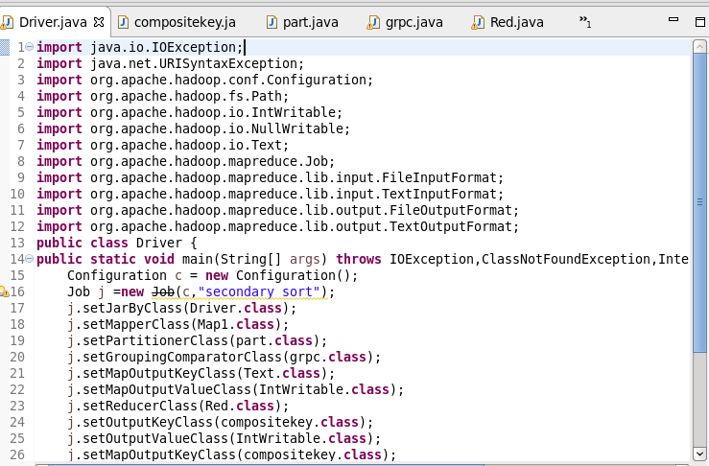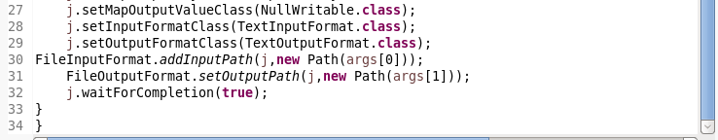

IN DRIVER CLASS WE WILL SET MAPPER CLASS,PARTITIONER CLASS, GROUP COMPARATOR CLASS , COMPOSITE KEY CLASS as MAP OUTPUT CLASS, REDUCER CLASS.

**Mapper Class:**

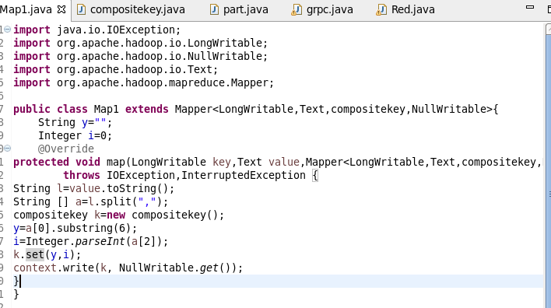

Here, In mapper class splitting the data by comma and then sending compositekey as key and value as nullwritable.

**Compositekey class**:

Here, overriding compareto and toString methods and also reading and writing the fields are happening.

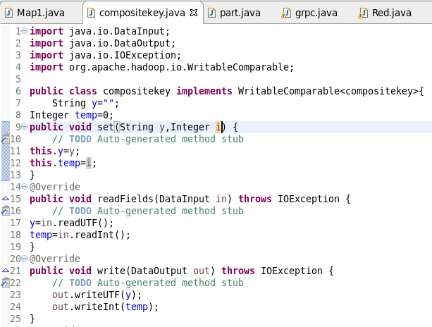

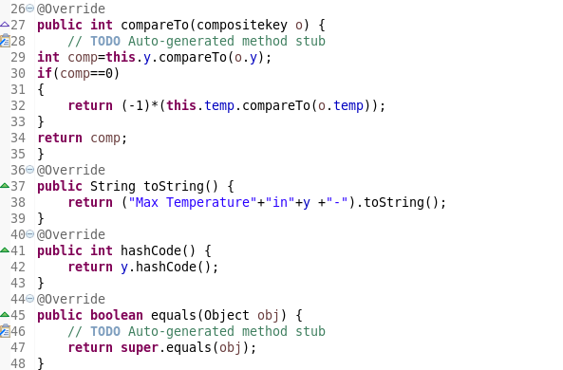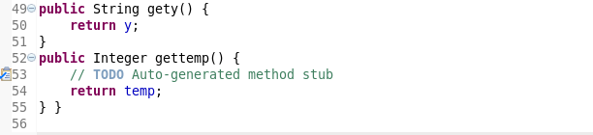

**Partition class:**

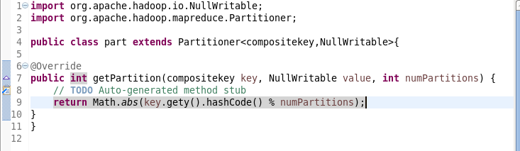

Here, in partition class sending the key-value pair from mapper to reducer.

**Groupcomparator class:**

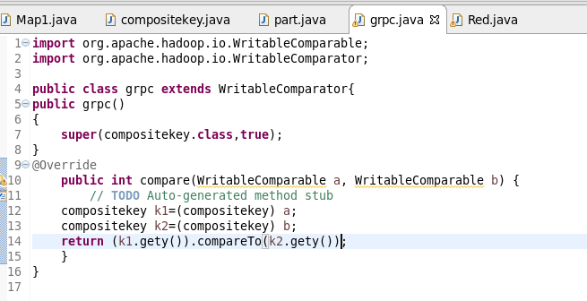

**Reducer class:**

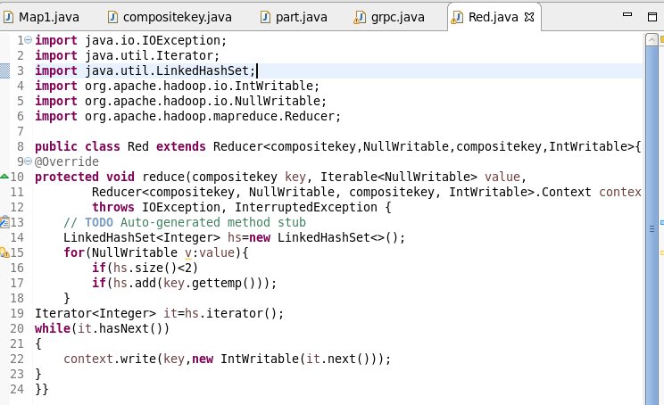

To get two maximum temperature, I am using linked hashmap of size 2.

**Running jar**

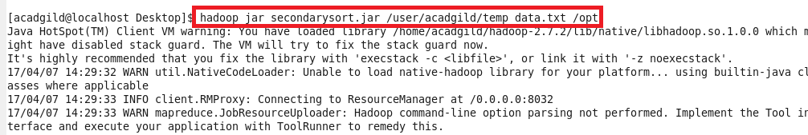

**OUTPUT**

