**Assignment 17.3**

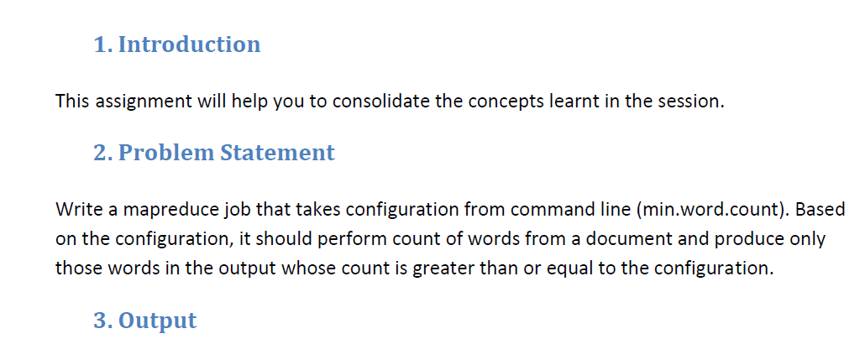

**Driver Class:**

In Driver class we are making it the extends configured class , implementing tool interface and tool runner static method run which creates a configuration object before the run method.

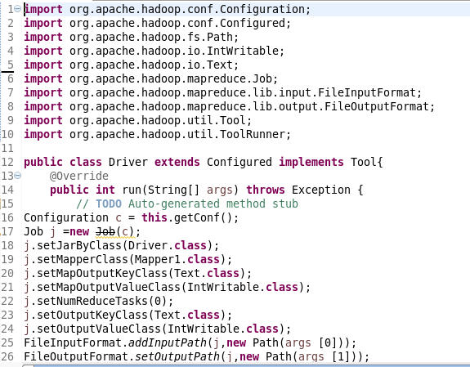

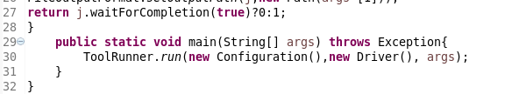

**Mapper Class:**

In Mapper, I am using hashmap and if hashmap contains the word the count will be incremented or else a count of 1 will be made.

Words will be counted only if the occurrence of word is greater than or equal to the given value

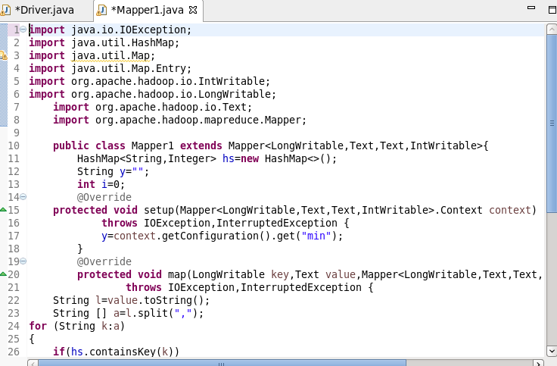

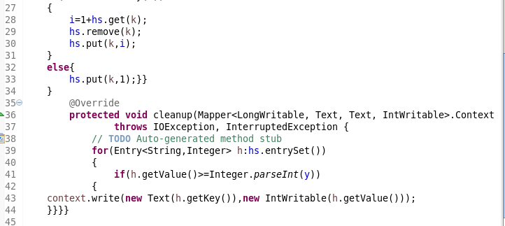

**RUNNING JAR**

**Here I have specified the mincount=3 by giving** –D name=3 **as highlighted below**

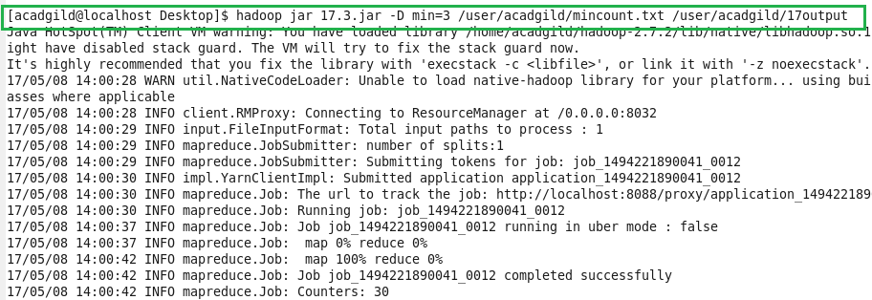

**Input :**

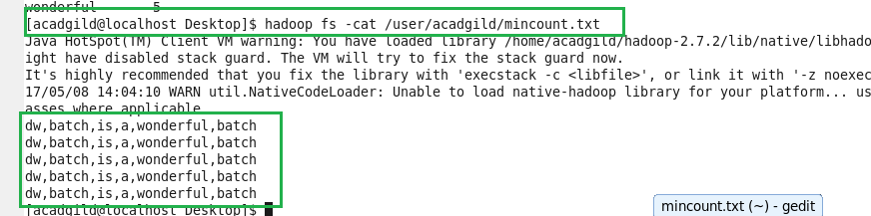

**Output:**

