**ASSIGNMENT11.2**

**Sample file:**

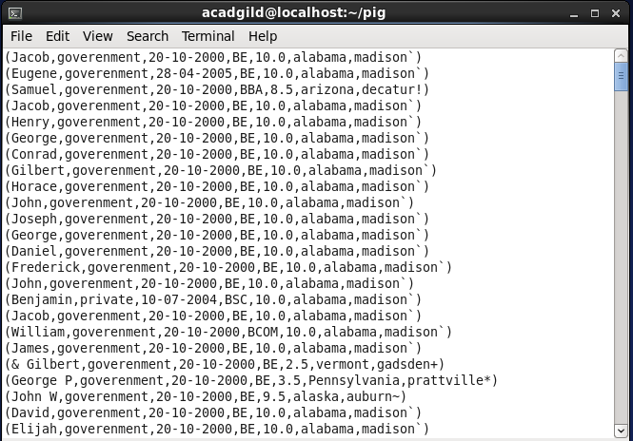

* **Find the number of students who scored more than 5(50%).**
* First the file is loaded;
* Then the data is filtered according to grade > 5.0
* The output is then grouped into a single bag and counted.

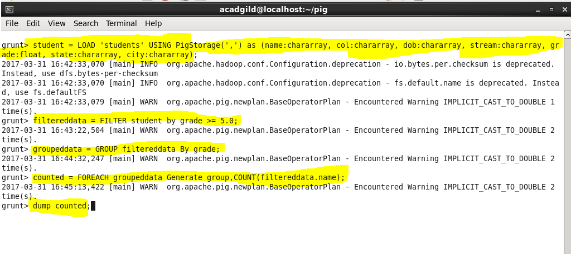

**Output of each step:**

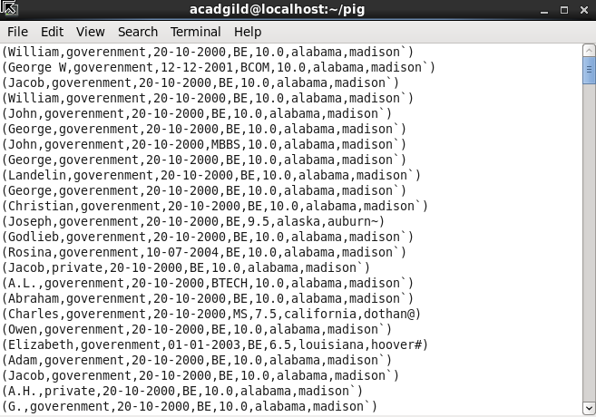

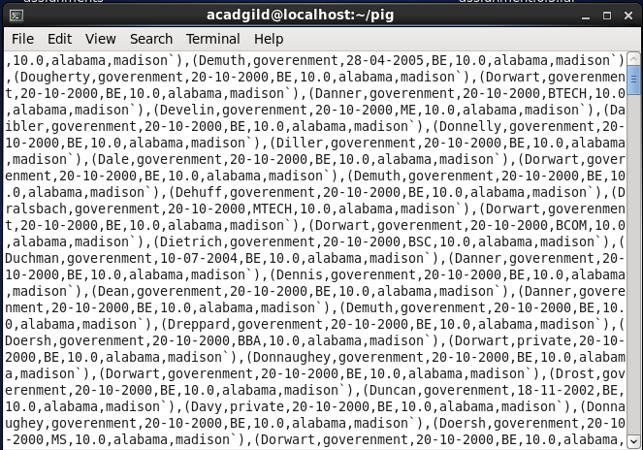



* **List the name of students who are from Alaska**.
* First filter the dataset by city name =’alaska’
* Group the output by all
* Then finally print the name of the people that belong to Alaska

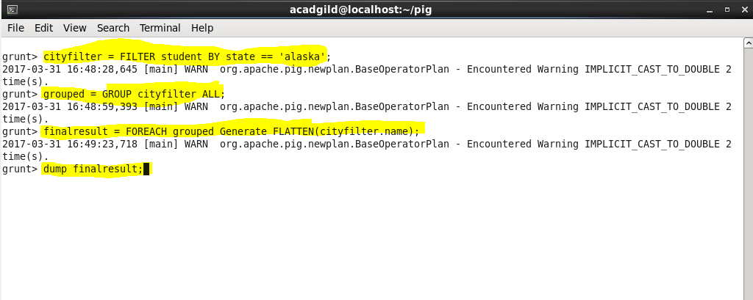

**OUTPUT for each command:**

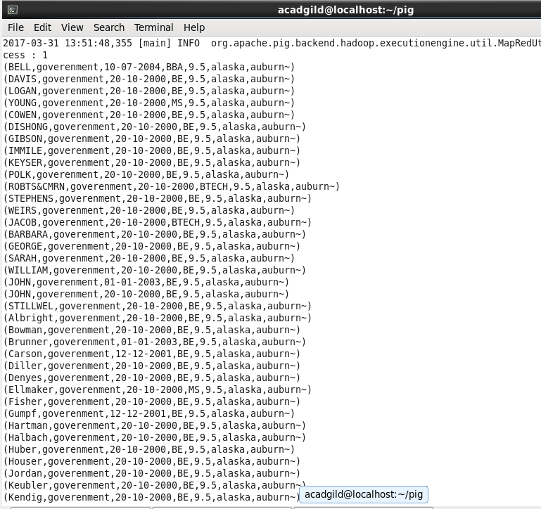

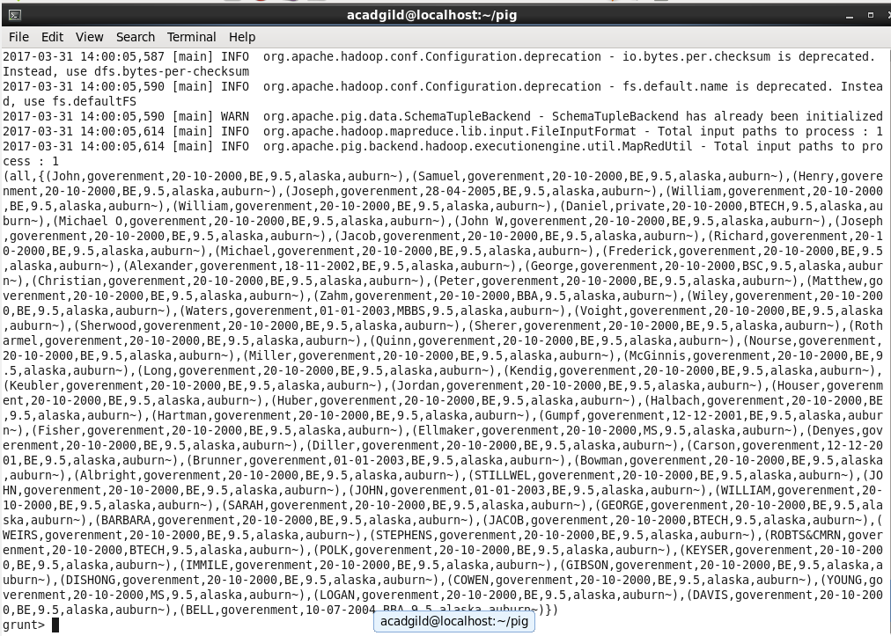

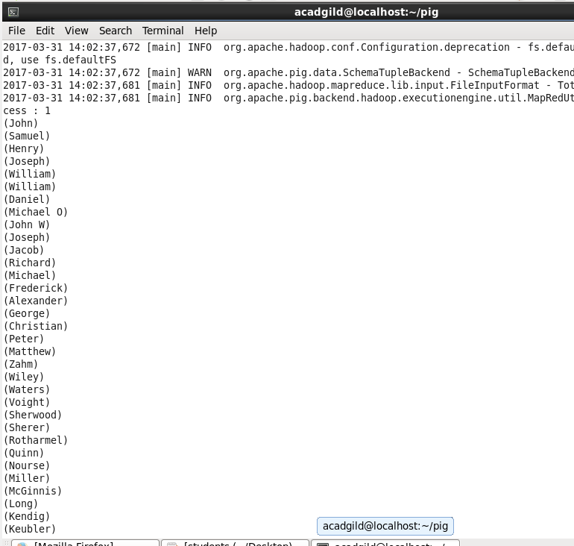

* **How many government colleges are there in Alabama?**

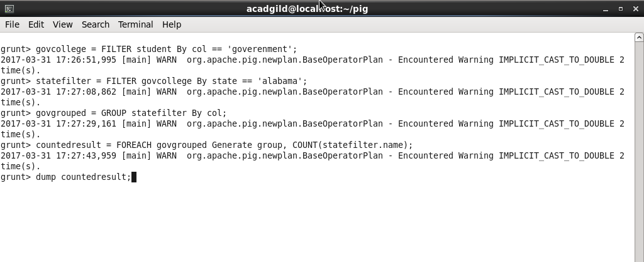

**OUTPUT for each command:**

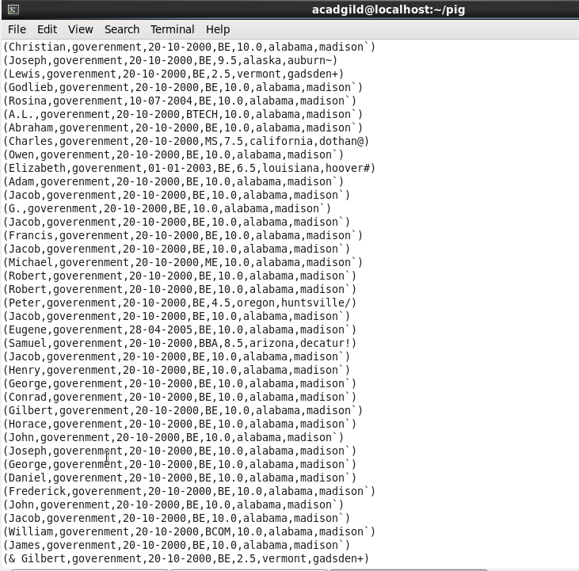

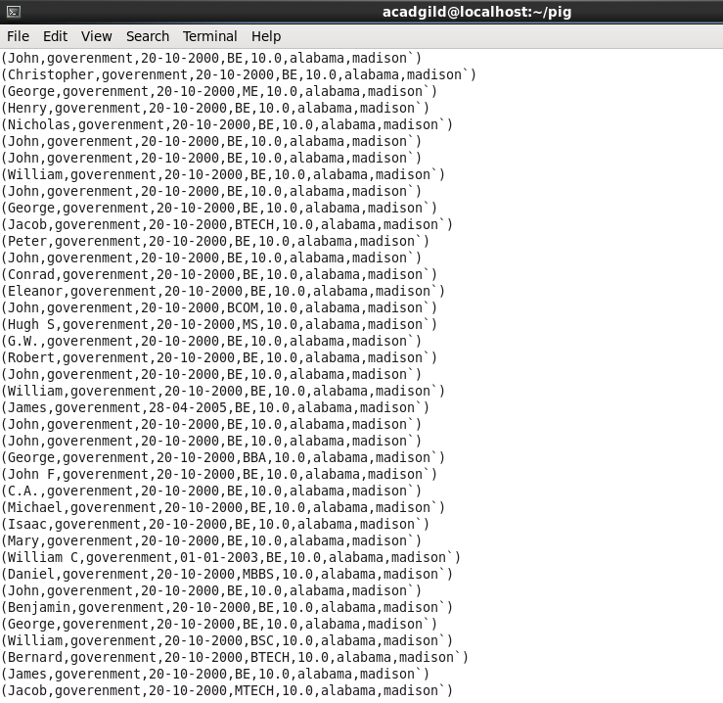

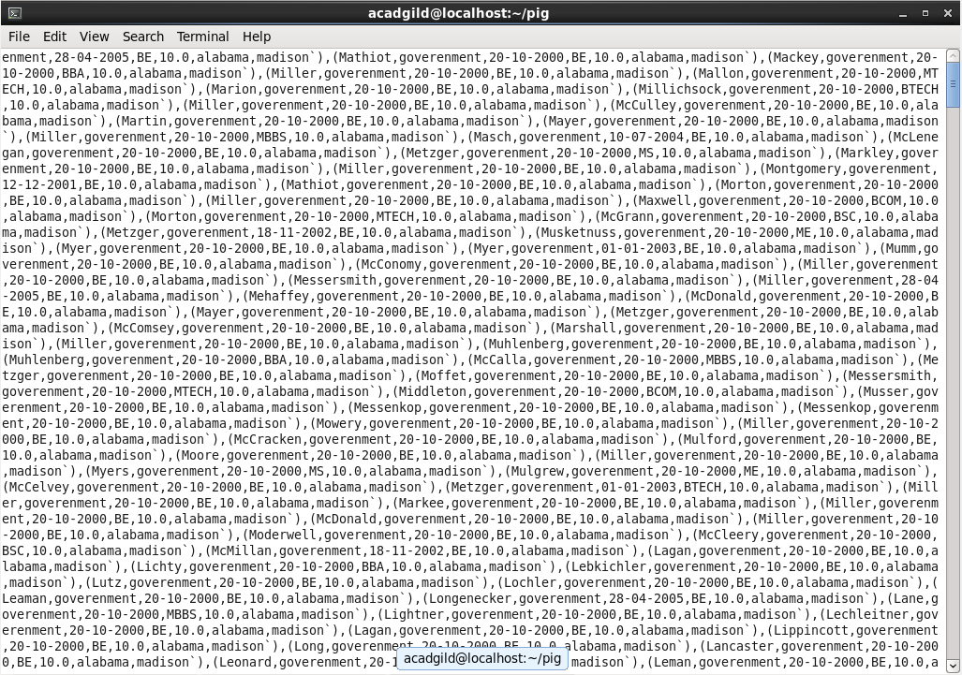

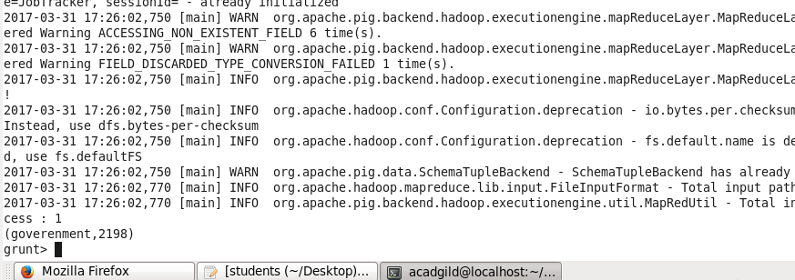

* **List the name of students who are from Oregon and pursuing BE**.
* Filter data by stream = BE and state = Oregon and generate the names

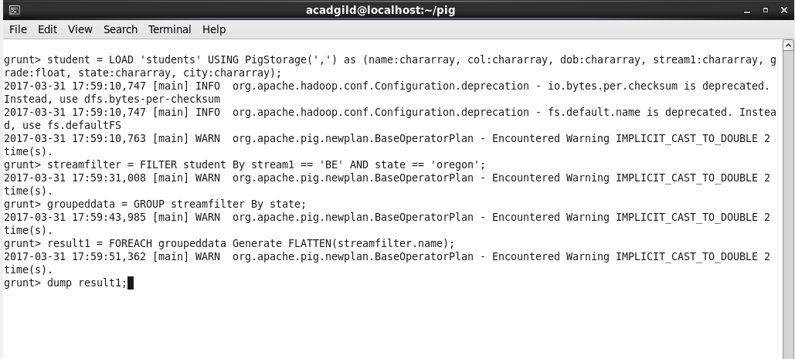

**OUTPUTS**



